Supplementary Information
Eco-friendly flame-retardant wood-plastic composites from wood-fiber and polyurethane
Xuanye Wang ^{a,b,1}, Beibei Wang ^{a,b,1}, Jingmeng Sun ^{a,b}, Lei Yu ^{a,b}, Guochao Yang*^{,a,b}, Hongwu Guo^{*,a,b}
a. Key Laboratory of Wood Material Science and Application (Beijing Forestry University), Ministry of Education, Beijing 100083, China
b. Beijing Key Laboratory of Wood Science and Engineering, Beijing Forestry University, Beijing 100083, China
* Corresponding author: Guochao Yang. E-mail: yangguochao@bjfu.edu.cn
Hongwu Guo, guohongwu_305@bjfu.edu.cn
¹ Xuanye Wang and ¹ Beibei Wang contributed equally to this work.

Table.S1. Combustion characteristic parameters for WPUCs
Samples | LOI / % | Melting droplet | UL 94 V
Control | 22.5 | No | V-2
WPUC-5 | 25.8 | No | V-1
WPUC-6 | 27.2 | No | V-0
WPUC-7 | 31.2 | No | V-0
WPUC-8 | 29.2 | No | V-0
WPUC-9 | 27.8 | No | V-0

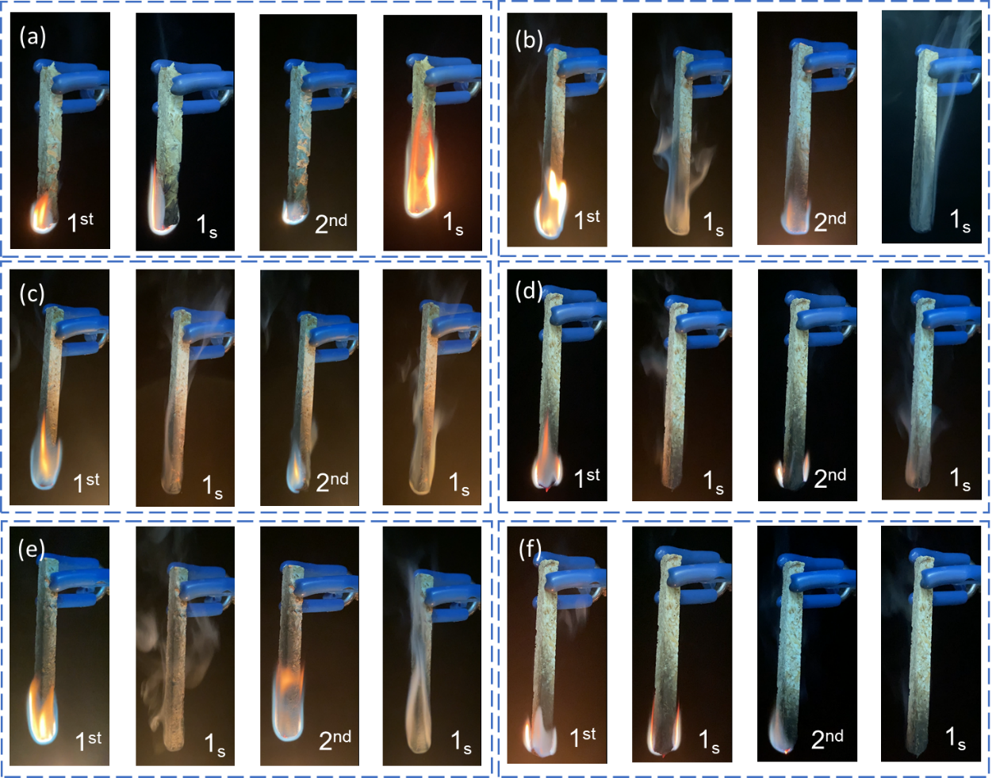
Fig.S1 The UL-94 test figure of Control (a), WPUC-5 (b), WPUC-6 (c), WPUC-7 (d), WPUC-8 (e) and WPUC-9 (f).

Table.S2. Physical and mechanical properties comparison between similar WPCs.
Sample | Plastic matrix (Pm) | Percentage of Pm (wt. %) | IB(MPa) | MOE(GPa) | MOR(MPa) | References
1 | Polypropylene | 30 | —— | 10.00 | 90.00 | (Schmidt et al. 2013)
2 | Polypropylene | 73 | —— | 3.50 | —— | (Yadav and Bin Yusoh 2019)
3 | Polypropylene | 30 | 1.42 | 3.18 | 23.30 | (Benthien and Thoemen 2012)
4 | Polystryrene | 40 | 0.34 | 0.88 | 7.90 | (Lyutyy et al. 2018)
5 | Polyethylene | 30 | —— | 2.27 | 54.80 | (Gallagher and Mcdonald 2013)
6 | Styrene | 40 | —— | 4.92 | 48.20 | (Devi et al. 2007)
7 | High density polyethylene | 30 | —— | 7.01 | 79.26 | (Zolfaghari et al. 2015)
8 | Polypropylene | 38.5 | —— | 3.60 | 37.90 | (Xu et al. 2019)
9 | Polypropylene/polyethylene | 28 | —— | 4.00 | 25.22 | (Zhao et al. 2020)
This work | Polyurethane | 36 | 2.34 | 10.70 | 10.50

Table.S3. Thickness swelling of WPUCs in 2 h, 24 h, 2 d, and 7 d.
 | 2 h | 24 h | 2 d | 7 d
Control | 8.3 | 10.2 | 12.5 | 13.2
WPUC-5 | 6 | 7.8 | 8.3 | 8.6
WPUC-6 | 2.9 | 4.7 | 5.1 | 6.2
WPUC-7 | 4 | 4.8 | 4.9 | 5.2
WPUC-8 | 3.8 | 5.7 | 7.6 | 7.9
WPUC-9 | 5.5 | 8.5 | 9.1 | 9.6

Table.S4. Water absorption of WPUCs in 2 h, 24 h, 2 d and 7 d.
 | 2 h | 24 h | 2 d | 7 d
Control | 68.7 | 72.5 | 85.2 | 98.2
WPUC-5 | 54.5 | 56.8 | 70.6 | 81.7
WPUC-6 | 42.6 | 45.8 | 59.7 | 72.7
WPUC-7 | 32.7 | 35.7 | 39.9 | 52.9
WPUC-8 | 28.9 | 31.3 | 37.7 | 52.4
WPUC-9 | 24.7 | 29.8 | 32.0 | 45.8

References
Benthien JT, Thoemen H (2012) Effects of raw materials and process parameters on the physical and mechanical properties of flat pressed wpc panels. Compos Part a Appl Sci Manuf 43:570-576. https://doi.org/10.1016/j.compositesa.2011.12.028
Devi RR, Saikia CN, Thakur AJ, Maji TK (2007) Modification of rubber wood with styrene in combination with diethyl allyl phosphate as the flame-retardant agent. J Appl Polym Sci 105:2461-2467. https://doi.org/10.1002/app.26342
Gallagher LW, Mcdonald AG (2013) The effect of micron sized wood fibers in wood plastic composites. Maderas 15:357-374. https://doi.org/10.4067/S0718-221X2013005000028
Lyutyy P, Bekhta P, Ortynska G (2018) Lightweight flat pressed wood plastic composites: possibility of manufacture and properties. Drv Ind 69:55-62. https://doi.org/10.5552/drind.2018.1746
Schmidt H, Benthien JT, Thoemen H (2013) Processing and flexural properties of surface reinforced flat pressed wpc panels. Eur J Wood Wood Prod 71:591-597. https://doi.org/10.1007/s00107-013-0719-y
Xu B, Deng C, Li Y, Lu P, Zhao P, Wang Y (2019) Novel amino glycerin decorated ammonium polyphosphate for the highly-efficient intumescent flame retardance of wood flour/polypropylene composite via simultaneous interfacial and bulk charring. Compos B Eng 172:636-648. https://doi.org/10.1016/j.compositesb.2019.05.099
Yadav SM, Bin Yusoh K (2019) Subsurface mechanical properties and subsurface creep behaviour of modified nanoclay-based wood-plastic composites studied by nanoindentation. Polym Bull (Berl) 76:2179-2196. https://doi.org/10.1007/s00289-018-2497-5
Zhao Z, Zhang Q, Wang J (2020) Properties comparison of coextruded and un-coextruded wood plastic composites under high temperature accelerated water uptake. Polym Compos 41:2616-2624. https://doi.org/10.1002/pc.25560
Zolfaghari A, Behravesh AH, Shahi P (2015) Comparison of mechanical properties of wood-plastic composites reinforced with continuous and noncontinuous glass fibers. J Thermoplast Compos Mater 28:791-805. https://doi.org/10.1177/0892705713503676

