SUPPLEMENTARY INFORMATION
Effects of Hydrolysis and Bleaching Conditions on the Efficiency of Cellulose Microribbons Extraction from Coffee Parchment Through a Design of Experiments
Juan Esteban Henao Rodríguez¹, Daniel Escobar Rincón¹, Daniel Fernando Hincapié Rojas¹, Iván Gerardo Cely Orjuela², Leandro M. Socolovsky², Dariana Geraldine Erazo Rondón¹, César Leandro Londoño Calderón^{1*}
¹Departamento de Física y Matemáticas, Facultad de Ingeniería, Universidad Autónoma de Manizales, Antigua Estación del Ferrocarril, Manizales, Colombia.
²Universidad Tecnológica Nacional, Facultad Regional Santa Cruz - CIT Santa Cruz (CONICET), Río Gallegos, Santa Cruz, Argentina.
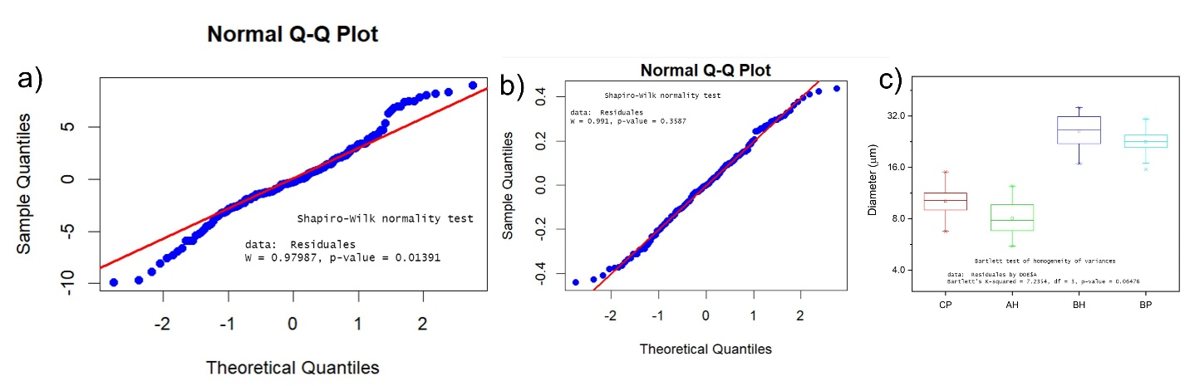
Figure S1. Testing of the assumptions in ANOVA for the results of the diameter measured from: (a) original data and (b) natural logarithmic transformation. (c) Box chart of the diameter measured from micrographs for coffee parchment untreated (CP), after acid hydrolysis (AH), after basic hydrolysis (BH) and after bleaching process (BP).

Table S1. Summary of the results obtained from the average experiments of the acid hydrolysis.
Treatments | Factors/Levels |  | Mass loss average (%)
 | HNO₃ %(v/v) | Time (min) | Mass loss average (%)
1 | 2,5 | 60 | 20.46
2 | 2,5 | 120 | 24,7
3 | 2,5 | 180 | 27,9
4 | 5 | 60 | 36,0
5 | 5 | 120 | 43,3
6 | 5 | 180 | 45,2

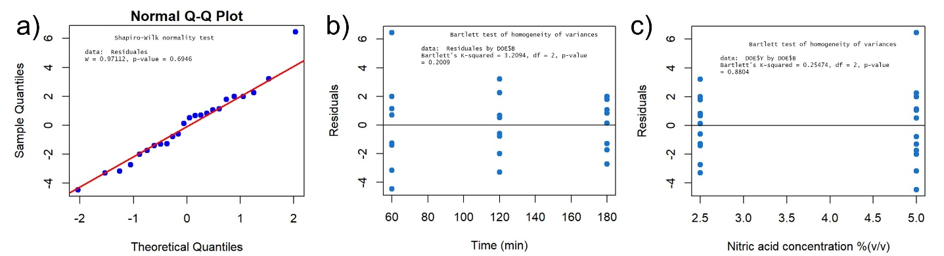
Figure S2. Testing of the assumptions in ANOVA for the results of the acid hydrolysis (Table S1): (a) normality of the population distribution for each factor level, the distributions have the same variance for each factor (b) time and (c) HNO₃ concentration.

Table S2. Summary of the results obtained from the average experiments of the basic hydrolysis.
Treatments | Factors/Levels |  | Mass loss average (%)
 | NaOH %(m/v) | Time (min) | Mass loss average (%)
1 | 1,5 | 45 | 36,7
2 | 1,5 | 90 | 41,8
3 | 3 | 45 | 42,8
4 | 3 | 90 | 44,3

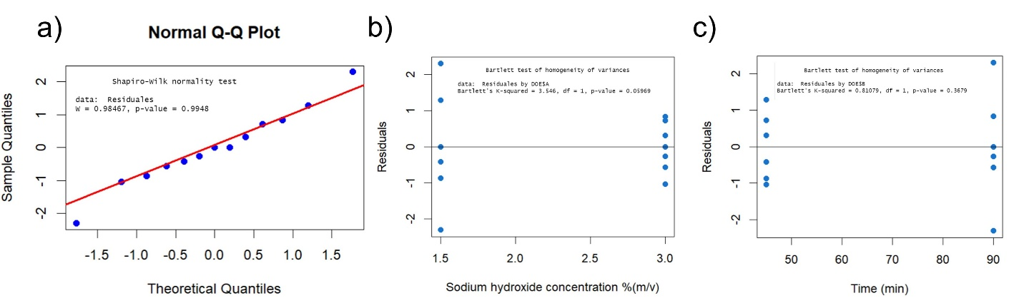
Figure S3. Testing of the assumptions in ANOVA for the results of the basic hydrolysis (Table S2): (a) normality of the population distribution for each factor level, the distributions have the same variance for each factor (b) NaOH concentration and (c) time.

Table S3. Summary of the results obtained from the average experiments of the bleaching.
Treatments | Factors/Levels |  | Mass loss average (%)
 | NaClO:CH₃COOH ratio | Time (min) | Mass loss average (%)
1 | 1:1 | 30 | 13,0
2 | 1:1 | 60 | 12.6
3 | 2:2 | 30 | 13,0
4 | 2:2 | 60 | 13.4

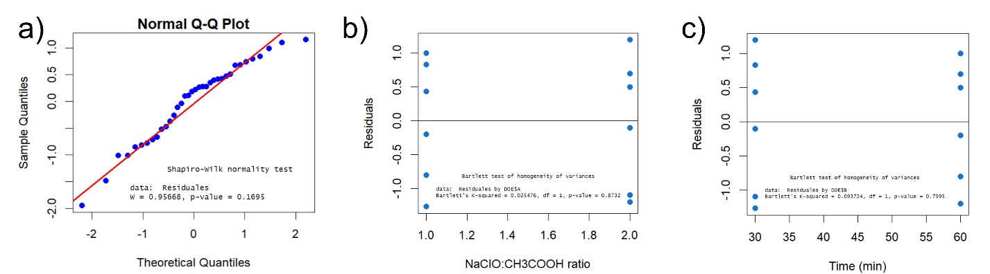
Figure S4. Testing of the assumptions in ANOVA for the results of the bleaching process (Table S3): (a) normality of the population distribution for each factor level, the distributions have the same variance for each factor (b) H₂O volume and (c) time.

Table S4. Summary of the results obtained from the average brightness of the bleaching.
Treatments | Factors/Levels |  | L* (%)
 | NaClO:CH₃COOH ratio | Time (min) | L* (%)
1 | 1:1 | 30 | 97.00
2 | 1:1 | 60 | 96.82
3 | 2:2 | 30 | 96.41
4 | 2:2 | 60 | 96.30

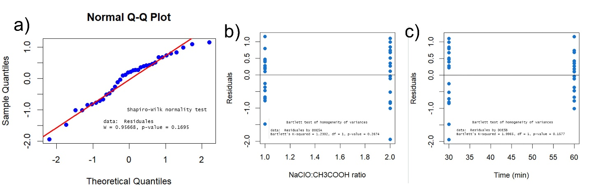
Figure S5. Testing of the assumptions in ANOVA for the results of the brightness in bleaching process (Table S4): (a) normality of the population distribution for each factor level, the distributions have the same variance for each factor (b) chemical precursors concentration and (c) time.

