Enumeration of plant-growth promoting bacteria Herbaspirillum seropedicae viable cells by a new propidium monoazide combined with quantitative PCR (PMA-qPCR) assay

Ana Marina Pedrolo¹, Elisandra Triches da Cunha¹, Nicolle Gnecco¹, Ana Carolina Maisonnave Arisi¹

¹ CAL CCA UFSC, Food Science and Technology Department, Agrarian Science Center, Federal University of Santa Catarina, Rod. Admar Gonzaga, 1346, 88034-001, Florianópolis, SC, Brazil.

Corresponding author: Ana Carolina Maisonnave Arisi, e-mail: ana.arisi@ufsc.br

Supplemental Tables and Figures:
Figure S1 Representation of serial dilution and drop plate count of bacterial culture in temperature assays for H. seropedicae SmR1
Figure S2 H. seropedicae enumeration (log CFU.mL⁻¹) obtained using drop plate count of culture samples submitted to heat treatment for different periods of time. Temperature: 38 °C (rhombus); 45 °C (triangles); 48 °C (circles) and 52 °C (square), and 48 °C (circles). Values are mean ± SD of three biological replicates (n = 3)
B
Figure S3 H. seropedicae species-specific qPCR assay standard curves (Cq versus log CFU) using primers HERBAS1. Quantification performed in six qPCR runs in different days using DNA isolated from H. seropedicae strain SmR1 culture. A: Heat treatment; B: In vitro assay
Table S1 Mean Cq and mean log CFU.mL⁻¹ obtained by H. seropedicae species-specific qPCR and PMA-qPCR assays using DNA isolated from heat-treated culture samples (48°C). Values are mean of qPCR triplicate performed in six different runs.
Table S2 Mean Cq and mean CFU.g⁻¹ obtained by H. seropedicae species-specific qPCR and PMA-qPCR assays using DNA isolated from control and inoculated maize roots samples. Values are mean of qPCR triplicate performed in two different runs.

Figure S1 Representation of serial dilution and drop plate count of bacterial culture in temperature assays for H. seropedicae SmR1.
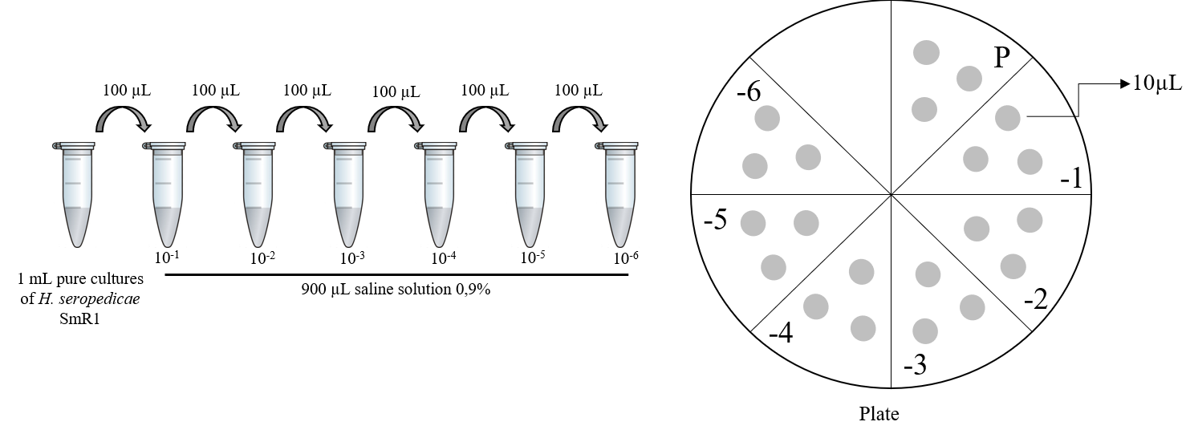

Figure S2 H. seropedicae enumeration (log CFU.mL⁻¹) obtained using drop plate count of culture samples submitted to heat treatment for different periods of time. Temperature: 38 °C (rhombus); 45 °C (triangles); 48 °C (circles) and 52 °C (square), and 48 °C (circles). Values are mean ± SD of three biological replicates (n = 3).
B

Figure S3 H. seropedicae species-specific qPCR assay standard curves (Cq versus log CFU) using primers HERBAS1. Quantification performed in six qPCR runs in different days using DNA isolated from H. seropedicae strain SmR1 culture. A: Heat treatment; B: In vitro assay

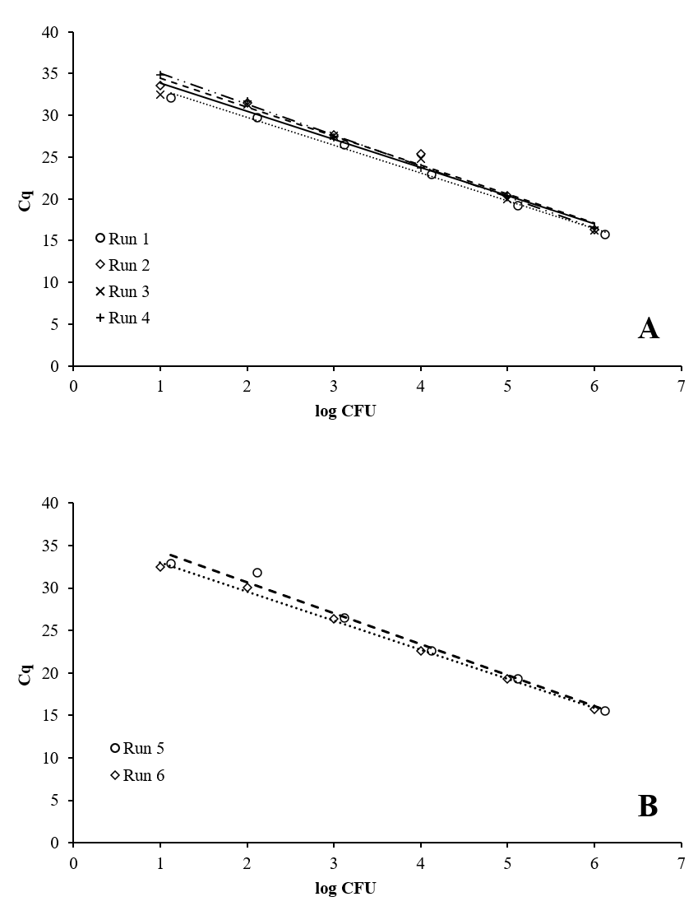

Table S1 Mean Cq and mean log CFU.mL⁻¹ obtained by H. seropedicae species-specific qPCR and PMA-qPCR assays using DNA isolated from heat-treated culture samples (48°C). Values are mean of qPCR triplicate performed in six different runs.
Time (minutes) | PMA-untreated samples  (mean Cq) | PMA-untreated samples  (mean  log CFU.mL⁻¹) | PMA-treated samples  (mean Cq) | PMA-treated samples  (mean  log CFU.mL⁻¹)
0’ | 15.31 | 8.91 | 19.5 | 7.42
0’ | 15.71 | 9.11 | 20.03 | 7.63
0’ | 15.21 | 8.95 | 15.61 | 8.51
0’ | 15.75 | 9.17 | 16.74 | 7.70
0’ | 15.3 | 8.75 | 16.12 | 8.21
0’ | 15.75 | 9.01 | 17.25 | 7.43
30’ | 15.14 | 8.76 | 20.45 | 5.8
30’ | 15.4 | 8.99 | 22.48 | 5.23
30’ | 15.49 | 9.21 | 20.74 | 6.09
30’ | 15.09 | 9.21 | 23.3 | 5.39
30’ | 15.56 | 9.03 | 17.55 | 6.85
30’ | 15.21 | 9.01 | 17.77 | 6.69
60’ | 15.38 | 8.9 | 19.06 | 6.01
60’ | 15.83 | 9.08 | 21.08 | 5.78
60’ | 15.53 | 8.83 | 16.58 | 7.08
60’ | 14.8 | 9.19 | 19.73 | 6.16
60’ | 15.48 | 8.68 | 17.06 | 6.82
60’ | 15.06 | 8.94 | 20.52 | 5.90
90’ | 15.46 | 8.89 | 16.99 | 6.63
90’ | 15.53 | 8.87 | 16.85 | 6.80
90’ | 15.57 | 9.17 | 17.57 | 6.80
90’ | 15.49 | 9.19 | 17.51 | 6.94
90’ | 14.88 | 8.53 | 20.72 | 5.99
90’ | 15.09 | 8.30 | 21.22 | 5.83
120’ | 15.32 | 8.83 | 17.24 | 6.84
120’ | 15.14 | 8.81 | 20.89 | 5.67
120’ | 15.68 | 9.04 | 18.18 | 6.90
120’ | 15.17 | 9.11 | 18.41 | 6.76
120’ | 15.69 | 8.92 | 18.23 | 6.52
120’ | 16.04 | 8.67 | 18.64 | 6.32
180’ | 15.57 | 8.85 | 18.18 | 6.31
180’ | 15.55 | 9.17 | 18.06 | 6.43
180’ | 14.71 | 8.90 | 18.94 | 6.43
180’ | 15.7 | 8.84 | 18.54 | 6.64
180’ | 15.02 | 8.64 | 17.3 | 6.77
180’ | 16.16 | 8.56 | 18.18 | 6.42

Table S2 Mean Cq and mean CFU.g⁻¹ obtained by H. seropedicae species-specific qPCR and PMA-qPCR assays using DNA isolated from control and inoculated maize roots samples. Values are mean of qPCR triplicate performed in two different runs.

PMA-untreated samples | mean Cq | Mean log CFU.g⁻¹ of roots | PMA-treated samples | mean Cq | Mean log CFU.g⁻¹ of roots
Control 1 | 34.06 | 2.87 | Control 1 | 33.85 | 2.15
Control 1 | 34.67 | 2.42 | Control 1 | 34.19 | 1.78
Control 2 | 33.16 | 2.78 | Control 2 | 32.39 | 2.55
Control 2 | 32.68 | 2.67 | Control 2 | 33.08 | 2.11
Control 3 | 33.88 | 2.8 | Control 3 | 32.88 | 2.4
Control 3 | 34.74 | 2.28 | Control 3 | 32.5 | 2.27
Inoculated 1 | 23.42 | 5.56 | Inoculated 1 | 26.53 | 3.9
Inoculated 1 | 23.86 | 5.34 | Inoculated 1 | 26.71 | 3.71
Inoculated 2 | 22.28 | 6.48 | Inoculated 2 | 25.49 | 3.89
Inoculated 2 | 22.44 | 6.37 | Inoculated 2 | 25.33 | 3.81
Inoculated 3 | 22.32 | 6.43 | Inoculated 3 | 27.64 | 3.6
Inoculated 3 | 22.25 | 6.38 | Inoculated 3 | 27.51 | 3.48

