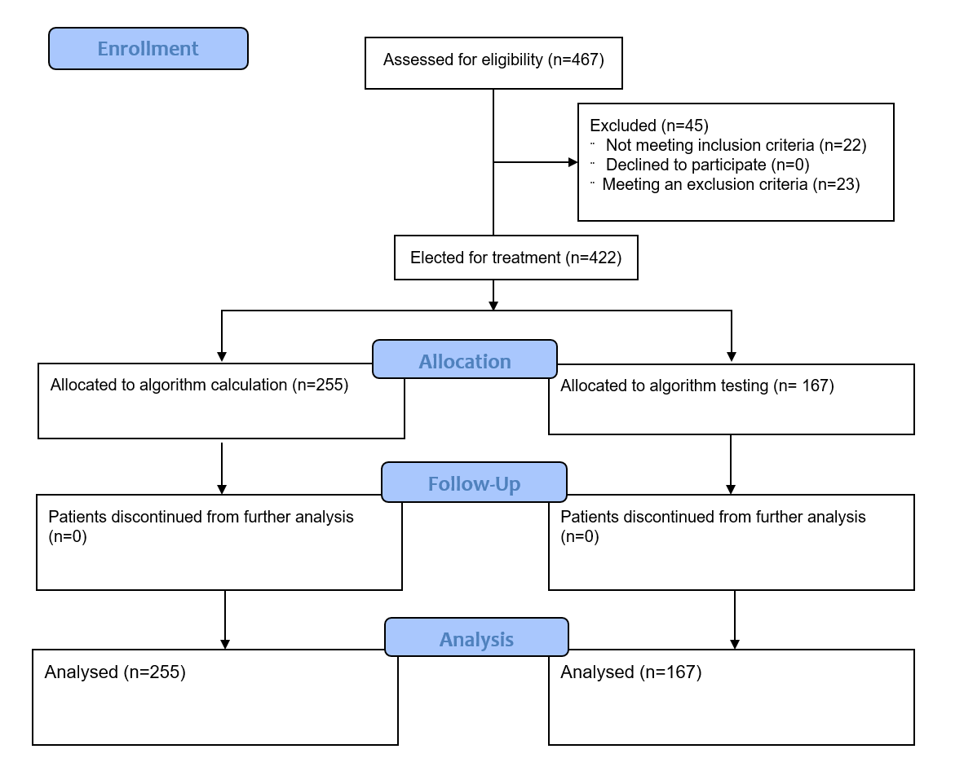
Supplementary figure 1. Screening and eligibility of clinical records. A total of 467 clinical files of SARS-CoV-2-positive patients were identified in two health centers in México. 422 met the inclusion criteria, while 45 met one or more exclusion criteria. Finally, 422 clinical files were included in the study.
Supplementary table 1. Association of different biomarkers with hospitalization requirement.
Biomarker | Odds ratio | 95% confidence interval | p value
Kirby index <300 | 5.58 | 1.95-15.97 | 0.0010
Kirby index <200 | 34.16 | 15.10 to 70.99 | 0.0001
sO₂ <90% | 2.15 | 1.138-3.930 | 0.0133
sO₂ <80% | 3.04 | 1.415-6.833 | 0.0043
CRP >120 mg/dL | 2.95 | 1.439-5.838 | 0.0021
LDH >400 U/L | 2.6 | 1.393-4.982 | 0.0034
LDH >211 U/L | 2.813 | 0.172-6.820 | 0.237
Creatinin >1 mg/dL | 1.965 | 0.9523-4.137 | 0.0652
d-Dimer >500 ng/mL | 1.403 | 0.6358-3.101 | 0.3911
MAP <65 | 0.1791-infinity
Lymphocytes <1000 cells/µL | 1.259 | 0.6909-2.245 | 0.4482
Glucose >200 mg/dL | 1.101 | 0.5239-2.237 | 0.7956
Age >60 years | 1.346 | 0.6792-2.668 | 0.4164
>2 comorbidities | 1.311 | 0.6722-2.613 | 0.4354
One comorbidity | 1.140 | 0.6396-2.075 | 0.6673
Neutrophils >7700 cells/µL | 1.672 | 0.9005-3.097 | 0.0917
% inf >15/25 | 1.160 | 0.3329-3.900 | 0.8218
Ferritin >150 ng/mL | 1.772 | 0.4695-6.645 | 0.4255
AST >70 U/L | 0.9281 | 0.3942 to 2.394 | 0.8729
Abbreviations: sO₂, oxygen saturation; CRP, C-reactive protein; LDH, lactate dehydrogenase; MAP, medium arterial pressure; %inf, percentage of inflammatory infiltration in the lungs; AST, aspartate aminotransferase.
Supplementary table 2. Association of different biomarkers with intensive care requirement.
Biomarker | Odds ratio | 95% confidence interval | p value
d-Dimer >500 ng/mL | 2.411 | 1.160 to 5.017 | 0.0179
Neutrophils >7700 cells/µL | 1.807 | 1.065 to 3.152 | 0.0323
% inf >15/25 | 3.904 | 1.598 to 9.573 | 0.0024
Age >60 years | 4.075 | 1.791 to 8.559 | 0.0004
Kirby <300 | 23.16 | 3.625 to 247.3 | <0.0001
Kirby <200 | 11.76 | 4.691 to 28.26 | <0.0001
sO₂ <90% | 2.619 | 1.347 to 5.031 | 0.0042
sO₂ <80% | 9.048 | 3.746 to 21.41 | <0.0001
CRP >120mg/dL | 2.611 | 1.467 to 4.591 | 0.0008
Ferritin >150 ng/mL | 91.38 | 22.49 to 387.3 | <0.0001
LDH >211 U/L | 5.876 | 1.811 to 19.26 | 0.0021
LDH >400 U/L | 2.730 | 1.575 to 4.673 | 0.0003
AST >70 U/L | 2.349 | 1.060 to 5.056 | 0.0330
Creatinin >1 mg/dL | 1.160 | 0.6531 to 2.039 | 0.6002
MAP <65 | 2.756 | 0.3102 to 40.49 | 0.3954
Procalcitonin >0.1 | 2.003 | 0.7814 to 5.058 | 0.1315
Glucose >200 mg/dL | 0.9332 | 0.5191 to 1.739 | 0.8221
Lymphocytes <1000 cells/µL | 1.306 | 0.7920 to 2.168 | 0.3022
One comorbidity | 1.044 | 0.6378 to 1.713 | 0.8657
>1 comorbidities | 1.171 | 0.6708 to 2.031 | 0.5851
Abbreviations: sO₂, oxygen saturation; CRP, C-reactive protein; LDH, lactate dehydrogenase; MAP, medium arterial pressure; %inf, percentage of inflammatory infiltration in the lungs; AST, aspartate aminotransferase.

Supplementary table 3. Association of different biomarkers with mortality.
Biomarker | Odds ratio | 95% confidence interval | p value
Creatinin >1 mg/dL | 2.4868 | 1.3698 to 4.5148 | 0.0023
d-Dimer >500 | 3.272 | 1.271 to 7.970 | 0.0130
Neutrophils >7700 cells/µL | 2.645 | 1.447 to 4.997 | 0.0018
% inf >15/25 | 80.35 | 31.95 to 194.4 | <0.0001
Age >60 years | 8 | 2.22 to 28.9 | 0.0191
MAP <65 | 4.085 | 1.016 to 18.04 | 0.0451
Kirby <300 | 7.282 | 1.141 to 78.42 | 0.0284
Kirby <140 | 6.517 | 2.361 to 16.10 | <0.0001
sO₂ <90% | 0.3199 | 0.1624 to 0.6408 | 0.0011
sO₂ <80% | 2.11 | 1.168 to 3.951 | 0.0143
CRP >120mg/dL | 4.546 | 2.596 to 8.178 | <0.0001
Ferritin >150 ng/mL | 8.517 | 0.4919 to 147.4732 | 0.0463
> 1 comorbidities | 2 | 1.0824 to 3.9972 | 0.0266
LDH >211 U/L | 4.0854 | 0.9290 to 17.9664 | 0.0451
LDH >400 U/L | 3.338 | 1.808 to 5.978 | <0.0001
Glucose >200 mg/dL | 1.3771 | 0.7421 to 2.5554 | 0.3092
Lymphocytes <1000 cells/µL | 0.9176 | 0.5347 to 1.5746 | 0.7548
AST >70 U/L | 1.5 | 0.6605 to 3.4068 | 0.3303
One Comorbidity | 1.5 | 0.8142 to 2.8699 | 0.1853
Procalcitonin >0.05 ng/ml | 1.2 | 0.6649 to 1.6722 | 0.7975
Abbreviations: sO₂, oxygen saturation; CRP, C-reactive protein; LDH, lactate dehydrogenase; MAP, medium arterial pressure; %inf, percentage of inflammatory infiltration in the lungs; AST, aspartate aminotransferase.

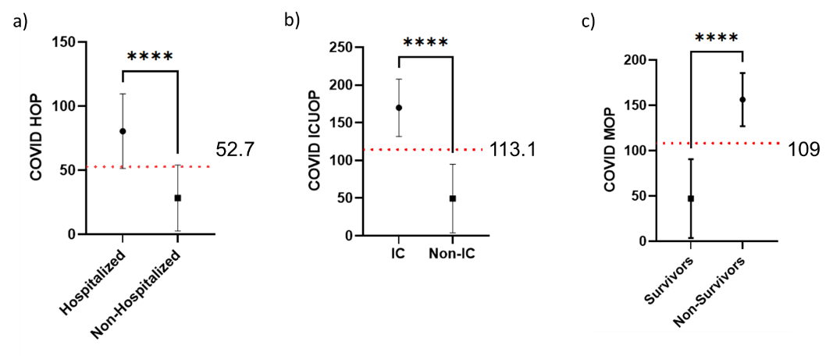
Supplementary figure 2. Cutoff values for the COVID HOP, ICOP and MOP scales. The cutoff value for the COVID HOP (a), COVID ICOP (b) and COVID MOP (c) prognostic scales was found by adding the standard deviation to the mean of the control group, subtracting the standard deviation to the mean of the affected group and finding the middle point between the two cyphers. Abbreviations: HOP, hospitalization outcome prognostic; ICOP, intensive care outcome prognostic; MOP, mortality outcome prognostic.

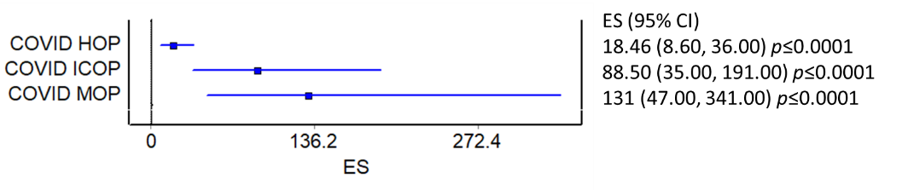
Supplementary figure 3. Odds ratios for the COVID-OP scales. The effect size (ES) for the three scales was calculated as an odds ratio, which was complimented by the 95% confidence interval. Abbreviations: HOP, hospitalization outcome prognostic; ICOP, intensive care outcome prognostic; MOP, mortality outcome prognostic.

