Appendix
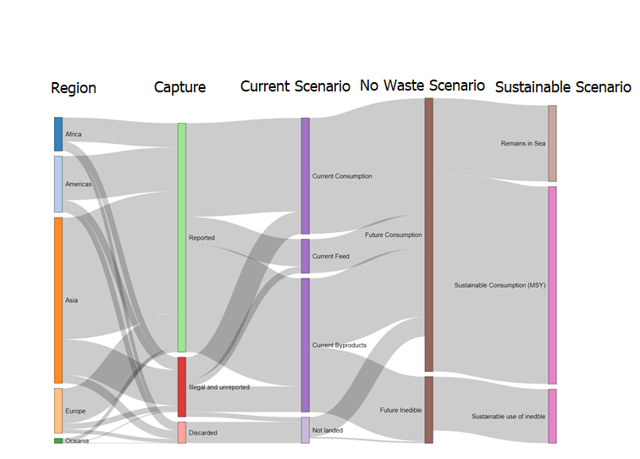
Figure 5 Biomass flows showing the current capture and its uses, capture and its uses in the No Waste Scenario and capture and its uses in the Sustainable Scenario.

