Supplementary Material

Understanding the Potential of Light Absorption in Dots-in-Host Semiconductors
- Mathematical Foundations
Here the authors provide a detailed development of the theoretical concepts used to obtain the results shown in the Main Manuscript. The complete development of Equation 1 in the Main Manuscript was already shown in a previous work.[1]
The diagonalization matrix can be created via the eigenvectors of the k.p Hamiltonian shown in Equation 2 in the Main Manuscript. To determine the eigenvectors, it is first necessary to determine the eigenvalues, that are as follows (each eigenvalue is doubly degenerate):
$$E_{L_{6}^{\text{-}}↑/↓}=E_{g}+\frac{ℏ^{2}k^{2}}{2m}-\frac{E_{g}}{2}-\sqrt{{\left(\frac{E_{g}}{2}+\frac{ℏ^{2}k^{2}}{2m}\right)}^{2}+\left(A^{2}+{\left|B\right|}^{2}\right)}$$ | (S1)
$$E_{L_{6}^{\text{+}}↑/↓}=-\frac{ℏ^{2}k^{2}}{2m}-\frac{E_{g}}{2}-\sqrt{{\left(\frac{E_{g}}{2}+\frac{ℏ^{2}k^{2}}{2m}\right)}^{2}+\left(A^{2}+{\left|B\right|}^{2}\right)}$$ | (S2)
Where E_{g} is the host bandgap, m is the effective mass of the QD material, k² is the wave-vector magnitude, $A=ℏP_{l}{k_{z}}/m$ and $B=ℏP_{t}{\left(k_{x}-{ik}_{y}\right)}/m$. In these last simplifications, P_{l} and P_{t} are the longitudinal and transverse momentum matrix elements.
The eigenvectors are thus as follows.
$$\left|\left.L_{6}^{\text{-}}↑\right\rangle \right.=\frac{1}{C_{α}}\left[\begin{aligned}-B \\ A \\ 0 \\ α-\sqrt{α^{2}+A^{2}+{\left|B\right|}^{2}}\end{aligned}\right]$$ | (S3)
$$\left|\left.L_{6}^{\text{-}}↓\right\rangle \right.=\frac{1}{C_{α}}\left[\begin{aligned}A \\ B^{\text{*}} \\ -\left(α-\sqrt{α^{2}+A^{2}+{\left|B\right|}^{2}}\right) \\ 0\end{aligned}\right]$$ | (S4)
$$\left|\left.L_{6}^{\text{+}}↑\right\rangle \right.=\frac{1}{C_{α}}\left[\begin{aligned}0 \\ α-\sqrt{α^{2}+A^{2}+{\left|B\right|}^{2}} \\ B \\ -A\end{aligned}\right]$$ | (S5)
$$\left|\left.L_{6}^{\text{+}}↓\right\rangle \right.=\frac{1}{C_{α}}\left[\begin{aligned}α-\sqrt{α^{2}+A^{2}+{\left|B\right|}^{2}} \\ 0 \\ A \\ B\end{aligned}\right]$$ | (S6)
Here, the authors chose the following simplifications:
$$\begin{aligned}α=\frac{E_{g}}{2}+\frac{ℏ^{2}k^{2}}{2m} \\ C_{α}=\sqrt{{\left(α-\sqrt{α^{2}+A^{2}+{\left|B\right|}^{2}}\right)}^{2}+A^{2}+{\left|B\right|}^{2}}\end{aligned}$$ | (S7)
The adjoint transformation matrix is necessary for the similarity transformation as it is the matrix that expands the diagonalized eigenfunctions in the k.p basis (Equation S8 - top equation for $L_{6}^{\text{+}}↑$). It is important to note that the diagonalized solutions are a column vector with a single unitary entry — Equation S8 bottom equation — representing each band (in this case there are two degenerate conduction and valence bands, as required by the k.p Hamiltonian).
$$\begin{aligned}Ψ_{\left|\left.L_{6}^{\text{+}}↑\right\rangle \right.}=\sum_{i}^{{CB}_{1},{CB}_{2},{VB}_{1},{VB}_{2}}{\left.\left\langle L_{6}^{\text{+}}↑\right.\right|}Φ_{i} \\ \left|\left.{CB}_{1}\right\rangle \right.=\left[\begin{aligned}1 \\ 0 \\ 0 \\ 0\end{aligned}\right]Φ_{{CB}_{1}},\left|\left.{CB}_{2}\right\rangle \right.=\left[\begin{aligned}0 \\ 1 \\ 0 \\ 0\end{aligned}\right]Φ_{{CB}_{2}},\left|\left.{VB}_{1}\right\rangle \right.=\left[\begin{aligned}0 \\ 0 \\ 1 \\ 0\end{aligned}\right]Φ_{{VB}_{1}},\left.{|VB}_{2}\right\rangle =\left[\begin{aligned}0 \\ 0 \\ 0 \\ 1\end{aligned}\right]Φ_{{VB}_{2}}\end{aligned}$$ | (S8)
As such, the transformation matrix can be defined as follows (Equation S9), where each element represents one of the expansion coefficients of the envolute function in terms of the diagonalized functions.
$$\begin{aligned}T^{\text{+}}=\left[\begin{aligned}\left.\left\langle L_{6}^{\text{-}}↑\right.\right| \\ \left.\left\langle L_{6}^{\text{-}}↓\right.\right| \\ \left.\left\langle L_{6}^{\text{+}}↑\right.\right| \\ \left.\left\langle L_{6}^{\text{+}}↓\right.\right|\end{aligned}\right]=\frac{1}{C_{α}}\left[\begin{matrix}-B^{\text{*}} & A & 0 & β \\ A & B & -β & 0 \\ 0 & β & B^{\text{*}} & A \\ β & 0 & A & B^{\text{*}}\end{matrix}\right] \\ β=α-\sqrt{α^{2}+A^{2}+{\left|B\right|}^{2}}\end{aligned}$$ | (S9)
Having determined the transformation matrix, it is then possible to convert the diagonalized eigenfunctions into the k.p envolutes, as described in the Main Manuscript.
The final absorption coefficient can be determined from the Main Manuscript Equation 5. In this expression, the more complicated term is the matrix element, where it is important to consider the incident light direction and polarization (angular development shown in Equation 4 of the Main Manuscript). For that, the problem has been simplified by making an angular average of all the results (integration from [0, 2π] for φ and [0, π] for θ). The final expression used is as follows.
$$\begin{aligned}\begin{matrix}{\left|\left\langle Ψ_{j} | ϵ⋅r | Ψ_{i}\right\rangle \right|}^{2} & = & \cos^{2}\left(ϕ\right)\sin^{2}\left(θ\right){\left|\left\langle Ψ_{j} | x | Ψ_{i}\right\rangle \right|}^{2} \\ & + & \sin^{2}\left(ϕ\right)\sin^{2}\left(θ\right){\left|\left\langle Ψ_{j} | y | Ψ_{i}\right\rangle \right|}^{2} \\ & + & \cos^{2}\left(θ\right){\left|\left\langle Ψ_{j} | z | Ψ_{i}\right\rangle \right|}^{2} \\ & + & 2cos\left(ϕ\right)sin\left(ϕ\right)sin\left(θ\right)\text{Re}\left[\left\langle Ψ_{j} | x | Ψ_{i}\right\rangle \left\langle Ψ_{j} | y | Ψ_{i}\right\rangle \right] \\ & + & 2cos\left(ϕ\right)sin\left(θ\right)cos\left(θ\right)\text{Re}\left[\left\langle Ψ_{j} | x | Ψ_{i}\right\rangle \left\langle Ψ_{j} | z | Ψ_{i}\right\rangle \right] \\ & + & 2sin\left(ϕ\right)sin\left(θ\right)cos\left(θ\right)\text{Re}\left[\left\langle Ψ_{j} | y | Ψ_{i}\right\rangle \left\langle Ψ_{j} | z | Ψ_{i}\right\rangle \right]\end{matrix} \\ {\left|\left\langle Ψ_{j} | ϵ⋅r | Ψ_{i}\right\rangle \right|}_{\left\langle ϕ_{avg}\right\rangle \left\langle θ_{avg}\right\rangle }^{2}=\frac{π}{4}\left(2{\left|\left\langle Ψ_{j} | x | Ψ_{i}\right\rangle \right|}^{2}+2{\left|\left\langle Ψ_{j} | y | Ψ_{i}\right\rangle \right|}^{2}+{\left|\left\langle Ψ_{j} | z | Ψ_{i}\right\rangle \right|}^{2}\right)\end{aligned}$$ | (S10)
At this point, there is an angular averaged matrix element for each band transition (VB1→CB1, VB1→CB2, VB2→CB1, VB2→CB2). The average of these 4 transitions is taken to obtain the final value. This process is also elaborated graphically in Figure 2 of the Main Manuscript.
The theoretical developments were then implemented and developed in Python®. The code is also available in a Github® repository (reference [2]).
- FEM Development of the Schrödinger Equation
Figure 1 of the Main Manuscript shows the results of several finite elements method (FEM) simulations, made to complement the standard analytical results from the spherical well potential. In this section we describe the mathematics behind this process. The authors follow the description shown in the Deall.II tutorial library, exercise 36.[3]
In FEM simulations, the first objective is to convert the differential equation into the weak form, such that it is then possible to build the matrix–vector equation that will be used to solve the problem. Here, the problem is defined by the Schrödinger equation (Equation S11 in non-dimensionalized form), where V(x) is the acting potential and Ω and ∂Ω represent the simulation domain and boundary, respectively. As numerical simulations always require boundary conditions — to define the simulation domain — the standard choice of Dirichlet boundary conditions was made. In this Dirichlet condition it is fundamental to consider a simulation region much larger than the QD size, in order to guarantee that the wavefunction, Ψ, has vanished in the boundaries (essentially confirming the boundary condition).
$$\begin{matrix}\left[-Δ+V\left(x\right)\right]Ψ\left(x\right) & = & EΨ\left(x\right) & & \text{in }Ω , \\ Ψ & = & 0 & & \text{on }∂Ω .\end{matrix}$$ | (S11)
Here, the standard finite-element approach is used by multiplying the equation from the left by a test function, integrating and then considering the wavefunctions expanded in a finite dimensional space $Ψ\left(x\right)≈Ψ_{h}\left(x\right)=\sum_{j}{ϕ_{j}}\left(x\right){\overset{\text{\sim }}{ψ}}_{j}$. The resulting discretized eigenvalue problem is then as follows (the bottom equation is in matrix-vector notation).
$$\begin{aligned}\sum_{j}{\left[\int_{Ω}{∇ϕ_{i}∇ϕ_{j}}+\int_{Ω}{V}\left(x\right)ϕ_{i}ϕ_{j}\right]}{\overset{\text{\sim }}{ψ}}_{j}=E_{h}\sum_{j}{\left[\int_{Ω}{ϕ_{i}}ϕ_{j}\right]}{\overset{\text{\sim }}{ψ}}_{j} \\ A\overset{\text{\sim }}{Ψ}=E_{h}M\overset{\text{\sim }}{Ψ}\end{aligned}$$ | (S12)
Here, A is the stiffness matrix and M the mass matrix.
The Deal.II library[3] was used to solve the problem. This library provides all the necessary structures to build and solve the problem (create grid, implement boundary conditions, solve the eigenvalue problem). In this case, the local integrals (built from the test functions) were solved using a 2nd order Gaussian quadrature. The eigenvalue problem was then solved using the Deal.II wrapper for the SLEPc Krylov-Schur eigenspectrum Solver.
The first process in the simulation focused on determining the accuracy and the mesh requirements needed to achieve the intended results. For that, the authors started by solving a reference spherical well problem, thus facilitating the comparison between the analytically obtained and numerically obtained results. Figure S1 shows the results for different meshes (the different vertical sections are labelled from 1–6 according to the mesh refinement) and simulation size (colour of the dots in each profile). The QD properties used for these simulations are V = 1 eV, m = 0.1m₀ and QD radius of 3.5 nm.
As a rule of thumb, global mesh refinements bellow 3 do not seem to provide accurate results. Beyond 3, there is still a clear dependency on the simulation size (bigger simulation size does require more refinement steps to better resolve QD features). Furthermore, as the energy levels increase there is also a tendency for the error to increase. This could be from the increasing delocalization of the wavefunction as the energy level increases. For the Main Manuscript results, the authors only used the first energy level. As such, a global mesh refinement of 5 was used, as Figure S1 a) clearly shows this mesh to be independent of the simulation size and thus the ratio QD Size/Simulation Size.
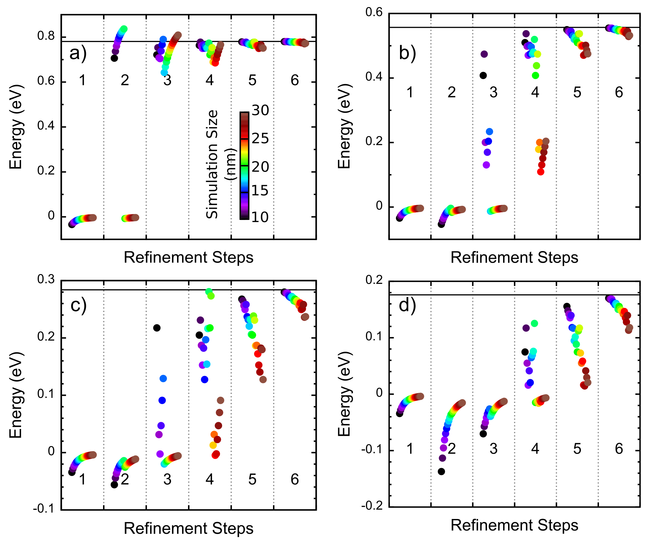
Figure S1: Convergence results for the FEM analysis of the spherical well problem. The top horizontal line represents the analytical solution. Each profile is subdivided into 6 different regions (for each refinement step in the algorithm) and in each region multiple simulation regions were tested (shown by different colour dots). The results are shown for a) first energy level; b) second energy level; c) third energy level; d) fourth energy level.
- Bandgap Studies
Figure S2 summarizes the dependency of the QD bandgap (E_{g-QD}) on different factors. Firstly, the QD radius, expectedly, shows a decrease in E_{g-QD} as the size increases, with the arrows on the right side of the plot indicating an exponential-like behaviour, also clearly seen in Figure 2 of the Main Manuscript. The Host Bandgap (E_{g-Host}) shows a more pronounced influence for lower QD sizes. As the QD size increases the energy levels tend to become more static (less influenced by size/potential changes). As the Host Bandgap increases there is a general trend to increase the QD bandgap, which conforms with the idea that, in the limit of the host bandgap tending to infinity, the results should tend to the infinite well problem, as marked in Figure 2 in the Main Manuscript. There is also an influence of the potential offset (difference between the potential height in the CB and VB, as defined in Figure 1 c)) on the QD bandgap. Offset values bellow 0.5 (bandgaps alignment corresponding to V_{CB}=V_{VB}) essentially shift the results down as represented in Figure S2.
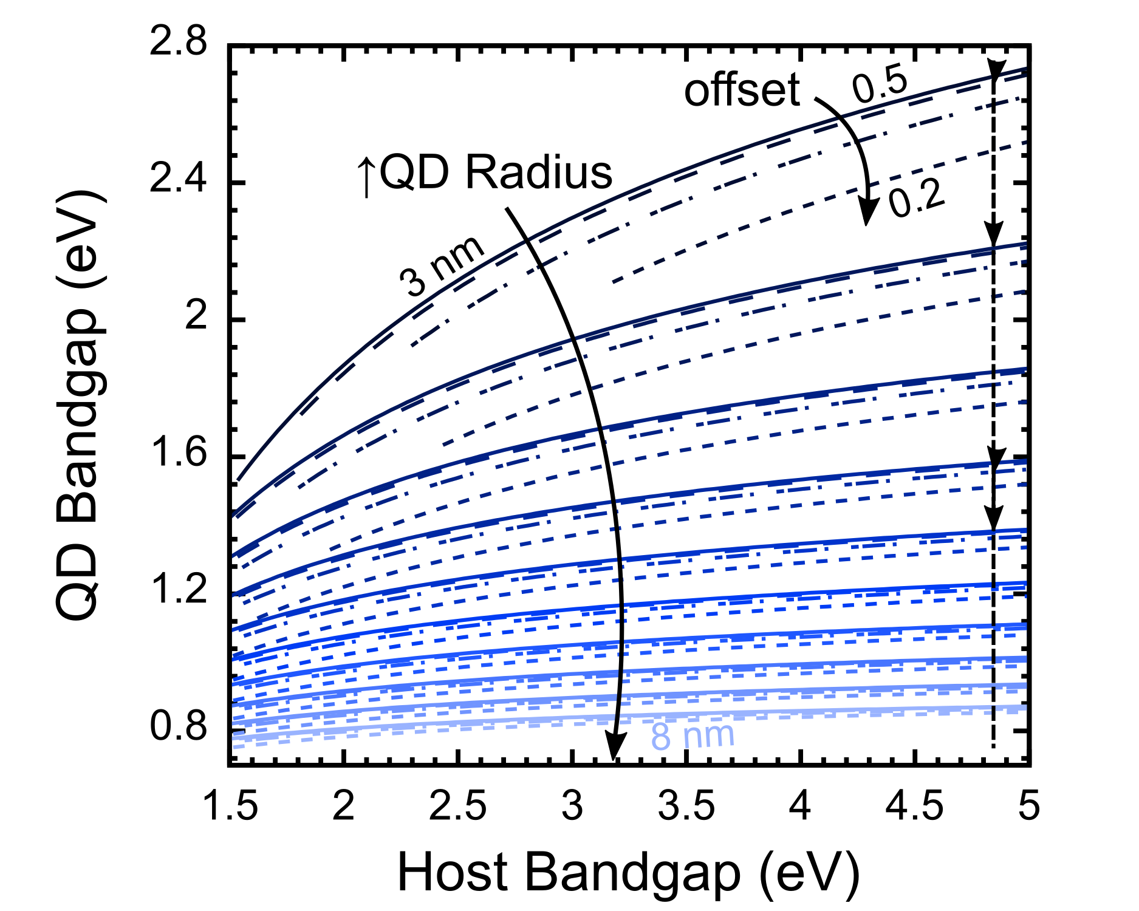
Figure S2: Quantum Dot Bandgap dependency on the Host Bandgap, QD radius (from 3 to 8 nm for different coloured lines, in steps of 1 nm) and Potential offset (0.5, 0.4, 0.3 and 0.2, as represented in Figure 1 c), from the solid, dashed, dot dashed and small dash lines, respectively).
- Convergence Tests
This section has 2 different parts. Firstly, the authors provide a heat map plot that describes the number of energy levels present in a single band of the QD system (Figure S3), depending on the size of the potential barrier and on the radius of the QD. This is important as it defines a good lower limit for the QD radius during the simulations, since at least one level is needed in the QD CB to calculate the interband transition properties. From the plot it can be seen that 3 nm is a minimum radius that can be used independently of the potential barrier.
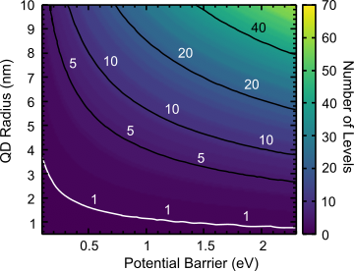
Figure S3: Heat map plot that indicates the number of energy levels present in a single band of the QD system, for changing QD radius and potential barrier. At least one level (marked by the white contour) is necessary in order to allow calculating interband transitions.
The second set of results show the dependency of the several parameters on the simulations size (SSize - Figure S4) and lattice size (LSize - Figure S5). The objective here is to determine the best simulation conditions that provide the best accuracy. The results do show that the simulation size, even though with some noise, does not have a significant impact on the results. Nevertheless, it is clear from the interaction with the lattice size, that lower values of the latter are preferred. From the lattice size results, it is also clear that lower values are preferred, as the results do show a general trend to increase with increased LSize. Furthermore, the actual parameters also have little impact on the results, as for the most part, changing these parameters simply moves the curves upwards or downwards, which is a consequence of the actual effect of the parameter rather than lower accuracy in the calculations.
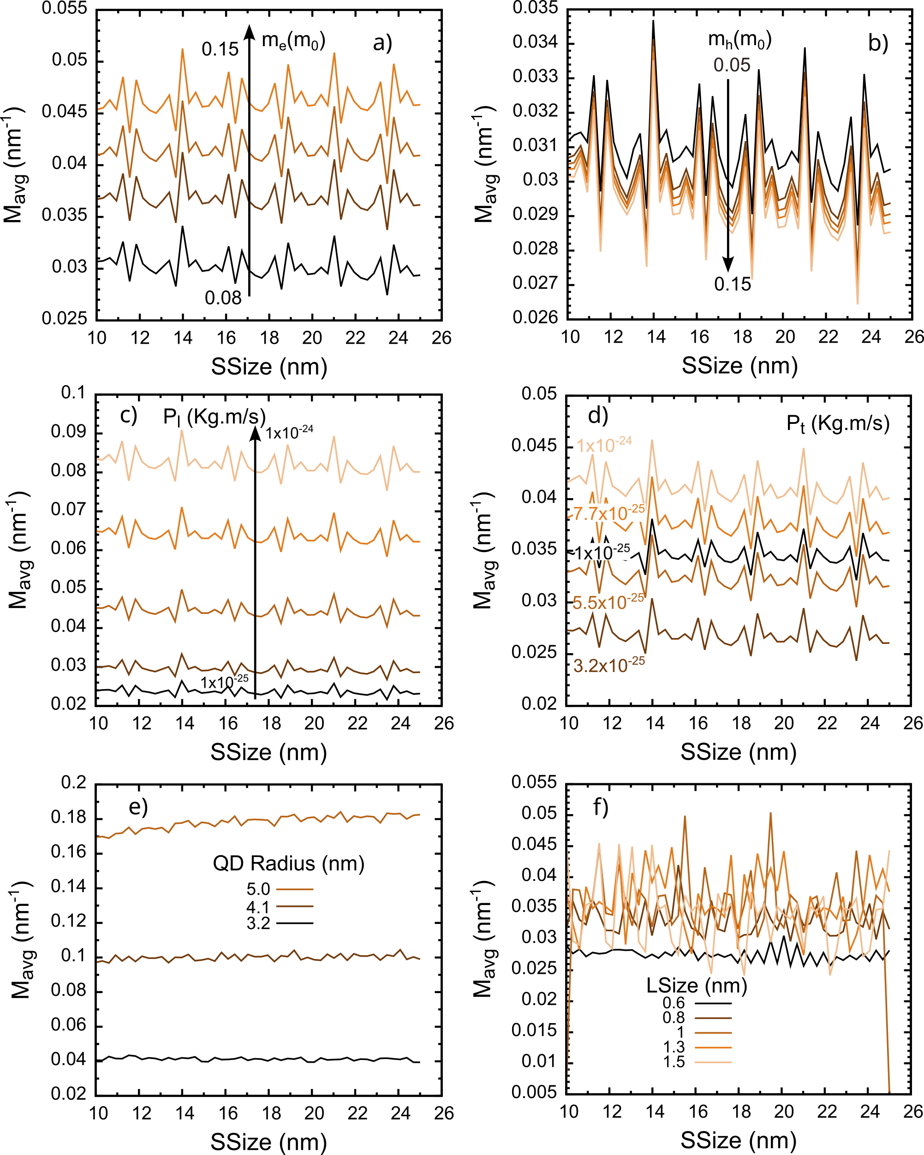
Figure S4: Convergence tests for the simulation size (SSize) dependency. a), b) dependency for changes in the electron and holes effective masses, respectively; c), d) changes on the longitudinal (P_{l}) and transverse (P_{t}) momentum matrix elements, respectively; e) dependency on the QD radius and f) dependency on the lattice size.
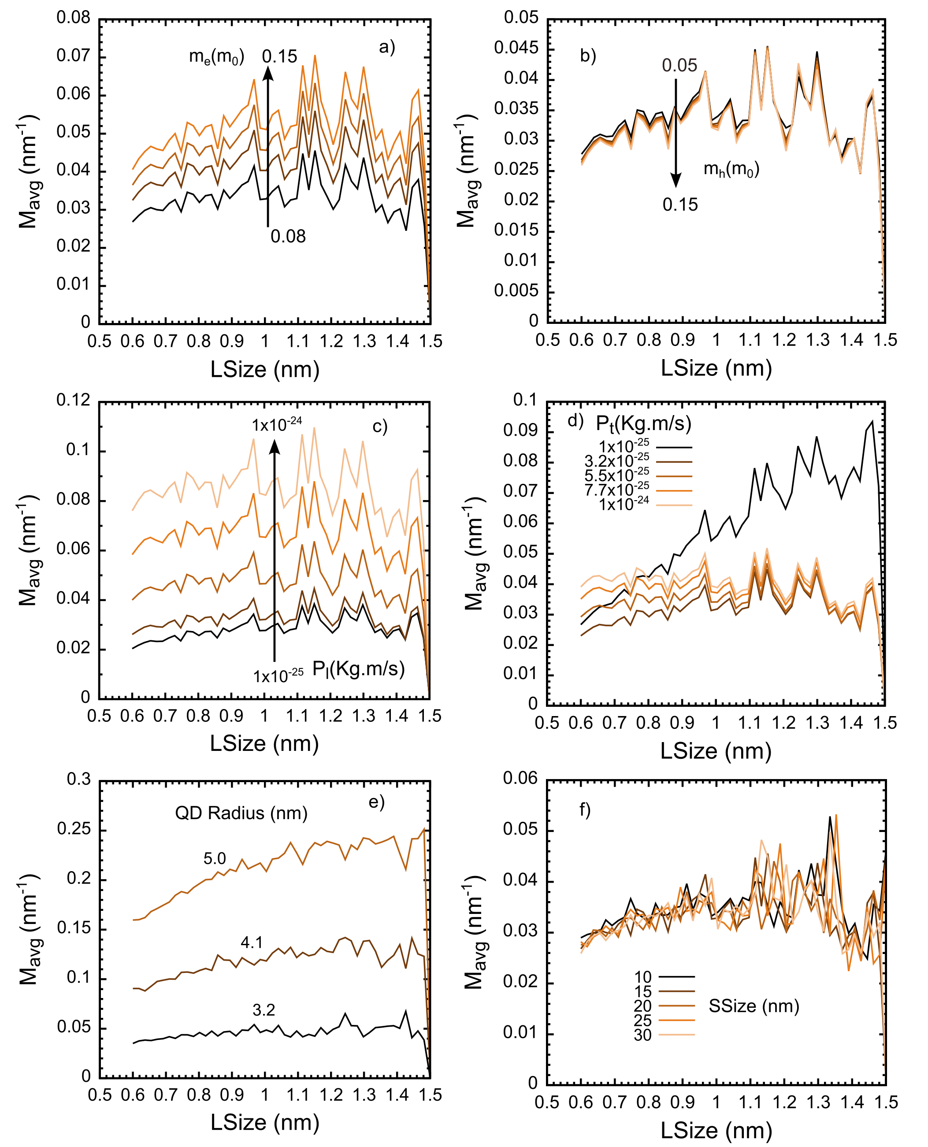
Figure S5: Convergence tests for the lattice size (LSize) dependency. a), b) dependency for changes in the electron and holes effective masses, respectively; c), d) changes on the longitudinal and transverse momentum matrix elements, respectively; e) dependency on the QD radius and f) dependency on the simulation size.
- Averaging Transitions
This section describes graphically the 2-step process used to average the 12 elements (combination of light polarization/incidence elements and band-to-band transitions) obtained from the transition properties. The process starts with the 12 elements, represented by the dashed lines, that are then angularly averaged obtaining 4 different results (solid lines). These results are then averaged again to obtain a final value that describes the entire problem (black line).
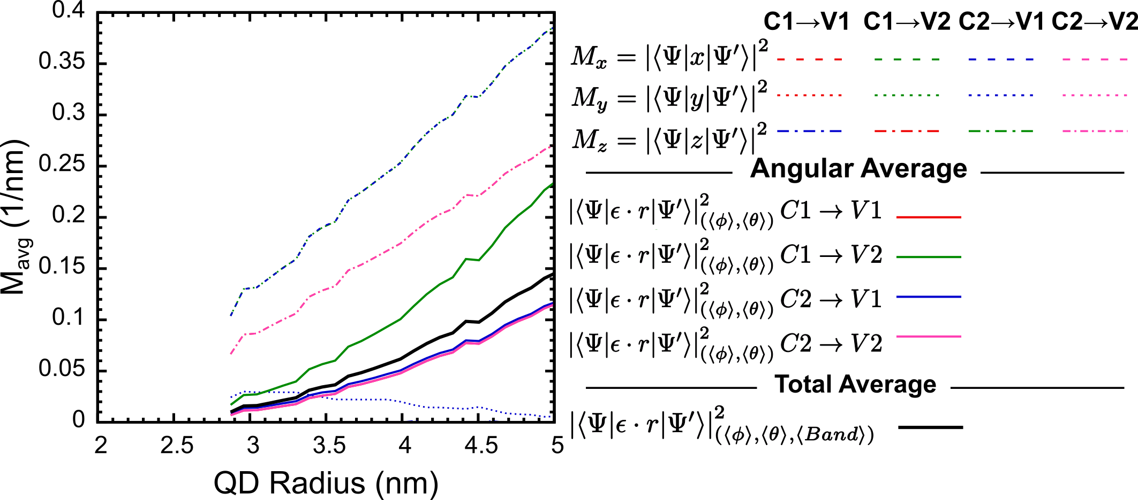
Figure S6: Graphical representation of the 2-step averaging process of the transition rates.
- Optical properties
In this section, the authors provide the bulk refractive index spectra, obtained from literature, for the wide-bandgap perovskite [4] and PbS [5] materials employed in the calculation of the effective medium, following the Bruggerman formalism presented in the Main Manuscript.

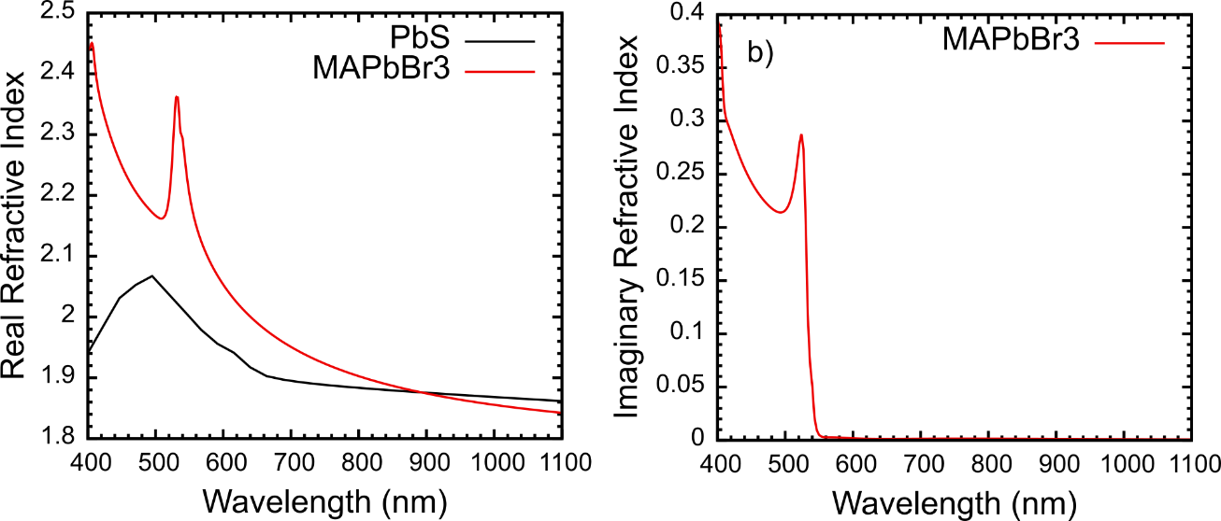
Figure S7: Optical properties taken for the constituent bulk materials of the QD (PbS) and Host (wide-bandgap perovskite, MAPbBr3) used for the Bruggerman effective medium calculations.
- Non-Dimensional Figure of Merit
Here, the authors provide the results for the dimensionless FoM (Figure S8) as calculated from the following equation.
$$FoM=\frac{\int{α/ρ}dλ}{min\left(\frac{E_{level}-E_{ideal}}{E_{ideal}}\right)×N_{Trn}×{QD}_{radius}^{3}}$$ | (S13)
The setup is the same as the that of the Main Manuscript Equation 1, but with the added QD_{radius} factor cubed that guarantees the non-dimensionality of the FoM.
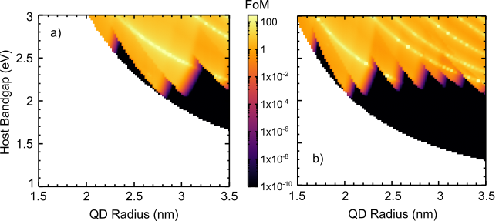
Figure S8: Non-dimensional FoM calculated from Equation S13, for a QD effective mass of a) 0.08m₀ and b) 0.15m₀.
As stated in the Main Manuscript, the results are quite similar to those of Figure 5, with the slight reduction in the overall peak intensity, due to the extra factor in the denominator. Regardless, the added effect does not significantly influence the results already provided in the Main Manuscript.

References
[1] M. Alexandre, H. Águas, E. Fortunato, R. Martins, M.J. Mendes, Light management with quantum nanostructured dots-in-host semiconductors, Light Sci. Appl. 10 (2021) 231. https://doi.org/10.1038/s41377-021-00671-x.
[2] perspe, 4-band k.p-based Method to Solve QD@Host Problems, (2022). https://github.com/perspe/qd-host (accessed November 3, 2022).
[3] The deal.II Finite Element Library, (n.d.). https://dealii.org/ (accessed November 3, 2022).
[4] S. Brittman, E.C. Garnett, Measuring n and k at the Microscale in Single Crystals of CH ₃ NH ₃ PbBr ₃ Perovskite, J. Phys. Chem. C. 120 (2016) 616–620. https://doi.org/10.1021/acs.jpcc.5b11075.
[5] S.I. Sadovnikov, A.I. Gusev, Structure and properties of PbS films, J. Alloys Compd. 573 (2013) 65–75. https://doi.org/10.1016/j.jallcom.2013.03.290.

