APPENDIX B. Relative Risk Computation II: weighted aggregation of sub-components

Table B.1. Operationalization of the Impact Chain of the Risk of Maritime Transport disruption for the control reference period.
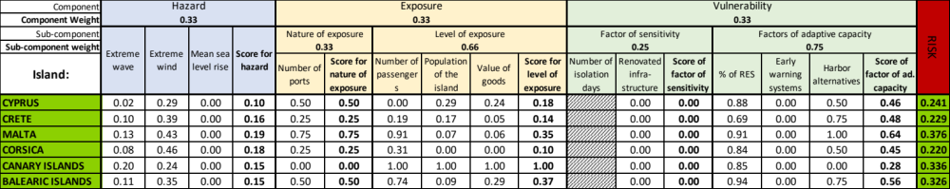

Table B.2. Same as Table B.1 for the mid-21st century (2046-2065) and pathway RCP2.6.
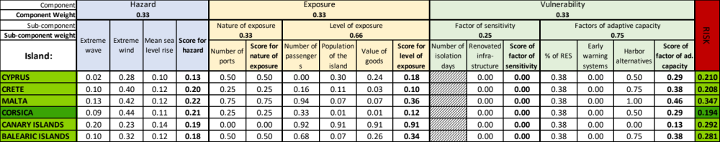

Table B.3. Same as Table B.1 for the end of the 21st century (2081-2100) and pathway RCP2.6.
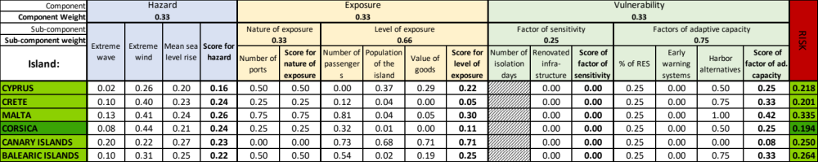

Table B.4. Same as Table B.1 for the mid-21st century (2046-2065) and pathway RCP8.5.
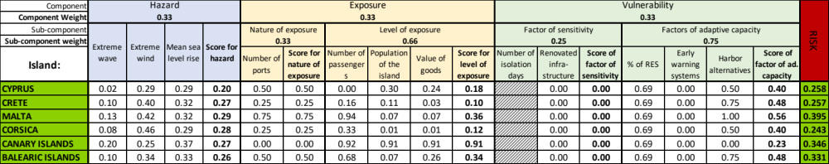

Table B.5. Same as Table B.1 for the end of the 21st century (2081-2100) and pathway RCP2.6.
