Additional file 3
Quality assessment of quantitative studies
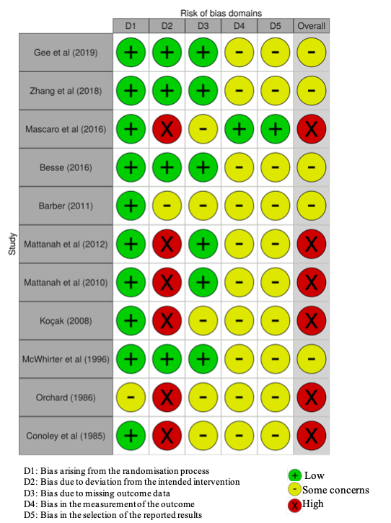

Figure A1 Quality assessment of randomised control trials producing quantitative data using ROB2

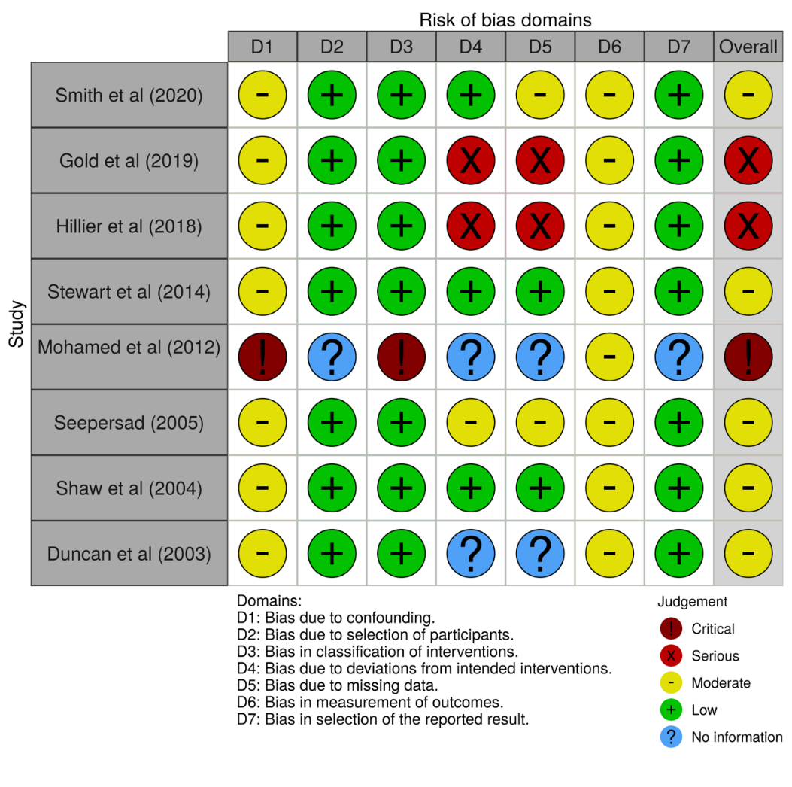

Figure A2 Quality assessment of non-randomised control trials producing quantitative data using ROBINS-I

