Additional file 4
Quality assessment of qualitative studies
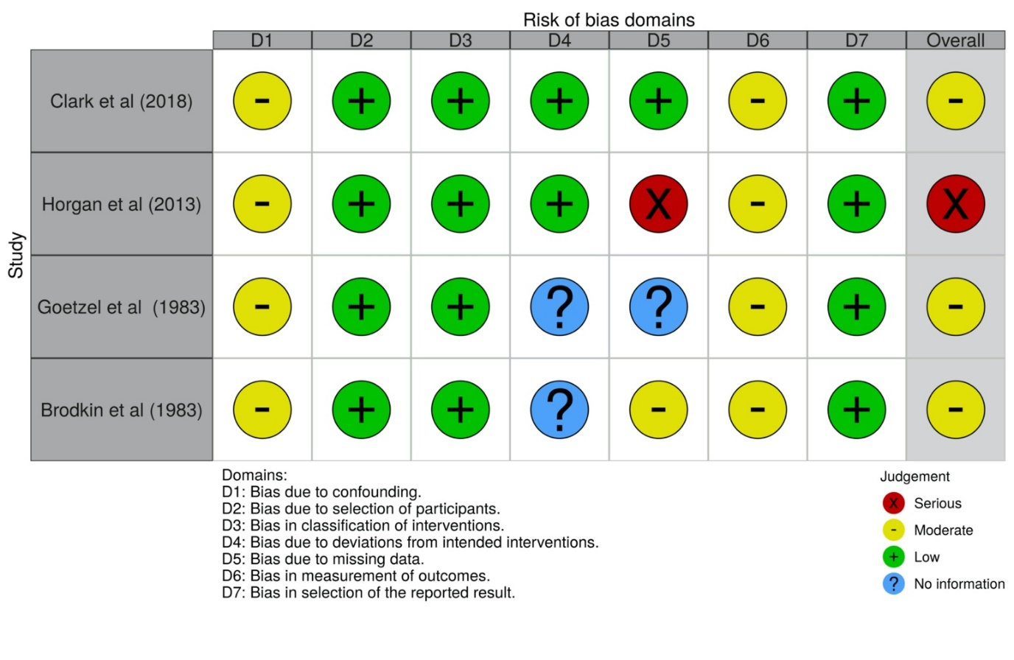
Figure A3 Quality assessment of non-randomised control trials producing qualitative data using ROBINS-I

