Supplementary information
Enhanced glycerol assimilation and lipid production in Rhodotorula toruloides CBS14 upon addition of hemicellulose primarily correlates with early transcription of energy-metabolism related genes

Giselle C. Martín-Hernandez^{a,†}, Mikołaj Chmielarz^{a,†}, Bettina Müllerª, Christian Brandt^{b}, Adrian Viehweger^{c}, Martin Hölzer^{d}, Volkmar Passoth^{a,*}

ªSwedish University of Agricultural Sciences, Department of Molecular Sciences, BioCenter, Box 7015, 75007 Uppsala, Sweden
^{b}Institute for Infectious Diseases and Infection Control, Jena University Hospital, Jena, Germany
^{c}Institute of Medical Microbiology and Virology, University Hospital Leipzig, 04103 Leipzig, Germany
^{d}Method Development and Research Infrastructure, Bioinformatics and Systems Biology, Robert Koch Institute, 13353 Berlin, Germany
*Corresponding author: Volkmar.passoth@slu.se
†These authors contributed equally to this work.

Table S1: Differentially expressed genes between growth on different media at 10 h
Table S2: Differentially expressed genes between growth on different media when glycerol consumption became visible
Table S3: Differentially expressed genes between growth on different media when glycerol concentration is lower
Table S4: Gene expression in TPM within central metabolic pathways

Figure S1: Principal Component Analysis based on expression level from the 500 highest expressed genes in each of the cultivation media and RNA sampling points
Figure S2: Overview of differential expression analysis between Rhodotorula toruloides CBS 14 cultivated on crude glycerol and a mixture of crude glycerol and hemicellulose hydrolysate, at 10 h cultivation
Figure S3: Overview of differential expression analysis between Rhodotorula toruloides CBS 14 grown on different media when glycerol consumption became visible
Figure S4: Overview of differential expression analysis between Rhodotorula toruloides CBS 14 grown on different media when about 20 g/l of glycerol were left
Figure S5: Differentially expressed genes in Rhodotorula toruloides CBS 14 within sampling time points in each of the growth media.
Figure S6: Examples of upregulated genes in Rhodotorula toruloides CBS 14 grown on a mixture of crude glycerol (CG) and hemicellulose hydrolysate (CGHH) for 10 h of cultivation, whose expression is higher than CG 10 h.
Figure S7: Examples of upregulated genes in Rhodotorula toruloides CBS 14 grown on a mixture of crude glycerol (CG) and hemicellulose hydrolysate (CGHH) for 10 h of cultivation, whose expression is higher than CG 30 h.
Figure S8: Examples of upregulated genes in Rhodotorula toruloides CBS 14 grown on a mixture of crude glycerol (CG) and hemicellulose hydrolysate (CGHH) for 36 h of cultivation, whose expression is higher than CG 60 h.
Figure S9: Distribution of shared ortholog clusters within differentially expressed genes in each of the three differential expression analyzes. The diagram was generated using OrthoVenn2.
Table S1: Differentially expressed genes between growth on different media at 10 h
Gene ID | baseMean | log2FoldChange | lfcSE | pvalue | padj
NANOZOOG825 | 11,1852881 | -8,8491887 | 2,83844349 | 2,2255E-10 | 2,9281E-08
NANOZOOG827 | 5,87716147 | -7,6658954 | 2,7541767 | 1,0892E-07 | 6,0429E-06
NANOZOOG7104 | 13,6400338 | 7,12779809 | 2,44614387 | 3,2874E-06 | 0,00011735
NANOZOOG826 | 4,07082745 | -6,7162258 | 2,61794704 | 1,374E-06 | 5,5995E-05
NANOZOOG3179 | 104,649965 | 6,63689911 | 2,20457253 | 2,0977E-06 | 8,1862E-05
NANOZOOG5335 | 5,73694102 | 6,45620136 | 2,45609974 | 5,4984E-06 | 0,00018086
NANOZOOG387 | 4,10252047 | -6,4507305 | 2,52940868 | 1,0116E-06 | 4,2348E-05
NANOZOOG2859 | 43,548459 | 6,33003419 | 2,54553348 | 6,1932E-05 | 0,00130825
NANOZOOG5806 | 5,60716221 | 6,31493248 | 2,27059816 | 2,6561E-06 | 9,7849E-05
NANOZOOG4366 | 6,0826476 | 6,29510152 | 2,49897375 | 3,1203E-05 | 0,00075276
NANOZOOG350 | 6,79355868 | 6,13551289 | 2,21640659 | 3,6739E-06 | 0,00013014
NANOZOOG8116 | 5,31130146 | 5,69893599 | 2,29674538 | 3,3107E-05 | 0,00078587
NANOZOOG5970 | 11,455005 | -5,5296689 | 1,02915813 | 7,4605E-08 | 4,5205E-06
NANOZOOG8056 | 22,7808221 | -5,5102891 | 0,70464777 | 1,9316E-15 | 7,4124E-13
NANOZOOG1031 | 5,04532831 | 5,47672572 | 2,54669373 | 0,00023812 | 0,00391617
NANOZOOG7955 | 5,28554133 | 5,47520873 | 2,26612024 | 4,4583E-05 | 0,00101353
NANOZOOG370 | 4,01663461 | -5,445739 | 2,50834372 | 5,6382E-05 | 0,00120762
NANOZOOG831 | 5,05141496 | -5,3567154 | 1,3862419 | 5,0278E-06 | 0,00017024
NANOZOOG8947 | 4,15694062 | 5,29273734 | 2,29917743 | 8,8096E-05 | 0,00177154
NANOZOOG901 | 33,4395467 | -5,2850799 | 0,50416163 | 3,977E-26 | 9,157E-23
NANOZOOG2231 | 37,8220243 | -5,2843948 | 0,6901195 | 1,2961E-15 | 5,4261E-13
NANOZOOG2307 | 5,60395817 | 5,2198646 | 2,21860536 | 5,9932E-05 | 0,00127182
NANOZOOG7869 | 11,1022052 | 4,80492945 | 1,99180715 | 4,4679E-05 | 0,00101353
NANOZOOG56 | 12,6994121 | -4,8033361 | 1,02564396 | 1,9172E-06 | 7,5459E-05
NANOZOOG3041 | 9,77639713 | -4,7781444 | 1,36075949 | 2,916E-05 | 0,00072332
NANOZOOG8232 | 14,5412779 | -4,659355 | 0,69673349 | 6,0009E-12 | 1,0629E-09
NANOZOOG8742 | 3,95562238 | -4,6255295 | 1,51315869 | 0,00012197 | 0,00231143
NANOZOOG451 | 14,4194683 | 4,61495529 | 2,29012717 | 0,00041181 | 0,00581709
NANOZOOG3971 | 6,34084497 | 4,61395518 | 1,34953684 | 4,968E-05 | 0,0011052
NANOZOOG2281 | 16,5904486 | -4,6119585 | 0,68053501 | 2,3533E-12 | 4,875E-10
NANOZOOG4877 | 33,2818588 | -4,6074378 | 0,49745043 | 3,3232E-21 | 3,0607E-18
NANOZOOG1824 | 3,68107888 | -4,5861893 | 1,36420947 | 5,105E-05 | 0,00113022
NANOZOOG1250 | 26,8430478 | 4,51114425 | 1,87400849 | 5,2199E-05 | 0,00114574
NANOZOOG2399 | 10,4418958 | 4,44744683 | 1,95173179 | 9,6912E-05 | 0,00191377
NANOZOOG7027 | 53,9811206 | 4,4017743 | 1,54947418 | 0,00019781 | 0,00333668
NANOZOOG2341 | 7,93235008 | 4,39541525 | 2,35027507 | 0,00073068 | 0,00899679
NANOZOOG1254 | 3,09792307 | 4,39310924 | 2,16775952 | 0,00029702 | 0,00462082
NANOZOOG5007 | 15,9697811 | 4,36949357 | 1,03100329 | 1,4103E-05 | 0,00039361
NANOZOOG908 | 3,49896372 | -4,3619559 | 1,76919969 | 0,00058161 | 0,0076547
NANOZOOG5985 | 9,41102942 | 4,3277887 | 1,60728506 | 0,00036931 | 0,00536643
NANOZOOG1159 | 7,71933027 | 4,31979728 | 2,30169465 | 0,00070283 | 0,00874744
NANOZOOG7440 | 11,2774384 | 4,30200308 | 0,98810831 | 1,0423E-05 | 0,00030966
NANOZOOG7323 | 10,5015246 | -4,2370137 | 0,74211423 | 3,215E-09 | 2,903E-07
NANOZOOG5227 | 6,42646066 | 4,23252801 | 1,59622277 | 0,00043107 | 0,00601537
NANOZOOG2057 | 7,20086197 | -4,1712267 | 2,5102151 | 0,00111134 | 0,01239158
NANOZOOG8241 | 6,65944979 | 4,15723833 | 1,43536038 | 0,00028802 | 0,00449611
NANOZOOG5831 | 7,91352116 | 4,14192607 | 1,3194805 | 0,00015717 | 0,00283924
NANOZOOG5617 | 3,39047344 | 4,08657699 | 2,24469179 | 0,00086632 | 0,01028197
NANOZOOG8336 | 7,71842985 | -4,0499473 | 0,87692025 | 6,2117E-07 | 2,7243E-05
NANOZOOG2343 | 4,04856484 | 4,03993237 | 2,18196557 | 0,00073885 | 0,00904891
NANOZOOG303 | 8,40449023 | 3,98590451 | 0,91975009 | 5,0003E-06 | 0,00017024
NANOZOOG3288 | 17,1981762 | 3,96475662 | 1,09253421 | 2,5619E-05 | 0,00066278
NANOZOOG4967 | 6,5617505 | 3,9432107 | 1,48792623 | 0,00049441 | 0,00677608
NANOZOOG6040 | 3,43837025 | 3,94037553 | 2,13149044 | 0,0007272 | 0,00899679
NANOZOOG2220 | 13,7061724 | 3,9114336 | 1,41168638 | 0,00036942 | 0,00536643
NANOZOOG5490 | 20,0118333 | 3,87813482 | 1,3395417 | 0,00040062 | 0,00570086
NANOZOOG4305 | 8,80256756 | 3,8779555 | 1,38448017 | 0,00036234 | 0,00532692
NANOZOOG4484 | 9,30730228 | -3,8755834 | 0,74376186 | 4,5551E-08 | 3,0463E-06
NANOZOOG3771 | 9,24167644 | 3,79325502 | 1,25798902 | 0,00025584 | 0,00410499
NANOZOOG4171 | 30,0756713 | -3,7758145 | 0,42823496 | 1,2677E-19 | 8,3395E-17
NANOZOOG5684 | 8,45646196 | -3,7543637 | 0,70150396 | 2,7061E-08 | 1,978E-06
NANOZOOG5991 | 5,35086811 | 3,73852012 | 2,00971755 | 0,00069672 | 0,00870596
NANOZOOG6010 | 4,4046335 | 3,72640202 | 1,47866343 | 0,00087606 | 0,01029153
NANOZOOG1345 | 4,53427256 | -3,717655 | 1,20369277 | 0,00016141 | 0,00289213
NANOZOOG52 | 22,3607474 | -3,7175592 | 0,65246512 | 1,0306E-09 | 1,0547E-07
NANOZOOG9451 | 5,97305545 | -3,6878962 | 0,95852248 | 2,2347E-05 | 0,00059484
NANOZOOG4483 | 18,1789856 | -3,6415133 | 0,54775907 | 3,4059E-12 | 6,5351E-10
NANOZOOG9111 | 181,909701 | 3,59795881 | 0,37858887 | 5,5495E-22 | 6,3889E-19
NANOZOOG6137 | 5,61077259 | -3,5952857 | 1,07738373 | 0,00022867 | 0,00380153
NANOZOOG4298 | 26,3973025 | 3,58906883 | 0,58209779 | 2,445E-10 | 3,043E-08
NANOZOOG7925 | 3,19684054 | 3,5553398 | 1,50182588 | 0,00139229 | 0,01487591
NANOZOOG5209 | 24,1999875 | 3,55020931 | 1,1524511 | 0,00011893 | 0,00227245
NANOZOOG1128 | 7,00362487 | 3,53899054 | 2,10581521 | 0,0013977 | 0,0148991
NANOZOOG7037 | 5,57069085 | -3,5362905 | 0,89093512 | 1,1071E-05 | 0,0003268
NANOZOOG2835 | 34,1463742 | 3,52272591 | 0,96851158 | 2,2219E-05 | 0,00059484
NANOZOOG7247 | 23,7754943 | 3,51370704 | 1,09298153 | 0,00014835 | 0,00271662
NANOZOOG4610 | 9,66274566 | -3,510153 | 0,75742709 | 4,5136E-07 | 2,0785E-05
NANOZOOG6880 | 25,5543312 | 3,49452219 | 1,09050223 | 0,00011739 | 0,00225234
NANOZOOG4921 | 9,97315954 | 3,48607081 | 1,29885006 | 0,00087549 | 0,01029153
NANOZOOG7324 | 128,578775 | 3,48168333 | 0,75256444 | 2,233E-07 | 1,13E-05
NANOZOOG6139 | 5,3060325 | 3,48147902 | 2,01883043 | 0,0012117 | 0,01322244
NANOZOOG1136 | 28,9894185 | 3,48015582 | 0,93565009 | 1,361E-05 | 0,00038858
NANOZOOG4496 | 14,5242335 | 3,47910863 | 1,28722958 | 0,00061879 | 0,00800816
NANOZOOG7781 | 6,12350139 | 3,47485145 | 2,02299826 | 0,0012257 | 0,01334363
NANOZOOG4175 | 31,2366973 | -3,4352473 | 0,42157036 | 4,931E-17 | 2,2707E-14
NANOZOOG5984 | 11,0806502 | 3,42819698 | 1,55380781 | 0,00213617 | 0,02070964
NANOZOOG7907 | 16,4348716 | 3,41992726 | 1,17157673 | 0,00034661 | 0,00521608
NANOZOOG6006 | 8,41460271 | -3,4144464 | 0,84539922 | 1,1934E-05 | 0,00034784
NANOZOOG8818 | 3,52151501 | -3,3838055 | 1,1560654 | 0,00055409 | 0,00741737
NANOZOOG3297 | 23,0113738 | 3,37677922 | 1,33293785 | 0,00065199 | 0,00834009
NANOZOOG9037 | 6,25749743 | -3,3566719 | 0,84463248 | 1,4677E-05 | 0,00040472
NANOZOOG4489 | 37,630092 | 3,35620942 | 1,22528671 | 0,00033075 | 0,00502673
NANOZOOG3928 | 5,4772569 | 3,30218515 | 1,4269604 | 0,00147419 | 0,01549918
NANOZOOG3518 | 15,696387 | 3,28366673 | 0,55546615 | 5,4304E-10 | 6,2518E-08
NANOZOOG4508 | 11,1320364 | 3,28355779 | 1,22285701 | 0,00101494 | 0,01154023
NANOZOOG6753 | 5,41694698 | 3,28312391 | 1,31220106 | 0,00112659 | 0,01253129
NANOZOOG8649 | 5,15572143 | 3,28134581 | 2,03679759 | 0,00176726 | 0,01776902
NANOZOOG7936 | 10,1059002 | 3,25836509 | 0,65434814 | 8,7728E-08 | 5,1793E-06
NANOZOOG5774 | 7,33724706 | 3,24884156 | 2,5588492 | 0,00401727 | 0,03339266
NANOZOOG5154 | 7,0747515 | -3,2472043 | 0,89233962 | 3,763E-05 | 0,00087519
NANOZOOG8467 | 7,38476691 | 3,24087322 | 1,99705697 | 0,001689 | 0,01716967
NANOZOOG6292 | 8,53547606 | 3,23587236 | 1,97903854 | 0,00162839 | 0,01670096
NANOZOOG1365 | 3,55407649 | 3,19633125 | 2,23522725 | 0,00314136 | 0,02798061
NANOZOOG8519 | 7,02329187 | 3,18297566 | 1,78804445 | 0,00304374 | 0,02748319
NANOZOOG9248 | 35,7151791 | 3,17652898 | 0,59241682 | 2,2104E-08 | 1,6686E-06
NANOZOOG994 | 62,3213066 | -3,1671409 | 0,35447413 | 3,9388E-20 | 3,023E-17
NANOZOOG1049 | 207,189312 | 3,15450489 | 1,26238447 | 0,00044043 | 0,00610903
NANOZOOG7704 | 10,0474018 | 3,14822297 | 1,10690937 | 0,00100452 | 0,01147845
NANOZOOG5838 | 4,99100354 | -3,1383262 | 0,96580067 | 0,00021062 | 0,00352691
NANOZOOG3450 | 3,10821944 | 3,13059031 | 2,36886919 | 0,00408857 | 0,03384656
NANOZOOG2923 | 19,9575495 | -3,1289363 | 0,52549517 | 3,4794E-10 | 4,2165E-08
NANOZOOG4562 | 29,9400609 | 3,11393825 | 0,92122999 | 0,00015469 | 0,00281569
NANOZOOG4086 | 6,84513299 | 3,11269376 | 1,07932415 | 0,00089793 | 0,01046827
NANOZOOG50 | 8,96269717 | -3,1070078 | 0,63760021 | 1,6153E-07 | 8,4528E-06
NANOZOOG9007 | 11,511231 | -3,101161 | 0,52685336 | 6,5821E-10 | 7,2168E-08
NANOZOOG2297 | 25,1954911 | 3,09510995 | 1,10424879 | 0,00102696 | 0,01164821
NANOZOOG6879 | 8,04267782 | 3,08101637 | 1,15370265 | 0,0008848 | 0,01036768
NANOZOOG3699 | 7,83621211 | 3,07125244 | 1,01630765 | 0,00027936 | 0,00439069
NANOZOOG4472 | 37,413628 | 3,06736791 | 0,55115159 | 2,7264E-09 | 2,5353E-07
NANOZOOG4798 | 3,15167477 | 3,06145395 | 1,59397056 | 0,00330645 | 0,02900232
NANOZOOG4462 | 12,5806857 | 3,05778504 | 1,25941952 | 0,00156644 | 0,01628007
NANOZOOG9079 | 6,04701576 | -3,0539052 | 0,79822782 | 1,6508E-05 | 0,00044718
NANOZOOG4135 | 7,28360182 | 2,99771411 | 1,00674492 | 0,00043259 | 0,00601837
NANOZOOG4261 | 5,11781988 | -2,9944247 | 1,13230923 | 0,00153021 | 0,01601502
NANOZOOG6866 | 3,38698148 | 2,99284141 | 2,08287523 | 0,0030842 | 0,0276857
NANOZOOG173 | 6,8295275 | 2,98797271 | 1,02609145 | 0,00104768 | 0,01185403
NANOZOOG4516 | 5,72216416 | -2,9849535 | 1,02931966 | 0,00108622 | 0,01217039
NANOZOOG3457 | 3,8866416 | 2,98151974 | 2,38698288 | 0,00476269 | 0,03787945
NANOZOOG9335 | 3,29075786 | -2,9742872 | 1,95658245 | 0,00504915 | 0,03947595
NANOZOOG3586 | 10,4018158 | -2,9701796 | 0,64835067 | 7,7999E-07 | 3,3885E-05
NANOZOOG2356 | 3,76821898 | 2,96908375 | 1,38393759 | 0,0028193 | 0,02575967
NANOZOOG8694 | 11,5129247 | 2,96625799 | 1,24538 | 0,00182637 | 0,01800953
NANOZOOG6302 | 4,88365455 | 2,96436363 | 1,28906226 | 0,00217447 | 0,02103667
NANOZOOG3603 | 3,97264257 | 2,96173402 | 2,07616698 | 0,00318646 | 0,02827288
NANOZOOG1757 | 13,5208293 | 2,95408716 | 0,70531876 | 5,3392E-06 | 0,00017688
NANOZOOG5022 | 3,56226191 | -2,9524924 | 1,0243196 | 0,00058249 | 0,0076547
NANOZOOG5127 | 16,7907299 | -2,9421459 | 0,53705902 | 6,387E-09 | 5,5495E-07
NANOZOOG1355 | 23,6332725 | 2,93627588 | 0,74510327 | 1,3905E-05 | 0,000392
NANOZOOG197 | 11,7250559 | 2,92577235 | 1,35641024 | 0,00207003 | 0,02019113
NANOZOOG6878 | 21,1081842 | 2,91847529 | 1,91080418 | 0,00228829 | 0,02183604
NANOZOOG4566 | 7,88599152 | 2,91097587 | 2,24568374 | 0,00434177 | 0,03538732
NANOZOOG3437 | 6,82919287 | -2,8901996 | 0,96000594 | 0,00051849 | 0,0070019
NANOZOOG9296 | 31,7672599 | 2,88882921 | 0,67657007 | 5,559E-06 | 0,00018156
NANOZOOG4670 | 16,8289723 | 2,86764705 | 0,89382706 | 0,00029891 | 0,0046346
NANOZOOG7480 | 5,33055482 | 2,86605202 | 1,36707966 | 0,00328499 | 0,02886906
NANOZOOG1422 | 11,3312125 | 2,86484215 | 0,7410046 | 1,3072E-05 | 0,000378
NANOZOOG468 | 10,2614176 | 2,86250836 | 1,01252335 | 0,00068099 | 0,00861522
NANOZOOG1220 | 952,831026 | -2,8610905 | 0,43204547 | 2,4349E-12 | 4,875E-10
NANOZOOG9299 | 3,32423773 | -2,8477073 | 1,19395041 | 0,00259326 | 0,02402807
NANOZOOG9040 | 4,95491646 | -2,8475194 | 0,87772473 | 0,00013199 | 0,00248089
NANOZOOG1872 | 10,8556682 | -2,8466326 | 0,77734455 | 3,6265E-05 | 0,00084771
NANOZOOG7175 | 111,962567 | 2,82295518 | 1,59360994 | 0,00240348 | 0,02258784
NANOZOOG1272 | 5,88442772 | 2,81907594 | 2,10685386 | 0,00399167 | 0,03339266
NANOZOOG3509 | 35,5787406 | -2,8182444 | 0,33281117 | 2,8461E-18 | 1,4563E-15
NANOZOOG4755 | 16,4187158 | -2,8051667 | 0,46764458 | 2,2978E-10 | 2,9393E-08
NANOZOOG2000 | 25,825969 | -2,8009291 | 0,4249976 | 4,8425E-12 | 8,9199E-10
NANOZOOG680 | 5,05794085 | 2,79607945 | 1,12820023 | 0,00141324 | 0,01499533
NANOZOOG7182 | 35,8335813 | 2,79512757 | 1,45590986 | 0,0041239 | 0,03403326
NANOZOOG2738 | 11,6453349 | 2,79466499 | 1,01169732 | 0,00049895 | 0,00681802
NANOZOOG9252 | 25,4456035 | -2,7914476 | 0,39078758 | 1,2638E-13 | 3,4234E-11
NANOZOOG2696 | 4,36959571 | 2,7849483 | 1,36427973 | 0,00370969 | 0,0317427
NANOZOOG3929 | 157,426197 | -2,7745533 | 0,36712373 | 3,2256E-15 | 1,061E-12
NANOZOOG2643 | 11,7726012 | 2,76428506 | 1,28942213 | 0,0029733 | 0,02700602
NANOZOOG1300 | 3,91393691 | 2,74664452 | 1,54352718 | 0,00531396 | 0,04092104
NANOZOOG9406 | 37,3888683 | -2,7461357 | 0,48082296 | 9,813E-10 | 1,027E-07
NANOZOOG8846 | 3,5332491 | 2,73628358 | 1,49790095 | 0,00487872 | 0,03853605
NANOZOOG3816 | 5,64253235 | -2,7362398 | 0,85701216 | 0,00024457 | 0,00395171
NANOZOOG6103 | 2,9270702 | 2,73130887 | 1,5149748 | 0,00508175 | 0,03966348
NANOZOOG7746 | 6,17723086 | -2,7189407 | 0,76276139 | 6,2612E-05 | 0,00131657
NANOZOOG6535 | 3,93181041 | -2,7178628 | 0,900639 | 0,00036124 | 0,00532692
NANOZOOG1935 | 29,7560599 | 2,71583293 | 0,74724051 | 2,9382E-05 | 0,00072355
NANOZOOG7375 | 8,17314818 | 2,70415233 | 1,14092831 | 0,00178898 | 0,01790751
NANOZOOG2031 | 5,64221924 | -2,6940986 | 0,93995276 | 0,00071615 | 0,00888916
NANOZOOG3957 | 8,84741716 | 2,6919233 | 1,42766319 | 0,00428223 | 0,03508837
NANOZOOG8737 | 20,1857249 | -2,6892784 | 0,6290593 | 2,8757E-06 | 0,0001051
NANOZOOG1067 | 119,474499 | 2,6866633 | 0,50155313 | 7,3423E-09 | 6,1475E-07
NANOZOOG7812 | 19,028802 | -2,6796168 | 0,57885882 | 4,3499E-07 | 2,0233E-05
NANOZOOG1182 | 24,2154792 | -2,6676225 | 0,43865295 | 1,1154E-10 | 1,657E-08
NANOZOOG3002 | 9,9863811 | 2,66683764 | 1,44382445 | 0,00537267 | 0,04096215
NANOZOOG3057 | 16,0389307 | 2,66622712 | 2,30585906 | 0,00532646 | 0,04094885
NANOZOOG5278 | 10,2701675 | -2,6653719 | 0,77848096 | 0,00014092 | 0,00261663
NANOZOOG6202 | 14,3806575 | -2,6633191 | 0,5156806 | 2,9748E-08 | 2,0756E-06
NANOZOOG3114 | 7,50495214 | 2,65205957 | 1,29698524 | 0,00386051 | 0,0328001
NANOZOOG4986 | 11,6465966 | -2,647092 | 0,87603111 | 0,00062618 | 0,00807717
NANOZOOG3033 | 15,0686661 | -2,6425403 | 0,53397678 | 9,3043E-08 | 5,2897E-06
NANOZOOG2337 | 5,18036299 | 2,63974636 | 1,54708885 | 0,00566535 | 0,04270614
NANOZOOG2512 | 8,73059628 | 2,63649402 | 1,05461819 | 0,00284156 | 0,0259117
NANOZOOG4327 | 18,2657437 | -2,6339883 | 0,43034808 | 1,373E-10 | 1,9159E-08
NANOZOOG6449 | 26,5563875 | 2,6291282 | 0,71741745 | 5,5189E-05 | 0,00120447
NANOZOOG3444 | 16,0913381 | 2,6221992 | 0,90528353 | 0,00077282 | 0,00936531
NANOZOOG648 | 11,0714378 | 2,61437726 | 1,28921074 | 0,00397151 | 0,03339266
NANOZOOG2713 | 42,2113882 | -2,6071991 | 0,48107147 | 4,7611E-09 | 4,2163E-07
NANOZOOG9174 | 6,88462928 | -2,5888855 | 0,80853391 | 0,00025871 | 0,00413671
NANOZOOG3605 | 7,60163965 | -2,5822965 | 0,69824132 | 2,365E-05 | 0,0006153
NANOZOOG9260 | 13,783931 | 2,5792353 | 0,7831479 | 0,0001337 | 0,00250284
NANOZOOG6716 | 5,42060943 | 2,57916324 | 1,32470564 | 0,00462906 | 0,03707271
NANOZOOG6217 | 5,96896804 | 2,57337335 | 1,55268461 | 0,0058099 | 0,04357428
NANOZOOG7071 | 8,98002991 | -2,5552328 | 0,90944981 | 0,00068092 | 0,00861522
NANOZOOG2987 | 9,57469465 | 2,54716068 | 1,54677929 | 0,00616287 | 0,04555377
NANOZOOG6874 | 31,584261 | 2,53971641 | 1,26283113 | 0,00209506 | 0,02035388
NANOZOOG3159 | 5,90295388 | 2,5362714 | 1,48565125 | 0,00578816 | 0,04348203
NANOZOOG888 | 81,634109 | 2,52192295 | 0,79284995 | 0,00017055 | 0,00297489
NANOZOOG9058 | 10,7662841 | 2,5209696 | 0,76482019 | 0,00013984 | 0,00260716
NANOZOOG3030 | 6,22407086 | 2,51738547 | 2,06669086 | 0,0055351 | 0,0420613
NANOZOOG667 | 45,2717667 | -2,5088981 | 0,34740741 | 5,4586E-14 | 1,571E-11
NANOZOOG7973 | 49,5229523 | -2,5069482 | 0,34388819 | 3,0275E-14 | 9,2944E-12
NANOZOOG6610 | 41,6105119 | 2,49456492 | 0,8017889 | 0,00016078 | 0,0028921
NANOZOOG2157 | 8,25430055 | 2,48898832 | 1,29328485 | 0,00512629 | 0,03987597
NANOZOOG3822 | 10,2914716 | -2,4886985 | 0,68783829 | 5,6843E-05 | 0,00121186
NANOZOOG8335 | 6,01591881 | -2,4877521 | 0,96114979 | 0,00160074 | 0,01645403
NANOZOOG7779 | 6,30473606 | 2,47705016 | 0,9722824 | 0,00174118 | 0,01758367
NANOZOOG9033 | 10,7882718 | 2,47620893 | 0,83667881 | 0,00038817 | 0,00558607
NANOZOOG2726 | 19,2943875 | -2,4746795 | 0,50539987 | 1,3025E-07 | 6,9746E-06
NANOZOOG6510 | 9,23198052 | 2,46853672 | 0,75186649 | 0,00015722 | 0,00283924
NANOZOOG8459 | 7,79578632 | -2,466989 | 0,74145602 | 0,00016675 | 0,00294215
NANOZOOG6038 | 5,03878331 | -2,4630302 | 0,95768551 | 0,00170094 | 0,01725288
NANOZOOG3241 | 33,0702194 | -2,4586054 | 0,43334441 | 1,5608E-09 | 1,5292E-07
NANOZOOG2579 | 7,57870551 | -2,4533622 | 0,72978687 | 7,8323E-05 | 0,0015889
NANOZOOG2460 | 4,93766239 | -2,4484699 | 1,33955093 | 0,00643801 | 0,04720868
NANOZOOG2591 | 10,3288342 | -2,44429 | 0,87076711 | 0,0004833 | 0,00664356
NANOZOOG7140 | 11,2141426 | 2,43800968 | 0,93069789 | 0,00156525 | 0,01628007
NANOZOOG3329 | 64,4655368 | -2,4283297 | 0,27978854 | 4,1134E-19 | 2,3678E-16
NANOZOOG2290 | 12,473745 | -2,4258517 | 0,6168347 | 8,9703E-06 | 0,00027723
NANOZOOG4968 | 19,1028576 | 2,42103902 | 0,52872663 | 9,1178E-07 | 3,8897E-05
NANOZOOG4060 | 12,7362619 | 2,40541483 | 0,60195104 | 9,7033E-06 | 0,00029437
NANOZOOG3087 | 7,79312718 | -2,4013749 | 0,80232799 | 0,00058145 | 0,0076547
NANOZOOG3062 | 20,4673878 | -2,4000102 | 0,47638594 | 6,8384E-08 | 4,1988E-06
NANOZOOG2683 | 20,2728066 | 2,37001727 | 0,82661157 | 0,00042255 | 0,00591448
NANOZOOG5958 | 11,7679965 | 2,36805778 | 0,72955216 | 0,00024054 | 0,00392018
NANOZOOG8667 | 30,7308764 | -2,364772 | 0,47521608 | 8,0311E-08 | 4,803E-06
NANOZOOG7705 | 16,4808555 | 2,3602482 | 0,75768202 | 0,00018373 | 0,00316888
NANOZOOG1051 | 2,93502421 | -2,3564907 | 1,18483664 | 0,00661014 | 0,04816409
NANOZOOG1722 | 18,8435701 | 2,35559244 | 0,95133055 | 0,0022903 | 0,02183604
NANOZOOG8868 | 8,73504862 | -2,3532473 | 0,93134429 | 0,00075048 | 0,00911859
NANOZOOG3330 | 14,5706288 | 2,35015807 | 0,86527072 | 0,00066857 | 0,00850486
NANOZOOG1415 | 25,2324094 | -2,3499488 | 0,46566403 | 6,344E-08 | 4,0575E-06
NANOZOOG2324 | 8,13830373 | -2,3478904 | 0,71679241 | 0,00013141 | 0,00248002
NANOZOOG1494 | 10,2749456 | -2,3410735 | 0,65329083 | 4,8292E-05 | 0,00109011
NANOZOOG5502 | 9,04167772 | 2,34102236 | 0,914202 | 0,00143187 | 0,01515811
NANOZOOG2236 | 27,0982402 | -2,339726 | 0,47825206 | 9,2374E-08 | 5,2897E-06
NANOZOOG4779 | 54,0184453 | 2,33648643 | 0,49915709 | 3,4623E-07 | 1,6961E-05
NANOZOOG6790 | 27,2594694 | -2,3360002 | 0,394172 | 4,4901E-10 | 5,3018E-08
NANOZOOG2191 | 13,5306591 | 2,33498348 | 0,58556434 | 9,5725E-06 | 0,00029387
NANOZOOG8726 | 30,5702933 | -2,3341182 | 0,36673462 | 2,0836E-11 | 3,4267E-09
NANOZOOG5177 | 8,31812342 | -2,3257641 | 0,81609785 | 0,00081033 | 0,00974295
NANOZOOG639 | 8,71051667 | -2,3230894 | 0,60596803 | 1,629E-05 | 0,00044652
NANOZOOG6809 | 26,9593259 | 2,32250556 | 0,87382823 | 0,00164945 | 0,01684192
NANOZOOG6425 | 291,158372 | 2,32235493 | 1,02483045 | 0,00129736 | 0,01405732
NANOZOOG5462 | 5,58938254 | 2,31526635 | 0,87007698 | 0,00094216 | 0,01090117
NANOZOOG9099 | 10,1439239 | -2,3114067 | 0,7407536 | 0,00027529 | 0,00435033
NANOZOOG505 | 7,79746033 | 2,30771771 | 1,10189815 | 0,00409393 | 0,03384656
NANOZOOG4368 | 179,243697 | -2,2973748 | 0,50095807 | 3,9186E-07 | 1,8603E-05
NANOZOOG3195 | 33,0595944 | 2,28322723 | 0,59173807 | 1,1193E-05 | 0,00032829
NANOZOOG6667 | 6,97930741 | -2,2659739 | 0,90201215 | 0,00165709 | 0,01688256
NANOZOOG4230 | 4,49638855 | 2,26540833 | 1,09964692 | 0,00513567 | 0,03988157
NANOZOOG5110 | 42,2354385 | -2,2610415 | 0,44749867 | 4,392E-08 | 3,0187E-06
NANOZOOG3634 | 9,17524668 | -2,260011 | 0,60257427 | 3,1222E-05 | 0,00075276
NANOZOOG3744 | 99,9214103 | -2,2484101 | 0,22641077 | 2,9081E-24 | 4,4639E-21
NANOZOOG7736 | 7,7140137 | -2,2451176 | 0,68863045 | 0,00019403 | 0,00330929
NANOZOOG2795 | 35,6566274 | -2,2394981 | 0,49113085 | 5,1119E-07 | 2,2854E-05
NANOZOOG6225 | 12,2587265 | -2,2347984 | 0,69068875 | 0,00018586 | 0,00319362
NANOZOOG8101 | 32,699018 | -2,2328377 | 0,32944084 | 2,1507E-12 | 4,7163E-10
NANOZOOG5824 | 11,2873541 | -2,2322319 | 0,65239044 | 9,0039E-05 | 0,00180274
NANOZOOG7299 | 96,8537927 | -2,2235349 | 0,31559045 | 2,0349E-13 | 4,932E-11
NANOZOOG2619 | 26,6243649 | 2,21143251 | 1,06067401 | 0,00448894 | 0,03639361
NANOZOOG8218 | 7,91078152 | -2,209057 | 0,684148 | 0,00018666 | 0,00319547
NANOZOOG5027 | 6,40972693 | -2,2066314 | 0,90422352 | 0,00203189 | 0,01986594
NANOZOOG797 | 18,5021964 | 2,20015996 | 0,75463083 | 0,00061666 | 0,00800816
NANOZOOG4066 | 46,0855194 | 2,19970063 | 0,3745289 | 6,519E-10 | 7,2168E-08
NANOZOOG6243 | 8,02569664 | -2,1940738 | 0,89420929 | 0,00178489 | 0,01790719
NANOZOOG3468 | 15,0129618 | 2,18127753 | 0,58370474 | 2,9898E-05 | 0,00073234
NANOZOOG694 | 29,3016347 | -2,1808772 | 0,38181587 | 1,3988E-09 | 1,4003E-07
NANOZOOG9188 | 3,49792852 | 2,17358904 | 1,04026587 | 0,00424123 | 0,03481435
NANOZOOG721 | 163,131818 | -2,1703256 | 0,49661053 | 1,1992E-06 | 4,9308E-05
NANOZOOG7117 | 17,4982969 | -2,163269 | 0,45516083 | 3,5371E-07 | 1,7138E-05
NANOZOOG2972 | 18,2977989 | -2,1628382 | 0,48348823 | 9,1223E-07 | 3,8897E-05
NANOZOOG5522 | 29,8190569 | -2,1590809 | 0,35236877 | 1,2896E-10 | 1,8558E-08
NANOZOOG4031 | 39,2449135 | -2,1515611 | 0,56278297 | 1,3134E-05 | 0,000378
NANOZOOG6199 | 18,0383189 | -2,1409721 | 0,77780438 | 0,00082922 | 0,00986704
NANOZOOG2998 | 3,99042636 | -2,1404002 | 0,99474567 | 0,00500086 | 0,03917064
NANOZOOG1320 | 16,3360673 | -2,1381644 | 0,40456142 | 1,8839E-08 | 1,4459E-06
NANOZOOG3970 | 11,6356274 | 2,12291999 | 0,81253098 | 0,00101021 | 0,01151491
NANOZOOG1024 | 9,83477282 | 2,11812497 | 0,80859066 | 0,00093646 | 0,01086248
NANOZOOG3078 | 6,76594295 | -2,1073342 | 0,94645864 | 0,00348099 | 0,03024525
NANOZOOG1185 | 14,3867878 | -2,1058267 | 0,50968856 | 4,3343E-06 | 0,00015121
NANOZOOG1053 | 12,5007213 | 2,09781245 | 0,86493265 | 0,00230522 | 0,02188769
NANOZOOG2514 | 94,1041735 | -2,0963311 | 0,37598583 | 2,7528E-09 | 2,5353E-07
NANOZOOG4354 | 13,1724708 | -2,09269 | 0,55069823 | 2,6193E-05 | 0,00067384
NANOZOOG1080 | 42,8041903 | -2,0874426 | 0,29398586 | 1,4213E-13 | 3,6362E-11
NANOZOOG7462 | 13,0534301 | -2,0811506 | 0,49262333 | 4,249E-06 | 0,00014936
NANOZOOG389 | 1754,182 | -2,0802666 | 0,19362383 | 8,4889E-28 | 3,9091E-24
NANOZOOG4862 | 11,2732095 | -2,0792433 | 0,72435231 | 0,00069761 | 0,00870596
NANOZOOG6214 | 4,35690975 | -2,0790916 | 1,03626918 | 0,00631643 | 0,04653946
NANOZOOG9353 | 416,265554 | -2,0777208 | 0,3361274 | 7,0839E-11 | 1,0874E-08
NANOZOOG4291 | 7,9476483 | -2,0695886 | 0,76518632 | 0,00079452 | 0,00957789
NANOZOOG3643 | 8,35097494 | -2,0693763 | 0,68902573 | 0,00031015 | 0,0047608
NANOZOOG4377 | 27,8739357 | -2,0673918 | 0,41783831 | 9,7267E-08 | 5,4624E-06
NANOZOOG8663 | 12,4604318 | 2,06694844 | 0,76983252 | 0,00079451 | 0,00957789
NANOZOOG6135 | 13,7776098 | -2,0661258 | 0,52906995 | 1,367E-05 | 0,00038858
NANOZOOG39 | 13,4721378 | -2,0606671 | 0,52114155 | 1,0036E-05 | 0,00030207
NANOZOOG1206 | 13,118621 | 2,05343805 | 1,0144187 | 0,00398648 | 0,03339266
NANOZOOG3584 | 6,5523407 | -2,0459472 | 0,93721038 | 0,00510402 | 0,03976988
NANOZOOG3173 | 68,1794329 | 2,03786601 | 0,42422073 | 2,49E-07 | 1,2329E-05
NANOZOOG2305 | 27,6098171 | 2,03657236 | 0,81859201 | 0,00134784 | 0,01452741
NANOZOOG6948 | 13,0370624 | 2,03533928 | 0,54045943 | 2,8496E-05 | 0,00072101
NANOZOOG6467 | 18,9985646 | -2,0288345 | 0,4979216 | 5,8258E-06 | 0,00018761
NANOZOOG3460 | 77,9679154 | -2,0287507 | 0,37678068 | 8,9625E-09 | 7,2407E-07
NANOZOOG1 | 23,0651078 | -2,0284711 | 0,40390949 | 6,1628E-08 | 3,9971E-06
NANOZOOG5058 | 154,16404 | -2,0254362 | 0,39103375 | 2,5851E-08 | 1,92E-06
NANOZOOG6327 | 27,5378976 | -2,0179375 | 0,37058744 | 6,9644E-09 | 5,9391E-07
NANOZOOG2790 | 12,0523228 | 2,01662637 | 0,8570983 | 0,00313869 | 0,02798061
NANOZOOG4064 | 26,1749132 | 2,01095356 | 0,62790916 | 0,00017545 | 0,00304893
NANOZOOG3054 | 9,54574205 | 2,00841765 | 0,74006061 | 0,00097719 | 0,0112218
NANOZOOG124 | 3,34000107 | -2,004682 | 0,89471271 | 0,00358912 | 0,03085099
NANOZOOG6224 | 28,3655625 | -1,9992453 | 0,45638705 | 1,4045E-06 | 5,6733E-05
NANOZOOG4781 | 12,2953674 | 1,99817094 | 0,75382081 | 0,00137405 | 0,0147151
NANOZOOG1965 | 17,301247 | -1,9940986 | 0,63797881 | 0,00019577 | 0,00332663
NANOZOOG2397 | 11,6690891 | 1,9874018 | 0,89762515 | 0,00359873 | 0,0308606
NANOZOOG801 | 15,1880003 | -1,9681662 | 0,45462069 | 2,3662E-06 | 8,8588E-05
NANOZOOG8721 | 81,8155264 | -1,9643586 | 0,67781905 | 0,00033556 | 0,00508313
NANOZOOG5236 | 308,655894 | -1,9629649 | 0,30160776 | 9,293E-12 | 1,585E-09
NANOZOOG6300 | 10,0645397 | -1,9470421 | 0,5635272 | 7,4068E-05 | 0,00153027
NANOZOOG3284 | 36,9930721 | 1,94176933 | 0,53646458 | 5,2249E-05 | 0,00114574
NANOZOOG1271 | 13,9944934 | -1,9386907 | 0,45365054 | 2,9938E-06 | 0,00010856
NANOZOOG8934 | 24,8239014 | -1,9274533 | 0,40943776 | 3,5728E-07 | 1,7138E-05
NANOZOOG7018 | 8,83682688 | -1,9271951 | 0,69985286 | 0,00069611 | 0,00870596
NANOZOOG2150 | 206,475206 | -1,9247741 | 0,39275484 | 1,2237E-07 | 6,6296E-06
NANOZOOG7185 | 8,81165965 | -1,9228667 | 0,56811425 | 9,493E-05 | 0,00188429
NANOZOOG4134 | 39,6497043 | 1,92086505 | 0,52025678 | 2,8684E-05 | 0,00072181
NANOZOOG3548 | 121,478873 | -1,9040089 | 0,37442392 | 4,5645E-08 | 3,0463E-06
NANOZOOG227 | 9,23489798 | 1,89664612 | 0,80627906 | 0,00265973 | 0,02444725
NANOZOOG8686 | 9,16346926 | 1,89463742 | 0,80619213 | 0,003119 | 0,02789795
NANOZOOG4848 | 41,0205573 | -1,8902104 | 0,41199713 | 5,7381E-07 | 2,5408E-05
NANOZOOG8296 | 12,4569947 | -1,8900219 | 0,66702003 | 0,00073584 | 0,00903611
NANOZOOG1014 | 15,6823519 | -1,8876978 | 0,63856106 | 0,0004011 | 0,00570086
NANOZOOG2314 | 16,9664846 | -1,881007 | 0,59200394 | 0,00023996 | 0,00392018
NANOZOOG9172 | 3,69119507 | -1,8755841 | 0,88821323 | 0,00536086 | 0,04096215
NANOZOOG9082 | 12,2801621 | 1,85715973 | 0,83500084 | 0,00459191 | 0,03690353
NANOZOOG5656 | 6,81342101 | -1,849946 | 0,69120714 | 0,00116553 | 0,01280965
NANOZOOG8333 | 32,1066768 | -1,8461532 | 0,36692073 | 6,5569E-08 | 4,0804E-06
NANOZOOG983 | 6,99107955 | -1,8442388 | 0,78127914 | 0,00319421 | 0,02828722
NANOZOOG5423 | 6,26984574 | -1,8369297 | 0,77119531 | 0,00181227 | 0,0179473
NANOZOOG3851 | 5,45088097 | -1,8364112 | 0,89000848 | 0,00615481 | 0,04555377
NANOZOOG8767 | 25,3503334 | 1,83613531 | 0,56509998 | 0,00020094 | 0,00337717
NANOZOOG3215 | 14,6573566 | -1,8300004 | 0,67907497 | 0,00086914 | 0,01028896
NANOZOOG4680 | 23,2243998 | 1,8297549 | 0,67695433 | 0,00136501 | 0,01465235
NANOZOOG2954 | 8,60585892 | 1,82878953 | 0,62170911 | 0,00056299 | 0,0075147
NANOZOOG2860 | 14,3470338 | -1,8286393 | 0,55660412 | 0,00016409 | 0,00292202
NANOZOOG7619 | 10,7206614 | -1,8264104 | 0,61622388 | 0,00056653 | 0,0075401
NANOZOOG740 | 32,2520998 | -1,8252661 | 0,44364787 | 5,0019E-06 | 0,00017024
NANOZOOG7443 | 20,8187836 | -1,8250913 | 0,43751395 | 4,5394E-06 | 0,00015717
NANOZOOG9085 | 41,6038065 | -1,8242372 | 0,37388137 | 1,5102E-07 | 7,9936E-06
NANOZOOG1570 | 27,6216752 | -1,8228572 | 0,3338892 | 8,5912E-09 | 7,0647E-07
NANOZOOG407 | 11,9520836 | -1,8161332 | 0,48232037 | 3,0081E-05 | 0,00073294
NANOZOOG3592 | 28,0029299 | -1,8091016 | 0,3718824 | 2,0712E-07 | 1,0597E-05
NANOZOOG4949 | 49,6504217 | -1,8066711 | 0,28301411 | 2,5596E-11 | 4,0645E-09
NANOZOOG3392 | 17,866845 | -1,8026806 | 0,45126328 | 9,7164E-06 | 0,00029437
NANOZOOG8369 | 40,8808978 | 1,79910452 | 0,58030193 | 0,00026994 | 0,00428654
NANOZOOG309 | 9,42737227 | -1,792448 | 0,57544189 | 0,00028774 | 0,00449611
NANOZOOG3287 | 21,246448 | 1,78998179 | 0,63636937 | 0,00081607 | 0,00978641
NANOZOOG4251 | 17,7173747 | -1,7880897 | 0,53771111 | 0,00017034 | 0,00297489
NANOZOOG2269 | 5,2723466 | -1,7859412 | 0,77047542 | 0,00299643 | 0,02710912
NANOZOOG3861 | 42,2750459 | -1,7838517 | 0,3431774 | 2,8703E-08 | 2,0335E-06
NANOZOOG6118 | 9,2851198 | -1,782069 | 0,74466543 | 0,00226962 | 0,02172886
NANOZOOG4155 | 6,04275426 | -1,7719383 | 0,72739309 | 0,00229939 | 0,02187743
NANOZOOG4281 | 15,3802095 | 1,77174825 | 0,80410352 | 0,00515439 | 0,03995956
NANOZOOG3574 | 5,05974515 | -1,7703135 | 0,79563398 | 0,00306531 | 0,02762375
NANOZOOG1046 | 16,7289934 | -1,7667619 | 0,63910582 | 0,00069406 | 0,00870596
NANOZOOG8470 | 7,52522337 | -1,7622338 | 0,68096069 | 0,00164143 | 0,01679732
NANOZOOG3512 | 13,5045079 | 1,75782998 | 0,75598551 | 0,00355308 | 0,03064029
NANOZOOG6728 | 10,8129728 | -1,7496895 | 0,60634211 | 0,00064444 | 0,00828947
NANOZOOG6635 | 26,1844126 | 1,74836497 | 0,49479103 | 7,4104E-05 | 0,00153027
NANOZOOG3843 | 24,304072 | -1,7481627 | 0,39496755 | 1,5942E-06 | 6,3286E-05
NANOZOOG8822 | 13,9026056 | -1,7454494 | 0,45665029 | 2,3295E-05 | 0,00061139
NANOZOOG5271 | 15,7964407 | -1,7452574 | 0,59785241 | 0,00064784 | 0,00831002
NANOZOOG2872 | 14,724585 | -1,7439793 | 0,52684721 | 0,00016434 | 0,00292202
NANOZOOG867 | 8,68952028 | -1,7435513 | 0,68189114 | 0,00157084 | 0,01628007
NANOZOOG7217 | 6717,66455 | -1,7434998 | 0,22804314 | 3,1142E-15 | 1,061E-12
NANOZOOG4787 | 342,78408 | -1,7365998 | 0,35213279 | 1,143E-07 | 6,266E-06
NANOZOOG3149 | 22,3078066 | -1,731242 | 0,56699903 | 0,00040068 | 0,00570086
NANOZOOG6045 | 68,8618212 | -1,725385 | 0,36069854 | 2,3384E-07 | 1,1705E-05
NANOZOOG6990 | 50,2147725 | -1,7228599 | 0,35595659 | 1,8705E-07 | 9,6783E-06
NANOZOOG5999 | 21,6560344 | -1,7226265 | 0,39647777 | 2,3172E-06 | 8,8189E-05
NANOZOOG3339 | 7,79305911 | 1,72039996 | 0,79465916 | 0,00536191 | 0,04096215
NANOZOOG6308 | 9,54202025 | -1,7199523 | 0,56567995 | 0,00037835 | 0,00547888
NANOZOOG7172 | 5,01193631 | -1,7158841 | 0,66045043 | 0,00150284 | 0,01576446
NANOZOOG1991 | 20,5466405 | -1,715549 | 0,55232549 | 0,00024248 | 0,00393178
NANOZOOG1273 | 9,92322028 | -1,7108334 | 0,57540798 | 0,00039186 | 0,00562161
NANOZOOG8709 | 8,46521919 | -1,7092515 | 0,71692095 | 0,0025122 | 0,02341834
NANOZOOG2556 | 35,2035694 | -1,7055742 | 0,39058656 | 2,1495E-06 | 8,3182E-05
NANOZOOG2229 | 72,6663268 | 1,70328734 | 0,3345955 | 6,4486E-08 | 4,0679E-06
NANOZOOG8643 | 15,7212462 | -1,7005655 | 0,53546924 | 0,00024091 | 0,00392018
NANOZOOG1673 | 22,6032221 | -1,7001537 | 0,405402 | 5,1976E-06 | 0,00017471
NANOZOOG1780 | 9,76302063 | 1,69878761 | 0,70179365 | 0,00262425 | 0,02422442
NANOZOOG3895 | 17,4709292 | -1,6934261 | 0,46068631 | 4,2545E-05 | 0,0009796
NANOZOOG1149 | 420,336594 | -1,6918615 | 0,38439094 | 1,5002E-06 | 6,0074E-05
NANOZOOG8982 | 14,3149071 | 1,68774079 | 0,84346651 | 0,00664737 | 0,04835885
NANOZOOG653 | 129,104847 | 1,68713371 | 0,77535098 | 0,00308127 | 0,0276857
NANOZOOG6400 | 25,1299151 | -1,6859027 | 0,3926707 | 3,0567E-06 | 0,00010997
NANOZOOG542 | 12,8748462 | -1,685574 | 0,46564626 | 5,6133E-05 | 0,00120762
NANOZOOG972 | 8,80954723 | -1,6811416 | 0,62082502 | 0,00120909 | 0,01322244
NANOZOOG9235 | 7,86131647 | 1,68098007 | 0,82010318 | 0,00577687 | 0,0434681
NANOZOOG6661 | 5,61793969 | -1,6804046 | 0,7737928 | 0,00480724 | 0,03810216
NANOZOOG41 | 15,1906121 | -1,6799821 | 0,49115146 | 9,277E-05 | 0,00184937
NANOZOOG1340 | 10,8461963 | -1,6799619 | 0,60736874 | 0,0008728 | 0,01029153
NANOZOOG3802 | 16,9069139 | -1,6794626 | 0,4116979 | 7,1559E-06 | 0,00022571
NANOZOOG3685 | 10,1791164 | -1,6774001 | 0,72134381 | 0,0026363 | 0,02428034
NANOZOOG6626 | 18,7439234 | -1,6763709 | 0,63057438 | 0,00144495 | 0,01526147
NANOZOOG7977 | 16,0350328 | 1,67124283 | 0,73600065 | 0,00359091 | 0,03085099
NANOZOOG7811 | 19,0225576 | -1,6697703 | 0,54771179 | 0,00036449 | 0,00532853
NANOZOOG1990 | 23,7330418 | -1,6680156 | 0,41702362 | 1,0397E-05 | 0,00030966
NANOZOOG3227 | 20,9403826 | -1,6667198 | 0,50431843 | 0,00014463 | 0,00267474
NANOZOOG4856 | 10,1735512 | -1,6660648 | 0,53778451 | 0,00035044 | 0,00525647
NANOZOOG4873 | 17,5527432 | 1,66591631 | 0,65196927 | 0,00172169 | 0,01742497
NANOZOOG6597 | 9,82082784 | -1,6641341 | 0,67029329 | 0,00184483 | 0,01815261
NANOZOOG6354 | 697,014764 | -1,6622411 | 0,28344421 | 7,0889E-10 | 7,5918E-08
NANOZOOG4304 | 33,1623604 | 1,65866679 | 0,77377083 | 0,00450802 | 0,03645159
NANOZOOG7381 | 10,9054695 | -1,6578903 | 0,51603243 | 0,00023304 | 0,00384645
NANOZOOG8772 | 43,433399 | -1,6488902 | 0,31522152 | 2,7529E-08 | 1,9808E-06
NANOZOOG312 | 10,289908 | 1,64560232 | 0,63770305 | 0,00180648 | 0,01792852
NANOZOOG3647 | 21,9213102 | 1,64488301 | 0,54045742 | 0,00046072 | 0,00637118
NANOZOOG6309 | 10,6120411 | -1,6436813 | 0,61066315 | 0,00107345 | 0,01207122
NANOZOOG5845 | 30,8392388 | -1,64312 | 0,34788364 | 4,0993E-07 | 1,9263E-05
NANOZOOG6600 | 17,6465462 | -1,6431033 | 0,44563267 | 3,975E-05 | 0,00091985
NANOZOOG7010 | 11,0337397 | -1,6396373 | 0,6680899 | 0,00249992 | 0,02335114
NANOZOOG4003 | 53,484035 | 1,63538906 | 0,43470413 | 3,2614E-05 | 0,00077818
NANOZOOG299 | 21,1897823 | -1,6352826 | 0,39372418 | 5,5994E-06 | 0,00018159
NANOZOOG6844 | 13,6118857 | -1,6340281 | 0,45724701 | 6,3258E-05 | 0,0013241
NANOZOOG1200 | 12,5242793 | 1,62254271 | 0,7174249 | 0,00400536 | 0,03339266
NANOZOOG1188 | 12,5243284 | -1,6183658 | 0,58465277 | 0,00097669 | 0,0112218
NANOZOOG3727 | 14,268174 | -1,615417 | 0,47439333 | 0,00011697 | 0,00225234
NANOZOOG5888 | 14,1724147 | 1,6152401 | 0,58277929 | 0,00107475 | 0,01207122
NANOZOOG6853 | 30,3327136 | 1,61377986 | 0,69775205 | 0,00271293 | 0,0248865
NANOZOOG7898 | 29,1494947 | 1,60947874 | 0,5099308 | 0,00030425 | 0,00468593
NANOZOOG231 | 61,3815248 | -1,6012821 | 0,29733361 | 1,2229E-08 | 9,5452E-07
NANOZOOG6772 | 42,0164785 | -1,6005397 | 0,46070263 | 7,7011E-05 | 0,00156919
NANOZOOG3211 | 21,8019284 | -1,5959412 | 0,41936487 | 2,6543E-05 | 0,00067905
NANOZOOG6481 | 9,99080222 | -1,5958697 | 0,70501072 | 0,00466339 | 0,03728285
NANOZOOG6298 | 30,0925843 | -1,5937933 | 0,34023307 | 4,7937E-07 | 2,1642E-05
NANOZOOG2569 | 27,9826588 | 1,58906373 | 0,6595264 | 0,00234099 | 0,0221816
NANOZOOG9001 | 14,8622587 | -1,5886916 | 0,53761357 | 0,00058345 | 0,0076547
NANOZOOG5947 | 24,2760321 | -1,5837592 | 0,40628732 | 1,6426E-05 | 0,00044718
NANOZOOG5195 | 8,90188757 | -1,5789234 | 0,76816506 | 0,00546614 | 0,0416059
NANOZOOG4969 | 23,5299895 | 1,57390576 | 0,53342599 | 0,00061909 | 0,00800816
NANOZOOG2533 | 15,5562625 | -1,5710748 | 0,51307835 | 0,00035157 | 0,00525647
NANOZOOG3579 | 10,9738758 | 1,5618885 | 0,71861989 | 0,00555077 | 0,0421109
NANOZOOG4103 | 19,6187156 | -1,5612787 | 0,39269457 | 1,3961E-05 | 0,000392
NANOZOOG2495 | 17,8624124 | -1,5569889 | 0,47925207 | 0,00023084 | 0,00382378
NANOZOOG4977 | 9,47251228 | -1,5482056 | 0,67825849 | 0,00380766 | 0,03247089
NANOZOOG2383 | 15,2610811 | -1,5469461 | 0,4337157 | 6,6853E-05 | 0,00139302
NANOZOOG2503 | 29,3830145 | 1,54688553 | 0,54654712 | 0,00089739 | 0,01046827
NANOZOOG1208 | 25,2566822 | 1,54647941 | 0,6975855 | 0,00413962 | 0,0341019
NANOZOOG3545 | 13,6848401 | -1,5403025 | 0,62705779 | 0,00256824 | 0,02384426
NANOZOOG2045 | 10,1578296 | -1,5391472 | 0,53341778 | 0,00072993 | 0,00899679
NANOZOOG99 | 20,5461316 | -1,5370133 | 0,49330414 | 0,00035924 | 0,00532692
NANOZOOG2032 | 19,9240556 | 1,53564186 | 0,68548999 | 0,0047905 | 0,0380349
NANOZOOG8418 | 143,574957 | -1,5353715 | 0,4207236 | 4,3583E-05 | 0,0009985
NANOZOOG5683 | 28,6303938 | -1,534521 | 0,45066724 | 0,00010494 | 0,00203899
NANOZOOG8693 | 15,4699491 | -1,5336934 | 0,53880719 | 0,00096108 | 0,01109212
NANOZOOG9017 | 32,2806043 | -1,5334878 | 0,33452323 | 9,2766E-07 | 3,9192E-05
NANOZOOG1941 | 10,6647384 | 1,5310479 | 0,73350929 | 0,00562594 | 0,04254098
NANOZOOG8653 | 18,4342099 | -1,5261812 | 0,4809007 | 0,00031709 | 0,00485116
NANOZOOG4254 | 11,5596912 | -1,5183794 | 0,71465198 | 0,00657625 | 0,04799305
NANOZOOG3869 | 7,9985734 | -1,5126129 | 0,66875165 | 0,00352372 | 0,03044416
NANOZOOG6101 | 22,5799359 | 1,50318732 | 0,60368755 | 0,00225355 | 0,02162
NANOZOOG4306 | 22,4435291 | -1,502845 | 0,39673917 | 2,8435E-05 | 0,00072101
NANOZOOG5238 | 65,4679197 | -1,4977124 | 0,34355995 | 2,3625E-06 | 8,8588E-05
NANOZOOG6128 | 17,4834849 | -1,4966213 | 0,42828293 | 9,7247E-05 | 0,00191377
NANOZOOG1895 | 154,815101 | -1,4914725 | 0,41498294 | 5,6196E-05 | 0,00120762
NANOZOOG8603 | 22,4299428 | -1,4838551 | 0,44671423 | 0,00016789 | 0,00295082
NANOZOOG3501 | 17,5170384 | -1,4792122 | 0,5126674 | 0,00074871 | 0,00911859
NANOZOOG1201 | 9,74133808 | -1,4736923 | 0,6695072 | 0,0053614 | 0,04096215
NANOZOOG4674 | 33,4247481 | 1,47334916 | 0,46848105 | 0,00033973 | 0,00512936
NANOZOOG7205 | 30,0567405 | 1,46867764 | 0,53551143 | 0,00113636 | 0,01257916
NANOZOOG2528 | 12,7017581 | 1,46713529 | 0,62446656 | 0,00371538 | 0,0317427
NANOZOOG6550 | 181,802627 | -1,4662541 | 0,50950508 | 0,00066658 | 0,00850303
NANOZOOG8188 | 556,979637 | -1,4658547 | 0,33446087 | 2,2093E-06 | 8,4781E-05
NANOZOOG8636 | 19,5225892 | -1,4645075 | 0,443403 | 0,00018172 | 0,00314591
NANOZOOG4167 | 45,1953936 | -1,4638488 | 0,34522453 | 5,255E-06 | 0,00017536
NANOZOOG4285 | 20,2392175 | -1,4623449 | 0,72013672 | 0,00676238 | 0,04911791
NANOZOOG5491 | 10,9476591 | 1,45770385 | 0,60934439 | 0,00311997 | 0,02789795
NANOZOOG4657 | 15,1546475 | 1,45559724 | 0,67867848 | 0,00629529 | 0,046458
NANOZOOG1744 | 18,2764723 | 1,45118445 | 0,68277886 | 0,00520397 | 0,04027613
NANOZOOG1224 | 37,7245723 | -1,4508575 | 0,35158053 | 7,3922E-06 | 0,00023157
NANOZOOG5006 | 20,3511365 | 1,45050877 | 0,62905762 | 0,00451192 | 0,03645159
NANOZOOG9202 | 95,8964907 | 1,44616145 | 0,39946276 | 5,5781E-05 | 0,00120762
NANOZOOG5378 | 20,9608867 | -1,444614 | 0,43689038 | 0,00019673 | 0,0033307
NANOZOOG4262 | 18,9656078 | -1,4430466 | 0,48689085 | 0,00069277 | 0,00870596
NANOZOOG3555 | 12,5666483 | -1,4419807 | 0,52012928 | 0,00114513 | 0,01264583
NANOZOOG1192 | 19,0849628 | 1,4376585 | 0,65281031 | 0,00527899 | 0,04078816
NANOZOOG8535 | 91,850603 | -1,4354182 | 0,31456694 | 1,0335E-06 | 4,2876E-05
NANOZOOG191 | 16,531987 | -1,4352722 | 0,56261502 | 0,00192438 | 0,01889505
NANOZOOG3126 | 25,0406053 | -1,434255 | 0,46509873 | 0,00041723 | 0,00587561
NANOZOOG7240 | 127,611873 | -1,432217 | 0,42758793 | 0,00014652 | 0,00269895
NANOZOOG2632 | 5,69773691 | -1,4304444 | 0,63574779 | 0,0049424 | 0,03889564
NANOZOOG9148 | 34,4266517 | -1,4298014 | 0,39934134 | 7,5875E-05 | 0,0015529
NANOZOOG2523 | 7,41295261 | -1,4246405 | 0,62966052 | 0,00500159 | 0,03917064
NANOZOOG2162 | 10,9211327 | -1,4232267 | 0,51260764 | 0,00114806 | 0,01264792
NANOZOOG2650 | 21,2434079 | 1,42111981 | 0,53707278 | 0,00182396 | 0,01800953
NANOZOOG2247 | 3282,50365 | -1,4197366 | 0,35882655 | 1,4413E-05 | 0,00039984
NANOZOOG4180 | 30,5618396 | -1,414352 | 0,36948103 | 2,9087E-05 | 0,00072332
NANOZOOG678 | 24,5419671 | -1,4081858 | 0,41706386 | 0,00014866 | 0,00271662
NANOZOOG2042 | 10,1887903 | -1,4058168 | 0,59507919 | 0,00399774 | 0,03339266
NANOZOOG8398 | 13,8016654 | -1,4057879 | 0,54049083 | 0,00179658 | 0,01790751
NANOZOOG8172 | 617,912454 | -1,4056475 | 0,44371866 | 0,00030131 | 0,00465611
NANOZOOG1932 | 17,9773575 | -1,4049096 | 0,4530789 | 0,00036323 | 0,00532692
NANOZOOG497 | 82,8808621 | -1,4032821 | 0,3834401 | 4,9635E-05 | 0,0011052
NANOZOOG4780 | 40,926465 | 1,40199229 | 0,4408571 | 0,00032018 | 0,00488218
NANOZOOG7015 | 12,0850088 | -1,4003226 | 0,61041306 | 0,00392561 | 0,03316963
NANOZOOG5711 | 14,260105 | -1,3954372 | 0,44428529 | 0,00040428 | 0,00572833
NANOZOOG766 | 40,6115685 | 1,39288116 | 0,26961286 | 5,6016E-08 | 3,685E-06
NANOZOOG2335 | 19,2077367 | 1,39103255 | 0,54610534 | 0,00238867 | 0,02249451
NANOZOOG7218 | 1279,94332 | -1,3909119 | 0,19517627 | 2,2559E-13 | 5,1943E-11
NANOZOOG8966 | 11,6288459 | -1,3905781 | 0,58507264 | 0,00351825 | 0,03044416
NANOZOOG5527 | 99,2323211 | -1,384473 | 0,31655353 | 2,5986E-06 | 9,6506E-05
NANOZOOG7978 | 41,921181 | -1,3799084 | 0,33030939 | 6,5084E-06 | 0,0002067
NANOZOOG9380 | 14,1436182 | 1,37260595 | 0,58268885 | 0,00401609 | 0,03339266
NANOZOOG5476 | 287,222275 | -1,371488 | 0,27166623 | 9,1232E-08 | 5,2897E-06
NANOZOOG9169 | 28,5313041 | -1,3705547 | 0,42533065 | 0,00024576 | 0,00395715
NANOZOOG2513 | 15,279076 | 1,36694692 | 0,62861667 | 0,0055948 | 0,04237506
NANOZOOG1264 | 27,8543982 | -1,3654749 | 0,42731191 | 0,00027585 | 0,00435033
NANOZOOG1253 | 14,3425646 | -1,3652351 | 0,55226632 | 0,0023722 | 0,02243114
NANOZOOG9162 | 15,715671 | -1,3614809 | 0,50138948 | 0,00141015 | 0,01499533
NANOZOOG4584 | 32,8586823 | 1,3603831 | 0,48641194 | 0,00113588 | 0,01257916
NANOZOOG6722 | 25,1003389 | 1,3584078 | 0,41933891 | 0,00026259 | 0,00418415
NANOZOOG8673 | 12,4990099 | -1,3578851 | 0,53791053 | 0,00275345 | 0,02520806
NANOZOOG7353 | 22,206953 | -1,3575713 | 0,44740033 | 0,00051046 | 0,00693406
NANOZOOG8339 | 14,0287731 | -1,349985 | 0,44278309 | 0,00050982 | 0,00693406
NANOZOOG8674 | 26,5356347 | -1,3409089 | 0,3764785 | 8,1118E-05 | 0,00163838
NANOZOOG4005 | 47,0384078 | 1,33586354 | 0,36898337 | 7,5671E-05 | 0,0015529
NANOZOOG2819 | 12,1463768 | -1,3358079 | 0,47259898 | 0,00109186 | 0,01220389
NANOZOOG6773 | 104,535517 | -1,3342299 | 0,34377416 | 2,3357E-05 | 0,00061139
NANOZOOG6987 | 12,1107146 | -1,3338521 | 0,546933 | 0,00299032 | 0,02710715
NANOZOOG7214 | 2522,45957 | -1,3333878 | 0,21645591 | 1,6812E-10 | 2,2771E-08
NANOZOOG2117 | 11,0425799 | -1,3268513 | 0,56728854 | 0,00395707 | 0,03337418
NANOZOOG8484 | 58,6979507 | -1,3259891 | 0,27985313 | 4,7285E-07 | 2,1559E-05
NANOZOOG7607 | 56,4046615 | -1,3250502 | 0,35010069 | 3,333E-05 | 0,00078711
NANOZOOG3400 | 29,1425395 | -1,3218694 | 0,44842467 | 0,00082846 | 0,00986704
NANOZOOG8933 | 22,1465828 | -1,3213694 | 0,44048773 | 0,00061141 | 0,00799866
NANOZOOG2447 | 10,823816 | -1,3087207 | 0,50569121 | 0,00207392 | 0,02019113
NANOZOOG30 | 28,0404458 | -1,3073797 | 0,31483404 | 8,1906E-06 | 0,00025485
NANOZOOG1695 | 19,5958836 | -1,3072397 | 0,45420612 | 0,00099908 | 0,01144471
NANOZOOG8207 | 14,6180791 | -1,304281 | 0,45285287 | 0,00090674 | 0,01054432
NANOZOOG1011 | 10,6596042 | -1,2880124 | 0,57563608 | 0,00598085 | 0,04461859
NANOZOOG1567 | 149,708367 | -1,2823198 | 0,46428638 | 0,00118287 | 0,01296938
NANOZOOG8257 | 25,5301412 | -1,2817385 | 0,33199147 | 2,3367E-05 | 0,00061139
NANOZOOG7760 | 15,7436501 | 1,27964726 | 0,44760073 | 0,00106584 | 0,01202988
NANOZOOG1495 | 30,5766311 | -1,2761595 | 0,33448166 | 3,588E-05 | 0,00084299
NANOZOOG79 | 15,758676 | -1,2740516 | 0,573474 | 0,00646869 | 0,04735821
NANOZOOG1498 | 18,0751642 | -1,2733331 | 0,48069231 | 0,00202097 | 0,01980121
NANOZOOG8654 | 11,0243472 | -1,2694599 | 0,53971907 | 0,00460118 | 0,03691363
NANOZOOG7884 | 15,5591625 | -1,2692635 | 0,51749332 | 0,00290283 | 0,02641807
NANOZOOG9083 | 64,5352375 | 1,26495687 | 0,45540513 | 0,00125035 | 0,01357989
NANOZOOG3671 | 20,2388803 | 1,26482272 | 0,57051401 | 0,00607342 | 0,04510982
NANOZOOG1692 | 50,4930618 | -1,2648209 | 0,50679602 | 0,0025643 | 0,02384426
NANOZOOG9124 | 23,3447121 | -1,2580449 | 0,39364249 | 0,00035314 | 0,00526282
NANOZOOG131 | 36,2054342 | -1,2533905 | 0,3280026 | 3,2113E-05 | 0,00077021
NANOZOOG7226 | 5750,32271 | -1,2530413 | 0,21870939 | 2,5778E-09 | 2,4731E-07
NANOZOOG8291 | 21,9078428 | -1,2508684 | 0,45419297 | 0,00135021 | 0,01452741
NANOZOOG7078 | 8,43210382 | -1,245973 | 0,57082254 | 0,00654319 | 0,04782763
NANOZOOG417 | 24,9549634 | 1,24539778 | 0,52108584 | 0,00421582 | 0,03466756
NANOZOOG7238 | 24,9546703 | -1,2447873 | 0,39483817 | 0,00042217 | 0,00591448
NANOZOOG1610 | 10,7561727 | -1,240264 | 0,55086094 | 0,0059879 | 0,04461859
NANOZOOG3935 | 20,8992705 | -1,2402069 | 0,39735189 | 0,00046628 | 0,00642881
NANOZOOG6423 | 30,3310807 | -1,2399158 | 0,33228802 | 4,9309E-05 | 0,0011052
NANOZOOG8109 | 14,7780065 | -1,2319109 | 0,53002219 | 0,0045273 | 0,03646324
NANOZOOG6126 | 17,5655218 | -1,223006 | 0,50047208 | 0,00336548 | 0,02945001
NANOZOOG3995 | 12,7690948 | -1,2207931 | 0,50731664 | 0,00386938 | 0,03281493
NANOZOOG74 | 19,4526118 | -1,2186922 | 0,52848578 | 0,00468862 | 0,03741959
NANOZOOG5508 | 13,4016071 | -1,2169874 | 0,49587938 | 0,00322923 | 0,02848774
NANOZOOG3691 | 21,3709909 | -1,2147291 | 0,44928947 | 0,00180242 | 0,01792684
NANOZOOG8670 | 21,2520019 | 1,21269529 | 0,48870836 | 0,00350578 | 0,03040322
NANOZOOG9428 | 44,7839882 | -1,2032559 | 0,28392094 | 5,9029E-06 | 0,00018877
NANOZOOG6241 | 25,0388457 | -1,2015506 | 0,47029852 | 0,0024962 | 0,02335114
NANOZOOG7743 | 40,8630416 | -1,1915881 | 0,45959143 | 0,00224423 | 0,02157556
NANOZOOG6714 | 22,3031579 | 1,18721956 | 0,53274876 | 0,00634807 | 0,04669788
NANOZOOG2372 | 57,0028491 | 1,185642 | 0,49902366 | 0,00430014 | 0,03517252
NANOZOOG3248 | 36,8813606 | 1,18347815 | 0,48883414 | 0,00399675 | 0,03339266
NANOZOOG5864 | 16,0172033 | -1,1807807 | 0,44887151 | 0,0024522 | 0,02299874
NANOZOOG3327 | 107,000692 | -1,179606 | 0,29648361 | 2,0285E-05 | 0,00054627
NANOZOOG8739 | 21,3710524 | -1,1739001 | 0,39190577 | 0,00074501 | 0,00910024
NANOZOOG3308 | 22,4650698 | 1,17247606 | 0,48158294 | 0,00406902 | 0,0337619
NANOZOOG7567 | 18,1959514 | -1,1675491 | 0,49744319 | 0,00444627 | 0,03611121
NANOZOOG498 | 478,853077 | -1,1657921 | 0,37744352 | 0,00052085 | 0,00701321
NANOZOOG3254 | 31,9440895 | 1,15943882 | 0,41695211 | 0,00157711 | 0,01628382
NANOZOOG7009 | 25,7465831 | -1,158807 | 0,37567868 | 0,00061385 | 0,00800787
NANOZOOG4351 | 9,81411027 | -1,1586646 | 0,5049139 | 0,00605002 | 0,04500864
NANOZOOG1603 | 27,6085539 | -1,1561019 | 0,32281286 | 0,00010265 | 0,00200302
NANOZOOG7931 | 29,1579173 | -1,1542119 | 0,34322071 | 0,000221 | 0,00368734
NANOZOOG1509 | 32,7813829 | -1,1497547 | 0,47282053 | 0,0038305 | 0,03260529
NANOZOOG3325 | 14,7071672 | -1,1488644 | 0,47030243 | 0,00391314 | 0,03312504
NANOZOOG6042 | 15,3136702 | -1,1484648 | 0,48947996 | 0,00529662 | 0,04085581
NANOZOOG5923 | 86,5906967 | -1,1445813 | 0,48683587 | 0,0045292 | 0,03646324
NANOZOOG3046 | 31,2916822 | -1,1395661 | 0,38539213 | 0,00082913 | 0,00986704
NANOZOOG1460 | 31,8335811 | -1,1352067 | 0,32900245 | 0,00016663 | 0,00294215
NANOZOOG7038 | 23,8969797 | -1,1332723 | 0,36283324 | 0,00051312 | 0,00694982
NANOZOOG5583 | 24,0544357 | -1,1317822 | 0,34826836 | 0,00036249 | 0,00532692
NANOZOOG1808 | 173,562425 | -1,1254527 | 0,28953066 | 2,9216E-05 | 0,00072332
NANOZOOG334 | 25,9292429 | -1,1212558 | 0,39385267 | 0,00130759 | 0,01413484
NANOZOOG5541 | 39,396568 | -1,1210246 | 0,3139188 | 0,00010242 | 0,00200302
NANOZOOG4810 | 24,7396756 | -1,117384 | 0,46757087 | 0,00441383 | 0,03591112
NANOZOOG3176 | 20,9260153 | -1,1097567 | 0,39911918 | 0,00157321 | 0,01628007
NANOZOOG8741 | 28,704774 | -1,1040126 | 0,43948717 | 0,00342749 | 0,02983665
NANOZOOG8634 | 15,7716973 | -1,0993259 | 0,47027482 | 0,00536959 | 0,04096215
NANOZOOG6556 | 25,3044418 | -1,0992603 | 0,4200308 | 0,00262497 | 0,02422442
NANOZOOG1794 | 19,0725323 | -1,0923038 | 0,41032212 | 0,00223471 | 0,02155178
NANOZOOG5019 | 24,8251059 | 1,08652192 | 0,4676522 | 0,00593827 | 0,04439244
NANOZOOG7096 | 19,7154562 | -1,0810562 | 0,45200985 | 0,00490942 | 0,03871214
NANOZOOG3569 | 13,8692435 | -1,0527692 | 0,41948674 | 0,00337974 | 0,02947667
NANOZOOG7904 | 1697,36501 | -1,0428598 | 0,29474114 | 0,00012068 | 0,00229636
NANOZOOG738 | 41,0503112 | -1,0344172 | 0,3269542 | 0,00053835 | 0,00722765
NANOZOOG2910 | 25,4457077 | -1,0229967 | 0,3958094 | 0,00316356 | 0,0281239
NANOZOOG2163 | 24,2316025 | -1,0169643 | 0,35577214 | 0,00145975 | 0,01538246
NANOZOOG476 | 24,6642193 | -0,9988963 | 0,3841667 | 0,0032061 | 0,02833798
NANOZOOG799 | 24,2234808 | -0,9970504 | 0,36647469 | 0,00237956 | 0,02245467
NANOZOOG5604 | 22,514905 | -0,981784 | 0,40155876 | 0,00494959 | 0,03889564
NANOZOOG8187 | 614,960848 | -0,9725194 | 0,34246004 | 0,00156729 | 0,01628007
NANOZOOG328 | 23,0091935 | -0,9703642 | 0,33953082 | 0,00159268 | 0,01640781
NANOZOOG6648 | 43,9861944 | 0,96693565 | 0,36841941 | 0,00326959 | 0,02878868
NANOZOOG3197 | 36,3278615 | -0,952211 | 0,37636562 | 0,00432093 | 0,03527997
NANOZOOG4645 | 39,3667043 | -0,9187881 | 0,28792686 | 0,0005685 | 0,00754455
NANOZOOG7030 | 21,5246938 | -0,8912641 | 0,3542531 | 0,0048549 | 0,0384138
NANOZOOG516 | 43,2329563 | -0,8821883 | 0,36064929 | 0,00611097 | 0,04531563
NANOZOOG2409 | 31,9922885 | 0,88143199 | 0,34793428 | 0,00472029 | 0,03760716
NANOZOOG1312 | 37,2121983 | -0,8635567 | 0,30789834 | 0,00223708 | 0,02155178
NANOZOOG7222 | 20001,2538 | -0,8557012 | 0,1528734 | 1,0119E-08 | 8,0339E-07
NANOZOOG3194 | 31,2641465 | 0,85008739 | 0,33997294 | 0,00566633 | 0,04270614
NANOZOOG4154 | 20,0602045 | -0,8106901 | 0,32383433 | 0,00582891 | 0,04364575
NANOZOOG4885 | 709,774022 | -0,8049158 | 0,29949942 | 0,00337028 | 0,02945001
NANOZOOG122 | 1831,64942 | -0,7847761 | 0,23429852 | 0,00038718 | 0,00558607
NANOZOOG3246 | 93,2281128 | -0,7817352 | 0,26858927 | 0,00179467 | 0,01790751
NANOZOOG7220 | 3551,93305 | -0,7574853 | 0,25724178 | 0,00175123 | 0,01764643
NANOZOOG7219 | 250825,212 | -0,7390034 | 0,19938043 | 0,00011266 | 0,00217984
NANOZOOG568 | 412,600457 | -0,6885889 | 0,2697607 | 0,00636764 | 0,04676714
Mean of normalized counts, fold-change, fold-change standard error, and p-values in genes that were differentially expressed between the samples CGHH 10 h and CG 10 h. CGHH 10 h and CG 10 h samples belong to three independent cultivations in culture medium containing as carbon source either CGHH (a mixture of hemicellulose hydrolysate and crude glycerol) or CG (crude glycerol), respectively at 10 h. Data was obtained using RNA-Seq.

Table S2: Differentially expressed genes between growth on different media when glycerol consumption became visible
Gene ID | baseMean | log2FoldChange | lfcSE | pvalue | padj
NANOZOOG5684 | 8,45646196 | -8,0779929 | 2,70776938 | 1,2049E-09 | 8,1703E-08
NANOZOOG2859 | 43,548459 | 8,02302956 | 2,54721368 | 1,6803E-06 | 4,8135E-05
NANOZOOG831 | 5,05141496 | -7,7396865 | 2,73314058 | 4,1421E-08 | 1,9636E-06
NANOZOOG1345 | 4,53427256 | -7,4593826 | 2,79647726 | 7,6182E-07 | 2,4947E-05
NANOZOOG3179 | 104,649965 | 7,06654138 | 2,21570751 | 6,0172E-07 | 2,0796E-05
NANOZOOG8742 | 3,95562238 | -6,9233835 | 2,72204597 | 2,6389E-06 | 7,2496E-05
NANOZOOG1824 | 3,68107888 | -6,8471187 | 2,61680957 | 6,3316E-07 | 2,1604E-05
NANOZOOG908 | 3,49896372 | -6,7088297 | 2,86268832 | 2,67E-05 | 0,00052201
NANOZOOG8056 | 22,7808221 | -6,680394 | 0,89313137 | 5,7459E-14 | 9,3275E-12
NANOZOOG8818 | 3,52151501 | -6,4673722 | 2,59436176 | 2,9827E-06 | 7,9494E-05
NANOZOOG9335 | 3,29075786 | -6,3917474 | 2,96682162 | 0,00011647 | 0,00191971
NANOZOOG2231 | 37,8220243 | -6,1623702 | 0,74800752 | 6,3913E-17 | 2,2825E-14
NANOZOOG825 | 11,1852881 | -6,1531326 | 1,0806821 | 8,4834E-09 | 4,7837E-07
NANOZOOG4618 | 2,50390674 | -6,079872 | 2,75497092 | 6,4044E-05 | 0,00114361
NANOZOOG8336 | 7,71842985 | -6,0245128 | 1,36056649 | 3,3842E-07 | 1,2532E-05
NANOZOOG901 | 33,4395467 | -5,8322871 | 0,54257627 | 2,8649E-27 | 7,6736E-24
NANOZOOG9299 | 3,32423773 | -5,8266291 | 2,52905925 | 2,0019E-05 | 0,00040322
NANOZOOG5876 | 3,67104235 | -5,5173441 | 2,64617565 | 0,00014041 | 0,00224533
NANOZOOG4877 | 33,2818588 | -5,4989581 | 0,56773769 | 4,4799E-23 | 3,9998E-20
NANOZOOG8232 | 14,5412779 | -5,4926941 | 0,79871053 | 3,607E-12 | 4,1112E-10
NANOZOOG9349 | 4,3139847 | -5,4044954 | 2,59088544 | 0,00013255 | 0,00213877
NANOZOOG6006 | 8,41460271 | -5,3539721 | 1,32832741 | 3,2855E-06 | 8,6276E-05
NANOZOOG9075 | 2,63027565 | -5,230995 | 2,48061408 | 9,7295E-05 | 0,00165463
NANOZOOG9040 | 4,95491646 | -5,1659454 | 1,38132511 | 1,1119E-05 | 0,00024922
NANOZOOG1250 | 26,8430478 | 5,13582401 | 1,88593103 | 7,0413E-06 | 0,00016839
NANOZOOG826 | 4,07082745 | -5,1041426 | 1,40869624 | 1,7353E-05 | 0,00035854
NANOZOOG999 | 2,9920704 | -5,0937312 | 2,43336443 | 9,875E-05 | 0,00166878
NANOZOOG2281 | 16,5904486 | -5,0933615 | 0,71311798 | 2,1064E-13 | 2,9695E-11
NANOZOOG827 | 5,87716147 | -5,0906525 | 1,18512423 | 4,2201E-06 | 0,00010756
NANOZOOG7746 | 6,17723086 | -4,9637345 | 1,30299791 | 9,5149E-06 | 0,00021876
NANOZOOG2947 | 2,93676794 | 4,90375344 | 2,25553458 | 0,00019002 | 0,00285972
NANOZOOG52 | 22,3607474 | -4,8820569 | 0,75529564 | 1,9688E-11 | 1,9531E-09
NANOZOOG387 | 4,10252047 | -4,857098 | 1,31528998 | 1,5194E-05 | 0,00032157
NANOZOOG4308 | 2,91931265 | -4,8562789 | 2,59143935 | 0,00046318 | 0,00606659
NANOZOOG8868 | 8,73504862 | -4,8498052 | 1,13103565 | 2,8919E-06 | 7,8242E-05
NANOZOOG1185 | 14,3867878 | -4,7542896 | 0,8005894 | 1,0341E-09 | 7,1024E-08
NANOZOOG1 | 23,0651078 | -4,6110509 | 0,56777714 | 1,2543E-16 | 3,9525E-14
NANOZOOG222 | 5,4943853 | 4,56694866 | 2,05720018 | 0,0001357 | 0,00218294
NANOZOOG4175 | 31,2366973 | -4,5217943 | 0,49071793 | 6,3117E-21 | 4,2265E-18
NANOZOOG7323 | 10,5015246 | -4,5094056 | 0,74216693 | 3,6231E-10 | 2,6957E-08
NANOZOOG8470 | 7,52522337 | -4,480742 | 1,29133855 | 4,4683E-05 | 0,00083114
NANOZOOG4484 | 9,30730228 | -4,4769533 | 0,80120234 | 9,7861E-09 | 5,3494E-07
NANOZOOG1254 | 3,09792307 | 4,45294708 | 2,15635632 | 0,00025963 | 0,00371884
NANOZOOG1161 | 3,68358528 | -4,4493414 | 2,40712154 | 0,00048068 | 0,00621981
NANOZOOG4247 | 8,90049846 | -4,3080836 | 1,11788476 | 3,3206E-05 | 0,00063759
NANOZOOG3509 | 35,5787406 | -4,2982968 | 0,41843169 | 1,8519E-25 | 2,4801E-22
NANOZOOG7037 | 5,57069085 | -4,177359 | 0,9653655 | 2,9334E-06 | 7,8965E-05
NANOZOOG2857 | 7,21868624 | 4,14989174 | 4,20422492 | 0,00484831 | 0,03780555
NANOZOOG3743 | 2,501203 | -4,1159613 | 2,40321372 | 0,00096136 | 0,01095742
NANOZOOG7182 | 35,8335813 | 4,1155971 | 1,35378944 | 0,00026226 | 0,00372656
NANOZOOG2284 | 2,14762296 | -4,0873763 | 2,45508153 | 0,0012398 | 0,01330987
NANOZOOG5926 | 5,36357943 | -4,0815451 | 2,28996273 | 0,00065856 | 0,00796373
NANOZOOG4664 | 12,8881063 | -4,0555441 | 0,80872685 | 1,3298E-07 | 5,356E-06
NANOZOOG2774 | 2,11359358 | -4,0549835 | 2,41626089 | 0,00111949 | 0,01231434
NANOZOOG2713 | 42,2113882 | -4,0511971 | 0,52722448 | 9,6099E-16 | 2,34E-13
NANOZOOG9230 | 2,06559299 | -4,0267202 | 2,41495721 | 0,00120579 | 0,0131289
NANOZOOG124 | 3,34000107 | -3,9671395 | 1,33723419 | 0,0002412 | 0,00349222
NANOZOOG270 | 2,07130042 | -3,9405884 | 2,44733268 | 0,00155802 | 0,01577751
NANOZOOG7443 | 20,8187836 | -3,940058 | 0,5796774 | 1,548E-12 | 1,8846E-10
NANOZOOG3552 | 5,1514999 | -3,9229481 | 1,37449737 | 0,00036198 | 0,00493423
NANOZOOG4483 | 18,1789856 | -3,9040573 | 0,54782053 | 1,0745E-13 | 1,693E-11
NANOZOOG3745 | 1,93409213 | -3,8885686 | 2,85691058 | 0,00342869 | 0,02957726
NANOZOOG9172 | 3,69119507 | -3,8680027 | 1,33507824 | 0,00034668 | 0,004762
NANOZOOG1272 | 5,88442772 | 3,85995843 | 2,033825 | 0,00067247 | 0,00811361
NANOZOOG2579 | 7,57870551 | -3,8350654 | 0,88234798 | 1,9466E-06 | 5,4883E-05
NANOZOOG3929 | 157,426197 | -3,8313 | 0,37758331 | 2,4126E-25 | 2,5849E-22
NANOZOOG3431 | 3,50698555 | -3,8267406 | 1,5863601 | 0,0008131 | 0,00948973
NANOZOOG50 | 8,96269717 | -3,798542 | 0,69480643 | 1,0248E-08 | 5,5453E-07
NANOZOOG5423 | 6,26984574 | -3,7956601 | 0,94128052 | 1,032E-05 | 0,00023427
NANOZOOG8393 | 5,43994606 | 3,75831505 | 1,99736738 | 0,00071194 | 0,00853216
NANOZOOG9194 | 7,21389191 | -3,7386385 | 1,00764428 | 3,883E-05 | 0,00073243
NANOZOOG3957 | 8,84741716 | 3,73220709 | 1,36422028 | 0,00050473 | 0,00648399
NANOZOOG7282 | 26,3175213 | -3,6945239 | 0,4201912 | 2,4865E-19 | 1,332E-16
NANOZOOG1128 | 7,00362487 | 3,68337259 | 2,06901218 | 0,00107482 | 0,01194568
NANOZOOG6692 | 2,3319665 | -3,6832521 | 2,39390672 | 0,00204176 | 0,01963686
NANOZOOG39 | 13,4721378 | -3,6814991 | 0,6620832 | 5,5017E-09 | 3,2388E-07
NANOZOOG2230 | 6,98858248 | -3,6750797 | 1,2329666 | 0,00041173 | 0,00555576
NANOZOOG4598 | 2,36301772 | -3,669336 | 1,56845039 | 0,00127683 | 0,0135714
NANOZOOG3485 | 7,43183846 | -3,664327 | 0,99013988 | 3,6352E-05 | 0,00069057
NANOZOOG8726 | 30,5702933 | -3,637432 | 0,42266948 | 5,5133E-19 | 2,685E-16
NANOZOOG5970 | 11,455005 | -3,6362455 | 0,61587374 | 3,5752E-10 | 2,6957E-08
NANOZOOG1365 | 3,55407649 | 3,62706138 | 2,17263484 | 0,00172691 | 0,01729167
NANOZOOG7185 | 8,81165965 | -3,6157272 | 0,72048629 | 1,1059E-07 | 4,5572E-06
NANOZOOG4171 | 30,0756713 | -3,6038783 | 0,39041669 | 3,4368E-21 | 2,6301E-18
NANOZOOG4462 | 12,5806857 | 3,59302923 | 1,2306485 | 0,00042204 | 0,00562406
NANOZOOG7175 | 111,962567 | 3,56469748 | 1,47017693 | 0,00056381 | 0,00710671
NANOZOOG8421 | 12,6828744 | 3,54982619 | 1,30292879 | 0,00061522 | 0,00750739
NANOZOOG1091 | 4,68627116 | 3,54980667 | 2,00130202 | 0,00112584 | 0,01233354
NANOZOOG2000 | 25,825969 | -3,5423515 | 0,45311533 | 6,5296E-16 | 1,6657E-13
NANOZOOG6834 | 2,80765906 | 3,54184118 | 2,08114942 | 0,00150981 | 0,01537654
NANOZOOG3335 | 2,18590606 | -3,5187365 | 1,47605677 | 0,001097 | 0,01209185
NANOZOOG3033 | 15,0686661 | -3,5182759 | 0,59101796 | 5,1403E-10 | 3,7373E-08
NANOZOOG4755 | 16,4187158 | -3,5139843 | 0,50635014 | 3,5794E-13 | 4,9167E-11
NANOZOOG6878 | 21,1081842 | 3,51013694 | 1,86385279 | 0,00074008 | 0,00881025
NANOZOOG1956 | 11,282317 | 3,50926498 | 1,25330357 | 0,00056532 | 0,00710896
NANOZOOG2399 | 10,4418958 | 3,50615222 | 1,91586164 | 0,00091683 | 0,01051341
NANOZOOG3869 | 7,9985734 | -3,4682468 | 0,84105332 | 5,8512E-06 | 0,00014313
NANOZOOG1976 | 4,88404986 | -3,4655064 | 1,43029752 | 0,00131111 | 0,01390819
NANOZOOG3605 | 7,60163965 | -3,4531678 | 0,76639323 | 9,8362E-07 | 3,0996E-05
NANOZOOG7027 | 53,9811206 | 3,44357253 | 1,58319793 | 0,00144326 | 0,0149546
NANOZOOG3946 | 4,57725143 | 3,42647513 | 2,01223479 | 0,00145853 | 0,01501419
NANOZOOG3925 | 6,42259336 | -3,4102075 | 2,34995499 | 0,00300755 | 0,02680777
NANOZOOG3802 | 16,9069139 | -3,4090748 | 0,5100193 | 4,0036E-12 | 4,4682E-10
NANOZOOG4510 | 8,79491967 | 3,39504141 | 1,19960773 | 0,0008047 | 0,00943281
NANOZOOG179 | 2,76006567 | -3,3848467 | 1,23209652 | 0,00080739 | 0,0094436
NANOZOOG6199 | 18,0383189 | -3,3675874 | 0,93924304 | 7,5417E-05 | 0,00131599
NANOZOOG3816 | 5,64253235 | -3,3590074 | 0,93115512 | 6,1518E-05 | 0,00110588
NANOZOOG9246 | 5,58339478 | 3,32942432 | 2,0399679 | 0,00189497 | 0,01851612
NANOZOOG9106 | 2,25328124 | -3,3134054 | 1,8049513 | 0,00360285 | 0,03056549
NANOZOOG4340 | 4,45634167 | -3,3132165 | 2,56364412 | 0,00443789 | 0,03563911
NANOZOOG9451 | 5,97305545 | -3,3129602 | 0,83000507 | 8,8668E-06 | 0,00020586
NANOZOOG2008 | 2,82783492 | 3,31195553 | 2,30095827 | 0,00361807 | 0,03057094
NANOZOOG9037 | 6,25749743 | -3,3078338 | 0,78946853 | 4,3203E-06 | 0,00010866
NANOZOOG3744 | 99,9214103 | -3,2855594 | 0,24352343 | 9,474E-43 | 5,0752E-39
NANOZOOG4327 | 18,2657437 | -3,2783866 | 0,45832838 | 1,2022E-13 | 1,84E-11
NANOZOOG721 | 163,131818 | -3,2650556 | 0,49926658 | 4,5998E-12 | 5,0288E-10
NANOZOOG5110 | 42,2354385 | -3,2512709 | 0,46962739 | 4,1228E-13 | 5,5215E-11
NANOZOOG9111 | 181,909701 | 3,24540043 | 0,37928798 | 3,0959E-18 | 1,2757E-15
NANOZOOG1273 | 9,92322028 | -3,2316055 | 0,66351242 | 1,4918E-07 | 5,876E-06
NANOZOOG3244 | 3,56279067 | -3,2150609 | 2,31329589 | 0,0035959 | 0,03056549
NANOZOOG9252 | 25,4456035 | -3,1921544 | 0,40040476 | 2,4752E-16 | 6,9789E-14
NANOZOOG3030 | 6,22407086 | 3,1880789 | 1,98294176 | 0,00208545 | 0,01987861
NANOZOOG9007 | 11,511231 | -3,1567031 | 0,50030972 | 4,9732E-11 | 4,3674E-09
NANOZOOG6144 | 14,5013254 | -3,1543168 | 0,66687445 | 2,8542E-07 | 1,0768E-05
NANOZOOG6398 | 8,42230008 | -3,1518881 | 0,87928024 | 5,1105E-05 | 0,0009312
NANOZOOG309 | 9,42737227 | -3,1456943 | 0,70788982 | 1,5426E-06 | 4,4913E-05
NANOZOOG7869 | 11,1022052 | 3,13604669 | 1,95027145 | 0,00207245 | 0,0197899
NANOZOOG7172 | 5,01193631 | -3,132337 | 0,82769288 | 3,5328E-05 | 0,00067349
NANOZOOG2236 | 27,0982402 | -3,1174941 | 0,49693978 | 3,1733E-11 | 3,0908E-09
NANOZOOG7962 | 5,25335823 | -3,1124559 | 0,96174418 | 0,00022748 | 0,00332947
NANOZOOG3569 | 13,8692435 | -3,1104161 | 0,52927121 | 5,1626E-10 | 3,7373E-08
NANOZOOG370 | 4,01663461 | -3,1087765 | 1,21267987 | 0,00149196 | 0,01525272
NANOZOOG9265 | 2,35910373 | -3,1079863 | 2,50831557 | 0,00549865 | 0,04114003
NANOZOOG9079 | 6,04701576 | -3,1060819 | 0,76734817 | 5,9502E-06 | 0,00014489
NANOZOOG2702 | 10,2813408 | 3,08949975 | 1,9214556 | 0,00217098 | 0,02047326
NANOZOOG2795 | 35,6566274 | -3,0885861 | 0,50936753 | 9,5248E-11 | 7,9725E-09
NANOZOOG3635 | 9,19352346 | 3,08783135 | 1,96352729 | 0,00236538 | 0,02202311
NANOZOOG8694 | 11,5129247 | 3,08005149 | 1,22094914 | 0,00142687 | 0,0148135
NANOZOOG2345 | 23,684122 | 3,07326443 | 1,14549737 | 0,00127136 | 0,0135714
NANOZOOG3685 | 10,1791164 | -3,0704267 | 0,81230869 | 2,0299E-05 | 0,00040727
NANOZOOG4082 | 4,33004604 | -3,0557027 | 2,53315317 | 0,00617409 | 0,04493832
NANOZOOG9296 | 31,7672599 | 3,04311924 | 0,665653 | 1,7076E-06 | 4,8659E-05
NANOZOOG109 | 4,46949426 | -2,998687 | 1,42413117 | 0,00309421 | 0,02739786
NANOZOOG694 | 29,3016347 | -2,9960786 | 0,41068318 | 2,8547E-14 | 4,9394E-12
NANOZOOG5154 | 7,0747515 | -2,995942 | 0,80259911 | 2,2085E-05 | 0,00043982
NANOZOOG648 | 11,0714378 | 2,98052948 | 1,25171275 | 0,00188549 | 0,01846541
NANOZOOG8889 | 2,00654914 | -2,9804787 | 2,85095982 | 0,0073395 | 0,04995894
NANOZOOG4216 | 3,85030227 | -2,9755713 | 1,4285614 | 0,003203 | 0,02817484
NANOZOOG3861 | 42,2750459 | -2,9675673 | 0,37379297 | 1,8542E-16 | 5,5183E-14
NANOZOOG8100 | 5,77183822 | 2,96500221 | 1,98772924 | 0,00311172 | 0,02750741
NANOZOOG3329 | 64,4655368 | -2,9600377 | 0,28832413 | 7,9054E-26 | 1,4116E-22
NANOZOOG3548 | 121,478873 | -2,946923 | 0,38545496 | 1,9576E-15 | 4,5594E-13
NANOZOOG7252 | 14,0752447 | -2,9418244 | 0,68165222 | 1,2326E-06 | 3,658E-05
NANOZOOG6866 | 3,38698148 | 2,93959734 | 2,02596355 | 0,00357852 | 0,03052568
NANOZOOG4519 | 7,03798722 | -2,937414 | 1,37402943 | 0,00375244 | 0,03136011
NANOZOOG1567 | 149,708367 | -2,9200981 | 0,47911322 | 9,1019E-11 | 7,7395E-09
NANOZOOG740 | 32,2520998 | -2,9157676 | 0,47140231 | 4,8131E-11 | 4,2973E-09
NANOZOOG6809 | 26,9593259 | 2,90697351 | 0,8379587 | 0,00017283 | 0,00264526
NANOZOOG7018 | 8,83682688 | -2,9015558 | 0,76323016 | 1,8838E-05 | 0,00038665
NANOZOOG8598 | 2,60055592 | -2,8984972 | 2,51837793 | 0,00687899 | 0,04823395
NANOZOOG4825 | 4,29135395 | -2,8934118 | 1,12856035 | 0,00197658 | 0,01921693
NANOZOOG7125 | 13,5137557 | -2,8720314 | 1,30161646 | 0,00138953 | 0,01456693
NANOZOOG5058 | 154,16404 | -2,8662309 | 0,39453057 | 3,1608E-14 | 5,2913E-12
NANOZOOG7850 | 9,10065199 | 2,86589542 | 0,95218999 | 0,00046534 | 0,00607789
NANOZOOG3968 | 4,47658407 | -2,8649516 | 1,0731577 | 0,00104331 | 0,01166813
NANOZOOG2619 | 26,6243649 | 2,84922001 | 1,01816929 | 0,00077953 | 0,00919816
NANOZOOG4823 | 18,5821301 | 2,83895565 | 1,465356 | 0,0030518 | 0,02706707
NANOZOOG8257 | 25,5301412 | -2,8368565 | 0,38579276 | 2,2442E-14 | 4,3998E-12
NANOZOOG6877 | 6,0142644 | -2,8305863 | 0,90248682 | 0,00041956 | 0,00561889
NANOZOOG8597 | 1,91975941 | -2,8304726 | 1,89808045 | 0,00699223 | 0,04870921
NANOZOOG1935 | 29,7560599 | 2,8181518 | 0,73506395 | 1,5882E-05 | 0,00033364
NANOZOOG4610 | 9,66274566 | -2,8141361 | 0,64504569 | 1,2473E-06 | 3,6713E-05
NANOZOOG5127 | 16,7907299 | -2,8052848 | 0,4974362 | 2,2469E-09 | 1,4679E-07
NANOZOOG4472 | 37,413628 | 2,8039208 | 0,55152717 | 4,5695E-08 | 2,1286E-06
NANOZOOG4706 | 28,7168902 | 2,80111445 | 1,38446431 | 0,00462073 | 0,03657928
NANOZOOG3066 | 8,47581688 | -2,785039 | 1,01396881 | 0,00069744 | 0,00837706
NANOZOOG4566 | 7,88599152 | 2,78271561 | 2,19359948 | 0,00544924 | 0,04097368
NANOZOOG393 | 4,13647544 | 2,77537861 | 2,04991012 | 0,00478197 | 0,03740963
NANOZOOG8594 | 2,76040573 | -2,7751136 | 1,30823637 | 0,00241221 | 0,02235677
NANOZOOG6535 | 3,93181041 | -2,7712729 | 0,84459857 | 0,000165 | 0,00256947
NANOZOOG6990 | 50,2147725 | -2,7711379 | 0,37706604 | 2,0112E-14 | 4,1438E-12
NANOZOOG1722 | 18,8435701 | 2,76947246 | 0,9199567 | 0,00060664 | 0,00743521
NANOZOOG5287 | 21,7280131 | 2,76699096 | 2,09451158 | 0,00478357 | 0,03740963
NANOZOOG4737 | 11,5623122 | -2,7636798 | 1,31451566 | 0,00394652 | 0,03263642
NANOZOOG8207 | 14,6180791 | -2,7635006 | 0,55678439 | 1,1021E-07 | 4,5572E-06
NANOZOOG3769 | 1,89392755 | -2,7594001 | 1,57069144 | 0,00584829 | 0,04327252
NANOZOOG9176 | 2,62886232 | -2,758168 | 1,40898259 | 0,00535986 | 0,04067503
NANOZOOG2134 | 6,80318106 | -2,7496783 | 0,77976847 | 7,7944E-05 | 0,00135128
NANOZOOG7657 | 4,03197367 | 2,74313246 | 1,35782293 | 0,00444511 | 0,03563911
NANOZOOG3460 | 77,9679154 | -2,7373042 | 0,38702589 | 1,4233E-13 | 2,1179E-11
NANOZOOG4156 | 3,42026242 | -2,7201104 | 1,36068512 | 0,00462277 | 0,03657928
NANOZOOG2150 | 206,475206 | -2,7188911 | 0,39663863 | 6,1623E-13 | 7,8598E-11
NANOZOOG1981 | 3,62636698 | -2,7184978 | 1,50830607 | 0,00594243 | 0,0437876
NANOZOOG3350 | 7,20093982 | -2,7182092 | 0,87657692 | 0,00024859 | 0,00357054
NANOZOOG4562 | 29,9400609 | 2,71590909 | 0,92202209 | 0,00068726 | 0,00827342
NANOZOOG6541 | 6,10420952 | -2,684766 | 1,26911071 | 0,00451512 | 0,03593985
NANOZOOG6180 | 7,77520469 | -2,6802195 | 0,88598995 | 0,00034103 | 0,00469646
NANOZOOG56 | 12,6994121 | -2,6782471 | 0,58755146 | 6,1889E-07 | 2,1252E-05
NANOZOOG1932 | 17,9773575 | -2,6699628 | 0,50597137 | 1,3185E-08 | 6,934E-07
NANOZOOG6550 | 181,802627 | -2,6681586 | 0,51526359 | 2,1307E-08 | 1,0768E-06
NANOZOOG6924 | 5,62550157 | -2,6651677 | 0,94596084 | 0,00097627 | 0,01105685
NANOZOOG1153 | 11,3741699 | -2,6623466 | 0,80743567 | 0,00015386 | 0,00242425
NANOZOOG5303 | 4,85580777 | 2,65944249 | 2,11118466 | 0,0061581 | 0,0448829
NANOZOOG3586 | 10,4018158 | -2,652654 | 0,58132618 | 6,5883E-07 | 2,2197E-05
NANOZOOG6870 | 22,2073953 | -2,6493797 | 0,51397122 | 2,5056E-08 | 1,2428E-06
NANOZOOG7826 | 14,4277573 | 2,64843858 | 0,87753397 | 0,00060792 | 0,00743521
NANOZOOG2272 | 6,41044532 | 2,64341926 | 1,96467612 | 0,00495722 | 0,03848671
NANOZOOG8010 | 60,9779655 | -2,6393406 | 0,57753179 | 5,1834E-07 | 1,8171E-05
NANOZOOG2075 | 3,88112672 | -2,626325 | 1,2595007 | 0,00320909 | 0,02818215
NANOZOOG3166 | 43,5967538 | -2,6243737 | 0,84178847 | 0,00015038 | 0,00237633
NANOZOOG7324 | 128,578775 | 2,62210808 | 0,76240759 | 4,7409E-05 | 0,00087576
NANOZOOG6391 | 14,2809983 | -2,6207412 | 0,80319357 | 0,00014193 | 0,00225616
NANOZOOG3574 | 5,05974515 | -2,6119886 | 0,85459425 | 0,00028887 | 0,00404044
NANOZOOG3643 | 8,35097494 | -2,6093809 | 0,7039171 | 3,124E-05 | 0,00060353
NANOZOOG1241 | 40,2623149 | -2,6081081 | 0,59639462 | 9,5705E-07 | 3,0337E-05
NANOZOOG6040 | 3,43837025 | 2,60284643 | 2,11388556 | 0,00692195 | 0,0484085
NANOZOOG2943 | 2,67968448 | -2,5970102 | 1,73978551 | 0,00686603 | 0,0482062
NANOZOOG6840 | 4,72186998 | -2,5954763 | 0,90212123 | 0,00056956 | 0,00713655
NANOZOOG1610 | 10,7561727 | -2,5905997 | 0,6954895 | 3,7918E-05 | 0,00071777
NANOZOOG4787 | 342,78408 | -2,5903996 | 0,35376686 | 2,3818E-14 | 4,3998E-12
NANOZOOG4278 | 3,24611363 | -2,5850971 | 1,15456402 | 0,00439003 | 0,03541779
NANOZOOG4172 | 2,54935841 | 2,58157037 | 2,11791102 | 0,0070768 | 0,0490432
NANOZOOG8820 | 5,50631122 | 2,58155226 | 1,03510341 | 0,00349459 | 0,03004898
NANOZOOG7884 | 15,5591625 | -2,5806668 | 0,57812168 | 8,8931E-07 | 2,8527E-05
NANOZOOG5236 | 308,655894 | -2,576112 | 0,3035756 | 1,9903E-18 | 8,8851E-16
NANOZOOG5922 | 7,00134917 | -2,5746146 | 0,68691067 | 3,08E-05 | 0,00059781
NANOZOOG2192 | 3,25885383 | -2,5737718 | 1,44503961 | 0,00693554 | 0,0484403
NANOZOOG8224 | 6,90999857 | -2,5737028 | 0,93510843 | 0,00123205 | 0,0132799
NANOZOOG2923 | 19,9575495 | -2,5727695 | 0,46160571 | 3,0467E-09 | 1,8978E-07
NANOZOOG9155 | 4,04200725 | 2,57136807 | 2,03270494 | 0,00625851 | 0,04526607
NANOZOOG3159 | 5,90295388 | 2,56953563 | 1,44936778 | 0,0060109 | 0,04404979
NANOZOOG5564 | 6,84686803 | -2,5654666 | 0,8098552 | 0,00024115 | 0,00349222
NANOZOOG4496 | 14,5242335 | 2,56396603 | 1,30003832 | 0,00470913 | 0,03704375
NANOZOOG4031 | 39,2449135 | -2,5611532 | 0,56507279 | 5,8368E-07 | 2,0304E-05
NANOZOOG5690 | 16,0600813 | -2,5518363 | 0,58906959 | 1,5817E-06 | 4,5801E-05
NANOZOOG5238 | 65,4679197 | -2,5503336 | 0,36090887 | 1,6012E-13 | 2,3184E-11
NANOZOOG8574 | 5,05225693 | 2,55019368 | 1,98090131 | 0,00596368 | 0,0438273
NANOZOOG7654 | 19,6567899 | -2,5371566 | 0,55919881 | 6,9836E-07 | 2,3237E-05
NANOZOOG1046 | 16,7289934 | -2,5370401 | 0,66831207 | 1,3622E-05 | 0,00029425
NANOZOOG188 | 71,2275968 | -2,5331162 | 0,56519735 | 7,6372E-07 | 2,4947E-05
NANOZOOG2598 | 10,2384527 | 2,53234832 | 1,02545475 | 0,0036077 | 0,03056549
NANOZOOG7973 | 49,5229523 | -2,5303444 | 0,33159811 | 3,3481E-15 | 7,4732E-13
NANOZOOG4488 | 9,73040215 | 2,52750761 | 1,01809507 | 0,00356482 | 0,03050566
NANOZOOG1340 | 10,8461963 | -2,5267056 | 0,65904737 | 1,9448E-05 | 0,00039614
NANOZOOG1965 | 17,301247 | -2,5219851 | 0,64739975 | 1,1532E-05 | 0,00025633
NANOZOOG7781 | 6,12350139 | 2,52006773 | 1,98831477 | 0,00626756 | 0,04526607
NANOZOOG9168 | 5,4353898 | -2,5188378 | 0,89843761 | 0,00076555 | 0,00905314
NANOZOOG8822 | 13,9026056 | -2,5168095 | 0,5010614 | 7,8655E-08 | 3,4257E-06
NANOZOOG1253 | 14,3425646 | -2,5119595 | 0,60520611 | 3,9318E-06 | 0,00010078
NANOZOOG2632 | 5,69773691 | -2,5047073 | 0,75776882 | 0,00016633 | 0,00258116
NANOZOOG1049 | 207,189312 | 2,50397973 | 1,29496871 | 0,00251965 | 0,02323191
NANOZOOG4810 | 24,7396756 | -2,5036231 | 0,53028448 | 2,777E-07 | 1,0551E-05
NANOZOOG1494 | 10,2749456 | -2,5010605 | 0,63018201 | 1,1999E-05 | 0,00026562
NANOZOOG1018 | 4,37249052 | -2,4949587 | 1,10536516 | 0,0049884 | 0,03867273
NANOZOOG1053 | 12,5007213 | 2,49283947 | 0,83318327 | 0,00053167 | 0,0067813
NANOZOOG3843 | 24,304072 | -2,4878038 | 0,42334675 | 5,4073E-10 | 3,8623E-08
NANOZOOG6327 | 27,5378976 | -2,4869767 | 0,38071247 | 8,0033E-12 | 8,5748E-10
NANOZOOG2643 | 11,7726012 | 2,4863925 | 1,27250354 | 0,00553787 | 0,04137566
NANOZOOG7004 | 10,2490233 | 2,48582136 | 1,24515069 | 0,0053814 | 0,04071775
NANOZOOG4440 | 6,82740591 | 2,47945911 | 1,29114917 | 0,00613663 | 0,04478737
NANOZOOG7785 | 4,23085564 | -2,4769268 | 1,198492 | 0,00648588 | 0,04626481
NANOZOOG2169 | 8,19131867 | -2,4763291 | 0,74141226 | 9,8659E-05 | 0,00166878
NANOZOOG7299 | 96,8537927 | -2,4756959 | 0,31502418 | 4,2836E-16 | 1,1474E-13
NANOZOOG1531 | 18,6015567 | -2,4729688 | 0,6144642 | 6,188E-06 | 0,00014932
NANOZOOG7247 | 23,7754943 | 2,47029909 | 1,11976527 | 0,00322355 | 0,02826281
NANOZOOG9162 | 15,715671 | -2,4670656 | 0,56745481 | 2,1459E-06 | 6,0187E-05
NANOZOOG2998 | 3,99042636 | -2,4574889 | 0,98491239 | 0,0021852 | 0,02053701
NANOZOOG191 | 16,531987 | -2,4560684 | 0,61887172 | 8,8247E-06 | 0,00020586
NANOZOOG6045 | 68,8618212 | -2,4551407 | 0,36744157 | 2,5479E-12 | 2,9672E-10
NANOZOOG1692 | 50,4930618 | -2,4535005 | 0,5346629 | 4,5681E-07 | 1,6314E-05
NANOZOOG4309 | 3,43096866 | -2,4532123 | 1,12189937 | 0,00516311 | 0,0397968
NANOZOOG4261 | 5,11781988 | -2,4522628 | 0,93607438 | 0,00126648 | 0,01356912
NANOZOOG7863 | 81,1573194 | -2,4512678 | 0,59322412 | 3,3772E-06 | 8,8252E-05
NANOZOOG5807 | 22,5706831 | -2,4485144 | 0,4948814 | 9,5219E-08 | 4,0483E-06
NANOZOOG6300 | 10,0645397 | -2,442108 | 0,58226544 | 3,4629E-06 | 9,0053E-05
NANOZOOG994 | 62,3213066 | -2,4385708 | 0,32787189 | 9,1858E-15 | 1,9683E-12
NANOZOOG2674 | 4,76514409 | -2,4372906 | 1,1067638 | 0,00390274 | 0,03236372
NANOZOOG4009 | 5,13981775 | -2,4318017 | 0,76945296 | 0,00021895 | 0,00322223
NANOZOOG7005 | 26,3098141 | 2,42800357 | 0,72963668 | 0,00018208 | 0,00275543
NANOZOOG4103 | 19,6187156 | -2,4255057 | 0,43837718 | 5,4778E-09 | 3,2388E-07
NANOZOOG4949 | 49,6504217 | -2,4249352 | 0,29540995 | 1,977E-17 | 7,565E-15
NANOZOOG7240 | 127,611873 | -2,4221049 | 0,43853283 | 3,5375E-09 | 2,1782E-07
NANOZOOG5028 | 11,7035219 | 2,42205544 | 1,02938673 | 0,00468656 | 0,03692047
NANOZOOG3771 | 9,24167644 | 2,41041766 | 1,27410333 | 0,00636014 | 0,04562802
NANOZOOG4234 | 5,41756619 | -2,4101 | 1,02466772 | 0,00294132 | 0,02639306
NANOZOOG2447 | 10,823816 | -2,4100475 | 0,58097592 | 5,5873E-06 | 0,00013793
NANOZOOG3062 | 20,4673878 | -2,4093054 | 0,45577344 | 1,9039E-08 | 9,7134E-07
NANOZOOG1014 | 15,6823519 | -2,4009251 | 0,65431718 | 2,5503E-05 | 0,00050228
NANOZOOG6880 | 25,5543312 | 2,39029976 | 1,12390786 | 0,00329992 | 0,028838
NANOZOOG9154 | 41,6005009 | -2,3896706 | 0,73780035 | 0,00011089 | 0,00183918
NANOZOOG8643 | 15,7212462 | -2,3893647 | 0,57320586 | 3,7225E-06 | 9,6112E-05
NANOZOOG1895 | 154,815101 | -2,3860249 | 0,42117296 | 1,5557E-09 | 1,0288E-07
NANOZOOG61 | 10,7380493 | -2,3829475 | 1,02546084 | 0,00152728 | 0,01552496
NANOZOOG1149 | 420,336594 | -2,3730736 | 0,38421884 | 6,8561E-11 | 5,9239E-09
NANOZOOG5007 | 15,9697811 | 2,37084751 | 1,07247997 | 0,00621343 | 0,04510208
NANOZOOG8333 | 32,1066768 | -2,3690065 | 0,37716128 | 4,5998E-11 | 4,1959E-09
NANOZOOG542 | 12,8748462 | -2,3652741 | 0,5027763 | 5,1898E-07 | 1,8171E-05
NANOZOOG1872 | 10,8556682 | -2,3640048 | 0,6604062 | 4,9634E-05 | 0,00091058
NANOZOOG584 | 7,73347534 | -2,358594 | 0,9004506 | 0,00134129 | 0,01411647
NANOZOOG2297 | 25,1954911 | 2,35732045 | 1,1174044 | 0,00636412 | 0,04562802
NANOZOOG4086 | 6,84513299 | 2,35445126 | 1,09067897 | 0,00626982 | 0,04526607
NANOZOOG9017 | 32,2806043 | -2,3543563 | 0,36273626 | 1,1876E-11 | 1,2235E-09
NANOZOOG7736 | 7,7140137 | -2,3513255 | 0,6543319 | 6,301E-05 | 0,00112891
NANOZOOG1519 | 16,9943121 | -2,3508838 | 0,5392606 | 1,8645E-06 | 5,2848E-05
NANOZOOG8667 | 30,7308764 | -2,3463093 | 0,46037199 | 4,3745E-08 | 2,0556E-06
NANOZOOG3114 | 7,50495214 | 2,34536466 | 1,27568928 | 0,00733341 | 0,04995894
NANOZOOG4361 | 5,18947235 | -2,3390299 | 0,90725233 | 0,00095165 | 0,0108699
NANOZOOG2860 | 14,3470338 | -2,335179 | 0,57921857 | 8,4794E-06 | 0,00020011
NANOZOOG7117 | 17,4982969 | -2,332051 | 0,44806553 | 2,8687E-08 | 1,4099E-06
NANOZOOG4298 | 26,3973025 | 2,32750246 | 0,601257 | 2,5935E-05 | 0,00050891
NANOZOOG1377 | 10,2512016 | -2,3204857 | 0,68613357 | 0,00011795 | 0,00193823
NANOZOOG9124 | 23,3447121 | -2,3111802 | 0,45409534 | 6,2845E-08 | 2,7595E-06
NANOZOOG5092 | 14,5829782 | -2,3111654 | 0,60024978 | 1,4055E-05 | 0,00030238
NANOZOOG407 | 11,9520836 | -2,3083838 | 0,50164079 | 7,9815E-07 | 2,5913E-05
NANOZOOG6315 | 11,4534504 | 2,30606323 | 0,64984198 | 8,2279E-05 | 0,00142184
NANOZOOG7967 | 4,97943119 | -2,3050225 | 0,88202816 | 0,00148917 | 0,01525272
NANOZOOG6224 | 28,3655625 | -2,3033383 | 0,45363564 | 5,2355E-08 | 2,3372E-06
NANOZOOG1991 | 20,5466405 | -2,3001812 | 0,56065518 | 4,7932E-06 | 0,00011943
NANOZOOG8982 | 14,3149071 | 2,29902903 | 0,8069654 | 0,00071602 | 0,00854693
NANOZOOG3041 | 9,77639713 | -2,2959305 | 0,74964991 | 0,00028051 | 0,00394412
NANOZOOG6651 | 6,1184093 | -2,2847585 | 0,98779407 | 0,00337588 | 0,02921583
NANOZOOG8439 | 6,23992571 | -2,2821488 | 0,85593047 | 0,00146669 | 0,01505185
NANOZOOG6597 | 9,82082784 | -2,2807202 | 0,69152355 | 0,00014168 | 0,00225616
NANOZOOG2148 | 30,3270722 | 2,27903997 | 0,89719585 | 0,00244439 | 0,02261593
NANOZOOG8772 | 43,433399 | -2,2777067 | 0,32779005 | 5,4852E-13 | 7,1669E-11
NANOZOOG2726 | 19,2943875 | -2,2755745 | 0,46029984 | 1,2267E-07 | 4,9784E-06
NANOZOOG7411 | 4,72587782 | -2,2731765 | 1,05714431 | 0,00457376 | 0,03635254
NANOZOOG5022 | 3,56226191 | -2,2726412 | 0,86478969 | 0,00097953 | 0,01107032
NANOZOOG7276 | 19,5350545 | -2,270559 | 0,49780008 | 7,3791E-07 | 2,4401E-05
NANOZOOG4733 | 12,7030084 | 2,26829902 | 0,85001836 | 0,00210605 | 0,02001741
NANOZOOG2835 | 34,1463742 | 2,2673433 | 1,00097298 | 0,00235217 | 0,02195223
NANOZOOG6667 | 6,97930741 | -2,2671908 | 0,84309938 | 0,0010036 | 0,01129476
NANOZOOG5301 | 12,7098966 | 2,26675867 | 0,76303765 | 0,00059071 | 0,0073082
NANOZOOG4155 | 6,04275426 | -2,2640282 | 0,75372372 | 0,00039922 | 0,00540053
NANOZOOG6308 | 9,54202025 | -2,2632691 | 0,58877903 | 1,9997E-05 | 0,00040322
NANOZOOG4291 | 7,9476483 | -2,2625314 | 0,74290672 | 0,00031289 | 0,00433121
NANOZOOG7449 | 59,4936326 | -2,2595156 | 0,61029863 | 2,1557E-05 | 0,0004309
NANOZOOG8516 | 8,48964468 | 2,25744931 | 1,06597293 | 0,00712624 | 0,04925841
NANOZOOG3634 | 9,17524668 | -2,2557594 | 0,56700758 | 1,2159E-05 | 0,00026694
NANOZOOG5541 | 39,396568 | -2,2552268 | 0,3455205 | 9,9768E-12 | 1,048E-09
NANOZOOG7148 | 4,69916403 | -2,2521936 | 0,96166674 | 0,00334805 | 0,02908768
NANOZOOG2045 | 10,1578296 | -2,2508651 | 0,57737256 | 1,5247E-05 | 0,00032157
NANOZOOG8739 | 21,3710524 | -2,2506318 | 0,43897972 | 5,0304E-08 | 2,2837E-06
NANOZOOG2610 | 6,53734727 | -2,2478799 | 0,99821018 | 0,00334217 | 0,02908768
NANOZOOG30 | 28,0404458 | -2,2361632 | 0,34673247 | 1,8728E-11 | 1,8929E-09
NANOZOOG1271 | 13,9944934 | -2,230802 | 0,45265886 | 1,3772E-07 | 5,5059E-06
NANOZOOG7564 | 9,14080424 | -2,2299511 | 0,86634621 | 0,00117861 | 0,01285914
NANOZOOG6886 | 11,6288179 | 2,22989145 | 0,88247932 | 0,00140291 | 0,01465632
NANOZOOG2383 | 15,2610811 | -2,2288739 | 0,46017994 | 2,0882E-07 | 8,1062E-06
NANOZOOG6311 | 4,37274483 | -2,2274423 | 0,81587282 | 0,00091848 | 0,01051341
NANOZOOG3441 | 9,34312796 | 2,21874505 | 0,89223956 | 0,00301278 | 0,02680971
NANOZOOG1732 | 7,47676535 | 2,21261142 | 1,12911591 | 0,00632405 | 0,04553489
NANOZOOG8636 | 19,5225892 | -2,2078754 | 0,47418779 | 4,0732E-07 | 1,4843E-05
NANOZOOG5261 | 9,30657193 | -2,2070481 | 0,77785234 | 0,00057954 | 0,00720328
NANOZOOG7381 | 10,9054695 | -2,2066428 | 0,54278796 | 7,1803E-06 | 0,00017095
NANOZOOG1182 | 24,2154792 | -2,2044461 | 0,40587373 | 6,7613E-09 | 3,8947E-07
NANOZOOG3348 | 13,9991194 | 2,20264322 | 0,61502526 | 5,3382E-05 | 0,00096611
NANOZOOG6874 | 31,584261 | 2,20161987 | 1,25491896 | 0,00508287 | 0,03934818
NANOZOOG8218 | 7,91078152 | -2,1770569 | 0,63512551 | 0,00010201 | 0,001713
NANOZOOG9248 | 35,7151791 | 2,17624231 | 0,60912015 | 8,279E-05 | 0,00142606
NANOZOOG9071 | 17,0074573 | 2,17548741 | 0,86067714 | 0,00295662 | 0,02644176
NANOZOOG7567 | 18,1959514 | -2,1740511 | 0,53478287 | 6,0166E-06 | 0,00014584
NANOZOOG7812 | 19,028802 | -2,1718921 | 0,52668675 | 4,3036E-06 | 0,00010866
NANOZOOG8823 | 16,2512312 | 2,17184194 | 0,66610315 | 0,00020908 | 0,00309409
NANOZOOG8418 | 143,574957 | -2,1695203 | 0,42379431 | 3,5765E-08 | 1,7106E-06
NANOZOOG5999 | 21,6560344 | -2,1672379 | 0,40514955 | 1,3332E-08 | 6,934E-07
NANOZOOG6202 | 14,3806575 | -2,1620134 | 0,45332018 | 2,4054E-07 | 9,2041E-06
NANOZOOG4188 | 16,3004164 | -2,1578946 | 0,65765837 | 0,00014573 | 0,00230962
NANOZOOG4368 | 179,243697 | -2,1552167 | 0,49686879 | 1,6611E-06 | 4,7841E-05
NANOZOOG1460 | 31,8335811 | -2,1533794 | 0,36052217 | 2,6215E-10 | 2,0353E-08
NANOZOOG2324 | 8,13830373 | -2,1504061 | 0,65380988 | 0,00013882 | 0,00222652
NANOZOOG639 | 8,71051667 | -2,1445435 | 0,55580467 | 1,6487E-05 | 0,00034501
NANOZOOG3540 | 3,76018662 | -2,144223 | 0,99497775 | 0,00536816 | 0,04067503
NANOZOOG6844 | 13,6118857 | -2,1413077 | 0,47630728 | 1,1106E-06 | 3,3998E-05
NANOZOOG8101 | 32,699018 | -2,1401649 | 0,31410617 | 1,3643E-12 | 1,6996E-10
NANOZOOG3444 | 16,0913381 | 2,13787562 | 0,9037886 | 0,00403362 | 0,03319219
NANOZOOG474 | 15,4976493 | 2,13717416 | 0,63042131 | 0,00012178 | 0,00199501
NANOZOOG9083 | 64,5352375 | 2,13685001 | 0,44518294 | 2,2702E-07 | 8,7493E-06
NANOZOOG1378 | 28,4906706 | -2,1361056 | 0,47883665 | 1,0474E-06 | 3,2621E-05
NANOZOOG5454 | 4,54837841 | -2,1344918 | 1,00939186 | 0,00564392 | 0,04199236
NANOZOOG5924 | 50,7284989 | 2,12400818 | 0,58020356 | 5,8935E-05 | 0,00106301
NANOZOOG4625 | 11,3826807 | -2,1237837 | 0,67669204 | 0,00016671 | 0,00258116
NANOZOOG2872 | 14,724585 | -2,1189264 | 0,53481404 | 1,2717E-05 | 0,00027694
NANOZOOG5177 | 8,31812342 | -2,1153739 | 0,71478279 | 0,00059486 | 0,00733013
NANOZOOG2533 | 15,5562625 | -2,1140064 | 0,52350106 | 8,6409E-06 | 0,00020302
NANOZOOG4779 | 54,0184453 | 2,11298859 | 0,49655011 | 3,2372E-06 | 8,585E-05
NANOZOOG5923 | 86,5906967 | -2,1127055 | 0,50462072 | 3,2558E-06 | 8,5919E-05
NANOZOOG678 | 24,5419671 | -2,1060674 | 0,43507503 | 1,9437E-07 | 7,6003E-06
NANOZOOG260 | 7,13899142 | 2,10543465 | 0,90729395 | 0,00368804 | 0,03101543
NANOZOOG1320 | 16,3360673 | -2,1052632 | 0,37906814 | 5,673E-09 | 3,3033E-07
NANOZOOG1608 | 12,6410831 | -2,1031141 | 0,58090072 | 4,4922E-05 | 0,00083268
NANOZOOG3284 | 36,9930721 | 2,10292282 | 0,52355782 | 1,2135E-05 | 0,00026694
NANOZOOG5987 | 4,9233613 | -2,1017119 | 0,87316422 | 0,00188324 | 0,01846541
NANOZOOG9353 | 416,265554 | -2,0973095 | 0,33433064 | 4,6212E-11 | 4,1959E-09
NANOZOOG8906 | 6,11128581 | -2,066581 | 0,83342784 | 0,00206037 | 0,01970966
NANOZOOG8104 | 6,19286135 | 2,06255746 | 0,99665899 | 0,00706626 | 0,0490432
NANOZOOG3241 | 33,0702194 | -2,0606833 | 0,40245215 | 4,6602E-08 | 2,139E-06
NANOZOOG2819 | 12,1463768 | -2,0590081 | 0,51043119 | 9,6237E-06 | 0,00022032
NANOZOOG7725 | 29,1925028 | 2,05814413 | 0,51027803 | 1,1366E-05 | 0,00025371
NANOZOOG7030 | 21,5246938 | -2,0569016 | 0,41030503 | 8,3517E-08 | 3,5792E-06
NANOZOOG5683 | 28,6303938 | -2,0565022 | 0,45580356 | 9,3355E-07 | 2,9768E-05
NANOZOOG7038 | 23,8969797 | -2,0560176 | 0,39695001 | 3,5331E-08 | 1,7051E-06
NANOZOOG4038 | 13,7239334 | -2,0521084 | 0,66800816 | 0,00029816 | 0,00414871
NANOZOOG6987 | 12,1107146 | -2,0515224 | 0,58348237 | 7,514E-05 | 0,00131544
NANOZOOG2663 | 11,1773885 | -2,0412867 | 0,71108428 | 0,0005392 | 0,00686105
NANOZOOG2305 | 27,6098171 | 2,03676167 | 0,80203915 | 0,00145581 | 0,01501419
NANOZOOG4848 | 41,0205573 | -2,0299346 | 0,40633666 | 8,2437E-08 | 3,5614E-06
NANOZOOG6227 | 14,4996003 | -2,0285034 | 0,50397199 | 1,0262E-05 | 0,00023394
NANOZOOG704 | 6,92999393 | 2,02838161 | 0,95874909 | 0,00655643 | 0,04652025
NANOZOOG6400 | 25,1299151 | -2,0263318 | 0,39711936 | 5,2024E-08 | 2,3372E-06
NANOZOOG8281 | 39,7672653 | -2,0224762 | 0,35947198 | 2,7805E-09 | 1,7732E-07
NANOZOOG189 | 13,1517645 | -2,0156891 | 0,96218486 | 0,00317082 | 0,02793764
NANOZOOG5027 | 6,40972693 | -2,0148226 | 0,80705285 | 0,00199757 | 0,01936858
NANOZOOG8096 | 40,085298 | -2,0132289 | 0,5212828 | 1,4576E-05 | 0,00031233
NANOZOOG3334 | 8,49503103 | 2,00476353 | 0,90290687 | 0,00610968 | 0,04465148
NANOZOOG6423 | 30,3310807 | -2,0025763 | 0,3550755 | 2,85E-09 | 1,7962E-07
NANOZOOG7673 | 10,2636721 | -2,0015727 | 0,68694147 | 0,00044766 | 0,00590672
NANOZOOG5845 | 30,8392388 | -1,9988838 | 0,35201812 | 2,4368E-09 | 1,5727E-07
NANOZOOG3811 | 22,0128419 | -1,998612 | 0,5294235 | 2,3057E-05 | 0,00045747
NANOZOOG6790 | 27,2594694 | -1,9982863 | 0,35933813 | 4,3137E-09 | 2,6259E-07
NANOZOOG4377 | 27,8739357 | -1,996798 | 0,40201604 | 9,6267E-08 | 4,0606E-06
NANOZOOG7236 | 10,7594988 | 1,99585467 | 0,65602257 | 0,00037783 | 0,0051371
NANOZOOG4670 | 16,8289723 | 1,98740907 | 0,90856245 | 0,00596418 | 0,0438273
NANOZOOG5838 | 4,99100354 | -1,9854188 | 0,7288168 | 0,00097202 | 0,01105546
NANOZOOG996 | 5,44503087 | -1,9852372 | 0,82315102 | 0,00272285 | 0,02468071
NANOZOOG5656 | 6,81342101 | -1,984822 | 0,66310698 | 0,00047917 | 0,00621529
NANOZOOG314 | 8,93996536 | -1,9832532 | 0,89372271 | 0,00394922 | 0,03263642
NANOZOOG972 | 8,80954723 | -1,9828644 | 0,61893371 | 0,00024861 | 0,00357054
NANOZOOG41 | 15,1906121 | -1,9782809 | 0,48987126 | 8,0311E-06 | 0,00019037
NANOZOOG2234 | 10,8163923 | 1,97819449 | 0,7893259 | 0,00286926 | 0,02578965
NANOZOOG8244 | 8,54812763 | 1,97404922 | 0,76995389 | 0,00180407 | 0,01793028
NANOZOOG7978 | 41,921181 | -1,9709449 | 0,34266251 | 1,4343E-09 | 9,6045E-08
NANOZOOG8533 | 5,00449001 | -1,9571225 | 0,88263895 | 0,00445068 | 0,03563911
NANOZOOG6772 | 42,0164785 | -1,9570668 | 0,46114493 | 2,9619E-06 | 7,9334E-05
NANOZOOG7121 | 32,8478384 | -1,9485927 | 0,64467055 | 0,0003165 | 0,0043698
NANOZOOG5604 | 22,514905 | -1,9458539 | 0,4521342 | 2,4979E-06 | 6,9334E-05
NANOZOOG5508 | 13,4016071 | -1,9453589 | 0,53122846 | 4,2885E-05 | 0,00080047
NANOZOOG1990 | 23,7330418 | -1,9436373 | 0,41414328 | 4,6979E-07 | 1,6667E-05
NANOZOOG8749 | 33,3567475 | 1,94334973 | 0,67433544 | 0,00051634 | 0,00661728
NANOZOOG7166 | 29,6826763 | -1,9412056 | 0,41401517 | 3,9028E-07 | 1,432E-05
NANOZOOG3176 | 20,9260153 | -1,9406454 | 0,43282876 | 1,1819E-06 | 3,5744E-05
NANOZOOG9169 | 28,5313041 | -1,9397708 | 0,43463981 | 1,224E-06 | 3,658E-05
NANOZOOG4061 | 26,2855273 | -1,9390421 | 0,58768108 | 0,00012998 | 0,00211008
NANOZOOG419 | 8,69027621 | -1,9387937 | 0,72170526 | 0,00127491 | 0,0135714
NANOZOOG8734 | 9,05712619 | -1,9387326 | 0,69027372 | 0,00104864 | 0,01169942
NANOZOOG2290 | 12,473745 | -1,9361202 | 0,53802551 | 5,0927E-05 | 0,00093112
NANOZOOG2972 | 18,2977989 | -1,9355498 | 0,45046217 | 2,8018E-06 | 7,619E-05
NANOZOOG4813 | 39,6228853 | -1,9343334 | 0,76353167 | 0,00141489 | 0,01471759
NANOZOOG8291 | 21,9078428 | -1,9329044 | 0,48114598 | 8,8771E-06 | 0,00020586
NANOZOOG6110 | 128,220148 | -1,9306905 | 0,47581708 | 6,6152E-06 | 0,00015891
NANOZOOG3173 | 68,1794329 | 1,9305322 | 0,42036548 | 8,5911E-07 | 2,7725E-05
NANOZOOG7214 | 2522,45957 | -1,9302856 | 0,21679678 | 8,5071E-20 | 5,0636E-17
NANOZOOG7171 | 10,2032743 | 1,92967205 | 0,78742915 | 0,00335021 | 0,02908768
NANOZOOG2247 | 3282,50365 | -1,9290299 | 0,35838816 | 1,1955E-08 | 6,4042E-07
NANOZOOG5283 | 22,9951546 | 1,92789231 | 0,56304883 | 0,00010866 | 0,00180776
NANOZOOG497 | 82,8808621 | -1,926562 | 0,3878528 | 1,0131E-07 | 4,2401E-06
NANOZOOG3327 | 107,000692 | -1,9252429 | 0,30353953 | 3,3248E-11 | 3,1805E-09
NANOZOOG7893 | 30,5064173 | -1,9245491 | 0,42964898 | 1,236E-06 | 3,658E-05
NANOZOOG8721 | 81,8155264 | -1,9238445 | 0,66805653 | 0,00045065 | 0,00593159
NANOZOOG8412 | 5,51683701 | -1,9192697 | 0,87087025 | 0,00512526 | 0,03958072
NANOZOOG7756 | 9,209962 | -1,9162916 | 0,60570516 | 0,00026213 | 0,00372656
NANOZOOG2661 | 4,89798048 | -1,9112085 | 0,92650031 | 0,00548392 | 0,0410872
NANOZOOG6137 | 5,61077259 | -1,910594 | 0,71305422 | 0,00109337 | 0,01207667
NANOZOOG1570 | 27,6216752 | -1,9017409 | 0,32577001 | 8,6788E-10 | 6,0379E-08
NANOZOOG738 | 41,0503112 | -1,897387 | 0,35511458 | 1,3268E-08 | 6,934E-07
NANOZOOG2269 | 5,2723466 | -1,895639 | 0,74043801 | 0,00166307 | 0,01671495
NANOZOOG7992 | 8,63867948 | -1,8941873 | 0,70802667 | 0,00133023 | 0,01405532
NANOZOOG6069 | 10,6274481 | 1,89413003 | 0,73652229 | 0,00224819 | 0,02104297
NANOZOOG6803 | 9,42774652 | -1,8937365 | 0,71456697 | 0,00108978 | 0,01206189
NANOZOOG3437 | 6,82919287 | -1,8927977 | 0,73613112 | 0,00176422 | 0,01759947
NANOZOOG5726 | 18,2155609 | -1,8915153 | 0,53754894 | 7,2249E-05 | 0,00127316
NANOZOOG8335 | 6,01591881 | -1,8806857 | 0,78544297 | 0,00272256 | 0,02468071
NANOZOOG8839 | 10,5692042 | -1,8787562 | 0,56782965 | 0,00017821 | 0,00271984
NANOZOOG3392 | 17,866845 | -1,8787054 | 0,43389209 | 2,6872E-06 | 7,3446E-05
NANOZOOG6600 | 17,6465462 | -1,8773049 | 0,44069825 | 3,7318E-06 | 9,6112E-05
NANOZOOG8147 | 16,6463734 | 1,87399377 | 0,74886926 | 0,00264429 | 0,02417313
NANOZOOG4089 | 20,8383215 | -1,8690002 | 0,50410789 | 4,2048E-05 | 0,00078759
NANOZOOG3703 | 12,6229702 | 1,86794095 | 0,85449428 | 0,00420513 | 0,03424827
NANOZOOG9235 | 7,86131647 | 1,86780426 | 0,79619958 | 0,003158 | 0,02787056
NANOZOOG7015 | 12,0850088 | -1,8677823 | 0,62678934 | 0,00043323 | 0,00574462
NANOZOOG6271 | 7,76217492 | 1,86620632 | 0,85454576 | 0,00573631 | 0,04262054
NANOZOOG2869 | 19,3434112 | 1,86392206 | 0,60346933 | 0,00045933 | 0,00603101
NANOZOOG6206 | 5,14474379 | -1,8573673 | 0,93325193 | 0,00721054 | 0,04952164
NANOZOOG888 | 81,634109 | 1,85698926 | 0,79588845 | 0,00326394 | 0,02857012
NANOZOOG585 | 11,0971319 | -1,8557218 | 0,64221149 | 0,00064551 | 0,00785906
NANOZOOG5711 | 14,260105 | -1,8548763 | 0,45915957 | 1,2338E-05 | 0,00026978
NANOZOOG7231 | 8,83930738 | 1,85267099 | 0,86013626 | 0,00657327 | 0,04654766
NANOZOOG8934 | 24,8239014 | -1,8510668 | 0,39097498 | 4,1298E-07 | 1,4948E-05
NANOZOOG4306 | 22,4435291 | -1,8493332 | 0,3982898 | 6,4736E-07 | 2,1949E-05
NANOZOOG6506 | 21,0966104 | -1,8488002 | 0,95033077 | 0,00578115 | 0,04286098
NANOZOOG1080 | 42,8041903 | -1,8483102 | 0,27078134 | 1,6979E-12 | 2,0213E-10
NANOZOOG7217 | 6717,66455 | -1,8461475 | 0,2276837 | 8,5616E-17 | 2,8665E-14
NANOZOOG7743 | 40,8630416 | -1,8382164 | 0,47236886 | 1,519E-05 | 0,00032157
NANOZOOG9148 | 34,4266517 | -1,8382035 | 0,4078602 | 1,1877E-06 | 3,5744E-05
NANOZOOG4491 | 6,8298273 | -1,8340797 | 0,78340727 | 0,00404911 | 0,03321761
NANOZOOG6135 | 13,7776098 | -1,8325677 | 0,48835583 | 3,132E-05 | 0,00060353
NANOZOOG4281 | 15,3802095 | 1,82913489 | 0,77528015 | 0,00449749 | 0,03586818
NANOZOOG9420 | 6,54697443 | -1,8284594 | 0,88284055 | 0,0071972 | 0,04949349
NANOZOOG4272 | 37,3738042 | 1,82541539 | 0,72052502 | 0,0018105 | 0,01793609
NANOZOOG4154 | 20,0602045 | -1,8244879 | 0,37884227 | 3,3921E-07 | 1,2532E-05
NANOZOOG231 | 61,3815248 | -1,8238559 | 0,29587068 | 1,1905E-10 | 9,6631E-09
NANOZOOG1785 | 17,940385 | -1,8230818 | 0,56911291 | 0,00019518 | 0,00292067
NANOZOOG8687 | 15,1700787 | 1,82072569 | 0,68858219 | 0,00181908 | 0,0179794
NANOZOOG1264 | 27,8543982 | -1,8185649 | 0,43236896 | 4,4577E-06 | 0,00011159
NANOZOOG8188 | 556,979637 | -1,8171334 | 0,33449582 | 9,5349E-09 | 5,2658E-07
NANOZOOG4134 | 39,6497043 | 1,81470853 | 0,51390336 | 7,1586E-05 | 0,00126563
NANOZOOG6730 | 15,0650947 | 1,81250031 | 0,84139656 | 0,00492976 | 0,03832905
NANOZOOG8369 | 40,8808978 | 1,80964507 | 0,5703281 | 0,00026183 | 0,00372656
NANOZOOG1495 | 30,5766311 | -1,8094044 | 0,34947305 | 4,6716E-08 | 2,139E-06
NANOZOOG7904 | 1697,36501 | -1,8078651 | 0,29749973 | 2,1349E-10 | 1,707E-08
NANOZOOG1566 | 74,9339159 | -1,8046248 | 0,60844926 | 0,00041419 | 0,00557007
NANOZOOG1612 | 12,2079046 | 1,80266508 | 0,72811963 | 0,00283714 | 0,0255438
NANOZOOG4838 | 160,612682 | -1,8007577 | 0,57084366 | 0,00023878 | 0,00347592
NANOZOOG3376 | 11,8799176 | 1,79933094 | 0,63887034 | 0,00112308 | 0,01232854
NANOZOOG2089 | 29,938812 | 1,79889177 | 0,59574577 | 0,0005297 | 0,00677227
NANOZOOG8767 | 25,3503334 | 1,79816864 | 0,55531295 | 0,00026525 | 0,00375913
NANOZOOG3281 | 22,2129465 | -1,7864868 | 0,48012083 | 3,9918E-05 | 0,00075032
NANOZOOG6056 | 14,6358101 | 1,78425768 | 0,79143637 | 0,00464946 | 0,03668215
NANOZOOG7119 | 17,901421 | -1,7829617 | 0,87928552 | 0,00544944 | 0,04097368
NANOZOOG8407 | 11,9997841 | -1,7814451 | 0,52809633 | 0,00012592 | 0,00205649
NANOZOOG3047 | 10,4517908 | 1,77548844 | 0,72122809 | 0,00273864 | 0,0247731
NANOZOOG3067 | 11,6119017 | -1,7722986 | 0,59987517 | 0,0005614 | 0,00709294
NANOZOOG5504 | 5,62018357 | -1,7654597 | 0,77817489 | 0,00440727 | 0,03550337
NANOZOOG3158 | 8,86379525 | -1,7642217 | 0,6565319 | 0,0014468 | 0,01496234
NANOZOOG653 | 129,104847 | 1,76386494 | 0,75839164 | 0,00254559 | 0,02339064
NANOZOOG8339 | 14,0287731 | -1,7596845 | 0,45366868 | 2,0022E-05 | 0,00040322
NANOZOOG3499 | 15,5742528 | 1,75884404 | 0,6850447 | 0,00205032 | 0,01968382
NANOZOOG9202 | 95,8964907 | 1,75605105 | 0,39015523 | 1,1703E-06 | 3,562E-05
NANOZOOG8933 | 22,1465828 | -1,755669 | 0,45138552 | 1,6927E-05 | 0,00035283
NANOZOOG3127 | 5,81033838 | -1,7511805 | 0,87881585 | 0,00727283 | 0,04975801
NANOZOOG9414 | 11,3932484 | 1,75042141 | 0,87448138 | 0,00731101 | 0,0498918
NANOZOOG3544 | 13,2784558 | -1,7481734 | 0,54080648 | 0,00021743 | 0,00320874
NANOZOOG3573 | 17,2280131 | 1,74761556 | 0,75698419 | 0,00356672 | 0,03050566
NANOZOOG2514 | 94,1041735 | -1,7462807 | 0,36707262 | 3,3151E-07 | 1,2419E-05
NANOZOOG2077 | 9,93847516 | -1,7462793 | 0,73781233 | 0,00274229 | 0,0247731
NANOZOOG5522 | 29,8190569 | -1,7394024 | 0,31346465 | 5,2332E-09 | 3,1499E-07
NANOZOOG6794 | 96,4683969 | -1,7391896 | 0,52039386 | 0,00012764 | 0,00207838
NANOZOOG897 | 15,7356212 | 1,73065437 | 0,58639156 | 0,00085105 | 0,00986815
NANOZOOG1809 | 10,2701722 | -1,7273654 | 0,60031524 | 0,00079658 | 0,00935801
NANOZOOG1933 | 35,4749831 | 1,72722682 | 0,50952681 | 0,000161 | 0,0025145
NANOZOOG7619 | 10,7206614 | -1,7217735 | 0,5568943 | 0,00046631 | 0,00607789
NANOZOOG8484 | 58,6979507 | -1,718612 | 0,28299697 | 2,4083E-10 | 1,8972E-08
NANOZOOG4873 | 17,5527432 | 1,71643178 | 0,63489565 | 0,00133778 | 0,01410729
NANOZOOG6128 | 17,4834849 | -1,7157235 | 0,42407366 | 1,0584E-05 | 0,0002389
NANOZOOG867 | 8,68952028 | -1,7123915 | 0,63920558 | 0,00137197 | 0,01441105
NANOZOOG3388 | 10,4063587 | -1,7093898 | 0,51954372 | 0,00021974 | 0,00322512
NANOZOOG3932 | 5,22812259 | -1,7087835 | 0,82873796 | 0,00598709 | 0,04393538
NANOZOOG2816 | 8,79704459 | -1,7078996 | 0,79266509 | 0,00413602 | 0,03382697
NANOZOOG6860 | 28,4555031 | 1,70588788 | 0,63769915 | 0,00123624 | 0,01329828
NANOZOOG3227 | 20,9403826 | -1,704358 | 0,49026036 | 8,396E-05 | 0,00144158
NANOZOOG2556 | 35,2035694 | -1,7039171 | 0,37985068 | 1,4207E-06 | 4,1588E-05
NANOZOOG3229 | 8,92015241 | -1,7037267 | 0,66253208 | 0,00175395 | 0,01752969
NANOZOOG199 | 14,7988756 | -1,7036914 | 0,53974184 | 0,00028387 | 0,00398092
NANOZOOG6298 | 30,0925843 | -1,7027664 | 0,33244839 | 5,7929E-08 | 2,5647E-06
NANOZOOG6241 | 25,0388457 | -1,6983499 | 0,486742 | 9,3739E-05 | 0,00159923
NANOZOOG6449 | 26,5563875 | 1,69771716 | 0,73078934 | 0,00481575 | 0,03760638
NANOZOOG4152 | 19,5058208 | -1,6966851 | 0,62693442 | 0,00122892 | 0,0132799
NANOZOOG7488 | 8,24318984 | -1,6937609 | 0,65851451 | 0,00205574 | 0,01970055
NANOZOOG5798 | 17,1122699 | -1,6936574 | 0,75637878 | 0,00359773 | 0,03056549
NANOZOOG7070 | 26,9278197 | 1,69361363 | 0,59501574 | 0,00108098 | 0,01198926
NANOZOOG8459 | 7,79578632 | -1,6908615 | 0,58168758 | 0,00075811 | 0,00898497
NANOZOOG7560 | 61,3881227 | -1,6898105 | 0,38983026 | 2,528E-06 | 6,9806E-05
NANOZOOG3141 | 33,1889291 | -1,6885152 | 0,75816383 | 0,00361172 | 0,03056549
NANOZOOG8551 | 12,0196233 | 1,68623838 | 0,79006263 | 0,00558477 | 0,04161002
NANOZOOG2406 | 20,2775287 | -1,6852429 | 0,51121806 | 0,00016752 | 0,00258621
NANOZOOG8419 | 23,8777227 | -1,6823514 | 0,85174165 | 0,00650866 | 0,04636453
NANOZOOG7168 | 6,11641181 | -1,6801989 | 0,72987745 | 0,00364641 | 0,03071353
NANOZOOG340 | 10,9411601 | -1,6756786 | 0,81383581 | 0,00539223 | 0,04074211
NANOZOOG5959 | 10,7815363 | -1,673901 | 0,66046596 | 0,00217459 | 0,02047326
NANOZOOG6309 | 10,6120411 | -1,6662821 | 0,58396433 | 0,00078778 | 0,00927506
NANOZOOG5824 | 11,2873541 | -1,6648887 | 0,56674713 | 0,00058487 | 0,00725267
NANOZOOG6354 | 697,014764 | -1,6643701 | 0,28190409 | 6,7804E-10 | 4,7793E-08
NANOZOOG5131 | 17,6186263 | 1,64643804 | 0,77420816 | 0,00545418 | 0,04097368
NANOZOOG1220 | 952,831026 | -1,6424682 | 0,42833342 | 2,4108E-05 | 0,00047656
NANOZOOG4354 | 13,1724708 | -1,6295555 | 0,46854533 | 0,00011255 | 0,00186095
NANOZOOG2035 | 38,3197079 | -1,6291617 | 0,38338121 | 4,2365E-06 | 0,00010756
NANOZOOG1071 | 67,4776107 | -1,6251889 | 0,32780378 | 1,391E-07 | 5,5199E-06
NANOZOOG8987 | 7,12209856 | -1,6251097 | 0,68471669 | 0,00364014 | 0,03070903
NANOZOOG5277 | 18,4399035 | 1,6238372 | 0,61923998 | 0,00201025 | 0,01936858
NANOZOOG2242 | 8,0054592 | -1,623728 | 0,5689366 | 0,0009046 | 0,01039902
NANOZOOG7566 | 8,35098806 | 1,62318826 | 0,75167612 | 0,0054556 | 0,04097368
NANOZOOG7462 | 13,0534301 | -1,622493 | 0,42211674 | 2,7194E-05 | 0,00052974
NANOZOOG3214 | 7,49075519 | -1,6204653 | 0,7108119 | 0,00532303 | 0,04056251
NANOZOOG5339 | 1084,53264 | -1,6158237 | 0,35432231 | 1,0146E-06 | 3,1785E-05
NANOZOOG7793 | 15,2521778 | 1,61174206 | 0,57140468 | 0,00121398 | 0,0131646
NANOZOOG4969 | 23,5299895 | 1,61054976 | 0,52005921 | 0,0004694 | 0,00610334
NANOZOOG5625 | 5,8822461 | -1,6103133 | 0,65731864 | 0,00269643 | 0,02456594
NANOZOOG2002 | 10,8453915 | -1,6039291 | 0,68464132 | 0,00413008 | 0,03382697
NANOZOOG4964 | 13,3607597 | 1,59871805 | 0,60531303 | 0,00213067 | 0,02015776
NANOZOOG6773 | 104,535517 | -1,5961333 | 0,34402882 | 6,7463E-07 | 2,2587E-05
NANOZOOG8814 | 18,9604719 | 1,59503645 | 0,72625566 | 0,00472078 | 0,03708094
NANOZOOG7885 | 20,5649146 | -1,5946603 | 0,64138521 | 0,00213355 | 0,02015776
NANOZOOG9406 | 37,3888683 | -1,5943964 | 0,43799428 | 4,9468E-05 | 0,00091058
NANOZOOG2058 | 40,4164751 | -1,5920751 | 0,54083523 | 0,00065847 | 0,00796373
NANOZOOG7220 | 3551,93305 | -1,5865068 | 0,26156349 | 2,7632E-10 | 2,1146E-08
NANOZOOG328 | 23,0091935 | -1,5858218 | 0,35935327 | 2,3464E-06 | 6,5467E-05
NANOZOOG1498 | 18,0751642 | -1,5839361 | 0,48259823 | 0,00024827 | 0,00357054
NANOZOOG8159 | 12,4164237 | 1,58152751 | 0,64394593 | 0,00346083 | 0,02980658
NANOZOOG9428 | 44,7839882 | -1,5802843 | 0,2885632 | 8,4034E-09 | 4,7837E-07
NANOZOOG3269 | 9,05470187 | 1,57262865 | 0,71882743 | 0,00652412 | 0,04636453
NANOZOOG1808 | 173,562425 | -1,5699018 | 0,29300732 | 1,8684E-08 | 9,6241E-07
NANOZOOG4043 | 42,7746408 | 1,5688519 | 0,47231081 | 0,00019058 | 0,00285972
NANOZOOG7290 | 17,8595793 | -1,5644672 | 0,46664942 | 0,00018046 | 0,00274211
NANOZOOG5140 | 211,804977 | -1,5637493 | 0,45278387 | 0,00010628 | 0,00177362
NANOZOOG8535 | 91,850603 | -1,562744 | 0,31128228 | 1,1213E-07 | 4,5852E-06
NANOZOOG8872 | 21,5257687 | 1,56177723 | 0,53295802 | 0,00071637 | 0,00854693
NANOZOOG8356 | 15,4036336 | -1,5571095 | 0,53095482 | 0,00083877 | 0,00976803
NANOZOOG8743 | 39,2513031 | -1,5539701 | 0,46414548 | 0,00015771 | 0,00247751
NANOZOOG1795 | 11,2887092 | -1,5515498 | 0,61421124 | 0,00237083 | 0,02202311
NANOZOOG8317 | 17,5067277 | 1,55093944 | 0,59977303 | 0,00223532 | 0,02097134
NANOZOOG7223 | 25,938494 | -1,5475272 | 0,48726377 | 0,00029593 | 0,00412843
NANOZOOG74 | 19,4526118 | -1,5411184 | 0,53183704 | 0,00074512 | 0,0088506
NANOZOOG8709 | 8,46521919 | -1,5395477 | 0,66431302 | 0,0036989 | 0,03105122
NANOZOOG667 | 45,2717667 | -1,5370573 | 0,29357189 | 3,0758E-08 | 1,4979E-06
NANOZOOG7965 | 17,8892651 | -1,5352798 | 0,51758996 | 0,00065224 | 0,007923
NANOZOOG2542 | 9,46642461 | 1,53283296 | 0,70673142 | 0,00726209 | 0,04975801
NANOZOOG4537 | 17,2333276 | -1,5318846 | 0,58711373 | 0,00162159 | 0,01635943
NANOZOOG3908 | 17,0895579 | 1,53025823 | 0,45187123 | 0,00018069 | 0,00274211
NANOZOOG9001 | 14,8622587 | -1,528663 | 0,50322176 | 0,0005488 | 0,00696665
NANOZOOG7068 | 9,3243468 | -1,5285672 | 0,72255549 | 0,00643435 | 0,04595842
NANOZOOG1702 | 22,7420905 | 1,52175032 | 0,49714921 | 0,00060282 | 0,0074067
NANOZOOG2591 | 10,3288342 | -1,5217431 | 0,72701179 | 0,00652583 | 0,04636453
NANOZOOG4003 | 53,484035 | 1,52091086 | 0,42806292 | 0,00010329 | 0,0017291
NANOZOOG3325 | 14,7071672 | -1,5193605 | 0,47807215 | 0,00035213 | 0,00482443
NANOZOOG4856 | 10,1735512 | -1,5183902 | 0,49198499 | 0,00048654 | 0,00626531
NANOZOOG3280 | 11,6176433 | -1,5129862 | 0,54784181 | 0,0014147 | 0,01471759
NANOZOOG783 | 23,9250202 | -1,5128262 | 0,67203983 | 0,00418973 | 0,03421396
NANOZOOG7044 | 19,3313513 | -1,5121852 | 0,44684249 | 0,00015962 | 0,00250023
NANOZOOG5583 | 24,0544357 | -1,5117898 | 0,35714075 | 5,7375E-06 | 0,00014099
NANOZOOG4270 | 10,1405501 | 1,51176857 | 0,64596519 | 0,00473227 | 0,03711676
NANOZOOG2335 | 19,2077367 | 1,51076176 | 0,53221781 | 0,00116576 | 0,01274482
NANOZOOG4066 | 46,0855194 | 1,50909952 | 0,38115404 | 1,9034E-05 | 0,00038917
NANOZOOG7687 | 12,6137499 | -1,5087441 | 0,55517169 | 0,00146022 | 0,01501419
NANOZOOG6661 | 5,61793969 | -1,50612 | 0,68754878 | 0,00642504 | 0,04595322
NANOZOOG1095 | 7,70344296 | -1,5052498 | 0,62250513 | 0,00341638 | 0,02951863
NANOZOOG1603 | 27,6085539 | -1,5030177 | 0,32771851 | 1,0636E-06 | 3,2936E-05
NANOZOOG5856 | 12,5335393 | -1,5025378 | 0,57054375 | 0,00189758 | 0,01851612
NANOZOOG6693 | 472,154199 | -1,5023199 | 0,50059905 | 0,00057151 | 0,00713655
NANOZOOG131 | 36,2054342 | -1,5008286 | 0,3280676 | 1,1028E-06 | 3,3952E-05
NANOZOOG7123 | 157,869722 | -1,5001894 | 0,52603506 | 0,00084487 | 0,00981777
NANOZOOG7614 | 17,4472351 | 1,50012036 | 0,57535534 | 0,00200791 | 0,01936858
NANOZOOG3520 | 12,3635957 | -1,4962425 | 0,56124931 | 0,00181135 | 0,01793609
NANOZOOG7014 | 11,9653541 | -1,4960335 | 0,66668291 | 0,00449361 | 0,03586818
NANOZOOG5527 | 99,2323211 | -1,4945167 | 0,31403363 | 4,2647E-07 | 1,5333E-05
NANOZOOG9099 | 10,1439239 | -1,4882348 | 0,59093589 | 0,0027887 | 0,02514998
NANOZOOG568 | 412,600457 | -1,4876742 | 0,27867179 | 2,1921E-08 | 1,0975E-06
NANOZOOG792 | 11,5575396 | -1,4855923 | 0,53942344 | 0,00140353 | 0,01465632
NANOZOOG3819 | 28,2253116 | 1,48205944 | 0,4701155 | 0,00043064 | 0,00572441
NANOZOOG2009 | 8,96555094 | -1,4819209 | 0,56454701 | 0,00185429 | 0,01826
NANOZOOG6923 | 10,0371674 | 1,47720496 | 0,65581112 | 0,00630967 | 0,04549249
NANOZOOG55 | 13,3103671 | -1,4769892 | 0,47053236 | 0,00041487 | 0,00557007
NANOZOOG3671 | 20,2388803 | 1,47690215 | 0,55172912 | 0,00195351 | 0,01902722
NANOZOOG7605 | 20,8236264 | 1,47590926 | 0,70899272 | 0,00719357 | 0,04949349
NANOZOOG4831 | 15,2872271 | 1,47416565 | 0,63478202 | 0,00521201 | 0,03988681
NANOZOOG4977 | 9,47251228 | -1,4717788 | 0,61902323 | 0,00401456 | 0,03308615
NANOZOOG7482 | 19,8094844 | -1,4623791 | 0,40618103 | 7,7396E-05 | 0,00134614
NANOZOOG2181 | 8,94846455 | -1,4590857 | 0,61590415 | 0,00420671 | 0,03424827
NANOZOOG3028 | 17,1841346 | -1,4589549 | 0,44508444 | 0,00023847 | 0,00347592
NANOZOOG299 | 21,1897823 | -1,4581955 | 0,3645823 | 1,7038E-05 | 0,00035377
NANOZOOG3113 | 7,62300205 | -1,4536584 | 0,69754587 | 0,00681659 | 0,04792187
NANOZOOG1695 | 19,5958836 | -1,4533371 | 0,44208997 | 0,00027474 | 0,00387307
NANOZOOG2031 | 5,64221924 | -1,4529733 | 0,66606327 | 0,00657767 | 0,04654766
NANOZOOG6723 | 12,0472718 | -1,452965 | 0,62786847 | 0,00404207 | 0,03321069
NANOZOOG7909 | 10,1145384 | 1,45104185 | 0,65659868 | 0,00727136 | 0,04975801
NANOZOOG606 | 24,1804678 | -1,4504875 | 0,5106456 | 0,00098566 | 0,01111612
NANOZOOG6715 | 10,3600504 | 1,45041471 | 0,66556012 | 0,00729402 | 0,04983938
NANOZOOG7096 | 19,7154562 | -1,4450224 | 0,46103633 | 0,00043886 | 0,00580487
NANOZOOG9174 | 6,88462928 | -1,4449485 | 0,5779153 | 0,00305055 | 0,02706707
NANOZOOG8347 | 12,939484 | -1,4430812 | 0,45729955 | 0,00038897 | 0,00527527
NANOZOOG4485 | 38,5847573 | 1,44306388 | 0,49405089 | 0,00105048 | 0,01169942
NANOZOOG6166 | 6,80032749 | -1,4394804 | 0,62248929 | 0,00458647 | 0,03639958
NANOZOOG389 | 1754,182 | -1,432354 | 0,19193185 | 2,3799E-14 | 4,3998E-12
NANOZOOG9329 | 10,7494404 | -1,4269621 | 0,60094616 | 0,00377344 | 0,03145691
NANOZOOG1586 | 37,183595 | -1,4248525 | 0,64363971 | 0,0053633 | 0,04067503
NANOZOOG7984 | 10,8594604 | -1,4247762 | 0,62581959 | 0,00586151 | 0,04331048
NANOZOOG5947 | 24,2760321 | -1,4245631 | 0,38531315 | 5,156E-05 | 0,00093629
NANOZOOG9085 | 41,6038065 | -1,4241864 | 0,3474946 | 9,2538E-06 | 0,00021368
NANOZOOG4180 | 30,5618396 | -1,4234289 | 0,35278174 | 1,4748E-05 | 0,00031475
NANOZOOG7078 | 8,43210382 | -1,416554 | 0,56343008 | 0,00263714 | 0,02414901
NANOZOOG6000 | 181,06188 | -1,4060799 | 0,46457071 | 0,00057741 | 0,00719344
NANOZOOG6428 | 33,3878016 | -1,40247 | 0,55243381 | 0,0023721 | 0,02202311
NANOZOOG8603 | 22,4299428 | -1,3970795 | 0,42893809 | 0,00027371 | 0,00386872
NANOZOOG8398 | 13,8016654 | -1,3948608 | 0,51448688 | 0,00159059 | 0,01607697
NANOZOOG1188 | 12,5243284 | -1,3842089 | 0,53753997 | 0,00225082 | 0,02104297
NANOZOOG803 | 36,1151097 | -1,375496 | 0,59275683 | 0,00436187 | 0,03524366
NANOZOOG509 | 17,6501712 | 1,37271023 | 0,58909558 | 0,00557979 | 0,04161002
NANOZOOG7353 | 22,206953 | -1,3649881 | 0,43220685 | 0,00042126 | 0,00562406
NANOZOOG7226 | 5750,32271 | -1,3641054 | 0,21843242 | 1,1607E-10 | 9,5657E-09
NANOZOOG3046 | 31,2916822 | -1,3640406 | 0,38566077 | 9,9077E-05 | 0,00166904
NANOZOOG2117 | 11,0425799 | -1,3588613 | 0,5383841 | 0,00298068 | 0,02661254
NANOZOOG6467 | 18,9985646 | -1,3573529 | 0,43965307 | 0,0004836 | 0,00624248
NANOZOOG3822 | 10,2914716 | -1,3471601 | 0,50558478 | 0,00210749 | 0,02001741
NANOZOOG498 | 478,853077 | -1,3465187 | 0,37713375 | 9,1614E-05 | 0,00156798
NANOZOOG8669 | 28,8254612 | -1,346467 | 0,38833717 | 0,00013246 | 0,00213877
NANOZOOG1224 | 37,7245723 | -1,3439857 | 0,33698371 | 1,7401E-05 | 0,00035854
NANOZOOG3754 | 21,4665871 | 1,34249903 | 0,57068243 | 0,0052283 | 0,03993236
NANOZOOG7298 | 11,7504044 | -1,3328168 | 0,47427066 | 0,00131523 | 0,01392425
NANOZOOG4319 | 105,386085 | -1,3296342 | 0,3652125 | 7,4259E-05 | 0,00130428
NANOZOOG8187 | 614,960848 | -1,3241181 | 0,34550922 | 3,4559E-05 | 0,0006612
NANOZOOG5723 | 20,437289 | 1,31980601 | 0,50634785 | 0,00265602 | 0,024239
NANOZOOG2736 | 14,5584839 | -1,3184981 | 0,53453201 | 0,00354709 | 0,0304515
NANOZOOG2524 | 15,9766271 | -1,3080917 | 0,44938213 | 0,00097551 | 0,01105685
NANOZOOG3211 | 21,8019284 | -1,3069982 | 0,38668835 | 0,00020835 | 0,00309178
NANOZOOG3248 | 36,8813606 | 1,30298463 | 0,47731746 | 0,00186852 | 0,01836632
NANOZOOG7065 | 41,5898197 | -1,301404 | 0,3029897 | 4,8773E-06 | 0,00012096
NANOZOOG2577 | 10,762965 | -1,2913877 | 0,55809305 | 0,00521009 | 0,03988681
NANOZOOG2162 | 10,9211327 | -1,2906598 | 0,47237296 | 0,00184344 | 0,01818658
NANOZOOG8634 | 15,7716973 | -1,2906201 | 0,46511685 | 0,00163038 | 0,01641723
NANOZOOG9380 | 14,1436182 | 1,28445181 | 0,56594429 | 0,00705974 | 0,0490432
NANOZOOG8936 | 10,8899475 | -1,2803261 | 0,51553148 | 0,00370389 | 0,03105122
NANOZOOG2906 | 21,0818128 | -1,2801619 | 0,46064595 | 0,00154475 | 0,01567278
NANOZOOG1509 | 32,7813829 | -1,2745615 | 0,46663813 | 0,00171993 | 0,01725408
NANOZOOG6108 | 187,461267 | -1,2715145 | 0,43460085 | 0,00089426 | 0,01030221
NANOZOOG5186 | 23,8971687 | -1,2678404 | 0,3716369 | 0,00019052 | 0,00285972
NANOZOOG3895 | 17,4709292 | -1,2673062 | 0,40512449 | 0,00057077 | 0,00713655
NANOZOOG6641 | 589,742908 | -1,2663168 | 0,3060063 | 1,0614E-05 | 0,0002389
NANOZOOG2953 | 17,2232804 | -1,2662798 | 0,42375075 | 0,00088746 | 0,0102459
NANOZOOG6504 | 11,0367063 | -1,2641587 | 0,56588261 | 0,00673661 | 0,04754679
NANOZOOG323 | 13,2893999 | -1,2609803 | 0,55210047 | 0,00622629 | 0,04513429
NANOZOOG3920 | 16,9204746 | 1,2590758 | 0,53421376 | 0,00578467 | 0,04286098
NANOZOOG99 | 20,5461316 | -1,252796 | 0,44317336 | 0,00149641 | 0,01526906
NANOZOOG3452 | 22,0677997 | 1,24863307 | 0,4674437 | 0,00253823 | 0,02336304
NANOZOOG7218 | 1279,94332 | -1,2453078 | 0,1939911 | 4,405E-11 | 4,1399E-09
NANOZOOG3149 | 22,3078066 | -1,2378524 | 0,48818826 | 0,0033672 | 0,02918782
NANOZOOG2685 | 13,9770084 | 1,23725476 | 0,54673577 | 0,00718035 | 0,04949349
NANOZOOG6728 | 10,8129728 | -1,23229 | 0,52462407 | 0,00520943 | 0,03988681
NANOZOOG2503 | 29,3830145 | 1,23201205 | 0,53800652 | 0,00714317 | 0,04931179
NANOZOOG8243 | 63,5639123 | 1,23189676 | 0,33284621 | 6,9083E-05 | 0,00122543
NANOZOOG2534 | 11,8949264 | -1,2301698 | 0,54969279 | 0,00677706 | 0,04773613
NANOZOOG1468 | 33,8904056 | 1,22778387 | 0,42049811 | 0,00127277 | 0,0135714
NANOZOOG3592 | 28,0029299 | -1,2174312 | 0,32907244 | 6,785E-05 | 0,00120756
NANOZOOG4034 | 25,0063972 | 1,20397059 | 0,48420293 | 0,00445073 | 0,03563911
NANOZOOG8654 | 11,0243472 | -1,1980873 | 0,50012073 | 0,00533779 | 0,04061727
NANOZOOG8109 | 14,7780065 | -1,197783 | 0,49999356 | 0,00523288 | 0,03993236
NANOZOOG4645 | 39,3667043 | -1,1925361 | 0,28952853 | 1,3298E-05 | 0,00028841
NANOZOOG5278 | 10,2701675 | -1,1835381 | 0,50456876 | 0,00620953 | 0,04510208
NANOZOOG5544 | 19,8172307 | -1,1829278 | 0,46831675 | 0,00374665 | 0,03136011
NANOZOOG5378 | 20,9608867 | -1,1713399 | 0,39493853 | 0,00101294 | 0,01137597
NANOZOOG1950 | 32,5731134 | 1,17032476 | 0,39817503 | 0,00122979 | 0,0132799
NANOZOOG1171 | 14,1333079 | -1,1625568 | 0,45675007 | 0,00357048 | 0,03050566
NANOZOOG3773 | 25,4016655 | 1,15492086 | 0,43222405 | 0,00261796 | 0,02401443
NANOZOOG3531 | 19,07399 | -1,1530379 | 0,43236431 | 0,00271082 | 0,02465513
NANOZOOG4559 | 22,4697759 | 1,14795438 | 0,43651314 | 0,00295629 | 0,02644176
NANOZOOG7222 | 20001,2538 | -1,1454007 | 0,15322855 | 2,8583E-14 | 4,9394E-12
NANOZOOG8737 | 20,1857249 | -1,1421602 | 0,4691487 | 0,00489529 | 0,03811639
NANOZOOG9067 | 25,5302232 | -1,138941 | 0,35898136 | 0,00055891 | 0,00707824
NANOZOOG3995 | 12,7690948 | -1,137565 | 0,47776526 | 0,00587695 | 0,04336479
NANOZOOG4973 | 32,2866847 | -1,1299267 | 0,3836484 | 0,00120916 | 0,01313889
NANOZOOG2229 | 72,6663268 | 1,12335032 | 0,33595699 | 0,00031075 | 0,00431261
NANOZOOG8610 | 15,5815947 | 1,12260021 | 0,46666784 | 0,00603804 | 0,04418822
NANOZOOG7219 | 250825,212 | -1,1217626 | 0,20085037 | 8,7001E-09 | 4,8548E-07
NANOZOOG9274 | 23,8387545 | -1,1188345 | 0,48381728 | 0,00691011 | 0,04838883
NANOZOOG8674 | 26,5356347 | -1,1135962 | 0,3531777 | 0,00059522 | 0,00733013
NANOZOOG7932 | 18,471066 | -1,0870835 | 0,43661227 | 0,00463189 | 0,03659736
NANOZOOG7931 | 29,1579173 | -1,0810371 | 0,32586456 | 0,0003535 | 0,00483086
NANOZOOG4098 | 24,7161536 | 1,07948916 | 0,44861308 | 0,00634221 | 0,04560435
NANOZOOG8979 | 17,5696216 | -1,0679485 | 0,41342706 | 0,00377577 | 0,03145691
NANOZOOG6762 | 386,406821 | -1,0661986 | 0,30882616 | 0,00020687 | 0,00307838
NANOZOOG4885 | 709,774022 | -1,0615467 | 0,3020554 | 0,00017129 | 0,00262922
NANOZOOG8653 | 18,4342099 | -1,0610562 | 0,41436638 | 0,00389854 | 0,03236372
NANOZOOG9100 | 2011,99447 | 1,05925815 | 0,30429765 | 0,00019841 | 0,0029607
NANOZOOG3010 | 286,595942 | -1,0547826 | 0,37849429 | 0,00200384 | 0,01936858
NANOZOOG871 | 29,3835862 | 1,04589484 | 0,40688657 | 0,00431313 | 0,03495371
NANOZOOG3727 | 14,268174 | -1,0430538 | 0,40616845 | 0,00381857 | 0,03176407
NANOZOOG7301 | 40,0240404 | 1,03732514 | 0,40454469 | 0,0039539 | 0,03263642
NANOZOOG2163 | 24,2316025 | -1,0336083 | 0,34228458 | 0,00102584 | 0,01149668
NANOZOOG1138 | 36,1716457 | 1,01392178 | 0,3536037 | 0,00177487 | 0,0176728
NANOZOOG8138 | 40,7971545 | 0,9984595 | 0,3630228 | 0,00250048 | 0,02309496
NANOZOOG1794 | 19,0725323 | -0,9962815 | 0,38788673 | 0,00427387 | 0,03474222
NANOZOOG5329 | 21,314081 | -0,9910554 | 0,41196206 | 0,00678126 | 0,04773613
NANOZOOG8057 | 1143,09276 | -0,9807437 | 0,34771987 | 0,00200837 | 0,01936858
NANOZOOG7238 | 24,9546703 | -0,968914 | 0,3644682 | 0,00333919 | 0,02908768
NANOZOOG4005 | 47,0384078 | 0,95316768 | 0,36462196 | 0,00429051 | 0,03482466
NANOZOOG801 | 15,1880003 | -0,9373075 | 0,37279526 | 0,00520051 | 0,03988681
NANOZOOG3039 | 30,7026147 | -0,9217355 | 0,38134361 | 0,00709721 | 0,04912116
NANOZOOG7009 | 25,7465831 | -0,8805556 | 0,33707613 | 0,00449942 | 0,03586818
NANOZOOG7568 | 43,8143966 | 0,8684325 | 0,35081588 | 0,00696688 | 0,04859581
NANOZOOG122 | 1831,64942 | -0,8409305 | 0,23387667 | 0,0001696 | 0,00261071
NANOZOOG7607 | 56,4046615 | -0,8311544 | 0,32585698 | 0,00546112 | 0,04097368
NANOZOOG4318 | 421,699662 | 0,80368444 | 0,25346553 | 0,00086872 | 0,01005124
NANOZOOG766 | 40,6115685 | 0,78718313 | 0,27111123 | 0,00212699 | 0,02015776
NANOZOOG3257 | 90,1680387 | 0,77604648 | 0,30991898 | 0,00707435 | 0,0490432
NANOZOOG1312 | 37,2121983 | -0,7726349 | 0,29517201 | 0,00512769 | 0,03958072
NANOZOOG4167 | 45,1953936 | -0,7621062 | 0,29189816 | 0,00520935 | 0,03988681
NANOZOOG9044 | 1228,06035 | -0,7535852 | 0,296271 | 0,00637106 | 0,04562802
NANOZOOG2596 | 35,8727935 | -0,7510011 | 0,29599774 | 0,00661984 | 0,04678425
NANOZOOG5476 | 287,222275 | -0,6981216 | 0,25747941 | 0,00431946 | 0,03495371
Mean of normalized counts, fold-change, fold-change standard error, and p-values in genes that were differentially expressed between the samples CGHH 10 h and CG 30 h. CGHH 10 h and CG 30 h samples belong to three independent cultivations in culture medium containing as carbon source either CGHH (a mixture of hemicellulose hydrolysate and crude glycerol) or CG (crude glycerol), respectively. The samples were collected at 10 h and 30 h cultivation, respectively. Data was obtained using RNA-Seq.

Table S3: Differentially expressed genes between growth on different media when glycerol concentration is lower
Gene ID | baseMean | log2FoldChange | lfcSE | pvalue | padj
NANOZOOG7221 | 31,1033687 | 7,59776522 | 3,36324049 | 0,00014453 | 0,00336492
NANOZOOG6644 | 5,81187966 | 5,87848361 | 2,62410278 | 0,00016742 | 0,00365949
NANOZOOG6579 | 3,81261933 | -3,508259 | 1,75067056 | 0,00166771 | 0,01789663
NANOZOOG4321 | 7,29022995 | -3,4971355 | 1,39874718 | 0,00045629 | 0,00696683
NANOZOOG4823 | 18,5821301 | -3,3929374 | 1,22329166 | 0,00018455 | 0,00386419
NANOZOOG4748 | 3,79980533 | -3,3704473 | 1,71973211 | 0,00223447 | 0,02180179
NANOZOOG6723 | 12,0472718 | -3,2765398 | 0,8058362 | 6,2052E-06 | 0,00035301
NANOZOOG188 | 71,2275968 | -3,1930122 | 0,53853353 | 2,2187E-10 | 2,8741E-07
NANOZOOG1700 | 4,26629481 | -3,0835322 | 1,43382755 | 0,0021276 | 0,02103793
NANOZOOG4049 | 4,63877153 | -2,9237862 | 1,20942434 | 0,00195535 | 0,02000142
NANOZOOG2663 | 11,1773885 | -2,885371 | 0,90049367 | 0,00018827 | 0,00387077
NANOZOOG6151 | 51,5811901 | -2,881272 | 0,70602341 | 2,1862E-06 | 0,00015389
NANOZOOG4706 | 28,7168902 | -2,8237977 | 0,94088785 | 9,957E-05 | 0,00253691
NANOZOOG2969 | 23,2029585 | -2,6790474 | 0,80549579 | 4,1366E-05 | 0,00155686
NANOZOOG6898 | 31,4554182 | -2,6646907 | 0,83271295 | 5,5409E-05 | 0,00177465
NANOZOOG6816 | 20,6290017 | -2,6353005 | 0,92335756 | 0,00018167 | 0,00386419
NANOZOOG4625 | 11,3826807 | -2,5902677 | 0,75341223 | 4,1611E-05 | 0,00155686
NANOZOOG1932 | 17,9773575 | -2,5808683 | 0,65894285 | 1,0735E-05 | 0,00056983
NANOZOOG4549 | 10,5651319 | -2,5106705 | 1,45583948 | 0,00274491 | 0,0250541
NANOZOOG1567 | 149,708367 | -2,5084022 | 0,49353001 | 2,1719E-08 | 5,0111E-06
NANOZOOG4366 | 6,0826476 | -2,4988271 | 1,45440998 | 0,00234734 | 0,02251386
NANOZOOG2795 | 35,6566274 | -2,4965787 | 0,5809785 | 1,5034E-06 | 0,00011562
NANOZOOG1795 | 11,2887092 | -2,475661 | 0,59756204 | 2,7738E-06 | 0,00018179
NANOZOOG6182 | 9,64211249 | 2,46334907 | 0,6718885 | 2,2418E-05 | 0,0009598
NANOZOOG9426 | 25,771583 | -2,4552104 | 1,39850032 | 0,00203461 | 0,02050911
NANOZOOG4637 | 18,4596069 | -2,4039692 | 0,57888852 | 2,8015E-06 | 0,00018179
NANOZOOG3566 | 6,84146771 | -2,4004198 | 0,80329405 | 0,0003295 | 0,00572561
NANOZOOG3810 | 4,79821872 | -2,3946497 | 1,29992197 | 0,00416592 | 0,03326236
NANOZOOG3481 | 29,0458468 | 2,35546076 | 0,38078407 | 4,6996E-11 | 9,7586E-08
NANOZOOG6772 | 42,0164785 | -2,3512779 | 0,49444156 | 1,5207E-07 | 1,9736E-05
NANOZOOG4803 | 8,90158941 | 2,33985143 | 0,48214533 | 1,6842E-07 | 2,0572E-05
NANOZOOG4059 | 5,49717691 | -2,3301375 | 1,45912647 | 0,00647312 | 0,04450805
NANOZOOG3179 | 104,649965 | -2,3174465 | 1,0212449 | 0,00075524 | 0,0102301
NANOZOOG6164 | 4,21969435 | -2,308416 | 1,11802683 | 0,00239126 | 0,02277725
NANOZOOG2089 | 29,938812 | -2,3036953 | 0,42781975 | 6,244E-09 | 1,6207E-06
NANOZOOG7897 | 18,8863237 | 2,29580242 | 0,47269836 | 9,3342E-08 | 1,3367E-05
NANOZOOG5333 | 11,0686791 | -2,2852017 | 0,78715612 | 0,00024587 | 0,00464134
NANOZOOG1241 | 40,2623149 | -2,2672095 | 0,6082399 | 1,0839E-05 | 0,00056983
NANOZOOG1826 | 5,68693779 | -2,2470136 | 1,32824536 | 0,00739651 | 0,04899157
NANOZOOG4713 | 31,1778052 | -2,2419621 | 0,86955073 | 0,00043195 | 0,00671875
NANOZOOG6693 | 472,154199 | -2,2416244 | 0,50058329 | 4,3832E-07 | 4,2334E-05
NANOZOOG9219 | 8,45529913 | -2,2135458 | 0,90142849 | 0,00072313 | 0,00997722
NANOZOOG6597 | 9,82082784 | -2,1988055 | 0,71997134 | 0,00019728 | 0,00403604
NANOZOOG606 | 24,1804678 | -2,1922187 | 0,48212123 | 4,0791E-07 | 4,0835E-05
NANOZOOG7751 | 5,69349129 | -2,1887427 | 0,73160434 | 0,00033138 | 0,00573432
NANOZOOG5287 | 21,7280131 | 2,18200936 | 0,7614208 | 0,00021376 | 0,00426797
NANOZOOG4707 | 14,7122943 | 2,17568393 | 1,59877994 | 0,00434476 | 0,0341092
NANOZOOG6733 | 6,93348615 | -2,1664413 | 1,02929121 | 0,00175615 | 0,01854601
NANOZOOG8743 | 39,2513031 | -2,1528407 | 0,46572408 | 3,1648E-07 | 3,3701E-05
NANOZOOG3929 | 157,426197 | -2,1306485 | 0,39577578 | 5,107E-09 | 1,5149E-06
NANOZOOG189 | 13,1517645 | -2,1269062 | 0,979408 | 0,00134038 | 0,01517697
NANOZOOG3737 | 14,856422 | 2,1162472 | 0,46821837 | 5,657E-07 | 5,1072E-05
NANOZOOG7772 | 19,1539824 | 2,11143692 | 0,37102955 | 1,0761E-09 | 4,9654E-07
NANOZOOG7015 | 12,0850088 | -2,0797 | 0,63916407 | 9,3818E-05 | 0,00243517
NANOZOOG3156 | 6,59915134 | -2,0553341 | 0,88814427 | 0,00164259 | 0,01776477
NANOZOOG6201 | 8,21467673 | -2,0533144 | 0,76402151 | 0,00052635 | 0,00777911
NANOZOOG1674 | 8,20348682 | -2,0508609 | 1,11955509 | 0,00243344 | 0,02307324
NANOZOOG6922 | 7,59714324 | -2,0494819 | 1,135109 | 0,00396497 | 0,03222412
NANOZOOG4678 | 10,4935775 | -2,0318707 | 0,94386264 | 0,00140822 | 0,01572134
NANOZOOG6763 | 20,4783982 | -2,0318312 | 0,79946572 | 0,0005701 | 0,00827848
NANOZOOG4705 | 18,5218936 | -2,0257909 | 0,91489424 | 0,00107262 | 0,01291187
NANOZOOG3215 | 14,6573566 | -2,024382 | 0,62378854 | 8,1122E-05 | 0,00217594
NANOZOOG4472 | 37,413628 | -2,0152335 | 0,42972572 | 1,8565E-07 | 2,1416E-05
NANOZOOG9223 | 20,0723074 | -2,0054864 | 0,61378729 | 6,9935E-05 | 0,00197577
NANOZOOG6337 | 7,53634566 | -2,0052492 | 0,87553646 | 0,00152269 | 0,01677387
NANOZOOG4152 | 19,5058208 | -2,003745 | 0,58213849 | 4,6526E-05 | 0,00161019
NANOZOOG5313 | 16,0954071 | 2,00236928 | 0,43774051 | 4,067E-07 | 4,0835E-05
NANOZOOG6908 | 5,38206568 | 1,98419517 | 0,63430761 | 0,00014924 | 0,00342425
NANOZOOG3028 | 17,1841346 | -1,9792403 | 0,56365273 | 4,6285E-05 | 0,00161019
NANOZOOG9153 | 72,7839524 | -1,9781298 | 0,80068748 | 0,00061881 | 0,0088313
NANOZOOG2043 | 5,34561019 | -1,9721695 | 0,86888789 | 0,00201401 | 0,02041375
NANOZOOG5843 | 17,3996826 | -1,968123 | 0,46567778 | 2,4137E-06 | 0,00016168
NANOZOOG9017 | 32,2806043 | -1,9667596 | 0,34283278 | 1,0302E-09 | 4,9654E-07
NANOZOOG7863 | 81,1573194 | -1,9634538 | 0,6158659 | 8,1735E-05 | 0,00217594
NANOZOOG2610 | 6,53734727 | 1,9538421 | 0,86924269 | 0,00149395 | 0,01654495
NANOZOOG9071 | 17,0074573 | 1,93949123 | 0,3283516 | 3,4592E-10 | 2,8741E-07
NANOZOOG7621 | 35,7543463 | -1,9333858 | 0,38104811 | 3,3087E-08 | 6,5433E-06
NANOZOOG4984 | 8,4806398 | -1,9305052 | 1,0583149 | 0,00327405 | 0,02862551
NANOZOOG3112 | 14,6311159 | -1,9301676 | 0,80266196 | 0,0011509 | 0,01357868
NANOZOOG5092 | 14,5829782 | -1,9243671 | 0,73248744 | 0,00069905 | 0,00967722
NANOZOOG6392 | 7,35954835 | 1,92356372 | 0,56998662 | 6,9717E-05 | 0,00197577
NANOZOOG5403 | 14,6529964 | 1,91939619 | 0,56621749 | 5,8286E-05 | 0,0018338
NANOZOOG9051 | 9,98308463 | -1,911357 | 0,71541651 | 0,00050154 | 0,00746551
NANOZOOG8043 | 8,56642485 | -1,9062242 | 1,97152912 | 0,00561309 | 0,04079042
NANOZOOG2150 | 206,475206 | -1,8960575 | 0,40198253 | 1,7378E-07 | 2,0621E-05
NANOZOOG1635 | 5,66991972 | -1,8860937 | 1,08333412 | 0,00469403 | 0,03603387
NANOZOOG3041 | 9,77639713 | 1,87386523 | 0,73274283 | 0,00067988 | 0,00950685
NANOZOOG7654 | 19,6567899 | -1,8726 | 0,52343715 | 3,1706E-05 | 0,00125403
NANOZOOG9336 | 5,80266689 | 1,87203279 | 0,77595752 | 0,00118693 | 0,01392468
NANOZOOG3640 | 12,7056686 | 1,87001536 | 0,48596085 | 1,004E-05 | 0,00054861
NANOZOOG6934 | 13,148244 | 1,84701803 | 0,45282889 | 3,5912E-06 | 0,00021615
NANOZOOG6906 | 6,17492077 | 1,84607861 | 0,91918406 | 0,0026423 | 0,02443978
NANOZOOG8224 | 6,90999857 | -1,8451013 | 0,58715614 | 0,000152 | 0,00344951
NANOZOOG7251 | 13,8342354 | 1,84208435 | 0,44689298 | 3,5147E-06 | 0,00021466
NANOZOOG5209 | 24,1999875 | -1,8412393 | 1,31051581 | 0,00453181 | 0,0352446
NANOZOOG2507 | 23,2162728 | -1,8303965 | 1,63192285 | 0,00519379 | 0,0383859
NANOZOOG4780 | 40,926465 | -1,8254675 | 0,32555777 | 1,9849E-09 | 7,8137E-07
NANOZOOG2724 | 75,0943071 | -1,8237838 | 1,24211128 | 0,00407691 | 0,03287655
NANOZOOG2648 | 7,73600854 | -1,8220585 | 0,61085226 | 0,00026336 | 0,0048366
NANOZOOG3735 | 4,27285917 | -1,82145 | 1,22547765 | 0,0073109 | 0,04850189
NANOZOOG740 | 32,2520998 | -1,8196866 | 0,51594786 | 3,765E-05 | 0,0014613
NANOZOOG4247 | 8,90049846 | -1,8151116 | 0,95516377 | 0,00399178 | 0,03237862
NANOZOOG4464 | 19,2651512 | 1,79918128 | 0,3371974 | 7,4373E-09 | 1,8169E-06
NANOZOOG1377 | 10,2512016 | -1,7965132 | 0,6427632 | 0,00049165 | 0,00737125
NANOZOOG8515 | 5,37346491 | -1,7964347 | 1,45873756 | 0,00697931 | 0,04673178
NANOZOOG8507 | 21,44485 | 1,79583438 | 0,36815328 | 9,0571E-08 | 1,3367E-05
NANOZOOG7914 | 9,69763874 | 1,79302122 | 0,52170756 | 4,3013E-05 | 0,00157064
NANOZOOG9154 | 41,6005009 | -1,7896578 | 0,7932461 | 0,00128225 | 0,01475118
NANOZOOG5138 | 26,0706973 | 1,78909086 | 0,31908964 | 2,0696E-09 | 7,8137E-07
NANOZOOG4061 | 26,2855273 | -1,7825863 | 0,60938574 | 0,00026317 | 0,0048366
NANOZOOG5629 | 6,58536152 | 1,77720794 | 1,99718322 | 0,00679813 | 0,04590673
NANOZOOG435 | 9,33617492 | -1,7769743 | 0,97428919 | 0,00330315 | 0,0287144
NANOZOOG7143 | 4,29384416 | -1,773697 | 1,1349329 | 0,00746387 | 0,04920228
NANOZOOG4346 | 3,79840287 | -1,7678061 | 1,02764315 | 0,00606192 | 0,0428149
NANOZOOG6005 | 5,37801627 | -1,7676805 | 0,82457355 | 0,00278168 | 0,0252786
NANOZOOG7137 | 7,3315722 | -1,7644303 | 0,89149387 | 0,0032315 | 0,02841278
NANOZOOG9246 | 5,58339478 | -1,7624924 | 0,7139082 | 0,0009838 | 0,01207874
NANOZOOG4572 | 4,80194971 | -1,7529578 | 0,71850694 | 0,00117926 | 0,01387384
NANOZOOG4664 | 12,8881063 | -1,7452471 | 0,55667571 | 0,0001508 | 0,00344099
NANOZOOG8990 | 5,72069668 | -1,7433907 | 1,52499845 | 0,00677604 | 0,04586385
NANOZOOG2579 | 7,57870551 | -1,7413022 | 0,91989382 | 0,00428565 | 0,03379957
NANOZOOG3548 | 121,478873 | -1,741301 | 0,39374699 | 8,7893E-07 | 7,4494E-05
NANOZOOG8704 | 25,3296908 | -1,739277 | 1,02596643 | 0,00357783 | 0,03038596
NANOZOOG7252 | 14,0752447 | 1,7354554 | 1,09269637 | 0,00694857 | 0,04661939
NANOZOOG2372 | 57,0028491 | -1,73308 | 0,44827916 | 8,6048E-06 | 0,00048291
NANOZOOG3200 | 4,89663256 | -1,7288878 | 0,84636917 | 0,00307383 | 0,02727635
NANOZOOG4737 | 11,5623122 | 1,72608354 | 0,50711769 | 6,0199E-05 | 0,00186437
NANOZOOG5110 | 42,2354385 | -1,7245105 | 0,48952408 | 3,336E-05 | 0,00130701
NANOZOOG4086 | 6,84513299 | -1,7158399 | 0,83318254 | 0,00344136 | 0,02946794
NANOZOOG3834 | 6,13010234 | -1,709376 | 0,76779362 | 0,00246453 | 0,02331477
NANOZOOG6242 | 15,6022472 | 1,70705599 | 0,48015542 | 3,0509E-05 | 0,00123388
NANOZOOG4213 | 6,45657904 | -1,7067754 | 1,03275544 | 0,00566935 | 0,04094746
NANOZOOG5923 | 86,5906967 | -1,705923 | 0,51792246 | 6,9252E-05 | 0,00197577
NANOZOOG3505 | 6,9297119 | -1,7056005 | 0,85114544 | 0,00359097 | 0,03043532
NANOZOOG3198 | 54,2336566 | 1,70476388 | 0,33464713 | 2,6119E-08 | 5,4236E-06
NANOZOOG3925 | 6,42259336 | -1,7046002 | 0,87329724 | 0,00329403 | 0,0287144
NANOZOOG9218 | 3,85509157 | -1,7035536 | 0,99918713 | 0,00644047 | 0,04435703
NANOZOOG738 | 41,0503112 | -1,6988729 | 0,33435084 | 3,6891E-08 | 6,9641E-06
NANOZOOG1066 | 15,2990982 | 1,69495105 | 0,45611311 | 1,9673E-05 | 0,00086916
NANOZOOG7885 | 20,5649146 | -1,6915094 | 0,65595155 | 0,00065506 | 0,00928607
NANOZOOG3210 | 30,4776656 | 1,69004448 | 0,412499 | 3,0645E-06 | 0,00019283
NANOZOOG7240 | 127,611873 | -1,6889746 | 0,44558163 | 1,1596E-05 | 0,00059182
NANOZOOG7347 | 6,63208747 | -1,6885142 | 1,38245277 | 0,00649251 | 0,04455927
NANOZOOG1173 | 5,9564204 | 1,68553388 | 0,76866738 | 0,00192707 | 0,01980969
NANOZOOG4241 | 3,79100374 | -1,6823908 | 0,71922618 | 0,00195377 | 0,02000142
NANOZOOG1378 | 28,4906706 | -1,681248 | 0,48000682 | 4,2471E-05 | 0,00157064
NANOZOOG9367 | 16,5625846 | 1,67879267 | 0,44372728 | 1,1925E-05 | 0,00059358
NANOZOOG3057 | 16,0389307 | -1,6748933 | 0,97688559 | 0,0033746 | 0,02919732
NANOZOOG1785 | 17,940385 | -1,6670251 | 0,61089202 | 0,00053872 | 0,00790962
NANOZOOG4038 | 13,7239334 | -1,6669521 | 0,65980688 | 0,00088018 | 0,01117861
NANOZOOG6122 | 12,8848845 | 1,66680179 | 0,48292845 | 4,8306E-05 | 0,00164518
NANOZOOG1067 | 119,474499 | -1,6662048 | 0,40762923 | 3,4846E-06 | 0,00021466
NANOZOOG7121 | 32,8478384 | -1,6652583 | 0,6640581 | 0,0007664 | 0,01030051
NANOZOOG1991 | 20,5466405 | -1,6647851 | 0,59083492 | 0,00038872 | 0,00637245
NANOZOOG1080 | 42,8041903 | -1,6645936 | 0,28849819 | 8,536E-10 | 4,9654E-07
NANOZOOG4336 | 27,3291038 | 1,66348546 | 0,32319346 | 2,4327E-08 | 5,3173E-06
NANOZOOG5926 | 5,36357943 | -1,6631366 | 0,65913292 | 0,00113483 | 0,01346554
NANOZOOG2433 | 6,43961302 | -1,6543339 | 0,69759753 | 0,00161103 | 0,01756066
NANOZOOG1480 | 9,77859047 | -1,651728 | 0,53472733 | 0,00022205 | 0,00430925
NANOZOOG2233 | 30,7881909 | 1,64694234 | 0,29810897 | 2,929E-09 | 1,0137E-06
NANOZOOG5690 | 16,0600813 | -1,6462196 | 0,57980786 | 0,00039304 | 0,00637245
NANOZOOG2181 | 8,94846455 | -1,6456285 | 0,60259069 | 0,00066802 | 0,00940429
NANOZOOG7068 | 9,3243468 | -1,643689 | 0,65073657 | 0,00097504 | 0,01205165
NANOZOOG4481 | 4,02477424 | -1,6428367 | 1,05107904 | 0,00497964 | 0,03753257
NANOZOOG7990 | 42,865065 | -1,642755 | 1,25692713 | 0,00584493 | 0,04188805
NANOZOOG3229 | 8,92015241 | -1,6413936 | 0,71531319 | 0,00175948 | 0,01854601
NANOZOOG7299 | 96,8537927 | -1,6357584 | 0,33069577 | 7,4995E-08 | 1,2013E-05
NANOZOOG2378 | 20,160664 | -1,6298664 | 0,46937573 | 4,5938E-05 | 0,00161019
NANOZOOG5717 | 6,29514564 | -1,6293772 | 0,63598459 | 0,00100689 | 0,01226276
NANOZOOG7725 | 29,1925028 | 1,62275687 | 0,29927097 | 5,9556E-09 | 1,6207E-06
NANOZOOG6428 | 33,3878016 | -1,622221 | 0,58872122 | 0,00045036 | 0,00690168
NANOZOOG3882 | 17,2239549 | 1,61747882 | 0,53724102 | 0,00020946 | 0,00420494
NANOZOOG650 | 10,0519092 | -1,6165733 | 0,77940334 | 0,00238254 | 0,02274645
NANOZOOG2306 | 7,35543389 | -1,6143901 | 0,6555107 | 0,00131261 | 0,01501616
NANOZOOG4285 | 20,2392175 | 1,6098075 | 0,59783962 | 0,0004699 | 0,00712229
NANOZOOG5976 | 15,4183667 | 1,60560778 | 0,59770691 | 0,00047852 | 0,0072265
NANOZOOG2623 | 13,1754107 | -1,6003964 | 0,69749938 | 0,00135724 | 0,01531688
NANOZOOG7965 | 17,8892651 | -1,6003718 | 0,47760934 | 7,3681E-05 | 0,0020381
NANOZOOG7988 | 9,78794233 | -1,596083 | 0,64598718 | 0,00109054 | 0,01308967
NANOZOOG1037 | 10,7204227 | -1,590992 | 0,68797921 | 0,00185674 | 0,01926413
NANOZOOG3298 | 26,0788635 | 1,59097415 | 0,36385352 | 1,1945E-06 | 9,5403E-05
NANOZOOG6916 | 20,6179429 | -1,5903012 | 0,42741086 | 1,8121E-05 | 0,00082699
NANOZOOG4192 | 13,7347415 | 1,58911547 | 0,50361739 | 0,00013245 | 0,00317949
NANOZOOG5018 | 13,1607688 | 1,58295614 | 0,40453382 | 8,8508E-06 | 0,0004901
NANOZOOG803 | 36,1151097 | -1,5828283 | 0,62310314 | 0,00083434 | 0,01079447
NANOZOOG8569 | 59,9520979 | -1,5827772 | 0,7261668 | 0,00174229 | 0,01850574
NANOZOOG7824 | 6,55783263 | -1,5807654 | 0,8342696 | 0,00361045 | 0,03053811
NANOZOOG194 | 28,0466938 | 1,5754842 | 0,37427958 | 2,1286E-06 | 0,00015389
NANOZOOG6116 | 5,95042581 | 1,57097911 | 0,71694417 | 0,00218814 | 0,02153399
NANOZOOG973 | 641,375708 | 1,570617 | 0,27005063 | 6,0936E-10 | 4,2178E-07
NANOZOOG694 | 29,3016347 | -1,570608 | 0,41252009 | 1,5948E-05 | 0,00074418
NANOZOOG4121 | 32,4773694 | 1,56815463 | 0,37014068 | 2,3101E-06 | 0,00015727
NANOZOOG4087 | 5,45383625 | -1,5643887 | 0,95965824 | 0,0075273 | 0,0494634
NANOZOOG7632 | 16,6582547 | 1,56140195 | 0,4525591 | 4,8726E-05 | 0,00164518
NANOZOOG5922 | 7,00134917 | -1,5595245 | 0,69576023 | 0,00250784 | 0,02349976
NANOZOOG1586 | 37,183595 | -1,5544662 | 0,73264231 | 0,0021346 | 0,02105697
NANOZOOG2464 | 38,2779578 | 1,55431949 | 0,33877351 | 4,1297E-07 | 4,0835E-05
NANOZOOG7488 | 8,24318984 | -1,5470401 | 0,60435645 | 0,00097247 | 0,01205165
NANOZOOG7096 | 19,7154562 | -1,5463834 | 0,42212658 | 2,5903E-05 | 0,00107577
NANOZOOG2683 | 20,2728066 | 1,5422825 | 0,70305884 | 0,00182353 | 0,01902791
NANOZOOG5270 | 5,03699721 | -1,5410217 | 0,70509282 | 0,00263807 | 0,02443978
NANOZOOG6037 | 32,958775 | 1,52901863 | 0,35839586 | 1,999E-06 | 0,00014825
NANOZOOG6289 | 14,703732 | -1,5223546 | 1,09115331 | 0,00698782 | 0,04673178
NANOZOOG609 | 33,5477408 | 1,5206011 | 0,34199328 | 9,4597E-07 | 7,8572E-05
NANOZOOG8367 | 12,9725809 | 1,51744527 | 0,45573429 | 8,8447E-05 | 0,00231019
NANOZOOG6324 | 19,7135082 | 1,51692738 | 0,42621954 | 3,0602E-05 | 0,00123388
NANOZOOG500 | 15,2481707 | 1,51409197 | 0,58701347 | 0,00072972 | 0,01000174
NANOZOOG7831 | 10,9422793 | 1,51398973 | 0,66885925 | 0,00163901 | 0,01776477
NANOZOOG6199 | 18,0383189 | -1,5124495 | 0,53250464 | 0,00039151 | 0,00637245
NANOZOOG1451 | 22,8738492 | 1,51041495 | 0,3048867 | 8,4158E-08 | 1,2945E-05
NANOZOOG8096 | 40,085298 | -1,5077912 | 0,54078248 | 0,00045972 | 0,00699344
NANOZOOG5238 | 65,4679197 | -1,5062328 | 0,34810146 | 1,5887E-06 | 0,00011996
NANOZOOG2766 | 23,971511 | -1,5022822 | 0,96755237 | 0,00578398 | 0,0415586
NANOZOOG6538 | 6,04609347 | 1,50064464 | 0,81480886 | 0,00412233 | 0,03310929
NANOZOOG7123 | 157,869722 | -1,4988763 | 0,54455787 | 0,00044279 | 0,00683608
NANOZOOG8223 | 26,8106476 | -1,4948115 | 0,7920244 | 0,00323603 | 0,02841278
NANOZOOG1168 | 8,93847749 | 1,49215504 | 0,52283827 | 0,00039801 | 0,00640668
NANOZOOG1740 | 24,1993551 | -1,4920383 | 0,43787197 | 6,6121E-05 | 0,00197282
NANOZOOG7978 | 41,921181 | -1,4918549 | 0,32441539 | 4,8342E-07 | 4,4911E-05
NANOZOOG4778 | 24,9590806 | 1,47729299 | 0,30230414 | 1,1236E-07 | 1,5554E-05
NANOZOOG3519 | 7,37490052 | 1,47304712 | 0,48789561 | 0,00026187 | 0,0048366
NANOZOOG2180 | 8,92477418 | 1,46739049 | 0,51795396 | 0,00042852 | 0,00669039
NANOZOOG1039 | 5,09084901 | -1,4660257 | 0,86764085 | 0,00749805 | 0,04934927
NANOZOOG6676 | 6,16749424 | 1,46486459 | 0,65533274 | 0,00202857 | 0,02049789
NANOZOOG4188 | 16,3004164 | -1,4643864 | 0,59072482 | 0,00114792 | 0,01357868
NANOZOOG5159 | 11,5223845 | -1,4622867 | 4,68190107 | 0,0070863 | 0,04731414
NANOZOOG5086 | 28,9377396 | 1,46208318 | 0,31979367 | 4,8663E-07 | 4,4911E-05
NANOZOOG5058 | 154,16404 | -1,4599119 | 0,41411323 | 4,3114E-05 | 0,00157064
NANOZOOG5723 | 20,437289 | 1,4597827 | 0,37517783 | 1,1518E-05 | 0,00059182
NANOZOOG6809 | 26,9593259 | 1,45887676 | 0,29302424 | 7,5206E-08 | 1,2013E-05
NANOZOOG1024 | 9,83477282 | -1,458604 | 0,76174178 | 0,00389056 | 0,03207882
NANOZOOG3276 | 54,1606763 | -1,4583295 | 0,83179002 | 0,00439554 | 0,03444282
NANOZOOG948 | 5,72711198 | 1,45800215 | 0,83626952 | 0,00519453 | 0,0383859
NANOZOOG4364 | 17,2145877 | 1,45368284 | 0,42697687 | 6,8414E-05 | 0,00197577
NANOZOOG4509 | 81,5214626 | 1,4496315 | 0,20116197 | 8,1034E-14 | 3,3654E-10
NANOZOOG3260 | 28,4804106 | 1,44944332 | 0,35288401 | 4,2956E-06 | 0,00025485
NANOZOOG3056 | 28,2180744 | 1,44871729 | 0,79887195 | 0,00414306 | 0,03315243
NANOZOOG19 | 4,30468164 | -1,448537 | 0,82121517 | 0,00511377 | 0,03799191
NANOZOOG7853 | 20,1755122 | -1,4480463 | 0,4871775 | 0,0002801 | 0,00505757
NANOZOOG7446 | 15,5086983 | 1,44373261 | 0,39591613 | 2,8225E-05 | 0,00116056
NANOZOOG8287 | 12,2182212 | 1,43972723 | 0,49686413 | 0,00040041 | 0,00642041
NANOZOOG980 | 11,3371773 | 1,43531332 | 0,41614889 | 6,2482E-05 | 0,00189408
NANOZOOG6713 | 7,86686843 | 1,43402172 | 0,93734186 | 0,00711591 | 0,04743558
NANOZOOG4779 | 54,0184453 | -1,4331451 | 0,35343787 | 4,8231E-06 | 0,00028212
NANOZOOG1744 | 18,2764723 | -1,4322724 | 0,77438357 | 0,00428742 | 0,03379957
NANOZOOG2657 | 8,88414802 | 1,43178328 | 0,67506644 | 0,00270629 | 0,02486554
NANOZOOG8681 | 12,1296796 | -1,4311686 | 0,74931519 | 0,00365867 | 0,03069588
NANOZOOG352 | 42,3142094 | 1,42772498 | 0,37098307 | 1,3072E-05 | 0,00063866
NANOZOOG7793 | 15,2521778 | 1,42483915 | 0,39630785 | 3,1388E-05 | 0,00125342
NANOZOOG3620 | 7,2932912 | -1,424134 | 0,75857136 | 0,00565652 | 0,04092604
NANOZOOG7310 | 9,4072229 | -1,4209067 | 0,80564916 | 0,00501516 | 0,03773178
NANOZOOG1933 | 35,4749831 | 1,42018375 | 0,29305378 | 1,398E-07 | 1,8729E-05
NANOZOOG5795 | 21,5994113 | 1,41905546 | 0,29559372 | 1,952E-07 | 2,191E-05
NANOZOOG4170 | 26,2515752 | 1,41811335 | 0,46835467 | 0,00022974 | 0,00441718
NANOZOOG7893 | 30,5064173 | -1,4100954 | 0,41480835 | 6,9831E-05 | 0,00197577
NANOZOOG2692 | 16,9423008 | 1,4068725 | 0,64881282 | 0,00225936 | 0,02187209
NANOZOOG5878 | 12,6821472 | 1,40605526 | 0,43747837 | 0,00013442 | 0,00320832
NANOZOOG944 | 19,7258083 | 1,40498307 | 0,39378136 | 3,9484E-05 | 0,00150436
NANOZOOG111 | 19,8810081 | 1,40492764 | 0,36494358 | 1,2006E-05 | 0,00059358
NANOZOOG140 | 11,956456 | 1,40270362 | 0,43808365 | 0,00014781 | 0,00341029
NANOZOOG6031 | 19,7941626 | 1,4025321 | 0,48268478 | 0,00036481 | 0,00610909
NANOZOOG5140 | 211,804977 | -1,3995876 | 0,47740123 | 0,00027661 | 0,00503848
NANOZOOG1692 | 50,4930618 | -1,3986557 | 0,53629977 | 0,00074506 | 0,01014501
NANOZOOG6396 | 19,1678493 | 1,395626 | 0,46224233 | 0,00024381 | 0,00464134
NANOZOOG5632 | 14,5431109 | 1,39236051 | 0,36252978 | 1,4728E-05 | 0,00070307
NANOZOOG4907 | 8,01604105 | 1,39072099 | 0,56575284 | 0,00136648 | 0,0153794
NANOZOOG330 | 35,3831241 | -1,3891877 | 0,31580435 | 1,2237E-06 | 9,5891E-05
NANOZOOG8584 | 13,4009641 | 1,38732362 | 0,40707667 | 7,4104E-05 | 0,0020381
NANOZOOG2598 | 10,2384527 | 1,37885651 | 0,53735664 | 0,0010066 | 0,01226276
NANOZOOG1192 | 19,0849628 | 1,37732171 | 0,5221715 | 0,00074266 | 0,01014501
NANOZOOG2988 | 8,10474228 | 1,37436058 | 0,581706 | 0,00166192 | 0,01788073
NANOZOOG4185 | 19,1298819 | -1,3733925 | 0,77555492 | 0,00518534 | 0,0383859
NANOZOOG682 | 10,7351832 | 1,37149036 | 0,44913522 | 0,00024821 | 0,00466441
NANOZOOG3744 | 99,9214103 | -1,3710693 | 0,2717494 | 6,3268E-08 | 1,0948E-05
NANOZOOG6981 | 13,8675248 | 1,36989153 | 0,44471618 | 0,00019895 | 0,00405022
NANOZOOG8835 | 11,8839696 | 1,36736201 | 0,44018717 | 0,00021891 | 0,00430925
NANOZOOG88 | 17,1502149 | 1,3659911 | 0,38993627 | 4,9935E-05 | 0,00165061
NANOZOOG1643 | 8,41776554 | 1,36316675 | 0,62726686 | 0,00230493 | 0,02226132
NANOZOOG5339 | 1084,53264 | -1,362745 | 0,36008205 | 1,6155E-05 | 0,00074546
NANOZOOG5671 | 11,0448569 | 1,36049461 | 0,43364753 | 0,00018721 | 0,00386802
NANOZOOG7290 | 17,8595793 | -1,3600603 | 0,50146248 | 0,00077352 | 0,01036271
NANOZOOG1261 | 7,38294406 | 1,35983637 | 0,60562817 | 0,00237571 | 0,02273349
NANOZOOG5967 | 22,7526873 | 1,35749016 | 0,35048205 | 1,1685E-05 | 0,00059182
NANOZOOG2171 | 11,8558736 | 1,35563349 | 0,44681426 | 0,00027813 | 0,00504391
NANOZOOG4338 | 8,40505067 | 1,3550143 | 0,50940409 | 0,00080843 | 0,01065846
NANOZOOG1950 | 32,5731134 | 1,35415961 | 0,24423442 | 3,3608E-09 | 1,0737E-06
NANOZOOG7884 | 15,5591625 | -1,3531616 | 0,60825044 | 0,00254129 | 0,02371676
NANOZOOG6265 | 9,81073691 | 1,35101772 | 0,51085094 | 0,00086695 | 0,01104431
NANOZOOG1541 | 20,2764937 | 1,34750487 | 0,40239462 | 9,7904E-05 | 0,00251128
NANOZOOG8407 | 11,9997841 | -1,3466096 | 0,52071313 | 0,00111932 | 0,01335782
NANOZOOG349 | 16,5078988 | 1,34274186 | 0,435297 | 0,00020729 | 0,00419945
NANOZOOG5079 | 14,0874049 | 1,33999487 | 0,34945907 | 1,5712E-05 | 0,00074148
NANOZOOG7166 | 29,6826763 | -1,3398623 | 0,38471593 | 5,957E-05 | 0,0018601
NANOZOOG8209 | 9,44115425 | 1,33917438 | 0,51695316 | 0,00097438 | 0,01205165
NANOZOOG4562 | 29,9400609 | -1,3355525 | 0,46867583 | 0,00042329 | 0,00664855
NANOZOOG1078 | 9,34134063 | 1,33434027 | 0,52300616 | 0,00094172 | 0,01181565
NANOZOOG797 | 18,5021964 | 1,33265406 | 0,40809506 | 0,0001219 | 0,00303152
NANOZOOG8463 | 22,4777775 | 1,33242837 | 0,42973097 | 0,00018606 | 0,00386419
NANOZOOG2713 | 42,2113882 | -1,3312684 | 0,52443684 | 0,00112264 | 0,01335907
NANOZOOG678 | 24,5419671 | -1,330699 | 0,45306831 | 0,00041102 | 0,00654005
NANOZOOG6540 | 11,3628275 | 1,33045575 | 0,4339737 | 0,00026116 | 0,0048366
NANOZOOG3161 | 7,2546732 | -1,3303865 | 0,62987529 | 0,0035343 | 0,03007777
NANOZOOG7586 | 7,27078619 | -1,3288682 | 0,68484467 | 0,00502492 | 0,03773684
NANOZOOG1566 | 74,9339159 | -1,3274996 | 0,66450903 | 0,00344128 | 0,02946794
NANOZOOG871 | 29,3835862 | 1,32713848 | 0,27995023 | 2,7274E-07 | 2,9808E-05
NANOZOOG6790 | 27,2594694 | -1,3260302 | 0,34799624 | 1,8596E-05 | 0,00083601
NANOZOOG4485 | 38,5847573 | 1,3251775 | 0,25908681 | 4,2475E-08 | 7,6695E-06
NANOZOOG5931 | 11,4984672 | 1,3241723 | 0,44287562 | 0,00029922 | 0,00531057
NANOZOOG214 | 7,58640769 | 1,32412902 | 0,65485744 | 0,00377274 | 0,03133637
NANOZOOG4645 | 39,3667043 | -1,3224306 | 0,29067258 | 8,0987E-07 | 7,007E-05
NANOZOOG9274 | 23,8387545 | -1,3203731 | 0,41852938 | 0,00018008 | 0,00386297
NANOZOOG1781 | 13,9124233 | 1,31997091 | 0,42018727 | 0,00018586 | 0,00386419
NANOZOOG7167 | 13,5986413 | -1,3194358 | 0,70878609 | 0,00454799 | 0,03530432
NANOZOOG1858 | 6,44246789 | -1,3176269 | 0,74783863 | 0,00626502 | 0,04365543
NANOZOOG8435 | 10,377095 | 1,31445067 | 0,43821414 | 0,00031823 | 0,00561031
NANOZOOG2077 | 9,93847516 | -1,3122811 | 0,72440765 | 0,00536094 | 0,03947514
NANOZOOG5236 | 308,655894 | -1,311991 | 0,31204933 | 2,9941E-06 | 0,0001913
NANOZOOG6492 | 15,4737877 | 1,31137668 | 0,39159065 | 8,5987E-05 | 0,00226014
NANOZOOG9035 | 20,3293022 | 1,31069305 | 0,37528023 | 5,5598E-05 | 0,00177465
NANOZOOG9344 | 10,3703066 | -1,3046696 | 0,69248984 | 0,00428904 | 0,03379957
NANOZOOG7075 | 13,469198 | 1,30296293 | 0,40657639 | 0,00016135 | 0,00358325
NANOZOOG2032 | 19,9240556 | 1,3017658 | 0,38134162 | 7,0565E-05 | 0,00198011
NANOZOOG7214 | 2522,45957 | -1,3010444 | 0,21867833 | 3,4603E-10 | 2,8741E-07
NANOZOOG2886 | 26,9146377 | 1,30096126 | 0,30164949 | 2,1852E-06 | 0,00015389
NANOZOOG6961 | 14,4047214 | -1,2994352 | 0,68112885 | 0,00457145 | 0,03542024
NANOZOOG7030 | 21,5246938 | -1,298189 | 0,39937912 | 0,00016695 | 0,00365949
NANOZOOG2267 | 5,14465096 | 1,29754877 | 0,68149224 | 0,00466454 | 0,03594034
NANOZOOG5359 | 36,0088705 | 1,29546062 | 0,40973147 | 0,00015619 | 0,00350632
NANOZOOG5043 | 16,0286117 | -1,2950288 | 0,5590575 | 0,00225375 | 0,02186873
NANOZOOG8833 | 53,4867909 | -1,2932421 | 0,71897901 | 0,0049778 | 0,03753257
NANOZOOG6754 | 28,5169009 | 1,29293553 | 0,26668149 | 1,631E-07 | 2,0526E-05
NANOZOOG5410 | 10,7273528 | 1,29203165 | 0,52215799 | 0,00130914 | 0,01501616
NANOZOOG51 | 6,80758665 | -1,2882237 | 0,69323632 | 0,00570798 | 0,04115493
NANOZOOG2990 | 33,822494 | -1,2857232 | 0,60780504 | 0,0029223 | 0,02617478
NANOZOOG3512 | 13,5045079 | 1,28530768 | 0,38876899 | 0,00011193 | 0,00280022
NANOZOOG7023 | 13,5799338 | 1,28492598 | 0,37828631 | 8,1478E-05 | 0,00217594
NANOZOOG9326 | 19,689179 | -1,2846002 | 0,36705289 | 6,0604E-05 | 0,00186437
NANOZOOG5512 | 33,0293769 | 1,28216962 | 0,27909566 | 5,84E-07 | 5,1603E-05
NANOZOOG2914 | 15,8781956 | 1,28172105 | 0,40273567 | 0,00018609 | 0,00386419
NANOZOOG6078 | 15,7059958 | 1,2800613 | 0,40474453 | 0,00018482 | 0,00386419
NANOZOOG5634 | 13,6211355 | 1,27906805 | 0,46131376 | 0,00060701 | 0,00872287
NANOZOOG2515 | 4,96310018 | -1,2784786 | 0,71599373 | 0,00741832 | 0,04901115
NANOZOOG5523 | 17,9031373 | 1,27788023 | 0,38959852 | 0,00013038 | 0,00316646
NANOZOOG2447 | 10,823816 | -1,2774481 | 0,55990172 | 0,00272065 | 0,02494228
NANOZOOG206 | 88,4882664 | -1,2679205 | 0,44123438 | 0,00043963 | 0,00681256
NANOZOOG5094 | 20,7139753 | 1,26558908 | 0,35645153 | 4,6487E-05 | 0,00161019
NANOZOOG7114 | 14,7355033 | 1,26010601 | 0,36492323 | 6,9615E-05 | 0,00197577
NANOZOOG7736 | 7,7140137 | -1,2587116 | 0,58629378 | 0,00401308 | 0,03248795
NANOZOOG3861 | 42,2750459 | -1,2581483 | 0,38687016 | 0,00014503 | 0,00336492
NANOZOOG1224 | 37,7245723 | -1,2541268 | 0,32933948 | 1,8721E-05 | 0,00083601
NANOZOOG6087 | 28,2289301 | 1,25327581 | 0,33563569 | 2,3789E-05 | 0,00100812
NANOZOOG2923 | 19,9575495 | -1,2475316 | 0,4981753 | 0,00150406 | 0,01661268
NANOZOOG3420 | 12,2539018 | 1,24594827 | 0,42600027 | 0,00039435 | 0,00637245
NANOZOOG2142 | 6,22993027 | -1,2445308 | 0,6179874 | 0,00492618 | 0,03740118
NANOZOOG3329 | 64,4655368 | -1,2437871 | 0,34476593 | 4,6308E-05 | 0,00161019
NANOZOOG6101 | 22,5799359 | 1,24209888 | 0,42671415 | 0,00039168 | 0,00637245
NANOZOOG42 | 13,8290104 | 1,23826623 | 0,4542235 | 0,00077655 | 0,01036976
NANOZOOG3176 | 20,9260153 | -1,2372423 | 0,4340416 | 0,00057347 | 0,00829837
NANOZOOG7443 | 20,8187836 | -1,2364008 | 0,48734349 | 0,00134119 | 0,01517697
NANOZOOG8476 | 15,9556605 | 1,23088709 | 0,36903102 | 0,00010685 | 0,00270584
NANOZOOG9151 | 24,6448209 | -1,2280736 | 0,68118538 | 0,00585343 | 0,04188805
NANOZOOG2000 | 25,825969 | -1,2262063 | 0,47843205 | 0,00131613 | 0,01501616
NANOZOOG3509 | 35,5787406 | -1,2253025 | 0,39997156 | 0,00029181 | 0,00522369
NANOZOOG1497 | 15,0282588 | 1,22502049 | 0,38058021 | 0,00015735 | 0,00351327
NANOZOOG6769 | 12,6416303 | 1,22432931 | 0,52801203 | 0,00208907 | 0,02078036
NANOZOOG9304 | 21,7170717 | 1,22294973 | 0,37967457 | 0,00015451 | 0,00348738
NANOZOOG2793 | 33,532351 | 1,22110722 | 0,31626598 | 1,457E-05 | 0,00070307
NANOZOOG2408 | 17,0090627 | 1,22088201 | 0,40646121 | 0,00032082 | 0,00561031
NANOZOOG7860 | 28,3103535 | 1,21860247 | 0,28367926 | 2,2833E-06 | 0,00015727
NANOZOOG9058 | 10,7662841 | -1,2165877 | 0,58981854 | 0,00379152 | 0,0314295
NANOZOOG4345 | 13,24143 | -1,2164255 | 0,36727513 | 0,00013121 | 0,00316812
NANOZOOG2592 | 17,5096109 | 1,21313129 | 0,51612598 | 0,00201532 | 0,02041375
NANOZOOG6263 | 6,61532048 | 1,21263856 | 0,57561073 | 0,00377186 | 0,03133637
NANOZOOG6438 | 15,7934889 | 1,21103039 | 0,33868836 | 4,9833E-05 | 0,00165061
NANOZOOG7798 | 27,2872069 | 1,20877194 | 0,31928011 | 2,1285E-05 | 0,0009208
NANOZOOG5376 | 9,91700145 | 1,20565259 | 0,60248901 | 0,0045261 | 0,0352446
NANOZOOG7317 | 36,1394657 | -1,2051941 | 0,50144965 | 0,00177241 | 0,01863077
NANOZOOG5006 | 20,3511365 | 1,20317779 | 0,33652674 | 5,0079E-05 | 0,00165061
NANOZOOG7646 | 15,7830202 | 1,20178636 | 0,37182487 | 0,0001444 | 0,00336492
NANOZOOG2810 | 12,409676 | -1,2000273 | 0,56183397 | 0,00324844 | 0,02846159
NANOZOOG7567 | 18,1959514 | -1,1984185 | 0,57923963 | 0,00412969 | 0,03310929
NANOZOOG4062 | 10,2735839 | -1,1976332 | 0,50538602 | 0,00208278 | 0,02078036
NANOZOOG9204 | 16,76218 | 1,19589035 | 0,36006836 | 0,00012386 | 0,00306177
NANOZOOG2937 | 93,0977843 | -1,1946677 | 0,40220078 | 0,00036877 | 0,00615053
NANOZOOG1658 | 12,9207217 | 1,18638257 | 0,41182157 | 0,0005461 | 0,00798574
NANOZOOG7641 | 21,2907329 | 1,18619425 | 0,45905231 | 0,00106951 | 0,01291185
NANOZOOG2148 | 30,3270722 | 1,18425814 | 0,393166 | 0,00032092 | 0,00561031
NANOZOOG416 | 15,2851156 | 1,18413461 | 0,48142941 | 0,00157568 | 0,01726594
NANOZOOG3843 | 24,304072 | -1,1823876 | 0,43987794 | 0,00096418 | 0,0120247
NANOZOOG7457 | 18,3541831 | 1,18217261 | 0,62937815 | 0,00559348 | 0,0407539
NANOZOOG8027 | 7,69231927 | 1,18055224 | 0,56116141 | 0,00364208 | 0,03065996
NANOZOOG3273 | 18,3403404 | 1,18041256 | 0,39996868 | 0,0003902 | 0,00637245
NANOZOOG3736 | 9,95615956 | 1,17992366 | 0,42371201 | 0,00068746 | 0,00954854
NANOZOOG6400 | 25,1299151 | -1,1778391 | 0,37213741 | 0,00022164 | 0,00430925
NANOZOOG2070 | 14,499067 | 1,17596405 | 0,36354603 | 0,00017102 | 0,00371866
NANOZOOG4544 | 15,9566362 | 1,17493578 | 0,34423877 | 9,796E-05 | 0,00251128
NANOZOOG5397 | 8,50182962 | -1,1675953 | 0,60681488 | 0,00601904 | 0,0426246
NANOZOOG1527 | 10,586291 | 1,16621212 | 0,53647665 | 0,00308054 | 0,02727635
NANOZOOG3284 | 36,9930721 | 1,16579268 | 0,31102464 | 2,4525E-05 | 0,00102882
NANOZOOG7886 | 7,58854481 | -1,1657104 | 0,60480173 | 0,00602471 | 0,0426246
NANOZOOG7933 | 10,8363518 | 1,16040922 | 0,46858616 | 0,0016419 | 0,01776477
NANOZOOG3546 | 17,6210319 | 1,15949998 | 0,32190172 | 4,4718E-05 | 0,00161019
NANOZOOG344 | 23,6435812 | 1,15928713 | 0,39353876 | 0,00042424 | 0,00664855
NANOZOOG2625 | 6,50684602 | 1,15683455 | 0,59626742 | 0,00544395 | 0,03994472
NANOZOOG3333 | 12,5076137 | 1,15657821 | 0,42300258 | 0,00081788 | 0,01068047
NANOZOOG5857 | 95,1336634 | -1,1563292 | 0,63140418 | 0,00587734 | 0,04188805
NANOZOOG4831 | 15,2872271 | 1,15327758 | 0,35893038 | 0,0001791 | 0,00386297
NANOZOOG2170 | 9,80444094 | 1,15177473 | 0,52942969 | 0,00339699 | 0,0292691
NANOZOOG4749 | 13,5155972 | 1,15031339 | 0,41365533 | 0,00072569 | 0,00997945
NANOZOOG5598 | 18,1463456 | 1,14755863 | 0,36238807 | 0,00020959 | 0,00420494
NANOZOOG4063 | 10,374626 | -1,1464872 | 0,47231012 | 0,00207612 | 0,02078036
NANOZOOG6225 | 12,2587265 | -1,145062 | 0,49657426 | 0,00269378 | 0,02480543
NANOZOOG1657 | 34,3389656 | -1,1449185 | 0,38394861 | 0,00041349 | 0,00655425
NANOZOOG5541 | 39,396568 | -1,1409703 | 0,32906817 | 8,253E-05 | 0,00218311
NANOZOOG5583 | 24,0544357 | -1,1398608 | 0,35850259 | 0,00022166 | 0,00430925
NANOZOOG76 | 43,9178476 | 1,13692213 | 0,40783363 | 0,00067306 | 0,00944328
NANOZOOG6722 | 25,1003389 | -1,1352758 | 0,33923427 | 0,0001262 | 0,00310132
NANOZOOG6604 | 16,5735653 | 1,13247833 | 0,41465049 | 0,00084138 | 0,01081806
NANOZOOG7700 | 10,6602499 | 1,13230618 | 0,50598193 | 0,00285468 | 0,02577279
NANOZOOG7771 | 36,0430477 | 1,12997641 | 0,25011436 | 1,1108E-06 | 9,0451E-05
NANOZOOG2875 | 16,1045019 | 1,12936531 | 0,36053943 | 0,0002428 | 0,00464134
NANOZOOG5188 | 11,2682227 | 1,12689231 | 0,40869814 | 0,00085708 | 0,0109521
NANOZOOG8429 | 9,53423079 | 1,12683137 | 0,53413627 | 0,00430325 | 0,03384734
NANOZOOG180 | 15,3716865 | 1,1236318 | 0,35901849 | 0,00026437 | 0,0048366
NANOZOOG8824 | 12,4881758 | 1,12361867 | 0,42938653 | 0,00120354 | 0,01404015
NANOZOOG5875 | 19,9730013 | 1,12208182 | 0,38712628 | 0,00049392 | 0,00737856
NANOZOOG4977 | 9,47251228 | -1,1214327 | 0,5643768 | 0,00574496 | 0,04134976
NANOZOOG6068 | 13,9198446 | 1,1212124 | 0,38281889 | 0,00048323 | 0,00727126
NANOZOOG56 | 12,6994121 | -1,1181608 | 0,49154811 | 0,00286525 | 0,02581211
NANOZOOG2426 | 13,1798643 | 1,11757842 | 0,50985126 | 0,00336887 | 0,02919732
NANOZOOG3544 | 13,2784558 | -1,1167605 | 0,47471898 | 0,0024835 | 0,0233877
NANOZOOG1537 | 14,3519569 | -1,1125428 | 0,47555043 | 0,00251238 | 0,02349976
NANOZOOG8708 | 26,6102316 | 1,11112343 | 0,33852806 | 0,00014468 | 0,00336492
NANOZOOG6048 | 15,2614072 | 1,11016125 | 0,36028923 | 0,00029634 | 0,00528206
NANOZOOG7135 | 7,15960992 | 1,10738741 | 0,52979691 | 0,00460262 | 0,03559533
NANOZOOG7637 | 15,9676488 | 1,10700692 | 0,39599833 | 0,00078458 | 0,01042925
NANOZOOG6885 | 14,8654606 | 1,10673087 | 0,4927012 | 0,00284493 | 0,02574075
NANOZOOG3697 | 22,3578392 | 1,1059164 | 0,35444473 | 0,00025651 | 0,00479854
NANOZOOG946 | 23,3247261 | 1,10508513 | 0,30829753 | 5,5334E-05 | 0,00177465
NANOZOOG5521 | 15,7030792 | 1,1007785 | 0,47368289 | 0,00258631 | 0,02408284
NANOZOOG4031 | 39,2449135 | 1,10047757 | 0,53151082 | 0,00421695 | 0,03348562
NANOZOOG2808 | 7,21173339 | 1,09795033 | 0,56971583 | 0,00630237 | 0,0436957
NANOZOOG4848 | 41,0205573 | -1,0977683 | 0,39567011 | 0,00083127 | 0,01078831
NANOZOOG1679 | 10,4141791 | 1,09228443 | 0,44196689 | 0,00188048 | 0,01942693
NANOZOOG7044 | 19,3313513 | -1,0919189 | 0,44409964 | 0,00209155 | 0,02078036
NANOZOOG7909 | 10,1145384 | 1,09112788 | 0,44869705 | 0,00208762 | 0,02078036
NANOZOOG8819 | 15,2090709 | 1,08918599 | 0,33198942 | 0,00016342 | 0,00360997
NANOZOOG7597 | 16,461477 | 1,08885778 | 0,39244928 | 0,00080252 | 0,01061427
NANOZOOG6582 | 14,5094706 | 1,08696122 | 0,4504362 | 0,00211781 | 0,02099106
NANOZOOG1668 | 19,0581611 | 1,08434773 | 0,39987037 | 0,00093468 | 0,01176283
NANOZOOG9284 | 13,2267324 | 1,08426052 | 0,42759401 | 0,00144486 | 0,01604413
NANOZOOG6157 | 10,8103035 | 1,08153219 | 0,43123855 | 0,00171802 | 0,01834176
NANOZOOG2274 | 29,2329365 | 1,08124495 | 0,374118 | 0,00055043 | 0,00802078
NANOZOOG3551 | 10,6018145 | 1,08058624 | 0,40501629 | 0,00111464 | 0,01334037
NANOZOOG8965 | 12,0813439 | 1,07909525 | 0,46812054 | 0,00292442 | 0,02617478
NANOZOOG6108 | 187,461267 | -1,0790672 | 0,45826293 | 0,00234392 | 0,02251386
NANOZOOG5604 | 22,514905 | -1,0752003 | 0,40970985 | 0,00119214 | 0,01394637
NANOZOOG994 | 62,3213066 | -1,0727034 | 0,35505334 | 0,00040553 | 0,0064776
NANOZOOG4415 | 27,8989852 | 1,06943856 | 0,30263319 | 6,6505E-05 | 0,00197282
NANOZOOG4949 | 49,6504217 | -1,0679045 | 0,29219235 | 4,8657E-05 | 0,00164518
NANOZOOG2410 | 28,3412612 | 1,06563106 | 0,43183776 | 0,00174787 | 0,01851756
NANOZOOG5222 | 20,2039168 | 1,06537031 | 0,31759521 | 0,0001281 | 0,00312947
NANOZOOG1442 | 17,881952 | 1,06406405 | 0,34615158 | 0,00033333 | 0,0057441
NANOZOOG3186 | 31,9387033 | 1,06398902 | 0,31281374 | 0,0001115 | 0,00280022
NANOZOOG7904 | 1697,36501 | -1,0624669 | 0,30059401 | 6,171E-05 | 0,00188442
NANOZOOG3524 | 19,4441193 | -1,0605043 | 0,33061618 | 0,00022204 | 0,00430925
NANOZOOG8253 | 25,9803008 | 1,06046557 | 0,30029677 | 6,4494E-05 | 0,00194088
NANOZOOG8920 | 26,5641306 | 1,06006717 | 0,33429202 | 0,00024506 | 0,00464134
NANOZOOG5093 | 27,507704 | -1,0576105 | 0,29781581 | 6,7044E-05 | 0,00197471
NANOZOOG3910 | 12,3573523 | 1,05727206 | 0,38481287 | 0,00091147 | 0,01150558
NANOZOOG554 | 11,2026226 | 1,05527451 | 0,53805997 | 0,00586677 | 0,04188805
NANOZOOG2454 | 26,2667229 | 1,05422054 | 0,38497925 | 0,00090858 | 0,01150401
NANOZOOG1231 | 34,3714776 | 1,05185564 | 0,34514604 | 0,00034344 | 0,00583278
NANOZOOG2705 | 7,12177545 | 1,04789274 | 0,51682577 | 0,00565175 | 0,04092604
NANOZOOG2526 | 25,8779991 | 1,04615126 | 0,34647218 | 0,00041984 | 0,0066296
NANOZOOG1584 | 18,1184628 | 1,04535968 | 0,3445451 | 0,0003835 | 0,00634535
NANOZOOG8849 | 9,26372239 | 1,04424037 | 0,45800617 | 0,00317957 | 0,02803559
NANOZOOG2503 | 29,3830145 | 1,04187387 | 0,28945679 | 5,3592E-05 | 0,00175249
NANOZOOG7361 | 23,1221892 | -1,0401277 | 0,33590062 | 0,00034448 | 0,00583278
NANOZOOG1384 | 16,5243994 | -1,0396647 | 0,47747889 | 0,00390122 | 0,03207882
NANOZOOG5711 | 14,260105 | -1,0389451 | 0,37504678 | 0,00098596 | 0,01207874
NANOZOOG8243 | 63,5639123 | 1,02972187 | 0,27926033 | 3,9099E-05 | 0,00150348
NANOZOOG3118 | 39,5225439 | 1,02816573 | 0,33601287 | 0,0003455 | 0,00583278
NANOZOOG319 | 10,9611787 | 1,02808465 | 0,39823913 | 0,00159514 | 0,01743317
NANOZOOG3174 | 21,5430635 | 1,02668357 | 0,31992654 | 0,00022546 | 0,00435501
NANOZOOG3811 | 22,0128419 | -1,0246534 | 0,51060539 | 0,00594691 | 0,04221799
NANOZOOG2522 | 10,116942 | 1,02437121 | 0,45412763 | 0,00330496 | 0,0287144
NANOZOOG8484 | 58,6979507 | -1,0204985 | 0,28880309 | 7,1787E-05 | 0,00200088
NANOZOOG7220 | 3551,93305 | -1,0203984 | 0,26490606 | 2,0498E-05 | 0,00089608
NANOZOOG1570 | 27,6216752 | -1,0186423 | 0,32409567 | 0,00028638 | 0,00514862
NANOZOOG3520 | 12,3635957 | -1,0163182 | 0,51574592 | 0,00678074 | 0,04586385
NANOZOOG2524 | 15,9766271 | -1,0120912 | 0,50024661 | 0,00613218 | 0,04301852
NANOZOOG6990 | 50,2147725 | -1,0119453 | 0,37697696 | 0,00121649 | 0,0141515
NANOZOOG9310 | 12,9757932 | 1,01175735 | 0,35906567 | 0,00082039 | 0,01068047
NANOZOOG2860 | 14,3470338 | -1,0083798 | 0,4639672 | 0,00468263 | 0,0360129
NANOZOOG7356 | 12,0199041 | 1,00643899 | 0,39679311 | 0,00171489 | 0,01834176
NANOZOOG4343 | 11,7510895 | 1,00557267 | 0,40580257 | 0,00206916 | 0,02078036
NANOZOOG7272 | 20,5353342 | -1,0030559 | 0,37406466 | 0,00124927 | 0,014453
NANOZOOG2972 | 18,2977989 | -1,0016518 | 0,46618153 | 0,00495173 | 0,03752529
NANOZOOG8322 | 11,4168764 | 0,99916089 | 0,47996113 | 0,00538079 | 0,0395512
NANOZOOG6131 | 14,3167288 | -0,9976866 | 0,48862976 | 0,00650203 | 0,04455927
NANOZOOG2751 | 25,6099248 | -0,9959362 | 0,36156806 | 0,00095234 | 0,01191288
NANOZOOG2334 | 46,0146735 | -0,9951415 | 0,35328546 | 0,00081161 | 0,0106665
NANOZOOG6835 | 28,1398287 | 0,99332859 | 0,27381372 | 5,5979E-05 | 0,00177465
NANOZOOG1702 | 22,7420905 | 0,99225964 | 0,29357274 | 0,00014052 | 0,00333485
NANOZOOG2991 | 1180,24534 | -0,9898258 | 0,3295502 | 0,00044711 | 0,00687722
NANOZOOG5019 | 24,8251059 | 0,98947509 | 0,33832878 | 0,0005758 | 0,00830316
NANOZOOG8823 | 16,2512312 | 0,9884093 | 0,41739173 | 0,00339508 | 0,0292691
NANOZOOG4103 | 19,6187156 | -0,986793 | 0,38153675 | 0,00173296 | 0,0184538
NANOZOOG7509 | 20,6334864 | 0,98499019 | 0,31912902 | 0,00034541 | 0,00583278
NANOZOOG866 | 17,2266254 | 0,98236655 | 0,39608218 | 0,00221729 | 0,02171789
NANOZOOG1619 | 19,0929665 | 0,97927514 | 0,32802912 | 0,00052111 | 0,00772913
NANOZOOG5262 | 14,7998519 | 0,97891737 | 0,38871707 | 0,001831 | 0,01905799
NANOZOOG3139 | 14,7074182 | 0,97848009 | 0,42600768 | 0,00363368 | 0,03065996
NANOZOOG7811 | 19,0225576 | -0,9784015 | 0,46832748 | 0,00554686 | 0,04055655
NANOZOOG8014 | 18,6241582 | 0,97815419 | 0,45557551 | 0,00489934 | 0,03726552
NANOZOOG2608 | 18,6843089 | 0,97741992 | 0,29632018 | 0,00018045 | 0,00386297
NANOZOOG8281 | 39,7672653 | -0,9727305 | 0,3100987 | 0,00032152 | 0,00561031
NANOZOOG1886 | 8,7466158 | 0,9696593 | 0,42210249 | 0,00371022 | 0,0310031
NANOZOOG5627 | 75,8123685 | -0,9689993 | 0,39820843 | 0,00247227 | 0,02333483
NANOZOOG6586 | 17,2424796 | 0,96748142 | 0,47981177 | 0,00659044 | 0,04503287
NANOZOOG299 | 21,1897823 | -0,966701 | 0,35564738 | 0,00125285 | 0,014453
NANOZOOG4854 | 11,7198013 | 0,96478671 | 0,41105333 | 0,0030869 | 0,02727635
NANOZOOG7895 | 13,0451286 | 0,96375186 | 0,35783486 | 0,00138769 | 0,01557589
NANOZOOG2953 | 17,2232804 | -0,9614583 | 0,37390707 | 0,00190439 | 0,01962515
NANOZOOG9312 | 19,9292919 | 0,95754073 | 0,39382691 | 0,00249403 | 0,02343368
NANOZOOG6298 | 30,0925843 | -0,9546335 | 0,33128372 | 0,00076266 | 0,01028355
NANOZOOG9001 | 14,8622587 | -0,9486212 | 0,42822724 | 0,00484536 | 0,03693942
NANOZOOG7306 | 31,5417813 | 0,94729364 | 0,2672374 | 7,8708E-05 | 0,00213643
NANOZOOG3589 | 8,65990845 | 0,93978096 | 0,45428839 | 0,00639165 | 0,04409388
NANOZOOG7832 | 23,9036815 | -0,93476 | 0,41334503 | 0,00419063 | 0,03334038
NANOZOOG4787 | 342,78408 | -0,9332557 | 0,35785484 | 0,00157218 | 0,01726594
NANOZOOG7760 | 15,7436501 | -0,9215907 | 0,37051131 | 0,00261576 | 0,02430259
NANOZOOG1895 | 154,815101 | -0,9197324 | 0,42855227 | 0,00557092 | 0,04066089
NANOZOOG1495 | 30,5766311 | -0,9196549 | 0,29070195 | 0,00034209 | 0,00583278
NANOZOOG2903 | 12,40865 | -0,9144157 | 0,42597738 | 0,00561814 | 0,04079042
NANOZOOG8739 | 21,3710524 | -0,9108718 | 0,41044342 | 0,00509684 | 0,03793399
NANOZOOG2702 | 10,2813408 | 0,91060609 | 0,44552694 | 0,00742307 | 0,04901115
NANOZOOG1223 | 11,7627324 | -0,9080308 | 0,40870784 | 0,0049606 | 0,03752529
NANOZOOG3327 | 107,000692 | -0,9054824 | 0,31128584 | 0,00078602 | 0,01042925
NANOZOOG3400 | 29,1425395 | 0,90291835 | 0,31928509 | 0,00098462 | 0,01207874
NANOZOOG7038 | 23,8969797 | -0,8989593 | 0,40069394 | 0,00484758 | 0,03693942
NANOZOOG97 | 9,26019934 | 0,89616847 | 0,42978523 | 0,00665378 | 0,04522611
NANOZOOG8930 | 34,2414414 | 0,89419799 | 0,39891183 | 0,00442939 | 0,03464265
NANOZOOG8424 | 10,9323171 | 0,89215974 | 0,41255919 | 0,00588026 | 0,04188805
NANOZOOG5113 | 30,0981007 | 0,88946166 | 0,38791721 | 0,00410158 | 0,03301135
NANOZOOG754 | 29,5688779 | 0,88714014 | 0,32791281 | 0,00140099 | 0,01568275
NANOZOOG2771 | 25,3735156 | 0,88678164 | 0,29748957 | 0,00061517 | 0,00880967
NANOZOOG236 | 12,6939253 | 0,88369225 | 0,419966 | 0,00637409 | 0,04404592
NANOZOOG6327 | 27,5378976 | -0,8825925 | 0,36175118 | 0,00301422 | 0,02680526
NANOZOOG8020 | 17,3363489 | 0,88019379 | 0,39382782 | 0,00461458 | 0,03562151
NANOZOOG5389 | 12,3180692 | 0,87923098 | 0,41686745 | 0,00625437 | 0,04365543
NANOZOOG4989 | 17,780838 | 0,87866592 | 0,39776472 | 0,00508823 | 0,03793399
NANOZOOG5367 | 28,1234114 | 0,87649769 | 0,33469621 | 0,00180635 | 0,01889615
NANOZOOG7339 | 24,0663982 | 0,8761575 | 0,3354906 | 0,00186008 | 0,01926413
NANOZOOG3877 | 29,4374549 | 0,87548018 | 0,26672223 | 0,00021595 | 0,00429115
NANOZOOG1953 | 25,595749 | 0,87518534 | 0,30385664 | 0,00085432 | 0,01095055
NANOZOOG2864 | 23,5713578 | 0,87498463 | 0,39156366 | 0,00483435 | 0,03693942
NANOZOOG3754 | 21,4665871 | 0,87426894 | 0,33794746 | 0,00196264 | 0,02002665
NANOZOOG568 | 412,600457 | -0,8731508 | 0,2776593 | 0,00035816 | 0,00602201
NANOZOOG5818 | 17,7091509 | 0,87216145 | 0,38441155 | 0,00475309 | 0,03641989
NANOZOOG6806 | 19,5132213 | 0,86904797 | 0,3544543 | 0,00289631 | 0,0260354
NANOZOOG30 | 28,0404458 | -0,8688123 | 0,34693031 | 0,00273839 | 0,02504963
NANOZOOG5076 | 11,3926077 | 0,86729181 | 0,41095568 | 0,00659282 | 0,04503287
NANOZOOG198 | 22,2150782 | -0,8603515 | 0,31029445 | 0,00125152 | 0,014453
NANOZOOG6153 | 17,9138544 | 0,85775562 | 0,3347854 | 0,00224862 | 0,02186873
NANOZOOG3588 | 20,7110462 | 0,8548977 | 0,28750102 | 0,00068603 | 0,00954854
NANOZOOG6889 | 34,0307984 | 0,85453798 | 0,28680548 | 0,00065515 | 0,00928607
NANOZOOG5850 | 18,8280775 | -0,8527265 | 0,39268072 | 0,00607258 | 0,04281734
NANOZOOG5767 | 19,96915 | 0,85193514 | 0,34302739 | 0,00282787 | 0,02564223
NANOZOOG3029 | 16,6146525 | 0,85106137 | 0,36112471 | 0,00393212 | 0,03218793
NANOZOOG3460 | 77,9679154 | -0,8446051 | 0,39724427 | 0,00661856 | 0,0450746
NANOZOOG4318 | 421,699662 | -0,844016 | 0,2339764 | 7,6326E-05 | 0,00208542
NANOZOOG6124 | 13,5021223 | 0,84059989 | 0,35359577 | 0,00396129 | 0,03222412
NANOZOOG6449 | 26,5563875 | 0,83963425 | 0,32545844 | 0,00223635 | 0,02180179
NANOZOOG235 | 18,6248422 | 0,83702525 | 0,38470401 | 0,00610225 | 0,0429288
NANOZOOG5905 | 14,1373029 | 0,83531013 | 0,33334061 | 0,00277072 | 0,02523419
NANOZOOG7218 | 1279,94332 | -0,8342768 | 0,19478999 | 4,8935E-06 | 0,00028226
NANOZOOG8690 | 19,1372377 | 0,83383269 | 0,35560695 | 0,00423251 | 0,03354505
NANOZOOG7560 | 61,3881227 | -0,8303923 | 0,39386918 | 0,00721965 | 0,04805002
NANOZOOG1675 | 26,0433752 | 0,82811351 | 0,28158354 | 0,00081945 | 0,01068047
NANOZOOG5644 | 21,9018519 | -0,8231613 | 0,34453759 | 0,00390147 | 0,03207882
NANOZOOG2481 | 27284,5577 | -0,8177106 | 0,27710854 | 0,00075623 | 0,0102301
NANOZOOG2950 | 18,315533 | 0,81672761 | 0,36008527 | 0,00503438 | 0,03773969
NANOZOOG2817 | 17,2342287 | 0,81302202 | 0,35560085 | 0,00509024 | 0,03793399
NANOZOOG6079 | 47,9067247 | 0,81300311 | 0,27520694 | 0,00084074 | 0,01081806
NANOZOOG5242 | 18,3540647 | 0,80637263 | 0,30065962 | 0,00177649 | 0,01863077
NANOZOOG7973 | 49,5229523 | -0,8052169 | 0,29665813 | 0,00166018 | 0,01788073
NANOZOOG9252 | 25,4456035 | -0,801727 | 0,34833011 | 0,00533657 | 0,03936551
NANOZOOG8260 | 21,5469474 | 0,80152766 | 0,32777449 | 0,0034998 | 0,02984531
NANOZOOG8025 | 14,9178639 | 0,797943 | 0,34506187 | 0,00505698 | 0,03784082
NANOZOOG2005 | 16,4018312 | 0,79501882 | 0,34726042 | 0,00545521 | 0,0399568
NANOZOOG3819 | 28,2253116 | 0,79129677 | 0,28425348 | 0,00133143 | 0,01514909
NANOZOOG4665 | 35,4751727 | 0,78756689 | 0,32235522 | 0,00364701 | 0,03065996
NANOZOOG4993 | 15,0028236 | 0,78485675 | 0,35082768 | 0,00625593 | 0,04365543
NANOZOOG2247 | 3282,50365 | -0,7825987 | 0,35918427 | 0,00672921 | 0,04566407
NANOZOOG3950 | 19,6091246 | 0,77883166 | 0,32230143 | 0,00390847 | 0,03207882
NANOZOOG6146 | 28,411867 | 0,77786098 | 0,27001057 | 0,00105275 | 0,0127466
NANOZOOG8772 | 43,433399 | -0,776213 | 0,30558555 | 0,00296743 | 0,02650269
NANOZOOG9463 | 26,9650327 | 0,77292984 | 0,25460636 | 0,00066328 | 0,00936939
NANOZOOG1580 | 23,1763267 | 0,77090878 | 0,3001384 | 0,00269029 | 0,02480543
NANOZOOG7065 | 41,5898197 | -0,769398 | 0,30179925 | 0,00297529 | 0,02651585
NANOZOOG3920 | 16,9204746 | 0,76524073 | 0,32182252 | 0,00449796 | 0,03511284
NANOZOOG5428 | 17,4927189 | 0,76401883 | 0,34239162 | 0,00629384 | 0,0436957
NANOZOOG3936 | 19,1885874 | -0,7535357 | 0,33620244 | 0,00662064 | 0,0450746
NANOZOOG122 | 1831,64942 | -0,7510118 | 0,23530012 | 0,00038344 | 0,00634535
NANOZOOG176 | 20,4146948 | 0,75091229 | 0,30908683 | 0,00417281 | 0,03326236
NANOZOOG8610 | 15,5815947 | 0,74695957 | 0,32880306 | 0,00622174 | 0,04357319
NANOZOOG6423 | 30,3310807 | -0,742106 | 0,32245505 | 0,00610906 | 0,0429288
NANOZOOG4098 | 24,7161536 | 0,73731121 | 0,26156624 | 0,0014284 | 0,01590389
NANOZOOG8188 | 556,979637 | -0,7316875 | 0,32933716 | 0,00628625 | 0,0436957
NANOZOOG7783 | 45,2494296 | 0,72909541 | 0,27050178 | 0,00201287 | 0,02041375
NANOZOOG231 | 61,3815248 | -0,7285477 | 0,29432305 | 0,00395762 | 0,03222412
NANOZOOG6420 | 22,5761621 | 0,72785763 | 0,32453349 | 0,0068128 | 0,04593112
NANOZOOG6861 | 16,6850536 | 0,72277143 | 0,32070382 | 0,00690911 | 0,04643268
NANOZOOG3295 | 19,2813084 | 0,72195327 | 0,31390802 | 0,00632056 | 0,04374882
NANOZOOG7217 | 6717,66455 | -0,7115637 | 0,22684052 | 0,00053899 | 0,00790962
NANOZOOG3144 | 29,4107246 | 0,70357897 | 0,27744194 | 0,00340721 | 0,02929639
NANOZOOG1468 | 33,8904056 | 0,68817212 | 0,27050387 | 0,00347351 | 0,0296821
NANOZOOG3079 | 27,6836782 | 0,68599178 | 0,30307884 | 0,00728864 | 0,04843156
NANOZOOG4005 | 47,0384078 | 0,67712264 | 0,22830748 | 0,00101236 | 0,01229336
NANOZOOG9047 | 21,9744332 | 0,66978207 | 0,26487661 | 0,00380833 | 0,03150598
NANOZOOG4605 | 39,4867873 | 0,65937589 | 0,25949408 | 0,00377177 | 0,03133637
NANOZOOG8689 | 32,0867617 | 0,65653182 | 0,27593888 | 0,00590495 | 0,04199188
NANOZOOG7222 | 20001,2538 | -0,6430934 | 0,15287694 | 1,0191E-05 | 0,00054964
NANOZOOG5223 | 24,3997245 | 0,62747377 | 0,24194366 | 0,00370356 | 0,0310031
NANOZOOG6681 | 52,7199331 | -0,6197435 | 0,22358299 | 0,00220655 | 0,02166386
NANOZOOG3230 | 30,8605481 | 0,59314495 | 0,22877137 | 0,00404962 | 0,03272
NANOZOOG7226 | 5750,32271 | -0,5631557 | 0,21537973 | 0,00393727 | 0,03218793
NANOZOOG7219 | 250825,212 | -0,556619 | 0,19875486 | 0,00231101 | 0,02226827
NANOZOOG3132 | 4,06062439 | 0,46127113 | 0,87350348 | 0,00241067 | 0,02290967
NANOZOOG6065 | 4,68587238 | -0,4581336 | 0,86056506 | 0,00690956 | 0,04643268
Mean of normalized counts, fold-change, fold-change standard error, and p-values in genes that were differentially expressed between the samples CGHH 36 h and CG 60 h. CGHH 36 h and CG 60 h samples belong to three independent cultivations in culture medium containing as carbon source either CGHH (a mixture of hemicellulose hydrolysate and crude glycerol) or CG (crude glycerol), respectively. The samples were collected at 36 h and 60 h cultivation, respectively. Data was obtained using RNA-Seq.

Table S4: Gene expression within central metabolic pathways
Gene name | Gene ID | CGHH-10h | CGHH-36h | CGHH-60h | CG-10h | CG-30h | CG-60h
lbsA | NANOZOOG1991 | 347 | 132 | 76 | 141 | 108 | 56
NdufS7 | NANOZOOG6298 | 283 | 127 | 55 | 134 | 147 | 95
NdufA8 | NANOZOOG6990 | 766 | 199 | 121 | 327 | 191 | 144
nuo21.3c | NANOZOOG7015 | 84 | 55 | 27 | 39 | 34 | 19
NDUFA1 | NANOZOOG7030 | 290 | 137 | 72 | 223 | 117 | 74
PRR36 | NANOZOOG2057 | 18 | 29 | 4 | 0 | 14 | 28
NDUFA6 | NANOZOOG4848 | 542 | 287 | 164 | 209 | 222 | 191
RIP1 | NANOZOOG1224 | 173 | 121 | 44 | 87 | 114 | 77
QCR7 | NANOZOOG3327 | 1845 | 539 | 390 | 1204 | 830 | 424
COX12 | NANOZOOG6045 | 1606 | 301 | 218 | 682 | 491 | 300
ATP16 | NANOZOOG7299 | 1775 | 481 | 169 | 561 | 546 | 237
ATP4 | NANOZOOG8484 | 500 | 209 | 99 | 288 | 262 | 149
ATP5 | NANOZOOG7743 | 376 | 152 | 82 | 223 | 168 | 123
ATP7 | NANOZOOG5110 | 540 | 133 | 54 | 149 | 93 | 61
ATP14 | NANOZOOG7884 | 326 | 98 | 29 | 167 | 84 | 50
PHB1 | NANOZOOG8333 | 243 | 84 | 64 | 92 | 78 | 83
PHB2 | NANOZOOG7096 | 69 | 69 | 36 | 44 | 40 | 35
PET9 | NANOZOOG1808 | 511 | 373 | 250 | 337 | 294 | 429
RIB3 | NANOZOOG9252 | 151 | 78 | 38 | 97 | 14 | 17
RIB4 | NANOZOOG2556 | 293 | 127 | 73 | 127 | 151 | 175
RIB5 | NANOZOOG2045 | 85 | 31 | 24 | 40 | 28 | 26
THI80 | NANOZOOG9040 | 98 | 12 | 2 | 15 | 2 | 8
LIP5 | NANOZOOG5711 | 63 | 52 | 39 | 31 | 26 | 35
CPR6 | NANOZOOG5522 | 72 | 18 | 15 | 23 | 38 | 47
IDP1 | NANOZOOG5845 | 46 | 19 | 13 | 19 | 19 | 30
IDH1 | NANOZOOG435 | 16 | 34 | 12 | 29 | 16 | 10
LSC2 | NANOZOOG7009 | 65 | 57 | 34 | 42 | 60 | 68
LSC1 | NANOZOOG528 | 11 | 14 | 8 | 11 | 11 | 8,86
AAEL001134 | NANOZOOG3041 | 36 | 5 | 12 | 1 | 10 | 39
ETR1 | NANOZOOG8822 | 76 | 16 | 23 | 32 | 22 | 19
GCDH | NANOZOOG7323 | 114 | 4 | 8 | 7 | 8 | 11
YAT1 | NANOZOOG1185 | 60 | 3 | 4 | 18 | 3 | 8
MZM1 | NANOZOOG3643 | 111 | 47 | 18 | 34 | 25 | 31
Acadsb | NANOZOOG5684 | 76 | 5 | 3 | 7 | 0 | 8
RHTO_00476 | NANOZOOG3149 | 20 | 17 | 22 | 8 | 13 | 31
SPAC806.04c | NANOZOOG8109 | 71 | 41 | 34 | 38 | 47 | 46
AAT1 | NANOZOOG6123 | 27 | 10 | 4 | 41 | 18 | 2,80
PDB1 | NANOZOOG206 | 83 | 561 | 297 | 171 | 253 | 312
lat1 | NANOZOOG6289 | 6 | 41 | 17 | 25 | 43 | 11,59
PDA1 | NANOZOOG1243 | 10 | 86 | 42 | 54 | 65 | 48
ACL1 | NANOZOOG7175 | 2 | 170 | 64 | 44 | 81 | 42
ACS1 | NANOZOOG8257 | 103 | 9 | 10 | 56 | 24 | 4
ACC1 | NANOZOOG8968 | 8 | 88 | 30 | 28 | 48 | 38
OAR1 | NANOZOOG8056 | 363 | 9 | 5 | 11 | 6 | 12
etr1 | NANOZOOG8822 | 76 | 16 | 23 | 32 | 22 | 19
FAS1 | NANOZOOG8939 | 3 | 58 | 26 | 12 | 39 | 20
FAS2 | NANOZOOG6383 | 6 | 80 | 32 | 18 | 48 | 36
FAS21 | NANOZOOG6384 | 0 | 0 | 0 | 0 | 0 | 1
ACAD10 | NANOZOOG4755 | 153 | 8 | 15 | 29 | 23 | 11
Acadsb | NANOZOOG5684 | 76 | 5 | 3 | 7 | 0 | 8
GCDH | NANOZOOG7323 | 114 | 4 | 8 | 7 | 8 | 11
POT1 | NANOZOOG52 | 169 | 15 | 13 | 17 | 9 | 49
POT1 | NANOZOOG3816 | 38 | 3 | 8 | 6 | 5 | 5
Acaa2 | NANOZOOG3149 | 20 | 17 | 22 | 8 | 13 | 31
ACADM | NANOZOOG1965 | 66 | 10 | 12 | 21 | 17 | 47
ACAD11 | NANOZOOG8232 | 176 | 4 | 7 | 10 | 6 | 16
ECI1 | NANOZOOG4877 | 700 | 32 | 20 | 39 | 27 | 31
FOX2 | NANOZOOG4031 | 67 | 19 | 15 | 20 | 18 | 87
HSD17B4 | NANOZOOG901 | 598 | 9 | 11 | 21 | 18 | 15
Acaa1a | NANOZOOG2943 | 18 | 5 | 3 | 1 | 2 | 7,77
fadJ | NANOZOOG5824 | 73 | 21 | 20 | 16 | 35 | 32,31
FAA1 | NANOZOOG2650 | 6 | 46 | 26 | 31 | 30 | 50
ZWF1 | NANOZOOG6681 | 79 | 134 | 79 | 115 | 139 | 126
GND1 | NANOZOOG3886 | 26 | 140 | 28 | 88 | 101 | 71
ME3 | NANOZOOG4381 | 8 | 10 | 4 | 5 | 12 | 11
MAE1 | NANOZOOG166 | 3 | 13 | 6 | 3 | 11 | 5
MAE1 | NANOZOOG167 | 4 | 6 | 9 | 0 | 3 | 8
STL1 | NANOZOOG7915 | 8 | 48 | 8 | 51 | 22 | 69
GUP1 | NANOZOOG4353 | 0 | 4 | 4 | 6 | 0 | 6
GUT1 | NANOZOOG4714 | 38 | 38 | 17 | 57 | 71 | 50
GUT2 | NANOZOOG5741 | 9 | 12 | 7 | 9 | 11 | 20
GCY1 | NANOZOOG4361 | 90 | 12 | 7 | 52 | 23 | 18
GCY1 | NANOZOOG370 | 32 | 15 | 2 | 0 | 4 | 17
DAK2 | NANOZOOG2321 | 3 | 3 | 1 | 4 | 12 | 10
RTG_01831 | NANOZOOG6637 | 14 | 13 | 13 | 6 | 12 | 6
TPI1 | NANOZOOG1080 | 205 | 98 | 46 | 70 | 97 | 47
TPIP1 | NANOZOOG7548 | 37 | 32 | 31 | 55 | 31 | 65
GDP1 | NANOZOOG1674 | 4 | 50 | 19 | 12 | 8 | 9,72
glkA | NANOZOOG4916 | 17 | 60 | 45 | 46 | 45 | 64
HXK2 | NANOZOOG7316 | 12 | 27 | 16 | 44 | 15 | 27
yeaD | NANOZOOG9194 | 61 | 26 | 10 | 34 | 6 | 20,74
PGI1 | NANOZOOG771 | 20 | 47 | 14 | 54 | 38 | 32
PFK2 | NANOZOOG3173 | 6 | 40 | 41 | 41 | 46 | 71
FBA1 | NANOZOOG3590 | 70 | 69 | 39 | 204 | 78 | 40
TPI1 | NANOZOOG1080 | 205 | 98 | 46 | 70 | 97 | 47
GPD | NANOZOOG7990 | 58 | 215 | 52 | 222 | 118 | 54
Gapdhs | NANOZOOG1838 | 1 | 2 | 1 | 3 | 3 | 3
Gapdhs | NANOZOOG4829 | 6 | 10 | 5 | 1 | 13 | 15
aldA | NANOZOOG8569 | 101 | 113 | 31 | 413 | 169 | 41,83
PGK1 | NANOZOOG2622 | 18 | 32 | 9 | 50 | 38 | 15
GPM1 | NANOZOOG6772 | 400 | 191 | 104 | 182 | 166 | 50
GPM1 | NANOZOOG2179 | 4 | 30 | 13 | 30 | 6 | 25
ENO1 | NANOZOOG2969 | 34 | 135 | 19 | 56 | 62 | 25
PYK1 | NANOZOOG4157 | 4 | 94 | 15 | 35 | 27 | 46
PCK1 | NANOZOOG4519 | 14 | 2 | 1 | 8 | 2 | 10,38
PYC1 | NANOZOOG9202 | 11 | 105 | 66 | 51 | 72 | 126,10
TRX3 | NANOZOOG3685 | 147 | 52 | 60 | 45 | 23 | 39
TRX1 | NANOZOOG7078 | 93 | 35 | 17 | 45 | 54 | 29
txl1 | NANOZOOG3176 | 143 | 69 | 57 | 57 | 63 | 41
CPR6 | NANOZOOG5522 | 72 | 18 | 15 | 23 | 38 | 47
GST | NANOZOOG3574 | 62 | 24 | 7 | 20 | 13 | 11
gst2 | NANOZOOG4618 | 57 | 0 | 1 | 2 | 0 | 0
GSTU8 | NANOZOOG9349 | 33 | 8 | 3 | 40 | 0 | 12
GPX2 | NANOZOOG2851 | 24 | 20 | 9 | 12 | 5 | 8
SFA1 | NANOZOOG5726 | 86 | 16 | 30 | 50 | 35 | 47
cat-1 | NANOZOOG1031 | 0 | 3 | 0 | 29 | 2 | 16
npcC | NANOZOOG2281 | 217 | 4 | 9 | 12 | 10 | 6
xylB | NANOZOOG7746 | 50 | 11 | 11 | 9 | 2 | 15
nahG | NANOZOOG4610 | 84 | 5 | 9 | 9 | 19 | 20
pho2 | NANOZOOG8643 | 104 | 37 | 51 | 37 | 32 | 47
GCDH | NANOZOOG7323 | 114 | 4 | 8 | 7 | 8 | 11
Rhto_03963 | NANOZOOG7125 | 137 | 28 | 5 | 57 | 18 | 16,88
gar1 | NANOZOOG8868 | 126 | 2 | 5 | 25 | 5 | 5,43
SPAC2F3.05c | NANOZOOG6189 | 4 | 6 | 2 | 4 | 0 | 1,47
SPAC2F3.05c | NANOZOOG6194 | 0 | 1 | 1 | 0 | 0 | 2,14
SPAC2F3.05c | NANOZOOG3299 | 18 | 3 | 0 | 25 | 0 | 0,00
XYL2 | NANOZOOG9007 | 105 | 4 | 7 | 16 | 19 | 12
RHTO_04556 | NANOZOOG9455 | 1 | 0 | 0 | 0 | 0 | 0,00
SPBC24C6.09c | NANOZOOG7705 | 4 | 11 | 5 | 37 | 18 | 17
RPE1 | NANOZOOG6580 | 67 | 45 | 25 | 91 | 74 | 39,24
LAD1 | NANOZOOG4154 | 45 | 20 | 11 | 35 | 20 | 32
ARD1 | NANOZOOG6692 | 10 | 3 | 2 | 8 | 0 | 6,54
YDR109C | NANOZOOG5356 | 15 | 7 | 8 | 8 | 11 | 14
Gene expression in TPM values from each of the samples CGHH 10 h, CGHH 36 h and CGHH 60 h belongs to the mean values between three independent cultivations in culture medium containing CGHH as carbon source, at 10 h, 36 h and 60 h, respectively. Gene expression from each of the samples CG 10 h, CG 30 h and CG 60 h belongs to mean TPM values between three independent cultivations in culture medium containing CG as carbon source, taken at 10 h, 30 h and 60 h, respectively.

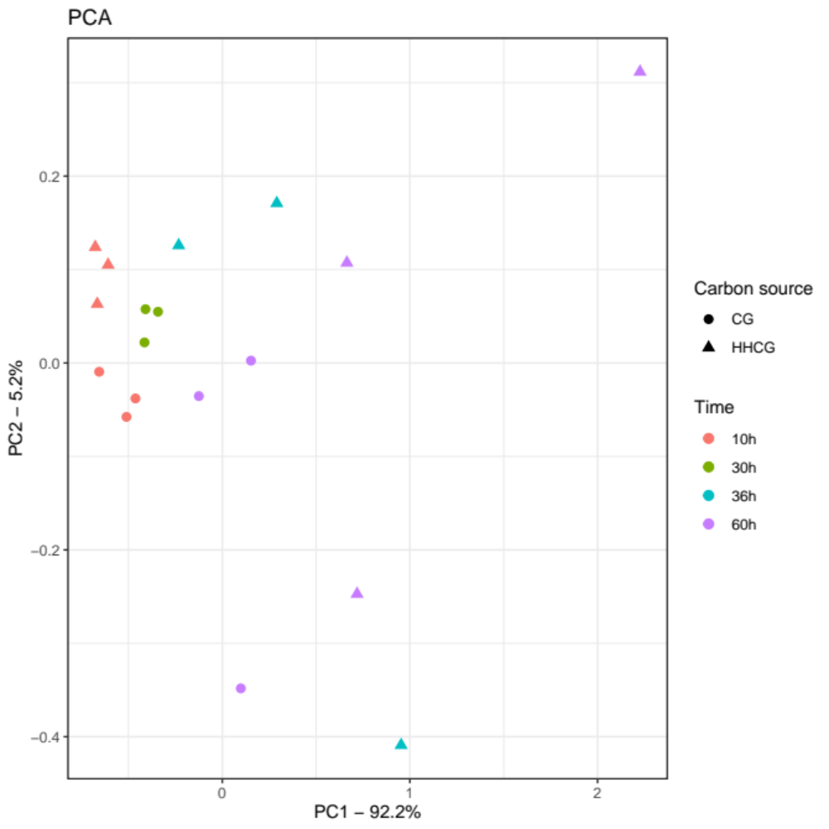Figure S1: Principal Component Analysis based on expression level from the 500 highest expressed genes in each of the cultivation media and RNA sampling points. CG, crude glycerol; CGHH, mixture of CG and hemicellulose hydrolysate

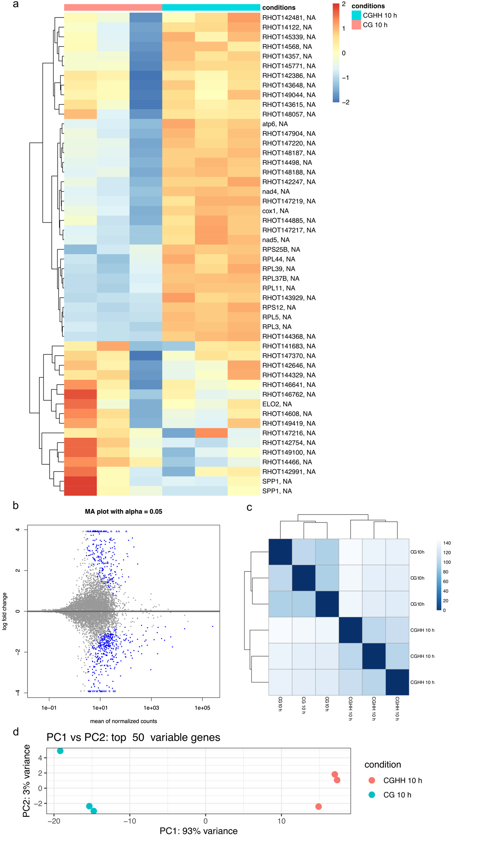
Figure S2: Overview of differential expression analysis between Rhodotorula toruloides CBS 14 cultivated on crude glycerol and a mixture of crude glycerol and hemicellulose hydrolysate, at 10 h cultivation. (A) Heatmap of the count matrix from the 50 genes whose expression varies the most, using variance stabilizing transformation and being row scaled. (B) MA-plot. (C) Heatmap of sample-to-sample distances on count matrix, which was variance-stabilized. Darker blue indicates a more similar expression level. (D) Principal Component Analysis (PCA) from the 50 genes whose expression varies the most, using variance stabilizing transformation. The samples CG 10 h belong to the three independent cultivations in culture medium containing CG as carbon source, respectively at 10 h. The samples CGHH 10 h belong to the three independent cultivations in culture medium containing CGHH as carbon source, respectively at 10 h.

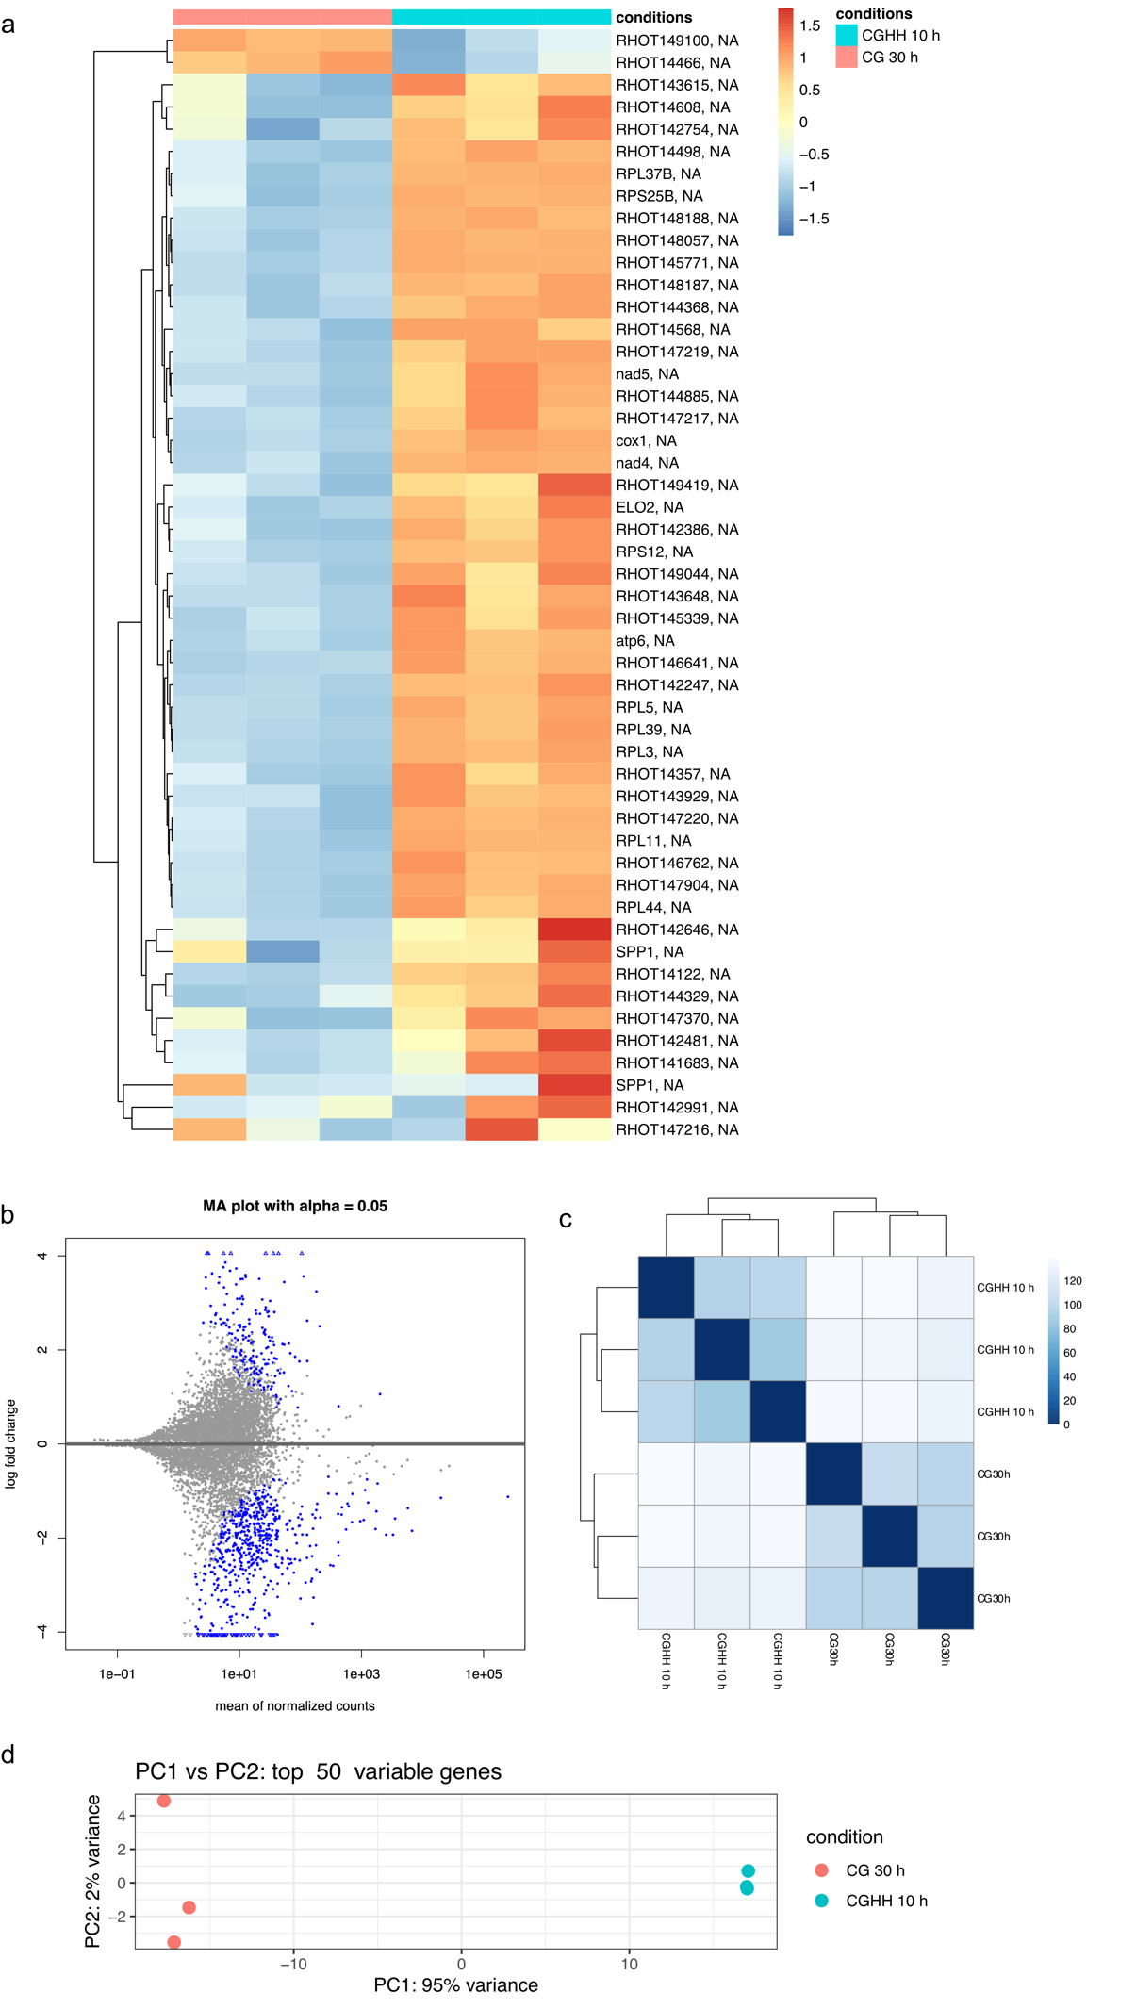
Figure S3: Overview of differential expression analysis between Rhodotorula toruloides CBS 14 grown on different media when glycerol consumption became visible: CG 30 h and CGHH 10 h cultivations. (A) Heatmap of the count matrix from the 50 genes whose expression varies the most, using variance stabilizing transformation and being row scaled. (B) MA-plot. (C) Heatmap of sample-to-sample distances on count matrix, which was variance-stabilized. Darker blue indicates a more similar expression level. (D) Principal Component Analysis (PCA) from the 50 genes whose expression varies the most, using variance stabilizing transformation. The samples CG 30 h belong to the three independent cultivations in culture medium containing CG as carbon source, respectively at 30 h. The samples CGHH 10 h belong to the three independent cultivations in culture medium containing CGHH as carbon source, respectively at 10 h.

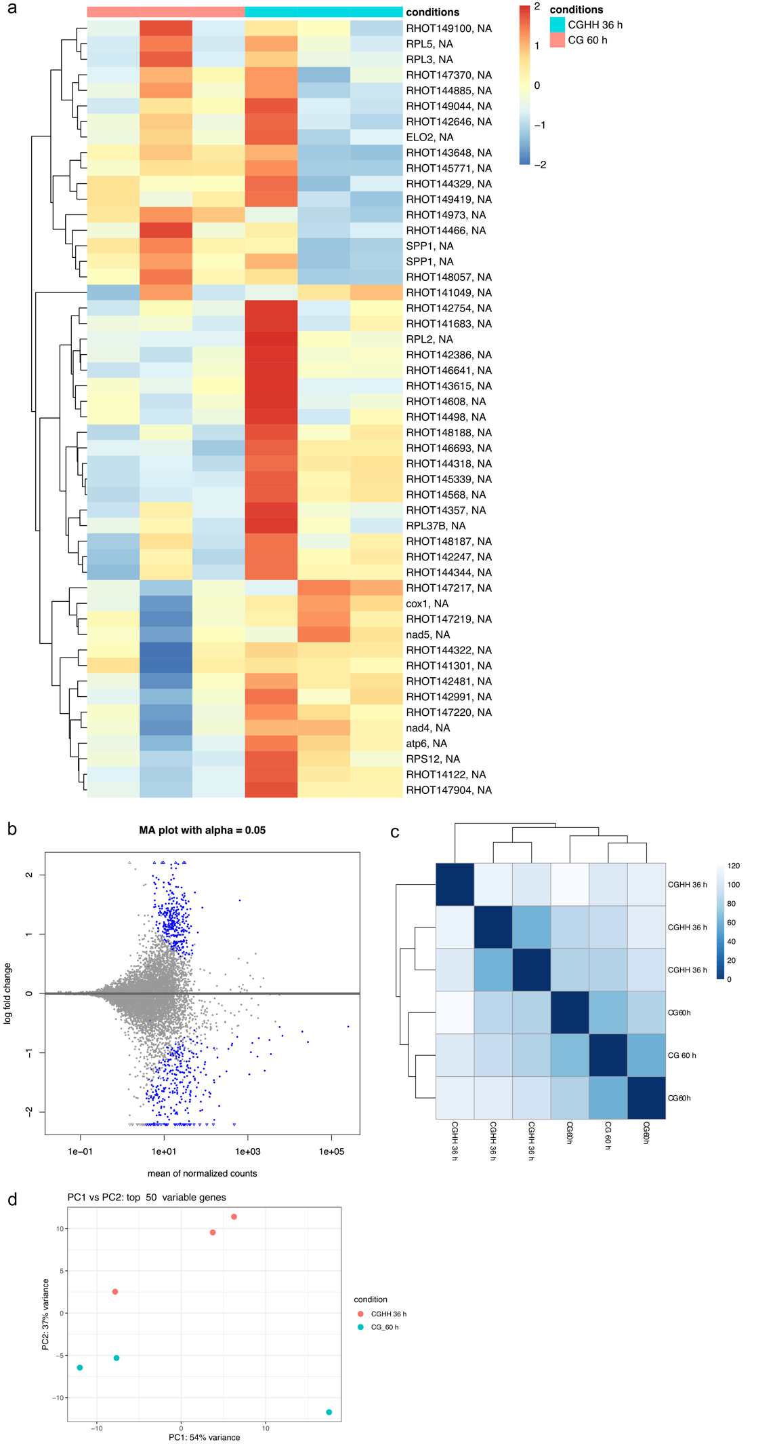
Figure S4: Overview of differential expression analysis between Rhodotorula toruloides CBS 14 grown on different media when about 20 g/l of glycerol were left: CG 60 h and CGHH 36 h cultivations. (A) Heatmap of the count matrix from the 50 genes whose expression varies the most, using variance stabilizing transformation and being row scaled. (B) MA-plot. (C) Heatmap of sample-to-sample distances on count matrix, which was variance-stabilized. Darker blue indicates a more similar expression level. (D) Principal Component Analysis from the 50 genes whose expression varies the most, using variance stabilizing transformation. The samples CG 60 h belong to the three independent cultivations in culture medium containing CG as carbon source, respectively at 60 h. The samples CGHH 36 h belong to the three independent cultivations in culture medium containing CGHH as carbon source, respectively at 36 h.
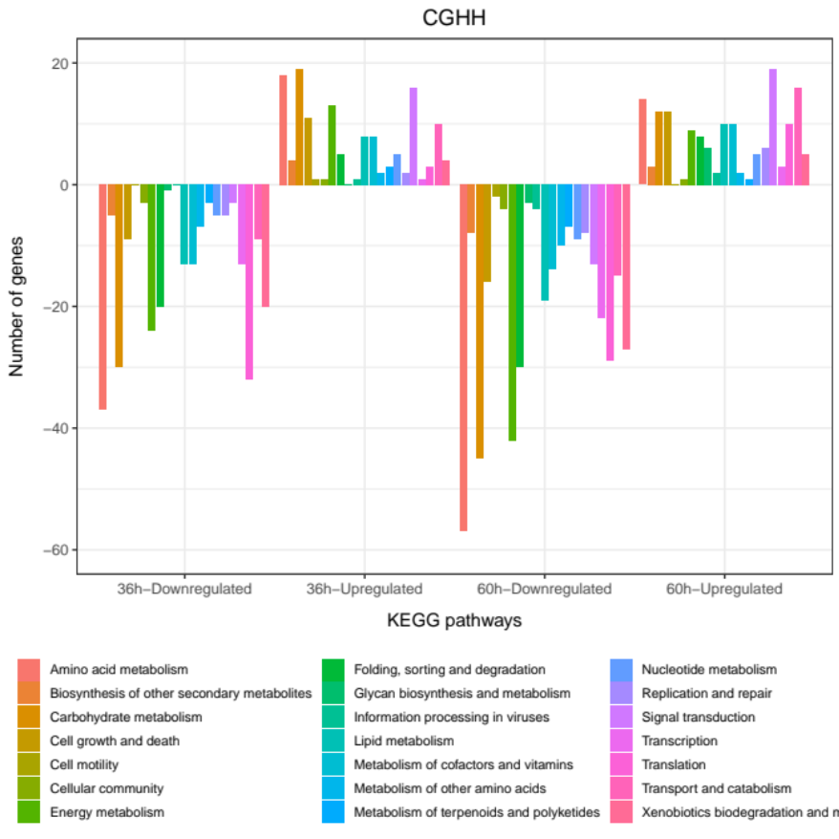
A)
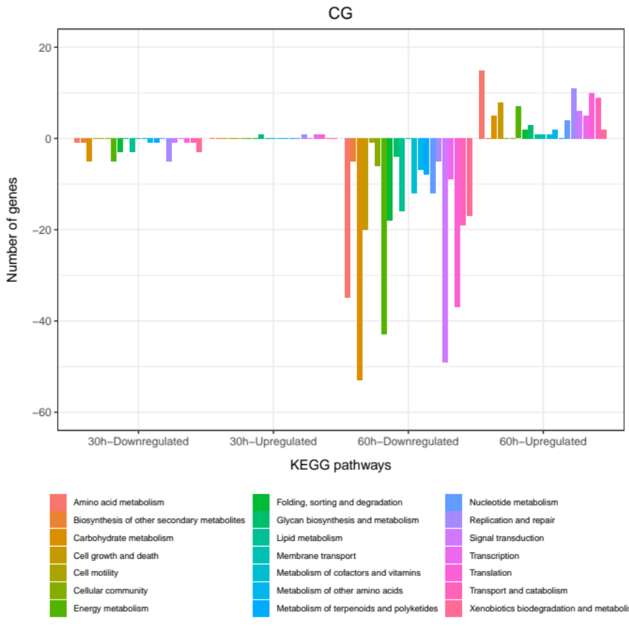
B)
Figure S5: Differentially expressed genes in Rhodotorula toruloides CBS 14 within sampling time points in each of the growth media. Barplot representation of the number of genes that are differentially expressed within each of the KEGG pathways and cellular processes for cells grown on media containing (A) CGHH as main carbon source or (B) CG. The acounted genes showed significat (p < 0.05) upregulation (+y axis) or downregulation (-y axis) compared to the 10 h sampling point, with a log₂Fold Change higher than 1.5. Bar colors indicate KEGG pathways. CG, crude glycerol; CGHH, mixture of CG and hemicellulose hydrolysate.

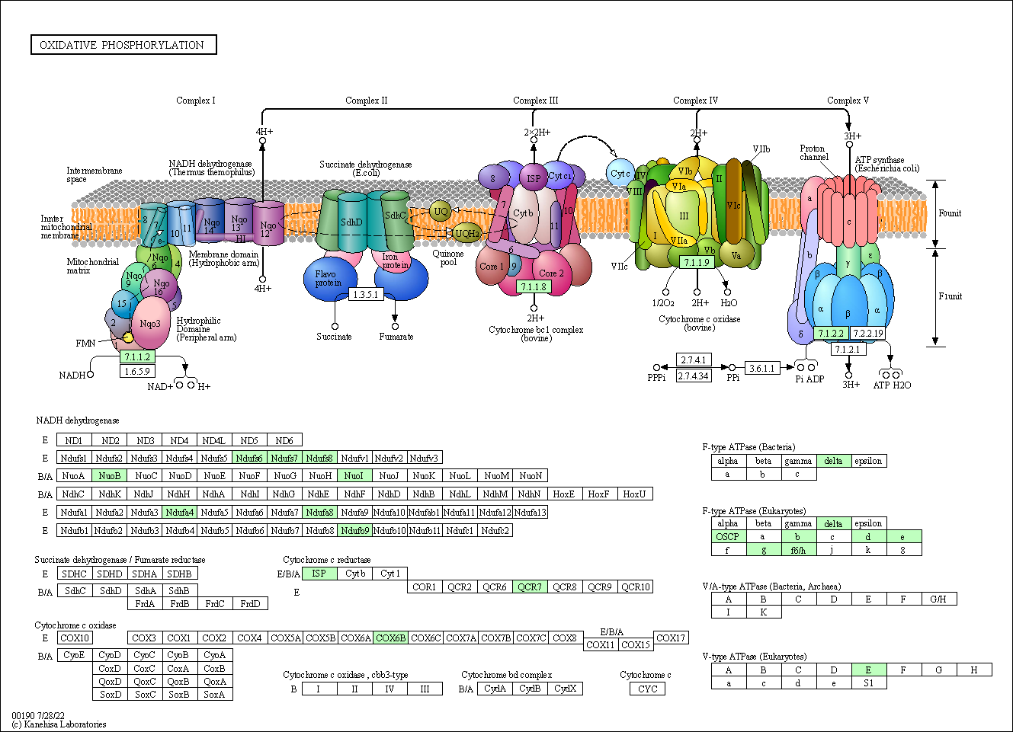
A)
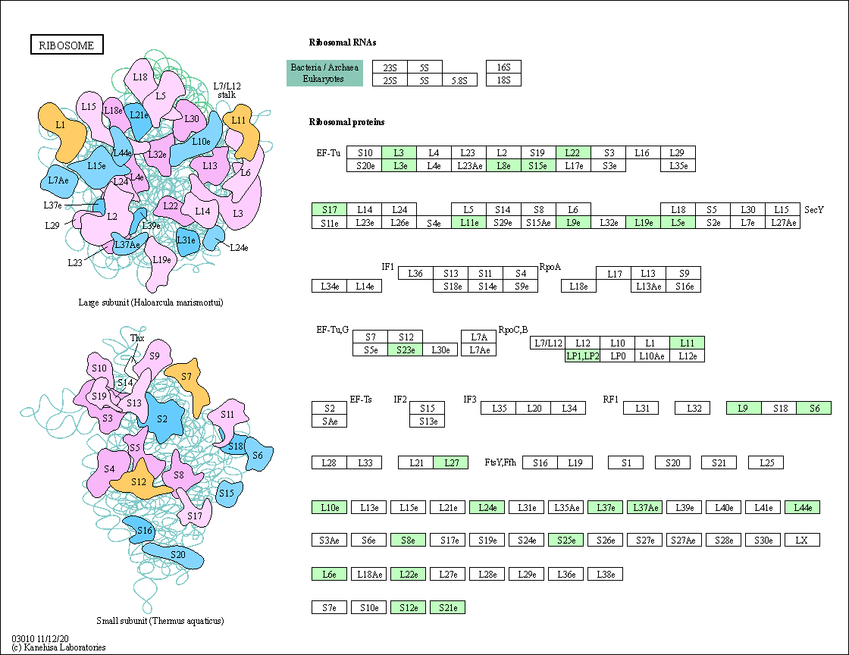
B)
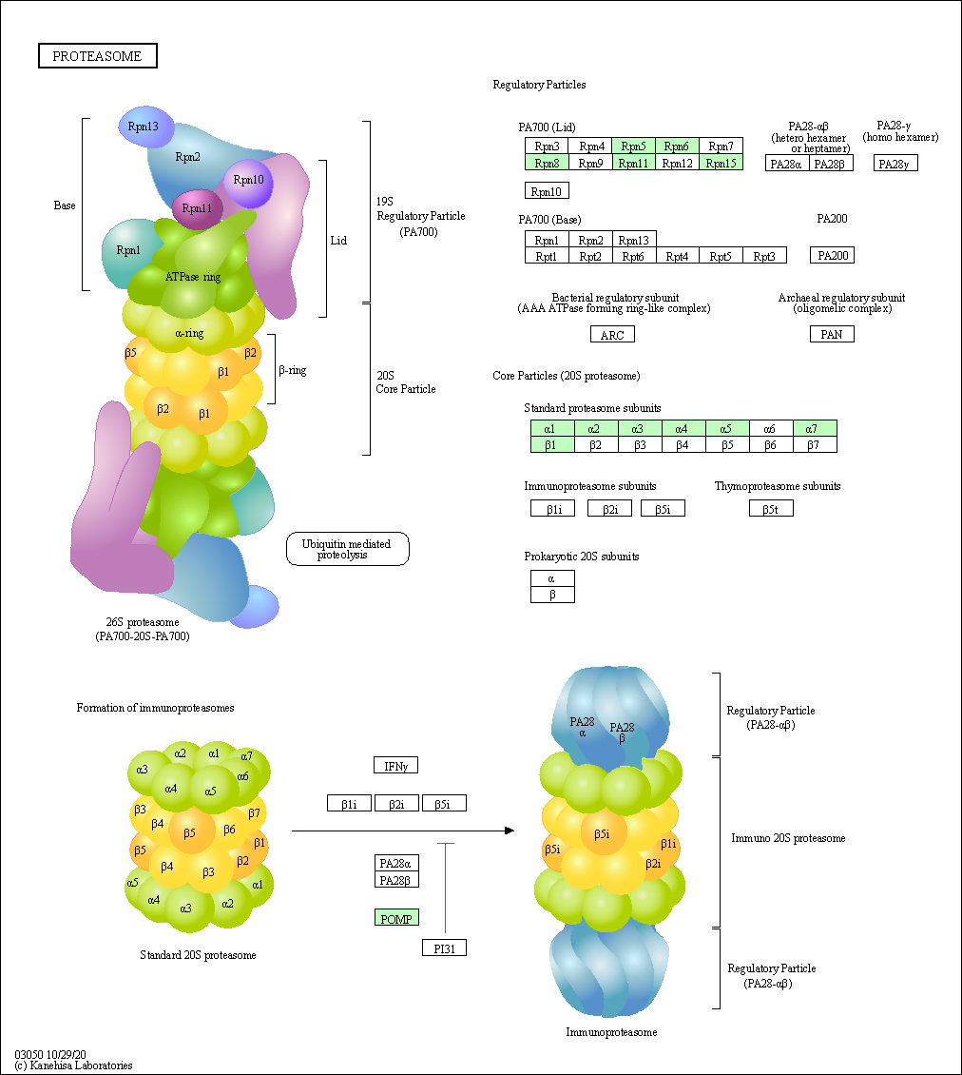
C)
Figure S6: Examples of upregulated genes in Rhodotorula toruloides CBS 14 grown on a mixture of crude glycerol (CG) and hemicellulose hydrolysate (CGHH) for 10 h of cultivation, whose expression is higher than CG 10 h. Genes encoding enzymes involved in (A) the respiratory chain, (B) ribosome biogenesis and (C) building of proteasome. Affected enzymes are highlighted in green. The figures were generated using the KEGG mapper.

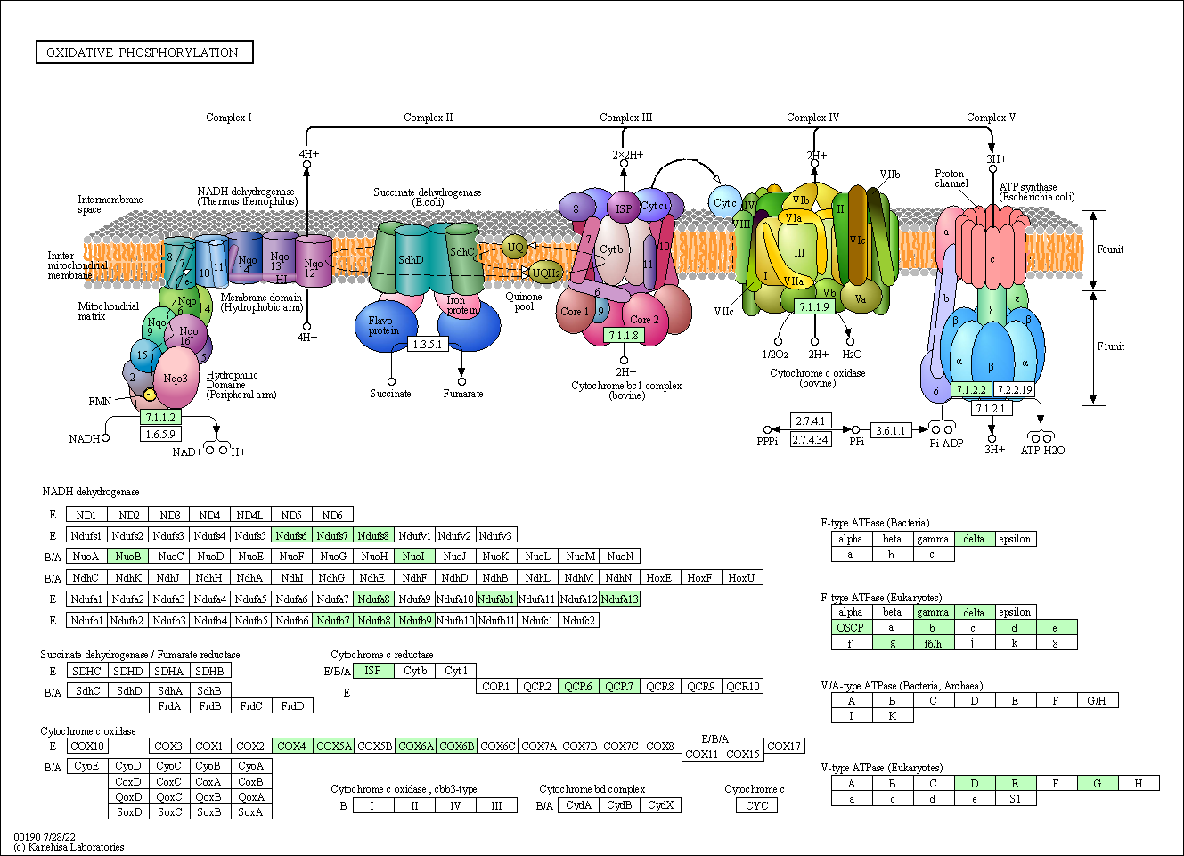
A)
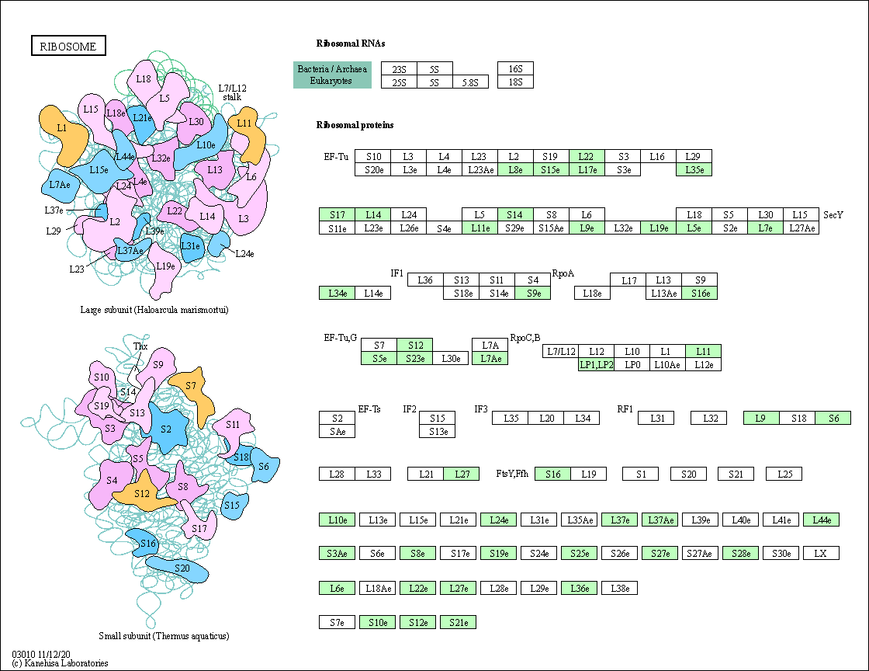
B)
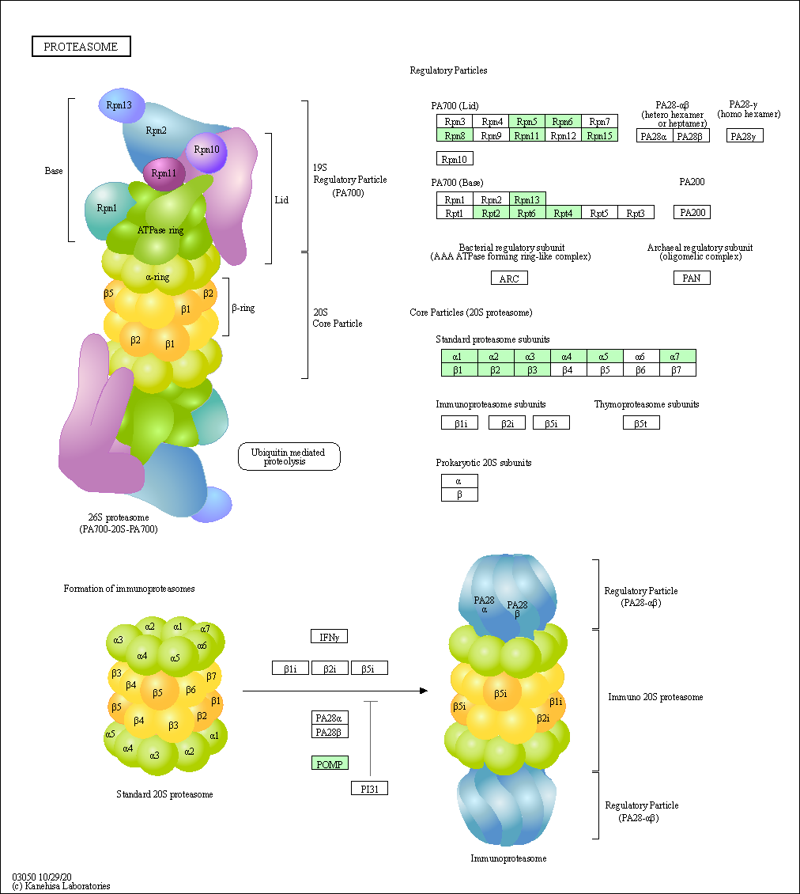
C)
Figure S7: Examples of upregulated genes in Rhodotorula toruloides CBS 14 grown on a mixture of crude glycerol (CG) and hemicellulose hydrolysate (CGHH) for 10 h of cultivation, whose expression is higher than CG 30 h. Genes encoding enzymes involved in (A) the respiratory chain, (B) ribosome biogenesis and (C) building of proteasome. Affected enzymes are highlighted in green. The figures were generated using the KEGG mapper.

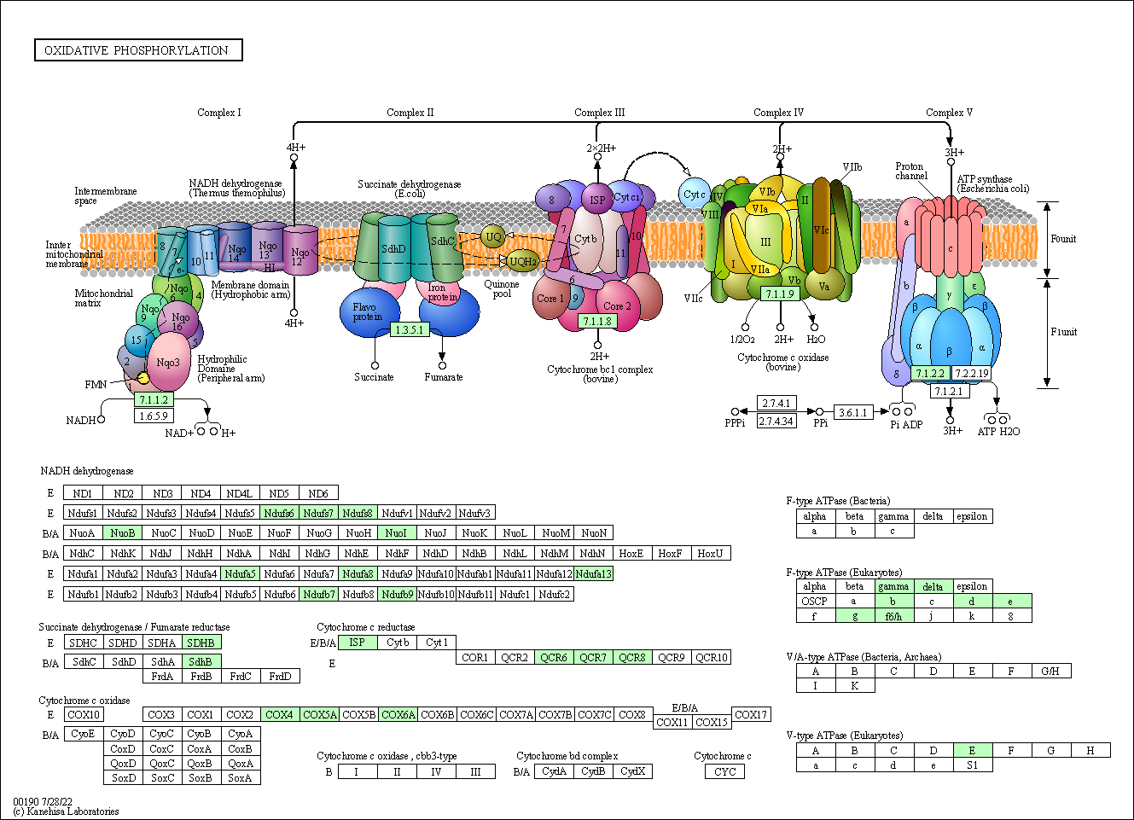
A)
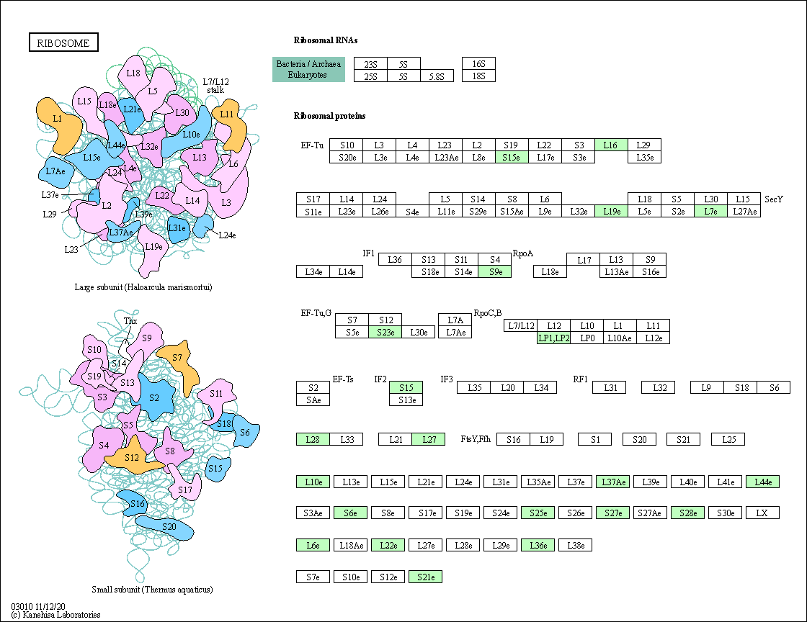
B)
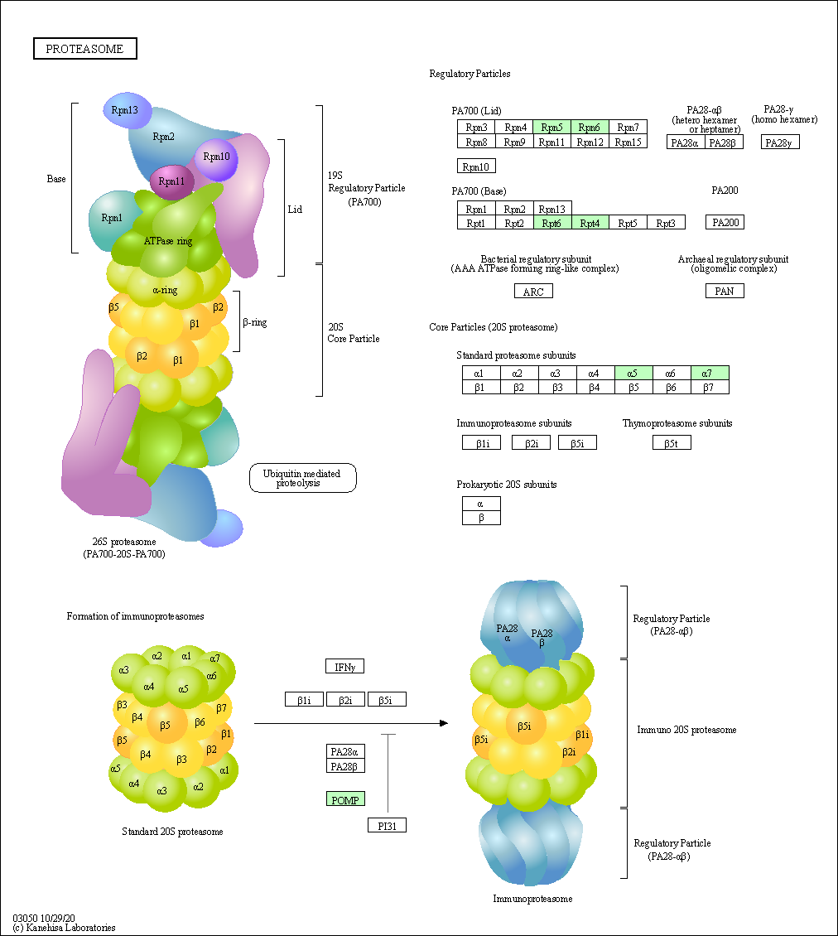
C)
Figure S8: Examples of upregulated genes in Rhodotorula toruloides CBS 14 grown on a mixture of crude glycerol (CG) and hemicellulose hydrolysate (CGHH) for 36 h of cultivation, whose expression is higher than CG 60 h. Genes encoding enzymes involved in (A) the respiratory chain, (B) ribosome biogenesis and (C) building of proteasome. Affected enzymes are highlighted in green. The figures were generated using the KEGG mapper.

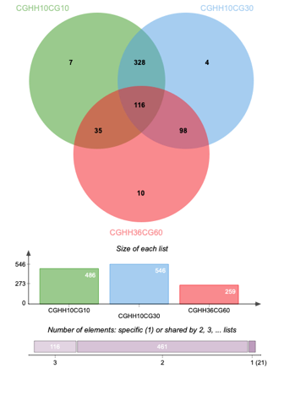
Figure S9: Distribution of shared ortholog clusters within differentially expressed genes in each of the three differential expression analyzes. The diagram was generated using OrthoVenn2.

