Supplementary Information

PM-bound polycyclic aromatic compounds (PACs) in two large-scale petrochemical bases in South China: Spatial variations, sources, and risk assessment

Qiqi Li ª, Yuan Zeng ^{a,*}, Yun Fan ^{b}, Siqi Fu ª, Yufeng Guan ª, Yuxin Sun ª, Shejun Chen ª

ª School of Environment, Guangdong Provincial Key Laboratory of Chemical Pollution and Environmental Safety, South China Normal University, Guangzhou 510006, China
^{b} State Key Laboratory of Freshwater Ecology and Biotechnology, Institute of Hydrobiology, Chinese Academy of Sciences, Wuhan 430072, China

* Corresponding author.
E-mail address: 20190838@m.scnu.edu.cn (Y. Zeng)

Chemical analysis
Target analytes included 40 parent PAHs (18 MW < 302 aum PAHs and 22 MW302 PAHs) and 30 PAH derivatives, which are listed in the table below. The solution standards of the target analytes and surrogate standards were purchased from Accustandard, Inc. (New Haven, CT, U.S.) The samples were Soxhlet extracted with a 200 mL mixture of hexane and acetone (v/v = 1:1) for 48 h, and prior to the extraction, 300 ng (for each standard, similarly hereinafter) and 120 ng deuterated surrogate standards for parent PAHs (ACE-d₁₀, PHE-d₁₀, CHR-d₁₂, PER-d₁₂, DahA-d₁₂, and DBalP-d₁₄) and PAH derivatives (2N-FLU-d₉ and 6N-CHR-d₁₁) were added to quantify and correct the results. The extracts were concentrated to 1 mL using a rotary evaporator and then purified and fractioned with a solid-phase extraction cartridge (CNWBOND ultraclean Si, 6 mL, 1 g). The first fraction (including all the parent PAHs and a part of PAH derivatives) was eluted with 5 mL of hexane and 5 mL of 2:8 hexane/dichloromethane (v/ v) from the column. The second fraction (the rest of PAH derivatives) was obtained by elution with 5 mL of ethyl acetate and 5 mL of acetone. Both fractions were concentrated under a gentle nitrogen stream to near dryness and then redissolved in 300 μL of isooctane. The internal standards, 2F-BIP and p-TPH-d₁₄ (300 ng), were added to the first fraction before parent PAH analysis. Equal volumes (150 μL) of the first and second fractions were mixed for PAH derivative analysis and 3N-FLA-d₉ (60 ng), the internal standard for PAH derivatives, was added to the mixture.
The target compounds were quantified using a Shimadzu QP2020 XN gas chromatograph-mass spectrometer (GC-MS). GC separation for PAH₁₈, MW302 PAHs, and PAH derivatives were accomplished by a DB-5 MS (30 m × 0.25 mm × 0.25 μm, Agilent), DB-17 MS (60 m × 0.25 mm × 0.25 μm, Agilent), and DB-17 MS (15 m × 0.25 mm × 0.25 μm, Agilent) capillary columns, respectively. The parent PAHs were operated in a selected ion monitoring mode and used electron impact ionization (GC-EI-MS), while PAH derivatives were operated in electron capture negative ionization (ECNI) mode. For PAH₁₈, the initial oven temperature was set at 80℃ (held for 5 min), ramped to 310℃ at 20℃/min and held for 15 min under 310℃. For MW302 PAHs, the initial oven temperature was set at 100℃ (held for 1 min), ramped to 200 at 45℃/min, to 310℃ at 2℃/min (held for 80 min), and finally reached 320°C at 45℃/min (held for 2 min). For the PAH derivatives, the initial column temperature was held at 80°C for 2 min and then programmed to 310℃ at 5℃/min (held for 5 min). The ion source, quadrupole, and interface temperatures were set at 250℃, 150°C, and 290℃, respectively, for parent PAH analysis, and were set to 200℃, 150℃, and 300℃, respectively, for PAH derivatives. Helium was used as the carrier gas for the gas chromatograph at a flow rate of 1 mL/min. For all the samples, the injection of 1 μL was performed with an automatic sampler in the splitless mode. The identification and quantification of 8 MW 302 PAHs (DBbkF, DbalP, N23kF, N23eP, N21aP, N23aP, DBaiP, and DbahP) was based on authentic standards. The identification of 14 other MW 302 isomers (DBbeF N12bF, N12kF, N23bF, DBakF, DBjlF, N12eP, N12aP, DBaeP, N21aP, DBelP, and three unknown isomers) was according to the methods reported in a previous study (Wang et al. 2011b).

Target compounds included PAH₁₈, MW302 PAHs, and PAH derivatives in this study.
Compound | Abbreviation |  |  | Compound |  | Abbreviation
PAH₁₈ |  |  | PAH derivatives
Acenaphthylene | ACY |  | 1,4-Naphthoquinone |  | 1,4-NQ
Fluorene | FLU |  | 1-Acenaphthenone |  | 1-ACP
Phenanthrene | PHE |  | 1,2-Acenaphthenequinone |  | 1,2-ACQ
Anthracene | ANT |  | 1,8-Naphthalicanhydride |  | 1,8-NANH
Fluoranthene | FLA |  | 5,12-Naphthacenequinone |  | 5,12-NACQ
Pyrene | PYR |  | 1,4-chrysenequinone |  | 1,4-CHR
Benzo[a]anthracene | BaA |  | 6H-Benzo[c,d]pyrene-6-one |  | 6H-BcdP
Chrysene | CHR |  | 7H-Benzo[d,e]anthracene-7-one |  | BEZO
Benzo[b]fluoranthene | BbF |  | 9-Fluorenone |  | 9-FLO
Benzo[k]fluoranthene | BkF |  | 1-Pyrenecarboxaldehyde |  | 1-PyCHO
Benzo[e]pyrene | BeP |  | Benzophenone |  | BP
Benzo[a]pyrene | BaP |  | Anthraquinone |  | ANTQ
Perylene | PER |  | Phenanthrene-9-carboxaldehyde |  | PCA
indeno[1,2,3-cd]pyrene | IcdP |  | Benz[a]anthracene-7,12-dione |  | BaAQ
Dibenzo[a,h]anthracene | DahA |  | 2-Methylanthraquinone |  | 2-MANTQ
Benzo[g,h,i]perylene | BghiP |  | 2-nitrofluorene |  | 2N-FLU
Picene | PIC |  | 9-nitroanthracene |  | 9N-ANT
Coronene | COR |  | 9-nitrophenanthrene |  | 9N-PHE
MW302 PAHs |  |  | 2-nitrodibenzothiophene |  | 2-NBT
Dibenzo[b,e]fluoranthene | DBbeF |  | 3-nitrophenanthrene |  | 3N-PHE
Unknown-1 | Unknown-1 |  | 2-nitroanthracene |  | 2N-ANT
Naphtho[1,2-b]fluoranthene | N12bF |  | 1-nitropyrene |  | 1N-PYR
Naphtho[1,2-k]fluoranthene | N12kF |  | 2-nitropyrene |  | 2N-PYR
Naphtho[2,3-b]fluoranthene | N23bF |  | 7-nitrobenz[a]anthracene |  | 7N-BaA
Dibenzo[b,k]fluoranthene | DBbkF |  | 1-nitrotriphenylene |  | 1-NTR
Dibenzo[a,k]fluoranthene | DBakF |  | 2,8-dinitrodibenzothiophene |  | 2,8-DNDB
Dibenzo[j,l]fluoranthene | DBjlF |  | 6-nitrochrysene |  | 6N-CHR
Naphtho[1,2-e]pyrene | N12eP |  | 3-nitrobenzanthrone |  | 3-NBA
Dibenzo[a,l]pyrene | DBalP |  | 3-nitrofluoranthene |  | 3N-FLA
Unknown-2 | Unknown-2 |  | 2-nitrofluoranthene |  | 2N-FLA
Naphtho[2,3-k]fluoranthene | N23kF |  | Deuterated standards
Naphtho[1,2-a]pyrene | N12aP |  | Acenaphthene-d₁₀ |  | ACE-d₁₀
Unknown-3 | Unknown-3 |  | Phenanthrene-d₁₀ |  | PHE-d₁₀
Naphtho[2,3-e]pyrene | N23eP |  | Chrysene-d₁₂ |  | CHR-d₁₂
Dibenzo[a,e]pyrene | DBaeP |  | Perylene-d₁₂ |  | PER-d₁₂
Naphtho[2,1-a]pyrene | N21aP |  | Dibenzo[a,h]anthracene-d₁₂ |  | DahA-d₁₂
Dibenzo[e,l]pyrene | DBelP |  | Dibenzo[a,l]pyrene-d₁₄ |  | DBalP-d₁₄
Naphtho[2,3-a]pyrene | N23aP |  | 2-nitrofluorene-d₉ |  | 2N-FLU-d₉
Benzo[b]perylene | BbPer |  | 6-nitrochrysene-d₁₁ |  | 6N-CHR-d₁₁
Dibenzo[a,i]pyrene | DBaiP |  | 2-Fluorobiphenyl |  | 2F-BIP
Dibenzo[a,h]pyrene | DBahP |  | p-Terphenyl-d₁₄ |  | p-TPH-d₁₄
 |  |  | 3-nitrofluoranthene-d₉ |  | 3N-FLA-d₉

Quality control
In the field blanks (n = 11) and procedural blanks (n = 13), several analysts, mainly including ACY, FLU, PHE, ANT, FLA, 1,4-NQ, 1,2-ACQ, 1,8-NANH, and ANTQ were found in the blanks with minor concentrations (< 7.6% of the amounts in most sample extracts). Concentrations in the field samples were blank-corrected accordingly. Recoveries of the surrogated standards (mean ± standard deviation) were 52.1 ± 9.82% for ACE-d₁₀, 73.4 ± 10.5% for PHE-d₁₀, 104 ± 8.00% for CHR-d₁₂, 114 ± 15.2% for PER-d₁₂, 111 ± 12.0% for DahA-d₁₂, 115 ± 14.4% for DBalP-d1₄, 103 ± 26.0% for 2N-FLU-d₉ and 89.1 ± 24.0% for 6N-CHR-d₁₁. The instrument detection limits (IDLs) defined as a signal of 3 times the noise level, ranged from 0.001 to 22.1 pg/m³ for all compounds. The method detection limits (MDLs), assigned as the average values of the field blanks plus three times the standard deviation or a signal of 10 times the noise level for compounds that were nondetectable in the blanks, and ranged from 2.21 to 69.6 pg/m³ for parent PAHs and 0.004 to 67.6 pg/m³ for PAH derivatives. Detailed IDLs and MDLs were listed in the table below.

The IDLs (pg/m³) and MDLs (pg/m³) of the target compounds
Compound | IDLs | MDLs |  | Compound | IDLs | MDLs |  | Compound | IDLs | MDLs
ACY | 0.114 | 7.55 |  | DBakF | 2.24 | 7.47 |  | 9-FLO | 0.001 | 0.004
FLU | 0.818 | 22.9 |  | DBjlF | 2.24 | 7.47 |  | 1-PyCHO | 0.028 | 3.43
PHE | 6.62 | 30.8 |  | N12eP | 2.24 | 7.47 |  | BP | 1.41 | 4.72
ANT | 22.1 | 11.8 |  | DBalP | 10.7 | 35.8 |  | ANTQ | 0.170 | 58.1
FLA | 0.100 | 18.4 |  | Unknown-2 | 2.24 | 7.47 |  | PCA | 0.043 | 0.143
PYR | 0.128 | 19.4 |  | N23kF | 13.8 | 46.1 |  | BaAQ | 0.010 | 0.034
BaA | 8.10 | 27.0 |  | N12aP | 2.24 | 7.47 |  | 2-MANTQ | 0.042 | 67.6
CHR | 16.1 | 6.03 |  | Unknown-3 | 2.24 | 7.47 |  | 2N-FLU | 0.002 | 15.9
BbF | 7.94 | 2.11 |  | N23eP | 2.24 | 7.47 |  | 9N-ANT | 0.007 | 38.8
BkF | 13.7 | 9.44 |  | DBaeP | 10.0 | 33.3 |  | 9N-PHE | 0.003 | 18.6
BeP | 9.68 | 3.75 |  | N21aP | 2.24 | 7.47 |  | 2-NBT | 0.005 | 25.0
BaP | 14.5 | 6.85 |  | DBelP | 2.24 | 7.47 |  | 3N-PHE | 0.004 | 0.012
PER | 11.8 | 39.3 |  | N23aP | 20.9 | 3.72 |  | 2N-ANT | 0.019 | 0.063
IcdP | 12.7 | 15.3 |  | BbPer | 2.24 | 7.47 |  | 1N-PYR | 0.004 | 0.014
DahA | 2.21 | 17.4 |  | DBaiP | 2.24 | 7.47 |  | 2N-PYR | 0.036 | 0.120
BghiP | 2.24 | 10.9 |  | DBahP | 20.9 | 69.6 |  | 7N-BaA | 0.005 | 0.018
PIC | 0.40 | 10.3 |  | 1,4-NQ | 15.1 | 50.2 |  | 1-NTR | 0.050 | 0.016
COR | 13.1 | 43.6 |  | 1-ACP | 0.012 | 0.039 |  | 2,8-DNDB | 0.029 | 0.096
DBbeF | 16.5 | 55.1 |  | 1,2-ACQ | 0.056 | 61.9 |  | 6N-CHR | 0.005 | 0.015
Unknown-1 | 2.24 | 7.47 |  | 1,8-NANH | 0.002 | 1.63 |  | 3-NBA | 0.081 | 0.279
N12bF | 2.24 | 7.47 |  | 5,12-NACQ | 1.42 | 4.72 |  | 3N-FLA | 0.005 | 0.016
N12kF | 2.24 | 7.47 |  | 1,4-CHR | 0.010 | 0.034 |  | 2N-FLA | 0.003 | 0.011
N23bF | 2.24 | 7.47 |  | 6H-BcdP | 0.009 | 24.4
DBbkF | 2.24 | 7.47 |  | BEZO | 1.42 | 4.72

Positive matrix factorization receptor model (PMF)
PMF is a well know source apportionment analysis model widely applied to identify and quantify source profiles and the contribution of contaminations in various environmental media. The governing equation of the PMF model is given as: X = GF + E. In this equation, X (n × m) is the sample matrix consisting of the measured concentrations (pg/m³) of m congeners in n samples. G (n × p) is the factor-score matrix describing the contribution of each factor to any given sample. F (p × m) is the factor-loading matrix expressing the PAC profiles of each factor. The p-value above is the number of factors or PAC sources. E (n × m) is a residue matrix. The input datasets of the PMF model include concentrations of samples and uncertainties of the datasets. For species uncertainty (Unc), if the concentration is less than or equal to MDLs, the Unc is calculated using the equation:
Unc = $\frac{\text{5}}{\text{6}}$ $\text{× MDLs}$
If the concentration is greater than the MDLs could be calculated based on the equation:
Unc =$\sqrt{{\text{( Error Fraction ×concentration)}}^{\text{2}}\text{+}{\text{(0.5 ×MDLs)}}^{\text{2}}}$
34 and 24 species were involved in the model for GDPB and HNPB, respectively. The criteria for the selection of species are 1) compounds with detection rates under 80% were excluded, 2) compounds with signal/noise under 0.5 in the PMF were excluded. The number of factors was determined by evaluating the PMF parameters, including mapping of bootstrap factors, Qrobust/Qtrue, and Qrobust/Qexpected values. Firstly, the model was run 200 times with different factors. The correlation R-value of 0.6 for stability estimation and solution results with >80% bootstrap mapping factors were considered stable and acceptable. Secondly, the Qrobust and Qtrue values were evaluated when a different number of factors was set. Qtrue is the goodness-of-fit parameter calculated, including all points. Qrobust is the goodness-of-fit parameter calculated excluding points not fit by the model, defined as samples for which the uncertainty-scaled residual is greater than 4. The Qrobust was about 10% lower than the Qtrue (namely Qrobust/Qtrue over 0.9), indicating some, but not heavy, impacts of outliers on the Q-value. No heavy impact of outliers was observed in this study because all of the Qrobust/Qtrue values were equal to 1. Thirdly, quality of fit is determined by examining the ratio of the calculated Q value by running PMF in the robust mode (Qrobust) to the expected Q value (Qexpected), where Qexpected is equal to (number of non-weak data values in X) - (numbers of elements in G and F, taken together). A good fit exists when Qrobust/Qexpected has the lowest value and approximates 1. Detailed running results are shown in the table below.

Table: Qrobust, Qtrue, Qrobust/Qtrue ratios, and parameters in the validation runs.
 | GDPB |  |  |  |  |  | HNPB
Parameters | Values |  |  |  |  |  | Values
Number of factors | 3 | 4 | 5 | 6 | 7 |  | 3 | 4 | 5 | 6 | 7
Rand Seed | 94 | 45 | 79 | 50 | 17 |  | 10 | 27 | 96 | 25 | 29
Number of species | 35 | 35 | 35 | 35 | 35 |  | 25 | 25 | 25 | 25 | 25
Strong of species | 32 | 32 | 32 | 32 | 32 |  | 23 | 23 | 23 | 23 | 23
Number of samples | 56 | 56 | 56 | 56 | 56 |  | 48 | 48 | 48 | 48 | 48
Number of factors | 3 | 4 | 5 | 6 | 7 |  | 3 | 4 | 5 | 6 | 7
Qtrue | 2403.1 | 1844 | 1351.2 | 1051 | 829.6 |  | 1440.5 | 938.4 | 670.5 | 504.7 | 355.7
Qrobust | 2380.7 | 1824.2 | 1343 | 1047.2 | 825.6 |  | 1380.2 | 933.6 | 667.2 | 504.1 | 355.3
Qrobust/Qtrue | 0.990 | 0.989 | 0.994 | 0.996 | 0.995 |  | 0.958 | 0.995 | 0.995 | 0.999 | 0.999
Qexpected | 1528 | 1440 | 1352 | 1264 | 1176 |  | 891 | 820 | 749 | 678 | 607
Qrobust/Qexpected | 1.558 | 1.267 | 0.993 | 0.8285 | 0.702 |  | 1.549 | 1.139 | 0.891 | 0.744 | 0.585

Table: Mapping of the bootstrap factors to base factors.
 | GDPB |  |  |  |  |  | HNPB
Parameters | Values |  |  |  |  |  | Values
Number of factors | 3 | 4 | 5 | 6 | 7 |  | 3 | 4 | 5 | 6 | 7
Boot and base Factor 1 | 100 | 98 | 99 | 94 | 94 |  | 91 | 98 | 94 | 100 | 99
Boot and base Factor 2 | 93 | 93 | 84 | 96 | 69 |  | 100 | 100 | 93 | 73 | 97
Boot and base Factor 3 | 97 | 97 | 100 | 83 | 85 |  | 100 | 82 | 99 | 99 | 96
Boot and base Factor 4 | / | 69 | 100 | 72 | 93 |  | / | 99 | 98 | 95 | 99
Boot and base Factor 5 | / | / | 90 | 99 | 97 |  | / | / | 85 | 97 | 96
Boot and base Factor 6 | / | / | / | 89 | 93 |  | / | / | / | 75 | 71
Boot and base Factor 7 | / | / | / | / | 95 |  | / | / | / | / | 85

Table: Correlation between observed/predicted concentrations.
GDPB |  |  |  |  |  |  |  |  | HNPB
Number of factors |  |  | 3 | 4 | 5 | 6 | 7 |  | Number of factors |  |  | 3 | 4 | 5 | 6 | 7
Compounds | Category | S/N | r² | r² | r² | r² | r² |  | Compounds | Category | S/N | r² | r² | r² | r² | r²
PHE | Weak | 2.883 | 0.166 | 0.162 | 0.604 | 0.575 | 0.583 |  | PHE | Strong | 2.590 | 0.695 | 0.789 | 0.786 | 0.788 | 0.795
FLA | Strong | 5.444 | 0.287 | 0.200 | 0.738 | 0.888 | 0.876 |  | FLA | Strong | 5.222 | 0.401 | 0.449 | 0.458 | 0.465 | 0.995
PYR | Strong | 5.469 | 0.299 | 0.213 | 0.592 | 0.782 | 0.768 |  | PYR | Strong | 4.691 | 0.733 | 0.901 | 0.907 | 0.905 | 0.880
BaA | Strong | 4.313 | 0.638 | 0.897 | 0.839 | 0.853 | 0.908 |  | BaA | Strong | 2.349 | 0.886 | 0.927 | 0.965 | 0.971 | 0.975
CHR | Strong | 5.651 | 0.680 | 0.814 | 0.856 | 0.843 | 0.884 |  | CHR | Strong | 5.547 | 0.843 | 0.899 | 0.902 | 0.905 | 0.922
BbF | Strong | 5.666 | 0.858 | 0.875 | 0.896 | 0.921 | 0.932 |  | BbF | Strong | 5.665 | 0.965 | 0.962 | 0.967 | 0.965 | 0.973
BkF | Strong | 5.654 | 0.828 | 0.738 | 0.938 | 0.951 | 0.935 |  | BkF | Strong | 5.253 | 0.971 | 0.969 | 0.973 | 0.970 | 0.978
BeP | Strong | 5.665 | 0.968 | 0.979 | 0.973 | 0.974 | 0.974 |  | BeP | Strong | 5.649 | 0.962 | 0.959 | 0.973 | 0.974 | 0.983
BaP | Strong | 5.623 | 0.853 | 0.958 | 0.938 | 0.951 | 0.969 |  | BaP | Strong | 5.306 | 0.868 | 0.880 | 0.963 | 0.974 | 0.976
PER | Strong | 1.880 | 0.911 | 0.930 | 0.965 | 0.972 | 0.974 |  | DahA | Strong | 1.551 | 0.857 | 0.859 | 0.868 | 0.929 | 0.931
DahA | Strong | 4.173 | 0.899 | 0.932 | 0.937 | 0.939 | 0.953 |  | PIC | Strong | 4.015 | 0.541 | 0.546 | 0.566 | 0.579 | 0.585
PIC | Strong | 5.060 | 0.902 | 0.935 | 0.935 | 0.938 | 0.944 |  | IcdP | Strong | 5.434 | 0.948 | 0.968 | 0.965 | 0.971 | 0.970
IcdP | Strong | 5.621 | 0.865 | 0.873 | 0.898 | 0.890 | 0.927 |  | BghiP | Strong | 5.571 | 0.950 | 0.969 | 0.962 | 0.972 | 0.974
BghiP | Strong | 5.651 | 0.915 | 0.889 | 0.901 | 0.899 | 0.924 |  | COR | Strong | 4.242 | 0.750 | 0.764 | 0.987 | 0.987 | 0.984
COR | Strong | 5.305 | 0.709 | 0.889 | 0.960 | 0.949 | 0.957 |  | DBaeF | Weak | 0.678 | 0.745 | 0.765 | 0.945 | 0.950 | 0.947
DBalP | Strong | 4.184 | 0.468 | 0.609 | 0.851 | 0.839 | 0.868 |  | N23eP | Strong | 3.586 | 0.704 | 0.710 | 0.942 | 0.943 | 0.942
DBaeF | Strong | 2.678 | 0.572 | 0.675 | 0.856 | 0.860 | 0.872 |  | DBaeP | Strong | 1.227 | 0.831 | 0.828 | 0.861 | 0.868 | 0.873
N23eP | Strong | 4.629 | 0.648 | 0.817 | 0.962 | 0.945 | 0.956 |  | N23aP | Strong | 3.724 | 0.878 | 0.874 | 0.897 | 0.908 | 0.921
DBaeP | Strong | 2.608 | 0.710 | 0.829 | 0.960 | 0.950 | 0.962 |  | 1,2-ACQ | Strong | 2.480 | 0.204 | 0.587 | 0.639 | 0.817 | 0.803
N23aP | Strong | 4.671 | 0.945 | 0.954 | 0.961 | 0.958 | 0.961 |  | 1.8-NANH | Strong | 5.662 | 0.097 | 0.685 | 0.742 | 0.971 | 0.987
9-FLO | Strong | 5.667 | 0.591 | 0.648 | 0.578 | 0.710 | 0.895 |  | 6H-BcdP | Strong | 4.349 | 0.828 | 0.892 | 0.892 | 0.898 | 0.901
1,2-ACQ | Strong | 5.483 | 0.730 | 0.729 | 0.718 | 0.732 | 0.754 |  | BEZO | Strong | 2.984 | 0.819 | 0.920 | 0.936 | 0.928 | 0.930
1.8-NANH | Strong | 5.662 | 0.880 | 0.879 | 0.931 | 0.897 | 0.943 |  | ANTQ | Strong | 1.624 | 0.627 | 0.679 | 0.701 | 0.701 | 0.796
1.4-CHR+BaAQ | Strong | 5.667 | 0.885 | 0.899 | 0.877 | 0.889 | 0.889 |  | 1-PyCHO | Strong | 5.270 | 0.822 | 0.890 | 0.910 | 0.905 | 0.904
6H-BcdP | Strong | 5.609 | 0.905 | 0.904 | 0.932 | 0.931 | 0.934 |  | Total | Weak | 10.000 | 0.977 | 0.989 | 0.996 | 0.996 | 0.999
BEZO | Strong | 5.501 | 0.897 | 0.903 | 0.901 | 0.912 | 0.913
ANTQ | Strong | 3.830 | 0.641 | 0.634 | 0.694 | 0.778 | 0.803
1-PyCHO | Strong | 5.602 | 0.809 | 0.862 | 0.862 | 0.874 | 0.885
2,8-DNDB | Strong | 5.667 | 0.355 | 0.381 | 0.363 | 0.389 | 0.388
3N-PHE | Weak | 5.060 | 0.574 | 0.773 | 0.855 | 0.868 | 0.891
9N-PHE | Weak | 0.802 | 0.344 | 0.475 | 0.500 | 0.519 | 0.627
2N-FLA | Strong | 5.667 | 0.657 | 0.509 | 0.828 | 0.902 | 0.901
1N-PYR | Strong | 5.667 | 0.374 | 0.848 | 0.911 | 0.932 | 0.947
7N-BaA | Strong | 5.667 | 0.762 | 0.793 | 0.774 | 0.789 | 0.828
Total | Weak | 10.000 | 0.976 | 0.984 | 0.981 | 0.982 | 0.981

Fig. S1 Spatial distribution of the PM concentrations in GDPB and HNPB.
Fig. S2 The PAC concentrations at the control site of HNPB.

Table S1 The mean concentrations of PM-bound PACs in other cities of China (ng/m³)
Location (Year) | Particle size | PAHs | OPAHs | NPAHs | Reference | Reference
Northern China
Beijing (2008-2009) | TSP | 104 | - | - | Ma et al., 2019 | (Ma et al. 2019)
Beijing (2016) | PM_{2.5} | 90.0. | 63.3 | 1.93 | Ei zein et al., 2019 | (Ei zein et al. 2019)
Lanzhou (2008-2009) | TSP | 190 | - | - | Ma et al., 2019 | (Ma et al. 2019)
Dalian (2008-2009) | TSP | 28.8 | - | - | Ma et al., 2019 | (Ma et al. 2019)
Shihezi (2008-2009) | TSP | 85.6 | - | - | Ma et al., 2019 | (Ma et al. 2019)
Xi’an (2013-2014) | TSP | 31.5 | 41.5 | - | Ren et al., 2017 | (Ren et al. 2017)
Xi’an (2008-2009) | TSP | 48.7 | - | - | Ma et al., 2019 | (Ma et al. 2019)
Tianjin (2015) | PM_{2.5} | 98 | 96.2 | - | Niu et al., 2017 | (Niu et al. 2017)
Shijiazhuang (2015) | PM_{2.5} | 211 | 180 | - | Niu et al., 2017 | (Niu et al. 2017)
Hengshui (2015) | PM_{2.5} | 169 | 121 | - | Niu et al., 2017 | (Niu et al. 2017)
Langfang (2015) | PM_{2.5} | - | 10.1 | 0.42 | Zhao et al., 2018 | (Zhao et al. 2018)
Taiyuan (2016) | PM_{2.5} | - | - | 4.89 | Zhang et al., 2018 | (Zhang et al. 2018)
Jinan (2016) | PM_{2.5} | - | 3.52 | 1.76 | Jiang et al., 2018 | (Jiang et al. 2018)
Changchun (2017) | PM | 48.6 | - | - | Yan et al., 2019 | (Yan et al. 2019)
Xinxiang (2017) | PM_{2.5} | 27.3 | - | 0.82 | Zhang et al., 2021 | (Zhang et al. 2021)
Harbin (2008-2009) | TSP | 38.6 | - | - | Ma et al., 2019 | (Ma et al. 2019)
Harbin (2017-2018) | PM_{2.5} | 89.6 | - | 5.48 | Ma et al., 2020 | (Ma et al. 2020)
Shenyang (2017-2018) | PM_{2.5} | 26.7 | - | 0.28 | Yang et al., 2021a | (Yang et al. 2021a)
Zhengzhou (2017-2018) | PM_{2.5} | 26.3 | - | - | Zhe et al., 2020 | (Zhe et al. 2020)
Southern China
Guangzhou (2013-2014) | TSP | 10.4 | 17 | - | Ren et al., 2017 | (Ren et al. 2017)
Guangzhou (2008-2009) | TSP | 10.7 | - | - | Ma et al., 2019 | (Ma et al. 2019)
Shanghai (2017-2018) | PM_{2.1} | 4.29 | - | 0.19 | Yang et al., 2021b | (Yang et al. 2021b)
Nanjing (2017) | PM_{2.5} | - | - | 2.11 | Yin et al., 2021 | (Yin et al. 2021)
Lhasa (2008-2009) | TSP | 14.2 | - | - | Ma et al., 2019 | (Ma et al. 2019)
Nanchang (2008-2009) | TSP | 13.7 | - | - | Ma et al., 2019 | (Ma et al. 2019)
Chengdu (2008-2009) | TSP | 81.1 | - | - | Ma et al., 2019 | (Ma et al. 2019)
Kunming (2008-2009) | TSP | 45.3 | - | - | Ma et al., 2019 | (Ma et al. 2019)
GDPB (2019-2020) | TSP | 7.14 | 7.29 | 0.260 | This study | This study
HNPB (2018-2019) | TSP | 2.55 | 0.790 | 0.059 | This study | This study

Table S2. The mean concentrations of PM-bound MW302 PAHs in other cities of China (pg/m³)
Location (Year) | Site type | Particle size | DBalP | DBaeP | DBahP | DBaiP | DBaeF | N23kF | N23eP | N23aP | ∑MW302 PAHs | Reference
Stockholm (2003,2005) | urban area | PM₁₀ | 3.39 | 23.7 | 1.86 | 5.52 | - | - | - | - | 34.5 | (Christoffer Bergvall and Rholm. 2007) | (Christoffer Bergvall and Rholm. 2007)
Beijing  (2008) | urban area | PM_{2.5} | 39.6 | 213.3 | 15.4 | 84.8 | 418 | 55.3 | 171 | 25.0 | 3900 | (Wang et al. 2011a) | (Wang et al. 2011a)
Guangzhou  (2010-2011) | urban area | PM | 33.6 | 170 | 8.07 | 55.2 | 307 | 7.76 | 127 | 7.75 | 1879 | (Chen et al. 2016) | (Chen et al. 2016)
Rome  (2011) | urban area | PM₁₀ | 14 | 70 | 9 | 20 | - | 8 | 40 | - | 291 | (Menichini and Merli 2012) | (Menichini and Merli 2012)
Qingyuan  (2009-2010) | industrial area | PM_{2.5} | 81.3 | 320 | 78.8 | 166 | 385 | 81.3 | 264 | 71.3 | 4861 | (Long et al. 2011) | (Long et al. 2011)
Qingyuan  (2010-2011) | industrial area | PM | 72.5 | 333 | 18.9 | 123 | 611 | 25.3 | 261 | 29.7 | 3670 | (Chen et al. 2016) | (Chen et al. 2016)
Shanghai  (2013-2014) | industrial area | PM_{2.5} | 44 | 340 | 5.2 | 43 | - | - | 160 | - | 3800 | (Chang Yi et al. 2017) | (Chang Yi et al. 2017)
HNPB  (2018-2019) | industrial area | TSP | 6.91 | 45.0 | 16.1 | 4.62 | 59.7 | 10.6 | 27.5 | 15.1 | 186 | This study | This study
GDPB  (2019-2020) | industrial area | TSP | 242 | 87.1 | 23.3 | 3.46 | 154 | 6.23 | 62.0 | 29.6 | 608 | This study | This study

Fig. S3-1 The daily variations of PACs in GDPB

Fig. S3-2 The daily variations of PACs in HNPB

Fig. S4 The composition profile of PACs in GDPB and HNPB.

Fig. S5-1 The daily variations of PAHs in GDPB

Fig. S5-2 The daily variations of MW302 PAHs in GDPB

Fig. S5-3 The daily variations of OPAHs in GDPB

Fig. S5-4 The daily variations of NPAHs in GDPB

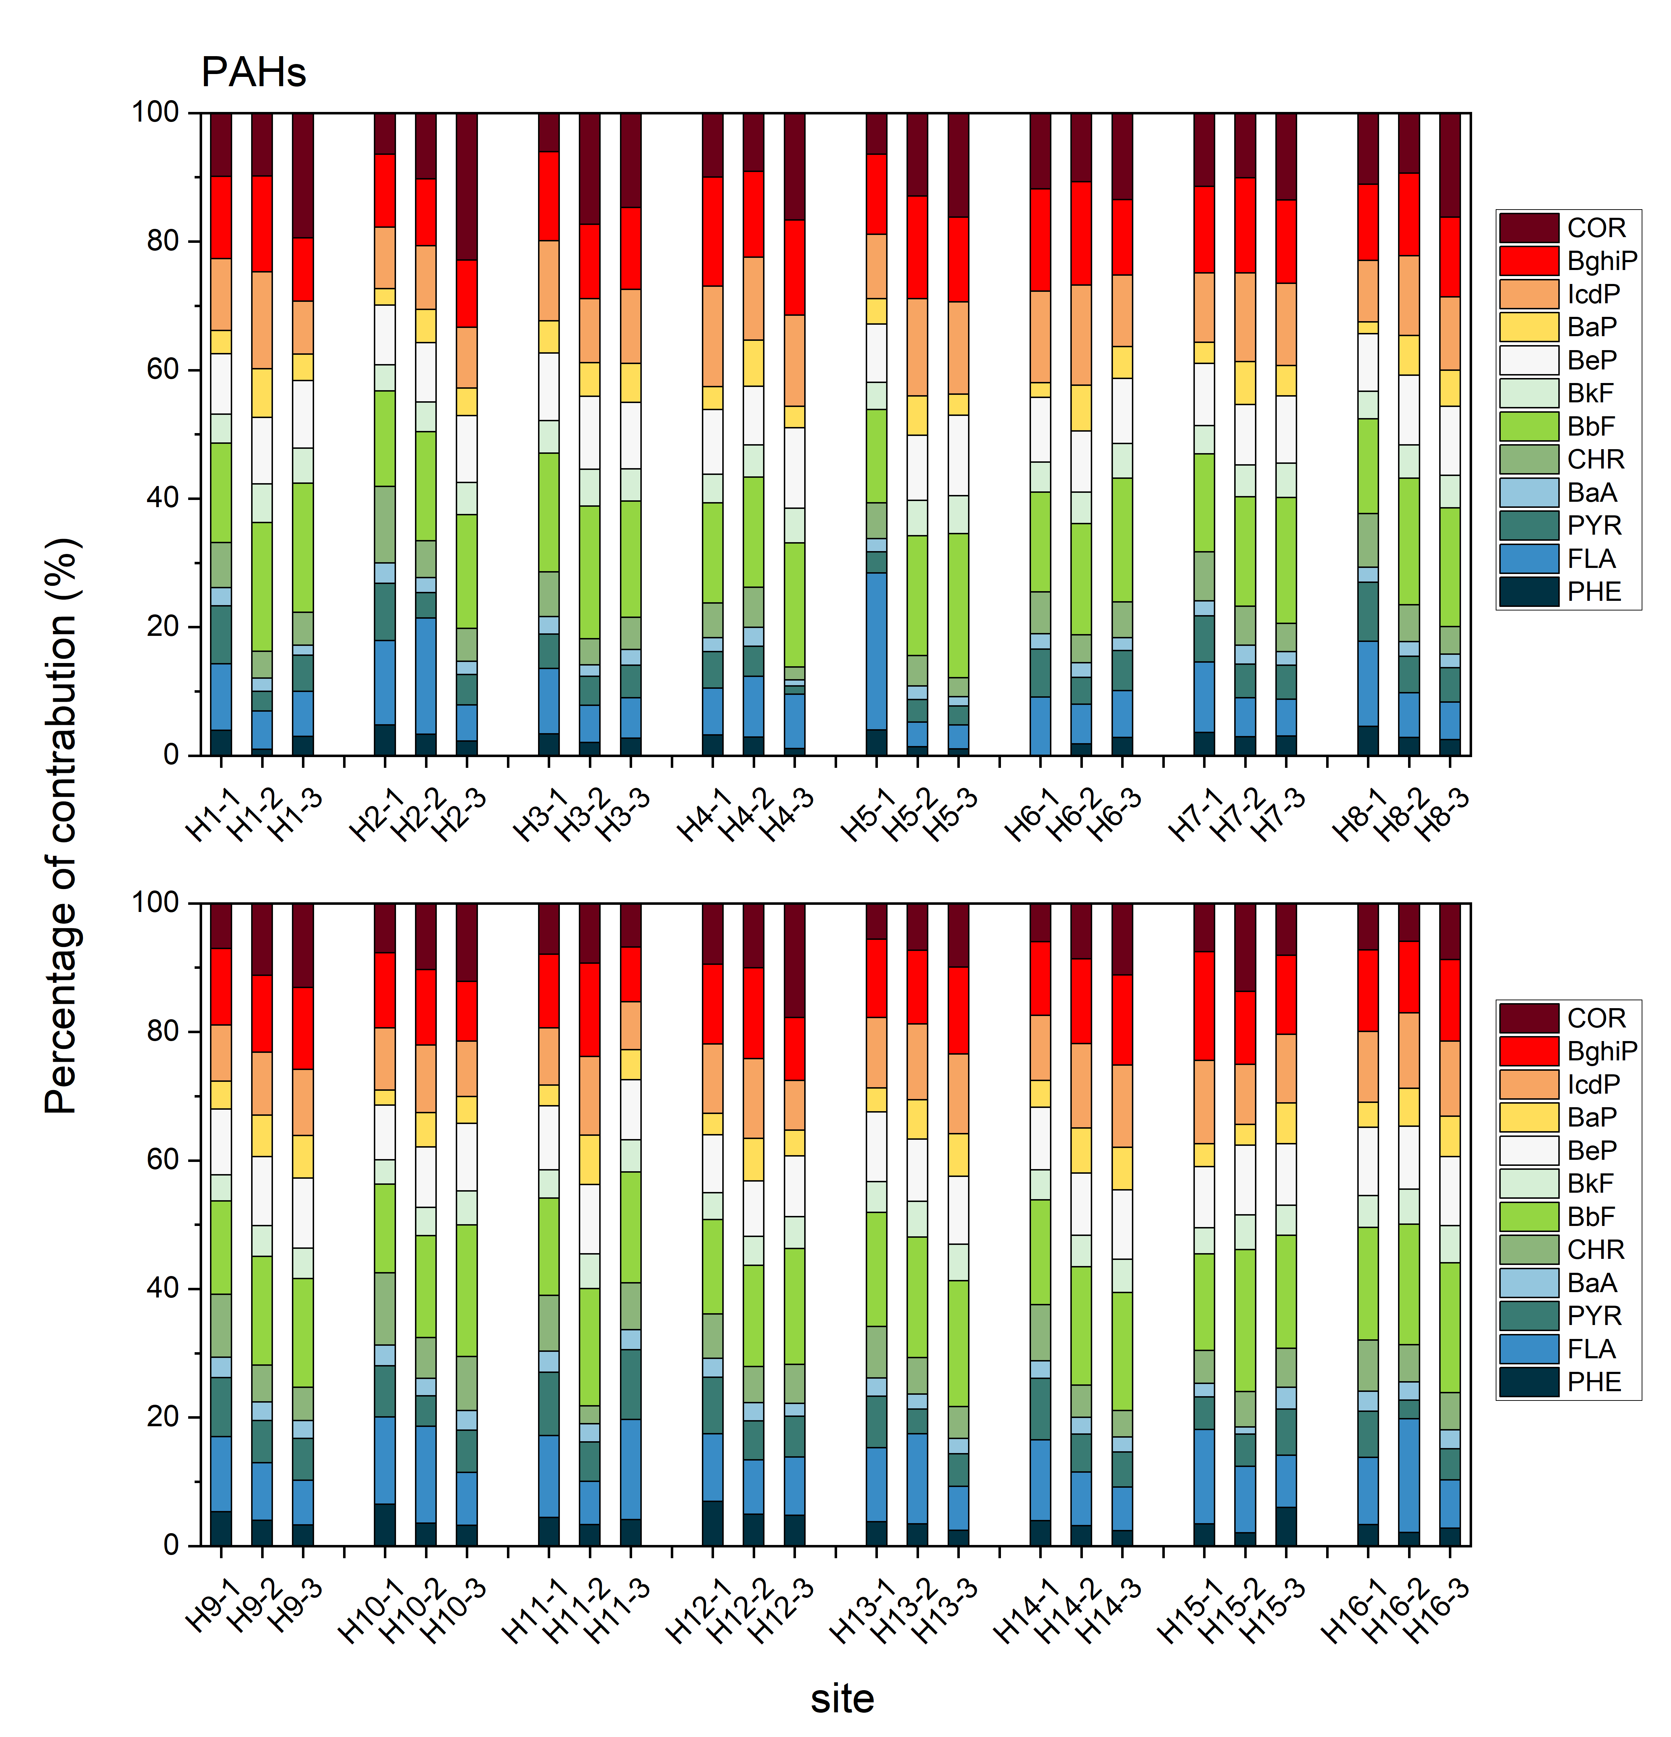
Fig. S6-1 The daily composition profiles of PAHs in HNPB

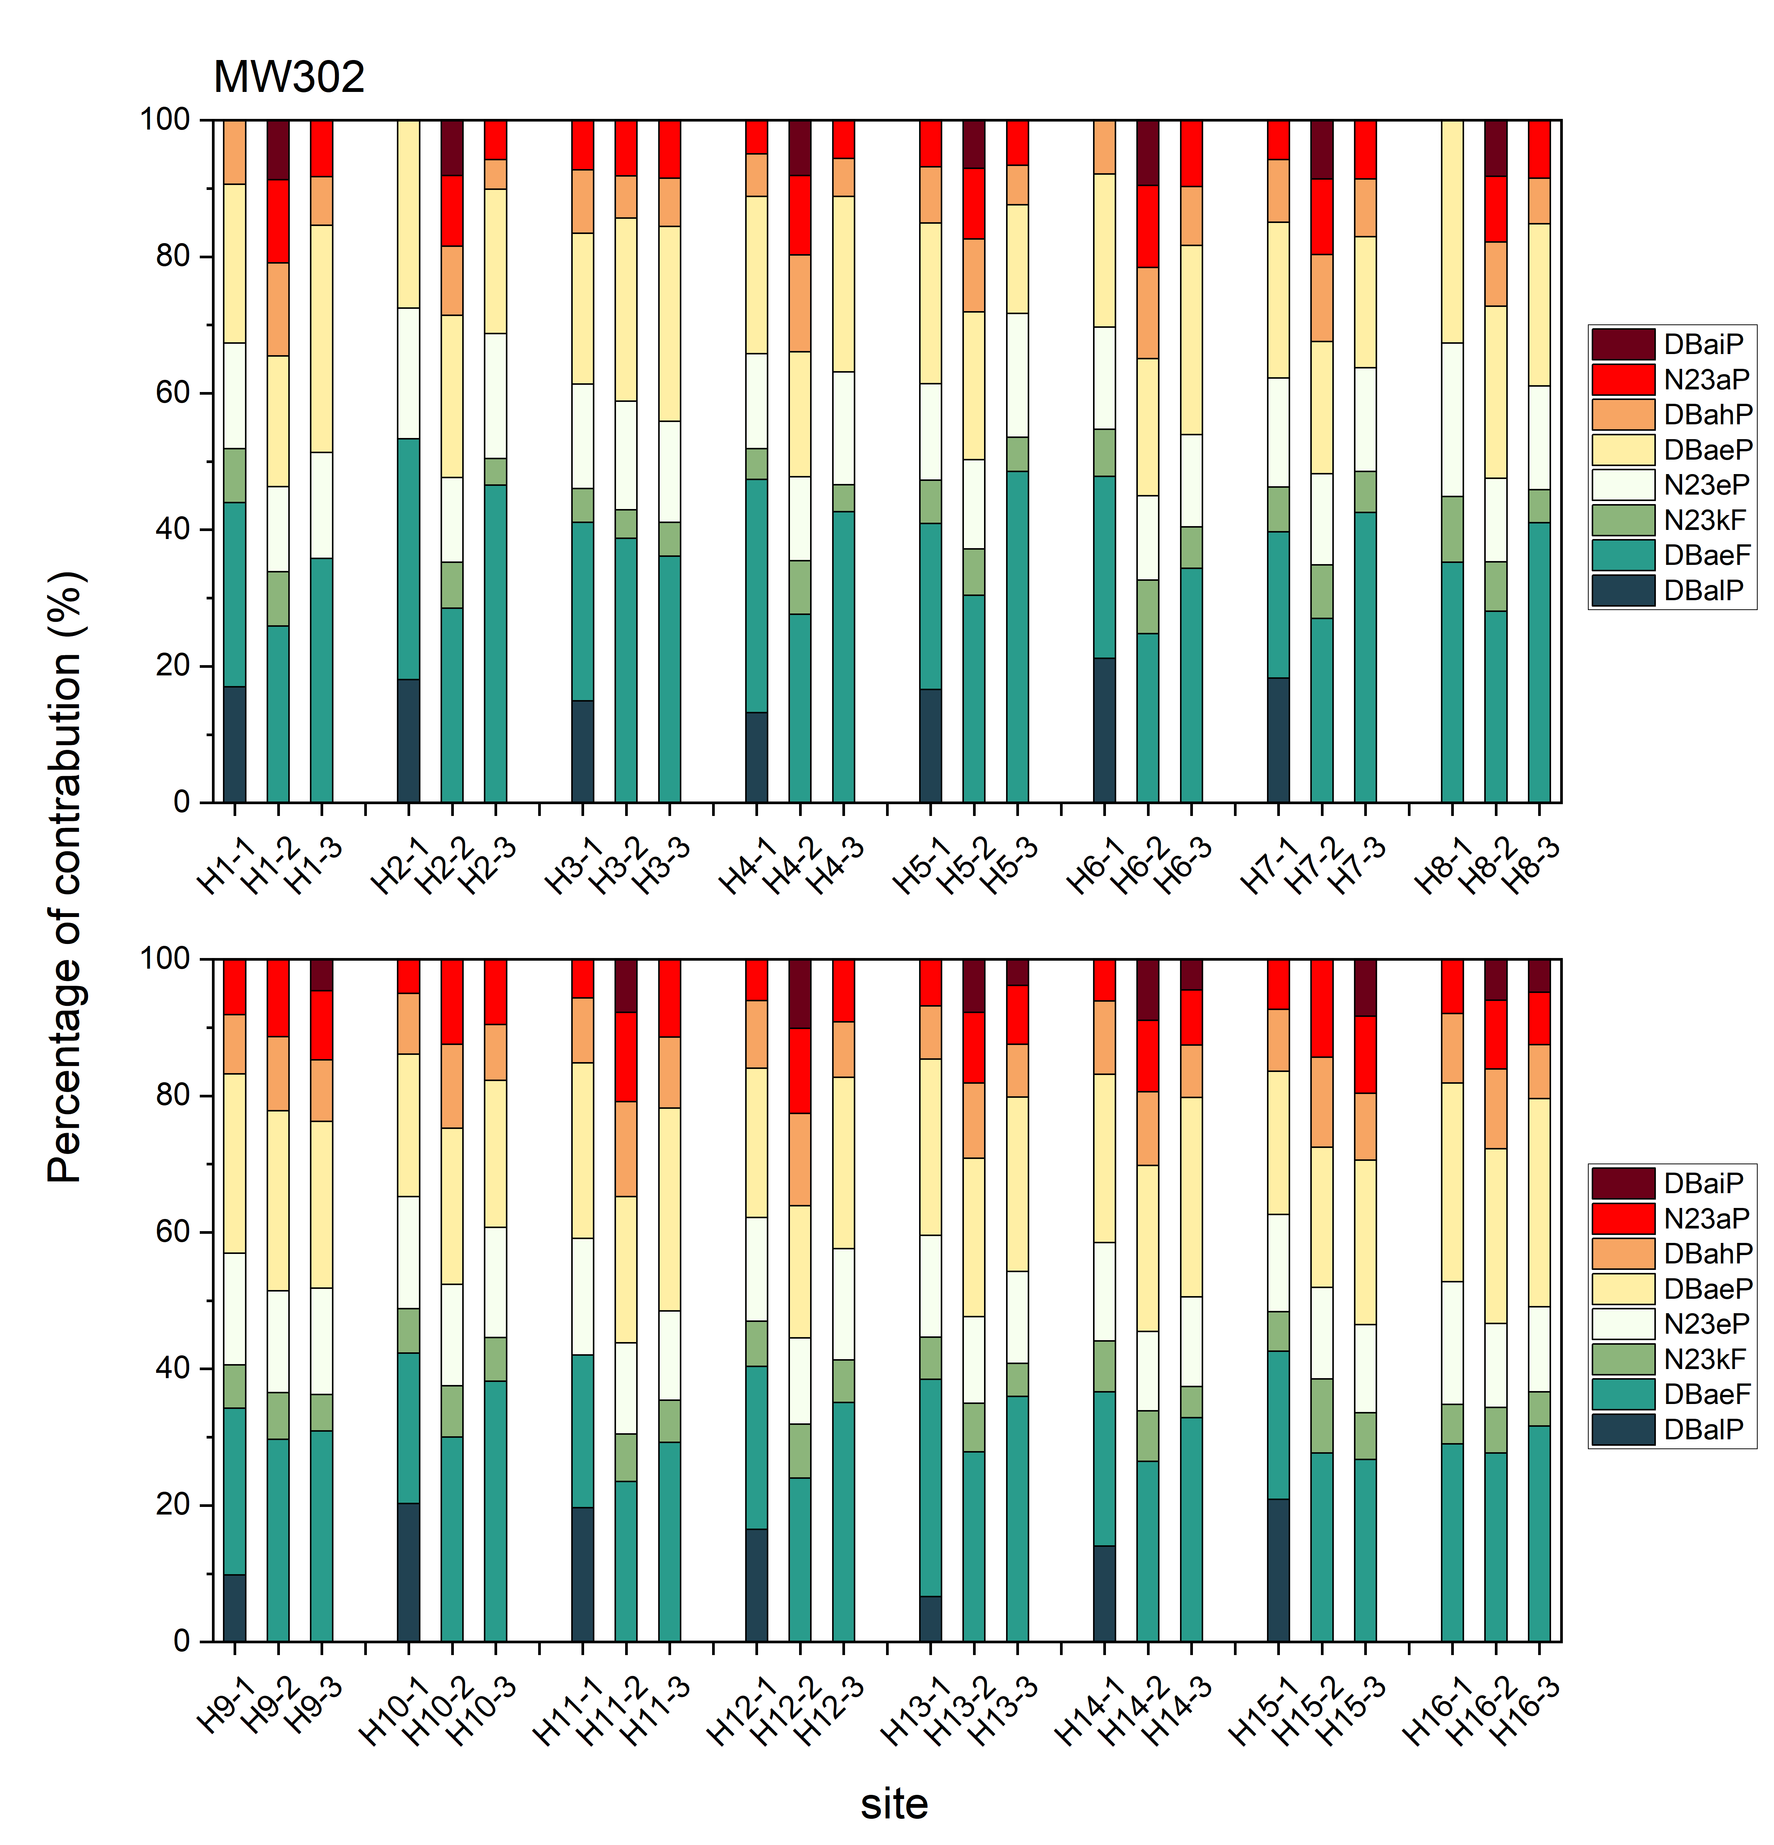
Fig. S6-2 The daily composition profiles of MW302 PAHs in HNPB

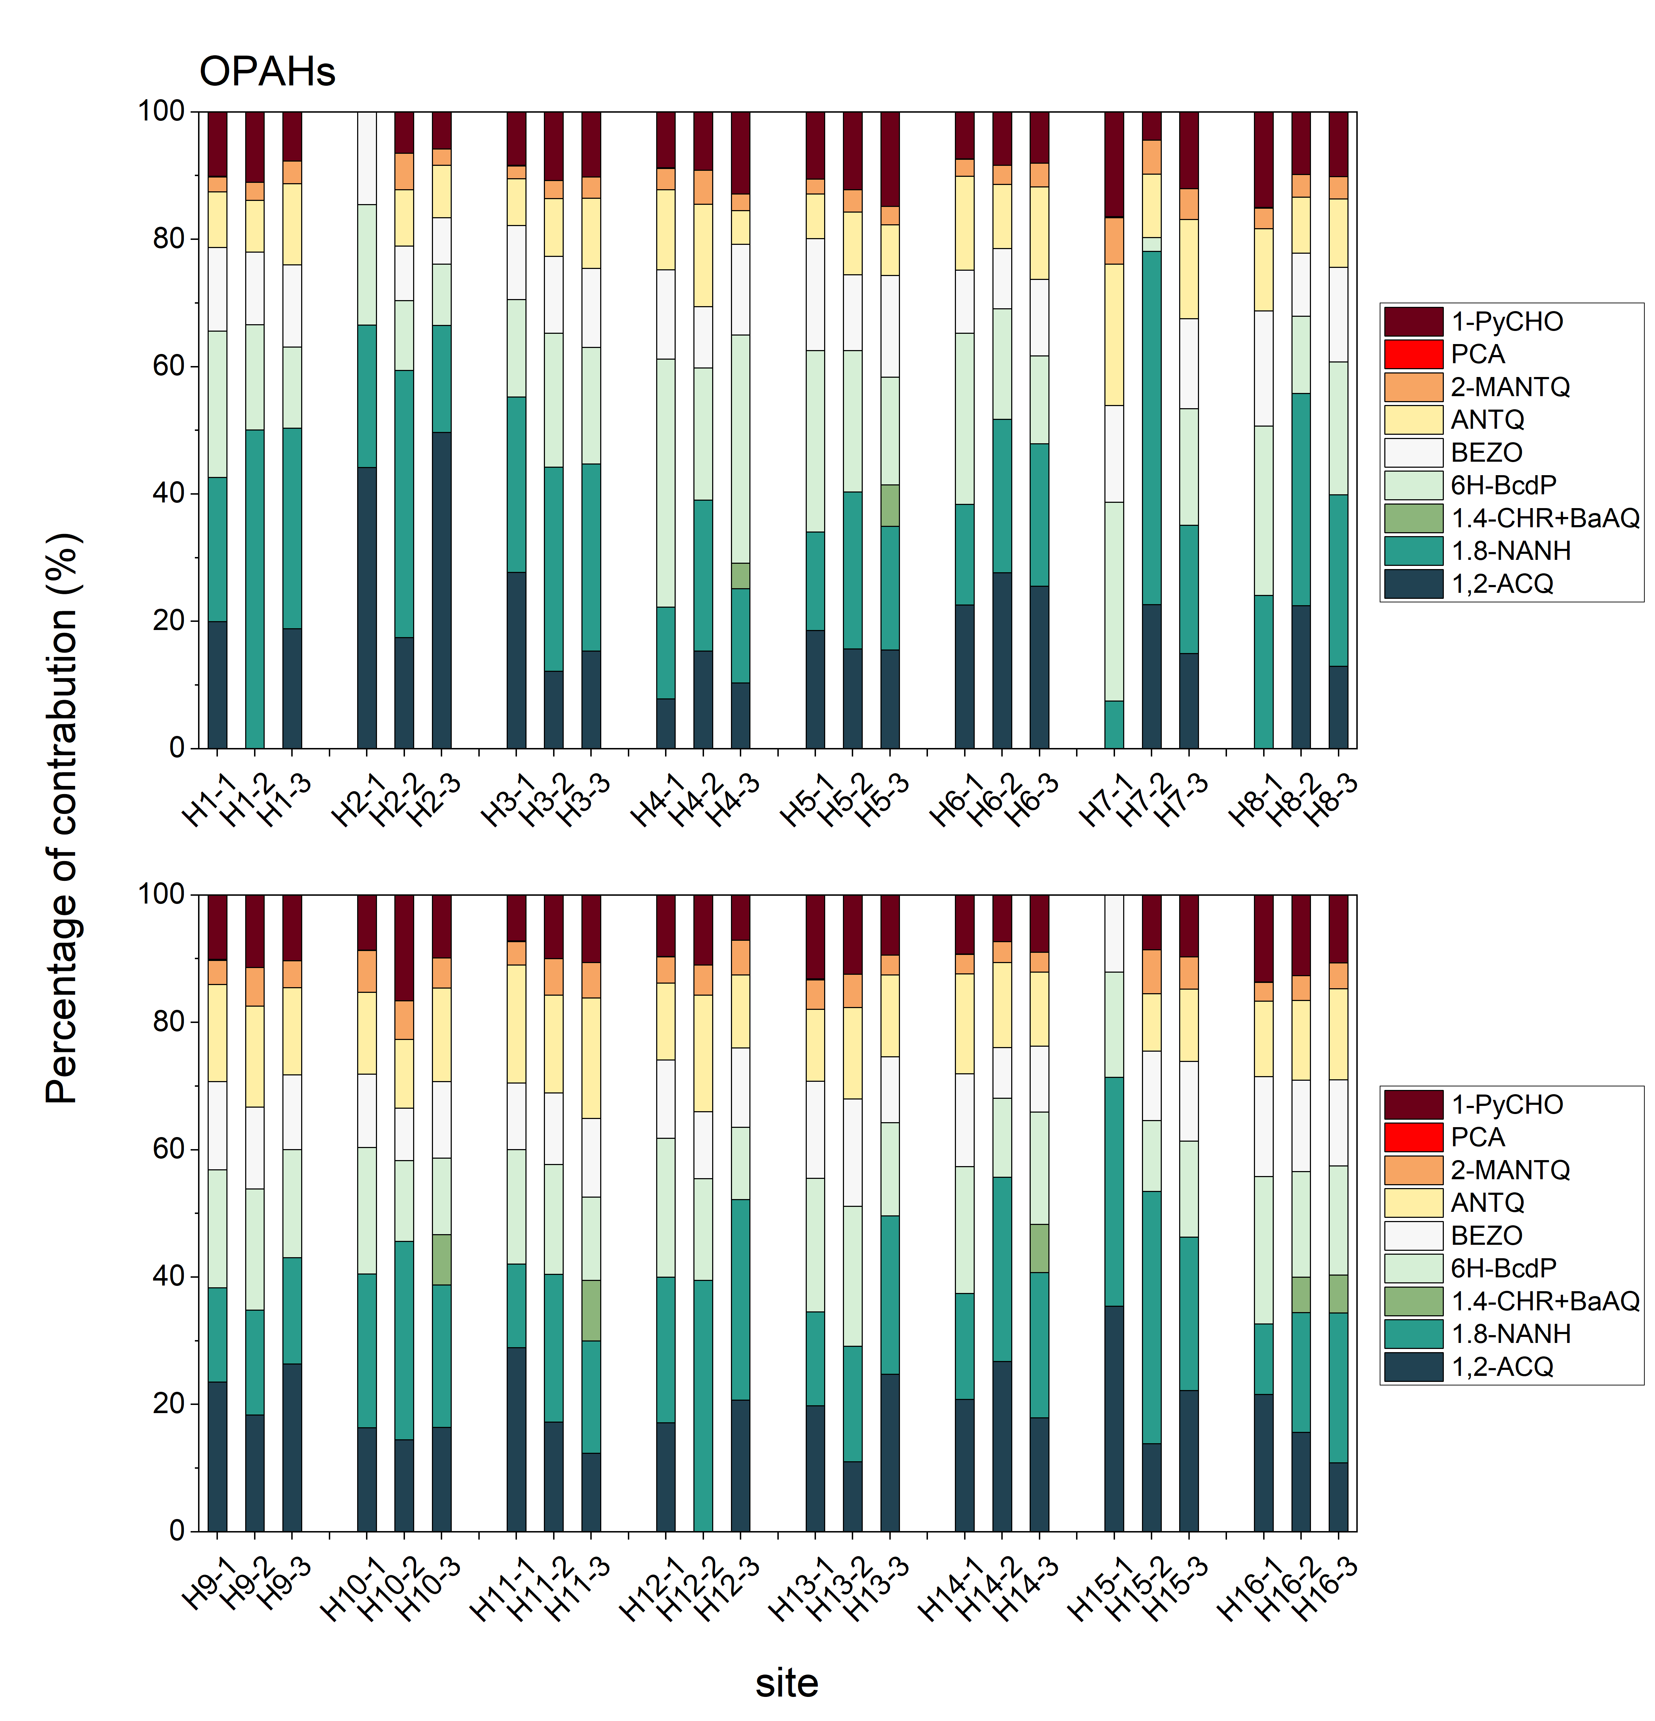
Fig. S6-3 The daily composition profiles of OPAHs in HNPB
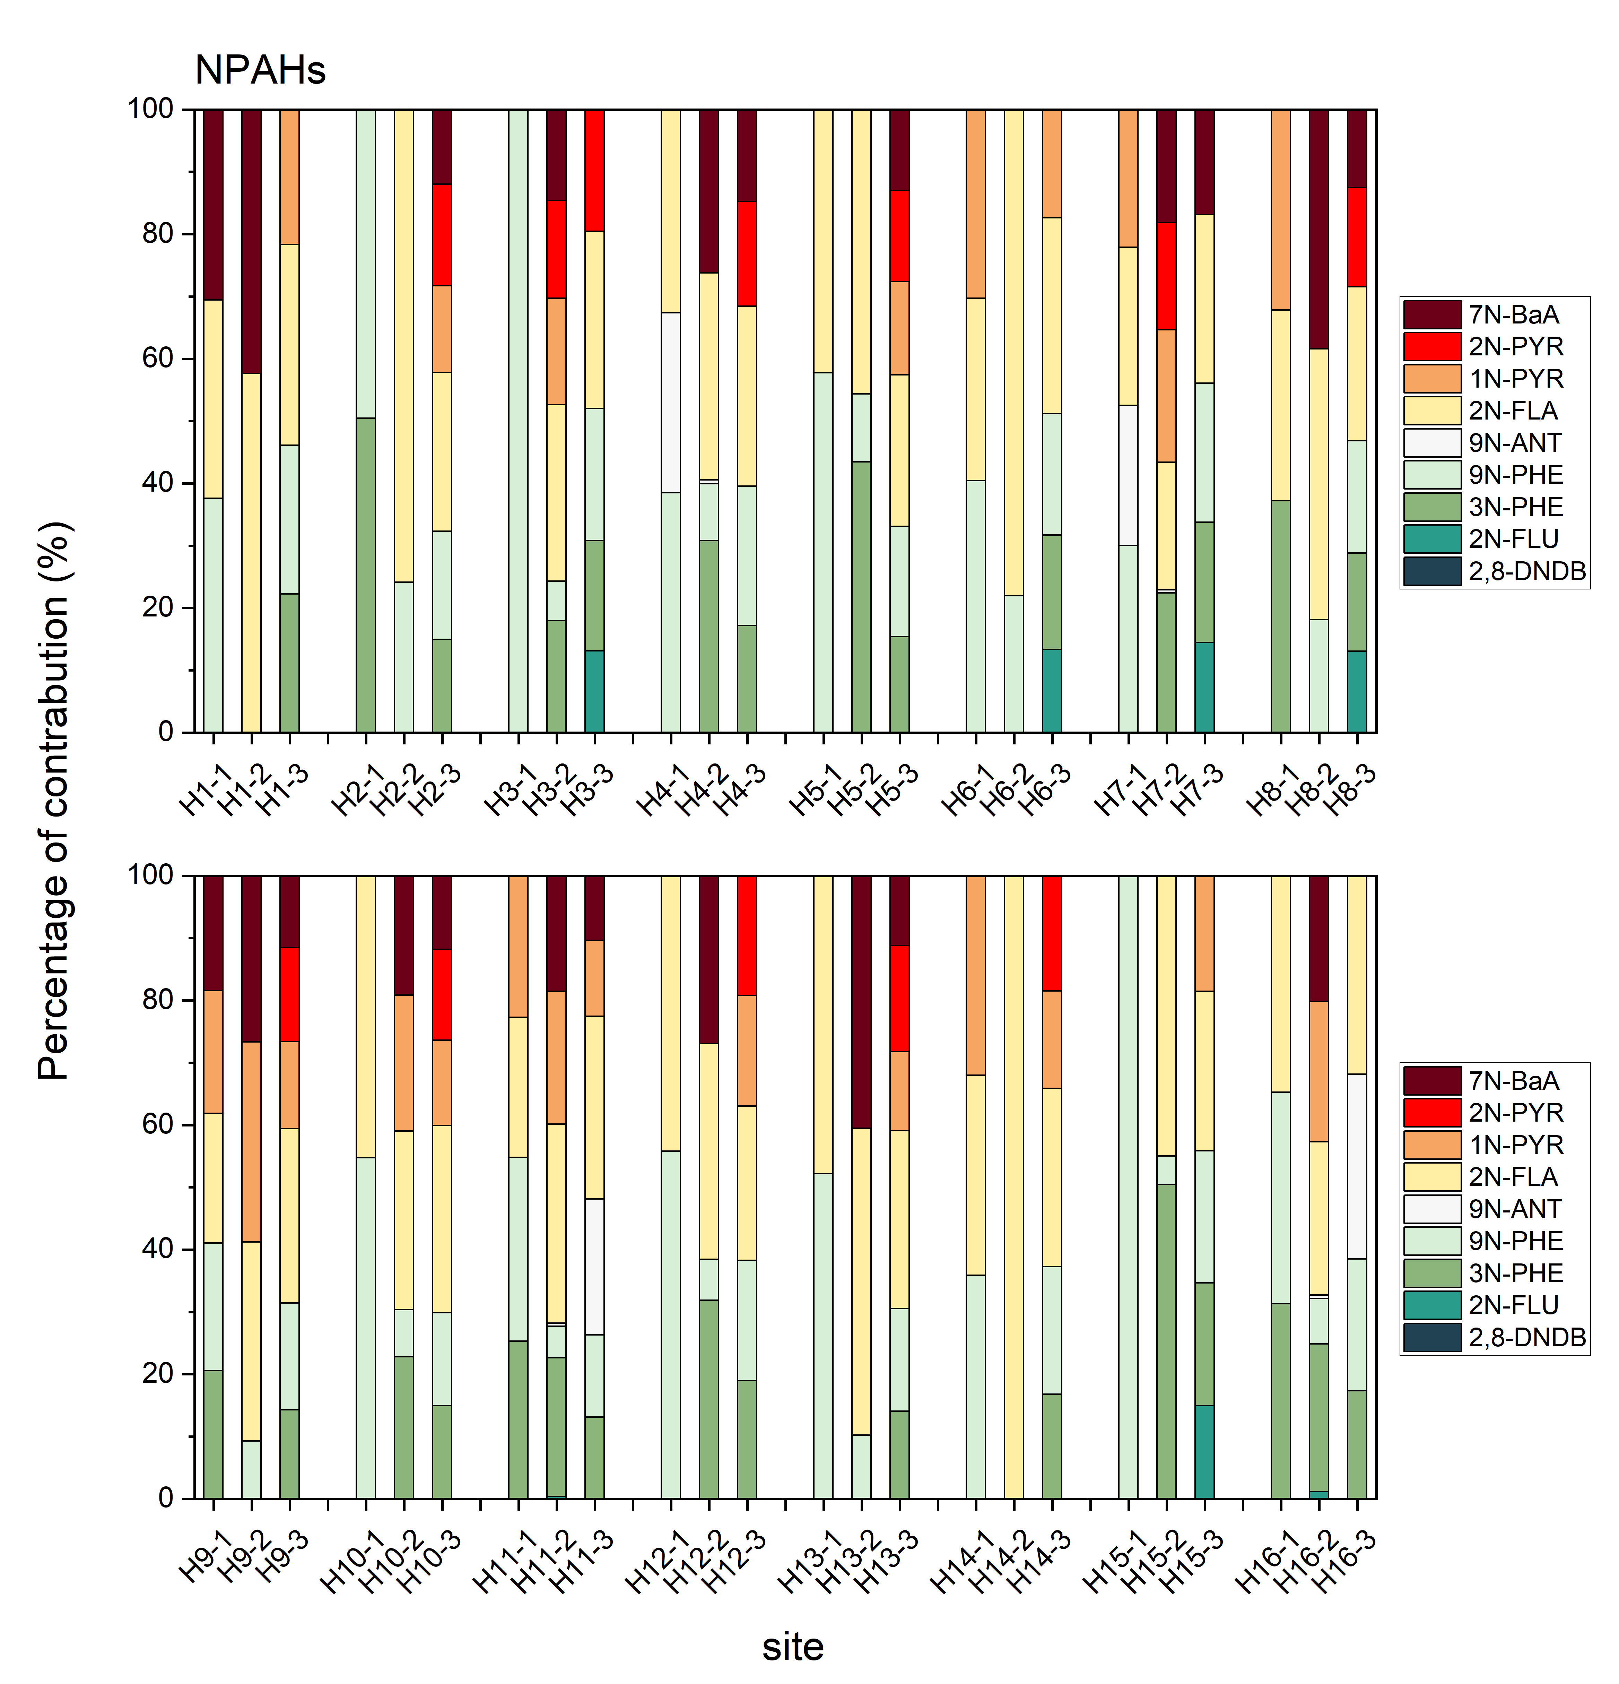
Fig. S6-4 The daily composition profiles of NPAHs in HNPB
Fig. S7 Incremental lifetime cancer risks (ILCRs) induced by PACs via inhalation for humans in GDPB region

Fig. S8 Incremental lifetime cancer risks (ILCRs) induced by PACs via inhalation for humans in GDPB region

Reference：
Chang Yi, Hu Junchao, Chen Huanbing, Huang Yining, Zhang Shenghua, Jialiang F (2017) Concentration, composition and seasonal variation of the high-molecular-weight PAHs in PM2.5 in Shanghai. Ecology and Environmental Sciences 26: 1180-1185
Chen SJ, Wang J, Wang T, Wang T, Mai BX, Simonich SLM (2016) Seasonal variations and source apportionment of complex polycyclic aromatic hydrocarbon mixtures in particulate matter in an electronic waste and urban area in South China. Sci Total Environ 573: 115-122
Christoffer Bergvall, Rholm. R (2007) Identification and Determination of Highly Carcinogenic Dibenzopyrene Isomers in Air Particulate Samples from a Street Canyon, a Rooftop, and a Subway Station in Stockholm. Environ Sci Technol 41: 731-737
Ei zein A, Dunmore RE, Ward MW, Hamilton JF, Lewis AC (2019) Variability of polycyclic aromatic hydrocarbons and their oxidative derivatives in wintertime Beijing, China. Atmos Chem Phys 19: 8741–8758
Jiang P, Yang L, Chen X, Gao Y, Li Y, Zhang J, Zhao T, Yu H, Wang W (2018) Impact of Dust Storms on NPAHs and OPAHs in PM2.5 in Jinan, China, in Spring 2016: Concentrations, Health Risks, and Sources. Aerosol Air Qual Res 18: 471-484
Long WS, Ming L, Bo H, hui BX, Ging SG, Mo FJ (2011) Polycyclic aromatic hydrocarbons with molecular weight 302 in PM 2.5 at two industrial sites in South China. J Environ Monitor 13: 2568-2574
Ma L, Li B, Liu Y, Sun X, Fu D, Sun S, Thapa S, Geng J, Qi H, Zhang A, Tian C (2020) Characterization, sources and risk assessment of PM2.5-bound polycyclic aromatic hydrocarbons (PAHs) and nitrated PAHs (NPAHs) in Harbin, a cold city in Northern China. Journal of Cleaner Production 264:
Ma WL, Zhu FJ, Liu LY, Jia HL, Yang M, Li YF (2019) PAHs in Chinese atmosphere: Gas/particle partitioning. Sci Total Environ 693: 133623
Menichini E, Merli F (2012) Dibenzopyrenes, other PAHs with molecular weight 302, and selected carcinogenic PAHs seldom determined: identification and one-year quantification in urban air. Int J Environ An Ch 92: 1609-1625
Niu X, Ho SSH, Ho KF, Huang Y, Sun J, Wang Q, Zhou Y, Zhao Z, Cao J (2017) Atmospheric levels and cytotoxicity of polycyclic aromatic hydrocarbons and oxygenated-PAHs in PM2.5 in the Beijing-Tianjin-Hebei region. Environ Pollut 231: 1075-1084
Ren Y, Zhou B, Tao J, Cao J, Zhang Z, Wu C, Wang J, Li J, Zhang L, Han Y, Liu L, Cao C, Wang G (2017) Composition and size distribution of airborne particulate PAHs and oxygenated PAHs in two Chinese megacities. Atmos Res 183: 322-330
Wang W, Jariyasopit N, Schrlau J, Jia Y, Tao S, Yu TW, Dashwood RH, Zhang W, Wang X, Simonich SL (2011a) Concentration and photochemistry of PAHs, NPAHs, and OPAHs and toxicity of PM2.5 during the Beijing Olympic Games. Environ Sci Technol 45: 6887-6895
Wang WT, Jariyasopit N, Schrlau J, Jia YL, Tao S, Yu TW, Dashwood RH, Zhang W, Wang XJ, Simonich SLM (2011b) Concentration and photochemistry of PAHs, NPAHs, and OPAHs and toxicity of PM2.5 during the Beijing Olympic Games. Environmental science & technology, 45: 6887-6895
Yan ZH, Ran WQ, Gulihumaer A, Nan HS, Tong JY, Lin XL (2019) Atmospheric PAHs levels and health risk assessment in summer in Changchun. Journal of Changchun Normal University 38: 179-183
Yang L, Zhang L, Chen L, Han C, Akutagawa T, Endo O, Yamauchi M, Neroda A, Toriba A, Tang N (2021a) Polycyclic aromatic hydrocarbons and nitro-polycyclic aromatic hydrocarbons in five East Asian cities: Seasonal characteristics, health risks, and yearly variations. Environ Pollut 287: 117360
Yang L, Zhang X, Xing W, Zhou Q, Zhang L, Wu Q, Zhou Z, Chen R, Toriba A, Hayakawa K, Tang N (2021b) Yearly variation in characteristics and health risk of polycyclic aromatic hydrocarbons and nitro-PAHs in urban shanghai from 2010-2018. J Environ Sci (China) 99: 72-79
Yin FY, Zhe WH, Hua WX, Yang YN, Bing L, Si W (2021) Pollution characteristics and risk assessment of nitro polycyclic aromatic hydrocarbons in PM_{2.5} of Nanjing, China. Environmental Science 42: 2626-2633
Zhang H, Yang L, Zhang X, Xing W, Wang Y, Bai P, Zhang L, Li Y, Hayakawa K, Toriba A, Tang N (2021) Characteristics and Health Risks of Polycyclic Aromatic Hydrocarbons and Nitro-PAHs in Xinxiang, China in 2015 and 2017. Int J Environ Res Public Health 18:
Zhang Y, Li R, Fang J, Wang C, Cai Z (2018) Simultaneous determination of eighteen nitro-polyaromatic hydrocarbons in PM2.5 by atmospheric pressure gas chromatography-tandem mass spectrometry. Chemosphere 198: 303-310
Zhao J, Zhang J, Sun L, Liu Y, Lin Y, Li Y, Wang T, Mao H (2018) Characterization of PM2.5-bound nitrated and oxygenated polycyclic aromatic hydrocarbons in ambient air of Langfang during periods with and without traffic restriction. Atmos Res 213: 302-308
Zhe D, Nan J, Jia W, Pin LL, Meng GM, Qin ZR (2020) Pollution characterization and health risk assessment of PM_{2.5}-bound PAHs in ambient air in Zhengzhou. Journal of Zhengzhou University 52: 108-113

