Mechanism Based Designing, Synthesis and Evaluation of Nitrogen and Non-nitrogen Derivatives of Biphosphonates as Anti-inflammatory Agents

SUPPLIMNETARY INFORMATION

LIST OF SUPPLIMENTARY FIGURES:

Figure- SI-1: Compound-2 docked in 3NT1
Figure- SI-2: Compound-3 docked in 3NT1
Figure- SI-3: Compound-4 docked in 3NT1
Figure- SI-4: Compound-8 docked in 3NT1
Figure- SI-5: Compound-9 docked in 3NT1
Figure- SI-6: Compound-10 docked in 3NT1
Figure- SI-7: Standard Zolidronate docked in 2E91
Figure-SI-8: Compound 1 docked in 2E94
Figure-SI-9: Compound-10 docked in 2E94
Figure- SI-10: Mass spectra of Compound-9
Figure- SI-11: NMR spectra of Compound-9
Figure- SI-12: Mass spectra of Compound-11
Figure- SI-13: NMR spectra of Compound-11

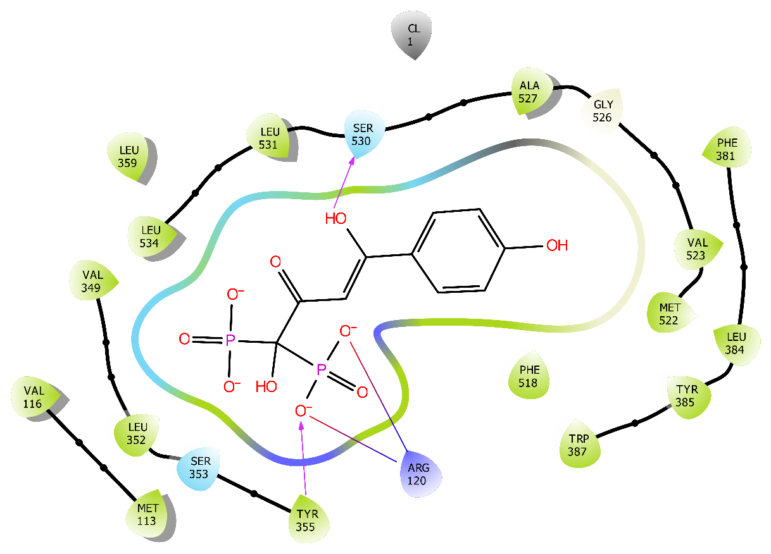
Figure- SI-1: The 2D image of Compound-2 docked in 3NT1 was constructed using the Maestro module in Schrodinger’s molecular modeling suite. Hydroxyl group of enols and one of O-atom of Biphosphate shows hydrogen bond with Ser 530 and Tyr 355 respectively.

Figure- SI-2: The 2D and 3D image of Compound-3 docked in 3NT1 was constructed using the Maestro module in Schrodinger’s molecular modeling suite. A hydrogen bond was observed Between Tyr 355 and Arg 120 with Biphosphate moiety in the purple line.

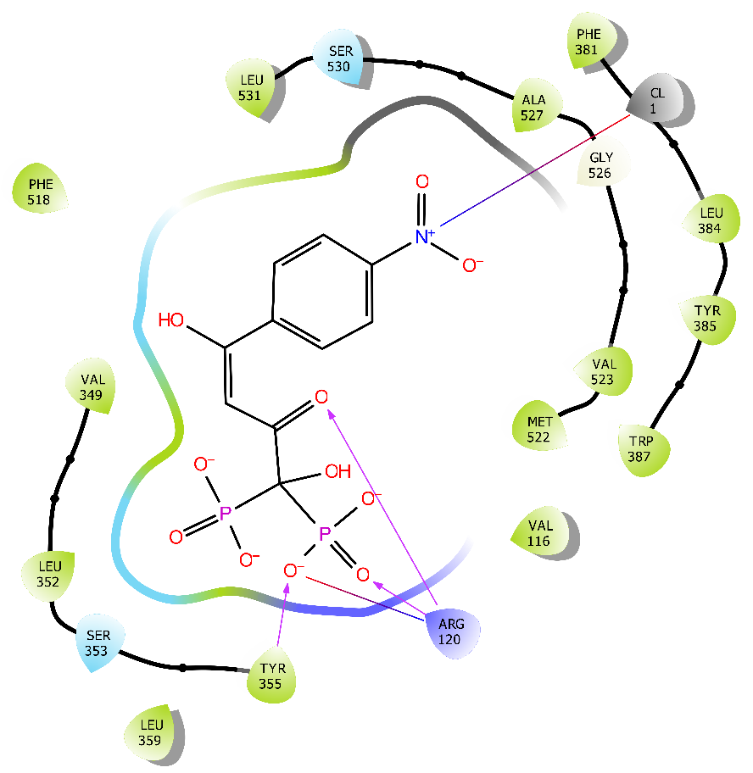
Figure-SI-3: The 2D image of Compound-4 docked in 3NT1 was constructed using the Maestro module in Schrodinger’s molecular modeling suite.The NO₂ group forms a salt bridge with the chlorine ion was observed by multiple colorlines and Tyr 355 and Arg 120 develop hydrogen bonds with the different oxygens in the Biphosphate group.

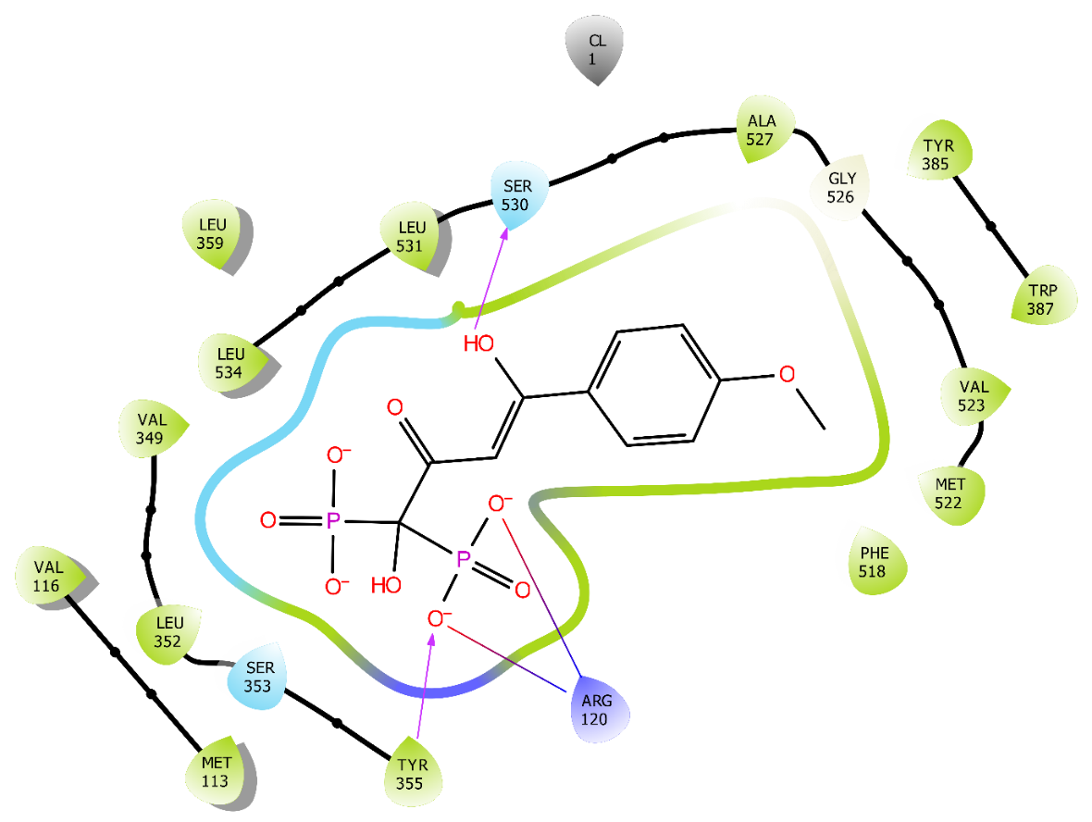
Figure-SI-4: The 2D image of Compound-8 docked in 3NT1 was constructed using the Maestro module in Schrodinger’s molecular modeling suite. Hydroxyl group of enol and one of O-atom of Biphosphate shows hydrogen bond in purple color line with Ser 530 and Tyr 355 respectively.

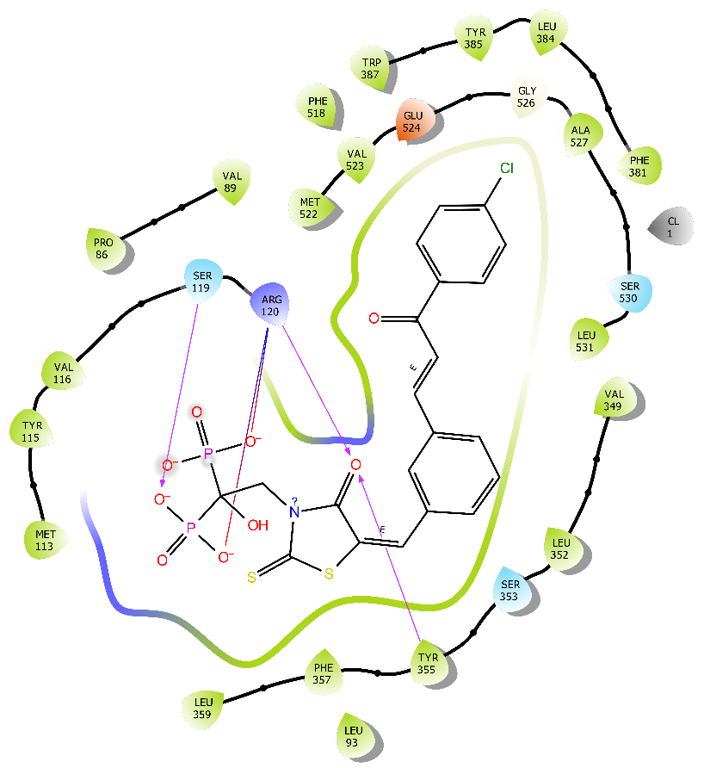
Figure- SI-5: The 2D image of Compound-9 docked in 3NT1 was constructed using the Maestro module in Schrodinger’s molecular modeling suite. Arg 120 and Tyr 355 form hydrogen bonds with the O-atom on the Rhodanine group represented in the purple color line, and Ser 119 develops a hydrogen bond with the O-atom on the Phosphate group.

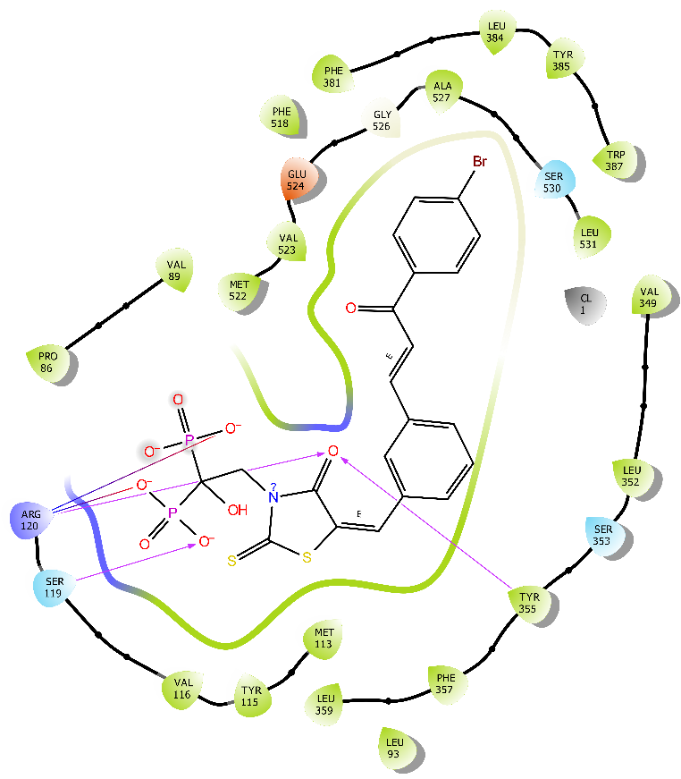
Figure- SI-6: The 2D image of Compound-10 docked in 3NT1 was constructed using the Maestro module in Schrodinger’s molecular modeling suite. Tyr 355 and Arg 120 show very interactive hydrogen bonding with Rhodanine's O-atom, while Ser 119 shows hydrogen bonding with the phosphate group.

Figure- SI-7: The 2D and 3D image of Standard Zolidronate docked in 2E91 was constructed using the Maestro module in Schrodinger’s molecular modeling suite. Thr 175 forms hydrogen bonds shown in purple colour line with the Nitrogen of the Imidazole ring, increasing the zoledronate's distinctive feature, and Gln 211, Arg 89, and Tyr 210 form hydrogen bonds with the Biphosphate group represented by purple colour line. Distance of C of P-C-P linkage and Free Nitrogen was 2.60 Å, and Free carbon and N distance was 1.55 Å.

Figure-SI-8: The 3D image of Compound-1 docked in 2E94 was constructed using the Maestro module in Schrodinger’s molecular modeling suite. On the Biphosphate moiety, all hydrogen and salt bridge interactions were observed. Magnesium ion shows Metal co-ordinate bond and salt bridge with O-atom in pink color dotted line, Lys 28, Lys 174, and Arg 89 show salt bridge in multiple colors dotted line.

Figure-SI-9: The 3D image of Compound-10 docked in 2E94 was constructed using the Maestro module in Schrodinger’s molecular modeling suite.Arg 44 establishes a hydrogen interaction with the enol's O-atom. Asp 214 and one of the O-atoms in the biphosphate group form a hydrogen bond with H₂O. With the O-atom of the biphosphate moiety, Gln 211 and Lys 238 display hydrogen bonding, Lys 174 and Lys 238 show the salt bridge, and Magnesium metal exhibits metal co-ordinate bond and salt bridge.

Figure- SI-10: Mass spectra of Compound-9

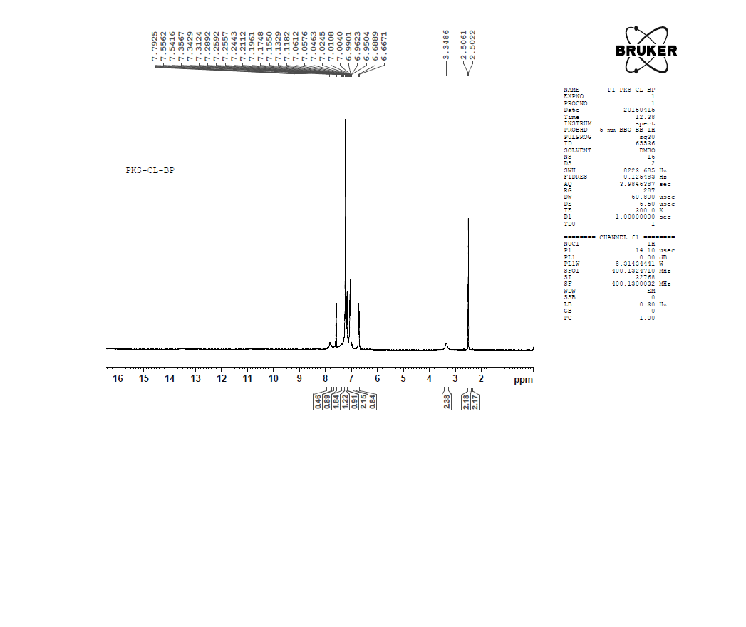
Figure- SI-11: NMR spectra of Compound-9

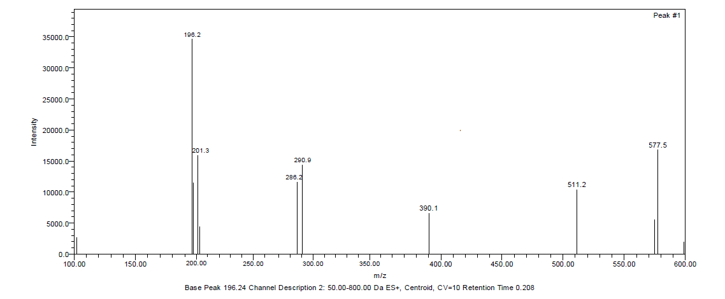
Figure- SI-12: Mass spectra of Compound-11

Figure- SI-13: NMR spectra of Compound-11

