The red part is the original data
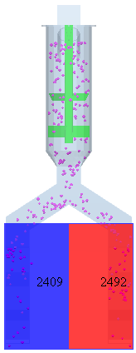 | 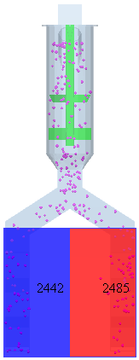 | 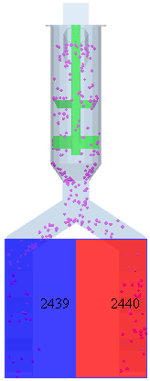 | 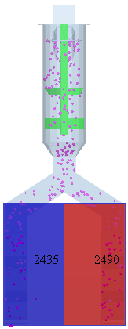 | 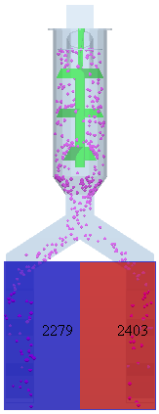
（a）A=100  r/min | （b）A=200 r/min | （c）A=300 r/min | （d）A=400 r/min | （e）A=500  r/min
Figure 5. Detection effect of stirring structure
Q1:
Answer: In this simulation, each speed is done three times, presenting the most ideal group in the table. The original data of the left and right fertilizer tubes are
- A=100r/min：2387,2450; 2397,2488; 2409,2492
- A=200r/min：2442,2485; 2441,2501; 2443,2489
- A=300r/min: 2439,2440; 2433,2444; 2441,2459
- A=400r/min: 2435,2490; 2421,2497; 2437,2524
- A=500r/min: 2279,2403; 2173,2411; 2377,2487

Q2:
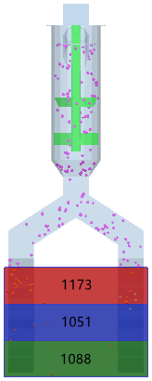 | 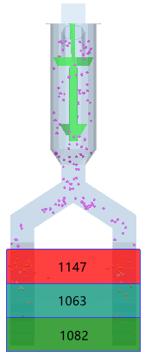 | 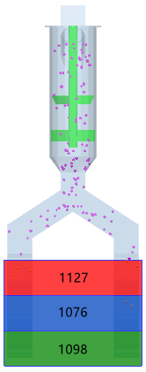 | 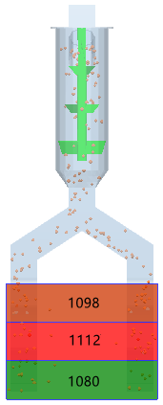
（a）B=140° | （b）B=150° | （c）B=160° | （d）B=170°
Figure 7. Fertilization amount at different bending angles
Answer: Because the optimum stirring speed obtained by the single factor test of stirring speed is 300 r/min, the stirring speed is 300 r/min. The number of tests is not limited. The original data of the upper and lower layers of the fertilization tube are as follows.
- B=140°：1173,1051,1088; 1153,997,1001;1187,1027,1097; 1056,1032,1103
- B=150°：1149,1057,1077; 1147,1063,1082; 1137,1068,1055
- B=160°：1127,1076,1098; 1033,1097,1079;
- B=170°：1098,1112,1080; 1076,1099,1127; 1097,1127,1073

Q3:

Table 5 Test plan and results
Numbering | Stirring speed A / (r/min) | Folding angle  B / (°) | Operating speed C / (km/h) | Upper fertilizer output  M₁ / kg | Middle fertilizer amount  M₂ / kg
1 | 400.00 | 170.00 | 3.00 | 180 | 179
2 | 200.00 | 170.00 | 3.00 | 188 | 184
3 | 400.00 | 160.00 | 3.00 | 183 | 190
4 | 200.00 | 160.00 | 3.00 | 240 | 232
5 | 400.00 | 165.00 | 2.00 | 193 | 210
6 | 200.00 | 165.00 | 2.00 | 213 | 211
7 | 400.00 | 165.00 | 4.00 | 187 | 184
8 | 200.00 | 165.00 | 4.00 | 214 | 218
9 | 300.00 | 170.00 | 2.00 | 207 | 203
10 | 300.00 | 160.00 | 2.00 | 240 | 234
11 | 300.00 | 170.00 | 4.00 | 189 | 193
12 | 300.00 | 160.00 | 4.00 | 230 | 237
13 | 300.00 | 165.00 | 3.00 | 203 | 199
14 | 300.00 | 165.00 | 3.00 | 197 | 202
15 | 300.00 | 165.00 | 3.00 | 213 | 215
16 | 300.00 | 165.00 | 3.00 | 205 | 201
17 | 300.00 | 165.00 | 3.00 | 198 | 193
Answer：In the simulation model, the corresponding influencing factors are used for simulation test and stirring speed, bending angle and working speed. In the post-processing of the simulation software, the counter is used to count the amount of fertilizer in the upper and middle layers. The test is repeated three times, and the best one is taken for test analysis. The original data of the three tests are :
Upper fertilizer output  M₁ / kg | Middle fertilizer amount  M₂ / kg
197; 175; 180 | 187, 193, 179
170, 189, 188 | 179, 180, 184
183, 189, 193 | 190, 199, 197
240, 210, 224 | 212, 210, 232
187, 179, 193 | 197, 213, 210
223, 213, 203 | 197, 211, 199
199, 187, 174 | 176, 180, 184
207, 214, 203 | 218, 200, 197
207, 209, 211 | 191, 203, 220
212, 214, 240 | 234, 221, 201
189, 199, 176 | 220, 193, 221
221, 209, 230 | 237, 201, 199
190, 214, 203 | 199, 179, 211
210, 197, 191 | 200, 202, 183
213, 200, 197 | 215, 230, 180
210, 205, 193 | 230, 201, 202
198, 187, 210 | 193, 230, 220

Q4: Raw data of fertilization location measurement results
Serial No. | Upper layer Fertilizer  /mm | Middle layer Fertilizer  /mm | Deep of lower layer fertilizer  /mm
1 | 197.8 | 88.2 | 90.3
2 | 206.0 | 87.3 | 70.3
3 | 203.4 | 89.7 | 68.7
4 | 201.3 | 88.5 | 99.4
5 | 201.5 | 90.2 | 92.4
6 | 203.0 | 88.3 | 88.5
7 | 202.6 | 92.7 | 90.7
8  9  10  11  12 | 198.4  180.5  173.8  188.3 | 95.2  120.3  117.5 | 84.3  97.6  98.2  11.2  80.1
mean value | 196.05 | 95.79 | 80.98

Q5：Table 9 The interaction effect of different fertilization methods on the growth and yield traits of summer maize analysis of the original data
年度  Year | 处理  Treatment | 株高  Plant height（cm） | 干重  Dry matter accumulation（g/plant） | 茎粗  Stem diameter（cm） | 根系数量  number of roots  (piece) | 根系长度  root length  (mm) | 百粒重  100-grain weight  （g） | 产量  Yield（kg/hm2）
2021 | CF | 281.43 | 263.14 | 7.80 | 49.00 | 153.00 | 33.41 | 13215.13
 | UF | 283.14 | 282.57 | 7.80 | 55.29 | 184.57 | 35.74 | 14522.22
2022 | CF | 281.00 | 269.14 | 7.94 | 48.57 | 163.43 | 32.24 | 13239.50
 | UF | 282.14 | 295.29 | 7.89 | 55.71 | 197.43 | 36.29 | 15202.28
Year |  | ns | ** | ** | ns | ns | ns | **
Treatment |  | ns | ** | ns | ** | ** | ** | **
Year×Treatment |  | ns | ns | ns | ns | ns | ** | **

The corresponding original data

Year | Treatment | Plant height（cm） | Dry matter accumulation（g/plant） | Stem diameter（cm） | number of roots  (piece) | root length  (mm) | 100-grain weight  （g） | Yield（kg/hm2）
2021 | CF | 287.33  274.90  275.38  288.11 | 259.42  263.54  259.76  269.84 | 7.81  7.63  7.78  7.98 | 50.00  48.00  49.00 | 154.22  149.56  155.22 | 32.51  34.56  33.16 | 13275.87  13154.39
2021 | UF | 286.14  275.64  287.22  283.56 | 287.87  277.89  284.67  279.85 | 7.84  7.81  7.73  7.82 | 53.00  58.00  54.00 | 187.87  186.54  179.30 | 36.37  35.29  35.56 | 14514.38  14530.06
2022 | CF | 283.18  279.36  284.59  276.87 | 270.34  267.54  270.27  268.41 | 7.99  7.83  7.87  8.07 | 49.00  51.00  47.00 | 167.53  162.98  159.78 | 32.37  32.79  31.56 | 13225.43  13253.57
2022 | UF | 283.99  283.78  283.27  277.52 | 293.79  289.56  298.45  299.36 | 7.53  8.21  7.77  8.05 | 57.00  56.00  55.00 | 199.53  189.56  203.2 | 35.49  36.78  36.60 | 15236.41  15168.15

