An Image Based 3D Modelling Framework for Li-S Batteries
Xiaoyu Dai^{1,2#}, Nivedita Kulkarni^{1,2#}, James B. Robinson^{1,2}, Dan J. L. Brett^{1,2}, Paul R. Shearing^{1,2}, Rhodri Jervis^{1, 2}*
This document includes the analysis of representative elementary volume, effect of Sulfur dissolution on tortuosity and Lithium ion distribution, mathematical expression of electrochemical reactions considered in the discharge process, the partial differential equations used for modelling the mass and charge transfer, initial and boundaries conditions applying to the domains, and constant parameters used in the paper.
- Representative elementary volume
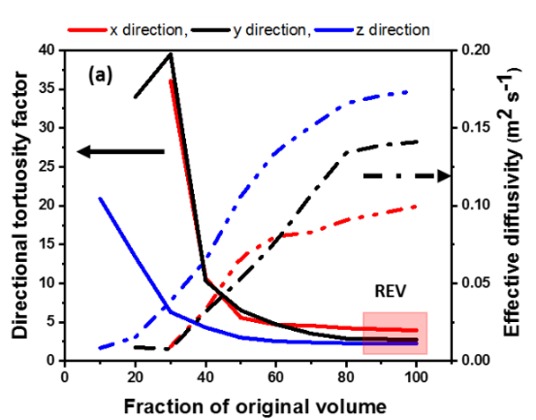
Figure S1 Representative elementary volume analysis performed in x, y and z directions using Tau factor.
The tortuosity factor describes resistance to the free flow due to convoluted paths present in the porous media. Figure S1 shows representative elementary volume (REV) analysis using the tortuosity factor obtained in orthogonal directions using the MATLAB application TauFactor [1], [2]. The results show that a REV could be obtained at 90% of total electrode volume, highlighting the extent of heterogeneity present in the electrode.
- Effect of sulfur dissolution on tortuosity and lithium ion distribution
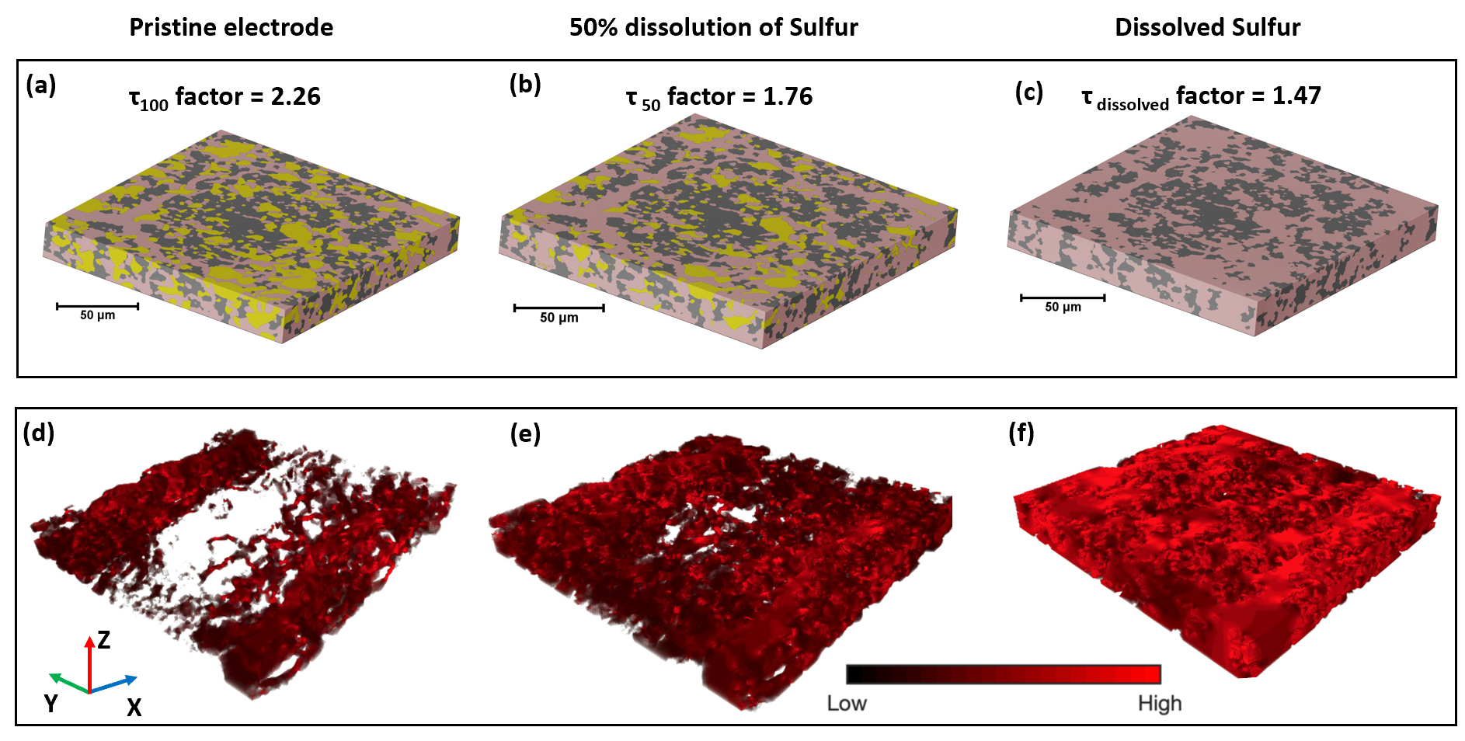
Figure S2 Effect of sulfur dissolution on the electrode microstructure. Top: effect of sulfur dissolution on tortuosity factor obtained at the pristine electrode with 100% sulfur loading (a), at 50% dissolution of sulfur (b) and 100% dissolution of elemental sulfur (c) in the electrolyte. Bottom: effect of the sulfur dissolution on Li+ ion flux obtained at the pristine electrode with 100% sulfur loading (d), at 50% dissolution of sulfur (e) and 100% dissolution of elemental sulfur (f) in the electrolyte. The results are obtained using MATLAB based code TauFactor [2]. Li+ concentration is shown in (d-f) as black-red (low to high), and areas of zero flux are transparent.
Tortuosity factor, when applied to the fluid phase represents the resistance to diffusive flow, and, when applied to the solid phase, represents the resistance to the electron transfer. The initial heterogeneous distribution of solid sulfur and electrolyte impacts the dissolution of sulfur in liquid electrolyte, altering the microstructure of the electrode. The effect of S8 dissolution on Li-ion flux is defined by Fick's law, which is a function of both the tortuosity and porosity of the electrode. In the current model, limitations on changing morphology mean that the dissolution process cannot be incorporated into the electrochemical model; however, as discussed later, approaches to account for dissolution (and precipitation of solid polysulfides) will be explored in future work.
We evaluate the effect of changing microstructure, due to sulfur dissolution (approximated by using an erosion technique on the S material voxels of the CT data) on the tortuosity of the electrode to highlight the effect of dynamic changes in microstructure in the early stages of the discharge cycle. Figure S2(a) shows the pristine electrode microstructure where all the sulfur present is in its elemental/solid form. When solid sulfur comes into contact with DOL:DME electrolyte, the sulfur dissolution process begins. This process is governed by the Nernst-Brunner equation [3], [4] and is a function of the particle size distribution and the interface area between sulfur and electrolyte. The dissolution of sulfur increases the pore volume, in turn affecting Li+ ion flux. To reveal the impact of sulfur dissolution on the microstructural properties, an erosion approach was applied to the sulfur phase to approximate the microstructure change during the discharging process. Figure S2(b) shows the electrode microstructure after 50% of the sulfur has dissolved. This microstructure is obtained by the erosion of S8 solid particles to the point at which 50% of S8 volume in the entire electrode remains. It can be seen that when 50% of the initial sulfur has been dissolved, the electrode tortuosity is lowered by ca. 22 %. During cell discharging, total dissolution of solid sulfur particles takes place [5], resulting in a two-phase microstructure; namely, the electrolyte saturated with dissolved sulfur and soluble polysulfides and CBD [Figure S2(c)]. This reduces the electrode tortuosity by ca. 35%, compared to the pristine electrode’s tortuosity factor. Figure S2(d-f) shows the evolution of total Li+ ion flux as a function of the dissolution of solid sulfur particles and hence the altered microstructure. However, it is important to note that Figure S2 depicts the effect of morphological changes on the Li+ ion flux and the potential accumulation/deposition of polysulfides are not considered in obtaining Li+ ion flux. Also, as shown by Tan et al., the dissolution of solid sulfur particles is complete by 30% depth of discharge (DoD) [5]. As shown by various researchers [5]–[7] the precipitation of solid polysulfides takes place after 80% DoD. Therefore, the effect of sulfur dissolution on Li+ ion flux will not be affected by the presence of solid polysulfides and is primarily dependent on particle size distribution, pore space and tortuosity.
- Electrochemical formulations, assumptions, and governing equations
In this study, a five-step sulfur reduction approach was adopted [8]. During the discharge process, lithium metal anode is oxidised to Li⁺.
$Li {⇌Li}^{+}+e^{-}$ Equation 1
At the beginning of the discharge, elemental sulfur is present in the solid phase ${(S}_{8 (solid)})$. The elemental sulfur is first dissolved in the electrolyte creating $S_{8 (dissolved)}$. This is a chemical reaction.
$S_{8 (solid)} ⇌S_{8 (dissolved)}$ Equation 2
Dissolved sulfur is then reduced to lower state sulfide ions as per following electrochemical reactions:
$\frac{1}{2}S_{8 (dissolved)} +e^{-}⇌\frac{1}{2}S_{8}^{2-}$ Equation 3
$\frac{3}{2}S_{8}^{2-} +e^{-}⇌{2S}_{6}^{2-}$ Equation 4
$S_{6}^{2-} +e^{-}⇌\frac{3}{2}S_{4}^{2-}$ Equation 5
$\frac{1}{2}S_{4}^{2-} +e^{-}⇌S_{2}^{2-}$ Equation 6
$\frac{1}{2}S_{2}^{2-} +e^{-}⇌\frac{1}{2}S^{2-}$ Equation 7
Among the formed polysulfides in the multi-reactions, due to limited solubilities in the electrolyte, the balances of dissolution and precipitation exist in ${Li}_{2}S$ and ${Li}_{2}S_{2}$.
$S^{2-} +{2Li}^{+}⇌{Li}_{2}S_{(solid)}$ Equation 8
${2S}^{2-} +{2Li}^{+}⇌{Li}_{2}{S_{2}}_{(solid)}$ Equation 9
The governing equations of species, ionic charge and electronic charge conservation in the model are summarized in the following, the model is developed and adapted from Kumaresan’s model [8].
In the electrolyte phase, the continuity equation of species $i$ is:
$\frac{∂εC_{i}}{∂t}=∇∙(D_{i}∇C_{i}+z_{i}\frac{D_{i}}{RT}FC_{i}∇ϕ_{e2})+a\left(t,ε\right)\sum_{j}{\frac{s_{i,j}i_{j}}{n_{j}F}-}\sum_{k}{γ_{i,k}R_{k}^{'}}$ Equation 10
Where $ε$ is the pore volume fraction in the cathode or separator, $C_{i}$is the concentration of ionic species $i$ ($i={Li}^{+}, S_{8}, S_{8}^{2-}, S_{6}^{2-}, S_{4}^{2-}, S_{2}^{2-}, S^{2-}$, and salt anion $A^{-}$), $D_{i}$ is the effective diffusion coefficient of species, $z_{i}$ is the charge number of species, $R$ is the gas constant, $T$ is temperature, $F$ is the Faraday constant, $ϕ_{e2}$ is the electrolyte-phase potential, $a\left(t,ε\right)$ represents the specific area of the porous cathode, which is a function of time $t$ and porosity $ε$, $n_{j}$ is the number of electrons transferred in reaction $j$, $s_{i,j}$ is the stoichiometric coefficient of species $i$ in electrochemical reaction $j$, $i_{j}$ is the current density due to the electrochemical reaction $j$ at the solid/electrolyte interface, $γ_{i,k}$ is the number of moles of ionic species $i$ in the solid species $k$, $R_{k}^{'}$ is the rate of precipitation of solid species $k$ ($k=S_{8 (solid)}, {Li}_{2}S_{(solid)}, {Li}_{2}{S_{2}}_{(solid)}$).
The rate of precipitation of species $k$, $R_{k}^{'}$, assuming that the precipitation reaction is kinetically controlled, which is written as:
${R_{k}^{'}=k}_{k}ε_{k}(\prod_{i}{C_{i}^{γ_{i,k}}-K_{sp,k}})$ Equation 11
Where $k_{k}$ is the rate constant of species $k$, $ε_{k}$ is the solid volume fraction of precipitation $k$, which is presented to consider the slow rate of nucleation at the beginning of the precipitation reaction. With the discharging of battery, the dissolution of solid sulfur $S_{8 }$, and the precipitation of ${Li}_{2}S$ and ${Li}_{2}S_{2}$ will affect the porosity of electrolyte as well as the specific surface area. However, the sum of volume fraction of electrolyte, solid $S_{8 }$, ${Li}_{2}S$ and ${Li}_{2}S_{2}$ is conservative.
$\frac{∂ε_{k}}{∂t}=\tilde{V_{k}}R_{k}^{'}$ Equation 12
The charge is conserved in the electrolyte and solid phase.
$∇∙i_{s}+∇∙i_{e}=0$ Equation 13
$i_{s}=-σ∇ϕ_{e1}$ Equation 14
$i_{e}=F\sum_{i}{z_{i}N_{i}}$
Where $σ$ is the solid-phase conductivity and $ϕ_{e1}$ is the solid-phase potential. The current in electrolyte-phase $i_{e}$ is produced by electrochemical reactions at electrolyte/solid interfaces, therefore:
$∇∙i_{e}=a\left(t,ε\right)\sum_{j}{i_{j}}$ Equation 15
The current densities due to electrochemical reactions are described by the Butler-Volmer equation:
$i_{j}=i_{0,j}\left\{\prod_{i}{{\left(\frac{C_{i}}{C_{i,ref}}\right)}^{p_{i,j}}exp\left(\frac{0.5F}{RT}η_{j}\right)}-\prod_{i}{{\left(\frac{C_{i}}{C_{i,ref}}\right)}^{q_{i,j}}exp\left(-\frac{0.5F}{RT}η_{j}\right)}\right\}$ Equation 16
$p_{i,j}=s_{i,j}$ Equation 17
$q_{i,j}={-s}_{i,j}$ Equation 18
Where $i_{0,j}$ is the exchange current density for reaction $j$, $C_{i,ref}$ is the reference concentration of species $i$.
The overpotential for reaction $j$ is:
$η_{j}=ϕ_{e1}-ϕ_{e2}-U_{j,ref}$ Equation 19
The equilibrium potential at $C_{i,ref}$ is:
$U_{j,ref}=U_{j}^{θ}-\frac{RT}{F}\sum{s_{i,j}ln(\frac{C_{i,ref}}{{10}^{3}})}$ Equation 20
Where is the standard equilibrium potential at ${10}^{3}$mol $m^{-3}$.
- Boundary conditions
At cathode/current collector interface ($x=L_{s}+L_{c}$):
No flux for all species: $N_{i}(x=L_{s}+L_{c}) = 0$ Equation 21
Solid-phase current density equals to the applied current density:
$i_{s}\left(x=L_{s}+L_{c}\right)=I_{app}/A$ Equation 22
where $I_{app}$ is the applied current and $A$ is the total geometric area of the current collector.
Electrolyte-phase current density equals to zero: $i_{e}(x=L_{s}+L_{c}) = 0$ Equation 23
At separator/cathode interface ($x=L_{s}$):
Continuity of species fluxes: $N_{i}|_{L_{s}}^{-}=N_{i}|_{L_{s}}^{+}$ Equation 24
Continuity of electrolyte-phase current density: $i_{e}|_{L_{s}}^{-}=i_{e}|_{L_{s}}^{+}$ Equation 25
The solid-phase current density is zero: $i_{s}\left(x=L_{s}\right)=0$ Equation 26
At anode/separator interface ($x=0$):
The electric potential is zero: $ϕ_{e1}\left(x=0\right)=0$ Equation 27
The species flux $N_{i}$, ($i$ = $S_{8}, S_{8}^{2-}, S_{6}^{2-}, S_{4}^{2-}, S_{2}^{2-}, S^{2-}, A^{-}$) is zero:
$N_{i}\left(x=0\right)=0$ Equation 28
The ${Li}^{+}$ flux: $N_{Li}\left(x=0\right)=\frac{i_{Li}}{F}$ Equation 29
The electrolyte-phase current density is: $i_{e}\left(x=0\right)=\sum_{i}{F}N_{Li}$ Equation 30
- Input parameters for electrochemical model
The parameters used in the current electrochemical model are modified and adapted from the values presented by Kumaresan et al. [8] and Zhang et al. [9], the kinetic and thermodynamic parameters for charge transfer, precipitation and dissolution parameters are same as the values used in [8]. The ionic diffusion coefficients are the values employed in [9]. The geometric properties of the cell are based on the image information.
Table S1 Kinetic and thermodynamic properties
Reaction $j$ | $i_{0,j}$(A/m²) | $U_{j}^{θ}$(V)
Equation 1 | 0.5 | 0.0
Equation 3 | 1.9 | 2.41
Equation 4 | 0.02 | 2.35
Equation 5 | 0.02 | 2.23
Equation 6 | $$2.0×{10}^{-4}$$ | 2.03
Equation 7 | $$2.0×{10}^{-9}$$ | 2.01

Table S2 Transport properties and reference concentrations
Species ($i$) | $$z_{i}$$ | $D_{i}$ (m2s-1) | $C_{i,ref}$(mol m-3)
$${Li}^{+}$$ | 1 | $$0.88×{10}^{-12}$$ | 1001
$$S_{8}$$ | 0 | $$0.88×{10}^{-11}$$ | 19.0
$$S_{8}^{2-}$$ | -2 | $$3.5×{10}^{-12}$$ | 0.18
$$S_{6}^{2-}$$ | -2 | $$3.5×{10}^{-12}$$ | 0.32
$$S_{4}^{2-}$$ | -2 | $$1.75×{10}^{-12}$$ | 0.02
$$S_{2}^{2-}$$ | -2 | $$0.88×{10}^{-12}$$ | $$5.23×{10}^{-7}$$
$$S^{2-}$$ | -2 | $$0.88×{10}^{-12}$$ | $$8.27×{10}^{-10}$$
$$A^{-}$$ | -1 | $$3.5×{10}^{-12}$$ | 1000

Table S3 Separator and cathode properties
Parameter | Separator | Cathode
Thickness (m) | $$5.13×{10}^{-7}$$ | $$2.27×{10}^{-5}$$
$σ$ (S m⁻¹) | - | 16500 (CBD)

Table S4 Precipitation and dissolution parameters
Precipitate ($k$) | $$k_{k}$$ | $$K_{sp}$$ | $$\tilde{V_{k}}$$
$$S_{8 (solid)}$$ | 1.0 s⁻¹ | 19.0 mol m⁻³ | $1.239×{10}^{-4}$ m³mol⁻¹
$${Li}_{2}S_{(solid)}$$ | $9.98×{10}^{-9}$ m⁶mol⁻²s⁻¹ | $9.95×{10}^{-4}$ mol³m⁻⁹ | $2.4×{10}^{-5}$ m³mol⁻¹
$${Li}_{2}{S_{2}}_{(solid)}$$ | $9.98×{10}^{-9}$ m⁶mol⁻²s⁻¹ | 0.606 mol³m⁻⁹ | $4.317×{10}^{-5}$ m³mol⁻¹
- Nomenclature
$$a$$ | Specific surface area between CBD and electrolyte phase, [m²/m³]
$$C$$ | Concentration [mol m⁻³]
$$D$$ | Diffusivity, [m² s⁻¹]
$$F$$ | Faraday’s constant, [C mol⁻¹]
$$i$$ | Superficial current density, [A cm⁻²]
$$I_{app}$$ | Applied current density, [A cm⁻²]
$$K_{sp}$$ | Solubility product of precipitate
$$k_{k}$$ | Rate constant of precipitate
$$L_{s}$$ | Thickness of the separator, [m]
$$L_{c}$$ | Thickness of the cathode, [m]
$$N_{i}$$ | Superficial flux of species $i$, [mol m² s⁻¹]
$$n_{j}$$ | Number of electrons transferred in electrochemical reaction $j$
$$p_{i,j}$$ | Anodic reaction order of species $i$ in electrochemical reaction $j$
$$q_{i,j}$$ | Cathodic reaction order of species $i$ in electrochemical reaction $j$
$$R$$ | Gas constant, [J kg⁻¹ mol⁻¹]
$$R_{k}^{'}$$ | Rate of precipitation of solid species $k$, [mol m³ s⁻¹]
$$s_{i,j}$$ | Stoichiometric coefficient of species $i$ in electrochemical reaction $j$
$$T$$ | Temperature, [K]
$$t$$ | Time [s]
$$U_{j}^{θ}$$ | Standard OCP of electrochemical reaction $j$, [V]
$$U_{j,ref}$$ | OCP of electrochemical reaction $j$ at reference concentrations, [V]
$$\tilde{V_{k}}$$ | Molar volume of the precipitate $k$, m³ mol⁻¹
$$z_{i}$$ | Charge number of species $i$
ε | Porosity
$$ε_{k}$$ | Volume fraction of precipitate $k$
$$ϕ_{e1}$$ | Potential in the solid phase, [V]
$$ϕ_{e2}$$ | Potential in the liquid phase, [V]
$$γ_{i,k}$$ | Number of ionic species $i$ produced by dissolution of precipitate $k$
$$η_{j}$$ | Overpotential for electrochemical reaction $j$
$$σ$$ | Electronic conductivity, [S/m]

Reference
[1] S. J. Cooper, A. Bertei, D. P. Finegan, and N. P. Brandon, “Simulated impedance of diffusion in porous media,” Electrochim Acta, vol. 251, pp. 681–689, Oct. 2017, doi: 10.1016/j.electacta.2017.07.152.
[2] S. J. Cooper, A. Bertei, P. R. Shearing, J. A. Kilner, and N. P. Brandon, “TauFactor: An open-source application for calculating tortuosity factors from tomographic data,” SoftwareX, vol. 5, pp. 203–210, Jan. 2016, doi: 10.1016/j.softx.2016.09.002.
[3] H. Cao, X. Jia, Y. Li, C. Amador, and Y. Ding, “CFD-DNS simulation of irregular-shaped particle dissolution,” Particuology, vol. 50, pp. 144–155, 2020, doi: 10.1016/j.partic.2019.08.003.
[4] P. P. R. M. L. Harks, C. B. Robledo, T. W. Verhallen, P. H. L. Notten, and F. M. Mulder, “The Significance of Elemental Sulfur Dissolution in Liquid Electrolyte Lithium Sulfur Batteries,” Adv Energy Mater, vol. 7, no. 3, pp. 1–5, 2017, doi: 10.1002/aenm.201601635.
[5] C. Tan, M. D. R. Kok, S. R. Daemi, D. J. L. Brett, and P. R. Shearing, “Three-dimensional image based modelling of transport parameters in lithium–sulfur batteries,” Physical Chemistry Chemical Physics, vol. 21, no. 8, pp. 4145–4154, 2019, doi: 10.1039/C8CP04763D.
[6] C. Tan et al., “Four-Dimensional Studies of Morphology Evolution in Lithium–Sulfur Batteries,” ACS Appl Energy Mater, vol. 1, no. 9, pp. 5090–5100, Sep. 2018, doi: 10.1021/acsaem.8b01148.
[7] A. Yermukhambetova et al., “Exploring 3D microstructural evolution in Li-Sulfur battery electrodes using in-situ X-ray tomography,” Sci Rep, vol. 6, no. May, pp. 1–9, 2016, doi: 10.1038/srep35291.
[8] K. Kumaresan, Y. Mikhaylik, and R. E. White, “A Mathematical Model for a Lithium–Sulfur Cell,” J Electrochem Soc, vol. 155, no. 8, p. A576, 2008, doi: 10.1149/1.2937304.
[9] T. Zhang, M. Marinescu, S. Walus, and G. J. Offer, “Modelling transport-limited discharge capacity of lithium-sulfur cells,” Electrochim Acta, vol. 219, pp. 502–508, 2016, doi: 10.1016/j.electacta.2016.10.032.

