SUPPLEMENTAL MATERIALS
Supplementary Table S1 Genome-wide significant variants of CRP levels and their association with T1D
Supplementary Table S2 Genome-wide significant variants of T1D and their association with CRP levels
Supplemental Table S3 Results for MR-Egger (intercept), Cochran’s Q test between CRP and T1D.
Supplemental Figure S1 Leave-one-out plots of SNPs associated with CRP and T1D.
Supplemental Figure S2 Forest and Scatter plots and of SNPs associated with CRP and T1D.
Supplemental Figure S3 Funnel plots of SNPs associated with CRP and T1D.
Supplemental Figure S4 Leave-one-out plots of SNPs associated with T1D and CRP.
Supplemental Figure S5 Funnel plots of SNPs associated with T1D and CRP.
Supplemental Figure S6 Forest and Scatter plots and of SNPs associated with T1D and CRP.

Supplementary Table S1 Genome-wide significant variants of CRP levels and their association with T1D

SNP | Gene | Effect allele | Other allele | Chr | Position | EAF | CRP |  |  |  | T1D
 |  |  |  |  |  |  | β | S.E. | P-value | F-statistic | β | S.E. | P-value
rs1260326 | GCKR | C | T | 2 | 27730940 | 0.607 | -0.0735 | 0.004 | 2.72×10⁻⁹² | 121.99 | 0.037 | 0.019 | 0.051
rs1386821 | IL6R | G | T | 1 | 154382049 | 0.19 | -0.0526 | 0.005 | 4.74×10⁻²⁹ | 86.43 | 0.001 | 0.023 | 0.965
rs1490384 | RP11-394G3.2 | T | C | 6 | 126851160 | 0.512 | -0.0248 | 0.004 | 2.6×10⁻¹² | 18.60 | 0.106 | 0.019 | 2.42×10⁻⁸
rs17616063 | RP11-437L7.1 | G | A | 16 | 51436882 | 0.085 | -0.1064 | 0.011 | 1.80×10⁻²¹ | 76.82 | -0.02 | 0.036 | 0.579
rs1800961 | HNF4A | T | C | 20 | 43042364 | 0.034 | -0.1115 | 0.011 | 4.63×10⁻²³ | 90.06 | -0.011 | 0.054 | 0.839
rs2315008 | ZGPAT | G | T | 20 | 62343956 | 0.688 | 0.0235 | 0.004 | 5.36×10⁻¹⁰ | 10.56 | 0.014 | 0.02 | 0.484
rs2352975 | TRAIP | C | T | 3 | 49891885 | 0.304 | 0.0249 | 0.004 | 6.43×10⁻¹¹ | 27.88 | 0.004 | 0.02 | 0.841
rs2836878 | PCP4 | A | G | 21 | 40465534 | 0.274 | -0.0429 | 0.004 | 7.71×10⁻²⁶ | 80.44 | -0.016 | 0.021 | 0.446
rs2852151 | PTPN2 | A | G | 18 | 12841176 | 0.405 | 0.0247 | 0.004 | 1.6×10⁻¹¹ | 23.84 | -0.1511 | 0.019 | 1.905×10⁻¹⁵
rs4129267 | IL6R | T | C | 1 | 154426264 | 0.386 | -0.0875 | 0.004 | 1.20×10⁻¹²⁹ | 273.14 | -0.052 | 0.019 | 0.006
rs4420638 | APOC1 | G | A | 19 | 45422946 | 0.18 | -0.2295 | 0.006 | 1.00×10⁻²⁰⁰ | 971.91 | -0.026 | 0.024 | 0.279
R2 was calculated using the following formula: (2×EAF×(1-EAF)×β2)/[(2×EAF×(1-EAF)×β2) + (2×EAF×(1-EAF)×N×S.E.2)], where EAF is the effect allele frequency, β is the estimated effect on T1D, Ν is the sample size of the GWAS for the SNP-CRP association and S.E. is the standard error of the estimated effect.
F statistics were calculated using the following formula: R2(N-2)/(1-R2) (Chen et al., 2021), where R2 is the proportion of variance in SNP-CRP explained.

Supplementary Table S2 Genome-wide significant variants of T1D and their association with CRP levels

SNP | Gene | Effect  allele | Other  allele | Chr | Position | EAF | T1D |  |  |  | CRP
 |  |  |  |  |  |  | β | S.E. | P-value | F-statistic | β | S.E. | P-value
rs11203203 | UBASH3A | A | G | 21 | 43836186 | 0.367 | 0.15 | 0.019 | 2.909×10-15 | 46.41 | 0.0049 | 0.004 | 0.189
rs12150079 | ZPBP2 | A | G | 17 | 38025417 | 0.311 | 0.114 | 0.02 | 1.198×10-08 | 25.26 | 0.0045 | 0.004 | 0.256
rs12927355 | CLEC16A | T | C | 16 | 11194771 | 0.326 | -0.192 | 0.02 | 7.995×10-22 | 52.11 | 0.0017 | 0.004 | 0.664
rs1456988 | LINC01550 | T | G | 14 | 98488007 | 0.699 | -0.111 | 0.02 | 2.857×10-08 | 8.34 | 0.0013 | 0.004 | 0.733
rs1574285 | GLIS3 | T | G | 9 | 4283137 | 0.579 | -0.115 | 0.019 | 1.425×10-09 | 13.83 | 0.0035 | 0.004 | 0.341
rs1701704 | IKZF4 | G | T | 12 | 56412487 | 0.325 | 0.223 | 0.019 | 8.251×10-32 | 119.66 | -0.0026 | 0.004 | 0.505
rs1893217 | PTPN2 | G | A | 18 | 12809340 | 0.163 | 0.192 | 0.024 | 1.244×10-15 | 66.29 | 0.0029 | 0.005 | 0.535
rs2111485 | FAP | G | A | 2 | 163110536 | 0.598 | 0.165 | 0.019 | 3.814×10-18 | 36.3 | -0.0076 | 0.004 | 0.044
rs2611215 | LINC02174 | G | A | 4 | 166574267 | 0.833 | -0.168 | 0.025 | 1.817×10-11 | 6.46 | 0.0004 | 0.005 | 0.932
rs3087243 | CTLA4 | A | G | 2 | 204738919 | 0.436 | -0.1781 | 0.019 | 7.362×10-21 | 42.02 | 0.0022 | 0.004 | 0.55
rs3184504 | SH2B3 | C | T | 12 | 111884608 | 0.522 | -0.2661 | 0.019 | 1.559×10-44 | 74 | -0.0021 | 0.004 | 0.565
rs4820830 | HORMAD2 | T | C | 22 | 30531091 | 0.632 | -0.135 | 0.019 | 1.201×10-12 | 16.37 | 0.0031 | 0.004 | 0.394
rs516246 | FUT2 | T | C | 19 | 49206172 | 0.466 | 0.1429 | 0.019 | 5.219×10-14 | 35.29 | 0.0166 | 0.004 | 5.480×10⁻⁵
rs6043409 | SIRPG | G | A | 20 | 1616206 | 0.671 | 0.126 | 0.02 | 2.976×10-10 | 14.94 | 0.0019 | 0.004 | 0.634
rs6679677 | PHTF1 | A | C | 1 | 114303808 | 0.102 | 0.636 | 0.027 | 1.102×10-122 | 1368.72 | 0.004 | 0.006 | 0.52
rs7239671 | CD226 | G | A | 18 | 67523260 | 0.474 | 0.121 | 0.018 | 1.790×10-11 | 27.04 | 0.0016 | 0.004 | 0.672
rs8056814 | CTRB1 | A | G | 16 | 75252327 | 0.087 | 0.278 | 0.031 | 3.026×10-19 | 101.68 | 0.0012 | 0.007 | 0.867
rs9585056 | CCR12P | T | C | 13 | 100081766 | 0.758 | -0.1160 | 0.021 | 3.317×10-08 | 6.62 | 0.0013 | 0.004 | 0.762
R² was calculated using the following formula: (2×EAF×(1-EAF)×β²)/[(2×EAF×(1-EAF)×β²) + (2×EAF×(1-EAF)×N×S.E.²)], where EAF is the effect allele frequency, β is the estimated effect on CRP, Ν is the sample size of the GWAS for the SNP-T1D association and S.E. is the standard error of the estimated effect.
F statistics were calculated using the following formula: R²(N-2)/(1-R²) (Chen et al., 2021), where R² is the proportion of variance in SNP-T1D explained.
Supplemental Table S3 Results for MR-Egger (intercept), Cochran’s Q test between CRP and T1D.

 | MR-Egger Test |  |  | Cochran’s Q Test
 | Intercept | SE | P-value | Q | Q_df | I² | P-value
CRP on T1D | 0.015 | 0.02 | 0.49 | 5.022 | 5 | 0.438 | 0.413
T1D on CRP | -0.001 | 0.002 | 0.565 | 11.24 | 13 | -15.658 | 0.591
I² was applied to estimate heterogeneity by the equation of (Q-Q_df)×100%/Q. And negative values of I² are put equal to zero (Higgins et al., 2003).

Supplemental Figure S1 Leave-one-out plots of SNPs associated with CRP and T1D.

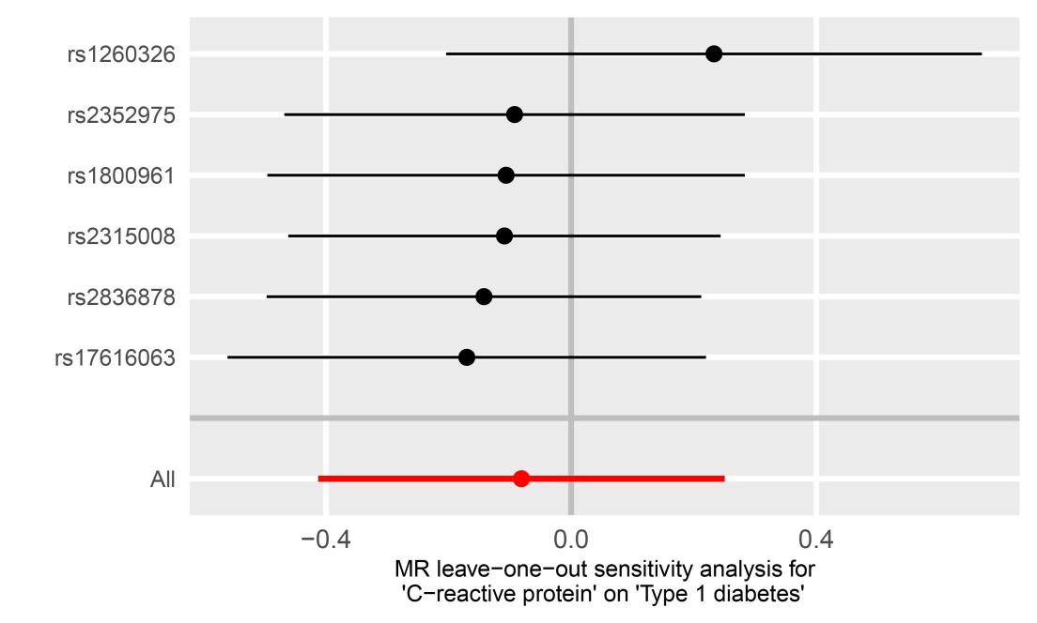
Note: Each row (black lines) represents the result after the removal of the corresponding SNP, and the overall effect is shown at the bottom (red line).

Supplemental Figure S2 Forest and Scatter plots and of SNPs associated with CRP and T1D.

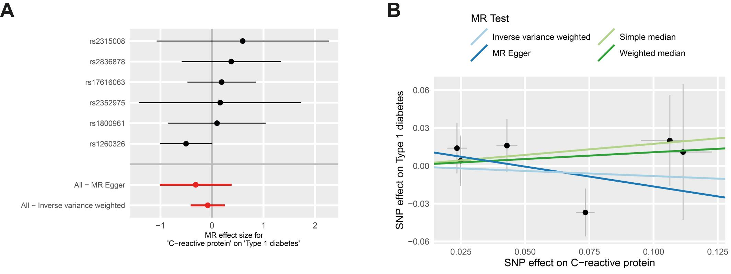
Note: Forest plot (A): Each row (black lines) represents the result after the removal of the corresponding SNP,with the horizontal lines indicating their 95% CIs. The overall MR estimate is represented by the center of the red spots, with the red lines indicating its 95% CI. Scatter plots for MR analysis of the causal effect of CRP on T1D (B).

Supplemental Figure S3 Funnel plots of SNPs associated with CRP and T1D.

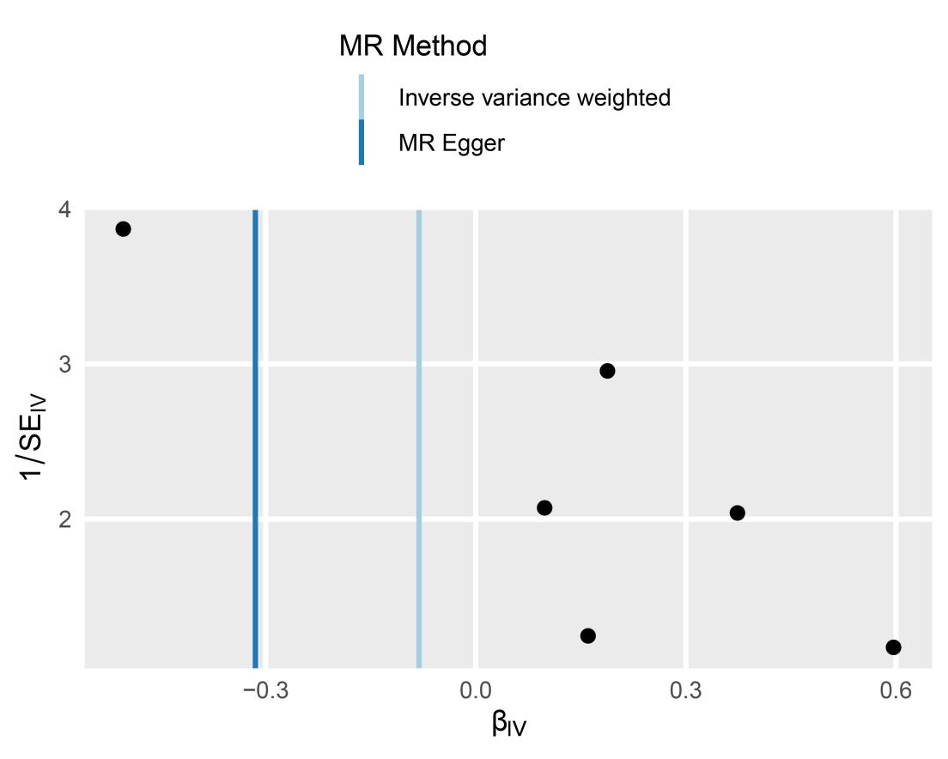
Note: The funnel plot showed that there was asymmetric.

Supplemental Figure S4 Leave-one-out plots of SNPs associated with T1D and CRP.

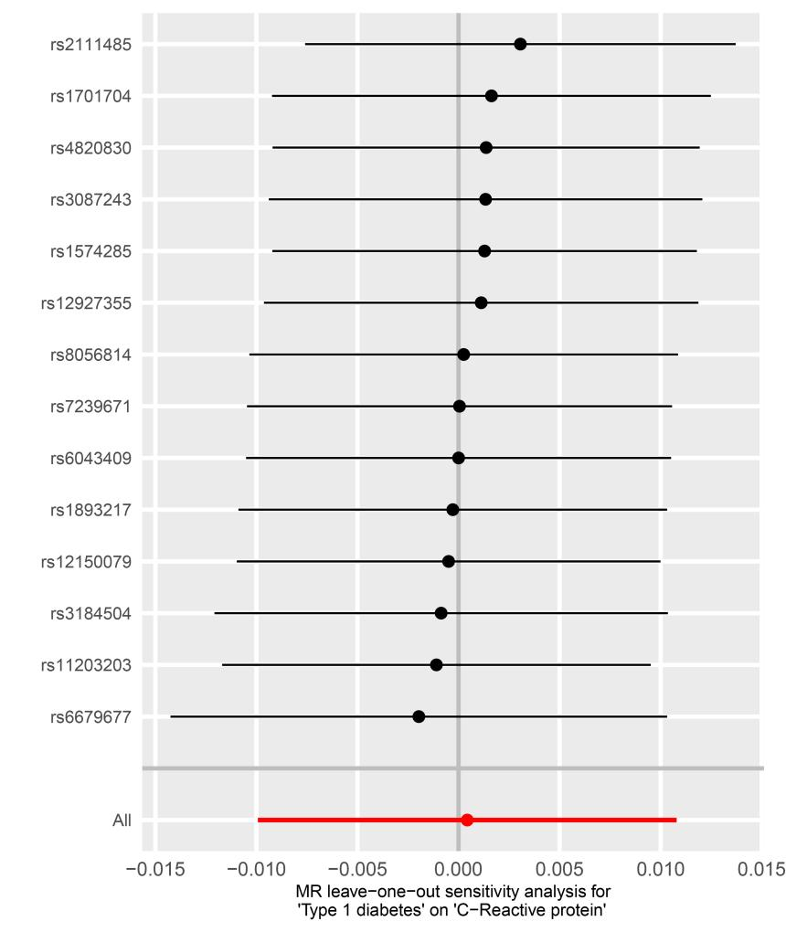
Note: Each row (black lines) represents the result after the removal of the corresponding SNP, and the overall effect is shown at the bottom (red line).
Supplemental Figure S5 Funnel plots of SNPs associated with T1D and CRP.

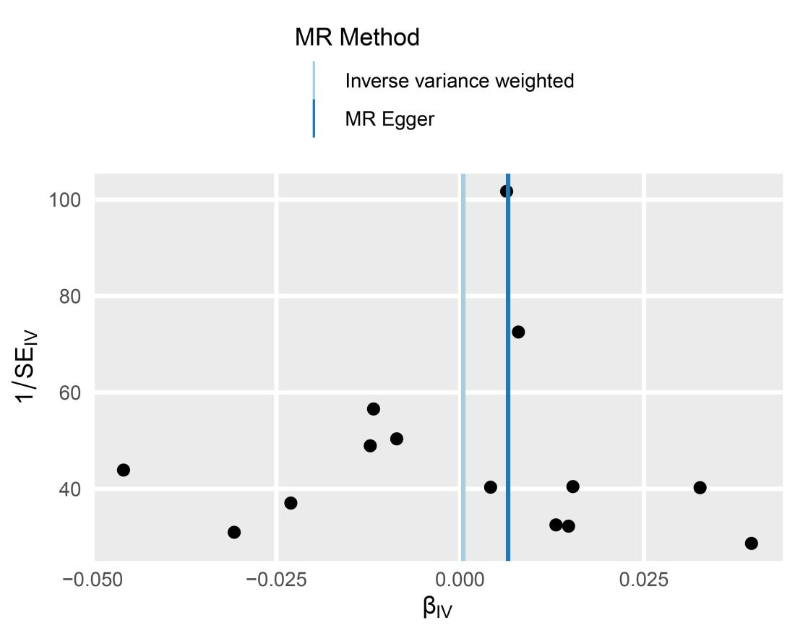
Note: The funnel plot showed that there was basically symmetry.

Supplemental Figure S6 Forest and Scatter plots and of SNPs associated with T1D and CRP.

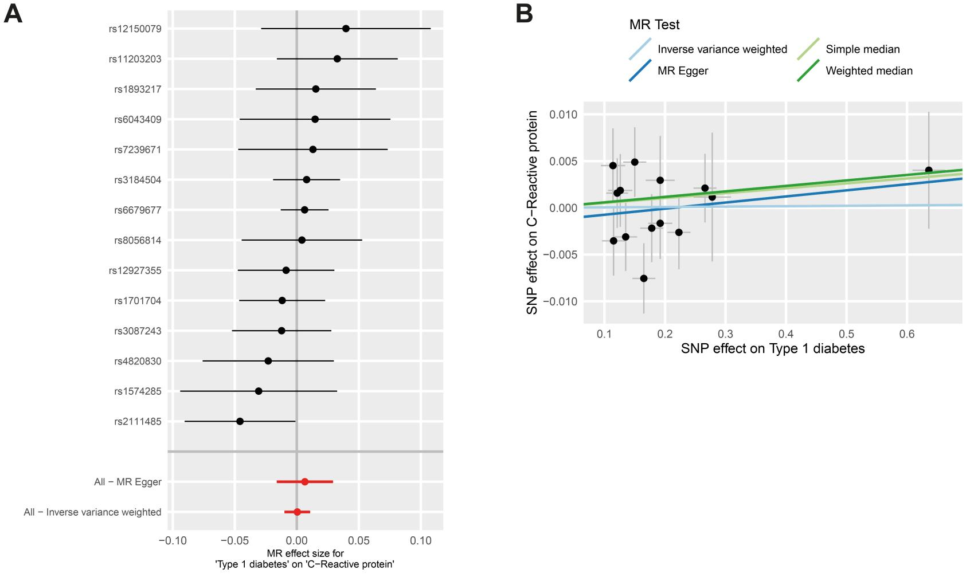
Note: Forest plot (A): Each row (black lines) represents the result after the removal of the corresponding SNP,with the horizontal lines indicating their 95% CIs. The overall MR estimate is represented by the center of the red spots, with the red lines indicating its 95% CI. Scatter plots for MR analysis of the causal effect of T1D on CRP (B).

References
Chen, H., Mi, S., Zhu, J., Jin, W., Li, Y., Wang, T., et al. (2021). No Causal Association Between Adiponectin and the Risk of Rheumatoid Arthritis: A Mendelian Randomization Study. Front Genet 12, 670282. doi: 10.3389/fgene.2021.670282.
Higgins, J.P., Thompson, S.G., Deeks, J.J., and Altman, D.G. (2003). Measuring inconsistency in meta-analyses. BMJ 327(7414), 557-560. doi: 10.1136/bmj.327.7414.557.

