Mathematical modeling of heat transfer in a complex building wall considering phase change hysteresis

Abdelkader Sarri*

Laboratory of New and Renewable Energies in Arid Zones (LENREZA), Road to Ghardaia, 3000 Ouargla, Algeria

*Corresponding author: abdelkader.sarri14@gmail.com

ABSTRACT
Mathematical modeling of various physical phenomena in general and heat transfer in phase change materials (PCMs) in particular is extremely important, as it allows a deep understanding of the physical laws surrounding latent thermal storage, and on the other hand, generation of models for numerical studies that simulate the experimental protocol with fewer possible errors. On this basis, this work presents a modeling study of a complex wall containing a layer of PCM, without and taking into account the partial phase change hysteresis using the MATLAB environment. A new approach for mathematical modeling of the physical problem was discussed and validated numerically using the dynamic simulation software EnergyPlus. Similar to previous studies, simulation results demonstrated that the phenomenon of phase change hysteresis must be taken into account to more precisely define heat transfer when using PCMs in building structures.

Keywords: Energy efficiency; PCMs; phase change hysteresis; Thermal insulation.

Melting
Solidification
1
2
s
m
Temperature
Enthalpy

Fig. 1. Modeling of the phase change hysteresis in the partial phase transition according to Bony and Citherlet [9].

Concrete
PCM layer
Shortwave radiation, including direct, reflected, and diffuse sunlight
Longwave radiation from the environment
Convective exchange with indoor air
Convective exchange with outside air

Fig. 2. Complex wall containing a layer of PCM.

Table 1. Thermophysical properties of concrete and PCM.
Material | Concrete | PCM
Thermal conductivity (W/m K) | 0.7330 | 0.7264
Density (kg/m³) | 2315 | 1601.85
Specific heat capacity (J/kg K) | 800 | 836.86
Latent heat of fusion (kJ/kg) | - | 137.40
Melting temperature (°C) | - | 22 (or 20 in case of solidification)
Thickness (m) | 0.15 | 0.02

Indoor
Outdoor
Layer 1

Layer 2

Layer (N-1)

Layer (N)

w

e

∆X

E

P

W

δX_{e}

δX_{w}

(a) | (b)
Fig. 3. Location of grid points for numerical models using the finite volume method: (a) grid points for a wall layer system including internal nodes and boundary nodes, (b) typical grid points for an intermediate layer.

Initial Conditions (T, h)
Boundary Conditions
Determine Update Coefficients (a_{e}, a_{w}, a_{p}, C, R)
Determine the New Enthalpy Value (h_{new})
Numerical Constrains (convergence, iterations)
Material
Properties
Time and
Spacious Grids
Input
Temperature Fields
Corrected Temperature Value (T_{new})
Solve Eq. 6 for Temperature (T) using TDMA
New Time Step
Converged?
Yes
No

Fig. 4. ICSH-TDMA Algorithm
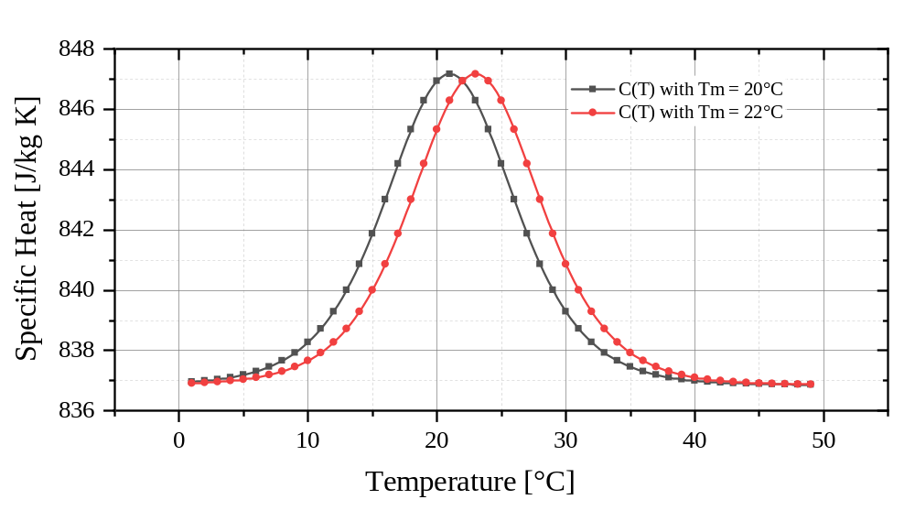
Fig. 5. Specific heat curves, C1 (T) melting state, C2 (T) solidifying state.

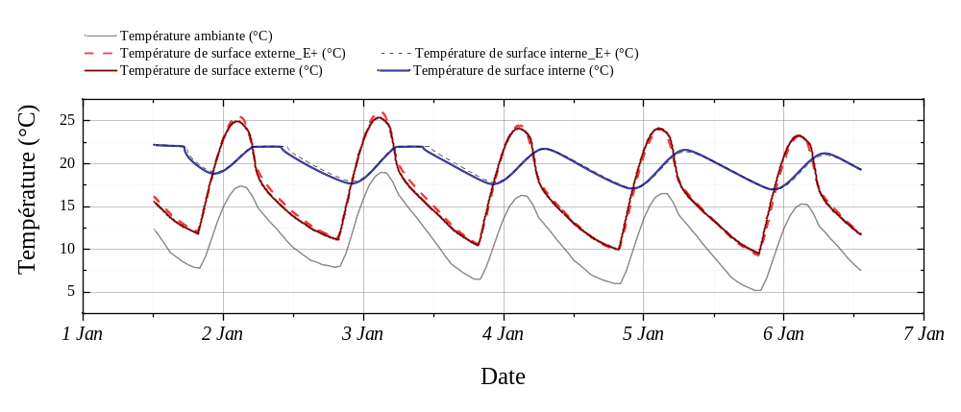
Fig. 6. Numerical validation of the ICS-TDMA algorithm.

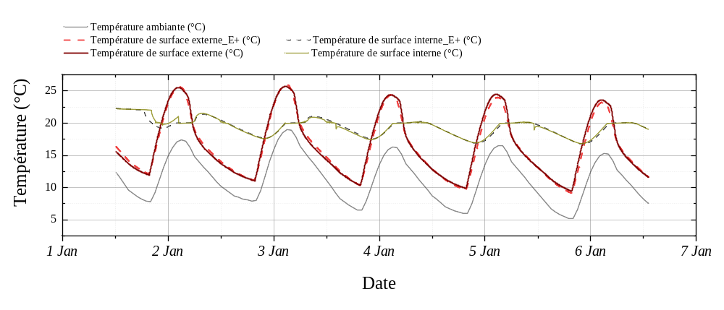
Fig. 7. Numerical validation of the ICSH-TDMA algorithm.

