Supplementary
Finite element method analysis of transverse crack onset strain for cross-ply CFRP laminates with thin and thick ply thickness

The finite element method (FEM) analysis with ABAQUS/CAE using Drucker-Prager elastoplastic damage model in the matrix, cohesive zone model in fiber-matrix and 0°–90° layer interfaces were performed.
Figure S1 shows the (a) reference image, (b) cross-ply with thin ply thickness, and (c) cross-ply with thick ply thickness models.

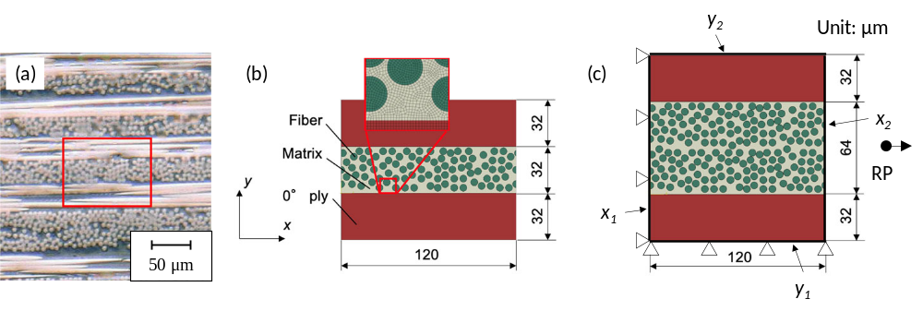
Figure S1. (a) reference image, (b) representative volume element (RVE) of cross-ply with thin ply thickness, and (c) RVE of cross-ply with thick ply thickness models.

The red colors showed the 0° ply. The fiber distributions in 90° ply were decided on the reference image. The boundary conditions are also shown in the figure. The lines x₁ and y₁ were pinned on the x and y-axis, respectively. Lines x₂ and y₂ have the same x and y displacements. The reference point was set to apply the 1.2 μm (a nominal strain of 1 %) of displacement. The analysis model was a two-dimensional plain strain model formed by isoparametric quadrilateral elements. The number of elements and nodes were (a) 83008, 91895 and (b) 117701, 134048, respectively.
The material properties are presented in Table S1. The modulus and Poisson’s ratio of CFRP were obtained from the tensile tests for unidirectional CFRP specimens with 0°, 45°, and 90° fiber orientations (specimen dimensions, testing machine, and testing conditions) the same). The matrix was modeled with elastoplastic damage material, and the plastic behavior of the matrix was used for the hyperbolic-type Drucker-Prager model. The material properties of the matrix were decided based on the literature²⁷. The cohesive zone models were introduced in the fiber/matrix and layer (0°/90°) interfaces. The damage initiation and propagation criteria were applied with the ellipse rule of traction and the energy release rate B-K criterion. The material characteristics of the fiber/matrix interface were decided according to the literature²⁷. The material properties of the layer interface were obtained from the double cantilever beam and end-notched flexure tests for unidirectional CFRP specimens with 0° fiber orientation. The specimen dimensions, testing machine, and testing conditions were the same as in the literature²⁸.

Fiber | Transverse Young’s modulus | 17.5 GPa
Fiber | Transverse Poisson’s ratio | 0.46
Fiber | Longitudinal shear modulus | 15.9 GPa
Matrix | Young’s modulus | 3.76 GPa
Matrix | Poisson’s ratio | 0.39
Matrix | Drucker-Prager Friction angle | 35 °
Matrix | Drucker-Prager Initial hydrostatic strength | 42.16 GPa
Matrix | Drucker-Prager Dilatation angle | 35 °
Matrix | Ductile damage Tensile failure strain | 0.008
Matrix | Ductile damage Compressive failure strain | 0.025
Matrix | Ductile damage Hydrostatic failure strain | 1.0 ×10⁻¹⁰
Matrix | Ductile damage Fracture toughness | 15 J/m²
CFRP | Longitudinal Young’s modulus | 152 GPa
CFRP | Transverse Young’s modulus | 8.21 GPa
CFRP | Longitudinal Poisson’s ratio | 0.26
CFRP | Transverse Poisson’s ratio | 0.46
CFRP | Longitudinal shear modulus | 4.0 GPa
Fiber/matrix interface | Mode I maximum traction | 53 MPa
Fiber/matrix interface | Mode II&III maximum traction | 0.17 MPa
Fiber/matrix interface | Mode I fracture toughness | 15 J/m²
Fiber/matrix interface | Mode II&III fracture toughness | 45 J/m²
Fiber/matrix interface | B-K mode parameter | 1.45
0°/90° interface | Mode I maximum traction | 71 MPa
0°/90° interface | Mode II&III maximum traction | 97 MPa
0°/90° interface | Mode I fracture toughness | 329 J/m²
0°/90° interface | Mode II&III fracture toughness | 915 J/m²
0°/90° interface | B-K mode parameter | 1.634

Table 1. Material properties for FEM analysis.

The distributions of the in-plane principal plastic strain of cross-ply CFRP laminates with thin and thick ply thickness are compared in Figure S2.

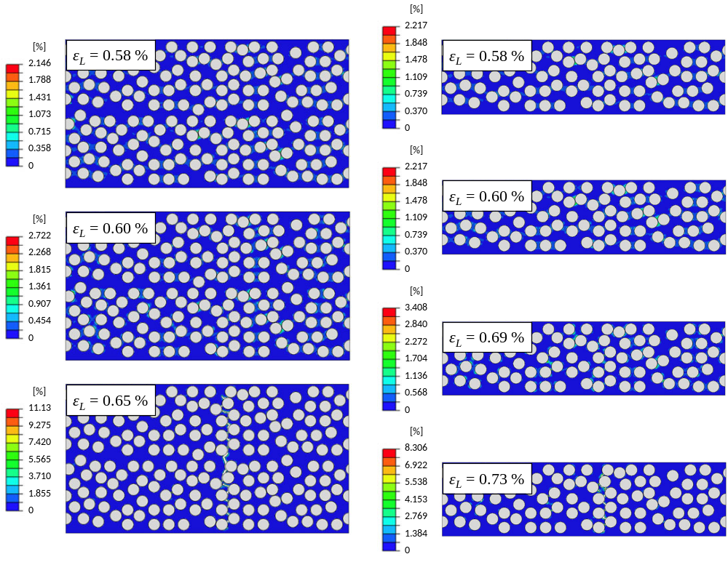
Figure S2. In-plane principal plastic strain distributions of cross-ply CFRP laminates with thin and thick ply thickness.

The plastic strain was concentrated in the fiber aggregation area, and debonding occurred in the fiber/matrix interface. The plastic strain increased near the debonding area, and then the matrix near the debonding area failed. A clear transverse crack was formed. The transverse crack for cross-ply CFRP laminate with thick ply thickness formed in a nominal tensile strain of 0.65%. However, a transverse crack of cross-ply CFRP laminated with thin ply thickness formed at the nominal tensile strain of 0.73%. The transverse crack onset strain of thin-90°-ply was higher than that of thick-90°-ply. Therefore, the tensile strength and failure strain of cross-ply CFRP laminate with thin ply thickness was higher than those of cross-ply with thick ply thickness one. The constraint effects of 0° layers were significant, and the onset of transverse matrix cracking through the thickness of the ply, delamination damage, and fiber breakage was suppressed.

References
- Higuchi, R., Aoki, R., Yokozeki, T. & Okabe, T. Evaluation of the in-situ damage and strength properties of thin-ply CFRP laminates by micro-scale finite element analysis. Adv. Compos. 29, 475–493, DOI: https://doi.org/10.1080/09243046.2020.1740867 (2020).
- Naito, K. & Nagai, C. Mode-I and mode-II interlaminar fracture properties of high modulus pitch-based carbon fiber reinforced polymers containing different nanostructures. J. Compos. Mater. 56, 397–407, DOI: https://doi.org/10.1177/00219983211049289 (2022).

