a
Fig.1. (a) Abrus precatorius medicinal plant, (b) Plant sample placed on a PDA medium, (c) Endophytic fungus grown from surface sterilized stem segment of Abrus precatorius on PDA media after 48 hours,(d) Colony morphology of Phyllosticta owaniana ,(e) Microscopic view of endophytic fungus Phyllosticta owaniana,

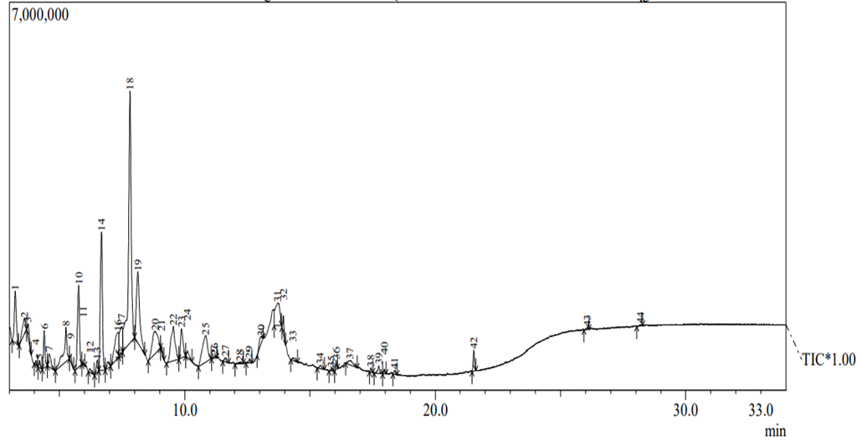
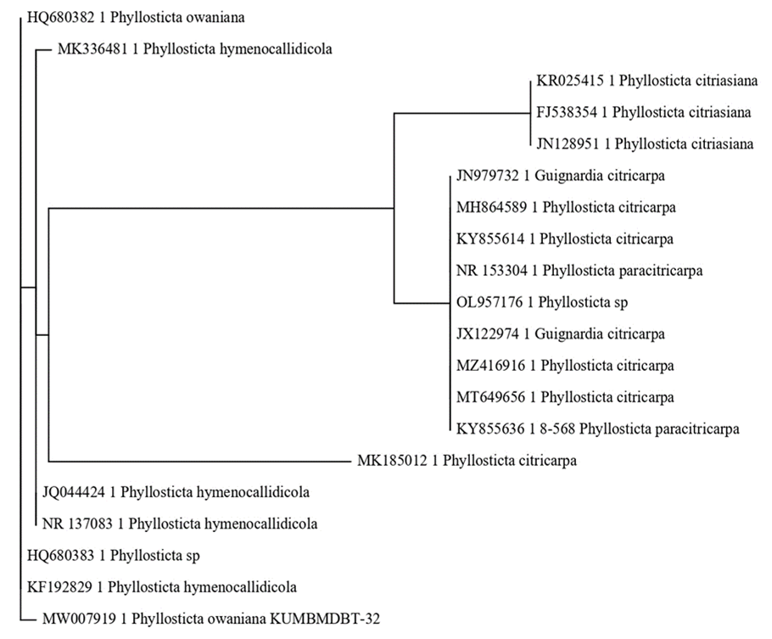
Fig.2. Phylogenetic analysis of Phyllosticta owaniana strains with ITS sequences of closely related fungal strains.
Fig. 3. GC-MS Chromatogram of ethyl acetate extract of endophytic fungus Phyllosticta owaniana.

b
Fig. 4. (a) Cell filtrate of endophytic fungus Phyllosticta owaniana, (b) Color change to reddish brown after treating with 1mM AgNO3,
a
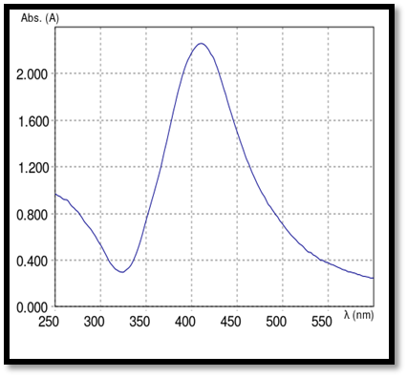
Fig.5. Bio-spectrophotometer of silver nanoparticles biosynthesis using Phyllosticta owaniana.

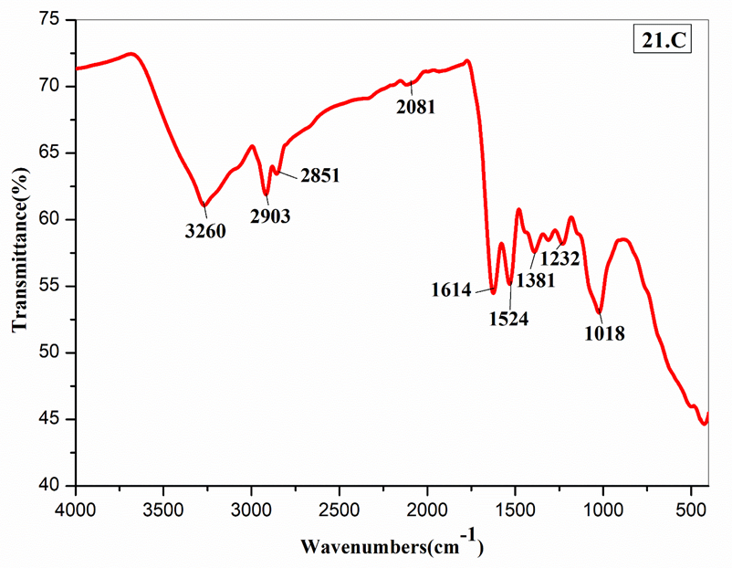
Fig. 6. FTIR pattern of biosynthesized silver nanoparticles of endophytic fungus Phyllosticta owaniana.

c
d
b
Fig. 7. (a), (b), (c) and (d) SEM images of biosynthesized silver nanoparticles of endophytic fungus Phyllosticta owaniana.
a

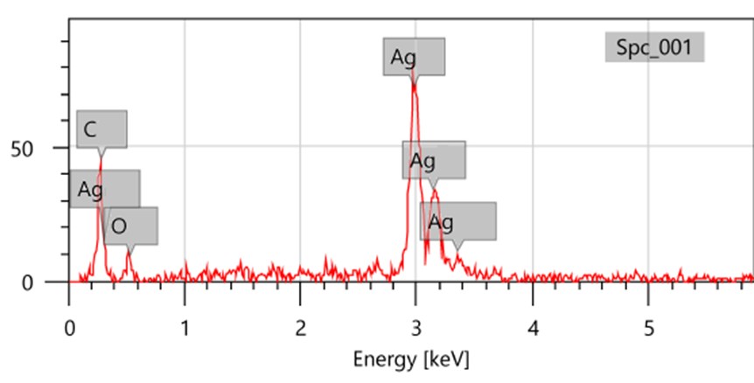
Fig. 8. EDX pattern of biosynthesized silver nanoparticles of endophytic fungus Phyllosticta owaniana.

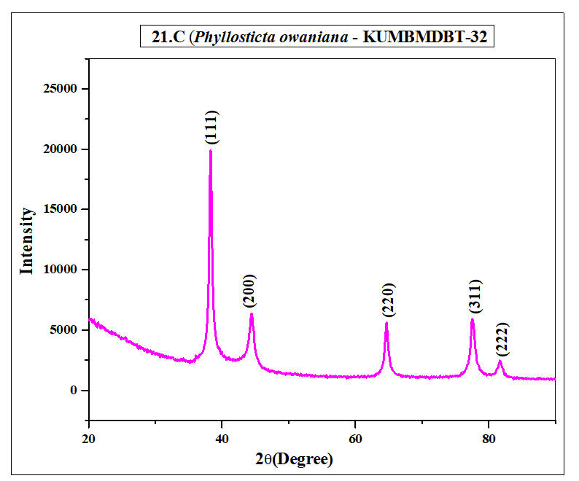
Fig. 9. XRD pattern of biosynthesized silver nanoparticles of endophytic fungus Phyllosticta owaniana.

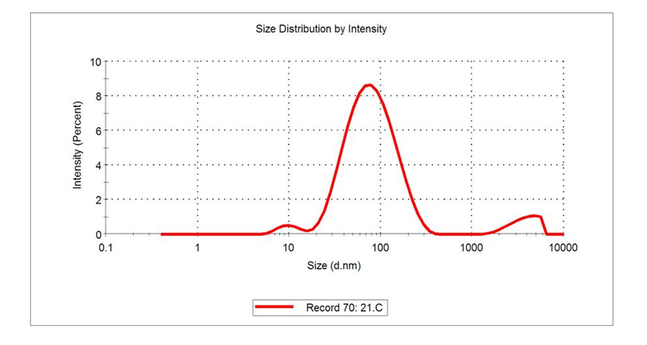
Fig. 10. DLS pattern of biosynthesized silver nanoparticles of endophytic fungus Phyllosticta owaniana.

b
a
c
d
e
a
c
b
d
e
Fig. 11. Positive Control plates of antibiotic enhancing activity against test bacterial pathogens, (a) E. coli, (b) S. aureus, (c) P. aeruginosa, (d) S. typhi, (e) K. pneumoniae.

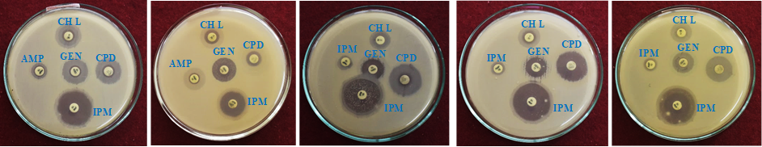
Fig. 12. Antibiotic enhancing activity of endophytic fungus Phyllosticta owaniana silver nanoparticles against pathogenic bacteria (a) E. coli, (b) S. aureus, (c) P. aeruginosa, (d) S. typhi, (e) K. pneumoniae.

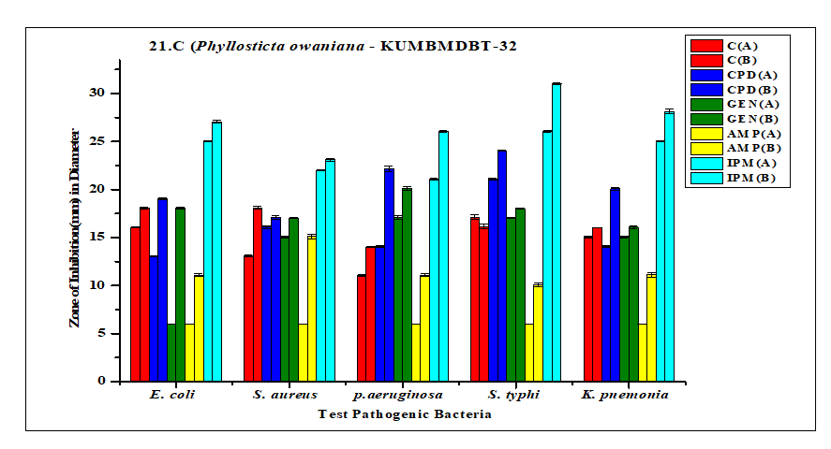
Fig. 13. Antibiotic enhancing activity of endophytic fungus Phyllosticta owaniana silver nanoparticles against bacterial pathogens.

a
b
c
d
e
Fig. 14. Positive Control plates of antibacterial activity against test bacteria pathogens (a) E.coli (b) S. aureus, (c) P. aeruginosa, (d) S. typhi, (e) K. pneumoniae.
e
d
c
a
b
Fig.15. Antibacterial activity of silver nanoparticles synthesized by endophytic fungus Phyllosticta owaniana against bacterial pathogens (a) E. coli, (b) S. aureus, (c) P. aeruginosa, (d) S. typhi, (e) K. pneumoniae.
Fig.16. Antibacterial activity of silver nanoparticles synthesized by endophytic fungus Phyllosticta owaniana against bacterial pathogens.
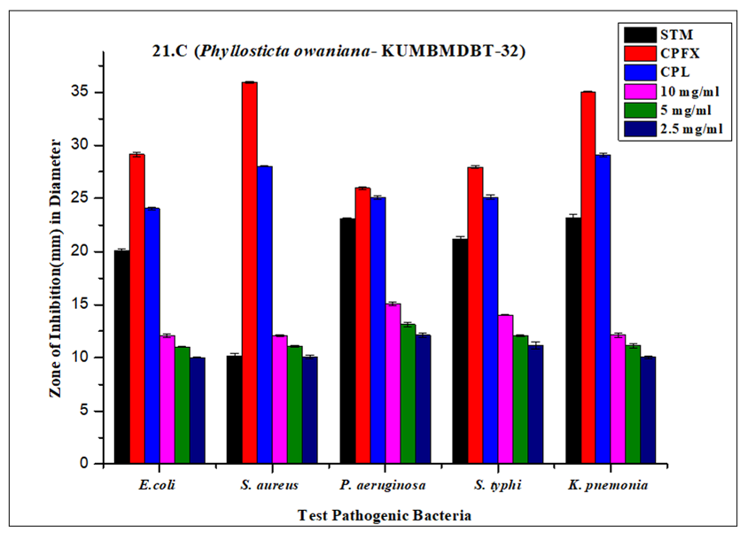

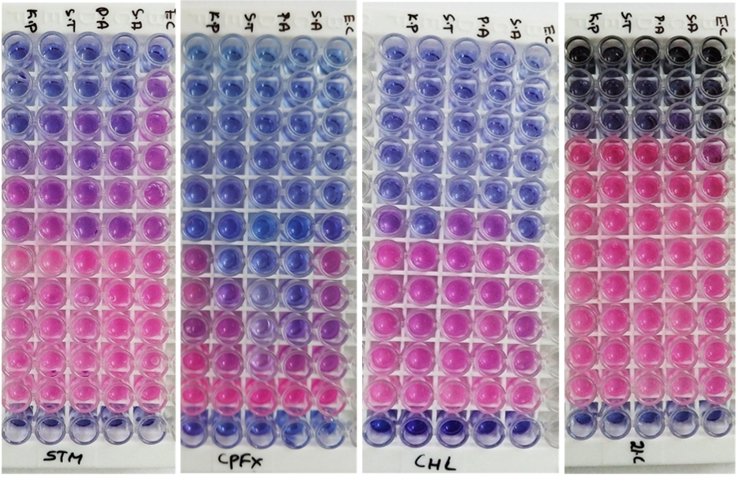
a
b
c
d
Fig.17. (a), (b) and (c). Minimum inhibitory concentration of Streptomycin, Ciprofloxacin and Chloramphenical against bacterial pathogens. (d) Minimum inhibitory concentration of silver nanoparticles synthesized by endophytic fungus Phyllosticta owaniana against bacterial pathogens.

a
b
c

Fig. 18. Positive Control plates showed antifungal activity against test fungal pathogens (a) Candida albicans, (b) Aspergillus brassiliensis, (c) Aspergillus flavus.

a
b
c

Fig.19. Antifungal activity of silver nanoparticles synthesized by endophytic fungus Phyllosticta owaniana (a) Candida albicans, (b) Aspergillus brassiliensis, (c) Aspergillus flavus.

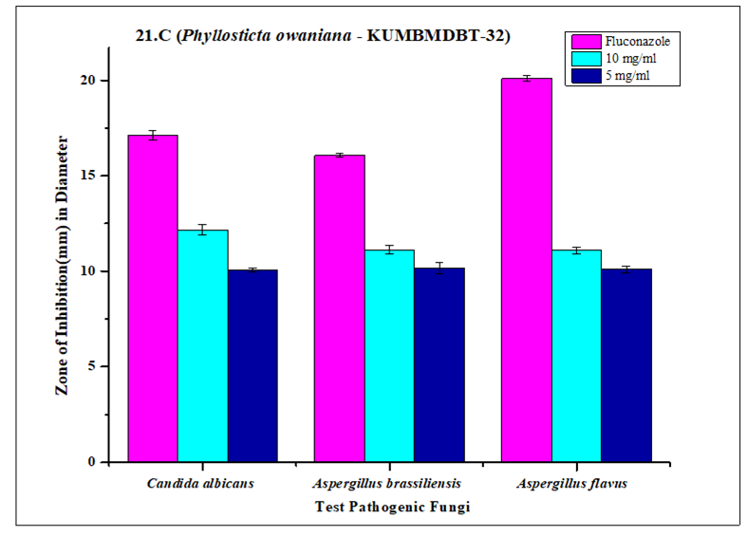
Fig.20. Antifungal activity of silver nanoparticles synthesized by endophytic fungus Phyllosticta owaniana against fungal pathogens.

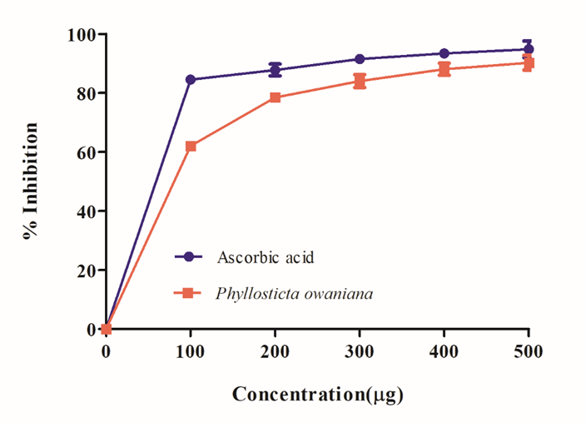
Fig.21. DPPH free radical scavenging activity of silver nanoparticles synthesized by endophytic fungus Phyllosticta owaniana.

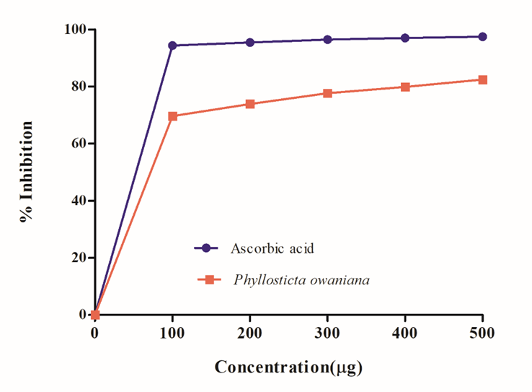
Fig 22. ABTS radical cation decolorization assay of silver nanoparticles synthesized by endophytic fungus Phyllosticta owaniana.
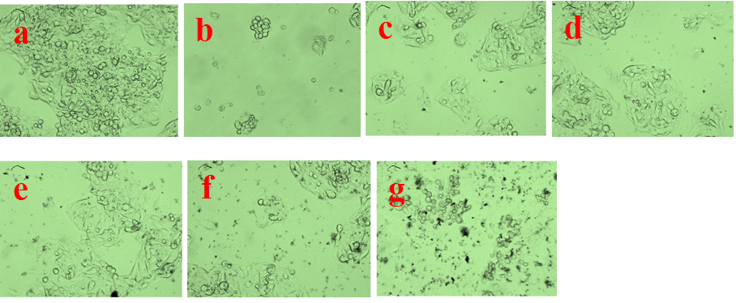

Fig.23. Percentage cell viability of synthesized silver nanoparticles Phyllosticta owaniana against A498 cell line at different concentration (a), Untreated, (b) Std control, Cisplatin, (c) 12.5 µg/ml, (d) 25 µg/ml, (e) 50 µg/ml, (f) 100 µg/ml, (g) 200 µg/ml.
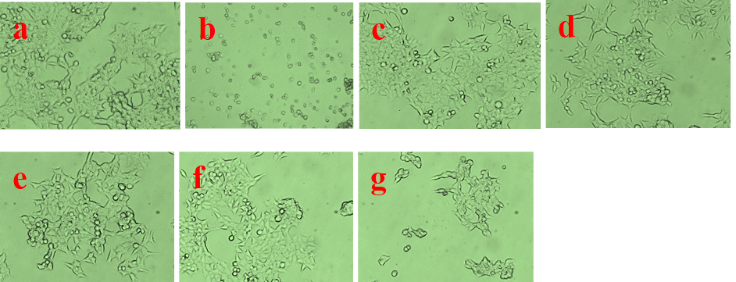

Fig. 24. Percentage cell viability of synthesized silver nanoparticles Phyllosticta owaniana against HepG2 cell line at different concentration (a), Untreated, (b) Std control, Cisplatin, (c) 12.5 µg/ml, (d) 25 µg/ml, (e) 50 µg/ml, (f) 100 µg/ml, (g) 200 µg/ml.

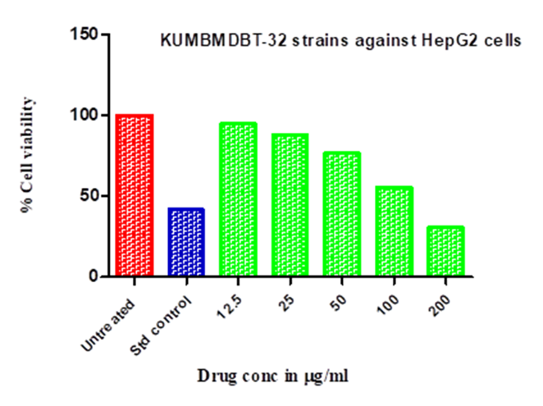
Fig. 25. Percentage cell viability of synthesized silver nanoparticles Phyllosticta owaniana against HepG2 cell line.
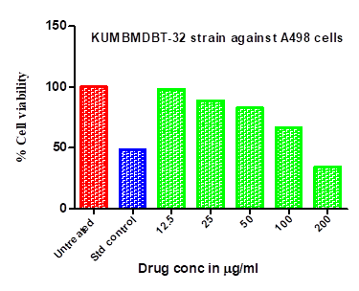
Fig. 26. Percentage cell viability of synthesized silver nanoparticles Phyllosticta owaniana against A498 cell line.
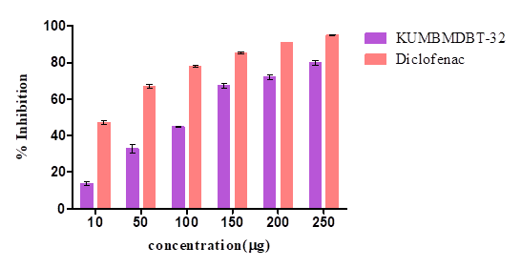
Fig.27. percentage inhibition of synthesized silver nanoparticles of Phyllosticta owaniana and Diclofenac against egg albumin denaturation.

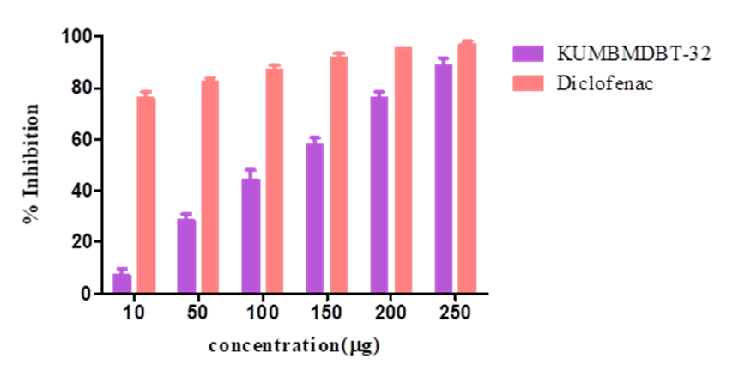
Fig. 28. Percentage inhibition of synthesized silver nanoparticles of Phyllosticta owaniana and Diclofenac against bovine serum albumin denaturation

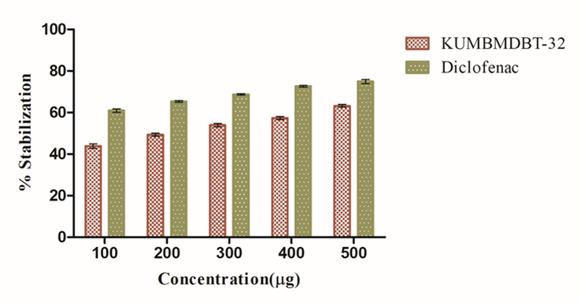
Fig. 29. Percentage inhibition of synthesized silver nanoparticles of Phyllosticta owaniana and Diclofenac against membrane stabilization test by hypotonicity-induced hemolysis

Fig. 30. Percentage inhibition of carrageenan induced paw edema at different concentrations of synthesized silver nanoparticles by endophytic fungus Phyllosticta owaniana.

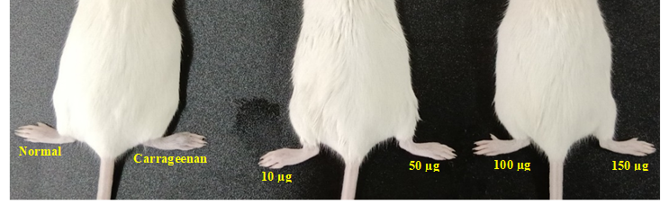
Fig. 31. Carrageenan induced paw edema at different concentrations of standard drug Diclofenac.
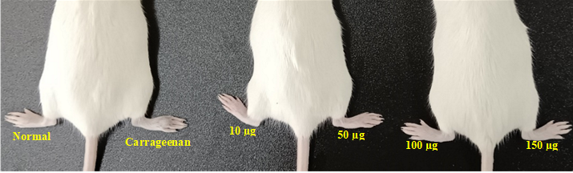

Fig. 32. Carrageenan induced paw edema at different concentrations of synthesized silver nanoparticles by endophytic fungus Phyllosticta owaniana.
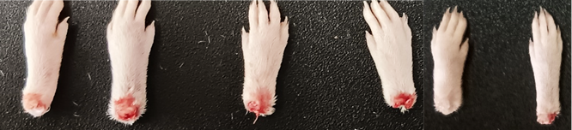
Fig.33. Histopathological studies of inflammations in legs of Swiss albino female mice.
Fig.34. Histopathological studies, (A) Untreated control, (B) Standard drug, Diclofenac shows the faster decrease in the inflammation, (C) Carrageenan paw edema shows the faster increase in the inflammation (D) Synthesized silver nanoparticles shows the gradual decrease in the inflammation with respect to time interval.

