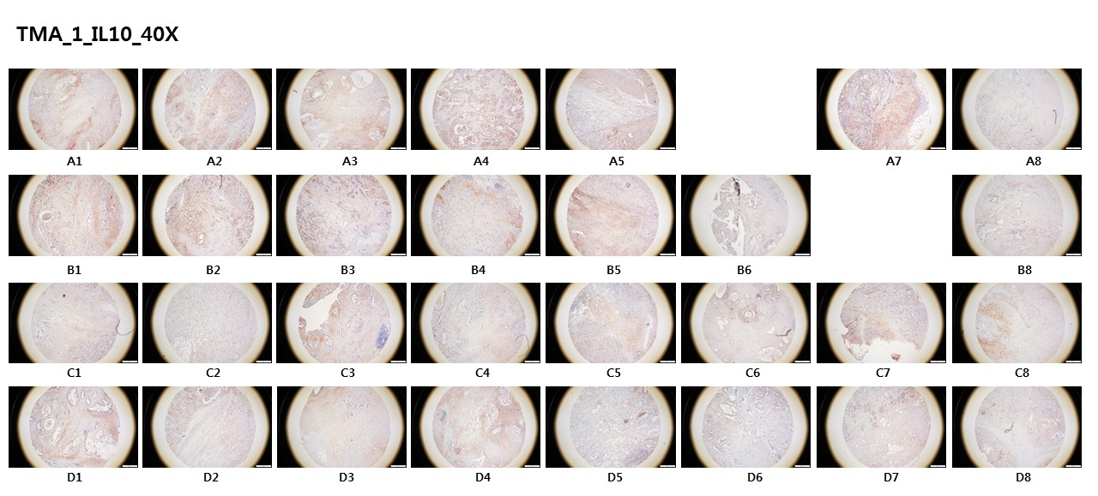
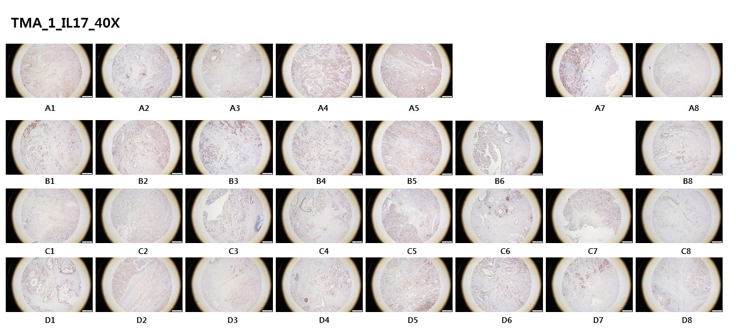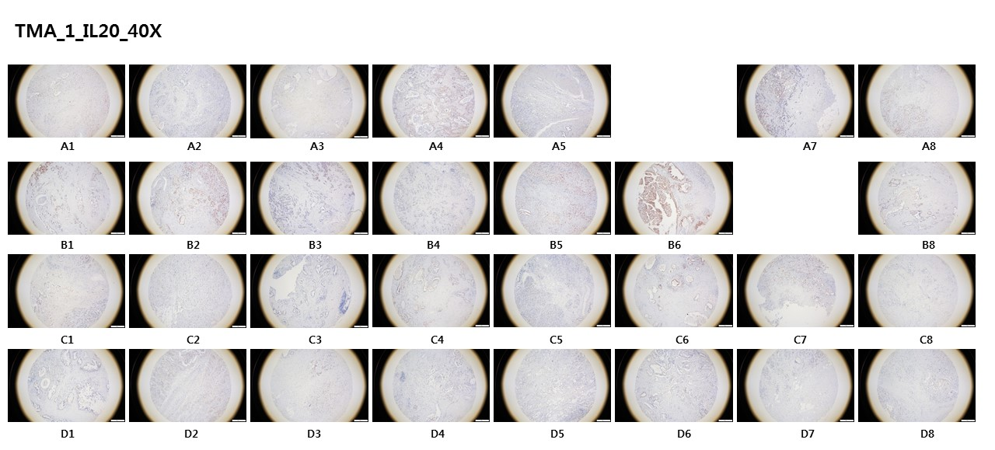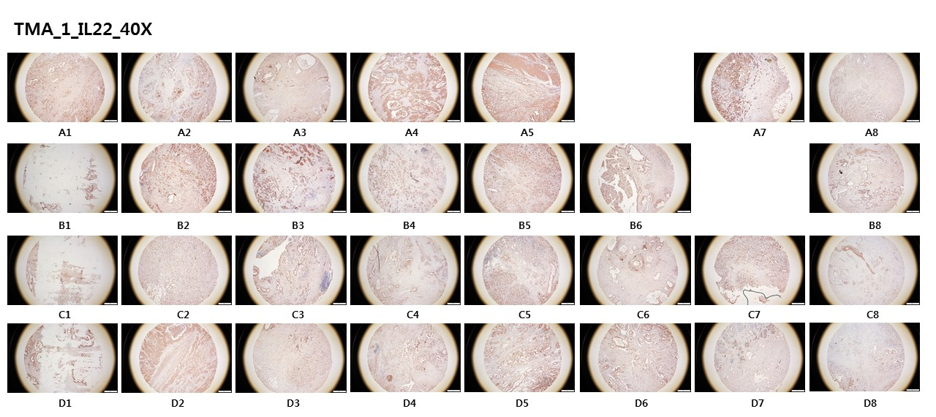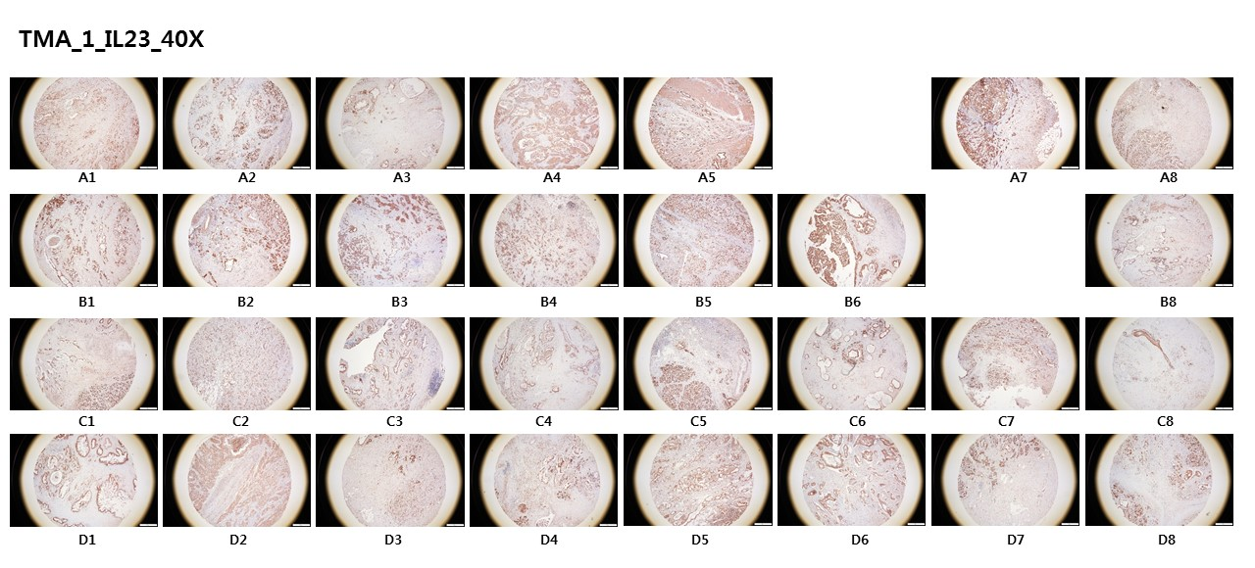
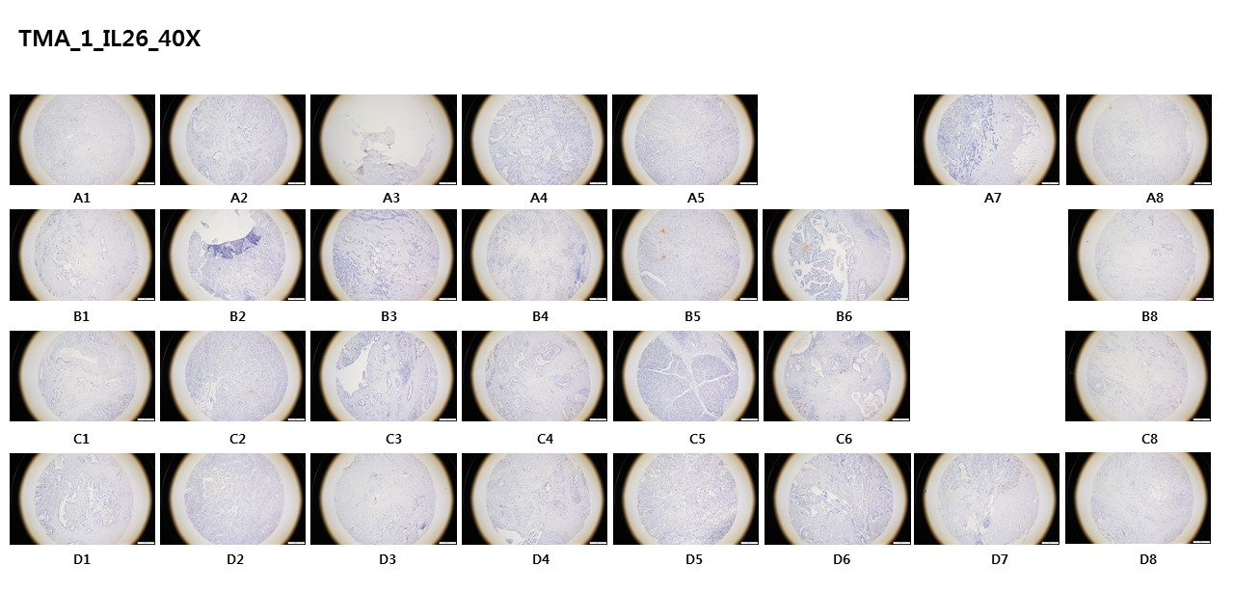
Figure S1. Representative immunohistochemical staining of IL-10 family cytokines on a TMA from a PDAC patient (n=29). The full images from microscope were presented.

Figure S2. Characterization of IL-10R2+ or IL-10R2- cells from PDAC patients. Representative images of IL-10R2+ or IL-22R1+ cells after Giemsa staining.

Figure S3. Characterization of the immune types of IL-10R2+ or IL-10R2- cells from PDAC patients. (A) Summary of patient metadata. (B) Heatmap showing the relative expression (Z-score) of the indicated cell type marker genes for monocytes/macrophages (CD14), monocytes/NK cells (CD16), B cells (CD19 and CD20), and T cells (CD3D, CD3E, and CD3G). The IL-10 receptor genes (IL10R1 and IL10R2) are included to show the upregulation of both genes. (C) UMAP plots showing the expression levels of the indicated marker genes.

Figure S4. Characterization of PBMC subtypes within the monocyte/macrophage compartment in PDAC patients. (A and B) t-distributed stochastic neighbor embedding (t-SNE) plots of each sample colored by cell clusters (left), the expression levels of CD14 (middle), and CD16 (right) in normal subjects (A) and PDAC patients (B). (C) Heatmap showing the relative expression (Z-score) of differentially expressed genes (adjusted P-value < 0.05) between IL10R2- (P5(-)) and IL10R2+ (P5) PBMCs from the same PDAC patient. (D) Violin plot showing the TEM signature score of CD16+ monocytes/macrophages between healthy donors and PDAC patients.

Figure S5. Kaplan-Meier survival curves of PDAC patients with either high or low expression of IL10R2 or IL-22R1. Kaplan-Meier survival curves using The Cancer Genome Atlas Program (TCGA) data revealed that there were worse overall survival rates for PDAC patients with high IL-10R2 expression compared to patients with low IL-10R2 expression (p=0.003). PDAC patients with high IL-22R1 expression had lower survival rates than patients with low IL-22R1 expression (p= 0.00008).

