Supplemental Figures:

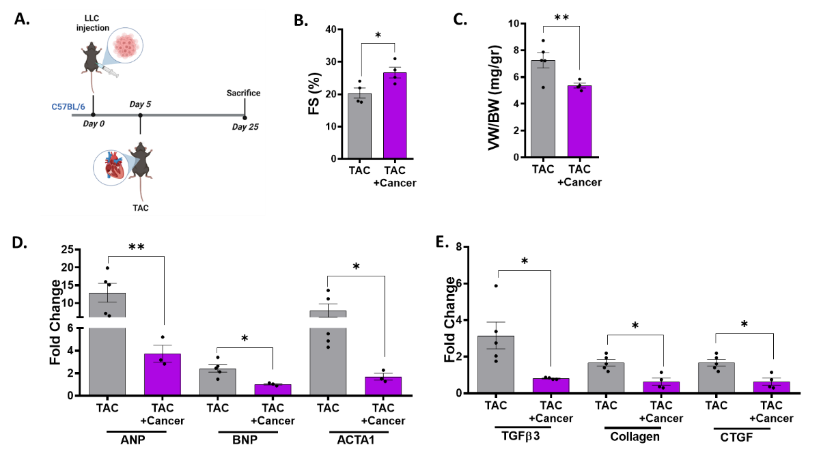

Supplemental Figure 1: LLC Tumor growth improves cardiac dysfunction following TAC in male mice.
A. A schematic diagram of the experimental flow chart B. Fractional shortening (FS) was calculated from echocardiography data. Echocardiography parameters are found in Supp. table 3. C. Ventricles/Body weight ratio (VW/BW). D. Heart mRNA levels of the hypertrophic markers ANP and BNP and ACTA1 were measured using qRT-PCR, normalized to GAPDH housekeeping gene. E. Heart mRNA levels of the fibrosis markers TGFb3, Collagen and CTGF were measured using qRT-PCR, normalized to GAPDH housekeeping gene. Results presented as mean ± SEM, student-t test. * P< 0.05, **P<0.01. Each dot represents one mouse.

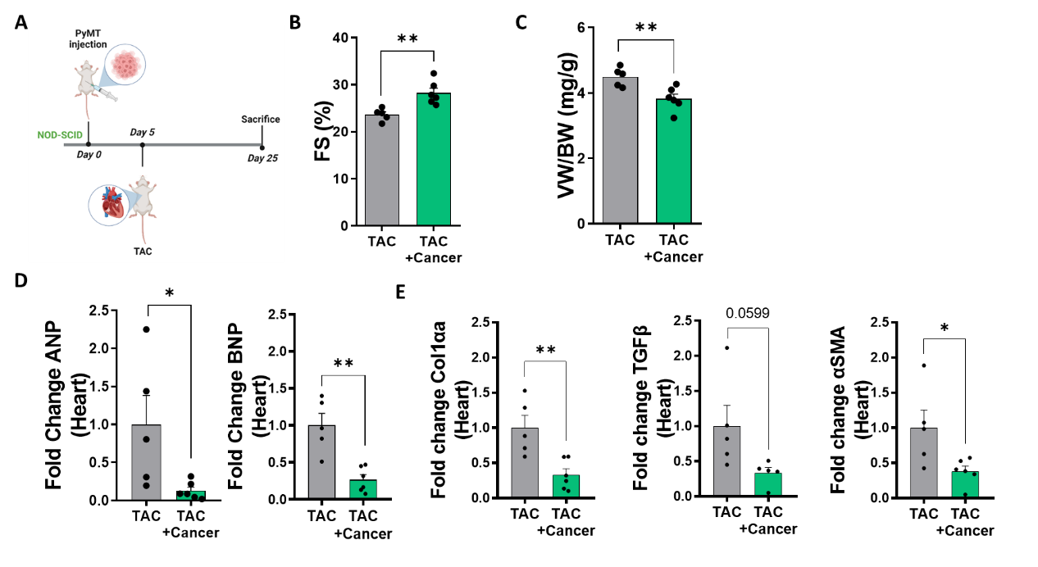
Supplemental Figure 2: Tumor growth beneficial effect in NOD-SCID females mice.
A. A schematic diagram of the experimental flow chart B. Fractional shortening (FS) was calculated from echocardiography data. Echocardiography parameters are found in Supp. table 4. C. Ventricles/Body weight ratio (VW/BW). D. Heart mRNA levels of the hypertrophic markers ANP and BNP were measured using qRT-PCR, normalized to GAPDH housekeeping gene. E. Heart mRNA levels of the fibrosis markers Collagen, TGFβ3 and αSMA were measured using qRT-PCR, normalized to GAPDH housekeeping gene. Results presented as mean ± SEM, student-t test. * P< 0.05, **P<0.01. Each dot represents one mouse.

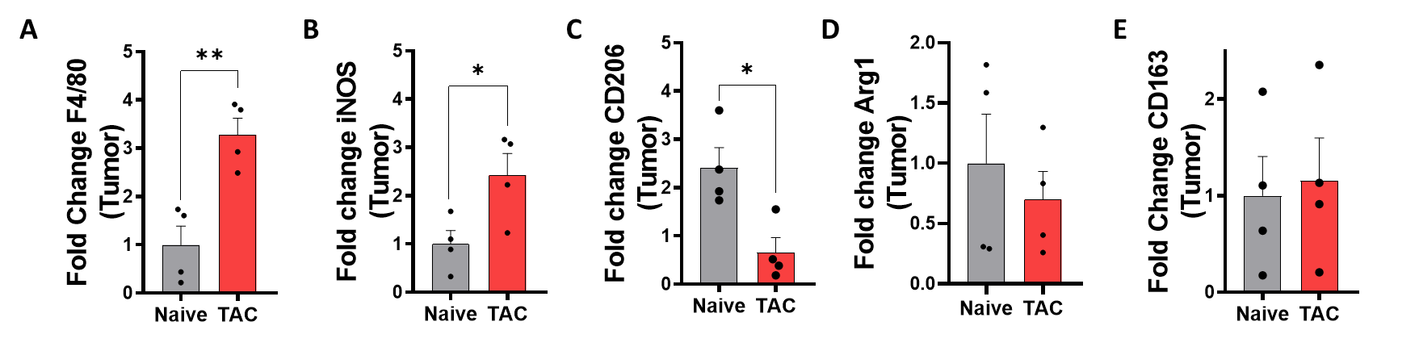
Supplemental Figure 3: M1 macrophage polarization in the tumor of TAC-operated female mice.
A-E Tumor mRNA levels of macrophages markers iNOS, CD206 and ARG1 using qRT-PCR, normalized to Hsp90 housekeeping gene. Results are presented as mean ± SEM, Student t-test. * P< 0.05, **P<0.01, ***P<0.001. Each dot represents one mouse.

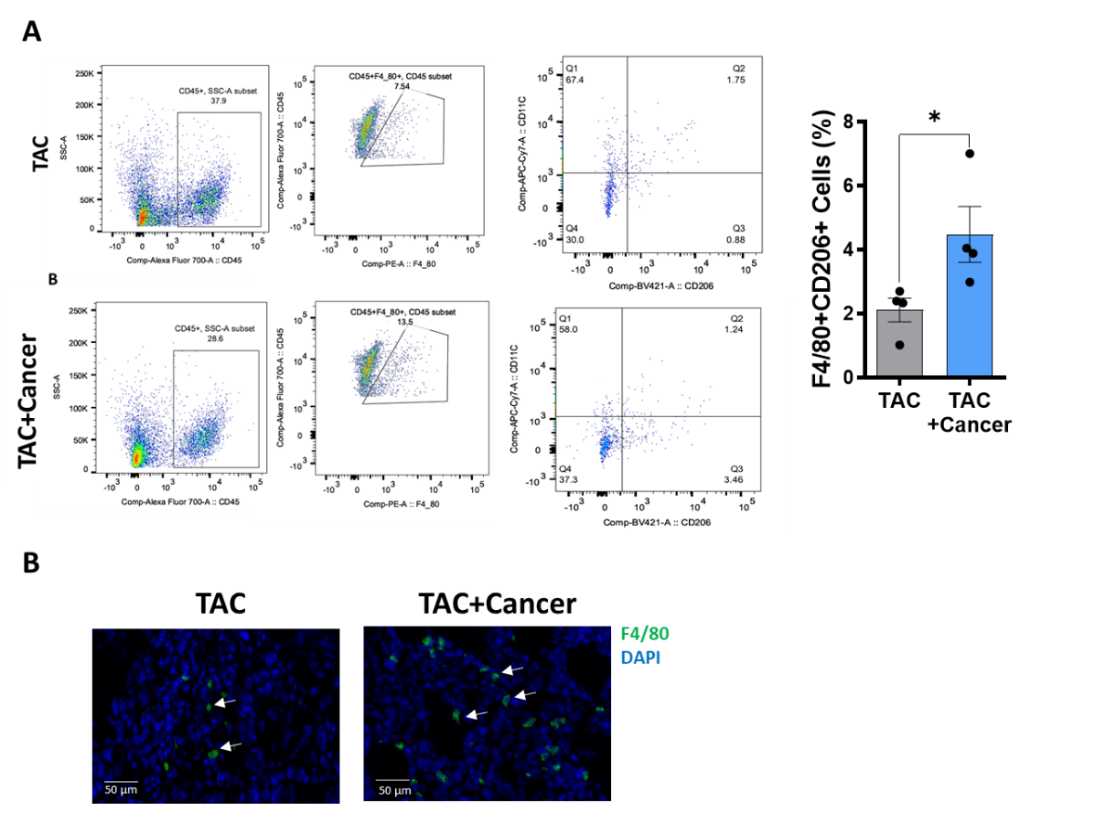

Supplemental Figure 4: Tumor growth induces cardiac macrophage polarization
A-B F4/80+CD206+ cells count (%) in either TAC mice hearts (n=5) or TAC+cancer hearts (n=5). C Representative heart sections stained with F4/80. Results are presented as mean ± SEM, Student t-test. * P< 0.05, **P<0.01, ***P<0.001. Each dot represents one mouse.

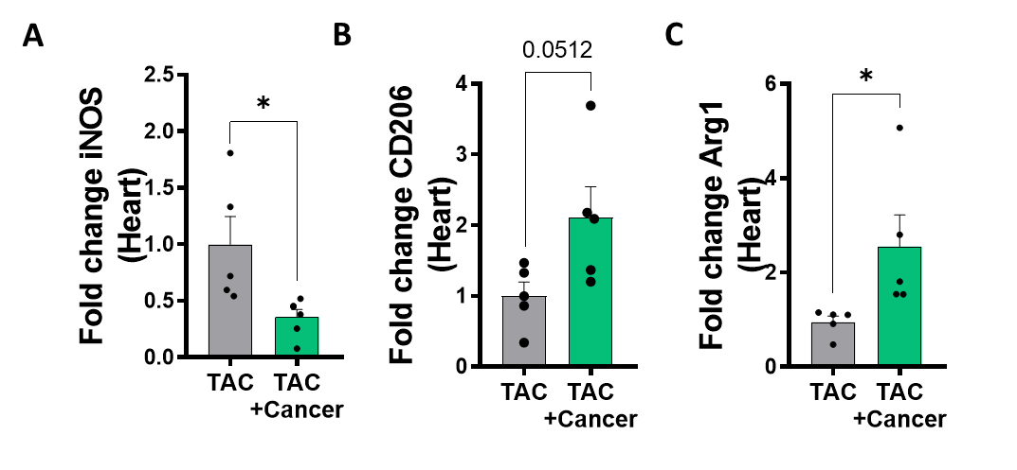
Supplemental Figure 5: M1/M2 polarization in NOD-SCID mice.
A-C Heart mRNA levels of macrophages markers iNOS, CD206 and ARG1 using qRT-PCR, normalized to GAPDH housekeeping gene. Results are presented as mean ± SEM, Student t-test. * P< 0.05, **P<0.01, ***P<0.001. Each dot represents one mouse.

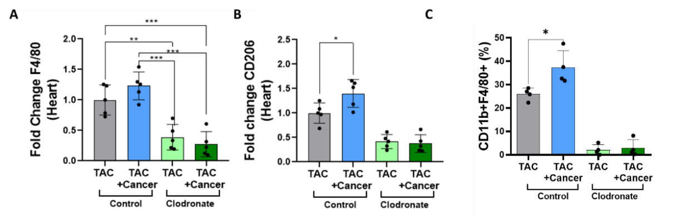
Supplemental Figure 6: Efficiency of macrophage depletion by Clodronate liposomes.
A Heart expression levels of macrophages markers F4/80 and CD206 were measured using qRT-PCR and normalized to HSP90 housekeeping gene. B CD11b+F4/80+ cell count in the heart using flow cytometry. Results are presented as mean ± SEM, Student t-test. * P< 0.05, **P<0.01, ***P<0.001. Each dot represents one mouse.

Gene | Forward | Reversed
Hsp90 | TCGTCAGAGCTGATGATGAAGT | GCGTTTAACCCATCCAACTGAAT
GAPDH | TTGCCATCAACGACCCCTTCAT | AGACTCCACGACATACTCAGCA
ANP | GCTTCCAGGCCATATTGGAG | GGGGGCATGACCTCATCTT
BNP | GAGGTCACTCCTATCCTCTGG | GCCATTTCCTCCGACTTTTCTC
ACTA-1 | GTGAGATTGTGCGCGACATC | GGCAACGGAAACGCTCATT
Col1α1 | CTGGCGGTTCAGGTCCAAT | TTCCAGGCAATCCACGAGC
TGFβ3 | CCTGGCCCTGCTGAACTTG | GACGTGGGTCATCACCGAT
CTgF | AGACCTGTGGGATGGGCAT | GCTTGGCGATTTTAGGTGTCC
αSMA | GTCCCAGACATCAGGGAGTAA | TCGGATACTTCAGCGTCAGGA
F4/80 | CCCCAGTGTCCTTACAGAGTG | GTGCCCAGAGTGGATGTCT
iNOS | GACATTACGACCCCTCCCAC | GCACATGCAAGGAAGGGAAC
CD206 | CTAACTGGGGTGCTGACGAG | GGCAGTTGAGGAGGTTCAGT
Arg1 | AATGAAGAGCTGGCTGGTGT | CTGGTTGTCAGGGGAGTGTT
CD163 | CCTCCTCATTGTCTTCCTCCTGTG | CATCCGCCTTTGAATCCATCTCTTG
INFγ | ACAGCAAGGCGAAAAAGGATG | TGGTGGACCACTCGGATGA
IL-13 | AACGGCAGCATGGTATGGAGTG | TGGGTCCTGTAGATGGCATTGC
CCL2 | GTGATGGAGGGGGTCAGGA | GGGATGGGACAGCCTAAACT
TNFα | CCCTCACACTCAGATCATCTTCT | GCTACGACGTGGGCTACAG
Supplemental table 1: Oligonucleotides sequence

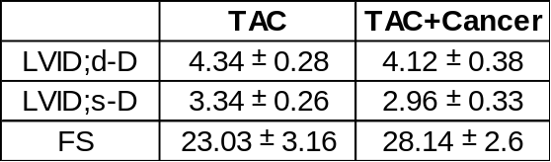

Supplemental table 2: Echocardiography parameters of figure 1B.
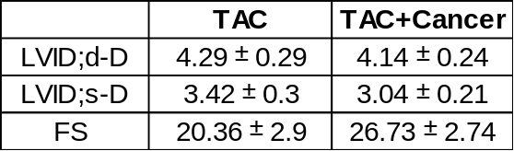
Supplemental table 3: Echocardiography parameters of Supp. figure 1B.
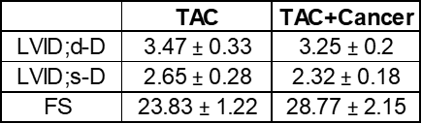
Supplemental table4: Echocardiography parameters of Supp. figure 2B.

