Supplementary information

Supplementary Table 1 The summary of clinical parameters and histology of SARS-CoV-2 infections in Roborovski SH101 hamster.
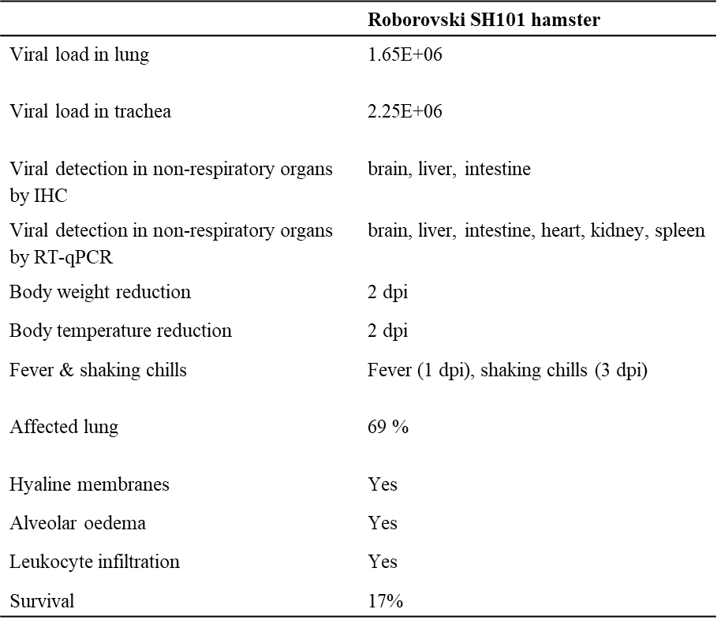

Supplementary Fig. 1 The infection rate in lung of Roborovski SH101 hamster infected with SARS-CoV-2. The infection rate was counted from lung imaging and pathological examination of infected Rovorovski SH101 hamsters at 2 and 4 dpi (n=6). VC, Virus control; ALD, Antibody low dose (SARS-CoV-2 + hzVSF-v13 10 mg/kg); AHD, Antibody high dose (SARS-CoV-2 + hzVSF-v13 30 mg/kg). RSV, remdesivir treatment (SARS-CoV-2 + remdesivir.

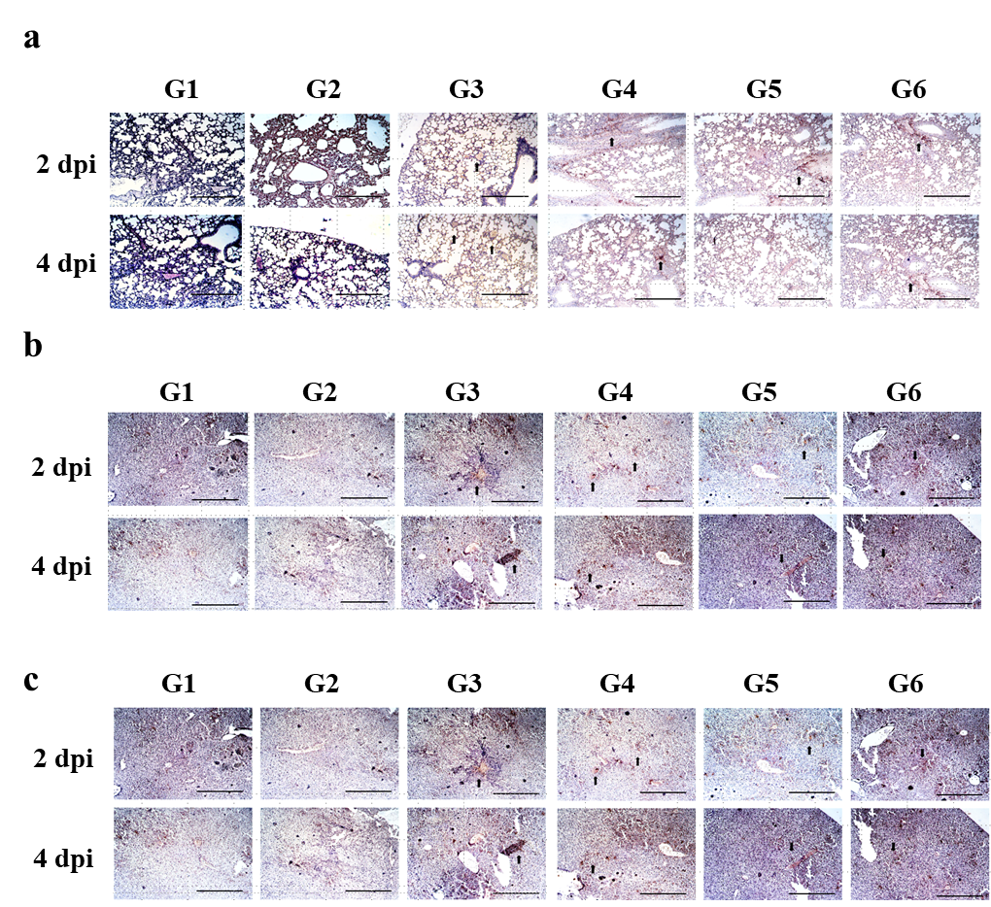

Supplementary Fig. 2 Histological examination of Roborovski SH101 hamster infected with SARS-CoV-2. The representative images of the IHC of the (a)lung, (b) brain and (c) liver of Roborovski SH101 hamster at 2 and 4 dpi of SARS-CoV-2. It has been observed that the brown portion of tissue increases according to the degree of viral infection (black arrow). G1, uninfected control; G2, antibody control group with hzVSF-v13 (10 mg/kg on 0 and 2 dpi); G3, virus control group treated with saline (0 and 2 dpi) after SARS-CoV-2 infection; G4, experimental group treated with hzVSF-v13 (10 mg/kg on 0 and 2 dpi) after SARS-CoV-2 infection; G5, experimental group treated with hzVSF-v13 (30 mg/kg on 0 and 2 dpi) after SARS-CoV-2 infection; G6, Remdesivir group treated with remdesivir (5 mg/kg for day 0 and 2.5 mg/kg afterwards) after SARS-CoV-2 infection. The scale bars represent 100 μm for 100ⅹ.

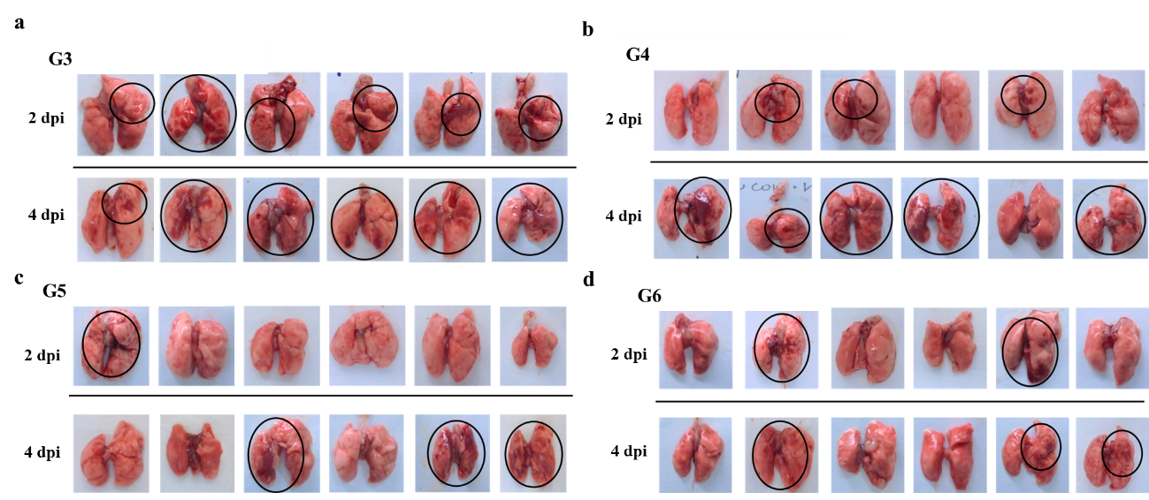
Supplementary Fig. 3 The photographic images of the dissected lungs of the SARS-CoV-2-infected Rovorovski SH101 hamster. G3, virus control group treated with saline (0 and 2 dpi) after SARS-CoV-2 infection; G4, experimental group treated with hzVSF-v13 (10 mg/kg on 0 and 2 dpi) after SARS-CoV-2 infection; G5, experimental group treated with hzVSF-v13 (30 mg/kg on 0 and 2 dpi) after SARS-CoV-2 infection; G6, Remdesivir group treated with remdesivir (5 mg/kg for day 0 and 2.5 mg/kg afterwards) after SARS-CoV-2 infection.

