Supplementary Information
Figure(s)
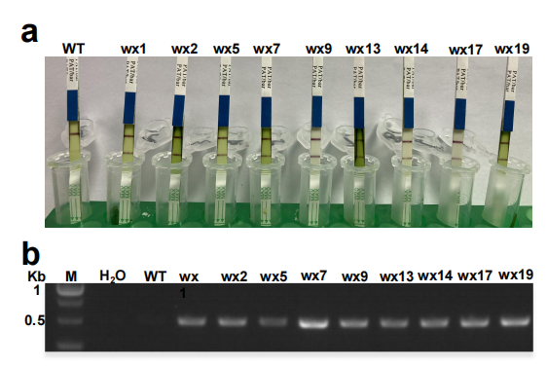
Figure S1. The determination of the transgenic plants. (a) Leaves assay of the transgenic plants for bar protein by PAT/bar test strip resistance kit. (b) PCR detection of Ubi region in the transgenic plants. WT: wild type; wx1 to wx19: independent transgenic plants.

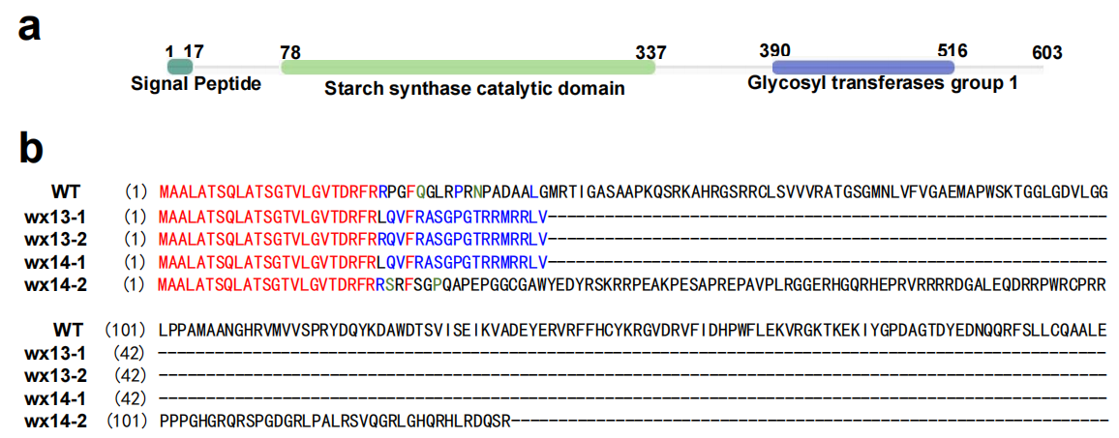
Figure S2. (a)The domains of GBSSI protein and (b) amino acids sequence alignment of Waxy allelic genes. WT: wild type.

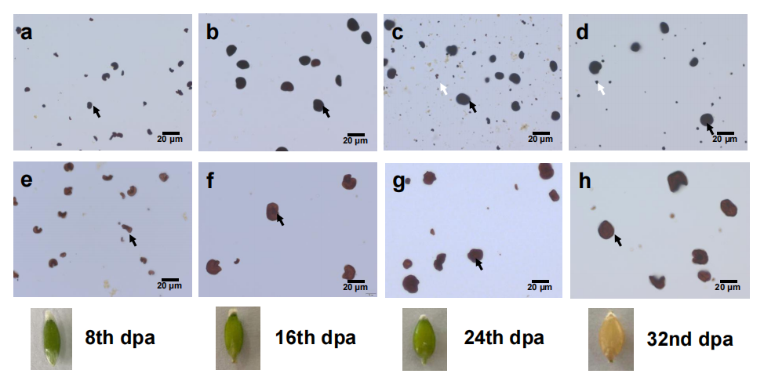
Figure S3. The starch granules images of different developing grains. (a-d) Wild type; (e-h) waxy mutants. Black arrow: A-type granules; white arrow: B-type granules. dpa: day post anthesis.

Figure S4. The relative expression levels of Waxy gene in different developing grains. dpa: day post anthesis; bars: standard errors; values followed by the same letters in each sample are not significantly different at p < 0.01 level.

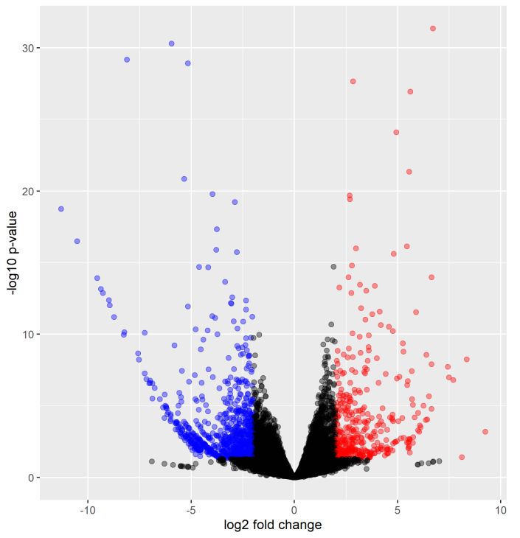
Figure S5. DEGs in the grains between the wild type and waxy mutants. Red point: down-regulated genes in the waxy mutants; blue point: up-regulated genes in the waxy mutants; grey point: not differentially expressed genes between the wild type and waxy mutants.

Figure S6. The KEGG pathway analysis of DEGs between the wild type and waxy mutants.

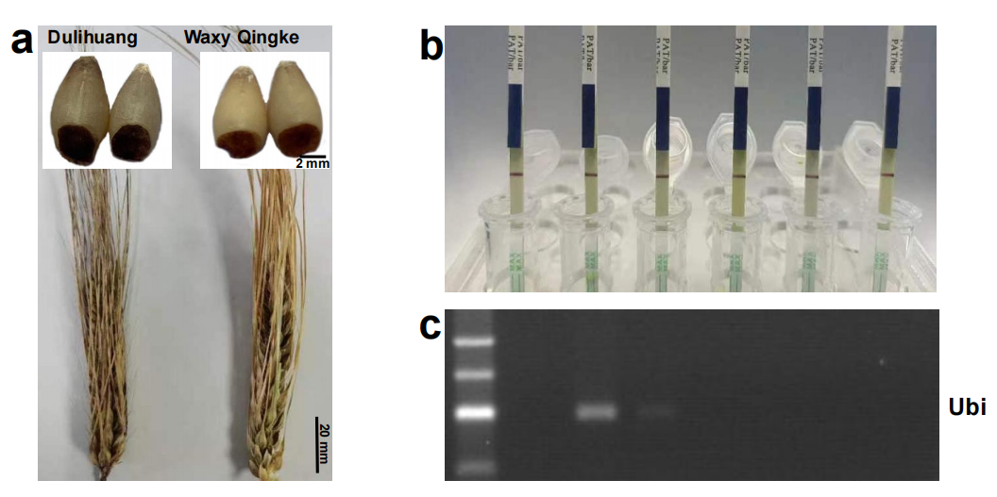
Figure S7. Selection of the marker-free waxy Qingke. (a) The performance of the spikes and grains. (b) Leaves assay for bar protein by PAT/bar test strip resistance kit. (c) PCR detection of Ubi region.

Table S1
Primer sequences used in this research.
Primers | Primer sequences
wxF | CTCTCACTGCAGGTAGCCAC
wxR | CAGGCGTCCTTGTACTGATC
T1F | AATAATGGTCTCAGGCGGCATGAACCTCGTGTTCGT
T1F0 | GGCATGAACCTCGTGTTCGTGTTTTAGAGCTAGAAATAGC
T2R0 | GGACGCCGGAATCTGTCGGTGCTTCTTGGTGCCGC
T2R | ATTATTGGTCTCTAAACGGACGCCGGAATCTGTCGGT
ubiF | CGGTAGTTCTACTTCTGTTC
ubiR | CATCTCTGTATATGCATCAG
wxQF | CCAGTCCAATGGCATCTACA
wxQR | GGCTCACCGTCAGCACCT
α-TublinF | CAAGGAGGTGGACGAGCAGATG
α-TublinR | GACTTGACGTTGTTGGGGATCCA

Table S2
Grain compounds between the wild type and waxy mutants.
 | Amylose (%) | Amylopection (%) | Soluble sugar (%) | Sucrose (%) | β-Glucan (%) | Protein (%)
Wild type | 33.50±2.64 | 39.00±3.12 | 10.2±0.35 | 0.73±0.08 | 3.22±0.12 | 10.88±0.08
Waxy | 0.00±0.00** | 31.73±0.50 | 37.3±2.54** | 1.20±0.07** | 4.36±0.15** | 11.94±0.15
Means values ± standard deviation; * P < 0.05; ** P < 0.01.

Table S3
Agronomic traits between the wild type and waxy mutants.
 | Plant height (cm) | Number of tillers | Panicle length (cm) | Grains per spike | Thousand grain weight(g)
Wild type | 79.35±3.28 | 9.05±2.41 | 9.33±1.20 | 30.60±2.56 | 44.40±1.42
Waxy | 78.75±3.29 | 8.20±1.69 | 9.35±0.97 | 28.80±2.67 | 39.77±0.54**
Means values ± standard deviation; ** P < 0.01.

Table S4
DEGs related to starch and sucrose metabolism between the wild type and waxy mutants.
Unigenes | log2FoldChange | Change in waxy mutants | KEGG Annotation | KEGG ID
HORVU.MOREX.r2.5HG0406880.1.mrna1 | 6.12 | up | beta-glucosidase | [EC:3.2.1.21]
HORVU.MOREX.r2.6HG0522120.1.mrna1 | 4.91 | up | beta-glucosidase | [EC:3.2.1.21]
HORVU.MOREX.r2.7HG0535140.1.mrna1 | 4.08 | up | glucan endo-1,3-beta-glucosidase 1/2/3 | [EC:3.2.1.39]
HORVU.MOREX.r2.7HG0598800.1.mrna1 | 3.60 | up | beta-glucosidase | [EC:3.2.1.21]
HORVU.MOREX.r2.6HG0508120.1.mrna1 | 3.26 | up | endoglucanase | [EC:3.2.1.4]
HORVU.MOREX.r2.5HG0414040.1.mrna1 | 3.25 | up | glucan endo-1,3-beta-glucosidase 1/2/3 | [EC:3.2.1.39]
HORVU.MOREX.r2.6HG0499810.1.mrna1 | 3.11 | up | beta-glucosidase | [EC:3.2.1.21]
HORVU.MOREX.r2.7HG0553070.1.mrna1 | 3.08 | up | starch synthase | [EC:2.4.1.21]
HORVU.MOREX.r2.2HG0158540.1.mrna1 | 2.96 | up | glucan endo-1,3-beta-glucosidase 1/2/3 | [EC:3.2.1.39]
HORVU.MOREX.r2.5HG0425120.1.mrna1 | 2.94 | up | glycogen phosphorylase | [EC:2.4.1.1]
HORVU.MOREX.r2.7HG0585010.1.mrna1 | 2.85 | up | beta-glucosidase | [EC:3.2.1.21]
HORVU.MOREX.r2.3HG0266640.1.mrna1 | 2.78 | up | glucan endo-1,3-beta-glucosidase 1/2/3 | [EC:3.2.1.39]
HORVU.MOREX.r2.7HG0540020.1.mrna1 | 2.73 | up | beta-glucosidase | [EC:3.2.1.21]
HORVU.MOREX.r2.2HG0137200.1.mrna1 | 2.67 | up | beta-fructofuranosidase | [EC:3.2.1.26]
HORVU.MOREX.r2.7HG0543180.1.mrna1 | 2.52 | up | starch synthase | [EC:2.4.1.21]
HORVU.MOREX.r2.7HG0623530.1.mrna1 | 2.40 | up | 1,4-alpha-glucan branching enzyme | [EC:2.4.1.18]
HORVU.MOREX.r2.7HG0577820.1.mrna1 | 2.35 | up | glucose-1-phosphate adenylyltransferase | [EC:2.7.7.27]
HORVU.MOREX.r2.6HG0510740.1.mrna1 | 2.25 | up | beta-glucosidase | [EC:3.2.1.21]
HORVU.MOREX.r2.6HG0498580.1.mrna1 | 2.23 | up | trehalose 6-phosphate phosphatase | [EC:3.1.3.12]
HORVU.MOREX.r2.2HG0136670.1.mrna1 | 2.23 | up | 1,4-alpha-glucan branching enzyme | [EC:2.4.1.18]
HORVU.MOREX.r2.1HG0075760.1.mrna1 | 2.05 | up | glucose-1-phosphate adenylyltransferase | [EC:2.7.7.27]
HORVU.MOREX.r2.1HG0045280.1.mrna1 | -2.00 | down | beta-amylase | [EC:3.2.1.2]
HORVU.MOREX.r2.7HG0535060.1.mrna1 | -2.04 | down | granule-bound starch synthase | [EC:2.4.1.242]
HORVU.MOREX.r2.4HG0344930.1.mrna1 | -2.11 | down | beta-fructofuranosidase | [EC:3.2.1.26]
HORVU.MOREX.r2.7HG0591610.1.mrna1 | -2.16 | down | beta-glucosidase | [EC:3.2.1.21]
HORVU.MOREX.r2.7HG0596110.1.mrna1 | -2.31 | down | alpha-glucosidase | [EC:3.2.1.20]
HORVU.MOREX.r2.3HG0261390.1.mrna1 | -2.35 | down | beta-glucosidase | [EC:3.2.1.21]
HORVU.MOREX.r2.7HG0596190.1.mrna1 | -2.49 | down | alpha-glucosidase | [EC:3.2.1.20]
HORVU.MOREX.r2.5HG0406300.1.mrna1 | -2.80 | down | alpha-glucosidase | [EC:3.2.1.20]
HORVU.MOREX.r2.2HG0094620.1.mrna1 | -2.80 | down | beta-fructofuranosidase | [EC:3.2.1.26]
HORVU.MOREX.r2.1HG0012530.1.mrna1 | -2.92 | down | endoglucanase | [EC:3.2.1.4]
HORVU.MOREX.r2.3HG0192330.1.mrna1 | -3.08 | down | beta-glucosidase | [EC:3.2.1.21]
HORVU.MOREX.r2.3HG0239670.1.mrna1 | -3.67 | down | beta-glucosidase | [EC:3.2.1.21]
HORVU.MOREX.r2.5HG0402940.1.mrna1 | -5.22 | down | alpha-amylase | [EC:3.2.1.1]
HORVU.MOREX.r2.7HG0596180.1.mrna1 | -5.27 | down | alpha-glucosidase | [EC:3.2.1.20]
HORVU.MOREX.r2.3HG0266210.1.mrna1 | -5.51 | down | glucan endo-1,3-beta-glucosidase 1/2/3 | [EC:3.2.1.39]

Table S5
Sensory evaluation of dry noodles between the wild type and waxy mutants .
 | Color | Appearance | Palatability | Elasticity | Sticky | Slipperiness | Taste
Wild type | 6.47±2.08 | 8.32±0.52 | 15.0±2.45 | 16.3±3.53 | 20.9±2.28 | 4.52±1.66 | 4.32±0.24
Waxy | 6.99±1.48 | 7.87±1.19 | 12.5±2.76 | 15±4.59 | 19.5±2.76 | 4.30±1.62 | 4.19±0.57
Means values ± standard deviation; * P < 0.05.

