Supporting Informations

Leaf vein topology confers water transport efficiency
Amy Ny Aina Aritsara^{1,2}, Ming-Yuan Ni³, Tahiana Ramananantoandro⁴, Shi-Dan Zhu¹, You-Zhi Li², Sean M. Gleason⁵, Lawren Sack⁶, Kun-Fang Cao¹*
¹ Plant Ecophysiology and Evolution Group, State Key Laboratory for Conservation and Utilization of Subtropical Agro-bioresources, and Guangxi Key Laboratory of Forest Ecology and Conservation, College of Forestry Guangxi University, Nanning, Guangxi, 530004, China
² College of Life Science and Technology, Guangxi University, Nanning 530004, China
³ School of Basic Medical Sciences, Youjiang Medical University for Nationalities, Baise 533000, China
⁴ Unité de Formation et de Recherche Sciences du Bois, Département Foresterie et Environnement, Ecole Supérieure des Sciences Agronomiques, Université d’Antananarivo, BP.175, Antananarivo, Madagascar
⁵ Water Management and Systems Research Unit, USDA-ARS, Fort Collins, CO 80526, USA
⁶ Department of Ecology and Evolutionary Biology, University of California, 621 Charles E. Young Drive South, Los Angeles, CA 90095-1606, USA
Author for correspondence:
Kun-Fang Cao
Tel: +86-18587786323, Email: kunfangcao@gxu.edu.cn,

- T-test and phylogenetic ANOVA comparison between two groups of species, including, vein density (VD), vein topological efficiency (VTE), non-vein area fraction (NV), leaf mass per area (LMA), stomatal conductance (G_{smax}), leaf turgor loss water potential (TLP) and leaf capacitance (C₁) before turgor loss. Significant differences are represented by: ***: p<0.001, *:0.01<p<0.05 and “ns” for non-significant correlations.

Traits | Tropical site | Subtropical site | T.test | Phylogenetic ANOVA
VD | 7.44 ± 0.41 | 8.21 ± 0.52 | ns | ns
VTE | 3.41 ± 0.5 | 6.33 ± 0.65 | *** | ns
LMA | 142 ± 7 | 82 ± 6 | *** | *
nVF | 67.3 ± 1.8 | 72.4 ± 1.8 | * | ns
C₁ | 0.999 ± 0.097 | 1.636 ± 0.209 | ** | *
TLP | -1.84 ± 0.08 | -1.87 ± 0.08 | ns | ns
G_{smax} | 0.621 ± 0.042 | 1.906 ± 0.172 | *** | ***

  - Independence of vein topological efficiency (VTE) and vein density (VD). The open circles are the species from the tropical site (Tr) and the filled points are those from the subtropical site (St). The error bars are the standard errors. “ns” refers to non-significant correlations.
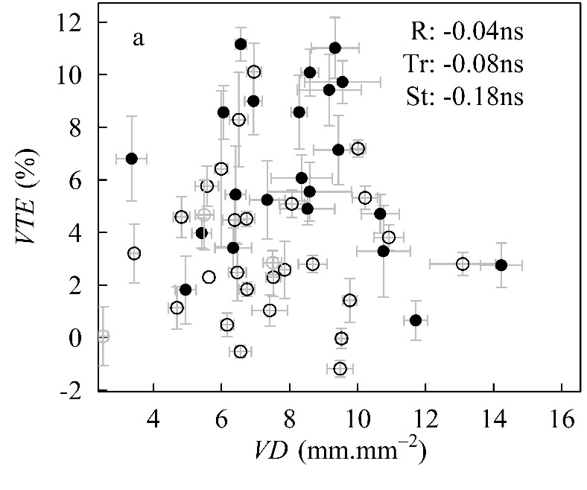
  - Contribution of different form of free end-veinlet (FEV) density to vein topological efficiency (VTE). The open circles and dashed lines are the species from the tropical site (Tr) and the filled points and dotted lines are those from the subtropical site (St). The strength and significance of each correlation are represented by the correlation coefficient (R), the error bars are the standard errors, and **: 0.001<p<0.01, *:0.01<p<0.05 and “ns” for non-significant correlations.
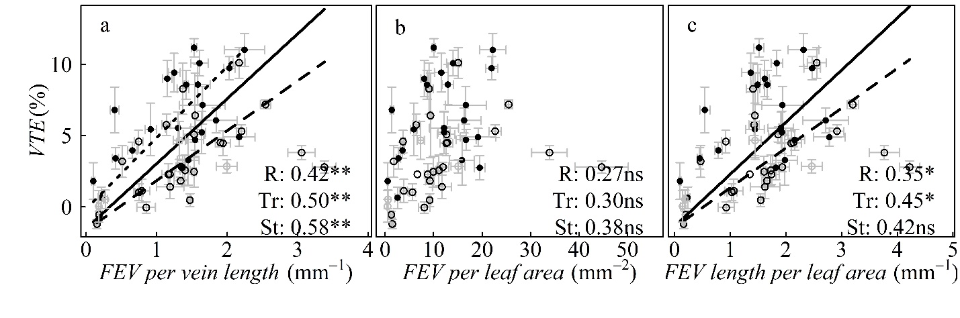

  - Leaf micrographs with different topology. Species from the tropical site are on the left column and those from the subtropical site are on the right.
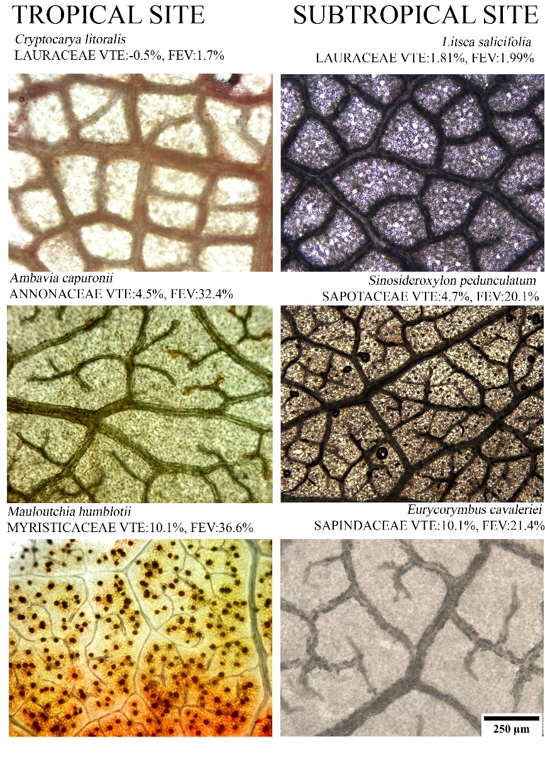

  - Correlations among leaf mass per area, the non-vein fraction area and the theoretical maximum stomatal conductance (G_{smax}). The open circles and dashed lines are the species from the tropical site (Tr) and the filled points and dotted lines are those from the subtropical site (St). The error bars are the standard errors. The significance of each correlation is represented by: ***: p<0.001, **: 0.001<p<0.01, *:0.01<p<0.05 and “ns” for non-significant correlations.
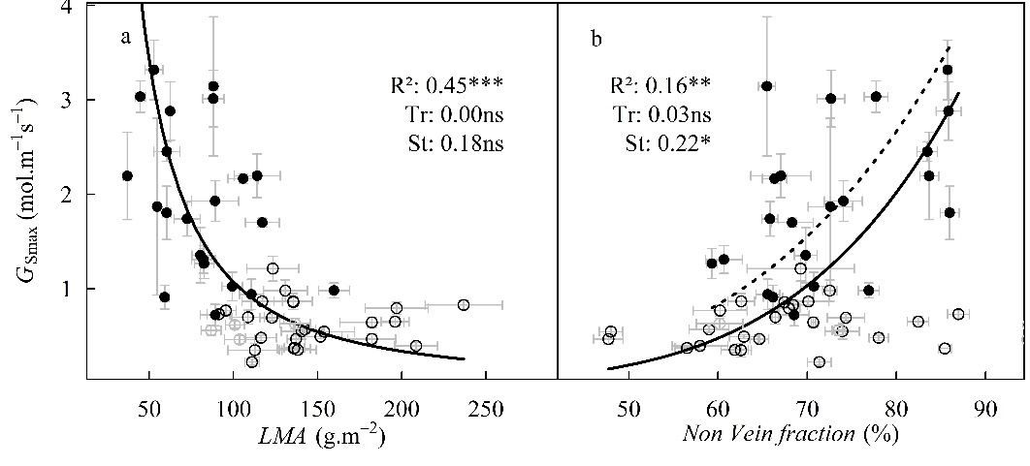

  - Correlations between the phylogenetic contrasts of vein topological efficiency (VTE), stomatal conductance (G_{smax}), non-vein area fraction and leaf mass per area (LMA). The significance of each correlation is represented by: ***: p<0.001 and “ns” for non-significant correlation (p>0.05).
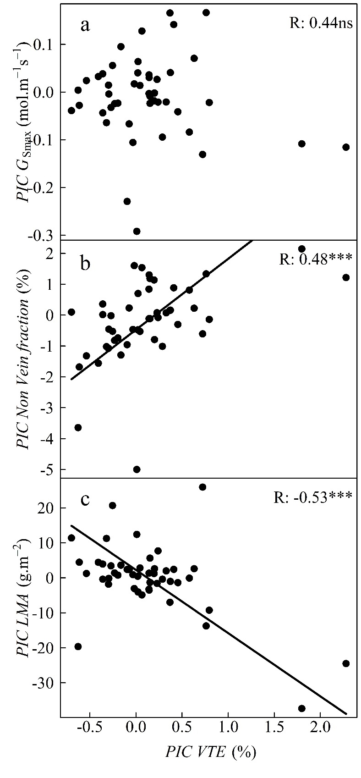
  - Correlations between vein topological efficiency (VTE), turgor loss water potential (TLP) and capacitance (C₁). The open circles are the species from the tropical site (Tr) and the filled points are those from the subtropical site (St). The significance of each correlation is represented by: ***: p<0.001, **: 0.001<p<0.01, *:0.01<p<0.05 and “ns” for non-significant correlations.
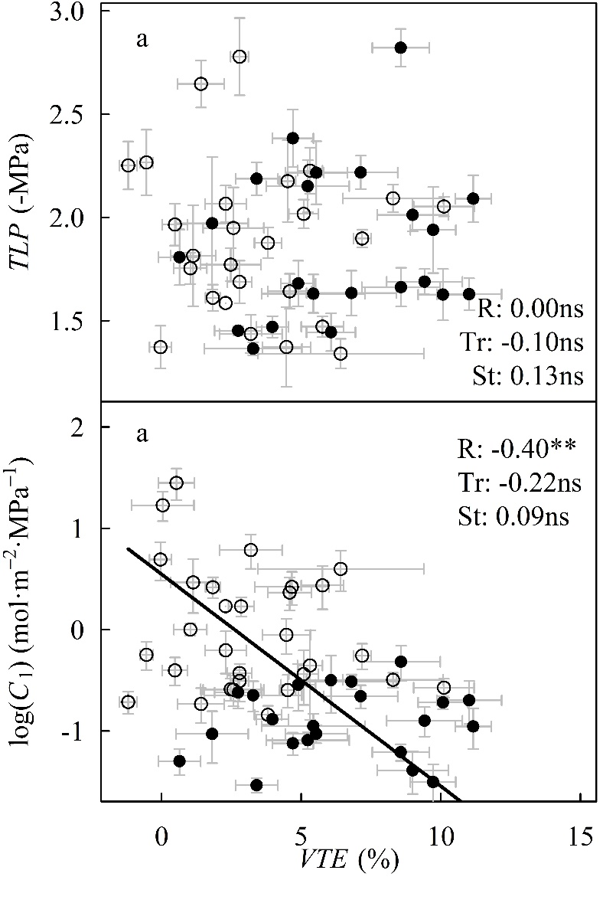
  - Phylogenetic tree of the studied species and phylogenetic signal (Blomberg’s K) of vein density (VD) and vein topological efficiency (VTE). The species from the tropical site are in blue and those from the subtropical site are in red.
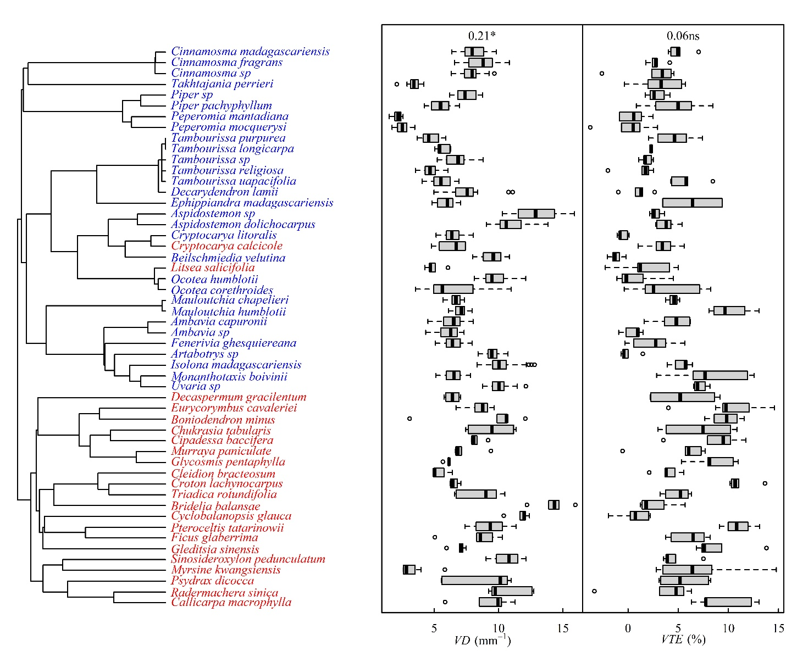

- Detailed calculation of equation (3)

We pose S is the side of the leaf area delimited in green in Error! Reference source not found.-1B. The area of this square A_{leaf} is S². The red line is the middle of the vein (in blue) associated to this area; T is the thickness of the vein.
So, the total area of the four regions in white (A_{areole}) is:
$A_{areole}=4{(S/2-T/2)}^{2}$,
Therefore, the vein area fraction is
$V_{f}=\frac{A_{leaf}-A_{areole}}{A_{leaf}}=\frac{1}{S^{2}}×\left[S^{2}-4{×(S/2-T/2)}^{2}\right]$,
The decomposition of this equation gives,
$V_{f}=2T/S-{(T/S)}^{2}$,

