Supplementary Information
Naked-Eye Observation of Water-Forming Reaction on Palladium Etalon: Transduction of Gas-Matter Reaction into Light-Matter Interaction
Jongsu Lee^{1,2}, Eui-Sang Yu¹, Taehyun Kim^{1,3}, In Soo Kim⁴, Jeonghun Kwak², Sin-Doo Lee², Seok Chung^{3,5}, Seung Jae Kwak⁶, Won Bo Lee⁶, Yusin Pak⁷*, and Yong-Sang Ryu^{1,8}*
¹ Brain Science Institute, Korea Institute of Science and Technology, Seoul 02792, Republic of Korea
² Department of Electrical and Computer Engineering, Seoul National University, Seoul 08826, Republic of Korea
³ Department of Micro/Nano Systems, Korea University, 02841, Seoul, Republic of Korea.
⁴ Nanophotonics Research Center, Korea Institute of Science and Technology, Seoul 02792, Republic of Korea
⁵ School of Mechanical Engineering, Korea University, Seoul 02841, Republic of Korea
⁶ School of Chemical and Biological Engineering, Seoul National University, Seoul 08826, Republic of Korea
⁷ Sensor System Research Center, Korea Institute of Science and Technology, Seoul 02792, Republic of Korea
⁸ KU-KIST Graduate School of Converging Science and Technology, Korea University, Seoul 02481, Republic of Korea

*Correspondence and requests for materials should be addressed to Y. P. (yusinpak@kist.re.kr) and Y.-S.R. (ysryu82@kist.re.kr).

Supplementary Note 1: DFT calculations
All density functional theory (DFT) calculations were performed using VASP6 (Vienna Ab-initio Software Package) with the projector augmented wave method (PAW) [1, 2, 3, 4]. The plane wave kinetic energy cutoff was set at 520 eV and Monkhorst-Pack 3×3×1 points were used for calculations [5]. Perdue-Burke-Ernzerhof (PBE) exchange-correlation functionals were used [6]. The forces acting on each atom were relaxed to under 0.02 eV/Å. Four metallic layers of the face-centered cubic (FCC) Pd(111)-p(2×2) and PdH(111)-c(2×2) surfaces were chosen to calculate the initial water formation reaction steps. The two bottom layers were fixed to the bulk coordinates. An oxygen coverage of 0.50 monolayer (ML) and hydrogen coverage of 0.50 ML were set to model the initially oxygen-saturated Pd and hydrogen-saturated PdH surfaces.

Supplementary Note 2: Polymer dielectric control experiments
Polymethyl methacrylate (PMMA) has been widely used as a protective insulator for the reactive metal layers of hydrogen sensors to increase their sensitivity by blocking the competitive adsorption of oxygen species. When the Pd surface was coated with 180-nm of PMMA by spin-coating, no water-bubble formation was observed, whereas the sample with the perfluoro-(butenyl vinyl ether) (PBVE) film showed a drastic color change (Fig. S1). Because only hydrogen is adsorbed and Pd becomes PdH_{X}, its overall reflectivity decreases slightly because of the different optical properties of PdH_{X} compared to Pd [7].
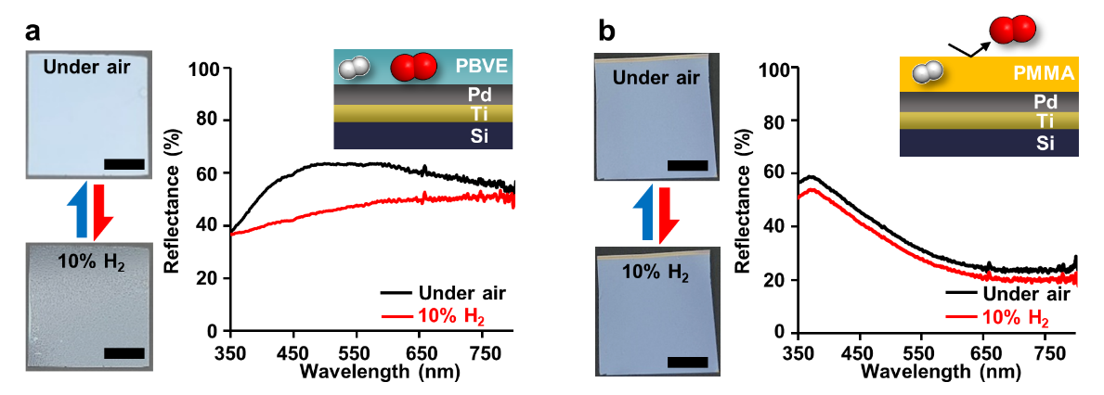
Figure S1. Effect of gas permeability of the polymer dielectric on water-forming reaction and following spectral response. (a, b) Photographs and measured reflectance spectra of the Pd/Ti/Si sample coated with 180 nm of PBVE (a) and PMMA (b) under air (top, black) and 10% H₂ exposure (bottom, red). Scale bars, 5mm.

Supplementary Note 3: FLIC simulation and fitting
For the three-dimensional (3D) analysis of water bubbles, calcein, as the fluorescent dye with excitation ($λ_{ex}$) and emission ($λ_{em})$ wavelengths of 488 and 525 nm, respectively, were applied on top of the PBVE layer. Because the z-direction height of the calcein layer (z) varies owing to the water formed underneath it, the normalized fluorescence (FL) intensity (F) can be derived using the following equation:
(S1)
$$F=\sin^{2}\left(\frac{2π\left(n_{water}∙z+n_{PBVE}{∙t}_{PBVE}\right)}{λ_{ex}}\right)\sin^{2}\left(\frac{2π\left(n_{water}∙z+n_{PBVE}{∙t}_{PBVE}\right)}{λ_{em}}\right)$$
where t_{PBVE} is the thickness of the PBVE, and both the refractive indices of water (n_{water}) and PBVE (n_{PBVE}) were approximated to be 1.34. As the height (h_{water}) and radius (r) of the water bubble are determined, the corresponding z-coordinate at the x-position can be calculated as follows:
(S2)
$$z=\frac{h_{water}+t_{PBVE}}{r}\sqrt{r^{2}-x^{2}}$$
derived from an elliptical equation. For example, when t_{PBVE} is 180 nm, the number of interference patterns increases for every 110 nm increment of h_{water} from 110 to 550 nm, as shown in Fig. S2. Therefore, it briefly interprets the 3D shape of the water bubbles.
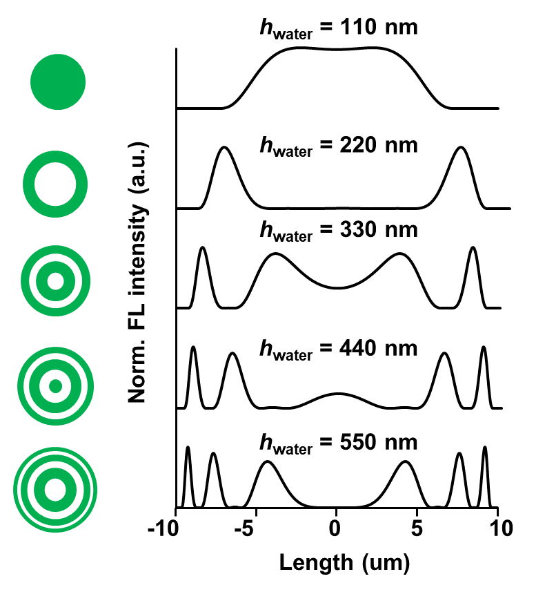

Figure S2. Expected interference patterns and FL intensity depending on the water bubble height. Simulated normalized FL intensity for h_{water} from 110 nm to 550 nm when t_{PBVE} is 180 nm.

Supplementary Note 4: Optical simulation
To predict the structural color of the Fabry-Perot (FP) resonating etalon, rigorous coupled wave analysis (RCWA) [8] was conducted with Bruggeman’s effective medium theory (BEMT) [9, 10] to approximate the nanostructure of the top metal. Because the top metal is a mixture of metal and air, its effective dielectric permittivity (ε_{eff}) can be calculated using the following equation:
$f_{1}\frac{ε_{1}-ε_{eff}}{ε_{1}+{κε}_{eff}}+f_{2}\frac{ε_{2}-ε_{eff}}{ε_{2}+{κε}_{eff}}=0$ (S3)
where ε_{i} (i=1, 2) and f_{i} (i=1, 2) are the permittivity and volumetric filling fraction of each material (metal and air), respectively. The Lorentz depolarization factor (κ) was 1, assuming that the top metal/air mixture film was 2-dimensional. As shown in Fig. S3, f_{Pd} was obtained from the scanning electron microscopy (SEM) images, and it increases proportionally with t_{Pd}. Based on the quartz crystal balance (QCM) thickness and filling fraction of Pd deposited on PBVE from SEM images, spectral simulation was obtained using RCWA and plotted on the CIE 1394 color map. The t_{Pd} of 15 nm with f_{Pd} of 0.45 shows the optimum color coverage as t_{PBVE} varies from 0 to 1200 nm.
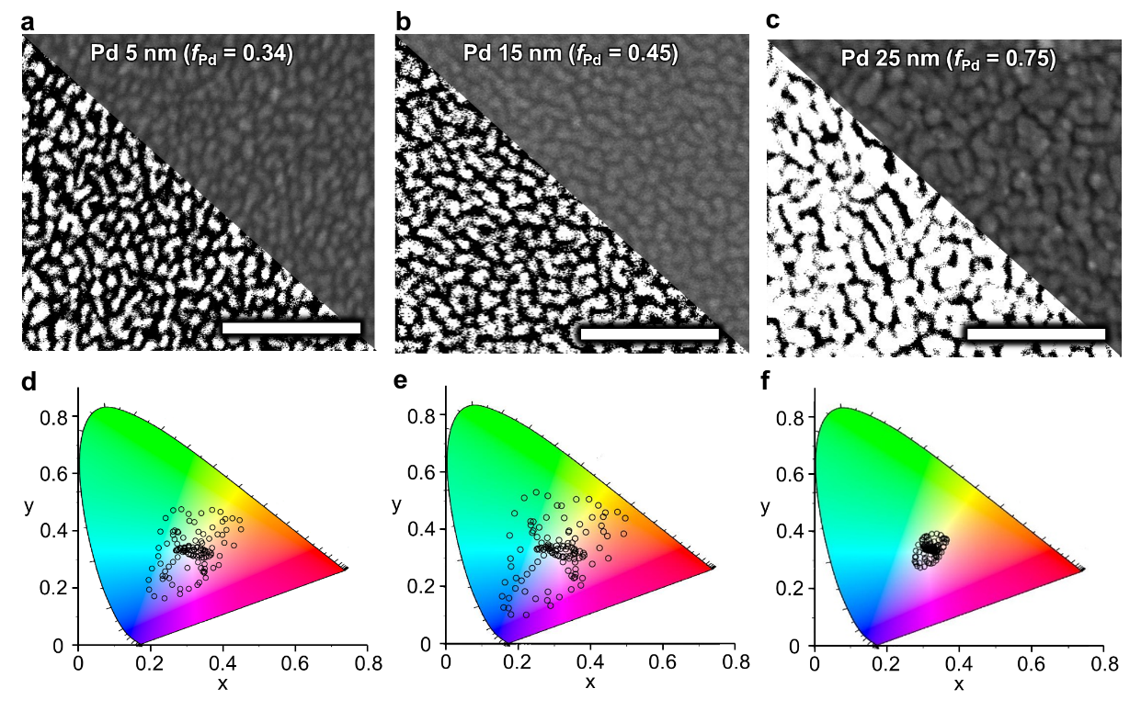
Figure S3. Filling fraction and color coverage depending on top Pd thickness. (a–c) Top view SEM images of 5 nm (a), 15 nm (b), and 25 nm (c) thick top Pd deposited on PBVE. (d–f) Simulated plots on CIE 1394 color map when t_{PBVE} varies from 0 nm to 1200 nm with 10 nm intervals. Top Pd thicknesses and filling fractions are adopted from a to c, respectively. Scale bars, 100 nm.

Supplementary Note 5: FP etalon fabrication process and color map
Modification of the t_{PBVE} is achieved by a reactive ion etching (RIE) process using a shadow mask. On a 4-inch silicon (Si) wafer, 10 nm of bottom Pd with a titanium (Ti) adhesion layer was thermally deposited. As shown in Fig. S4a, a PBVE with a thickness of 590 nm was spin-coated and cured. A shadow mask was moved from left to right and then from bottom to top by 1 cm between each dry etching process. Before top metal deposition, the sample was annealed on a hotplate at 180 °C for 30 min to recover the original surface energy of the PBVE. The PBVE layer thickness was calculated from the measured reflectance spectrum, as shown in Fig. S4b. The expected structural color map, depending on t_{PBVE}, was obtained from the optical simulation (Fig. S4c and S4d), and the experimental and simulation results match each other.
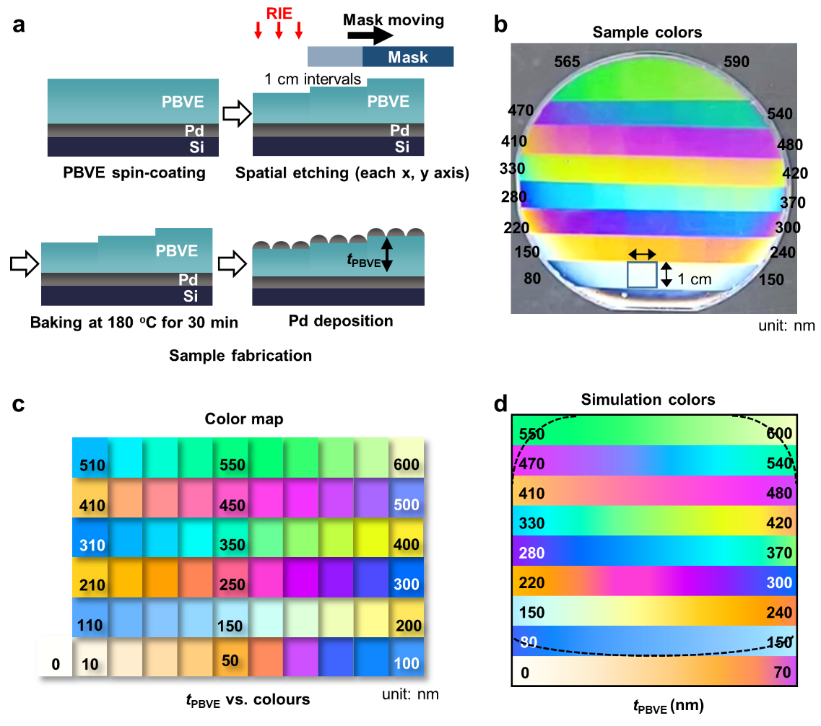
Figure S4. Fabrication process and structural color generations. (a) Schematic illustration of the fabrication process of the FP etalon on a Si wafer having various colors. (b) Photograph of the fabricated FP etalon sample with calculated t_{PBVE} labelled. (c) Simulated color map as t_{PBVE} varies from 0 nm to 600 nm with an interval of 10 nm. (d) Expected color of the FP etalon on a wafer based on the simulation results.

Supplementary Note 6: Spectral simulation for water film increment
When the thickness of dielectric layer (t_{dielectric}) is the sum of t_{PBVE} and height of the water layer (h_{water}), the measured spectra in Fig. 4c can be interpreted as the initial t_{dielectric} at 418 nm, increasing up to 719 nm, while sufficient O₂ is applied to the chamber. After cutting off the O₂ supply, the spectra change behavior follows a similar trend as t_{dielectric} decreases from 750 to 420 nm (Fig. S5).
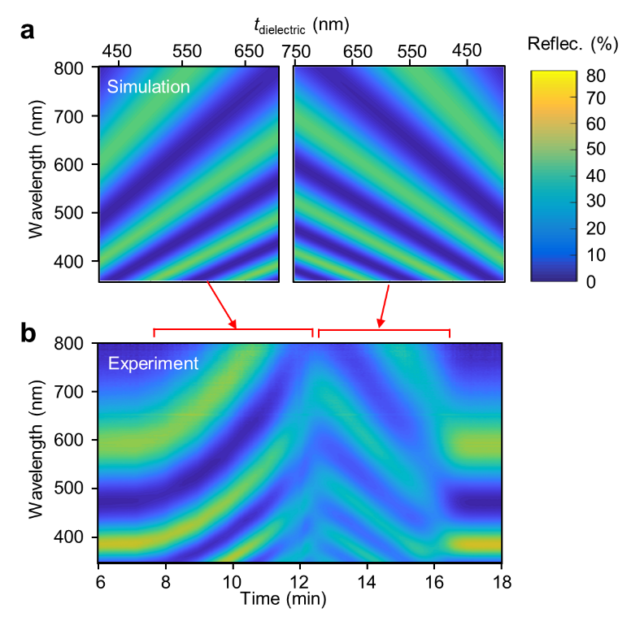
Figure S5. Spectral behavior depending on t_{dielectric}. (a) Simulated reflectance spectra of FP etalon as a function of t_{dielectric}. (b) Measured reflectance spectra from Fig. 4c which was enlarged for the area of spectral shifting.

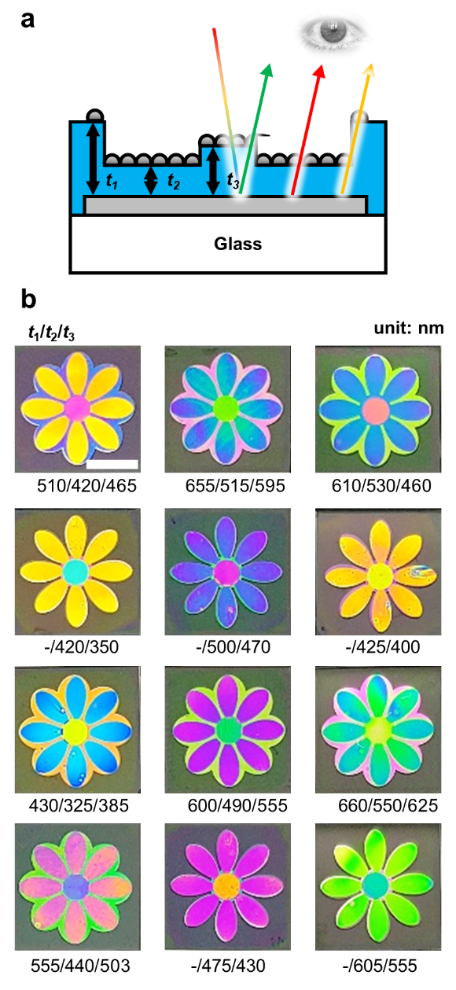
Figure S6. Dielectric thickness information of f-etalons. (a) Schematic illustration showing the underlying mechanism for colorimetric f-etalon. Modulating dielectric thickness results in color variation in visible spectra. (b) Calculated thickness of PBVE from the color spectra simulation as described in Supplmentary Note 4. All samples were prepared with the identical thickness of metal layers (top Pd: 15nm, bottom Pd: 10 nm, Ti adhesion layer: 10nm). Scale bar, 1 cm.

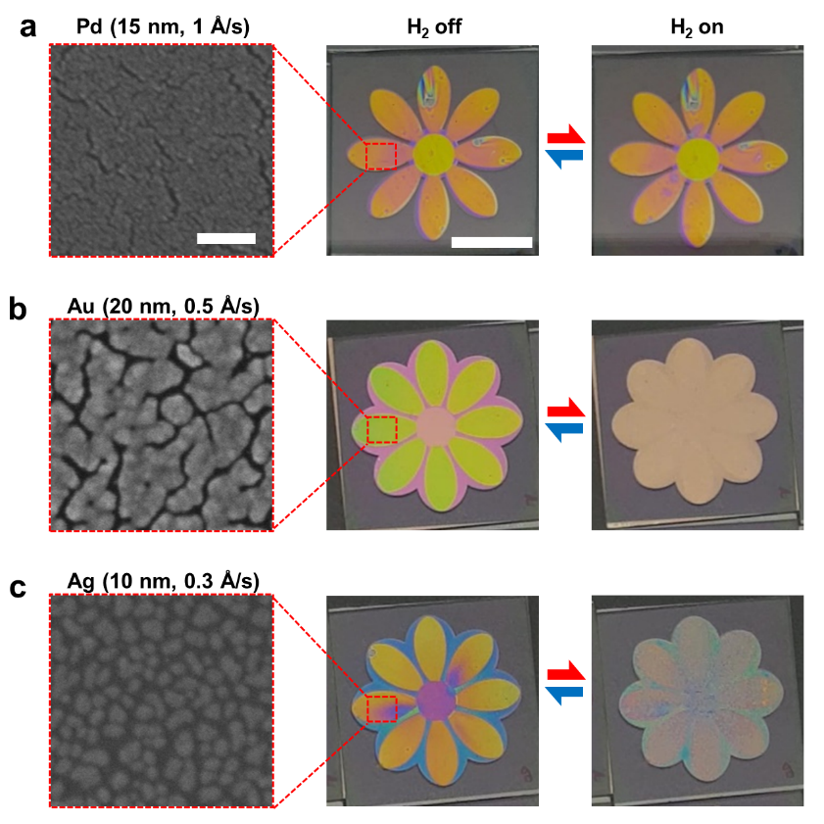
Figure S7. The f-etalons prepared with different top metals with various filling fraction. (a) No colorimetric changes were monitored when top metal metals were passivated with a flat film without nano-punctuation. Fast deposition rate (1 Å/s) results in full coverage of the dielectric layer barely allowing nano-apertures formation at the top metal layer when compared to the slow deposition rate (0.2 Å/s) of f-etalon as shown in main Fig. 5. (b, c) F-etalons prepared by gold (b) and silver (c) top metals. We monitored drastic color changes under H₂ exposure. SEM images demonstrate that the existence of nano-apertures is essential for gasochromic changes via water-film formation at the PBVE/Pd interface. All the samples were prepared with identical 10-nm-Pd film (bottom layer) with varying species and thickness of top metals. Also, identical gas moods were exposed to the samples (H₂/O₂/N₂= 10%/20%/70%). Scale bars in a, 100 nm (left) and 1 cm (middle); the scale bars in a also applies to b and c.

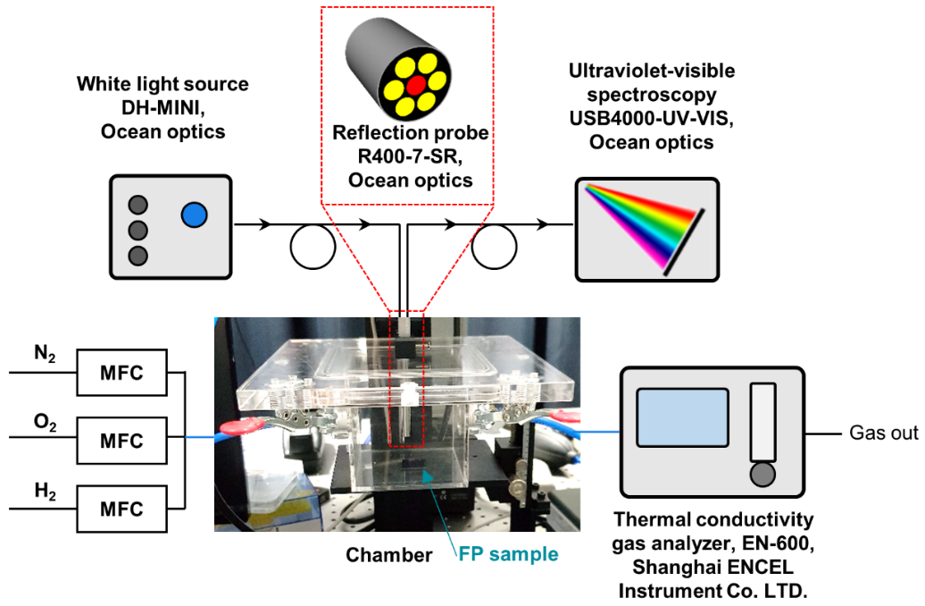
Figure S8. Experimental set-up. Schematic diagram of the gas exposure chamber with reflectance spectrum measurement. Each gas flow rate of N₂, O₂, and H₂ is precisely controlled by a MFC, and the H₂ concentration of the outlet gas was continuously monitored.

References
1. Kresse G, Furthmüller J. Efficiency of ab-initio total energy calculations for metals and semiconductors using a plane-wave basis set. Comput Mater Sci. 1996;6(1):15-50. doi:10.1016/0927-0256(96)00008-0.
2. Kresse G, Hafner J. Ab initio molecular dynamics for liquid metals. Phys Rev B. 1993;47(1):558. doi:10.1103/PhysRevB.47.558.
3. Kresse G, Furthmüller J. Efficient iterative schemes for ab initio total-energy calculations using a plane-wave basis set. Phys Rev B. 1996;54(16):11169. doi:10.1103/PhysRevB.54.11169.
4. Kresse G, Joubert D. From ultrasoft pseudopotentials to the projector augmented-wave method. Phys Rev B. 1999;59(3):1758. doi:10.1103/PhysRevB.59.1758.
5. Monkhorst HJ, Pack JD. Special points for Brillouin-zone integrations. Phys Rev B. 1976;13(12):5188. doi:10.1103/PhysRevB.13.5188.
6. Perdew JP, Burke K, Ernzerhof M. Generalized gradient approximation made simple. Phys Rev Lett. 1996;77(18):3865. doi:10.1103/PhysRevLett.77.3865.
7. She X, Shen Y, Wang J, Jin C. Pd films on soft substrates: a visual, high-contrast and low-cost optical hydrogen sensor. Light Sci Appl. 2019;8(1):1-10. doi:10.1038/s41377-018-0114-x.
8. Moharam M, Grann EB, Pommet DA, Gaylord T. Formulation for stable and efficient implementation of the rigorous coupled-wave analysis of binary gratings. J Opt Soc Am A. 1995;12(5):1068-76. doi:10.1364/JOSAA.12.001068.
9. Bruggeman DAG. The calculation of various physical constants of heterogeneous substances. I. The dielectric constants and conductivities of mixtures composed of isotropic substances. Ann Phys. 1935;416:636-791.
10. Choy TC. Effective medium theory: principles and applications. Oxford: Oxford University Press; 2015.

