Supplementary Material

Insight into the differences in carbon dots prepared from fish scales using conventional hydrothermal and microwave methods
Chengzhi Xu¹, Xiao Xiao², Chaonan Cai², Yanqiu Zhao², Lian Zhu^{1,3}, Juntao Zhang¹, Benmei Wei¹, Haibo Wang^{1,}*
¹ School of Chemistry and Environmental Engineering, Wuhan Polytechnic University, Wuhan, Hubei, China
² School of Food Science and Engineering, Wuhan Polytechnic University, Wuhan, Hubei, China
³ School of Chemistry and Environmental Engineering, Hubei Minzu University, Enshi, Hubei, China.
*To whom correspondence should be addressed: wanghaibo216@126.com

1. Macroscopic of fish scales with three different crushing methods
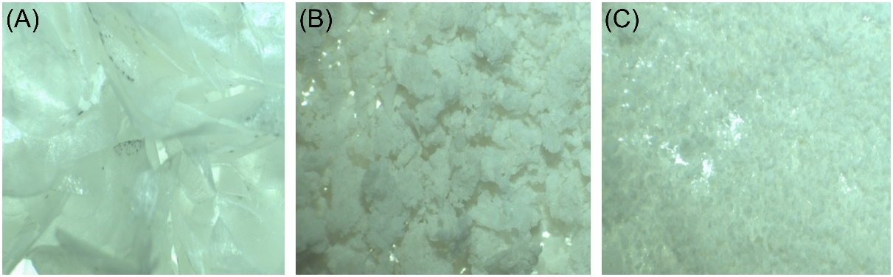
Figure S1. Effects of different crushing methods on scale morphology, shearing (A), ball milling (B), freezing grinding (C)

2. Single-factor analysis and orthogonal-experiment optimization reaction parameters for CDs
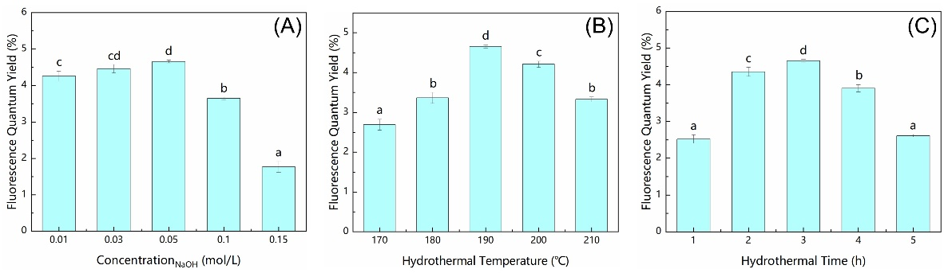
Figure S2. The effect of NaOH concentration (A), hydrothermal temperature (B) and hydrothermal time (B) on the quantum yield of CDs-HT. The results were presented as mean ± standard deviation (n=3). The differences between means were evaluated by Duncan’s multiple-range test, means that contain different letters are significantly different at P<0.05.

Tables S1 The experimental design based on L₉(3⁴) orthogonal array and experimental results of preparation conditions for CDs-HT
No. | A (NaOH concentration) | B (Hydrothermal time) | C (Empty column) | D (Hydrothermal temperature) | Quantum yield (%)
1 | 0.03 | 2 |  | 180 | 3.20
2 | 0.03 | 3 |  | 190 | 4.46
3 | 0.03 | 4 |  | 200 | 6.04
4 | 0.05 | 2 |  | 200 | 3.70
5 | 0.05 | 3 |  | 180 | 3.37
6 | 0.05 | 4 |  | 190 | 3.91
7 | 0.1 | 2 |  | 190 | 3.79
8 | 0.1 | 3 |  | 200 | 3.76
9 | 0.1 | 4 |  | 180 | 3.10
K₁ | 13.71 | 10.70 |  | 9.67
K₂ | 10.97 | 11.58 |  | 12.16
K₃ | 10.65 | 13.05 |  | 13.50
k₁ | 4.57 | 3.57 |  | 3.22
k₂ | 3.66 | 3.86 |  | 4.05
k₃ | 3.55 | 4.35 |  | 4.50
R | 3.06 | 2.35 |  | 3.83
K, Sum of quantum yield for the factors at each level; k, The mean values for the factors at each level; R, K_{max}-K_{min}.

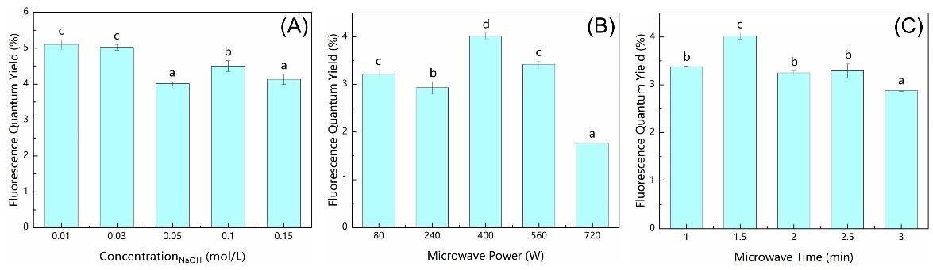
Figure S3. The effect of NaOH concentration (A), microwave power (B) and microwave time (C) on the quantum yield of CDs-MW. The results were presented as mean ± standard deviation (n=3). The differences between means were evaluated by Duncan’s multiple-range test, means that contain different letters are significantly different at P<0.05.

Table S2. The experimental design based on L₉(3⁴) orthogonal array and experimental results of preparation conditions for CDs-MW
No. | A (NaOH concentration) | B (Microwave time) | C (Empty column) | D (Microwave power) | Quantum yield (%)
1 | 0.01 | 1.0 |  | 240 | 3.55
2 | 0.01 | 1.5 |  | 400 | 5.10
3 | 0.01 | 2.0 |  | 560 | 4.55
4 | 0.03 | 1.0 |  | 560 | 3.90
5 | 0.03 | 1.5 |  | 240 | 4.44
6 | 0.03 | 2.0 |  | 400 | 4.06
7 | 0.05 | 1.0 |  | 400 | 3.38
8 | 0.05 | 1.5 |  | 560 | 4.01
9 | 0.05 | 2.0 |  | 240 | 2.82
K₁ | 13.20 | 10.83 |  | 10.81
K₂ | 12.41 | 13.55 |  | 12.54
K₃ | 10.20 | 11.43 |  | 12.46
k1 | 4.40 | 3.61 |  | 3.60
k2 | 4.14 | 4.52 |  | 4.18
k3 | 3.40 | 3.81 |  | 4.15
R | 3.00 | 2.72 |  | 1.73
K, Sum of quantum yield for the factors at each level; k, The mean values for the factors at each level; R, K_{max}-K_{min}.

3. Characterization of Surface Properties of CDs
Figure S4. XPS full-scan survey spectra of CDs-HT and CDs-MW

Figure S5. FTIR spectra of CDs-HT and CDs-MW

Table S3. Peak parameters obtained by deconvolution of the FTIR spectra (3800~2800cm⁻¹)
Sample | Peak | Center | Amplitude | FWHM | Area | Sample | Peak | Center | Amplitude | FWHM | Area
CDs-HT | 1 | 3560.7 | 0.133 | 127.6 | 18.1 | CDs-MW | 1 | 3563.5 | 0.103 | 114.2 | 12.5
CDs-HT | 2 | 3455.6 | 0.297 | 180.3 | 57.0 | CDs-MW | 2 | 3456.9 | 0.360 | 203.1 | 77.8
CDs-HT | 3 | 3286.7 | 0.490 | 266.9 | 139.2 | CDs-MW | 3 | 3302.7 | 0.486 | 301.9 | 156.1
CDs-HT | 4 | 3052.6 | 0.180 | 127.9 | 24.5 | CDs-MW | 4 | 3061.2 | 0.107 | 93.1 | 10.6
CDs-HT | 5 | 2965.4 | 0.238 | 49.3 | 12.5 | CDs-MW | 5 | 2958.3 | 0.145 | 81.1 | 12.6
CDs-HT | 6 | 2927.1 | 0.167 | 34.8 | 6.2 | CDs-MW | 6 | 2923.3 | 0.064 | 33.1 | 2.3
CDs-HT | 7 | 2882.0 | 0.172 | 70.4 | 12.9 | CDs-MW | 7 | 2873.6 | 0.072 | 55.9 | 4.3
Table S4. Peak parameters obtained by deconvolution of the FTIR spectra (1800~1300cm⁻¹)
Sample | Peak | Center | Amplitude | FWHM | Area | Sample | Peak | Center | Amplitude | FWHM | Area
CDs-HT | 1 | 1657.8 | 0.871 | 106.9 | 99.2 | CDs-MW | 1 | 1656.0 | 0.915 | 76.5 | 74.5
CDs-HT | 2 | 1568.9 | 0.408 | 65.1 | 28.3 | CDs-MW | 2 | 1559.8 | 0.389 | 71.4 | 29.6
CDs-HT | 3 | 1523.3 | 0.267 | 46.7 | 13.3 | CDs-MW | 3 | 1522.4 | 0.161 | 48.8 | 8.4
CDs-HT | 4 | 1458.3 | 0.221 | 26.5 | 6.2 | CDs-MW | 4 | 1452.1 | 0.191 | 39.6 | 8.0
CDs-HT | 5 | 1437.0 | 0.176 | 23.7 | 4.5 | CDs-MW | 5 | 1425.3 | 0.071 | 14.9 | 1.1
CDs-HT | 6 | 1407.8 | 0.227 | 37.7 | 9.1 | CDs-MW | 6 | 1402.8 | 0.165 | 22.9 | 4.0
CDs-HT | 7 | 1383.7 | 0.165 | 31.3 | 5.5 | CDs-MW | 7 | 1379.1 | 0.091 | 16.9 | 1.6

4. TGA analysis of the precipitate in the reaction system
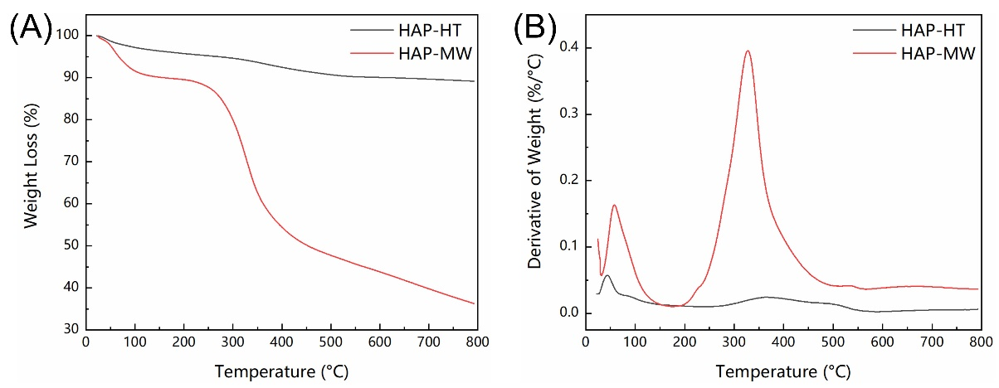
Figure S6. Thermogravimetric analysis of precipitate in preparation reaction

