Hybridization of papain molecules and DNA-wrapped single-walled carbon nanotubes evaluated by atomic force microscopy in fluids

Masaki Kitamura*, Kazuo Umemura
Department of Physics, Tokyo University of Science, 1-3 Kagurazaka, Shinjuku, 1628601, Japan
*Corresponding Author. E-mail: 1222518@ed.tus.ac.jp

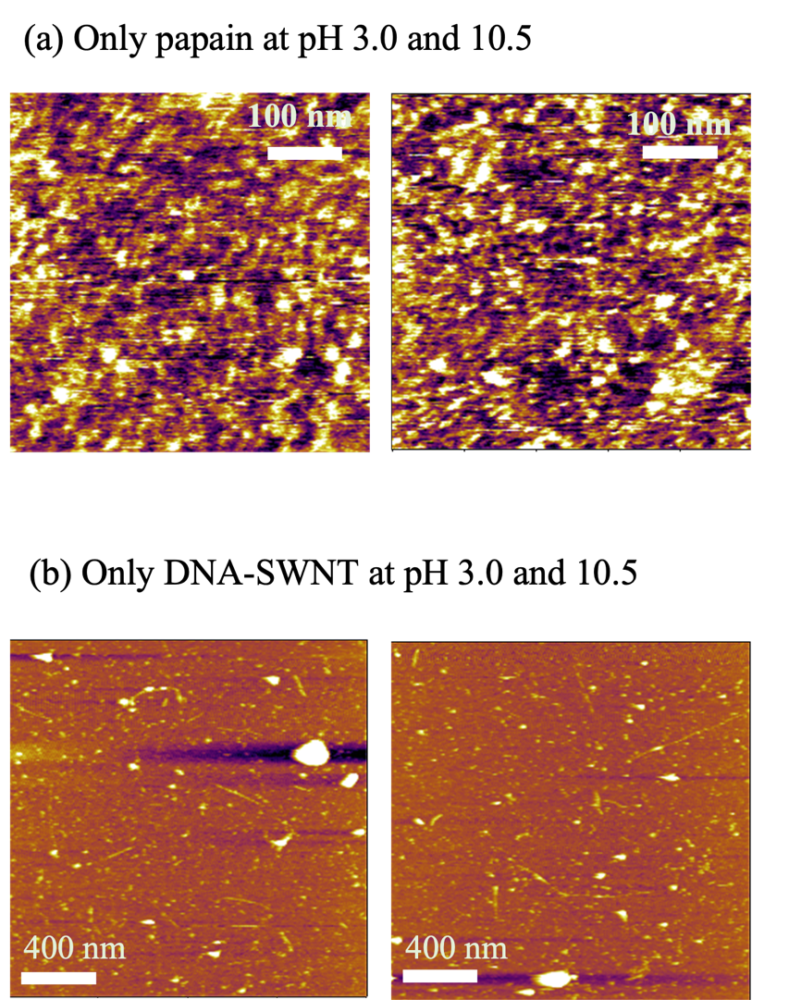
Figure S1 AFM images of the (a) papain molecules and (b) DNA–SWNTs with papain molecules at pH 3.0 and 10.5.

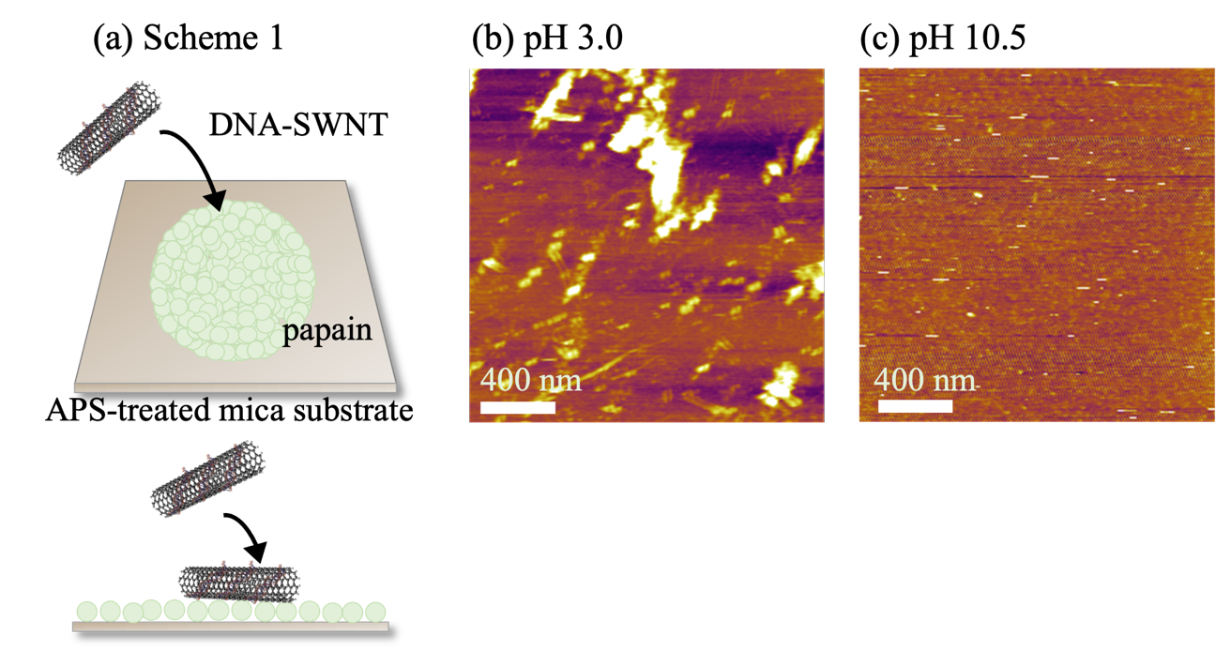
Figure S2. (a) Scheme 1 experiment, where papain molecules were first adsorbed, followed by the injection of DNA–SWNTs. AFM images at (b) pH 3.0 and (c) pH 10.5 after injection.

