Supporting Information

Ultrathin Cellulose Nanofiber Reinforced Ti₃C₂T_{x} Crosslinked Organohydrogel for Multifunctional and Sensitive Sensors

Kangjie Wu^{1,§}, Xiao Chen^{1,§,*}, Qing Wang¹, Chao Yu¹, Xuran Xu^{2,*}, Chuanxiang Chen^{1,*}

¹ School of Environmental and Chemical Engineering, Jiangsu University of Science and Technology, Zhenjiang, Jiangsu, 212100, China.
² School of Chemistry and Chemical Engineering, Nanjing University of Science and Technology, 200 Xiao Ling Wei, Nanjing 210094, China.

§These authors contributed equally to this work

* Corresponding author
C.X: Email: xiao_chen@just.edu.cn; Phone: 0086-051184400092
X.X: Email: jy03005746@sina.com
C.C: Email：cxchen@just.edu.cn;

Supporting Experimental Section
Characterization
Structures and morphologies of the synthesized samples were observed by scanning electron microscopy (SEM, Hitachi S-4800) combined with energy-dispersive spectroscopy (EDS) mapping, transmission electron microscopy (TEM, TECNAI G2-20 LaB6), and atomic force microscopy (AFM, Bruker Veeco Multimode 8). Mechanical properties were measured with an electronic universal testing machine (Tianyuan, TY8000-A). Electrical conductivities were measured with an RTS-9 four-probe array tech and a resistivity meter (Peak Meter, PM8233D). The EMI shielding properties were characterized by a vector network analyzer (Agilent N5230) using the wave guide method at the frequency of 8.2 to 12.4 GHz at room temperature. Zeta potential analysis was measured using the Microtrac ZETA potentiometric analyzer (STABINO ZETA). Dynamic rheological behaviors of the MPCB hydrogels were analyzed at 25 °C using a rheometer (TA ARES G2, USA).The gap distance was fixed at 0.5 mm. Initially, strain sweeps of the gels were performed from 10-1 % to 103 % at a frequency of 1 Hz. Frequency-sweeps were performed from 0.1 to 100 Hz with an appropriate strain of 101 % in the linear viscoelastic region.

Supporting figures

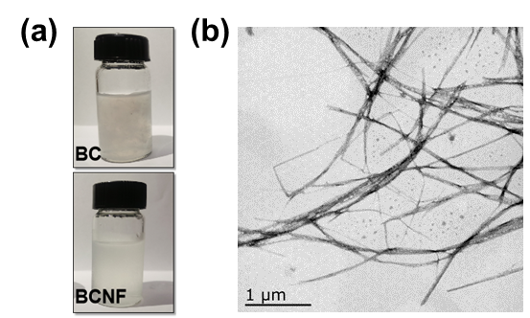

Figure. S1 (a) Digital images of BC and BCNF; (b) TEM of BCNF.

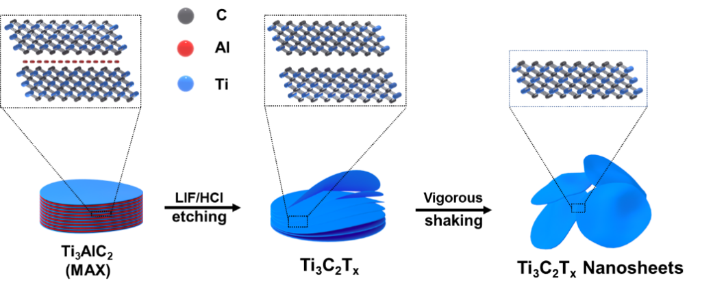
Figure. S2 Schematic illustration of the preparation of MXene nanosheet layers

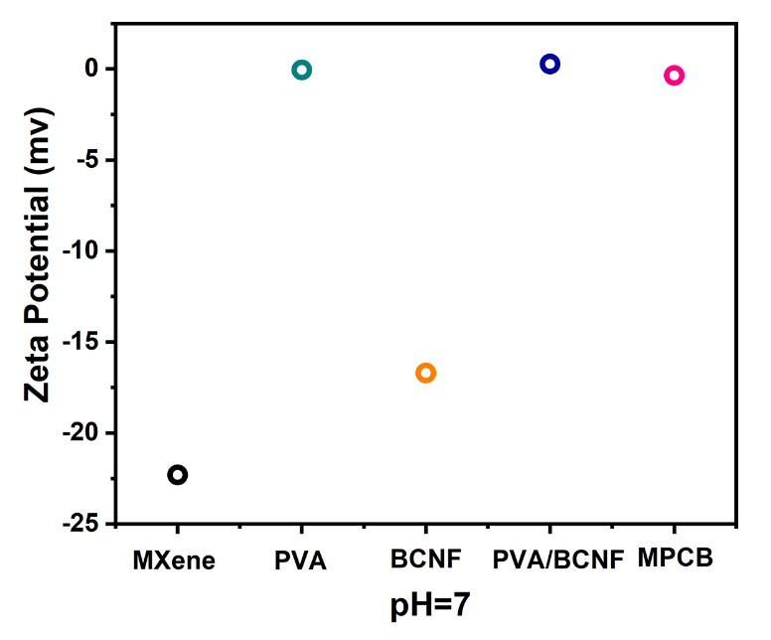
Figure. S3 Zeta potentiogram of MXene, PVA, BCNF, PVA/BCNF and MPCB at pH=7

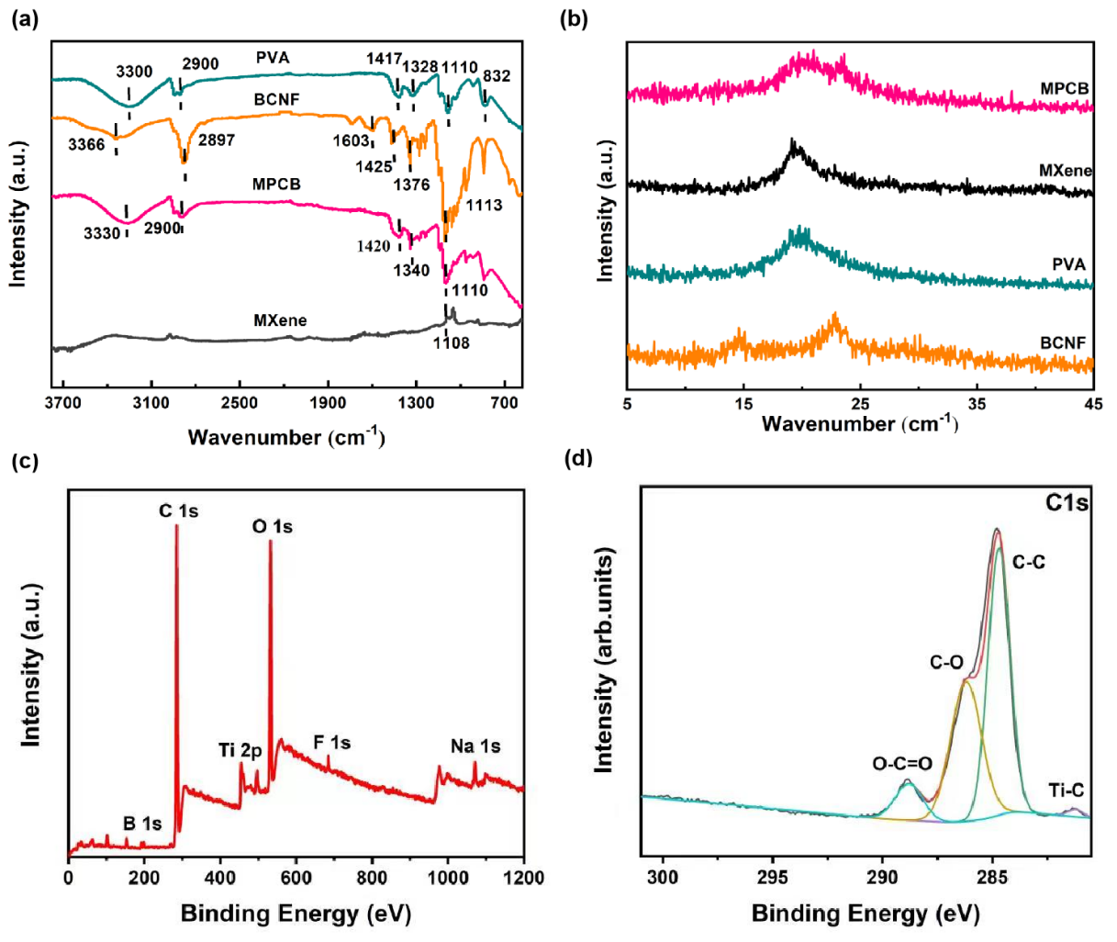
Figure S4. (a) FT-IR spectra of MXene, PVA, BCNF, and MPCB; (b) XRD pattern of MXene, PVA, BCNF, and MPCB; (c) XPS survey spectra of MPCB; (d) C 1 s.

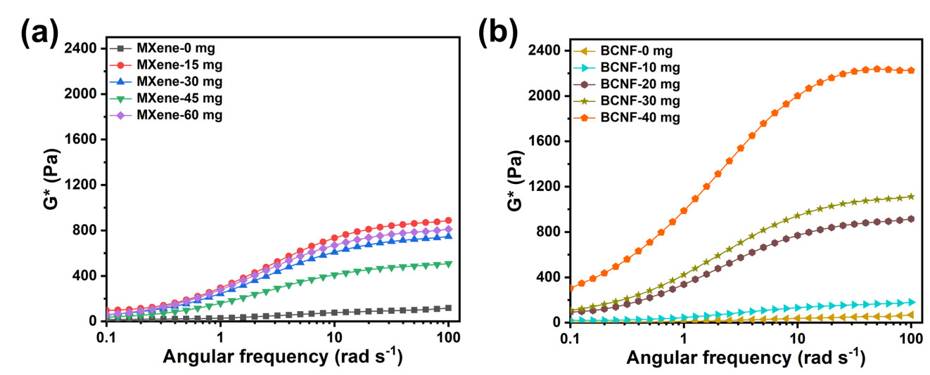
Figure S5. Dynamic viscoelasticity performance of hydrogels: Angular frequency dependence of G* of the prepared hydrogels with different content of (a) MXene and (b) BCNF.

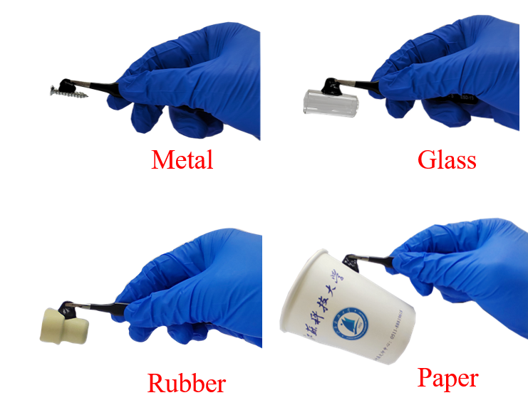
Figure S6. Adhesion of MPCB hydrogels exposed to air for 14 days on the surfaces of various substrates: metal, glass, rubber and paper.

Supporting Tables
Table S1 Comparison of multifunctional properties of various conductive hydrogels.
 | Conductivity | Tensile strain strength | Elongation at break | GF value | Refs
MPBC | 2.11×10⁻³ S cm⁻¹ | 47.5kPa | 1010.7% | 46.64(250%) | This work
PVA-BC-PANI | / | 171.52kPa | 1085.0% | 18.79(700%) | (Song et al., 2020)
PVA-MXene-PVP | / | / | / | 19.18(120%) | (Lu et al., 2020)
PVA-BC-SA | / | 786KPa | 313.0% | 5.01(200%) | (Huang et al., 2020)
PPy-BCNF | 1.08×10⁻³ S cm⁻¹ | 2.6MPa | 388.0% | 355.3(300%) | (Xu et al., 2021)
MXene-PAA | / | 300kPa | 450.0% | / | (Li et al., 2020)
MXene-BCNF | 443.5 S cm⁻¹ | 252.2MPa | / | / | (Xu et al., 2020)
MXene-PVA-CS | / | 12.01MPa | / | / | (Wang et al., 2022)
Conductive cellulose-PVA | 0.46×10⁻³ S cm⁻¹ | 37.3kPa | 747.0% | 1.04(500%) | (Wang et al., 2020)
PVA-AgNWs | 1.85×10⁻³ S cm⁻¹ | 900kPa | / | 0.34(550%) | (Azadi et al., 2020)
PVA-Gly-CB-CNT | / | 4.8MPa | / | 2.1(600%) | (Gu et al., 2020)
PVA-CNTs-graphene | / | 10kPa | / | 152.6(600%) | (Zhang et al., 2021)
PVA-PANI-MXene | 0.22 S cm⁻¹ | 4.1MPa | / | / | (Li et al., 2020)
MXene-PVA | / | 80MPa | 1200% | 0.4(200%) | (Zhang et al., 2019)
Borax-PVA | / | 5.6kPa | / | / | (Wang et al., 2022)
CNF-MXene | 14.9×10⁻⁶ S cm⁻¹ | 116kPa | / | 1.52(140%) | (Bai et al., 2020)
MXene-PAM-SA | / | 540kPa | 1170% | 1.21(600%) | (Huang et al., 2020)
MXene-NAGA | 17.3×10⁻³ S cm⁻¹ | 4.8MPa | / | 2.05(120%) | (Zeng et al., 2020)
TOCNFs-PAA-Fe³⁺ | 3.9×10⁻³ S cm⁻¹ | 0.6MPa | 890% | 7.3(800%) | (Chen et al., 2019)
LiCl-PAA-PVA-LS | / | 1.04MPa | 758% | / | (Zhang et al., 2021)
AAc-VBIMBr-Al³⁺ | 12.5×10⁻³ S cm⁻¹ | 0.16MPa | 604% | / | (Zhou et al., 2022)
PAA-PAM-MXene-TA | / | 0.251MPa | 560.82% | / | (Qin et al., 2022)

Table S2 Comparison of electromagnetic shielding performance of various MXene composites
Materials | Electromagnetic shielding performance | Refs
MPCB | 36.3dB | This work
MXene/wood composite | 32.7 dB | (Jiang et al., 2022)
MXene/PET/AgNW/ PVA-PSS | 30.5dB | (Liu et al.,2022)
MXene/NW | 28.2dB | (Wang et al., 2021)
MXene/CNF/MCS | 50.7dB | (Xin et al., 2019)
MXene/GR | 36dB | (Jin et al., 2022)
MXene/TOCN | 36dB | (Liu et al. 2022)

References
Song, M., Yu, H., Zhu, J., Ouyang, Z., Abdalkarim, S. Y., Tam, K. C., et al. (2020). Constructing stimuli-free self-healing, robust and ultrasensitive biocompatible hydrogel sensors with conductive cellulose nanocrystals. Chem. Eng. J, 398, 125547.
Lu, Y., Qu, X., Zhao, W., Ren, Y., Si, W., Y., & Wang, W. (2020). Highly Stretchable, Elastic, and Sensitive MXene-Based Hydrogel for Flexible Strain and Pressure Sensors.Research, 2020, 2038560.
Huang, J., Zhao, M., Cai, Y., Zimniewska, M., Li, D., & Wei, Q. (2020). A Dual-Mode Wearable Sensor Based on Bacterial Cellulose Reinforced Hydrogels for Highly Sensitive Strain/Pressure Sensing. ADV ELECTRON MATER, 6(1), 1900934.
Xu, X., Wu, S., Cui, J., Yang, L., Wu, K., Chen, X., et al. (2021). Highly stretchable and sensitive strain sensor based on polypyrrole coated bacterial cellulose fibrous network for human motion detection. Compos. B. Eng, 211, 108665.
Li, X., He, L., Li, Y., Chao, M., Li, M., Wan, P., & Zhang, L. (2021). Healable, Degradable, and Conductive MXene Nanocomposite Hydrogel for Multifunctional Epidermal Sensors. ACS Nano, 15(4), 7765–7773.
Xu, X., Wu, S., Cui, J., Yang, L., Liu, D., Wu, K., et al. (2020). Insights into the microstructures and reinforcement mechanism of nano-fibrillated cellulose/MXene based electromagnetic interference shielding film. Cellulose, 28, 3311–3325.
Wang, Z., Zhou, Z., Wang, S., Yao, X., Han, X., Cao, W., et al. (2022). An anti-freezing and strong wood-derived hydrogel for high-performance electronic skin and wearable sensing. Compos. B. Eng, 239, 109954.
Wang, Y., Zhang, L., & Lu, A. (2020). High stretchable, transparent cellulose/PVA composite hydrogel for multiple sensing and triboelectric nanogenerator. J. Mater, 8, 13935-13941.
Azadi, S., Peng, S., Moshizi, S. A., Asadnia, M., Xu, J., Park, I., et al. (2020) Biocompatible and highly stretchable PVA/AgNWs hydrogel strain sensors for human motion detection. Adv. Mater. Technol, 5(11), 1-12.
Gu, J., Huang, J., Chen, G., Hou, L., Zhang, J., Zhang, X., et al. (2020) Multifunctional poly(vinyl alcohol) nanocomposite organohydrogel for flexible strain and temperature sensor. ACS Appl. Mater, 12(36), 40815-40827.
Zhang, Y., Ren, E., Li, A., Cui, C., Guo, R., Tang, H., et al. (2021) A porous self-healing hydrogel with an island-bridge structure for strain and pressure sensors. J Mater Chem B, 9(3), 719-730.
Liu, S., Li, D., Wang, Y., Zhou, G., Ge, K., & Fang, D. (2022). Flexible, high-strength and multifunctional polyvinyl alcohol/MXene/polyaniline hydrogel enhancing skin wound healing. Biomater. Sci, DOI: 10.1039/d2bm00575a.
Zhang, J., Wan, L., Gao, Y., Fang, X., Lu, T., Pan, L., et al. (2019) Highly stretchable and self-healable MXene/Polyvinyl alcohol hydrogel electrode for wearable capacitive electronic skin. Adv. Electron. Mater., 5(7), 1-10.
Wang, C., Shen, Z., Hu, P., Wang, T., Zhang, X., Liang, L., et al. (2022). Facile fabrication and characterization of high-performance Borax-PVA hydrogel. J Solgel Sci Technol, 101(1), 103-113.
Bai, Y., Bi, S., Wang, W., Ding, N., Lu, Y., Jiang, M., et al. (2022). Biocompatible, stretchable, and compressible cellulose/MXene hydrogel for strain sensor and electromagnetic interference shielding. Soft Materials, DOI: 10.1080/1539445X.2022.2081580.
Huang, C., Luo, Q., Miao, Q., He, Z., Fan, P., Chen, Y., et al. (2022). MXene-based double-network organohydrogel with excellent stretchability, high toughness, anti-drying and wide sensing linearity for strain sensor. Polymer, 253, 124993.
Zeng, Z., Yu, S., Guo, C., Lu, D., Geng, Z., & Pei, D. (2020). Mxene Reinforced Supramolecular Hydrogels with High Strength, Stretchability, and Reliable Conductivity for Sensitive Strain Sensors. Macromol. Rapid Commun. 2200103.
Chen, Y., Lu, K., Song, Y., Yue, Y., Wu, Q., & Xiao, H. (2019). A Skin-Inspired Stretchable, Self-Healing and Electro-Conductive Hydrogel with A Synergistic Triple Network for Wearable Strain Sensors Applied in
Human-Motion Detection. Nanomaterials, 9, 1737.
Zhang, Y., Mao, J., Jiang, W., Wei, G., Zuo, M., Ni, Y., et al. (2021). Lignin sulfonate induced ultrafast polymerization of double network hydrogels with anti-freezing, high strength and conductivity and their sensing applications at extremely cold conditions. COMPOS PART B-ENG, 217, 108879.
Zhou, Y., Fei, X., Tian, J., Xu, L., Li, Y. (2022). A ionic liquid enhanced conductive hydrogel for strain sensing
applications. J. Colloid Interface Sci., 606, 192–203.
Qin, M., Yuan, W., Zhang, X., Wei, Y., Chen, W., Huang, D., et al. (2022). Preparation of PAA/PAM/MXene/TA hydrogel with antioxidant, healable ability as strain sensor. COLLOID SURFACE B, 214, 112482.
Jiang, Y., Ru, X., Che, W., Jiang, Z., Chen, H., Hou, J., et al. (2022). Flexible, mechanically robust and self-extinguishing MXene/wood composite for efficient electromagnetic interference shielding. COMPOS PART B-ENG, 229, 109460.
Liu, J., Zhang, Y., Cheng, W., Lei, S., Song, L., Hu, Y., et al. (2022). Anti-Fogging, Frost-Resistant transparent and flexible silver Nanowire-Ti3C2Tx MXene based composite films for excellent electromagnetic interference shielding ability. J. Colloid Interface Sci., 608, 2493–2504.
Wang, Z., Han, X., Wang, S., Han, X., & Pu, J. (2021). MXene/wood-based composite materials with electromagnetic shielding properties. Holzforschung, ; 75(5), 494–499.
Xin, W., Xi, G., Cao, W., Ma, C., Ma, M., & Bian, J. (2019). Lightweight and flexible MXene/CNF/Silver composite membranes with a brick-like structure and high-performance electromagnetic interference shielding. RSC Adv, 9, 29636.
Jin, L., Wang, P., Cao, W., Song, N., & Ding, P. (2022). Isolated Solid Wall-Assisted Thermal Conductive Performance of Three-Dimensional Anisotropic MXene/Graphene Polymeric Composites. ACS Appl. Mater., 14, 1747-1756.
Liu, D., Gao, Y., Song, Y., Shi, H., Yang, Q., & Xiong, C. (2022). Highly Sensitive Multifunctional Electronic Skin Based on Nanocellulose/MXene Composite Films with Good Electromagnetic Shielding Biocompatible Antibacterial Properties. Biomacromolecules, 23, 182-195.

