Dr. D.Devarajan Biblography

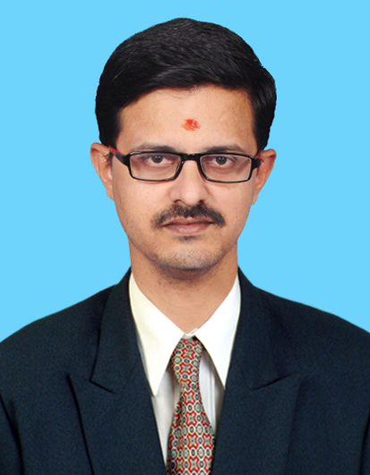

- Dr. D.Devarajan M.E.,Ph.D working as Head & Associate professor in Electronics and Communication Engineering Department, E.G.S.Pillay Engineering College,Nagapattinam,Tanil nadu,India.
- Completed Ph.D in Image processing at Anna University,Chennai and Post Graduate in Anna university,Trichirappalli.
- Having 12+ Years Experience in Teaching field .
- Published 9 Journal Papers in reputed journals with Electronic circuits book.
- Currently Serving Reviewer in 4 Journals.
- E-mail : devarajan@egspec.org

