Western Blot results
- BSA
Low Fertile sEV
High Fertile sEV
R1 R2 R3 R1 R2 R3 R1 R2 R3 R1 R2 R3
R1 R2 R3 R1 R2 R3 R1 R2 R3 R1 R2 R3
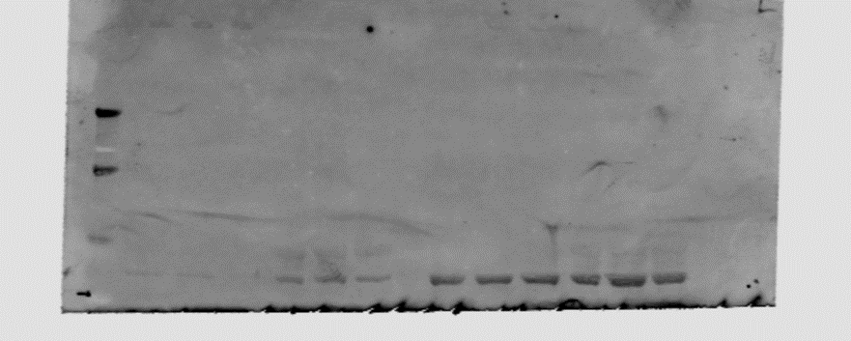
69 kDa
Pooled sEV fractions 7-10
Pooled sEV fractions 11-16

Low Fertile sEV
High Fertile sEV

- CD81
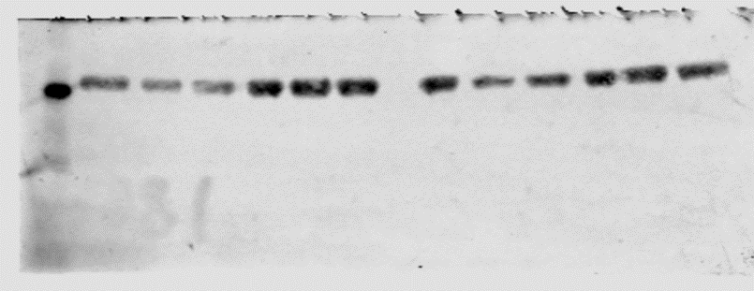
R1 R2 R3 R1 R2 R3 R1 R2 R3 R1 R2 R3
High Fertile sEV
Low Fertile sEV
Pooled sEV fractions 7-10
Pooled sEV fractions 11-16

Low Fertile sEV
High Fertile sEV
25 kDa

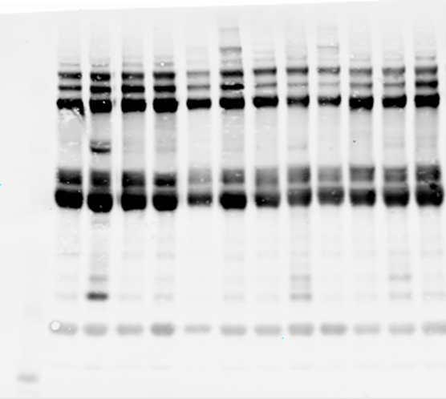
- Flotillin -1
R1 R2 R3 R1 R2 R3 R1 R2 R3 R1 R2 R3
High Fertile sEV
Low Fertile sEV
Pooled sEV fractions 7-10
Pooled sEV fractions 11-16

49 kDa
Low Fertile sEV
High Fertile sEV

