Table 1 The 11 active compounds of Coptidis Rhizoma.
ID | Name | 2D Structure | Database
CR1 | Berberine | 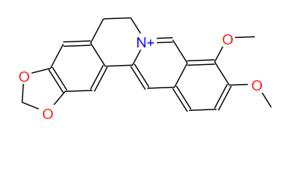 | TCMSP
CR2 | Berberrubine | 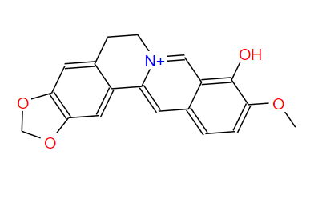 | TCMSP
CR3 | Berlambine | 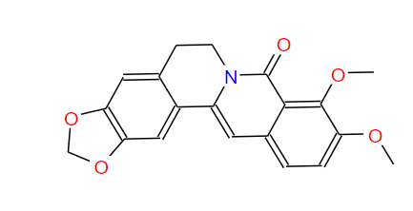 | TCMSP
CR4 | (R)-Canadine | 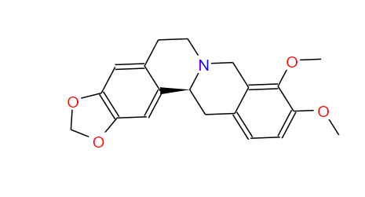 | TCMSP
CR5 | coptisine | 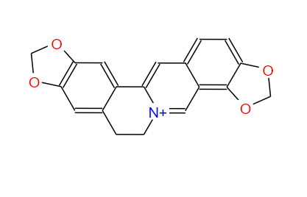 | TCMSP
CR6 | Corchoroside A_qt | 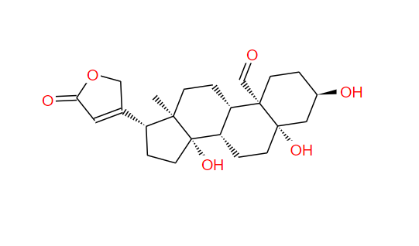 | TCMSP
CR7 | epiberberine | 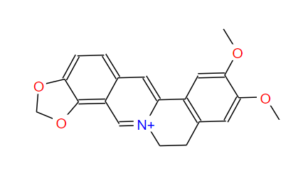 | TCMSP
CR8 | Magnograndiolide | 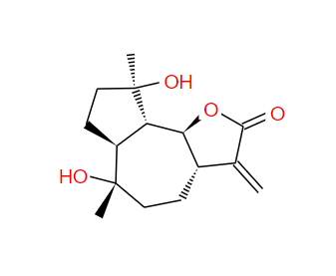 | TCMSP
CR9 | palmatine | 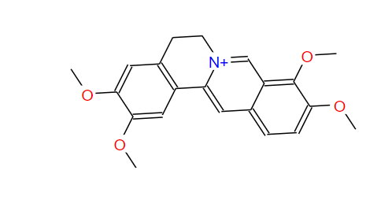 | TCMSP
CR10 | quercetin | 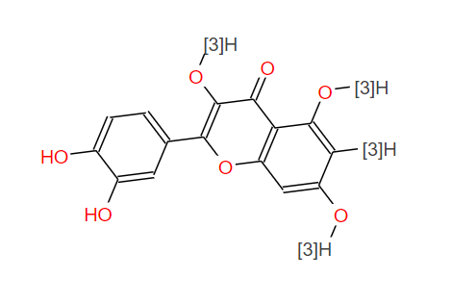 | TCMSP
CR11 | Worenine | 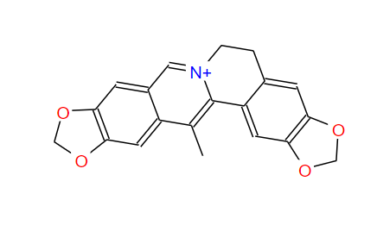 | TCMSP

Table 2 The top 10 core targets.
Gene | Targets | BC | CC | Degree
AKT1 | AKT serine/threonine kinase 1 | 0.04266 | 0.86111 | 78
TP53 | Tumor protein p53 | 0.03826 | 0.84545 | 76
MYC | MYC proto-oncogene, bHLH transcription factor | 0.03211 | 0.80869 | 71
VEGFA | Vascular endothelial growth factor A | 0.02884 | 0.80869 | 71
JUN | Jun proto-oncogene, AP-1 transcription factor subunit | 0.03174 | 0.80172 | 70
EGFR | Epidermal growth factor receptor | 0.03451 | 0.78151 | 67
CASP3 | Caspase 3 | 0.02045 | 0.78151 | 67
TNF | Tumor necrosis factor | 0.04298 | 0.7750 | 66
IL6 | interleukin 6 | 0.02339 | 0.7750 | 66
HIF1A | Hypoxia inducible factor 1 subunit alpha | 0.01535 | 0.76859 | 65

