Table 1 The 11 active compounds of Coptidis Rhizoma.
ID | Name | 2D Structure | Database
CR1 | Berberine | 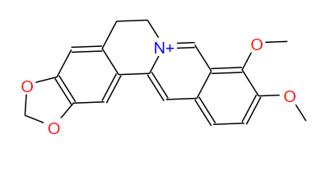 | TCMSP
CR2 | Berberrubine | 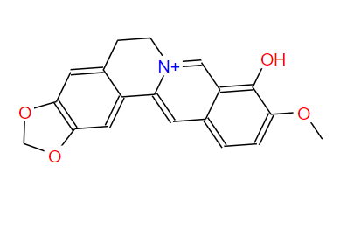 | TCMSP
CR3 | Berlambine | 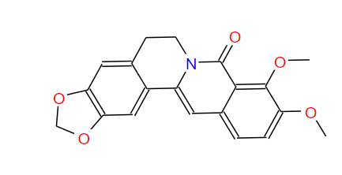 | TCMSP
CR4 | (R)-Canadine | 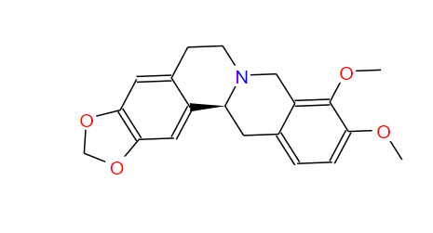 | TCMSP
CR5 | coptisine | 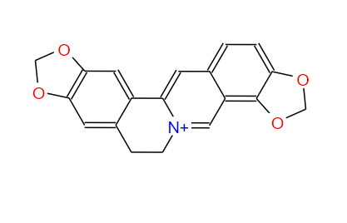 | TCMSP
CR6 | Corchoroside A_qt | 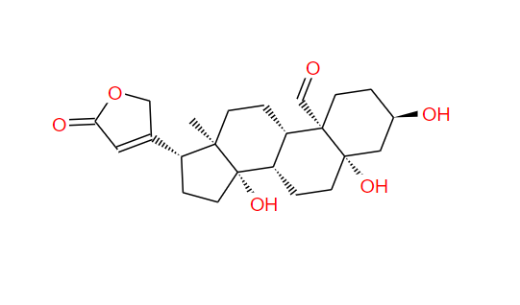 | TCMSP
CR7 | epiberberine | 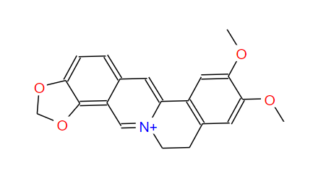 | TCMSP
CR8 | Magnograndiolide | 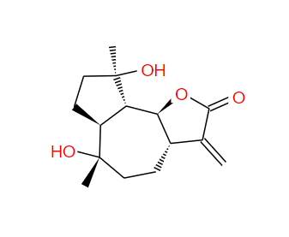 | TCMSP
CR9 | palmatine | 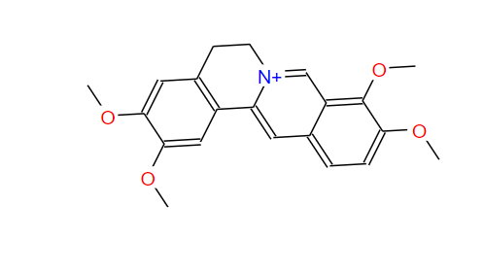 | TCMSP
CR10 | quercetin | 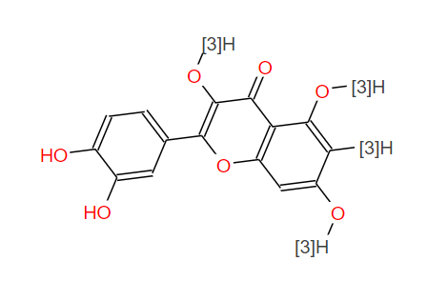 | TCMSP
CR11 | Worenine | 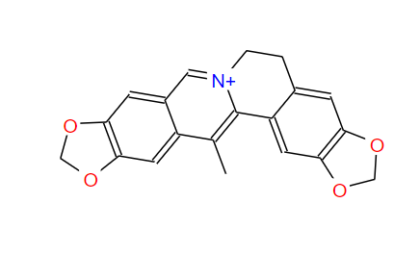 | TCMSP

