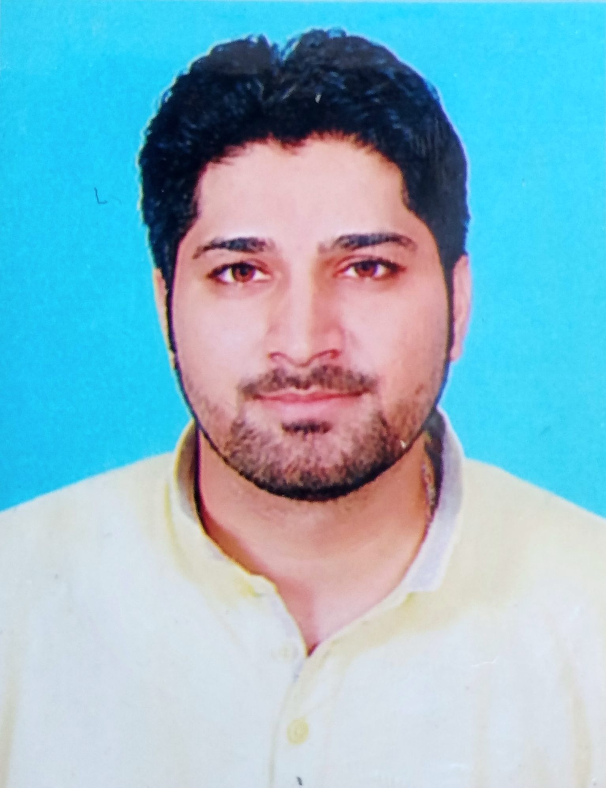
Kapil Jairath received the B.Sc and M.Sc degrees in physics from D.A.V. College, Jalandhar in 2009 and 2011, respectively. Now, he is pursuing Ph.D from Punjab Technical University, Kapurthala. His current research interests are in the field of antenna and communication, antenna miniaturization, slot antenna, optimization method.
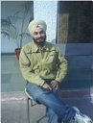
Dr. Navdeep Singh received his Ph.D in 2011 from NIT Jalandhar. He has published various research papers in field of antennas. His current research interest are in field of antenna and communication, metamaterials, band notching.

