Supplementary File 1
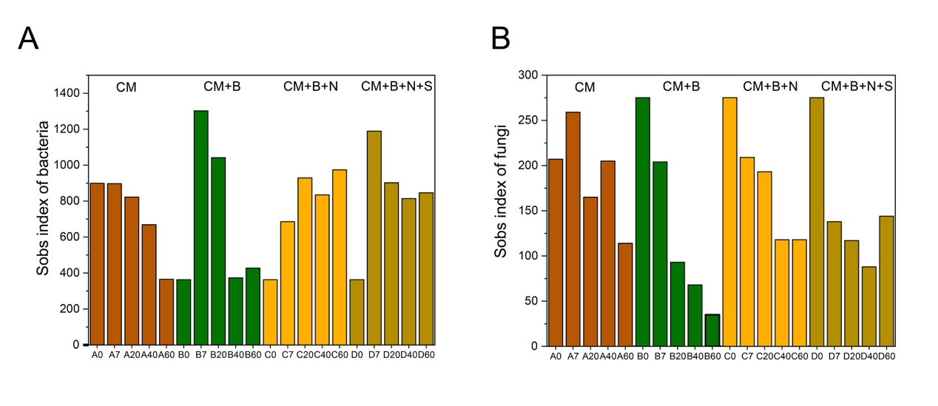
Figure S1. A. Sobs index of bacterial. B. Sobs index fungal communities.

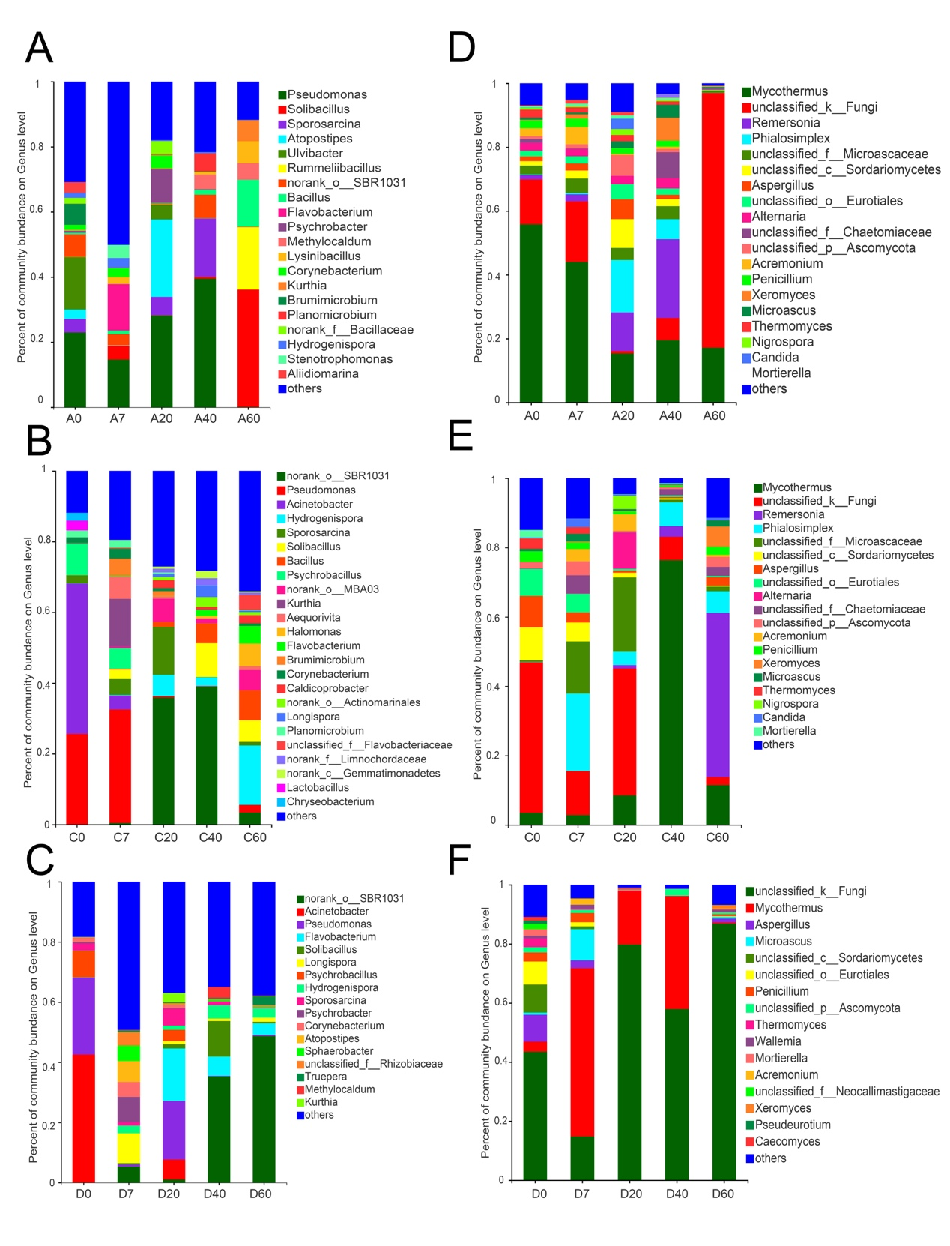
Figure S2. Change of bacteria community composition at genera level in four treatments. A. Bacterial community composition at genera level in composting process of CM group. B. Bacterial community composition at genera level in composting process of CM+B+N group. C. Bacterial community composition at genera level in composting process of CM+B+N+S group. D. Fungal community composition at genera level in composting process of CM. E. Fungal community composition at genera level in composting process of CM+B+N group. F. Fungl community composition at genera level in composting process of CM+B+N+S group.
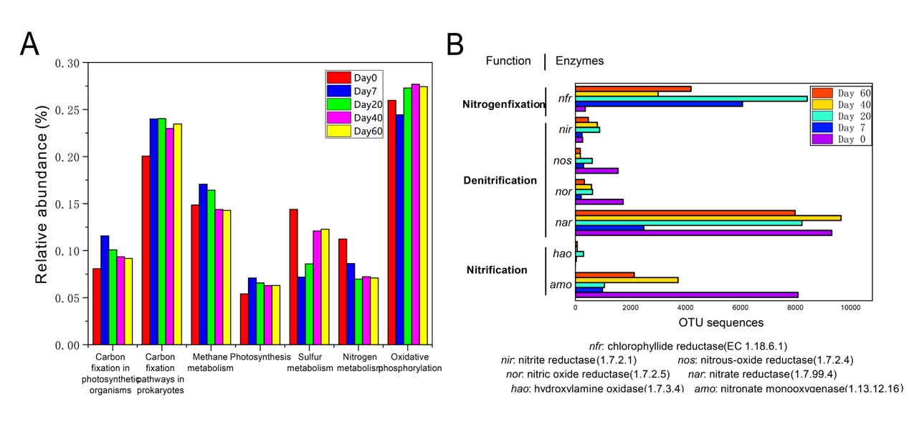
Figure S3. Prediction of bacterial functions in the co-composting of cow manure and bedding materials at ratio 1.32 (CM+B). A. Distribution of main KEGG pathways in microorganisms analyzed using PICRUSt; B. Relative amounts of functional enzymes involving nitrogen metabolism.
Figure S4. A. Heatmap of environment factors, composting periods and the top 20 bacterial genera in co-composting system of CM+B; B. Heatmap of environment factors, composting periods and the top 20 fungal genera in co-composting system of CM+B.
(*The X-axis and Y-axis are environmental factors and species, respectively, and the correlation R value and P value are obtained by calculation. The R value is displayed in different colors in the figure. If the P value is less than 0.05, it is marked with*. The legend on the right is the color interval of different R values; you can choose to display the species and environmental factor cluster trees (such as the left and upper sides); * 0.01 <P ≤ 0.05, ** 0.001 <P ≤ 0.01, *** P ≤ 0.001.)

Table S1. Environmental factor table for CCA analysis of bacteria in CM+B compost
 | CCA1 | CCA2 | r2 | p_values
Moisture | 0.8607 | -0.5091 | 0.8839 | 0.15
Temperature | -0.3078 | 0.9514 | 0.8985 | 0.075
pH | -0.9283 | 0.3718 | 0.9862 | 0.025
C_Nratio | 0.808 | -0.5892 | 0.9677 | 0.0333
 | RDA1 | RDA2 | r2 | p_values
Moisture | -0.8149 | 0.5796 | 0.8381 | 0.1417
Temperature | -0.6884 | -0.7253 | 0.3827 | 0.5833
pH | 0.1731 | -0.9849 | 0.463 | 0.5333
C_Nratio | -0.522 | 0.8529 | 0.6856 | 0.3167
Table S2. Environmental factor table for RDA analysis of fungi in CM+B compost

Table S3. P_Vaue table for heatmap of fungi in CM+B compost
 | Moisture | Temperature | pH | C_N Ratio
Paeniclostridium | 0.18812 | 0.28476 | 0.62384 | 0.87289
Caproiciproducens | 1 | 0.03739 | 0.18812 | 0.50463
norank_f_Limnochordaceae | 0 | 0.87289 | 0.62384 | 0.28476
Corynebacterium | 0.05385 | 0.80483 | 0.74058 | 0.32172
Lysinibacillus | 0 | 0.87289 | 0.62384 | 0.28476
Bacteroides | 0.03739 | 0.74706 | 0.87289 | 0.391
Bacillus | 0.03739 | 0.74706 | 0.391 | 0.18812
Turicibacter | 0.391 | 0.28476 | 0.62384 | 0.87289
Salinispora | 0.03739 | 0.74706 | 0.391 | 0.18812
norank_c__Gemmatimonadetes | 0 | 0.87289 | 0.62384 | 0.28476
Solibacillus | 0 | 0.87289 | 0.62384 | 0.28476
Ruminiclostridium | 0.87289 | 0 | 0.03739 | 0.18812
Symbiobacterium | 0.28476 | 0.18812 | 0.03739 | 0
Acinetobacter | 0.74706 | 0.03739 | 0.18812 | 0.28476
Pseudomonas | 0.87289 | 0.10409 | 0.391 | 0.62384
Thermobispora | 0.03739 | 0.62384 | 0.50463 | 0.18812
Chryseobacterium | 0.87289 | 0.18812 | 0.50463 | 0.62384
Romboutsia | 0.28476 | 0.18812 | 0.391 | 0.74706
Psychrobacillus | 0.62384 | 0.50463 | 0.62384 | 0.87289
Thermobacillus | 0 | 0.87289 | 0.62384 | 0.28476
*Pvalue is the significant P value of correlation, and P less than 0.05 indicates significant correlation.

Table S4. P_Vaue table for heatmap of bacterial in CM+B compost
 | Moisture | Temperature | pH | C_N Ratio
Penicillium | 0 | 0.87289 | 0.62384 | 0.28476
unclassified_c__Sordariomycetes | 0.00482 | 0.80483 | 0.49254 | 0.21889
Cutaneotrichosporon | 0.74058 | 0.80483 | 0.80483 | 0.49254
Candida | 0.28476 | 0.62384 | 0.391 | 0.10409
Thermomyces | 0.10409 | 1 | 0.74706 | 0.28476
Coniolariella | 0.5594 | 0.5594 | 1 | 0.5594
Mortierella | 0.00482 | 0.74058 | 0.55281 | 0.21889
unclassified_o__Eurotiales | 0.10409 | 1 | 0.74706 | 0.28476
unclassified_k__Fungi | 0.18812 | 0.50463 | 0.62384 | 0.87289
Ascochyta | 0.11761 | 0.85794 | 0.45018 | 0.11761
Apiotrichum | 0.21889 | 0.32172 | 0.74058 | 0.80483
Wallemia | 0.74706 | 0.87289 | 0.391 | 0.28476
Phialemoniopsis | 0.04052 | 0.58109 | 0.85794 | 0.71769
unclassified_f__Neocallimastigaceae | 0.04052 | 0.45018 | 0.21517 | 0.04052
unclassified_p__Ascomycota | 0.18812 | 0.28476 | 0.18812 | 0.03739
Pyrenochaetopsis | 1 | 0.18169 | 0.18169 | 0.18169
*Pvalue is the significant P value of correlation, and P less than 0.05 indicates significant correlation.

