Supporting Information
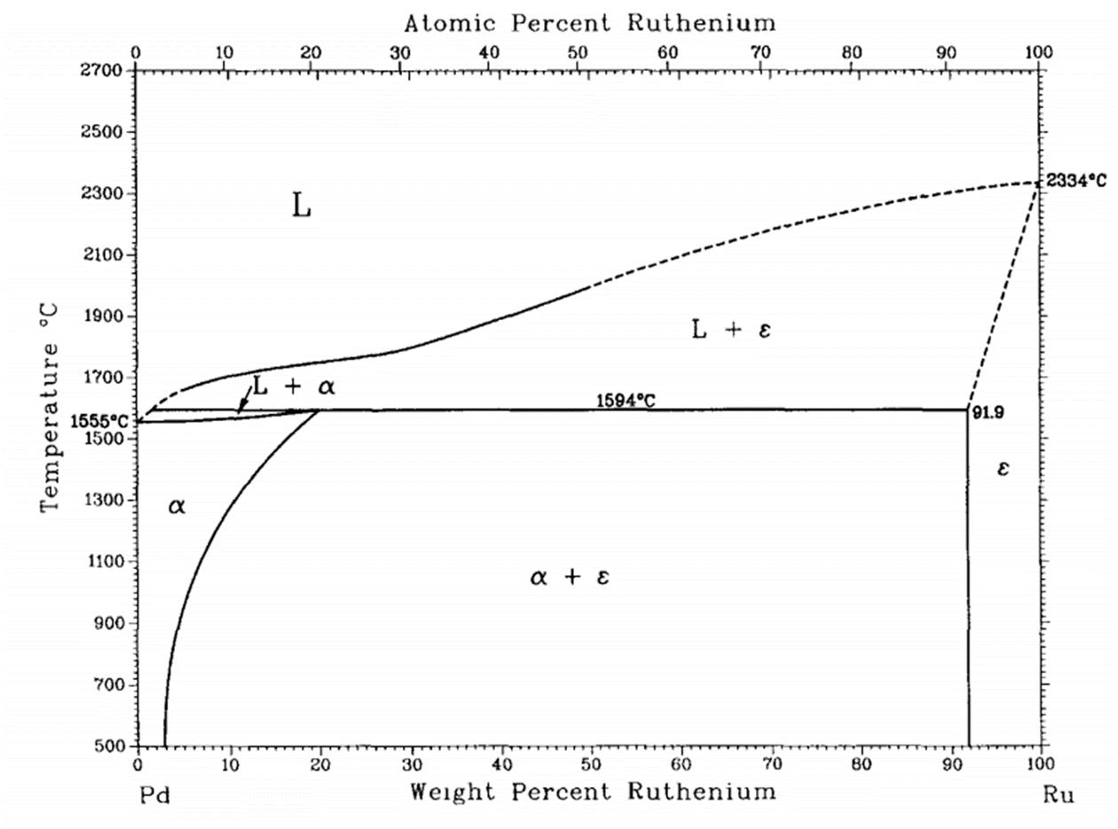
Figure S1. Phase diagram of Pd-Ru.

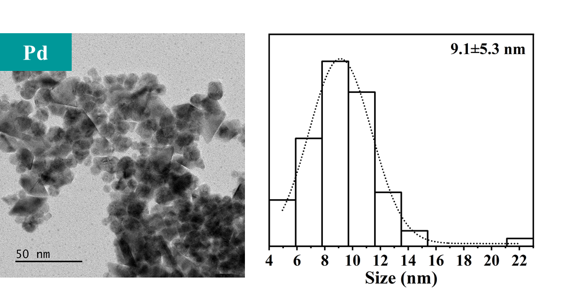
Figure S2. TEM image of Pd NPs and the corresponding particle size distribution.

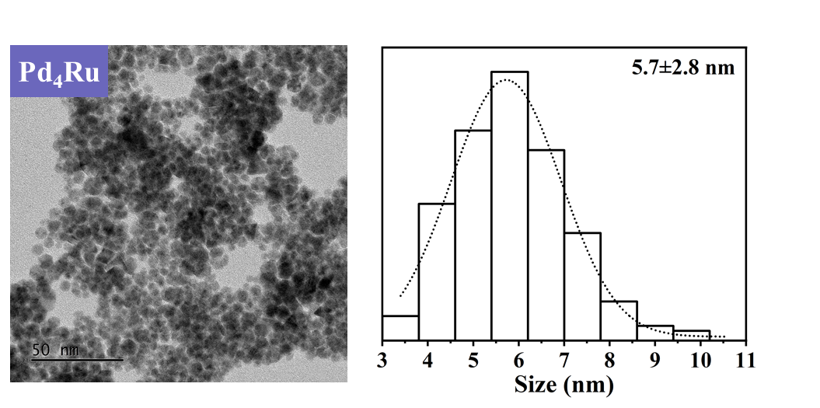
Figure S3. TEM image of Pd₄Ru NPs and the corresponding particle size distribution.

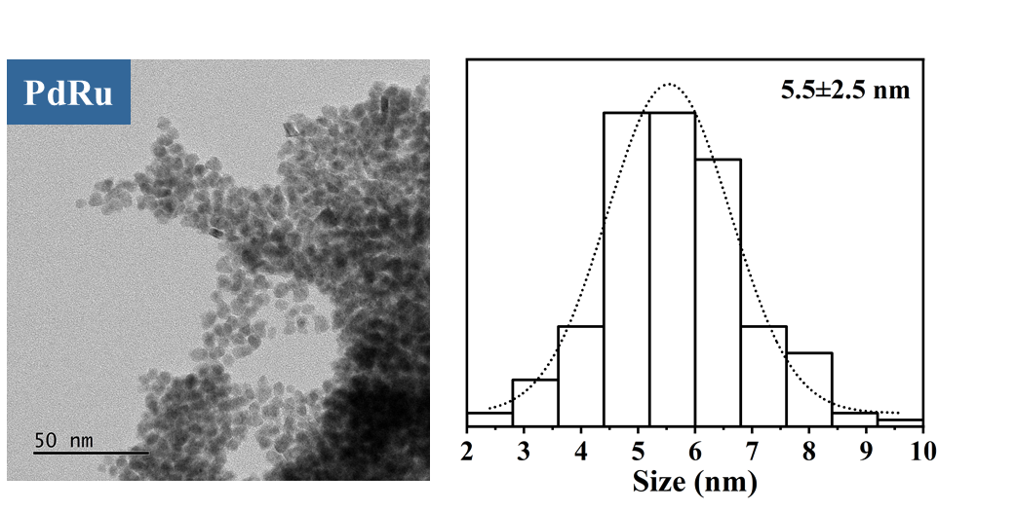
Figure S4. TEM image of PdRu NPs and the corresponding particle size distributiont.

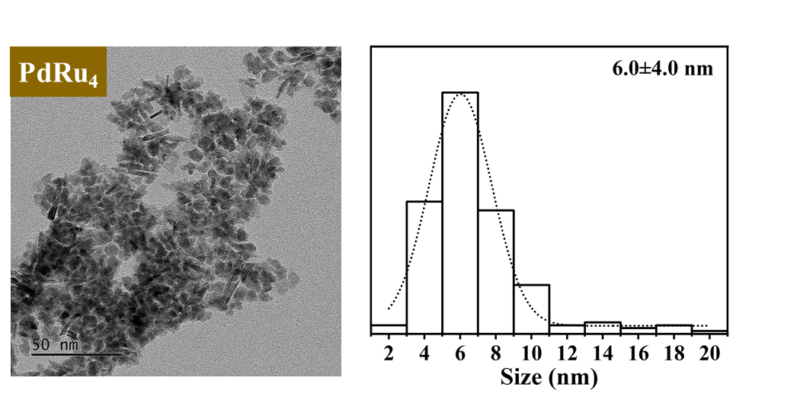
Figure S5. TEM image of PdRu₄ NPs and the corresponding particle size distribution.
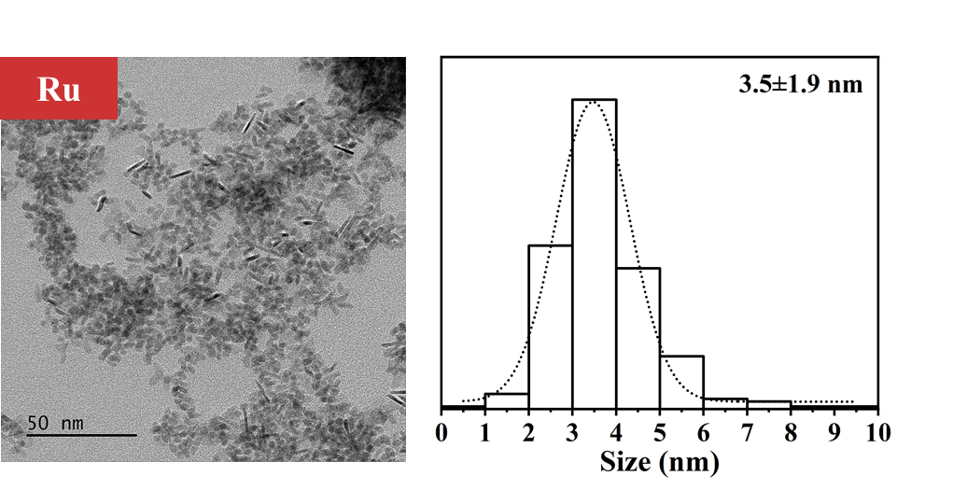
Figure S6. TEM image of PdRu4 NPs and the corresponding particle size distribution.

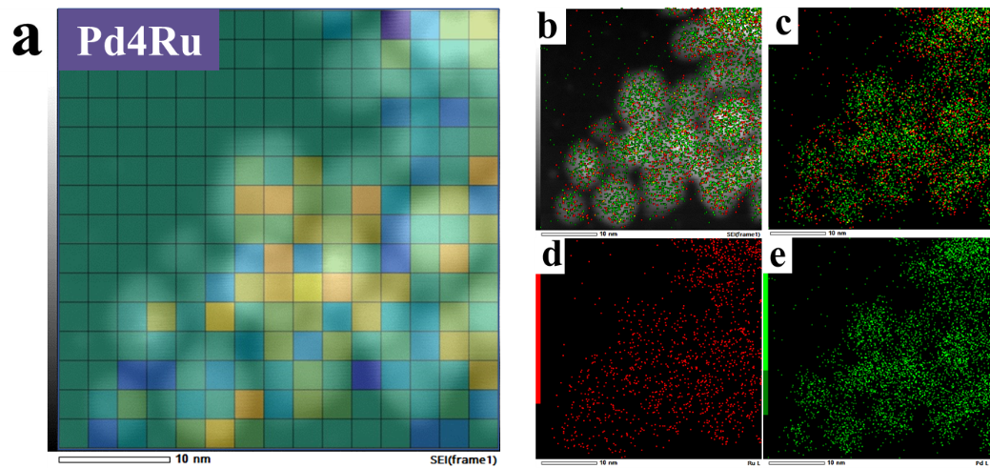
Figure S7. (a) Mosaic image of Pd₄Ru based on the value of each element in outlier matrix with HAADF-STEM image as background. (b) overlapping Pd and Ru elemental distribution in Pd4Ru sample with HAADF-STEM image as background. (c) overlapping Pd and Ru elemental distribution image. (d) Ru elemental distribution image. (e) Pd elemental distribution image.

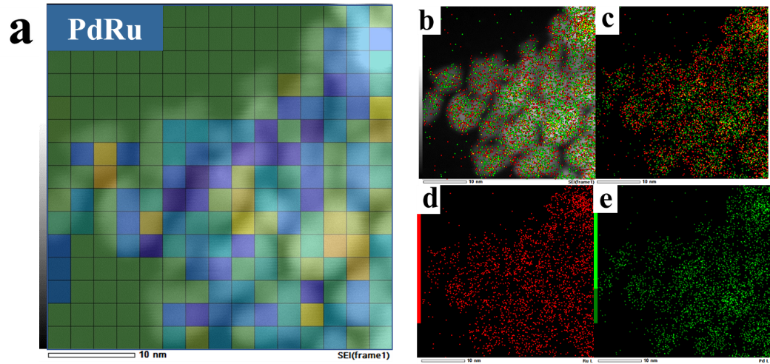
Figure S8. (a) Mosaic image of PdRu based on the value of each element in outlier matrix with HAADF-STEM image as background. (b) overlapping Pd and Ru elemental distribution in PdRu sample with HAADF-STEM image as background. (c) overlapping Pd and Ru elemental distribution image. (d) Ru elemental distribution image. (e) Pd elemental distribution image.

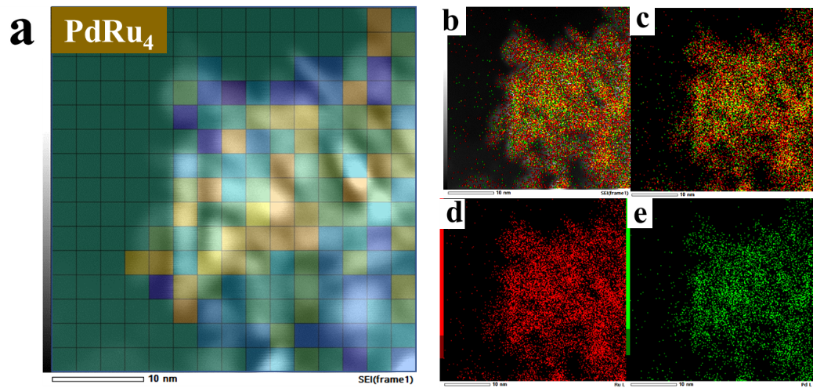
Figure S9. (a) Mosaic image of PdRu₄ based on the value of each element in outlier matrix with HAADF-STEM image as background. (b) overlapping Pd and Ru elemental distribution in PdRu4 sample with HAADF-STEM image as background. (c) overlapping Pd and Ru elemental distribution image. (d) Ru elemental distribution image. (e) Pd elemental distribution image.

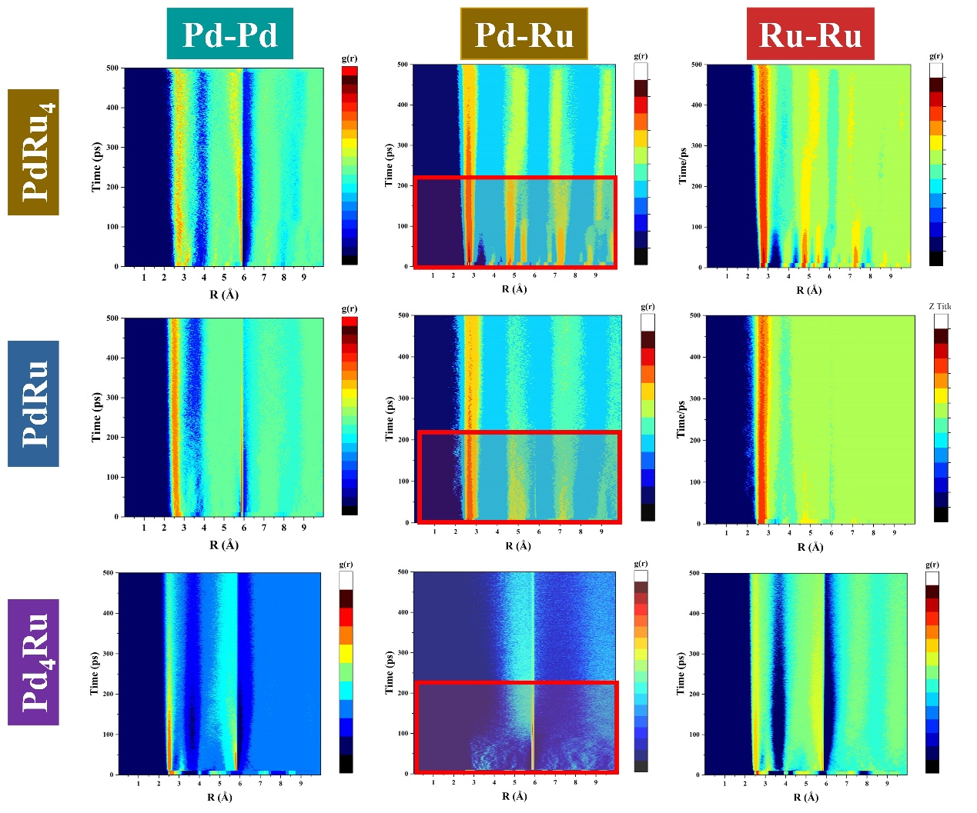
Figure S10. Partial radial distribution function (pRDF) in melting process obtained from molecular dynamics simulation. The pRDF evolution curve of Ru-Pd atom pair were highlighted by red rectangle in corresponding PdRu₄, PdRu and Pd₄Ru models.

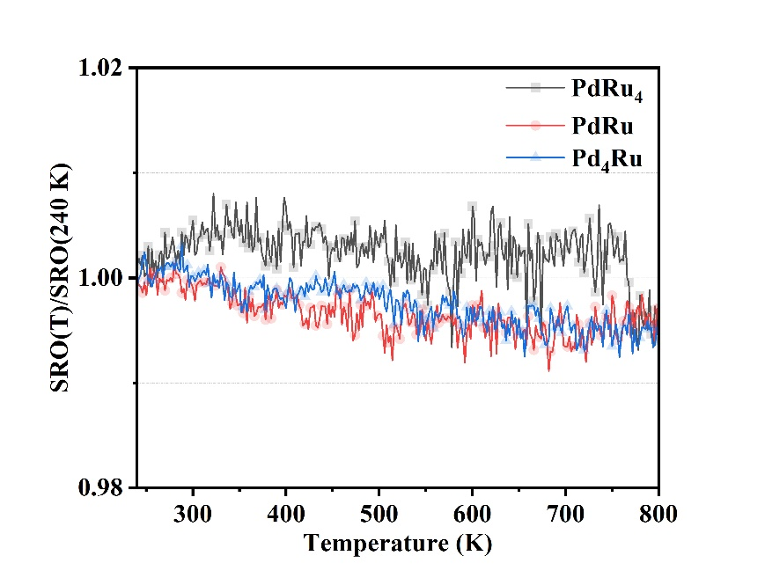
Figure S11. The SROs of Pd₄Ru, PdRu and PdRu₄ model changed with the increasing temperature.

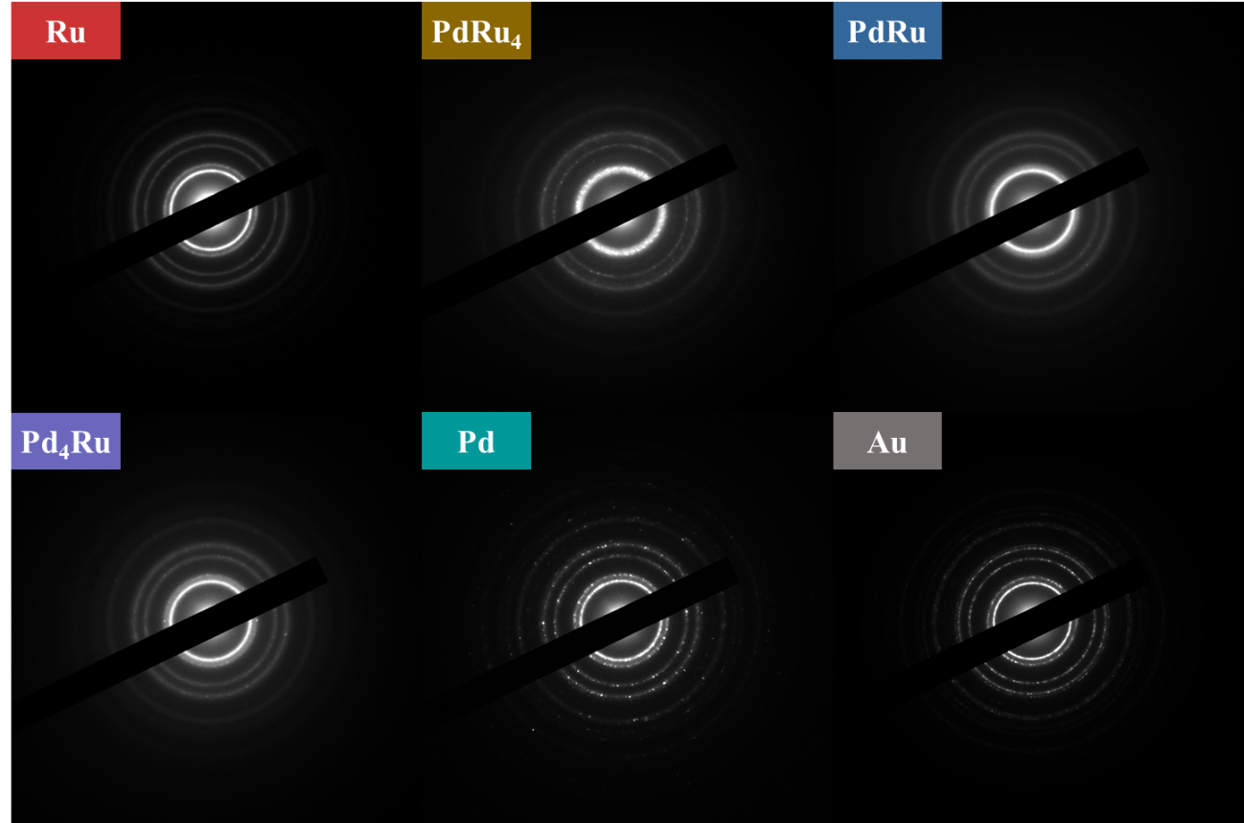
Figure S12. Selected area electron diffraction (SAED) patterns of Pd, Pd₄Ru, PdRu, PdRu₄, Ru, and Au.

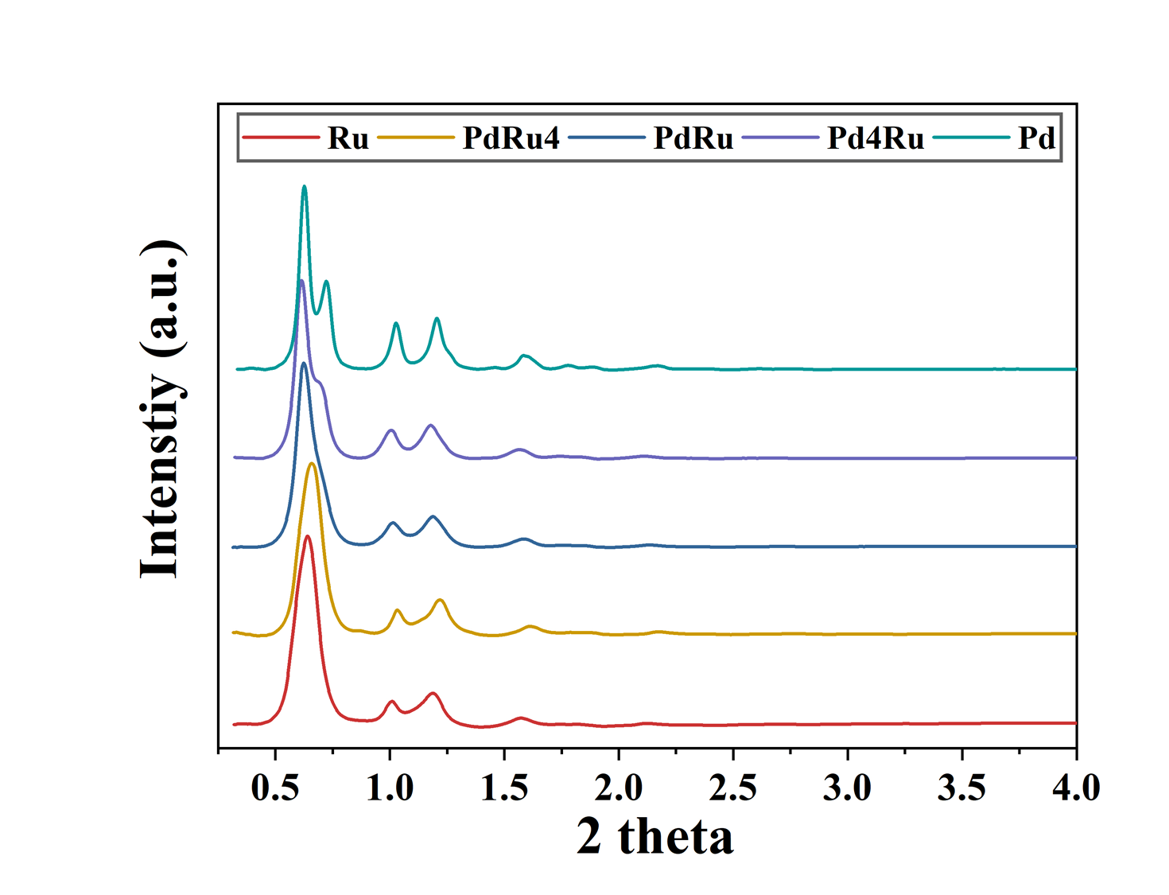
Figure S13. Ring integrated curves from SAED patterns of Pd, Pd₄Ru, PdRu, PdRu₄, and Ru.

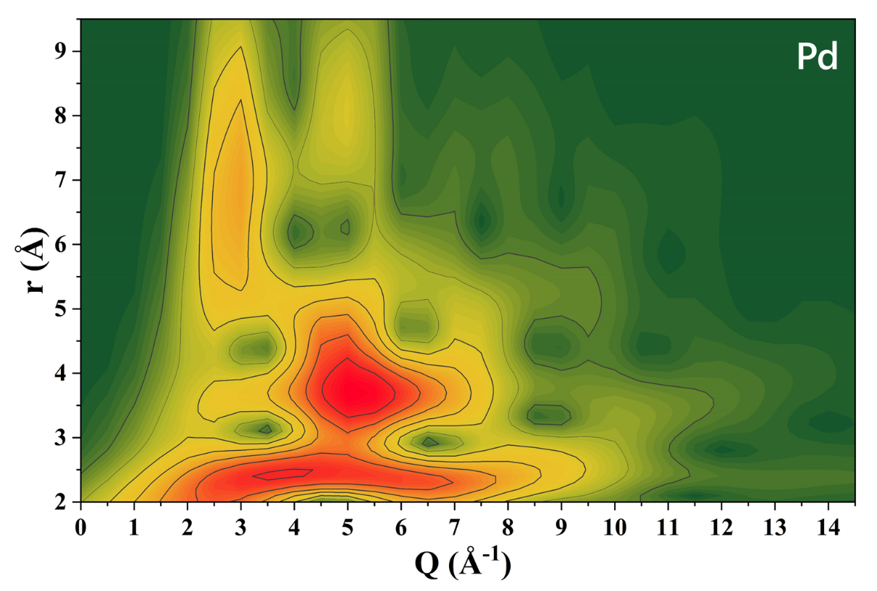
Figure S14. Wavelet-transformed reduced structure function F(Q) (G(r,Q)) of Pd

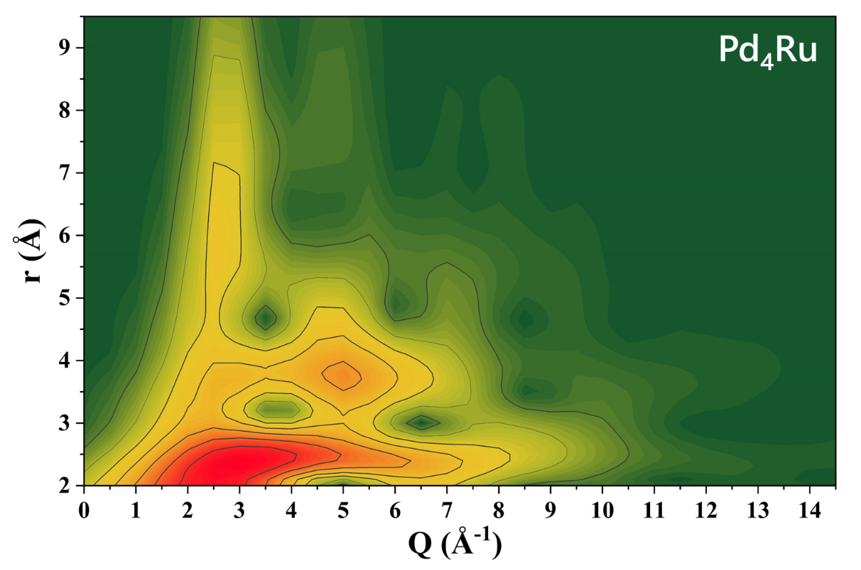
Figure S15. Wavelet-transformed reduced structure function F(Q) (G(r,Q)) of Pd₄Ru

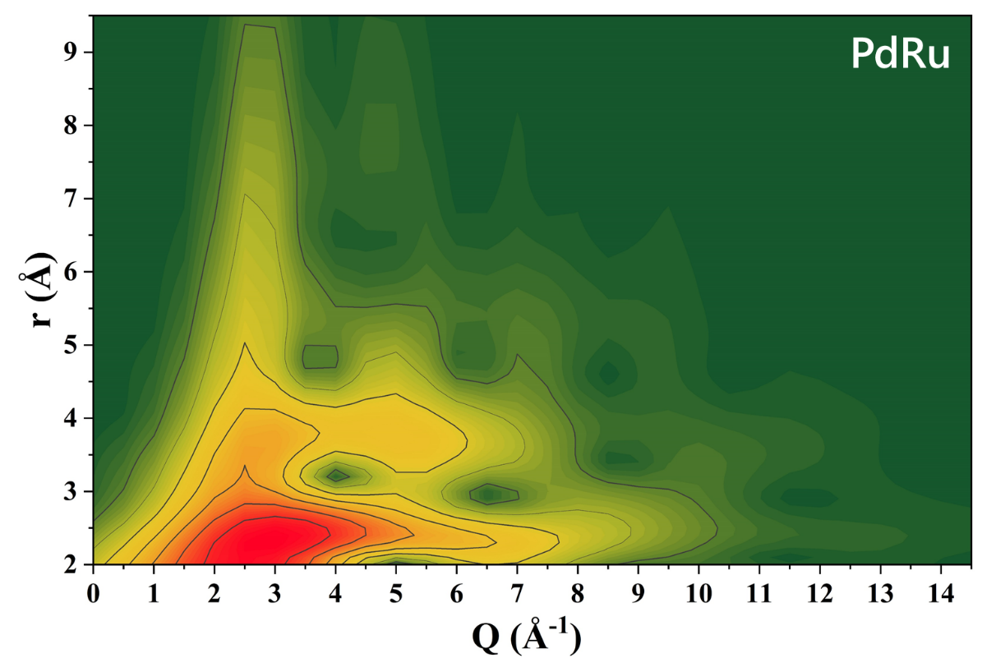
Figure S16. Wavelet-transformed reduced structure function F(Q) (G(r,Q)) of PdRu

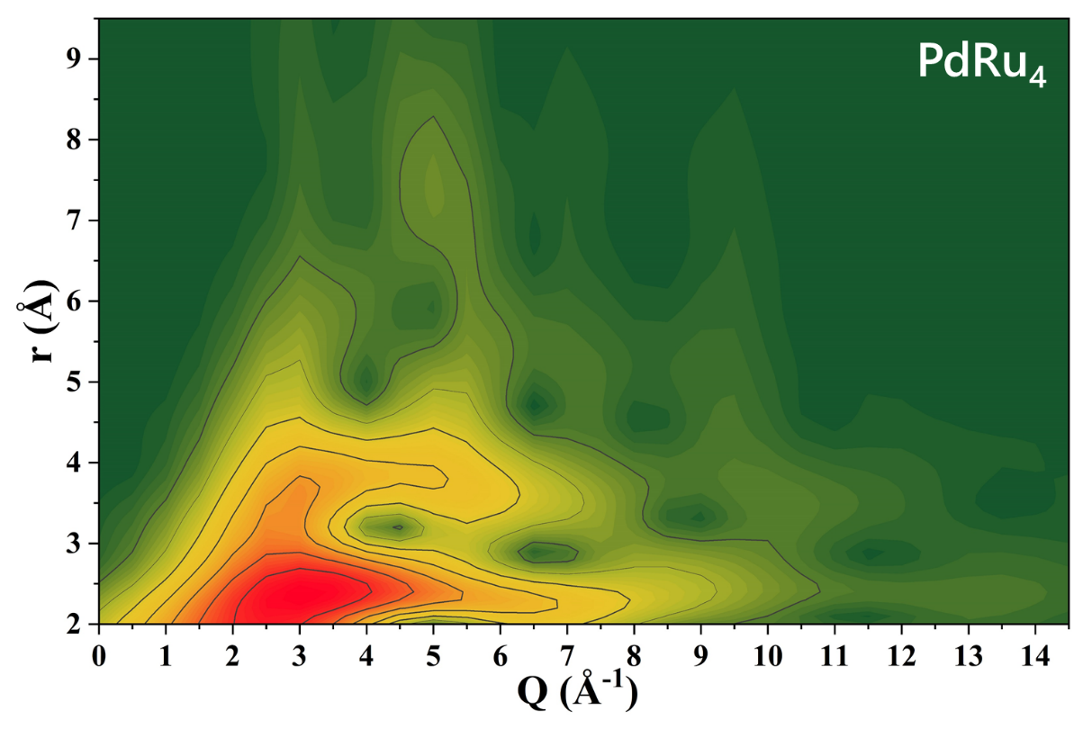
Figure S17. Wavelet-transformed reduced structure function F(Q) (G(r,Q)) of PdRu₄

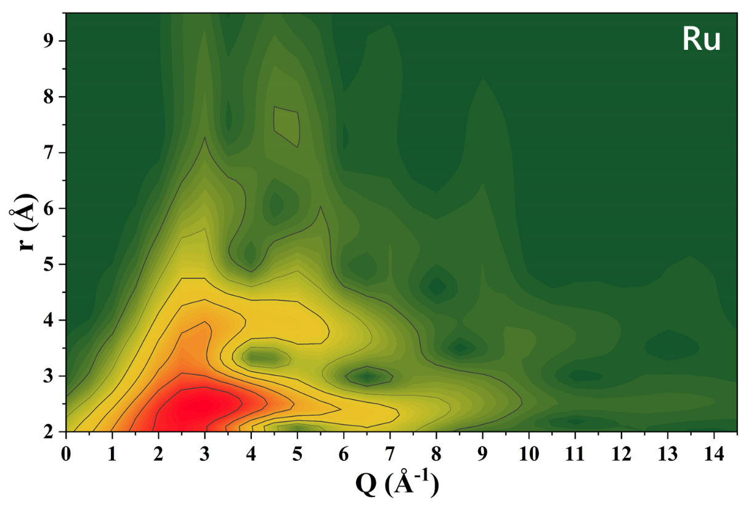
Figure S18. Wavelet-transformed reduced structure function F(Q) (G(r,Q)) of Ru

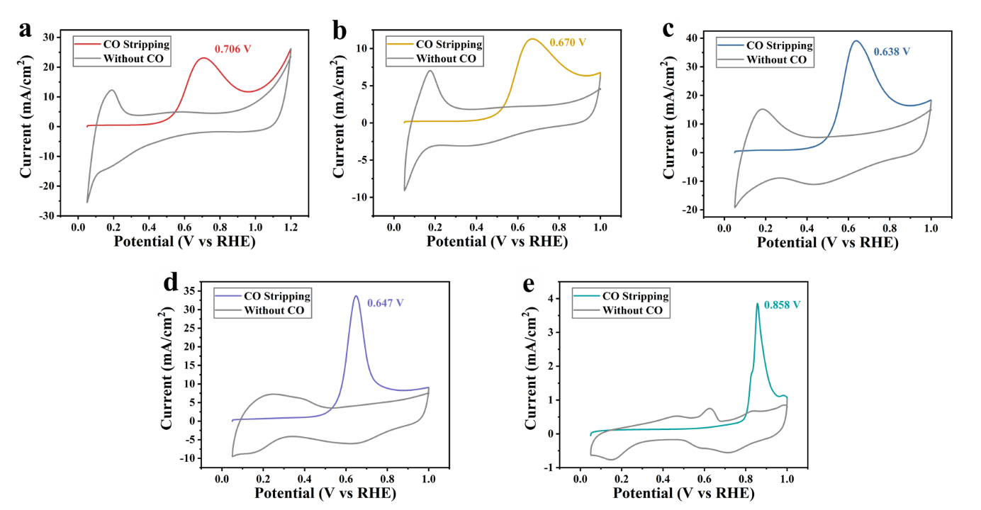
Figure S19. CO stripping curves of Pd, Pd₄Ru, PdRu, PdRu₄, and Ru.

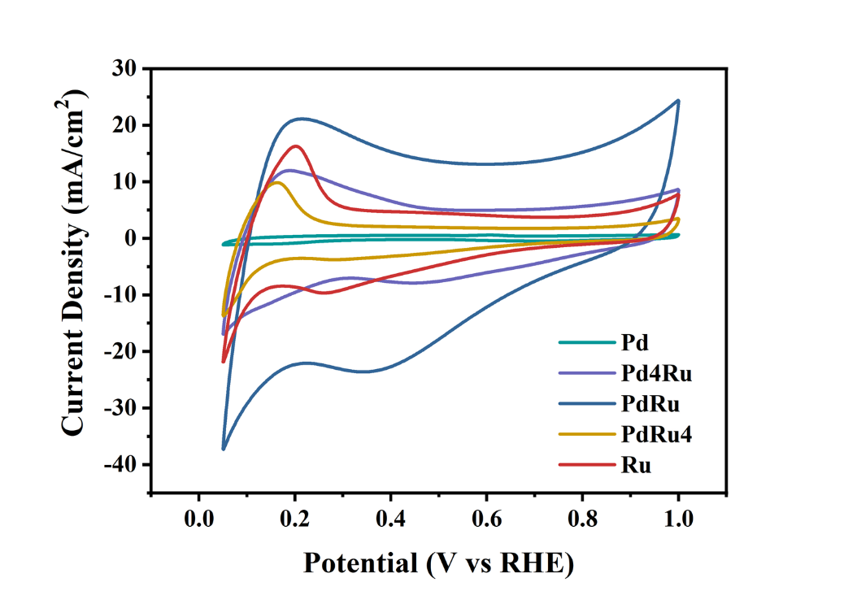
Figure S20. Cyclic voltammetry curve of Pd, Pd₄Ru, PdRu, PdRu₄, and Ru in 1 M KOH.

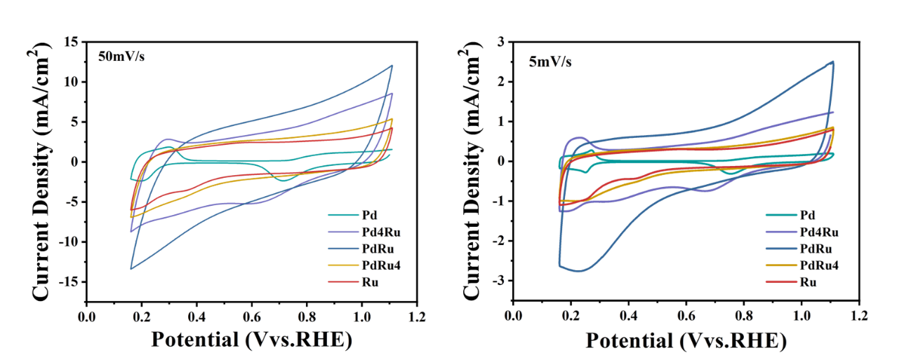
Figure S21. Cyclic voltammetry curve of Pd, Pd₄Ru, PdRu, PdRu₄, and Ru in 0.1 M H₂SO₄ with the scanning rate of 50 mV/s and 5 mV/s.

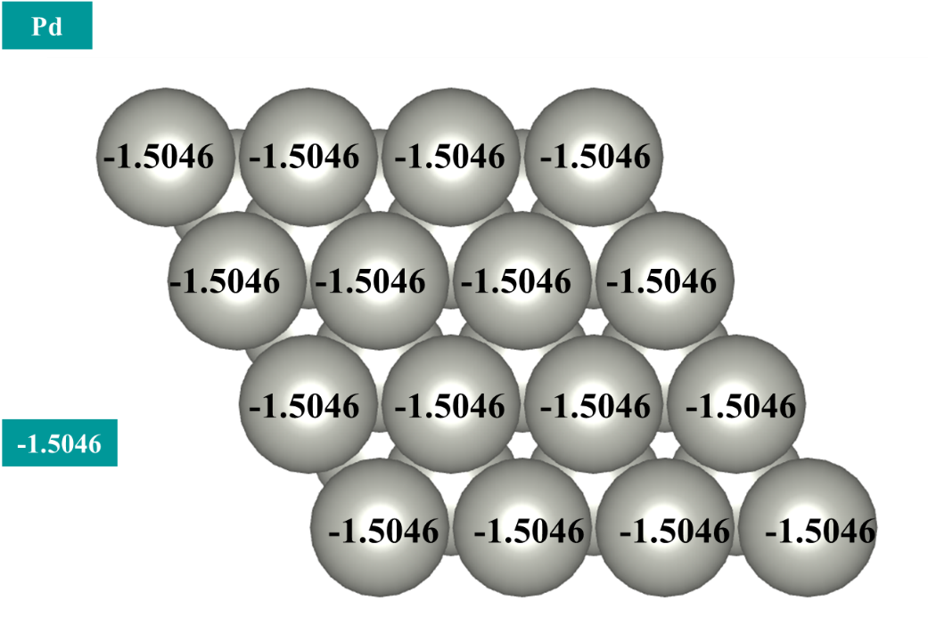
Figure S22. D-band center of surface atoms in Pd and corresponding average d-band center of surface atoms.

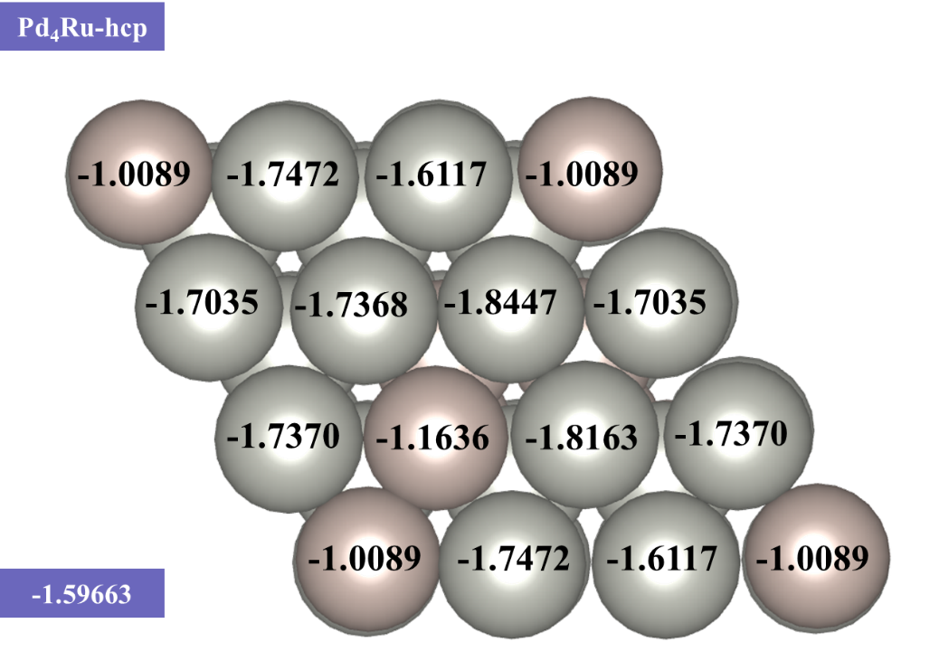
Figure S23. D-band center of surface atoms in random Pd₄Ru alloy and corresponding average d-band center of surface atoms.

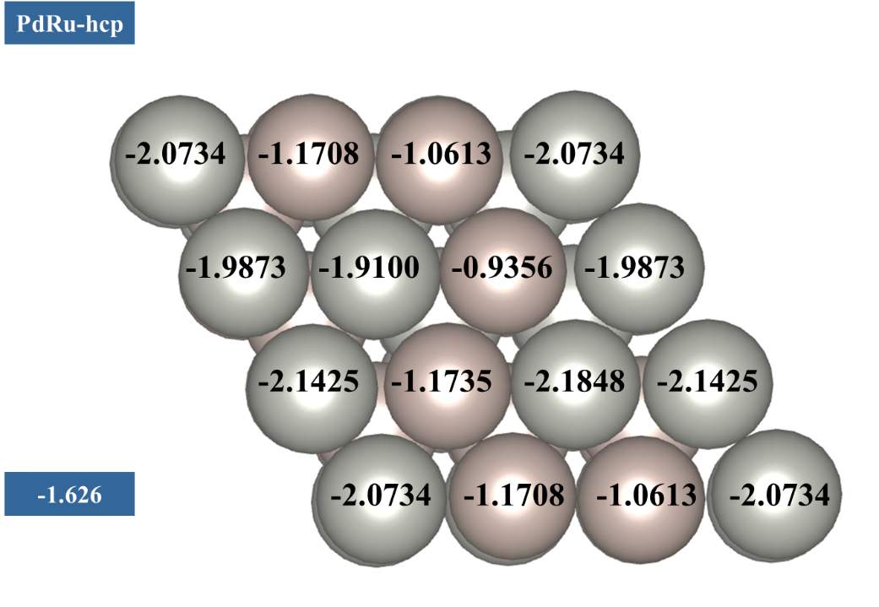
Figure S24. D-band center of surface atoms in random PdRu alloy and corresponding average d-band center of surface atoms.

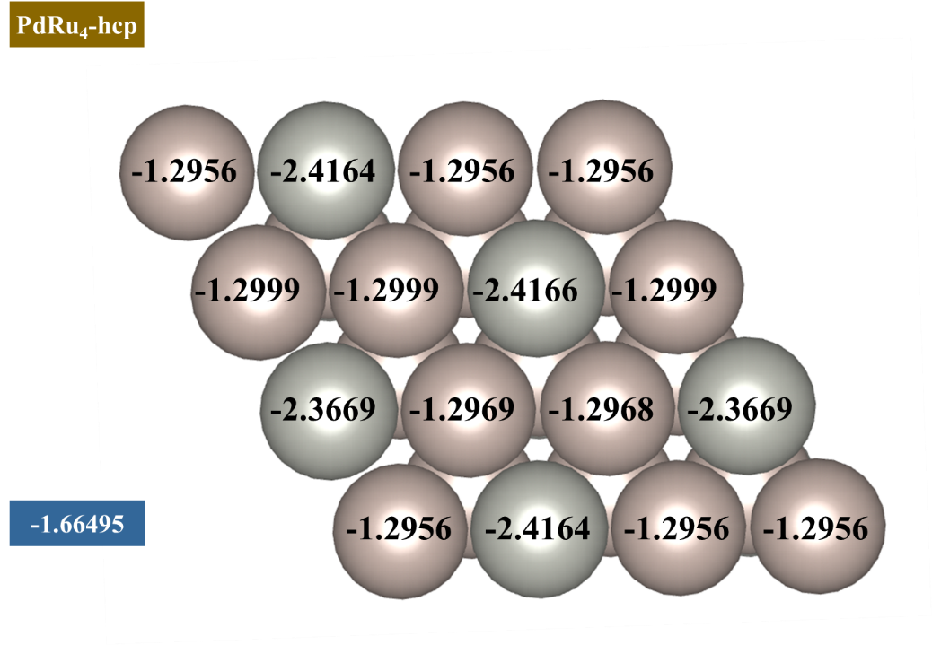
Figure S25. D-band center of surface atoms in random PdRu₄ alloy and corresponding average d-band center of surface atoms.

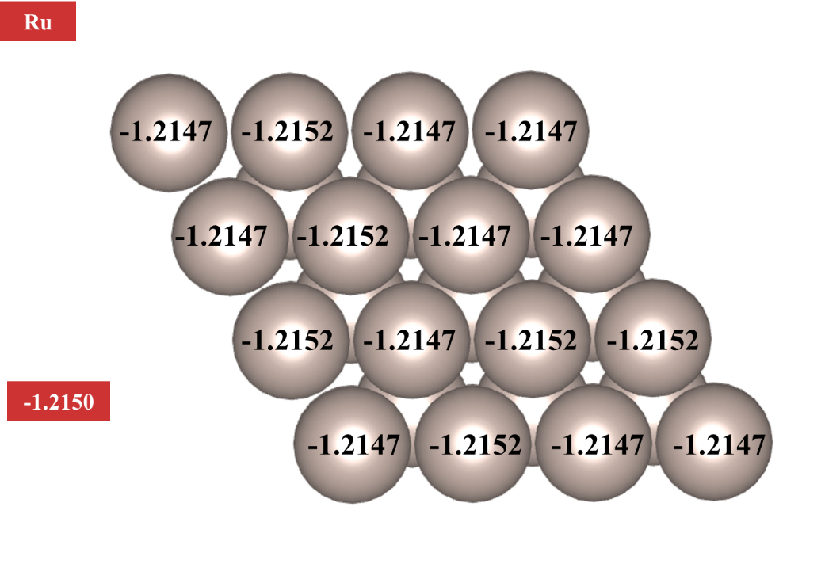
Figure S26. D-band center of surface atoms in Ru and corresponding average d-band center of surface atoms.

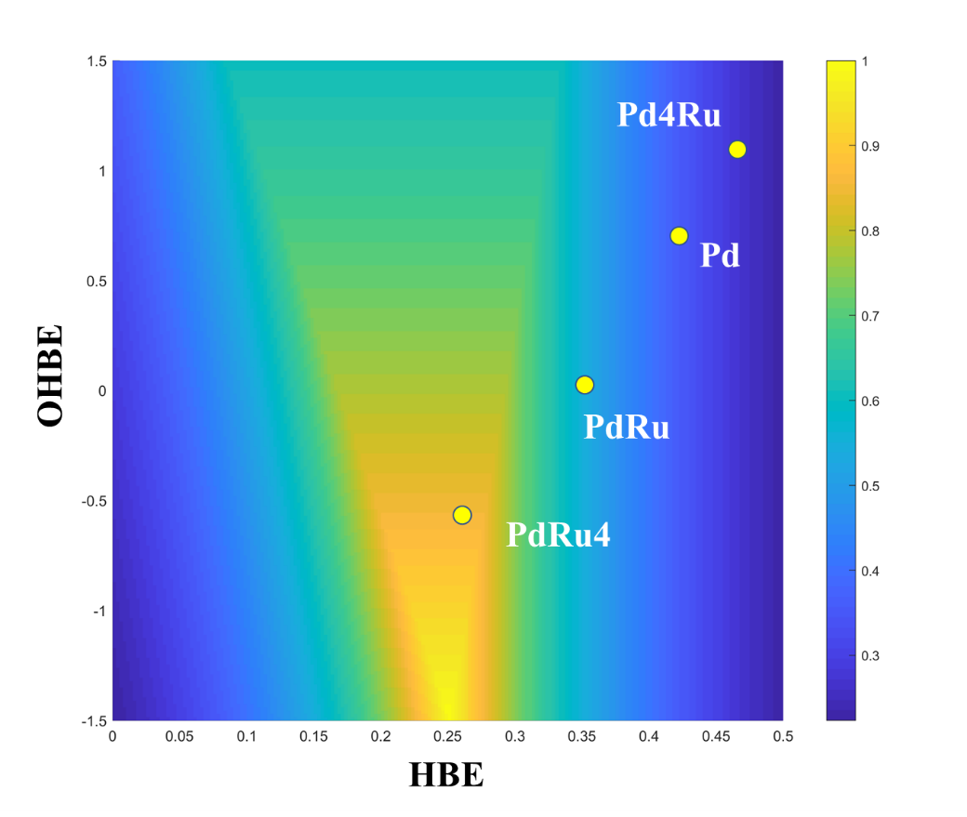
Figure S27. Contour mapping of limiting potential against HBE and OHBE

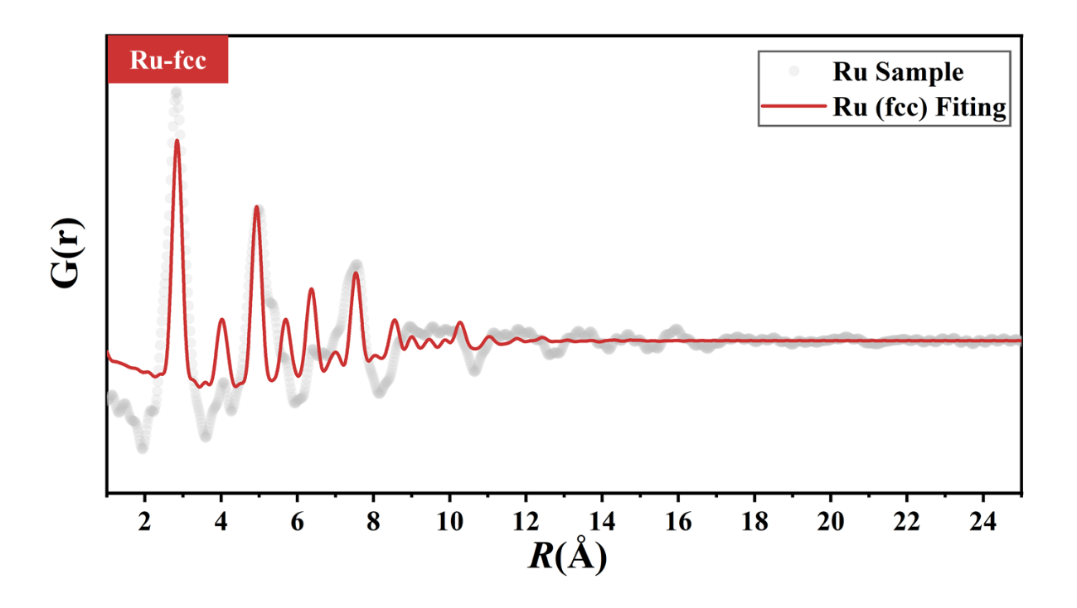
Figure S28. Ru PDF G(r) fitting by fcc Ru structure.

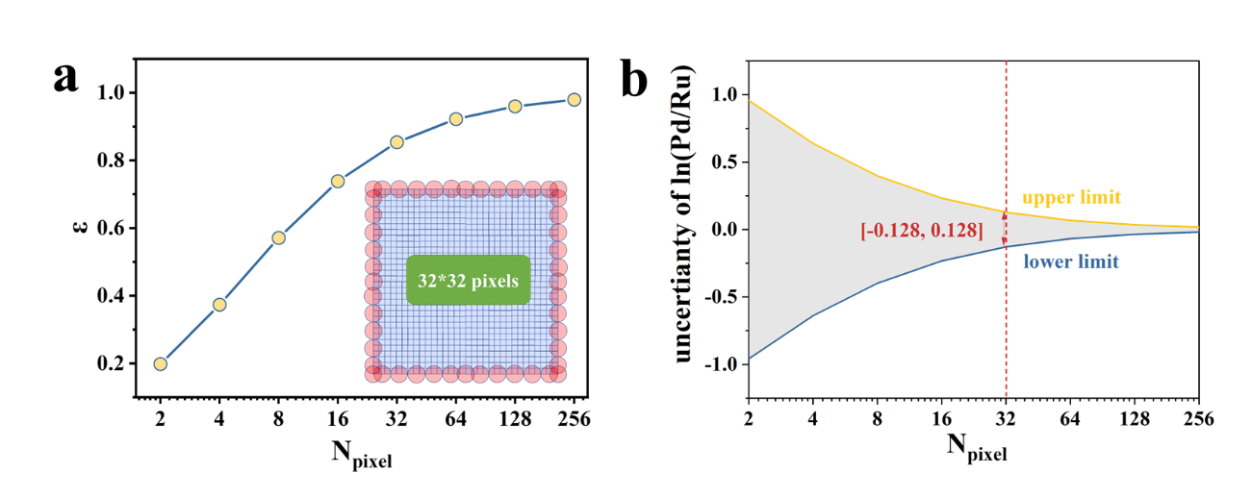
Figure S29. (a) The curve of value of total area divided by the area of circles in edge against number of pixels in a unit. (b) uncertainty of outlier values changes with the number of pixels on which a unit was predicated.

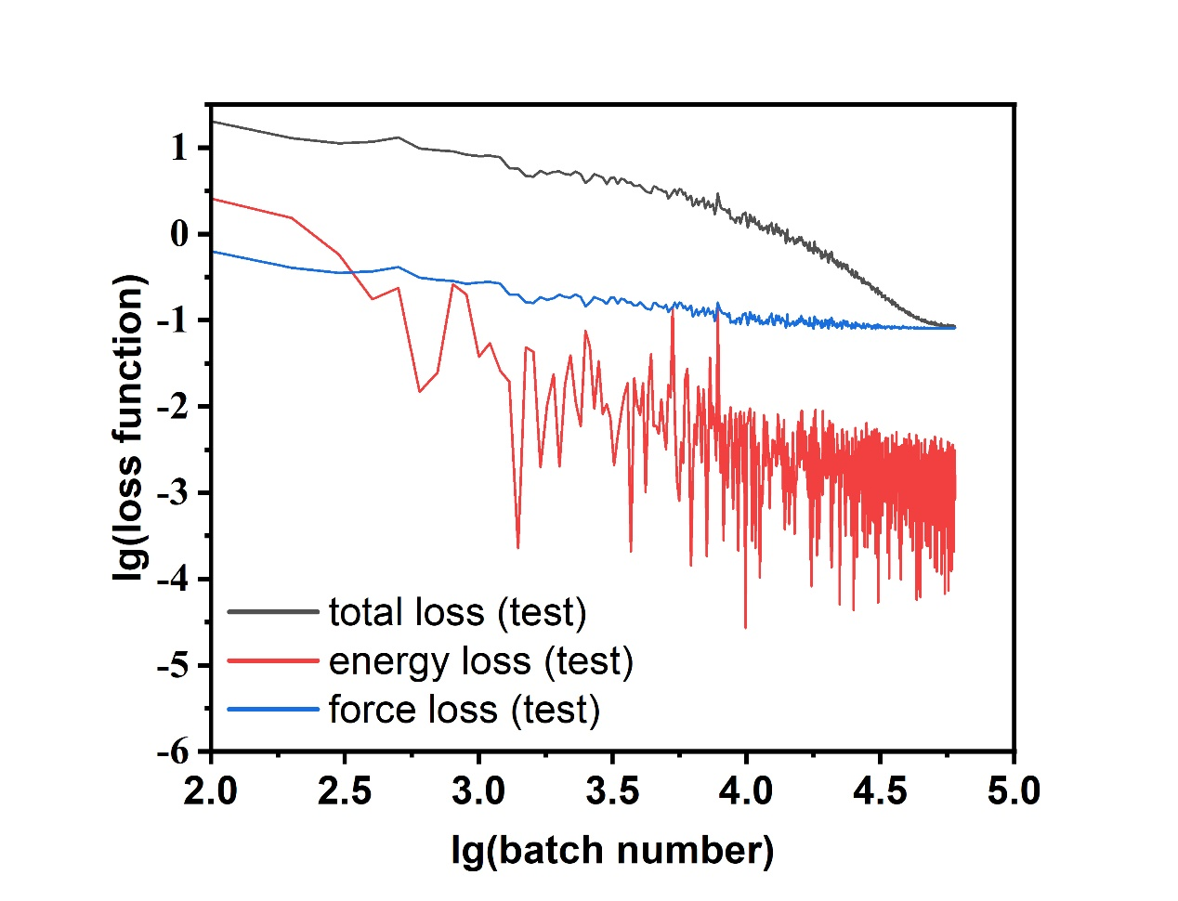
Figure S30. The force error, energy error and total loss function of Pd₄Ru test sets

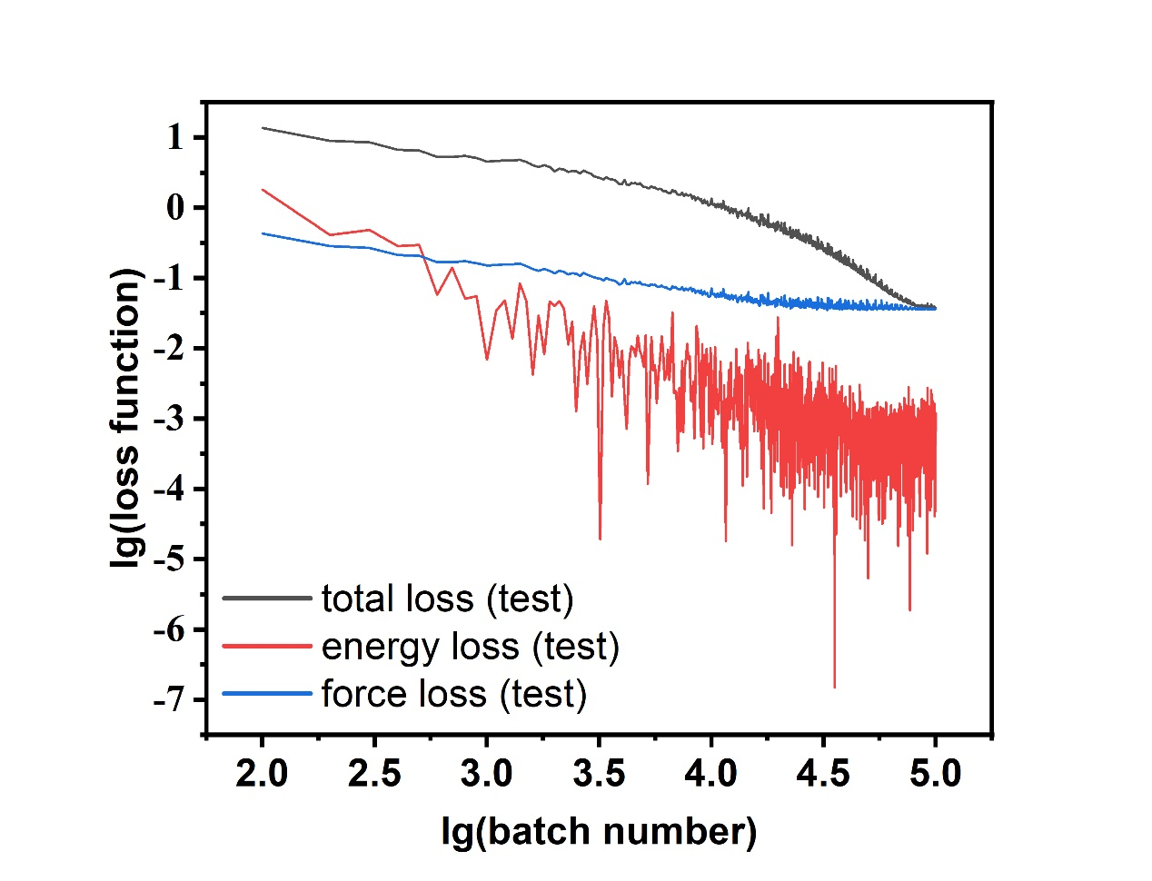
Figure S31. The force error, energy error and total loss function of PdRu test sets

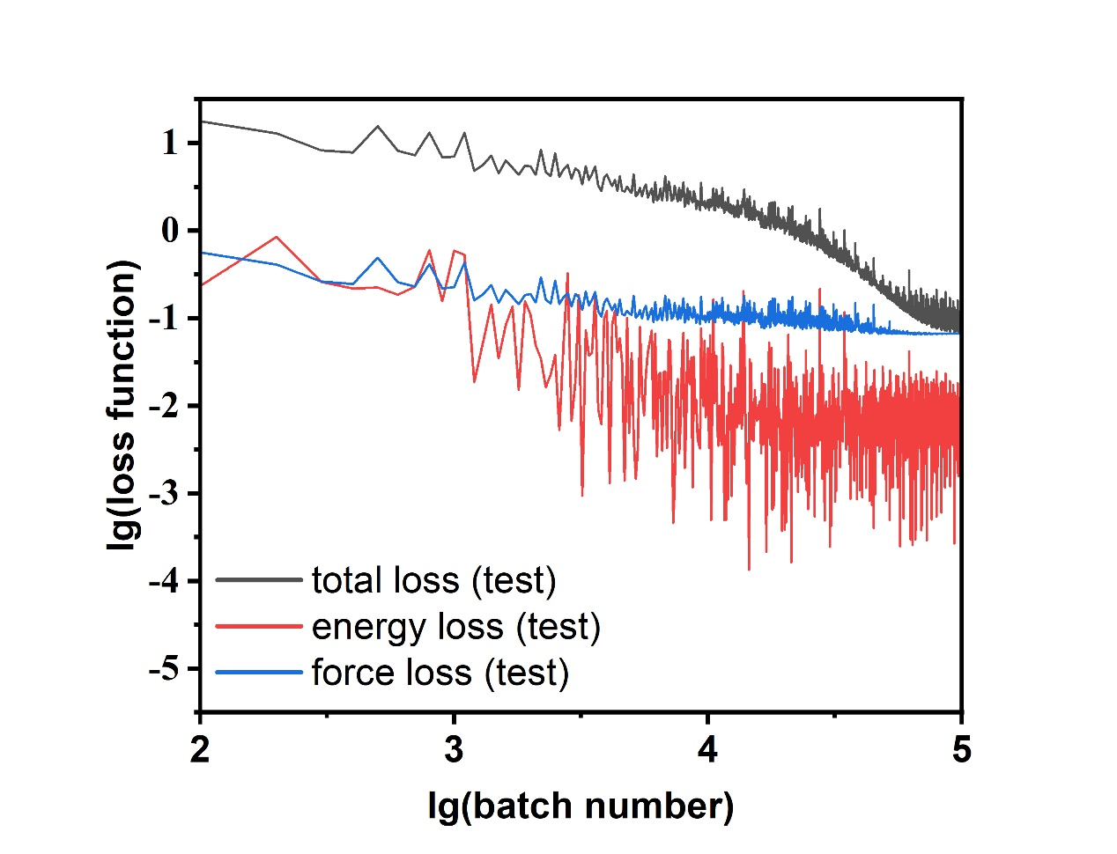
Figure S32. The force error, energy error and total loss function of PdRu₄ test sets

Table S2. Comparison between tafel slope and ε_{d}
Tafel Slope (mV/dec) | ε_{d}
384 | -1.5046
107 | -1.59663
64 | -1.626
63 | -1.66495
69 | -1.215

