Supplemental Information
Climate-Induced Shifts in Irrigation Water Demand and Supply during Sensitive Crop Growth
Phases in South Asia
Climatic Change Journal
Authors: Qurat-ul-Ain Ahmad^{a, b, *}, Eddy Moors^{a, c}, Hester Biemans^{d}, Nuzba Shaheen^{e}, Ilyas Masihª, Muhammad Zia ur Rahman Hashmi^{b}
ª Faculty of Sciences, Earth and Climate Cluster, De Boelelaan 1085, VU University Amsterdam, 1081 HV Amsterdam, The Netherlands
^{b} Water Resources and Glaciology Section, Global Change Impact Studies Centre (GCISC), Government of Pakistan, 6th Floor, Emigration Tower, 10-Mauve Area, G-8/1, Islamabad 44000, Pakistan
^{c} IHE Delft, Institute for Water Education, 2611 AX Delft, The Netherlands
^{d} Water and Food research group, Wageningen University & Research, P.O. Box 47, 6700 AA Wageningen, the Netherlands
^{e} Agriculture, Forestry and land use Section, Global Change Impact Studies Centre (GCISC), Government of Pakistan, 6th Floor, Emigration Tower, 10-Mauve Area, G-8/1, Islamabad 44000, Pakistan

* Corresponding Author, Email Address: q.u.r.a.t.ahmad@vu.nl, quratuetian29@gmail.com

Table 1 Phase-specific statistics and Mann-Kendall trends of (a) Temperature (Degree C) and (b) Precipitation (mm) during the vegetative (VEG) and reproductive (REP) phases of wheat (Rabi season) and rice (Kharif season) were calculated over six study sites for the period 1981-2100 in IGB river basins.
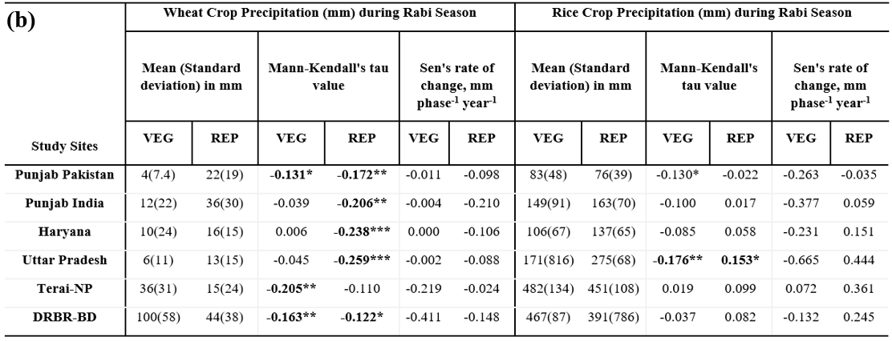
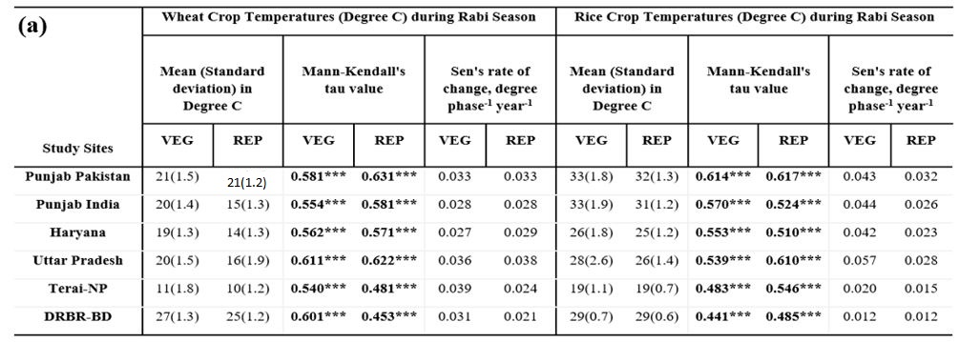
*, ** and *** signs indicate significant at 0.05, 0.01 and 0.001 level of significance, respectively.

Table 2 Irrigation water demand distribution in seasons and phases over six study sites for period 1981-2100 (a). Statistics and Mann-Kendall trends of simulated irrigation water demands (mm phase⁻¹ year⁻¹) during the vegetative (VEG) and reproductive (REP) phases of wheat and rice crops calculated over six study sites for period 1981-2100 in IGB river basins using the ensemble mean of four GCM’s of RCP4.5-SSP1 emission scenarios (b). Future changes in irrigation water demand (mm) of wheat and rice during the vegetative and reproductive crop growth phases during the periods F1 (2011-2040), F2 (2041-2070), F3 (2071-2100) and reference period (2011-2100) w.r.t control period (1981-2010) (c).
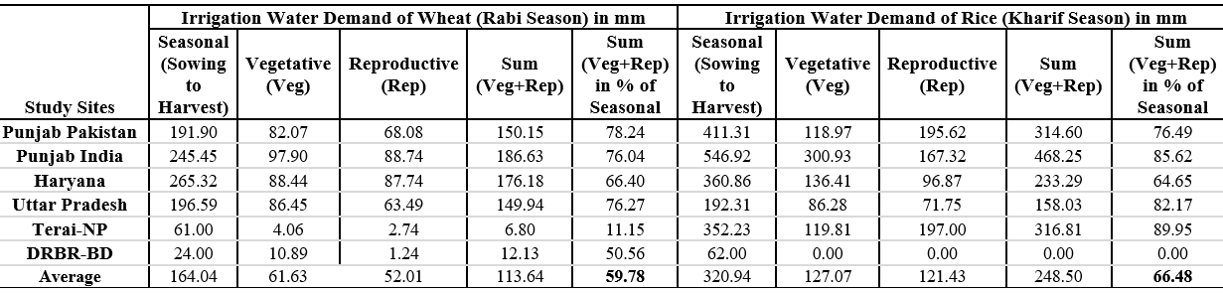
(a)

(b)  Study Sites | Wheat (Rabi Season) |  |  |  |  |  | Rice (Kharif Season)
(b)  Study Sites | Mean (Standard deviation), mm |  | Mann-Kendall's  tau value |  | Sen's rate of change, mm phase⁻¹ year⁻¹ |  | Mean (Standard deviation), mm |  | Mann-Kendall's tau value |  | Sen's rate of change, mm phase⁻¹ year⁻¹
(b)  Study Sites | VEG | REP | VEG | REP | VEG | REP | VEG | REP | VEG | REP | VEG | REP
Punjab Pakistan | 82(5) | 68(15) | 0.54*** | -0.48*** | 0.10 | -0.28 | 119(23) | 196(32) | -0.37*** | 0.4*** | -0.37 | 0.54
Punjab India | 98(6) | 89(18) | 0.51*** | -0.33*** | 0.07 | -0.18 | 301(77) | 167(65) | -0.18** | 0.23*** | -0.58 | 0.61
Haryana | 88(9) | 88(16) | 0.45*** | -0.51*** | 0.15 | -0.28 | 136(40) | 97(38) | -0.11 | 0.14* | -0.18 | 0.23
Uttar Pradesh | 86(11) | 63(12) | 0.4*** | -0.37*** | 0.17 | -0.17 | 86(31) | 72(34) | 0.2** | 0.29*** | 0.27 | 0.43
Terai-NP | 4(1) | 3(1) | 0.3*** | -0.32*** | 0.01 | -0.02 | 120(23) | 197(33) | -0.37*** | 0.4*** | -0.37 | 0.55
DRBR-BD | 11(2) | 1(2) | -0.37*** | -0.49*** | -0.02 | -0.01 | 0(0) | 0(0) | 0.00 | 0.00 | 0.00 | 0.00
*, ** and *** signs indicate significant at 0.05, 0.01 and 0.001 level of significance, respectively.
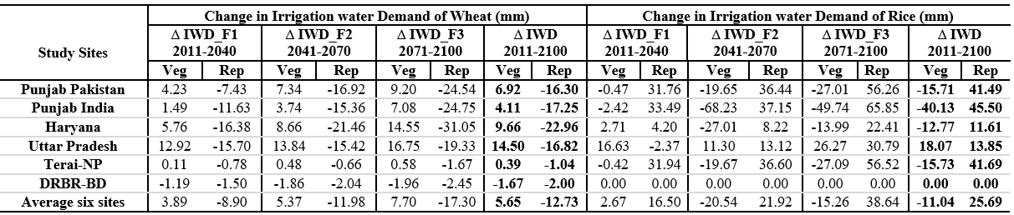
(c)

Table 3 Pearson correlations of crop and phase-specific irrigation water demand (IWD) and supply (surface water (IWSsur) and groundwater (IWSgw)) in mm with temperatures (a) and precipitation (b) over six study sites during the period 1981-2100.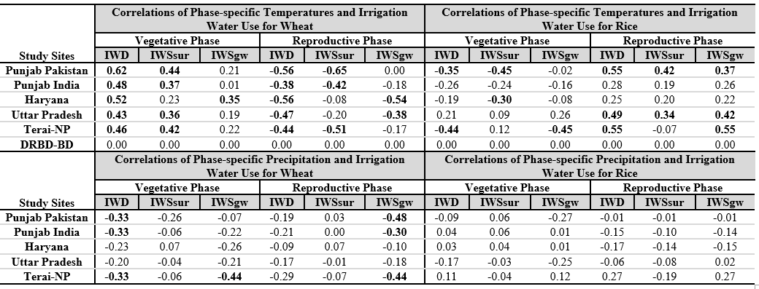
(b)
(a)

Table 4 30 years mean irrigation water demand (mm phase⁻¹ year⁻¹) by wheat and rice crops during the vegetative and reproductive crop growth Phases over six study sites for period 1981-2100 using ensemble mean of four GCM’s of RCP8.5-SSP3 emission scenarios.

Crops | Study Sites | Irrigation Water Demand (mm) during Vegetative Phase |  |  |  | Irrigation Water Demand (mm) during Reproductive Phase
Crops | Study Sites | 1981-2010 | 2011-2040 | 2041-2070 | 2071-2100 | 1981-2010 | 2011-2040 | 2041-2070 | 2071-2100
Wheat | Punjab Pakistan | 76.71 | 82.89 | 90.38 | 97.08 | 80.11 | 73.36 | 72.89 | 65.12
Wheat | Punjab India | 94.60 | 97.35 | 102.21 | 107.17 | 101.38 | 89.52 | 88.25 | 81.11
Wheat | Haryana | 81.12 | 89.61 | 96.00 | 102.92 | 104.66 | 88.62 | 83.57 | 79.13
Wheat | Uttar Pradesh | 75.61 | 92.32 | 96.88 | 104.32 | 76.13 | 57.19 | 57.68 | 59.40
Wheat | Terai-NP | 3.76 | 4.19 | 4.58 | 5.14 | 3.52 | 2.18 | 2.29 | 2.02
Wheat | DRBR-BD | 12.16 | 10.82 | 9.70 | 8.55 | 2.82 | 1.02 | 2.33 | 0.12
Rice | Punjab Pakistan | 130.82 | 140.35 | 133.82 | 117.20 | 164.60 | 199.86 | 236.79 | 275.40
Rice | Punjab India | 331.02 | 329.30 | 263.53 | 215.10 | 133.20 | 165.40 | 185.94 | 239.94
Rice | Haryana | 146.02 | 148.71 | 126.16 | 108.18 | 88.18 | 93.66 | 105.69 | 145.70
Rice | Uttar Pradesh | 72.75 | 94.72 | 99.75 | 96.24 | 61.39 | 53.71 | 75.23 | 136.83
Rice | Terai-NP | 2.49 | 3.33 | 3.50 | 2.49 | 1.74 | 0.44 | 0.96 | 2.21
Rice | DRBR-BD | 0.00 | 0.00 | 0.00 | 0.00 | 0.00 | 0.00 | 0.00 | 0.00

Table 5-I Statistics and Mann-Kendall trends of simulated irrigation supply from surface water (a) and groundwater (b) (mm phase⁻¹ year⁻¹) during the vegetative (VEG) and reproductive (REP) phases of wheat and rice crops calculated over Six Study Sites for the period 1981-2100 in IGB river basins using the ensemble mean of four GCM’s of RCP4.5-SSP1 emission scenarios.
Study Sites  (a) | Statistics and Mann-Kendall trends of irrigation water supply by surface water (mm phase⁻¹ year⁻¹) during vegetative and reproductive phases of Wheat and Rice crops calculated over Six Study Sites for period 1981-2100
Study Sites  (a) | Wheat Crop (Rabi Season) |  |  |  |  |  | Rice Crop (Kharif Season)
Study Sites  (a) | Mean (Standard deviation), mm |  | Mann-Kendall's tau value |  | Sen's rate of change, mm phase⁻¹ year⁻¹ |  | Mean (Standard deviation), mm |  | Mann-Kendall's  Tau value |  | Sen's rate of change, mm phase⁻¹ year⁻¹
Study Sites  (a) | VEG | REP | VEG | REP | VEG | REP | VEG | REP | VEG | REP | VEG | REP
Punjab Pakistan | 66 (5) | 52 (13) | 0.38*** | -0.55*** | 0.09 | -0.27 | 93 (17) | 150 (25) | -0.39*** | 0.28*** | -0.29 | 0.31
Punjab India | 48 (8) | 32 (11) | 0.28*** | -0.36*** | 0.10 | -0.16 | 191 (45) | 102 (40) | -0.16* | 0.16* | -0.32 | 0.27
Haryana | 22 (6) | 14 (4) | 0.16** | -0.09 | 0.04 | -0.02 | 54 (17) | 45 (17) | -0.25*** | 0.13* | -0.19 | 0.09
Uttar Pradesh | 60 (8) | 40 (8) | 0.33*** | -0.10 | 0.12 | -0.04 | 65 (24) | 60 (29) | 0.11 | 0.22*** | 0.12 | 0.28
Terai-NP | 3 (0) | 2 (1) | 0.32*** | -0.39*** | 0.01 | -0.01 | 2 (1) | 1 (1) | 0.12* | -0.01 | 0.01 | 0.00
DRBR-BD | 0 (0) | 0 (0) | 0.00 | 0.00 | 0.00 | 0.00 | 0 (0) | 0 (0) | 0.00 | 0.00 | 0.00 | 0.00
*, ** and *** signs indicate significant at 0.05, 0.01 and 0.001 level of significance, respectively.

Study Sites  (b) | Statistics and Mann-Kendall trends of irrigation water supply by groundwater (mm phase-1 year-1) during vegetative and reproductive phases of Wheat and Rice crops calculated over Six Study Sites for period 1981-2100
Study Sites  (b) | Wheat Crop (Rabi Season) |  |  |  |  |  | Wheat Crop (Rabi Season)
Study Sites  (b) | Mean (Standard deviation), mm |  | Mann-Kendall's tau value |  | Sen's rate of change, mm phase-1 year-1 |  | Mean (Standard deviation), mm |  | Mann-Kendall's tau value |  | Sen's rate of change, mm phase-1 year-1
Study Sites  (b) | VEG | REP | VEG | REP | VEG | REP | VEG | REP | VEG | REP | VEG | REP
Punjab Pakistan | 16 (3) | 16 (7) | 0 | -0.02 | 0 | 0 | 26 (12) | 45 (21) | -0.1 | 0.32*** | -0.05 | 0.25
Punjab India | 50 (8) | 57 (13) | -0.06 | -0.12* | -0.02 | -0.07 | 110 (58) | 66 (39) | -0.09 | 0.22*** | -0.23 | 0.34
Haryana | 66 (10) | 74 (16) | 0.23*** | -0.45*** | 0.1 | -0.26 | 82 (31) | 51 (28) | 0 | 0.09 | 0 | 0.11
Uttar Pradesh | 26 (8) | 23 (10) | 0.17** | -0.3*** | 0.06 | -0.13 | 21 (18) | 12 (17) | 0.18** | 0.18** | 0.12 | 0.12
Terai-NP | 1 (0) | 1 (1) | 0.09 | -0.12* | 0 | 0 | 117 (23) | 197 (33) | -0.37*** | 0.40*** | -0.38 | 0.55
DRBR-BD | 11 (2) | 1 (2) | -0.37*** | -0.5*** | -0.02 | -0.01 | 0 (0) | 0 (0) | 0 | 0 | 0 | 0
Table 5-II Future changes in irrigation water supply by surface water (c) and groundwater (d) in mm during the vegetative and reproductive crop growth phases of wheat and rice during the periods F1 (2011-2040), F2 (2041-2070), F3 (2071-2100) and reference period (2011-2100) w.r.t control period (1981-2010).

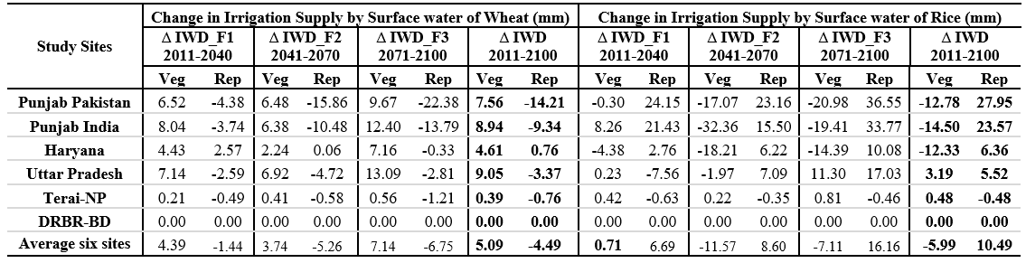
(c)
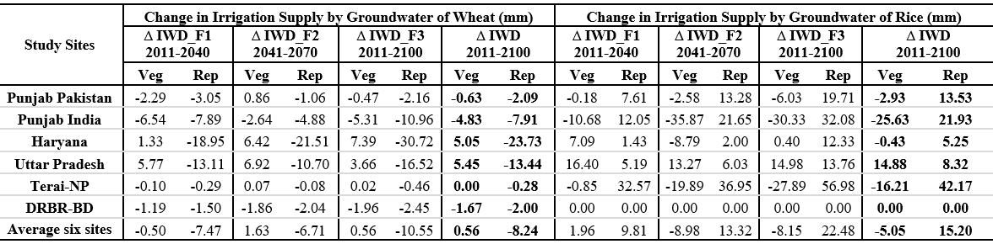
(d)

Table 6 Irrigation supply (mm phase⁻¹ year⁻¹) by sources (surface water and groundwater) for wheat and rice crops during the vegetative and reproductive phases for six study sites during the periods 1981-2010, 2011-2040, 2041-2070 and 2071-2100 using the ensemble mean of four GCM’s of RCP8.5-SSP3 emission scenarios.
Study Sites | Period | Vegetative Phase of Wheat |  | Reproductive Phase of Wheat |  |  | Vegetative Phase of  Rice |  |  | Reproductive Phase of Rice
Study Sites | Period | Surface | Groundwater | Surface | Groundwater |  | Surface | Groundwater |  | Surface | Groundwater
 | 1981-2010 | 60.06 | 16.86 | 62.63 | 17.48 |  | 102.48 |  | 28.34 | 129.42 | 35.18
Punjab Pakistan | 2011-2040 | 66.75 | 16.14 | 59.10 | 14.26 |  | 107.16 |  | 33.19 | 156.02 | 43.84
 | 2041-2070 | 69.86 | 20.52 | 51.28 | 21.61 |  | 100.95 |  | 32.87 | 167.75 | 69.04
 | 2071-2100 | 71.81 | 25.27 | 42.37 | 22.75 |  | 81.96 |  | 35.24 | 160.77 | 114.63
 | 1981-2010 | 41.62 | 53.24 | 39.20 | 62.29 |  | 201.84 |  | 129.19 | 83.90 | 49.30
Punjab India | 2011-2040 | 45.62 | 51.73 | 33.86 | 55.66 |  | 202.43 |  | 126.86 | 101.18 | 64.21
 | 2041-2070 | 47.31 | 54.90 | 27.49 | 60.76 |  | 166.57 |  | 96.96 | 111.23 | 74.71
 | 2071-2100 | 50.36 | 56.81 | 23.25 | 57.85 |  | 124.65 |  | 90.44 | 124.31 | 115.63
 | 1981-2010 | 18.74 | 62.48 | 13.48 | 91.53 |  | 63.41 |  | 82.61 | 40.64 | 47.54
Haryana | 2011-2040 | 20.21 | 69.40 | 13.51 | 75.11 |  | 58.96 |  | 89.75 | 42.73 | 50.93
 | 2041-2070 | 20.03 | 75.97 | 11.21 | 72.36 |  | 47.18 |  | 78.98 | 48.51 | 57.18
 | 2071-2100 | 20.23 | 82.69 | 9.92 | 69.21 |  | 36.99 |  | 71.19 | 57.64 | 88.05
 | 1981-2010 | 53.46 | 22.17 | 42.55 | 33.74 |  | 62.67 |  | 10.42 | 55.97 | 5.58
Uttar Pradesh | 2011-2040 | 57.54 | 34.78 | 34.15 | 23.04 |  | 72.51 |  | 23.28 | 44.57 | 10.78
 | 2041-2070 | 61.18 | 35.70 | 33.77 | 23.91 |  | 74.43 |  | 25.32 | 59.49 | 15.74
 | 2071-2100 | 66.36 | 37.95 | 34.72 | 24.68 |  | 72.27 |  | 23.97 | 103.99 | 32.84
 | 1981-2010 | 2.56 | 1.21 | 2.44 | 1.11 |  | 2.06 |  | 0.44 | 1.01 | 0.14
Terai-NP | 2011-2040 | 2.74 | 1.46 | 1.53 | 0.66 |  | 2.61 |  | 0.78 | 0.42 | 0.07
 | 2041-2070 | 3.01 | 1.56 | 1.50 | 0.79 |  | 2.67 |  | 0.83 | 0.79 | 0.16
 | 2071-2100 | 3.38 | 1.76 | 1.46 | 0.56 |  | 1.89 |  | 0.60 | 1.88 | 0.33
 | 1981-2010 | 0.00 | 12.16 | 0.00 | 2.82 |  | 0.00 |  | 0.00 | 0.00 | 0.00
DRBR-BD | 2011-2040 | 0.00 | 10.82 | 0.00 | 1.02 |  | 0.00 |  | 0.00 | 0.00 | 0.00
 | 2041-2070 | 0.00 | 9.70 | 0.00 | 0.36 |  | 0.00 |  | 0.00 | 0.00 | 0.00
 | 2071-2100 | 0.00 | 8.55 | 0.00 | 0.12 |  | 0.00 |  | 0.00 | 0.00 | 0.00

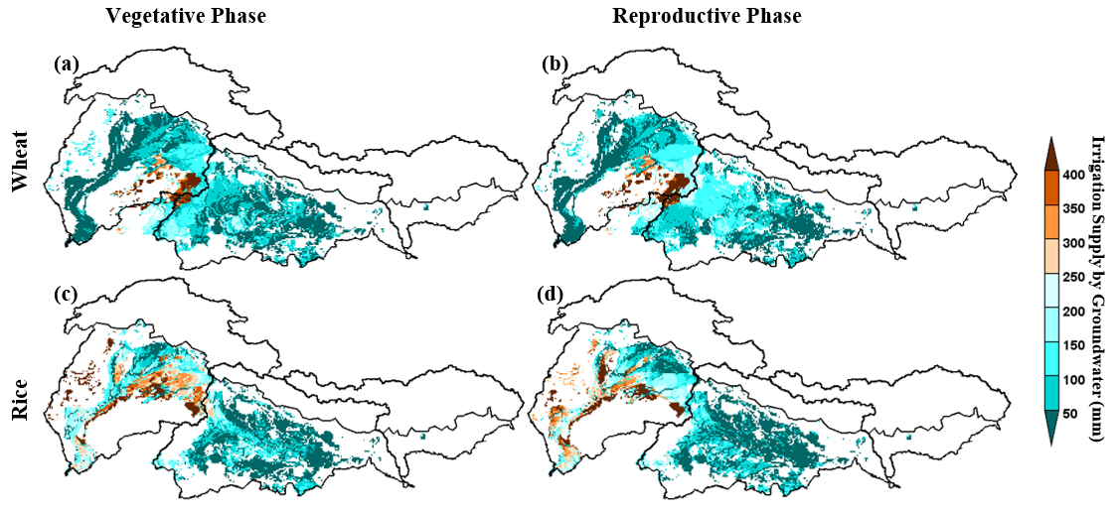
Fig. S1 Irrigation from groundwater (mm) during the vegetative (a, c) and reproductive (b, d) phases of wheat (a-b) and rice (c-d) crops over whole IGB river basins for the control period (1981-2010) using the ensemble mean of four GCM’s of RCP4.5-SSP1 emission scenarios.

