Appendix 1: FIS for Fuzzy Radon Hazard Index
[System]
Name='FRHI'
Type='mamdani'
Version=2.0
NumInputs=1
NumOutputs=1
NumRules=5
AndMethod='min'
OrMethod='max'
ImpMethod='min'
AggMethod='max'
DefuzzMethod='centroid'

[Input1]
Name='RadonConcentration(Bq/m3)'
Range=[0 1000]
NumMFs=5
MF1='LowestC':'gaussmf',[35 0]
MF2='LowC':'gaussmf',[20 85]
MF3='AveC':'gaussmf',[15 124]
MF4='HighC':'gaussmf',[50 225]
MF5='HighestC':'gaussmf',[330 1000]

[Output1]
Name='FuzzyRadonHazardIndex(FRHI)'
Range=[0 100]
NumMFs=5
MF1='NonHazardous':'gaussmf',[9 0]
MF2='LessHazardous':'gaussmf',[7 30]
MF3='RatherHazardous':'gaussmf',[7 50]
MF4='Hazardous':'gaussmf',[7 70]
MF5='VeryHazardous':'gaussmf',[15 100]

[Rules]
1, 1 (1) : 1
2, 2 (1) : 1
3, 3 (1) : 1
4, 4 (1) : 1
5, 5 (1) : 1

Appendix 2: The plans of selected residential unit in the studied area
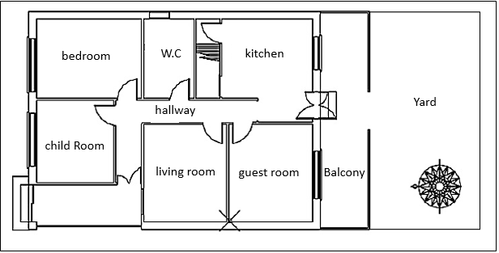
Appendix 2 Fig 1 First floor plan of the selected residential unit

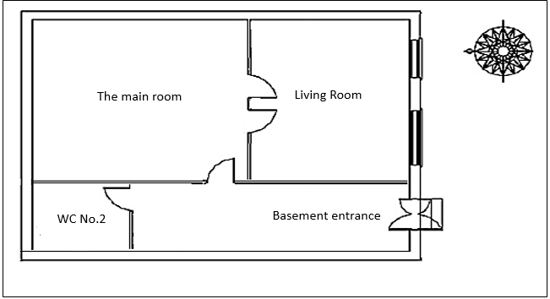
Appendix 2 Fig 2 Basement plan of the selected residential unit

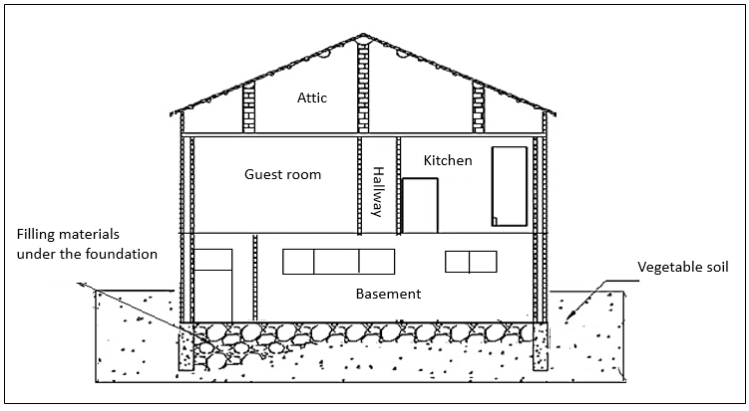
Appendix 2 Fig 3 Facade plan of the selected residential unit

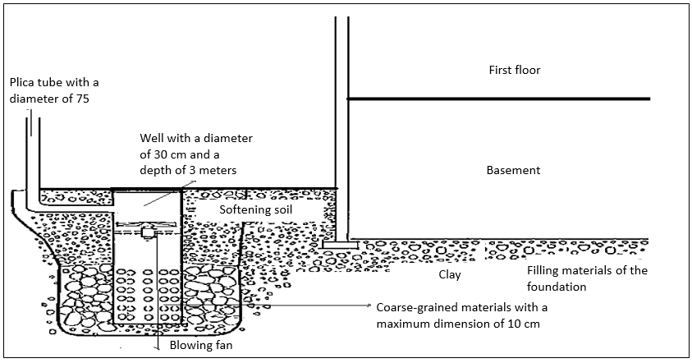
Appendix 2 Fig 4 Schematic plan of adopting the Radon disposal method in a residential unit located in the case study

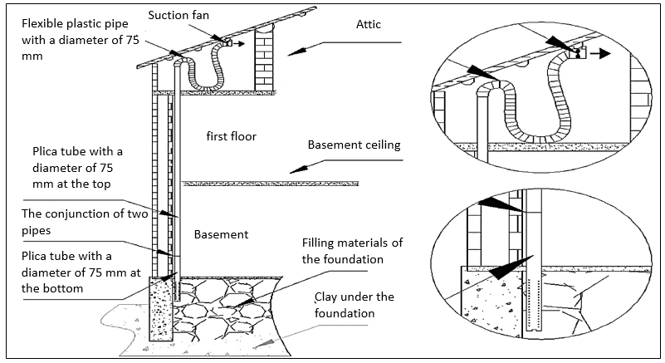
Appendix 2 Fig 5 Schematic plan of adopting the Radon disposal method in a residential unit located in the study area.

