Novel Artificial Intelligence platform leads to the discovery of new protoporphyrinogen oxidase inhibitors
Abigail L. Barker¹, Yosef Geva², Eyal Simonovsky², Netta Shemesh², Yael Phillip², Ifat Shub², Franck E. Dayan^{1*}
Supplemental Table 1. Chemical names and properties of the compounds analyzed in this study
Code | Mw | logP¹ | Rotatable  bonds | H-bond  acceptors | H-bond  donors | Chemical name
AGR001 | 315.24 | 3.48 | 7 | 2 | 0 | (2E)-4-chloro-N-[(6-chloro-3-pyridinyl)methyl]-N-isobutyl-2-pentenamide
AGR002 | 245.79 | 3.31 | 7 | 1 | 0 | (2E)-4-chloro-N,N-bis(isobutyl)-2-pentenamide
AGR003 | 315.24 | 3.42 | 7 | 2 | 0 | (2E)-4-chloro-N-[(5-chloro-2-pyridinyl)methyl]-N-isobutyl-2-pentenamide
AGR004 | 329.27 | 3.77 | 8 | 2 | 0 | (2E)-4-chloro-N-[(6-chloro-3-pyridinyl)methyl]-N-isopentyl-2-pentenamide
AGR005 | 305.81 | 2.66 | 7 | 3 | 0 | (2E)-4-chloro-N-[(6-cyano-3-pyridinyl)methyl]-N-isobutyl- 2-pentenamide
AGR006 | 320.27 | 4.22 | 7 | 1 | 0 | (2E)-4-chloro-N-[(5-chloro-2-thiophen-yl)methyl]-N-isobutyl-2-pentenamide
AGR007 | 334.30 | 4.50 | 8 | 1 | 0 | (2E)-4-chloro-N-[(5-chloro-2-thiophen-yl)methyl]-N-isopentyl-2-pentenamide
AGR008 | 321.26 | 3.55 | 7 | 2 | 0 | (2E)-4-chloro-N-[(2-chloro-5-thiazol-yl)methyl]-N-isobutyl-2-pentenamide
AGR009 | 271.71 | 3.39 | 7 | 4 | 0 | (2E)-4-chloro-N-isobutyl-N-2,2,2-trifluoroethyl-2-pentenamide
AGR010 | 273.85 | 4.00 | 9 | 1 | 0 | (2E)-4-chloro-N,N-bis(isopentyl)-2-pentenamide
AGR011 | 241.76 | 3.00 | 6 | 1 | 0 | (2E)-N-(2-butynyl)-4-chloro-N-isobutyl-2-pentenamide
AGR012 | 255.79 | 3.36 | 6 | 1 | 0 | (2E)-4-chloro-N-isobutyl-N-(2-pentynyl)-2-pentenamide
AGR013 | 285.81 | 3.01 | 8 | 2 | 0 | (2E)-4-chloro-N-(4-ethoxy-2-butynyl)-N-isobutyl-2-pentenamide
AGR014 | 295.81 | 3.05 | 8 | 2 | 0 | (2E)-4-chloro-N-isobutyl-N-[4-(2-propyn-1-yloxy)-2-butynyl]-2-pentenamide
¹logP was calculated as the average of 5 prediction algorithm using SwissADME¹

Supplemental Table 2. Docking of herbicides on catalytic domain of PPO.
Compounds | Major groups | Number of poses in group | Average docking energy  kcal/mol
AGR001 A | 1 | 18 | -4.98
 | 2 | 14 | -4.64
 | 3 | 13 | -4.71
 | 4 | 22 | -4.44
AGR001 B | 1 | 16 | -4.84
 | 2 | 25 | -4.84
 | 3 | 39 | -4.44
 | 4 | 6 | -4.72
AGR002 A | 1 | 29 | -3.27
 | 2 | 12 | -3.20
 | 3 | 13 | -3.11
 | 4 | 29 | -3.15
AGR002 B | 2 | 23 | -3.21
 | 3 | 42 | -3.07
 | 4 | 10 | -2.93
 | 5 | 12 | -2.81

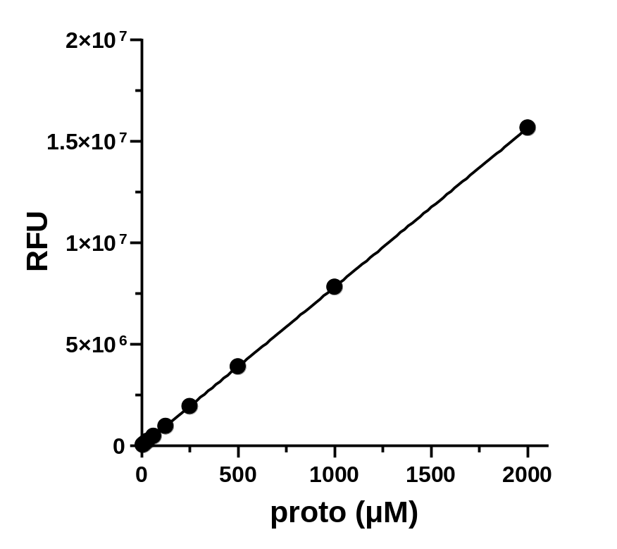
Supplemental Figure 1. Protoporphyrin standard curve

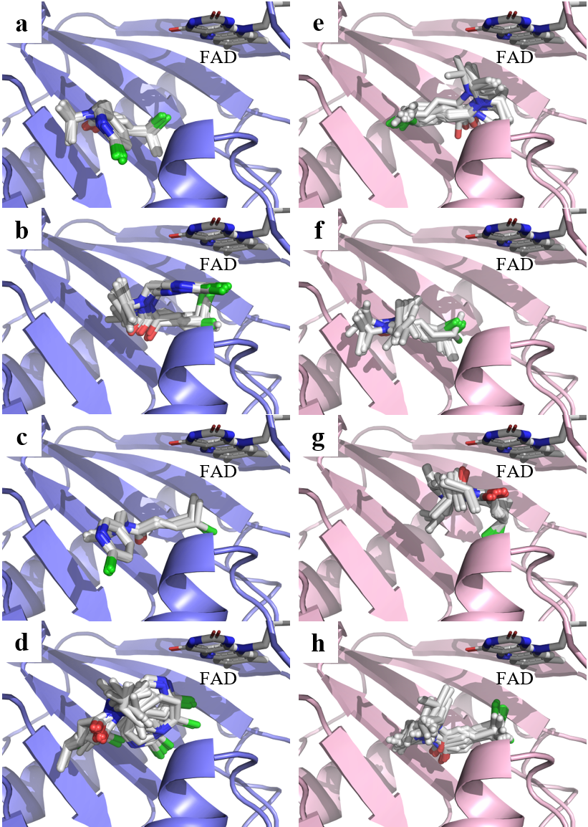
Supplemental Figure 2. Representative docking poses of A) group 1, B) group 2, C) group 3, and D) group 4 of AGR001 (protein is in light blue), and E) group 1, F) group 2, G) group 3, and H) group 4 of AGR002 (protein is in pink) on PPO. Refer to Supplemental Table 2 for number of poses in each group and average docking energies.

