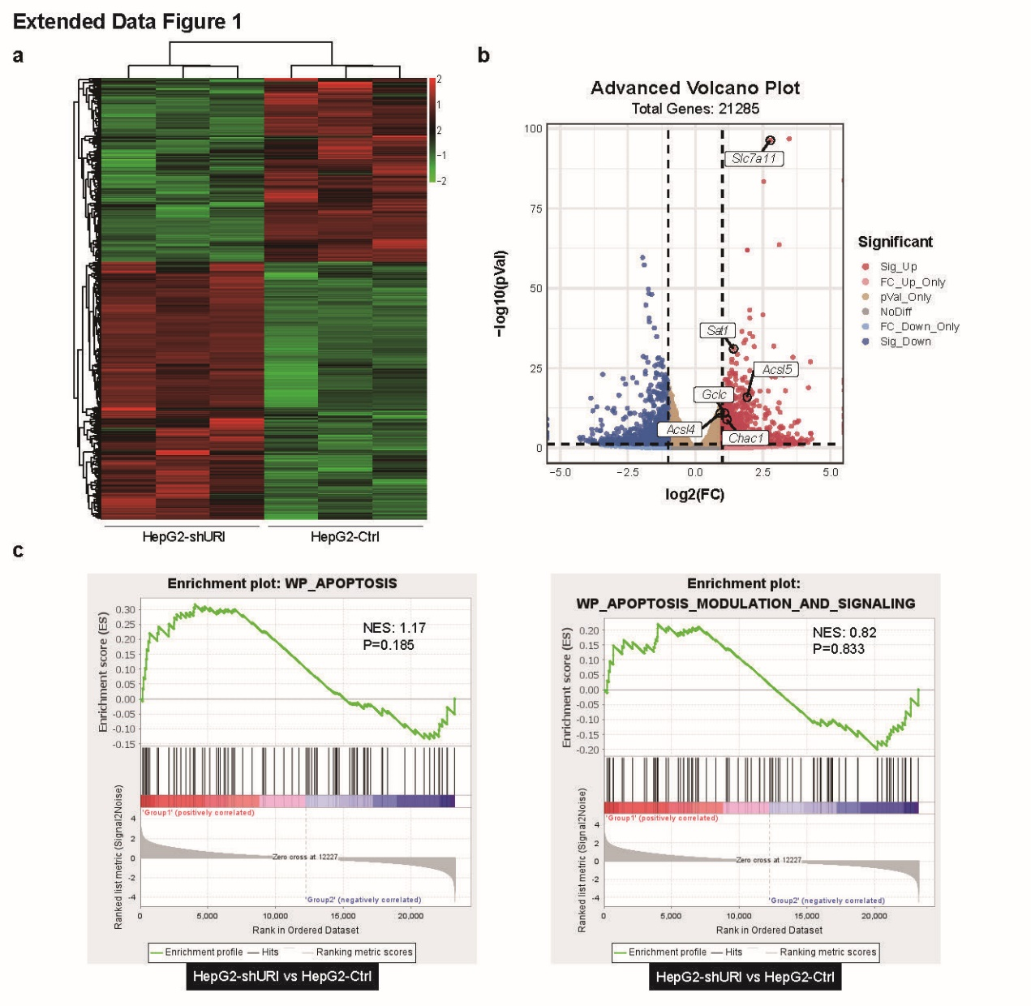
Extended Data Fig. 1 | RNA-sequencing analysis of URI depletion in HepG2 cells. a, The heatmap summarizes RNA-seq data for HepG2-Ctrl and HepG2-shURI cells with 975 up-regulated genes (red) and 701 downregulated genes (green). b, The volcano plot of gene expression in HepG2-shURI vs HepG2-Ctrl cell. The fold change is the average gene expression of the shURI group vs Ctrl group. Differentially expressed genes are shown in red (upregulated) and blue (downregulated). c, GSEA indicates that WP ‘Apoptosis’ and WP ‘Apoptosis modulation and signaling’ were not enriched in the HepG2-shURI cells based on additional gene alterations.
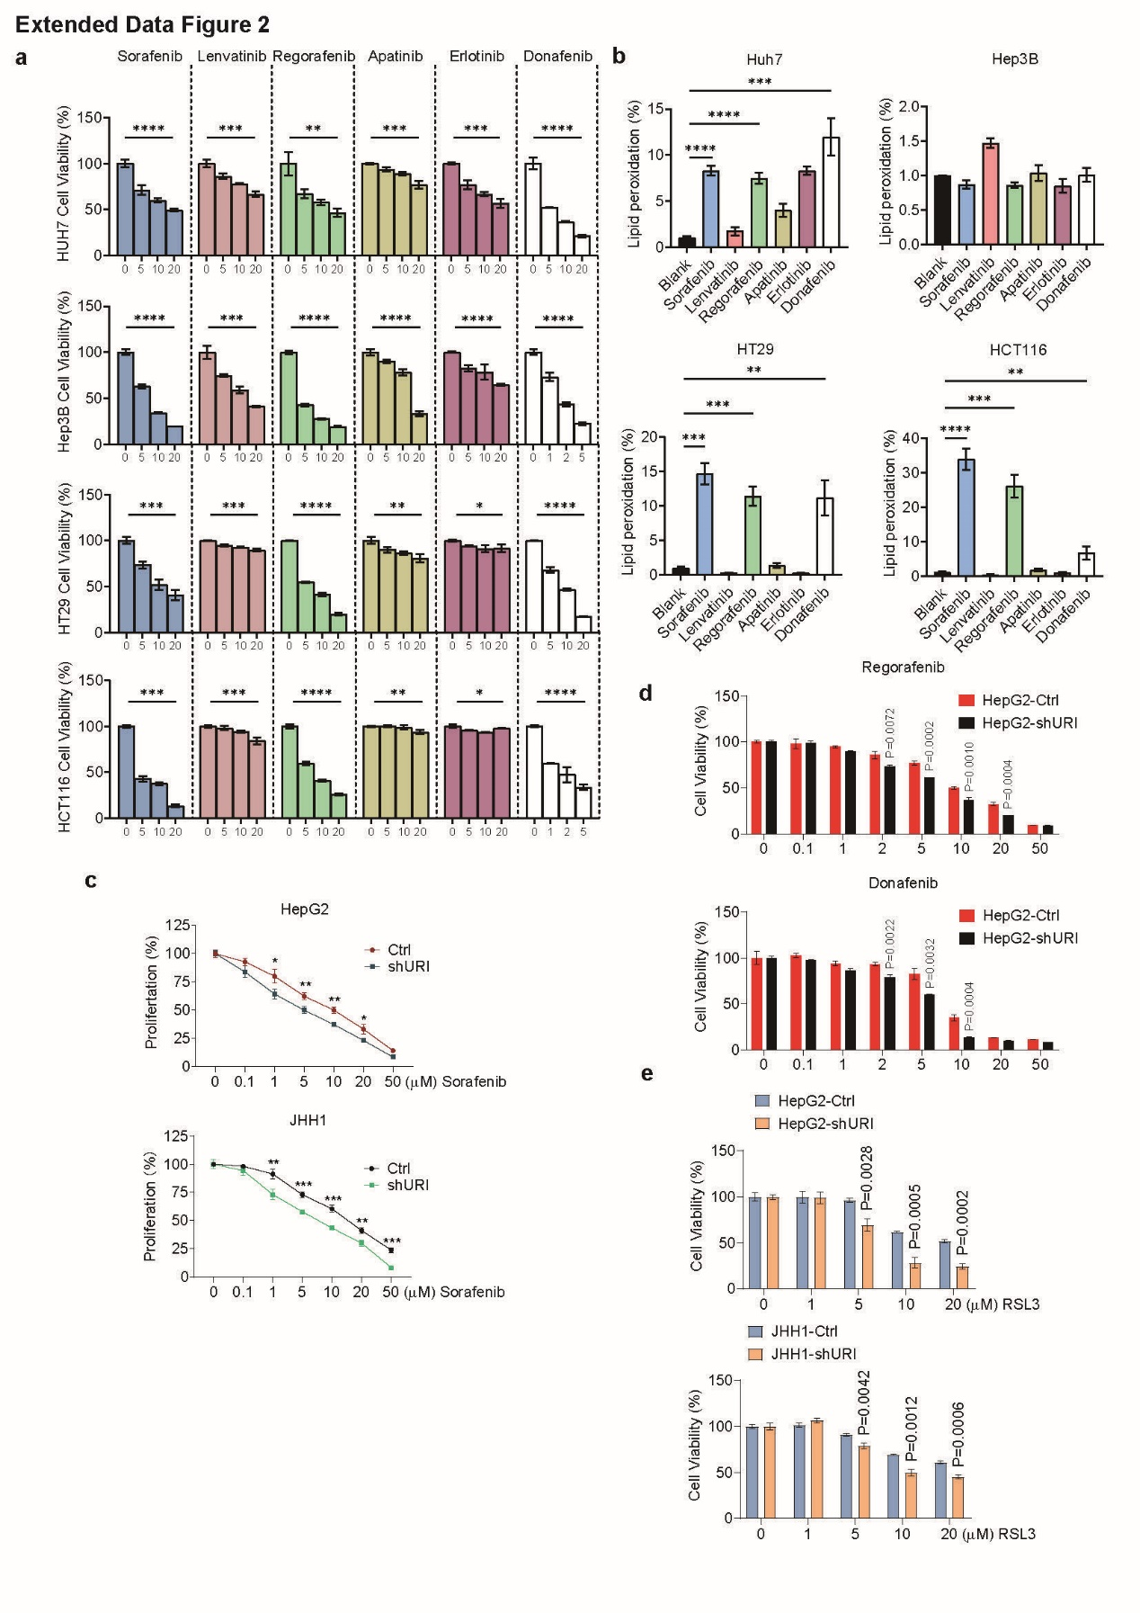
Extended Data Fig. 2 | URI depletion promotes TKI-induced ferroptosis in cancer cells. a, Relative viability of HUH7, Hep3B, HT29 and HCT116 cells treated with different concentrations of sorafenib, lenvatinib, regarofenib, apatinib, erlotinib or donafenib for 48 h (n = 3). Cell viability was measured. Data are mean ± s.e.m. (n=3). b, HUH7, Hep3B, HT29 and HCT116 cells were treated as indicated. Sorafenib, 10 μM; lenvatinib, 10 μM for Hep3B cells and 20 μM for HUH7, HT29 and HCT116 cells; regarofenib 10 μM; apatinib 20 μM; erlotnib 20 μM; donafenib 5 μM for HUH7 and HT29 cells, 10 μM for Hep3B and HCT116 cells. Lipid peroxidation was measured. Data are mean ± s.e.m. (n=3). c, Cell proliferation after 48h of sorafenib treatment was assessed by CCK-8. Data are mean ± s.e.m. (n=3). d, Relative viability of HepG2-Ctrl and HepG2-shURI cells treated with different concentrations of regarofenib or donafenib for 48 h. Cell viability was measured. Data are mean ± s.e.m. (n = 3). e, Relative viability of JHH1 cells and HepG2 cells with or without URI depletion treated with different concentrations of RSL3 for 48 h. Cell viability was measured. Data are mean ± s.e.m. (n = 3).
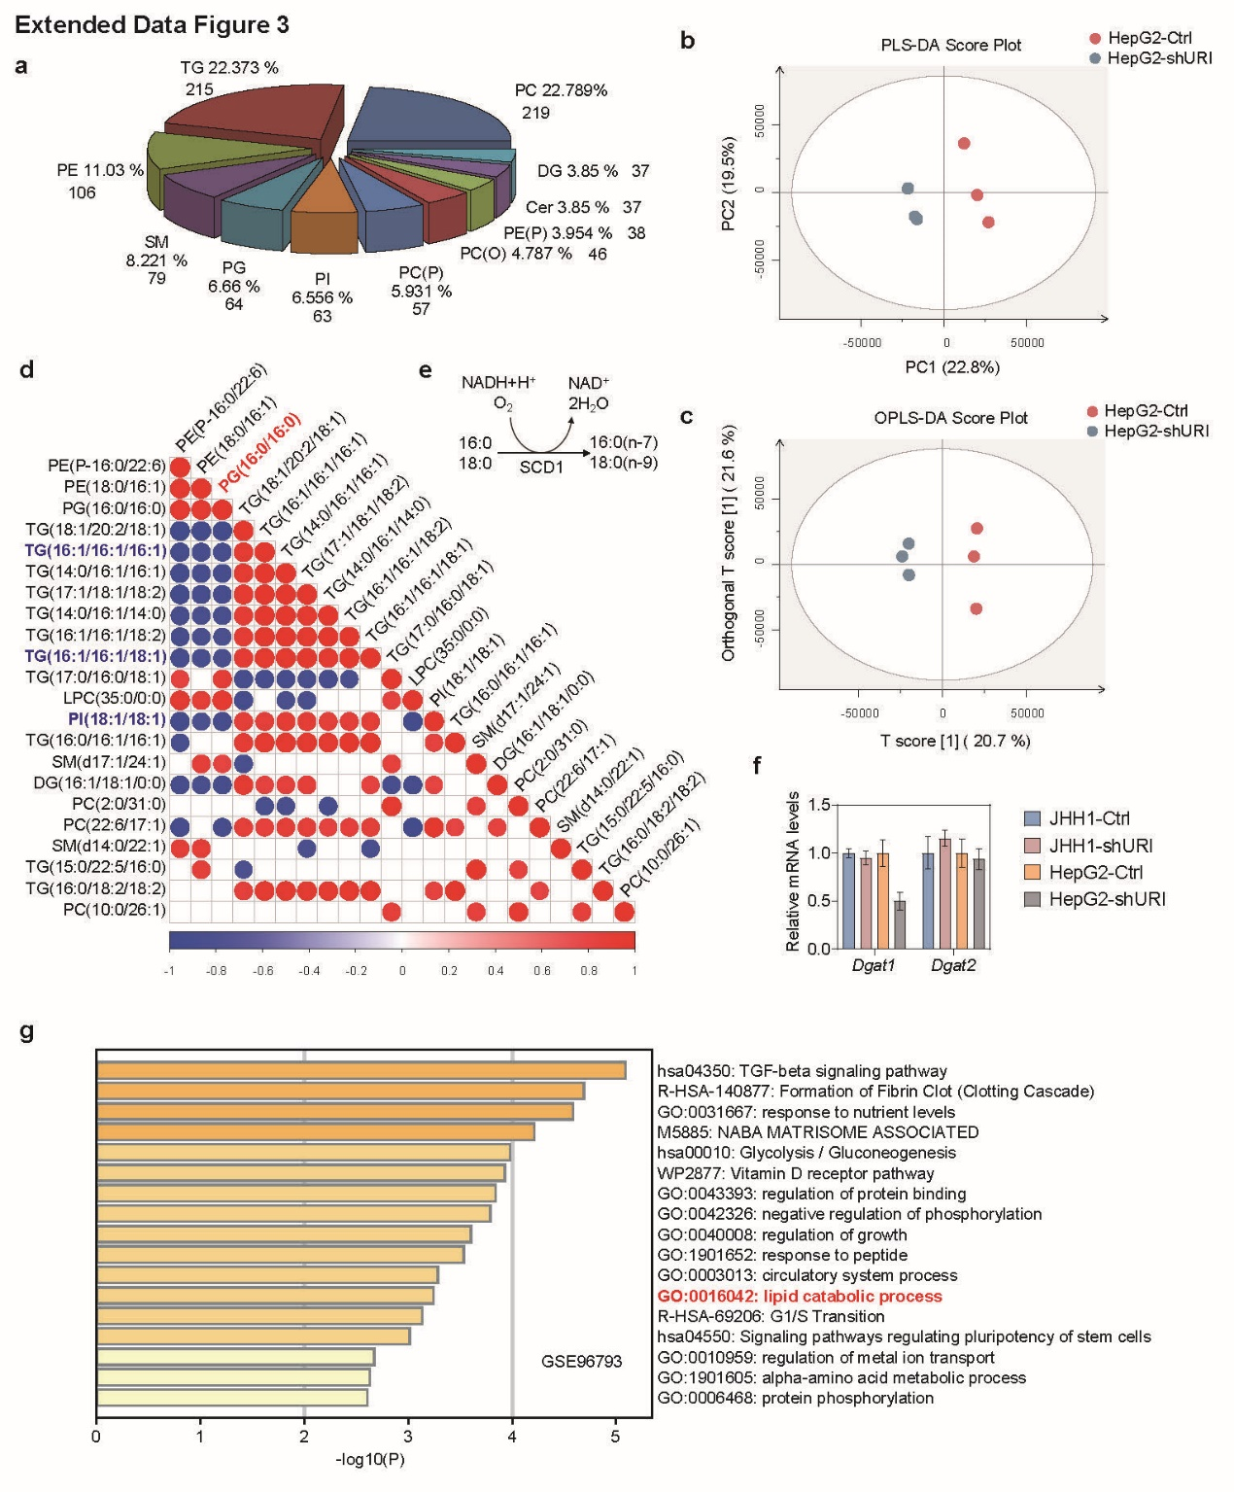
Extended Data Fig. 3 | URI depletion reprogrammed lipid metabolism of tumor cells. a, Composition of lipid classes that were considered for subsequent analysis in HepG2-Ctrl and HepG2-shURI cells detected by liquid chromatography–mass spectrometry/mass spectrometry. b, Lipid profiles were compared using partial least squares discriminant analysis (PLS-DA). c, Orthogonal (O)PLS-DA models were constructed to compare HepG2-shURI cells versus control. d, Correlation heatmap of different lipid species based on the basis of Fig. 2a. e, Schematic of the reaction catalysed by SCD1. f, mRNA expression of lipogenic genes Dgat1 and Dgat2 in HepG2 cells with or without URI depletion. Data are mean ± s.e.m. (n=3). g, GO enrichment analysis of genes in GSE96793 from GEO datasets.
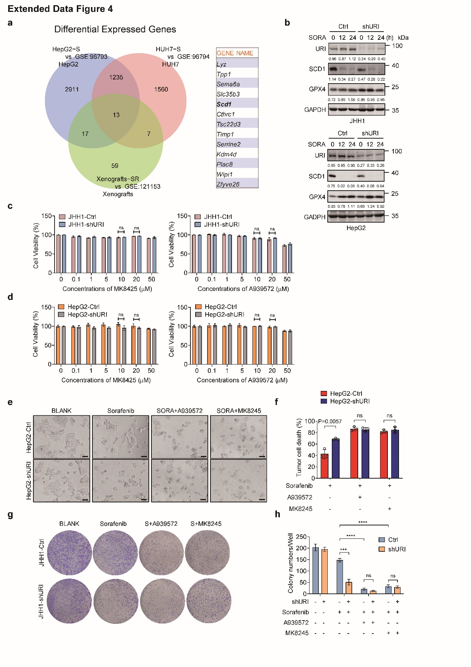
Extended Data Fig. 4 | URI alleviated TKI-induced ferroptosis in a SCD1-dependent manner. a, The venn diagram shows overlap of the 13 genes significantly altered after administrating with sorafenib in HepG2, HUH7 cells and Xenografts mouse models. b, Cells were treated with 20μM sorafenib for indicated time points, and cell lysates were immunoblotted with indicated antibodies. (n=3).c, d, Relative viability of JHH1 and HepG2 cells with or without URI depletion treated with A939572 or MK8245 at the indicated concentrations for 48h. Cell viability was measured. Data are mean ± s.e.m. (n=3). e, Representative images of HepG2-Ctrl and HepG2-shURI cells cultured with 10μM sorafenib in the presence and absence of A939572 (10μM) or MK8245 (10μM) for 48h. f, The cells were stained with PI followed by flow cytometry. Quantification of three independent assays. Data are mean ± s.e.m. (n=3). g, h, Long-term colony-formation assay of HepG2-Ctrl and HepG2-shURI cells. Cells were treated with 2.5μM sorafenib in the presence and absence of A939572 (10μM) or MK8245 (10μM) for 14 days, fixed and stained. Quantification of three independent assays. Data are mean ± s.e.m. (n=3).
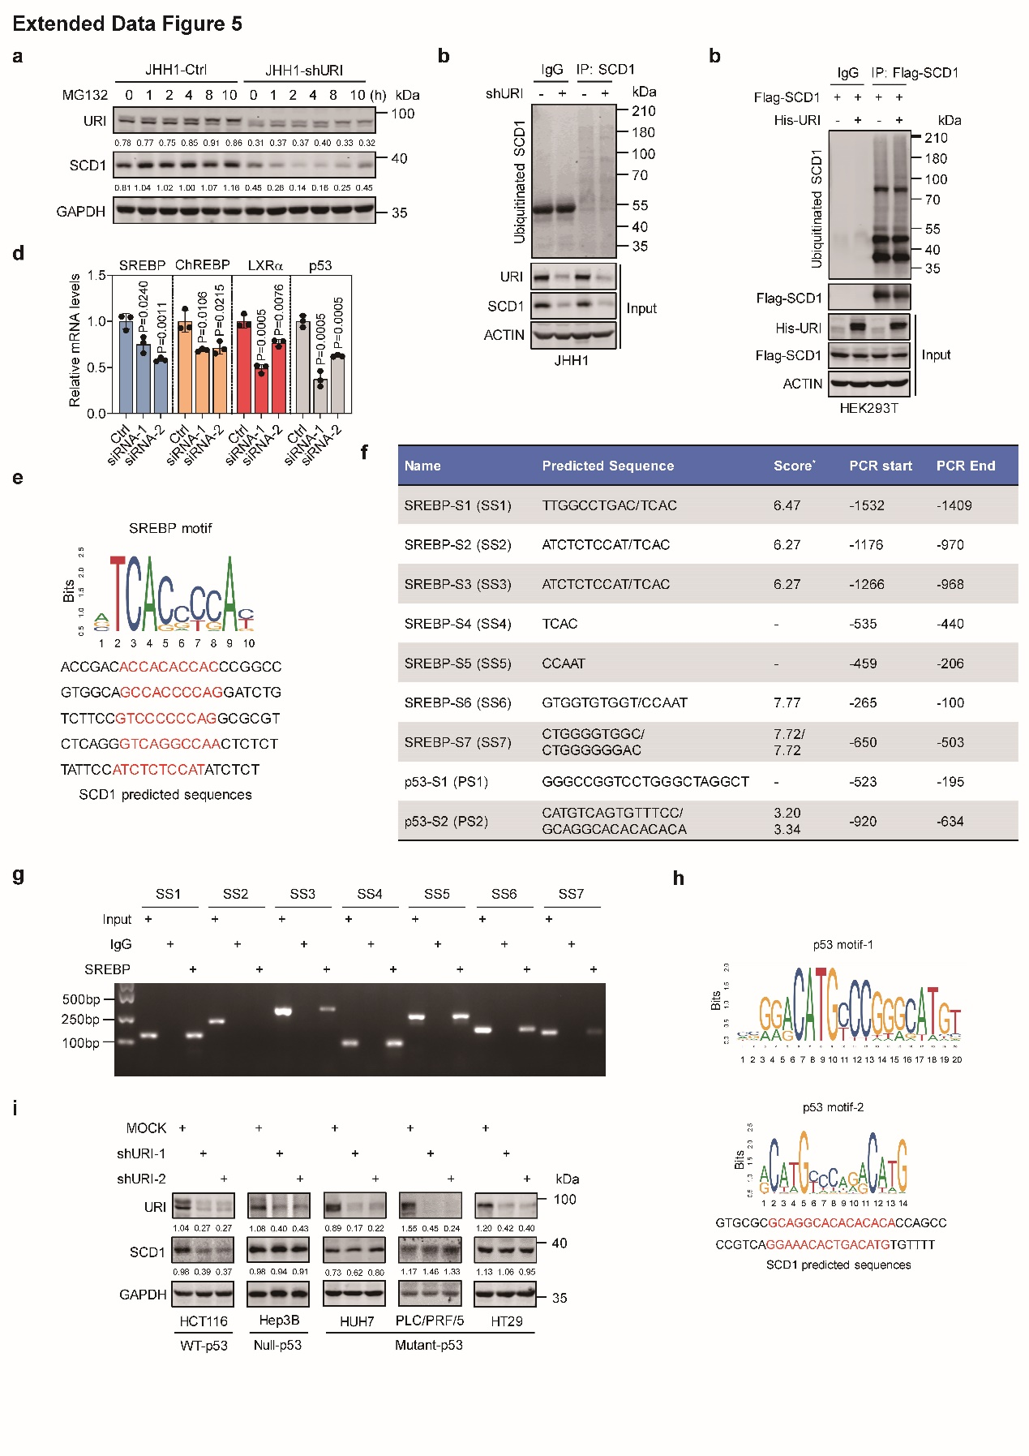
Extended Data Fig. 5 | URI promotes SCD1 transcription by inhibiting p53. a, JHH1-Ctrl and JHH1-shURI cells were treated with 10μM MG132 at the indicated time. Cell lysates were immunoblotted with indicated antibodies. (n=3). b, JHH1-Ctrl and JHH1-shURI cells were transfected with HA-tagged ubiquitin for 48h before anti-SCD1 immunoprecipitation and immunoblotting was performed. (n=3). c, HEK293T cells stably expressing His-URI were transfected with HA-tagged ubiquitin for 48h before anti-SCD1 immunoprecipitation and immunoblotting was performed. (n=3). d, mRNA expression of SREBP, ChREBP, LXRα and p53 in JHH1 and HepG2 cells transfected with siRNA of the indicated genes. Data are mean ± s.e.m. (n=3). e, Sequence logo for SREBF1 binding. f, The list shows potential sequences for SREBF1 and p53 binding derived from JASPAR database and existing literatures. g, ChIP assay was carried out in HepG2 cells. The precipitated DNA was amplified by qPCR using specific primers flanking the SREBP binding sites (SS1-SS7). (n=3). h, Sequence logo for p53 binding. i, Colon cancer cells (HCT116, HT29) and liver cancer cells (Hep3B, HUH7 and MHCC97H) with different p53 status were infected with shURI lentivirus. Cell lysates were immunoblotted with indicated antibodies. (n=3). The values under the panels indicate the quantification of the bands normalized to GAPDH.
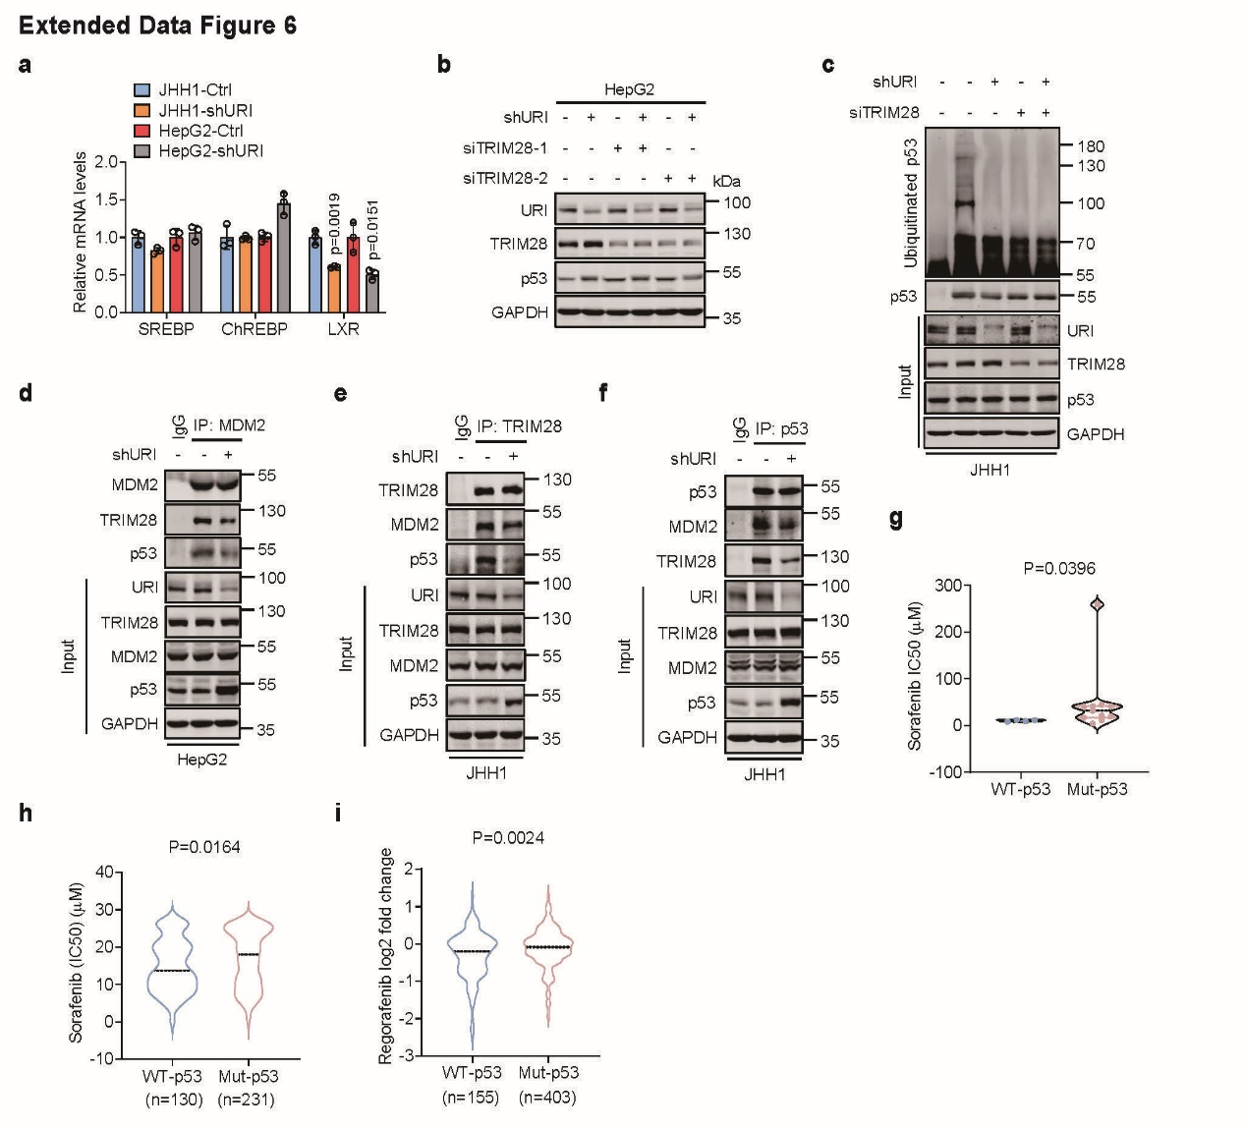
Extended Data Fig. 6 | URI promotes p53 ubiquitination and degradation by interacting with TRIM28. a, mRNA expression of SREBP, ChREBP and LXRα in JHH1 and HepG2 cells with or without URI depletion. Data are mean ± s.e.m. (n=3). b, HepG2-Ctrl and HepG2-shURI cells were transfected with MOCK or si-TRIM28 for 48h. Cell lysates were collected and immunoblotted with indicated antibodies. (n=3). c, JHH1-Ctrl and JHH1-shURI cells transfected with HA-tagged ubiquitin and with or without si-TRIM28 for 48h were treated with 10μM MG132 for 6h before anti-p53 immunoprecipitation and immunoblotting was performed. (n=3). d, HepG2-Ctrl and HepG2-shURI cell lysates were subjected to anti-MDM2 immunoprecipitation. Cell lysates and immunoprecipitated proteins were immunoblotted with indicated antibodies. (n=3). e, JHH1-Ctrl and JHH1-shURI cell lysates were subjected to anti-TRIM28 immunoprecipitation. Cell lysates and immunoprecipitated proteins were immunoblotted with indicated antibodies. (n=3). f, JHH1-Ctrl and JHH1-shURI cell lysates were subjected to anti-p53 immunoprecipitation. Cell lysates and immunoprecipitated proteins were immunoblotted with indicated antibodies. (n=3). g, Sorafenib IC50 value of liver cancer cell lines with different p53 status. Each dot represents a cell line. Data were adapted from CCLE datasets. Data are median ± s.e.m. h, Sorafenib IC50 value of p53 wild-type cell lines (n=130) compared with p53 mutant cell lines (n=231). Data were adapted from CCLE datasets. Data are median ± s.e.m. i, Efficacy of regorafenib in p53 wild-type cell lines (n=155) compared with p53 mutant cell lines (n=403). Data were adapted from CCLE datasets. Data are median ± s.e.m.
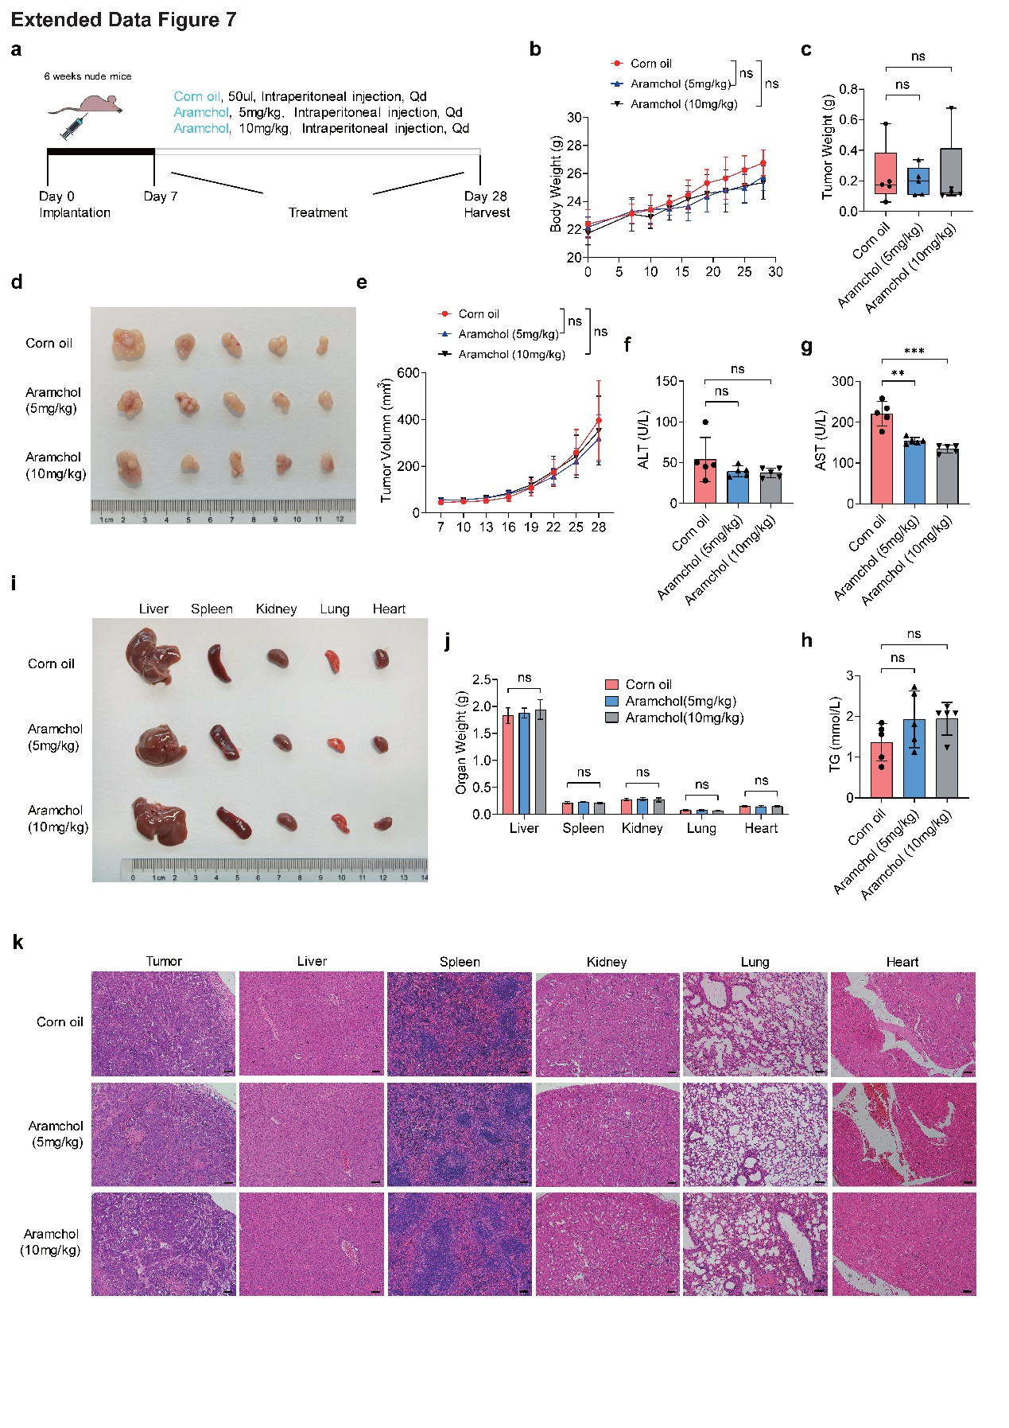
Extended Data Fig. 7 | Safety of aramchol in xenografts mice models. a, Schematic representation of the administration schedule for aramchol. b, Body weights of nude mice in the xenografts models with aramchol at the indicated concentrations were assessed. (n=5 mice per group). P values were determined by two-way ANOVA with Tukey multiple comparisons. c, Tumor weight of each group of HepG2 xenografts at the end of treatment. Data are mean ± s.e.m. (n=5 mice per group). d, Representative tumor images of each group of HepG2 xenografts at the end of treatment. (n=5 mice per group). e, Growth curves of each group of HepG2 xenografts. Data are mean ± s.e.m. (n=5 mice per group). P values were determined by two-way ANOVA with Tukey multiple comparisons correction. f, g, ALT (F) and AST (G) levels in each group were measured. Data are mean ± s.e.m. (n=5 mice per group). h, TG levels in each group were measured. Data are mean ± s.e.m. (n=5 mice per group). i, Representative images of liver, spleen, right kidney, left lung and heart from nude mice. j, Liver, spleen, right kidney, left lung and heart weights in each group were measured. Data are mean ± s.e.m. (n=5 mice per group). k, Representative hematoxylin and eosin (H&E) staining of tumors, livers, spleens, right kidneys, left lungs and hearts from nude mice. (Scale bar, 100 μm).
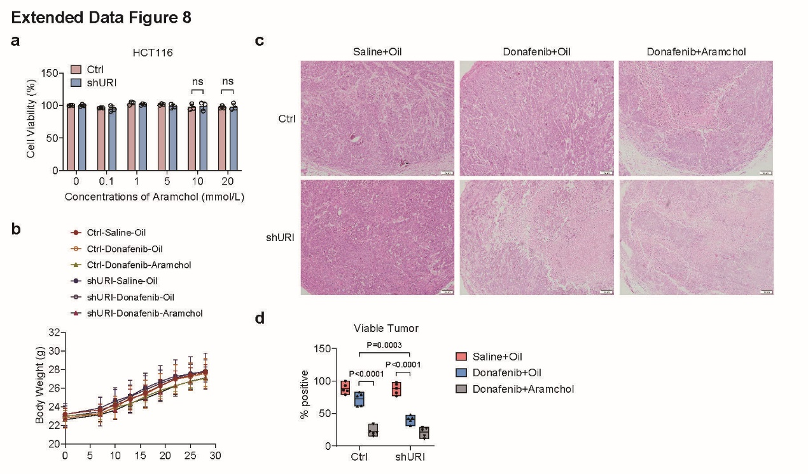
Extended Data Fig. 8 | SCD1 inhibitor aramchol enhances the efficacy of donafenib in vivo. a, HCT116 cells with or without URI depletion were treated with aramchol at the indicated concentrations. Cell viability was measured. Data are mean ± s.e.m. (n=3). b, Body weights of nude mice in the xenografts models with donafenib or combination therapy were measured. (n=5 mice per group). P values were determined by two-way ANOVA with Tukey multiple comparisons. c, Representative hematoxylin and eosin (H&E) staining of tumors from nude mice with donafenib or combination therapy. (Scale bar, 100 μm). d, Tumor viability assessed in H&E slides from the xenografts models.
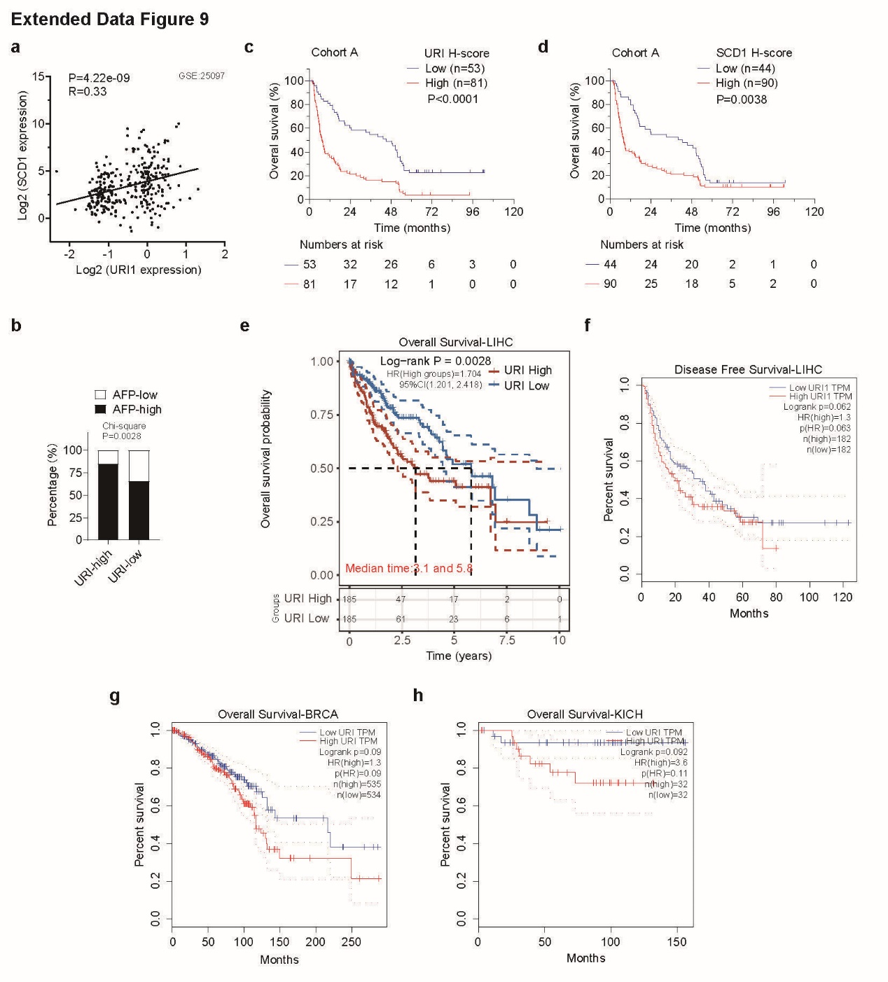
Extended Data Fig. 9 | URI is associated with poor survival in cancers. a, The correlation between URI and SCD1 expression in HCC patients. Each dot represents an HCC specimen. The Pearson correlation coefficient (R) and P value are shown. Data were adapted from GEO database. b, The correlation between AFP levels and URI expression in HCC tissues from cohort A was evaluated using a chi-square test. c, d, Kaplan–Meier survival analysis of cohort A stratified by URI (B) and SCD1 (C). Numbers below plots represent numbers of patients. (n=134 patients with available). e, Kaplan-Meier curves for OS between URI high expression and URI low expression in liver hepatocellular carcinoma (LIHC). Data were adapted from Gepia (http://gepia.cancer-pku.cn/). f, Kaplan-Meier curves for PFS between URI high expression and URI low expression in liver hepatocellular carcinoma (LIHC). Data were adapted from Gepia (http://gepia.cancer-pku.cn/). g, Kaplan-Meier curves for OS between URI high expression and URI low expression in breast cancer (BRCA). Data were adapted from Gepia (http://gepia.cancer-pku.cn/). h, Kaplan-Meier curves for OS between URI high expression and URI low expression in chromophobe carcinoma (KICH). Data were adapted from Gepia (http://gepia.cancer-pku.cn/).
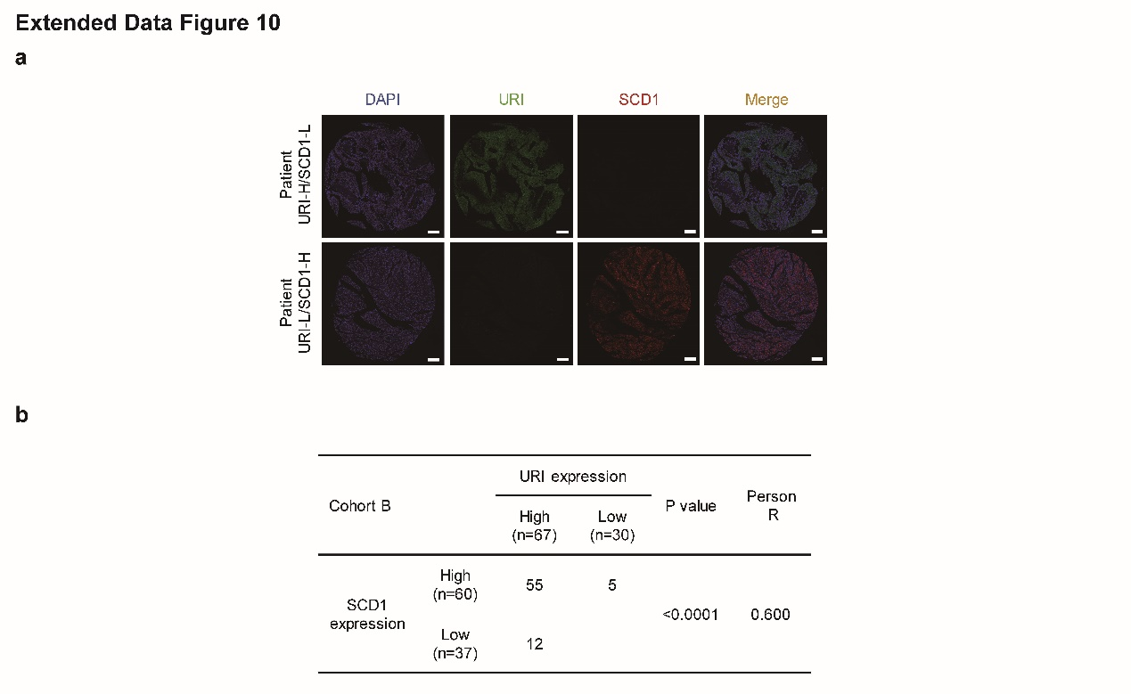
Extended Data Fig. 10 | URI and SCD1 expression in HCC from cohort B. a, Representative mIHC/IF images of URI (green) in combination with SCD1 (red) in HCC, selected from cohort B. Scale bar, 200 μm. (n=97 patients with available). b, The correlation between URI and SCD1 expression was analyzed in HCC tissues according to the scores of immunohistochemistry staining. The correlations were assessed by Pearson rank correlation analysis. (n=97 patients with available).

