Figure S1
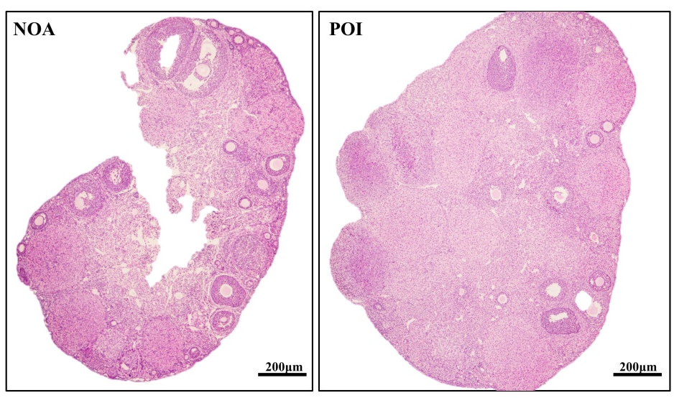
Figure S1. Validation of successful mouse POI model construction by histopathological examination and follicle counts in mouse ovaries. Scale bar: 200 μm.
Figure S2.
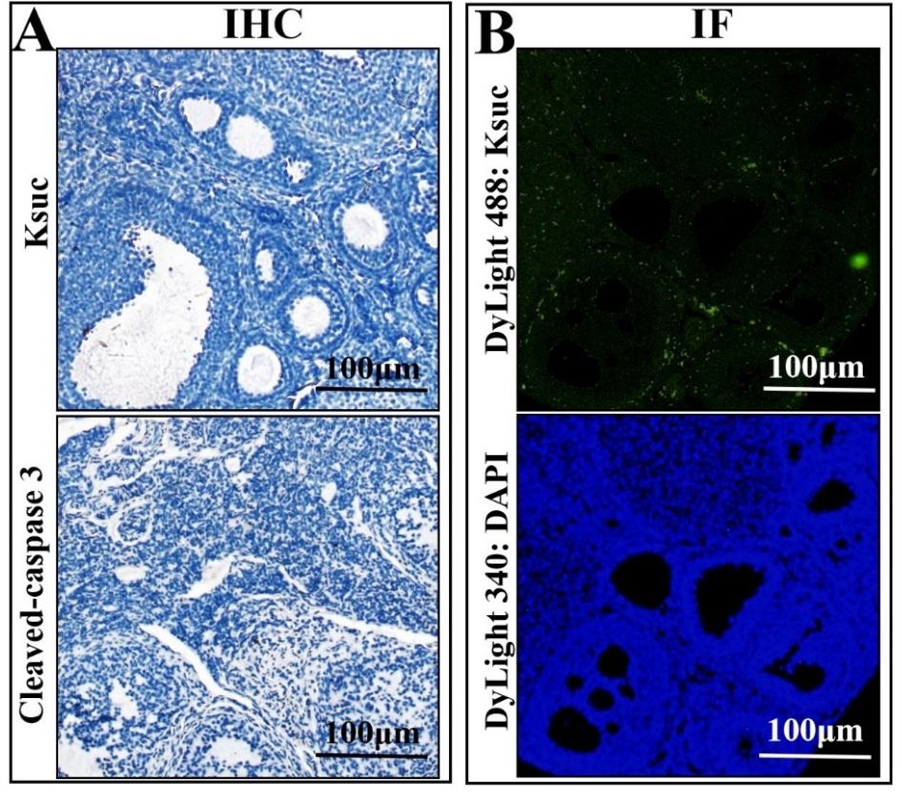
Figure S2. (A) The negative control of IHC-Ksuc and -Cleaved Caspase 3 in mouse ovarian sections. Scale bar: 100 μm (B) The negative control of IF-Ksuc (green) and -DAPI (blue) in mouse ovarian sections. Scale bar: 100 μm..
Figure S3.
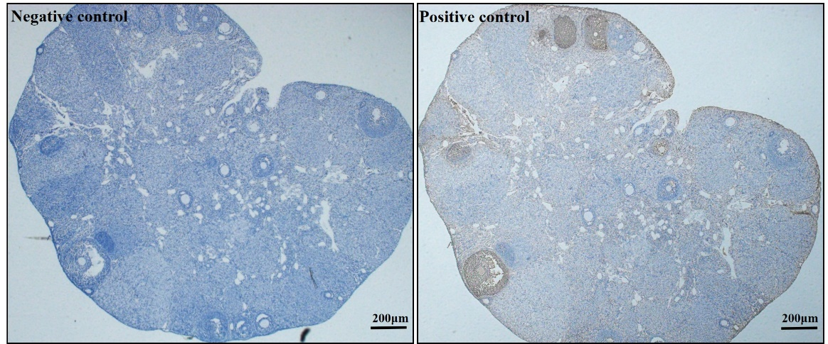
Figure S3. The negative control and positive control of TUNEL staining in mouse ovarian sections. Scale bar: 200 μm
Figure S4
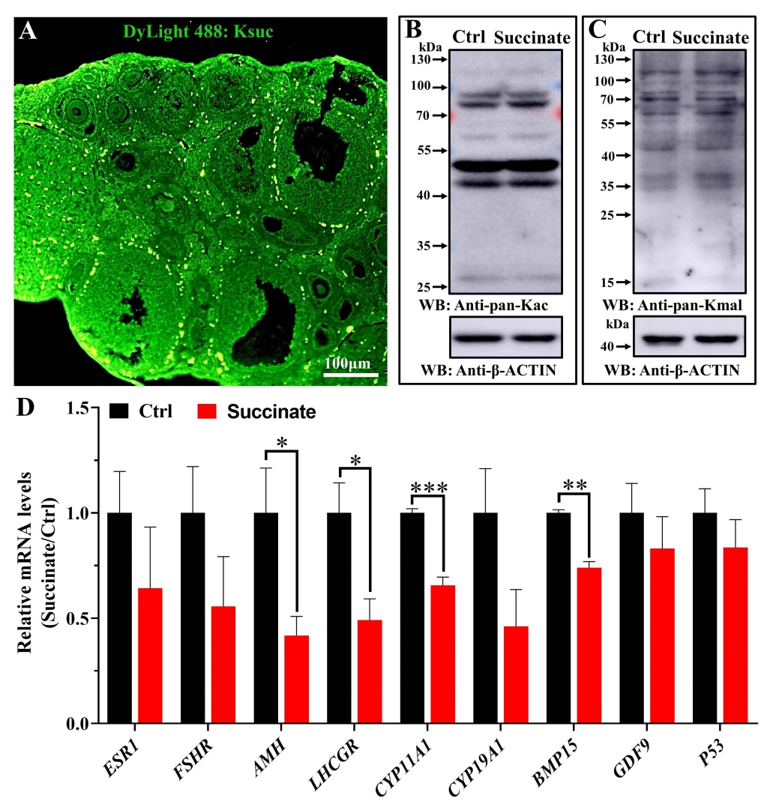
Figure S4. (A) The occurrence and distribution of Ksuc in mouse ovary were examined by immunofluorescence (IF) assays. Scale bar: 100 μm (B) The level of global lysine acetylation (Kac) of ovaries in succinate and control groups. (C) Western blot analysis of ovarian global lysine malonylation (Kmal) level of ovary in succinate compared with control group. (D) Relative quantitative transcription of ovarian function-related and folliculogenesis genes and P53, an ovarian aging-related marker of mice ovaries administrated with Nacl and succinate in vivo. Error bars: SEM; (n = 5 mice / group). * P < 0.05, ** P < 0.01, *** P < 0.001.

Table S1
Animal Use Permit
License No.: | SYXK (gan)-2021-0004
Name of the entity: | Nanchang University
Legal representative: | Changbing Zhou
Facility Address: | Medical Laboratory Animal Center, Nanchang University, No. 71 East Yangming Road, Nanchang city
Application: | barrier environment

Table S2
Clinical information of women with premature ovarian insufficiency and young women with normal ovarian aging
 | Patients number | Age  (years) | FSH (mIU/ml) | E2  (pmol/L) | LH  (mIU/ml) | AMH  (ng/ml) | BMI  (kg/m2)
NOA | 1 | 37 | 9.75 | 29 | 5.81 | 1.05 | 23.0
NOA | 2 | 35 | 2.84 | 184 | 4.18 | 2.99 | 22.4
NOA | 3 | 36 | 6 | 222 | 9.57 | 1.8 | 21.6
NOA | 4 | 32 | 4.49 | 16 | 2 | 2.42 | 22.0
NOA | 5 | 37 | 6.1 | 55 | 2.37 | 2.86 | 23.4
NOA | 6 | 36 | 7.06 | 151 | 4.55 | 2.02 | 21.1
NOA | 7 | 31 | 3.4 | 2408.06 | 1.91 | 11.3 | 22.7
NOA | 8 | 25 | 7.86 | 25.3 | 6.29 | 11.4 | 21.5
NOA | 9 | 31 | 4.34 | 134 | 7.6 | 6.4 | 22.4
NOA | 10 | 31 | 2.92 | 144 | 4.49 | 5.17 | 23.1
NOA | 11 | 35 | 4.22 | 128 | 4.97 | 5.04 | 22.6
NOA | 12 | 32 | 6.34 | 78.6 | 5.46 | 4.61 | 24.4
POI | 1 | 38 | 14.3 | 1055 | 4.06 | 1.25 | 22.8
POI | 2 | 36 | 17.7 | 296 | 5.4 | 0.22 | 25.7
POI | 3 | 35 | 7.13 | 51.8 | 2.61 | 0.23 | 20.3
POI | 4 | 36 | 16.7 | 18 | 5.06 | 0.41 | 22.0
POI | 5 | 33 | 8.41 | 10.1 | 6.55 | 0.894 | 22.5
POI | 6 | 33 | 9.33 | 29.2 | 3.4 | 0.48 | 22.8
POI | 7 | 35 | 7.97 | 51.19 | 2 | 0.54 | 23.3
POI | 8 | 39 | 7.86 | 31.88 | 1.86 | 0.971 | 22.6
POI | 9 | 25 | 6.22 | 10 | 0.95 | 0.834 | 21.7
POI | 10 | 37 | 7.55 | 39.6 | 6.6 | 0.845 | 22.5
POI | 11 | 32 | 6.65 | 10.56 | 2.85 | 0.71 | 23.2
POI | 12 | 29 | 13.3 | 18.6 | 4.85 | 0.718 | 24.1

Table S3
The information of primary antibodies used in western blot
Antibodies | dilution ratio | Origin
Ksuc | 1:1000 | PTMbio (PTM419)
Kmal | 1:1000 | PTMbio (PTM901)
Kac | 1:1000 | PTMbio (PTM-105RM)
Bcl2 | 1:2000 | Abcam (ab182858)
Bax | 1:5000 | Proteintech (50599-2-Ig)
Cleaved–Caspase 3 | 1:2000 | Cell Signaling Technology (#9664)
PCNA | 1:2000 | Proteintech (10205-2-AP)
P21 | 1:1000 | Abclonal (A21061)
β-Actin | 1:3000 | Proteintech (20536-1-AP)

Table S4
Gene | Primer (5′–3′)
Gene | Forward | Reverse
β-ACTIN | GCGGACTGTTACTGAGCTGC | CGCCTTCACCGTTCCAGTTT
BCL2 | GCTACCGTCGTGACTTCGC | CCCCACCGAACTCAAAGAAGG
BAX | CCTCCTTTCCTACTTCGG | GGTTTATTGGCACCTCCC
CASPASE3 | GGGGAGCTTGGAACGCTAA | CCGTACCAGAGCGAGATGAC
PCNA | TTGCACGTATATGCCGAGACC | GGTGAACAGGCTCATTCATCTCT
CYP19A1 | CGCAGAGTATCCAGAGGTCG | CGCATGACCAAGTCCACAAC
CYP11A1 | CCAACCTTTCCTGAGCCCTAC | AAACTGACTCCAAAGTGCCCA
BMP15 | TGGGTTCCTAAATGCCGGAC | TGCCTTTTTGCTGCTGACAC
GDF9 | AGTTCTCCCAAGTCATGGCAC | GGCTCCACTCTGGGATTCTTC
ESR1 | ACCGAAAACACAAGGCTCCC | AGAGAGGAACACGGGATGTG
AMH | TGGCTGAAGTGATATGGGAGC | TAGCACCAAATAGCGGGTGTC
FSHR | GAATCCCTGTTCCTCGGCTC | CCCTGACCTATCTGCCATGC
LHCGR | ACGAGACGCTTCATCACTCTG | GATGGCATGTCTCAGCCTCA
P21 | CCCGAGAACGGTGGAACTTT | GAGTGCAAGACAGCGACAAG
P53 | TCCGAAGACTGGATGACTGC | GATCGTCCATGCAGTGAGGT

