Changes in physicochemical characteristics and metabolites in the fermentation of goji juice by Lactiplantibacillus plantarum
Han Xie ^{a,b}, Pengyan Gao ^{a,b}, Zhen-Ming Lu ^{b}, Fang-Zhou Wang ^{c}, Li-Juan Chai ^{b}, Jin-Song Shi ^{d}, Hui-Ling Zhang ^{e}, Xiao-Juan Zhang ^{a,b *}, Zheng-Hong Xu ^{a,b *}
ª Key Laboratory of Industrial Biotechnology of Ministry of Education, School of Biotechnology, Jiangnan University, Wuxi 214122, PR China
^{b} National Engineering Research Center of Cereal Fermentation and Food Biomanufacturing, Jiangnan University, Wuxi 214122, China
^{c} Ningxia Red Power Goji Co., Ltd, Zhongwei, China
^{d} School of Life Science and Health Engineering, Jiangnan University, Wuxi 214122, China
^{e} School of Food and Wine, Ningxia University, School of Food & Wine, Ningxia University, Yinchuan 750021, PR China
*Corresponding author: National Engineering Research Center for Cereal Fermentation and Food Biomanufacturing, Jiangnan University, 1800 Lihu Avenue, Wuxi 214122, P.R. China
E-mail address: zhangxj@jiangnan.edu.cn(X.-J. Zhang) or zhenghxu@jiangnan.edu.cn (Z.-H. Xu)
Tel: 086-051085918206

Table of contents：
Figure S1. PLS-DA score plots and loading plots derived from LC-MS/MS data of goji juice before and after fermentation.
Figure S2. Differential metabolites between groups.
Table S1. Differential metabolites of goji juice after LP-D fermentation in positive-ion mode.
Table S2. Differential metabolites of goji juice after LP-F fermentation in positive-ion mode.
Table S3. Differential metabolites of goji juice fermented by two strains in positive-ion mode.
Table S4. Differential metabolites of goji juice after LP-D fermentation in negative-ion mode.
Table S5. Differential metabolites of goji juice after LP-F fermentation in negative-ion mode.
Table S6. Differential metabolites of goji juice fermented by two strains in negative-ion mode.
Table S7. Primary metabolites of LC-MS-MS data in goji juice before and after L. plantarum fermentation

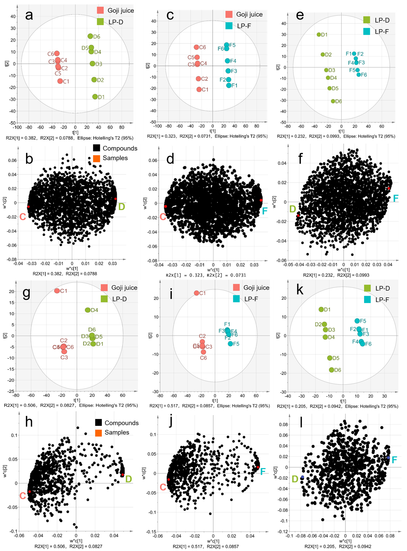
Figure S1. PLS-DA score plots and loading plots derived from LC-MS/MS data of goji juice before and after fermentation. a, c and e were the score plots derived from the different groups in the positive-ion mode; b, d and f were the loading plots derived from the different groups in the positive-ion mode; g, i and k were the score plots derived from the different groups in the negative-ion mode; h, j and l were the loading plots derived from the different groups in the negative-ion mode;C: goji juice; LP-D: fermented with L. plantarum D; LP-F: fermented with L. plantarum F.

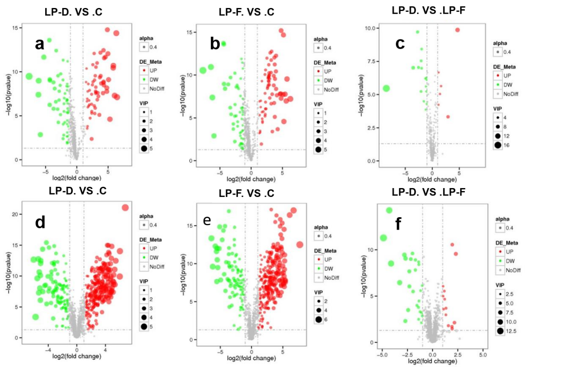
Figure S2. Differential metabolites between groups. a, b and c were positive ion mode; d, e and f were negative ion mode; red represents the upregulation and green represents the downregulation of the metabolites; large sizes represent high VIP values of metabolites; C, goji juice; LP-D, fermented goji juice with L. plantarum D; LP-F, fermented goji juice with L. plantarum F

Table S7. Differential primary metabolites of LC-MS-MS data in goji juice before and after L. plantarum fermentation
 | Metabolites | Rt | MS fragment | Exact_mass | Formula | Relative abundance
 |  |  |  |  |  | Control | LP-D | LP-F
Organic acids
1 | Succinate | 0.933 | 116.0325 | 116.0107 | C4 H4 O4 | 8555878 | 150392 | 139043
2 | Citric acid | 2.055 | 192.0231 | 192.0266 | C6 H8 O7 | 63548540 | 73830195 | 59561552
3 | Malic acid | 0.935 | 134.0174 | 134.0213 | C4 H6 O5 | 165617993 | 2417068 | 1917662
4 | Lactic acid | 1.339 | 90.0275 | 90.0315 | C3 H6 O3 | 6488159 | 369862030 | 342475061
Amino acids
5 | Aspartic acid | 1.144 | 134.0447 | 133.0381 | C4 H8 N2 O3 | 37954463 | 19649840 | 19957413
6 | Glutamic acid | 0.986 | 128.0354 | 147.0528 | C5 H9 N O4 | 118868189 | 121693067 | 126645475
7 | Serine | 1.02 | 106.0498 | 105.0425 | C3 H7 N O3 | 29964525 | 3352142 | 4577126
8 | Homoserine | 11.518 | 120.0497 | 119.0579 | C4 H9 N O3 | 2475 | 2322 | 2335
9 | Histidine | 0.961 | 156.0769 | 155.0692 | C6 H9 N3 O2 | 6069618 | 4976242 | 4649763
10 | Threonine | 0.994 | 120.0658 | 119.0585 | C4 H9 N O3 | 5797899 | 1982974 | 2631267
11 | L-alanine | 1.145 | 90.0552 | 89.04755 | C3 H7 N O2 | 2440917 | 1516335 | 1622527
12 | GABA | 1.045 | 104.0707 | 103.0632 | C4 H9 N O2 | 374682 | 8444039 | 8206342
13 | Tyrosine | 1.293 | 182.0814 | 181.0735 | C9 H11 N O3 | 6241812 | 2128059 | 1437690
14 | Methionine | 1.227 | 150.058 | 149.0508 | C5 H11 N O2 S | 374682 | 238475 | 229355
15 | Phenylalanine | 3.4 | 164.07 | 165.0783 | C9 H11 N O2 | 9261143 | 232598 | 197720
16 | Leucine | 1.629 | 130.0859 | 131.0945 | C6 H13 N O2 | 14156577 | 11095142 | 10868980
17 | Lysine | 0.897 | 147.1129 | 146.1053 | C6 H14 N2 O2 | 488122 | 191851 | 148129
18 | Proline | 1.08 | 231.1345 | 115.0637 | C5 H9 N O2 | 233290734 | 224164182 | 202149551
19 | Tryptophan | 5.872 | 205.0967 | 204.0849 | C11 H12 N2 O2 | 1725306 | 1576225 | 1750528
20 | Glutamine | 2.988 | 146.07 | 146.0691 | C5 H10 N2 O3 | 15079097 | 756535 | 746830
Sugars and sugar derivatives
21 | Raffinose | 1.103 | 505.1885 | 504.1676 | C18 H32 O16 | 6452110 | 5079948 | 4672991
22 | D-glucose-6P | 0.955 | 261.8548 | 260.0287 | C6 H13 O9 P | 4818372 | 4168032 | 3860592
23 | Glyceraldehyde-3P | 0.923 | 168.576 | 167.982 | C3 H7 O6 P | 69554 | 53994 | 61174
24 | Maltose | 1.125 | 343.1198 | 342.1148 | C12 H22 O11 | 27173588 | 31281287 | 29274597
25 | D-ribulose-5P | 0.932 | 231.7589 | 230.0185 | C5 H11 O8 P | 336375 | 110079 | 130680
26 | Mannose | 1.044 | 180.0588 | 180.0634 | C6 H O6 | 74556400 | 32812515 | 27743997
27 | Hexose | 1.172 | 180.0987 | 180.0635 | C6 H12 O6 | 23156362 | 13870478 | 13063045
Fatty acids
28 | Palmitic acid | 14.609 | 255.0727 | 256.2395 | C16 H32 O2 | 5761019 | 2225667 | 2806609
29 | Stearic acid | 15.357 | 284.2674 | 284.2707 | C18 H36 O2 | 23202435 | 15924874 | 15758105
30 | Oleic acid | 14.821 | 282.186 | 282.255 | C18 H34 O2 | 156917938 | 66377715 | 75338220
31 | Linoleic acid | 14.429 | 281.2464 | 280.2391 | C18 H32 O2 | 222507420 | 154505236 | 164751348

