Other supplementary material 1 Description of intervention content
Biofeedback intervention program:
Ask the participants to wear the sensing device and sit in a comfortable position. After the participants agreed to start the adjustment, click the ‘initialization’ icon on the main interface, click the ‘signal matching’ to complete the sensor number matching with the members, click the right ‘initialization’ to detect the signal quality for 20 seconds. After the signal matching is completed, the system will automatically return, and then click ‘standard scheme’ on the main page to complete the game in turn according to the experimental design scheme, and record and save the results respectively.
After each experiment project training is completed, the individual report feedback from the training project is clicked out. Combined with the individual biofeedback report, explain to the participants and analyze their current training results and how to improve them, so that the participants can have a timely understanding of their physiological and psychological state after each group biofeedback training.
Biofeedback intervention program for college students
Training times | Training programs |  |  |  | Total duration
 | Assessment Type | Relaxation treatment |  | Group Training
1 | Pre-resting（3min） | Music Therapy（Mental Stress Reduction） | Breathing Training（Chest Breathing Training） | Mindful Painting（Spring flowers） | 18
2 | Pre-resting（1min） | Music Therapy（ɑ wave music） | Muscle relaxation training（Full body scan relaxation） | Mindful Painting（High Autumn） | 26
3 | Pre-resting（1min） | Music Therapy（Pleasant mood） | Muscle relaxation training（Progressive muscle relaxation） | Mindful Painting（Charming Home） | 26
4 | Pre-resting（1min） | Breathing Training（Breathing range training） | Muscle relaxation training（Progressive muscle relaxation） | Save Sunflower | 26
5 | Pre-resting（1min） | Breathing Training（Chest Breathing Training） | Muscle relaxation training（Full body scan relaxation） | Mindful Painting（Heart to Heart） | 26
6 | Pre-resting（1min） | Breathing Training（Abdominal Breathing Training） | Dual Brain Synchronization | Mindful Painting（Spring flowers） | 21
7 | Pre-resting（1min） | Music Therapy（Relaxing hypnosis） | Muscle relaxation training（Full body scan relaxation） | Defend Mind Tree | 26
8 | Pre-resting（1min） | Music Therapy（ɑ wave music） | Meditation Training（Satya Meditation） | Mindful Painting（High Autumn） | 21
9 | Pre-resting（1min） | Breathing Training（Breathing rate training） | Dual Brain Synchronization | Mindful Painting（Charming Home） | 21
10 | Pre-resting（1min） | Music Therapy（Mental Stress Reduction） | Meditation Training（Satya Meditation） | Mindful Painting（Heart to Heart） | 21
11 | Pre-resting（1min） | Breathing Training（Breathing range training） | Meditation Training（Self Discipline Training） | Defend Mind Tree | 21
12 | Pre-resting（1min） | Breathing Training（Breathing rate training） | Dual Brain Synchronization | Mindful Painting（Spring flowers） | 22

Other supplementary material 2 Summaries of speech features
Prosodic Features | Changes over longer segments of time, which is perceived in the rhythm, stress, and intonation of speech.
F0 | Fundamental frequency: lowest frequency of the speech signal, perceived as pitch.
Duration | The duration of voice was defined as the time interval between the onset and offset of voice.
Intensity | Defined as the acoustic intensity (i.e.. power carried by sound per unit area in a direction perpendicular to that area) in decibels relative to a reference. value, perceived as loudness.
Dull | Unvoiced sound is produced by air friction and is equivalent to noise during analysis and research.
Voiceless | Voiced sound is the periodicity of the vibration of the vocal cords during pronunciation.
Short-energy | The time domain signal refers to the characteristics of the speech signal that are basically unchanged in a short period of time.
Zero crossing rate | The number of times the sampled value of the sound signal passes through zero in each frame of the sound signal.
Log energy | The volume of a voice box can better represent voice and distinguish noise.
Quality Features | The sound quality feature captures the vocalization type and guttural quality information carried by irregular vocalizations.
F1 | First peak in the spectrum (especially of voiced utterances such as vowels) that results from a reasonance of the human vocal tract.
F2 | Second peak in the spectrum (especially of voiced utterances such as vowels) that results from a reasonance of the human vocal tract.
F3 | Third peak in the spectrum (especially of voiced utterances such as vowels) that results from a reasonance of the human vocal tract.
B1 | The first formant bandwidth represents the bandwidth occupied by the first formant.
B2 | The second formant bandwidth represents the bandwidth occupied by the second formant.
B3 | The third formant bandwidth represents the bandwidth occupied by the third formant.
Jitter | Deviations in individual consecutive f0 period lengths,which indicates irregular closure and asymmetric vocal-fold vibrations.
Shimmer | Difference of the peak amplitudos of consecutive f0 periods, which indicates irregularities in voice intensity.
Spectrogram Features | Features characterizing the spectrum of speech, which is the frequency distribution of the speech signal at a specific time.
MFCCs | The coefficients derived by computing a spectrum of the log-magnitude Mel-spectrum of the audio segment, The lower coefficients represent the vocal tract filter and the higher coefficients represent periodic vocal fold sources.

Other supplementary material 3 detailed steps of using Librosa
Librosa is an audio processing tool with high flexibility that can extract the desired features individually as needed or customize some processing functions. The above-mentioned 29 LLDs features are extracted frame by frame from the speech signal after framed and windowed by Librosa. Firstly, the prosodic features of dull, voiceless and duration are calculated into five functions: maximum, minimum, range, mean and standard deviation. Then, the first-order differentials and second-order differentials of 6 prosodic features, 6 sound quality features and 13 spectral features, as well as the values of the maximum, minimum, range, average, standard deviation, skewness and kurtosis are calculated respectively. Jitter and shimmer calculate their corresponding relative and absolute perturbations. The above calculation is performed on 29 LLDs to obtain the 523-dimensional acoustic features of this study.
Other supplementary material 4 basic structure of this model
We constructed an ANN-based classification model and an ANN-based regression model respectively. The basic structure of this model is shown in Figure 2 (except for the output layer, other layers are scaled down by the actual 1:8 ratio). The basic structure of the ANN model consists of 5 layers of full connections. The first four layers are used for deep feature extraction, and the last layer is to map the high-dimensional features learned by the first four layers to the label space, calculate the label weight, and then normalize to get the corresponding the probability of the outcome. In terms of model parameters, the grid search method is used to obtain the best parameters. The parameters and parameter options of grid search are shown in the Table 3. The optimal model parameters obtained by grid search are as follows, the number of hidden layers is 4, the number of neurons in each layer is 32, 64, 32, 32, the activation function is ‘softplus’, the batch-size is 8, and training the model with Adam optimizer with learning rate set to 0.003 works best. At the same time, 5-fold cross-validation was used to evaluate the model performance to obtain more reliable results.
In the classification model and regression model constructed in this paper, they are the same except for the output layer. The output of the classification model is the binary label 0, 1, where 1 denotes ‘response’ and 0 denotes ‘nonresponse’. The label was set as a criterion for assessing efficacy: ≥50% reduction in GAD-7, ISS total score 4 weeks after intervention. The output of the regression model was the difference in GAD-7, ISS scores before and after biofeedback treatment.
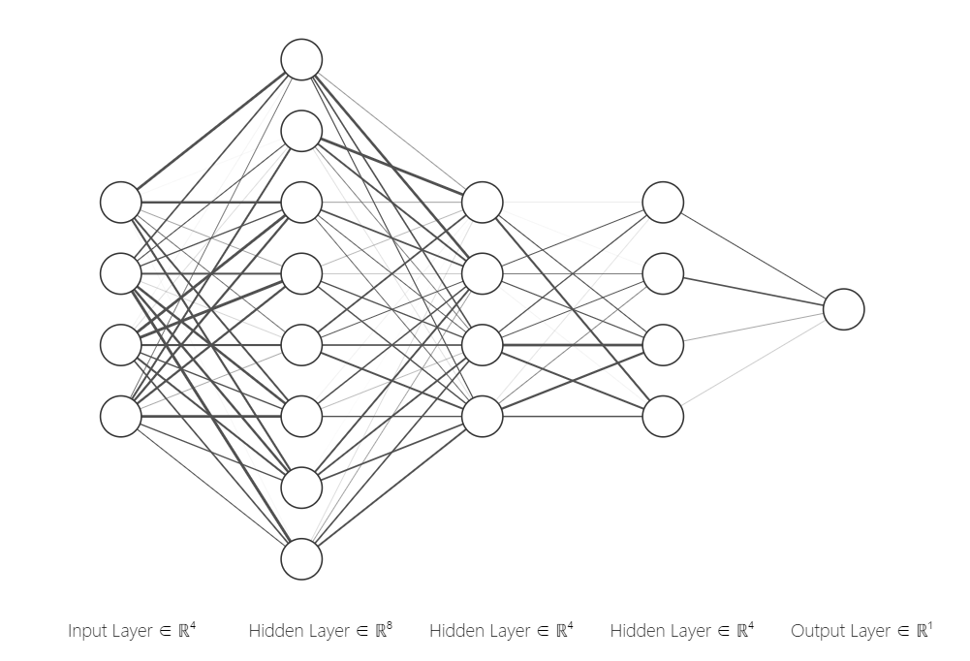
Parameters | Options
Hidden layer | {6, 5, 4, 3}
Hidden neurons | {128, 64,32,16}
Batch-size | {4,8,16,32}
Optimizer | {'sgd', 'RMSprop', 'Adam', 'Adadelta'}
Learning rate | {0.01, 0.05, 0.001, 0.003, 0.0001, 0.00001}
Activation function | {'relu', 'softmax', 'softplus', 'tanh', 'sigmoid'}

