DETAILS OF  TEXTILES ANALYSED | SITE AND PERIOD | DESCRIPTION | COLOR | FT-IR | FORS | RAMAN
Sample 1 : M1- A05842  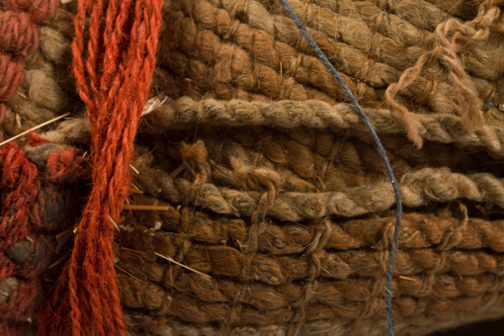 | Tarapacá-40  Context: SM’- T22  Formative period  (Fig. 2a) | Blanket | Red orange  Munsell  10R 5/10  L* a* b*  31.8 22.9 22 | Proteinaceous  fiber | Anthraquinone  insect | No Result
Sample 2: M2- A04024  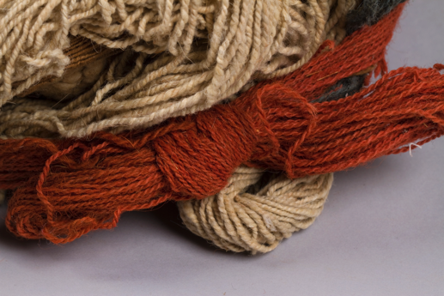 | Tarapacá-40  Context: SM-T22  Formative  Period  (Fig. 2b) | Headdress | Red orange  Munsell  10YR 5/8  L* a* b*  35 31.6 23.3 | Proteinaceous  fiber | Anthraquinone insect | No Result
Sample 3 : M4- A05823  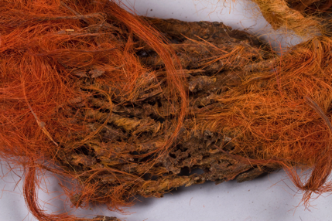 | Tarapacá-40  Context: SM’-T52  Formative period  (Fig. 2c) | Headdress | Red orange  Munsell  10R 5/12  L* a* b*  31.5 27.5 23 | Proteinaceous  fiber | Anthraquinone, posible cochineal | Anthraquinone
Sample 4 : M5- A05909  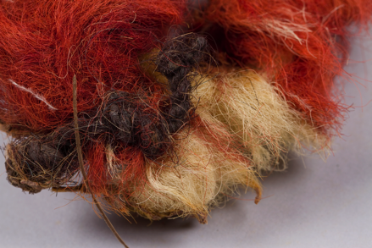 | Tarapacá-40  Context: SM’-T75  Formative period  (Fig. 2d) | Bracelet | Brown  Munsell  7.5R 4/8  L* a* b*  21.3 24 11.1 | Proteinaceous  fiber | Anthraquinone, posible cochineal | Carminic acid
Sample 5 : M19- A05859  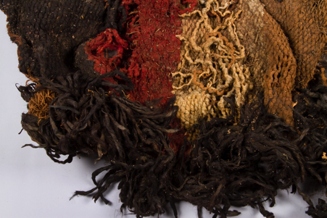 | Tarapacá-40  Context: SL-T8(δ)  Formative period  (Fig. 2e) | Blanket | Red  Munsell  7.5R/4.8  L* a* b*  22.2 20.4 11.8 | Proteinaceous  fiber | Posible alizarin | Anthraquinone
Sample 6: M6- A05769  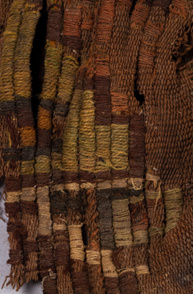 | Pica-8  Context: Sector A , Tumb 15  Late Intermediate period  (Fig. 2f) | Tunic | Green  Munsell  5GY 5/2  L* a* b*  39.4 -0.1 10.8 | Proteinaceous  fiber | - | Indigoide
Sample 7: M8- A05765  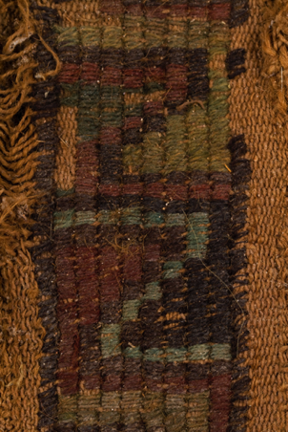 | Pica-8  Context unknown  Late Intermediate period  (Fig. 2g) | Tunic | Blue  Munsell  2.5B 4/2  L* a* b*  Not mesured | Proteinaceous  fiber | - | Indigoide
Sample 8: M9- 05765 | Pica-8  Context unknown  Late Intermediate period  (Fig. 2g) | Tunic | Green  Munsell  10Y 4/4  L* a* b*  31.3 2.7 16.4 | Proteinaceous  fiber | - | Indigoide
Sample 9: M10- A05765 | Pica-8  Context unknown  Late Intermediate period  (Fig. 2g) | Tunic | Green  Munsell  5GY 2.5/1  L* a* b*  33.4 6.9 14.7 | Proteinaceous  fiber | - | Indigoide
Sample 10: M11- A05751  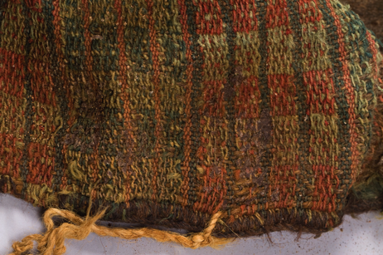 | Pica-8  Context unknown  Late Intermediate period  (Fig. 2h) | Loincloth | Red Orange  Munsell  2.5 YR 4/8  L* a* b*  33.7 21.2 18.9 | Proteinaceous  fiber | - | Carminic acid
Sample 11: M12- A05751 | Pica-8  Context unknown  Late Intermediate period  (Fig. 2h) | Loincloth | Green  Munsell  7.7GY 3/2  L* a* b*  30.6 3.2 9.6 | Proteinaceous  fiber | - | Indigo
Sample 12: M13- A05751 | Pica-8  Context unknown  Late Intermediate period  (Fig. 2h) | Loincloth | Green  Munsell  2,5GY 6/2  L* a* b*  45.0 1.0 19.1 | Proteinaceous  fiber | Indigoide | Indigoide
Sample 13: M14- A05749  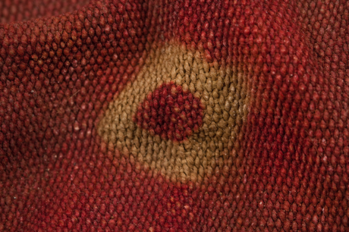 | Pica-8  Context: Sector D, Tumb 1  Late Intermediate period  (Fig. 2i) | Tunic | Red  Munsell  10R 4/6  L* a* b*  24.5 24.4 11.1 | Proteinaceous  fiber | Alizarin | Alizarin
Sample 14: M17- A03844  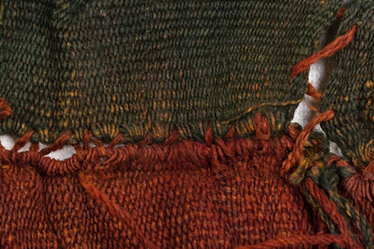 | Pica-8  Context: SF, T1  Late Intermediate period}  (Fig. 2j) | Tunic | Red  Munsell  10R 4/6  L* a* b*  23.3 16.1 11.0 | Proteinaceous  fiber | - | Carminic acid
Sample 15: M18- A03844 | Pica-8  Context: SF, T1  Late Intermediate period  (Fig. 2j) | Tunic | Blue  Munsell  7.5GY 3/2  L* a* b*  18.9 -1.3 2.2 | Proteinaceous  fiber | - | Indigo
Sample 16: M22- A05743  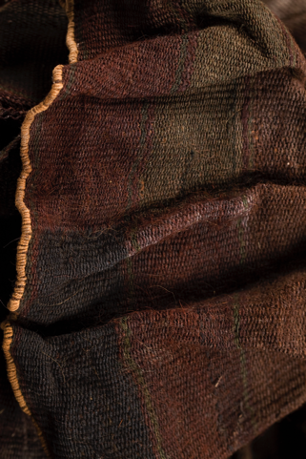 | Pica-8  Context: SI, T2  Late Intermediate period  (Fig. 2k) | Tunic | Brown  Munsell:  5YR 3/2  L* a* b*  24.4 4.1 6.2 | Proteinaceous  fiber | - | No Result
Sample 17: M23- A05743 | Pica-8  Context: SI, T2  Late Intermediate  Period  (Fig. 2k) | Tunic | Green  Munsell  2.5GY 3/2  L* a* b*  22.2 0.7 4.2 | Proteinaceous  fiber |  | Indigo
Sample 18: M27- A05768  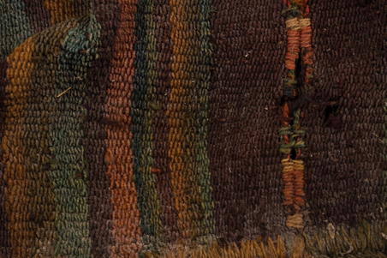 | Pica-8  Context unknown  Late Intermediate period  (Fig. 2l) | Tunic | Green  Munsell:  10GY 4/2  Colorimetría  L* a* b* | Proteinaceous  fiber | Indigoide | Indigoide
Sample 19: M28- A05768 | Pica-8  Context unknown  Late Intermediate period  (Fig. 2l) | Tunic | Yellow  Munsell:  10R 3/2  Colorimetría  L* a* b* | Proteinaceous  fiber | - | Indigo
Sample 20: M29- A05685  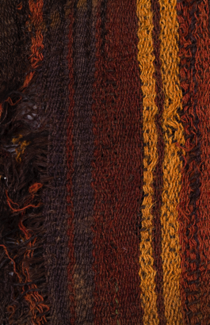 | Pica-8  Context: SD, T56  Late Intermediate period  (Fig. 2m) | Tunic | Brown  Munsell:  10R 4/8,  Colorimetría  L* a* b* | Proteinaceous  fiber | Alizarin | Anthraquinone
Sample 21: M30- A05685 | Pica-8  Context: SD, T56  Late Intermediate period  (Fig. 2m) | Tunic | Yellow  Munsell: 10R 4/8  Colorimetría  L* a* b* | Proteinaceous  fiber | - | Alizarin
Sample 22: M31- A05685 | Pica-8  Context: SD, T56  Late Intermediate period  (Fig. 2m) | Tunic | Brown  Munsell:  5YR 2.5/1  Colorimetría  L* a* b* | Proteinaceous  fiber | - | No Result

