Supplementary table
Primer sequence for fluorescence quantitative PCR
Gene | Primers
MhATPS1 | F:5’GGGAGGCTATACAAAGGCAGATGAC 3’  R:5’CCACAGTCGTCTCAGGATCAAGAAC 3’
MhFIT | F:5’ GGGAAACCATCAAGGAGGTCATA 3’  R:5’ AGCCATTCATCATAAGCTCAGGA 3’
MhIRT1 | F:5’ CATGGCACAAGTCCCTTTT 3’  R:5’ ACCACAGCCATCTCTTGGTC 3’
MhFRO2 | F:5’ TCAACAACCAAAGGGCAAAAAAA 3’  R:5’ AAGGCAATGAACATCACCAGGAAAG 3’
MhAHA2 | F:5’ ATCTGCCCTTACTGGGGAGT 3’  R:5’ AAATGCAGAAGTTCCCGATG 3’
MhAHA8 | F:5’ TCGGTGTGAＡTGTGAAGATGAT 3’  R:5’ TCAGGAAATACTCAGCAAATC 3’
NTIRT1 | F:5’TGTCACTCCTGAAAATGGTG3’  R:5’CTTTAGAGCTTAGGGATCCG3’
NTFRO2 | F:5’AGCAATCAACAACAGAAGACAAGA3’  R:5’ATAGCACCAAGCCAAAGCCA3’
NTFER1 | F:5’ATCATGCGATGTTTGCGTATTC  R:5’GGTGGCGCACAGATAGACA5’
NTActin | F:5’CTGAGGTCCTTTTCCAACCA3’  R:5’TACCCGGGAACATGGTAGAG3’

Supplementary Figure

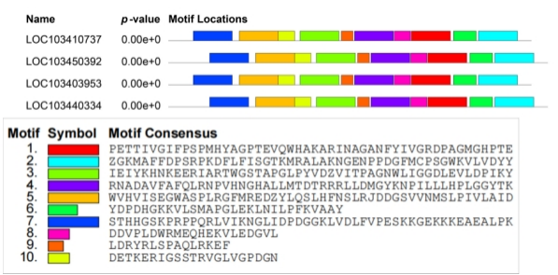
Fig. S1 Conserved motifs of four putative ATPS family proteins analyzed with MEME online tools.
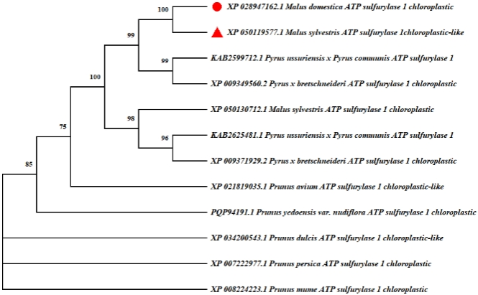
Fig. S2 Phylogenetic tree of the deduced amino acid sequences of ATPS in different plants. The phylogenetic tree of ATPS from different plants was determined by the MEGA X. Program using the neighbor-joining method. The numbers on the branches represents bootstrap support for 1 000 replicates.
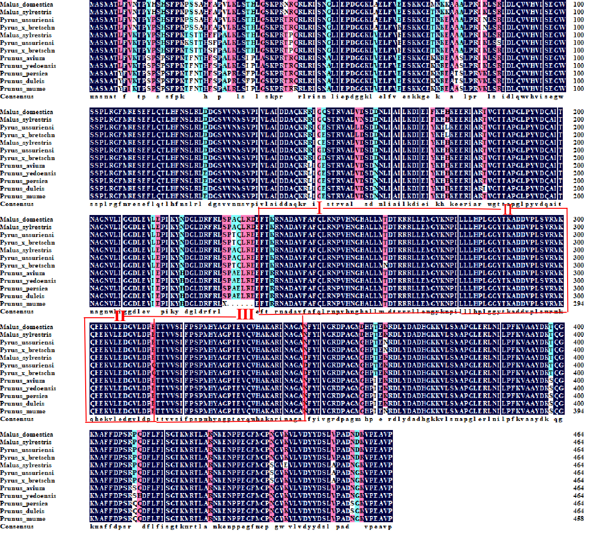
Fig. S3 Homologous sequence comparison of MhATPS1 protein with ATPS1 of other species.

