SUPPLEMENTARY MATERIAL

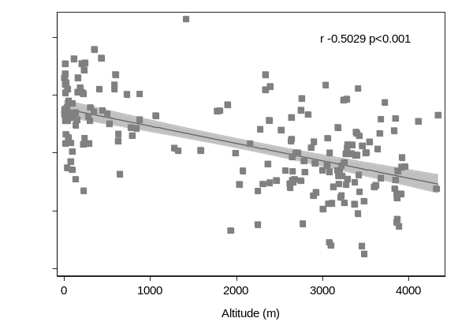
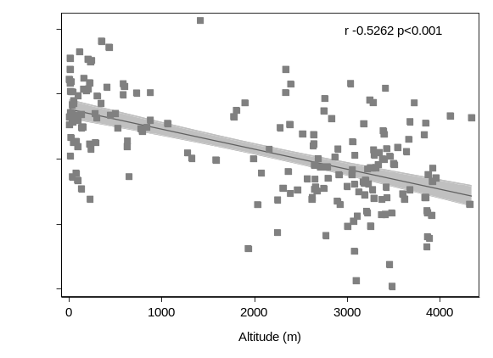
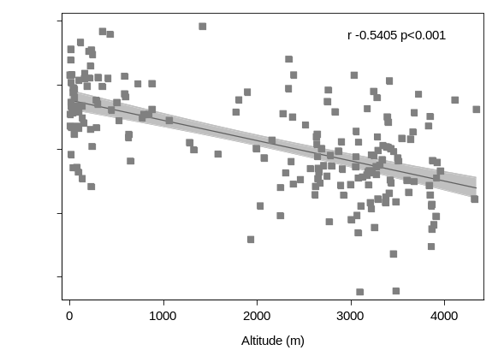
Supplementary Figure 1. Association between COVID-19 cases in Peru in relation to altitude (m): (A) total population, (B) men, and (C) women.
A
B
C

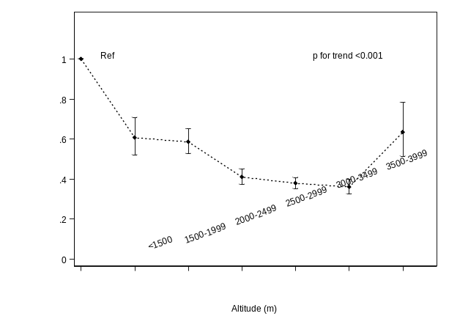
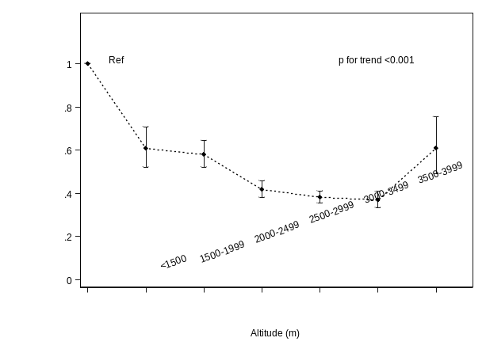
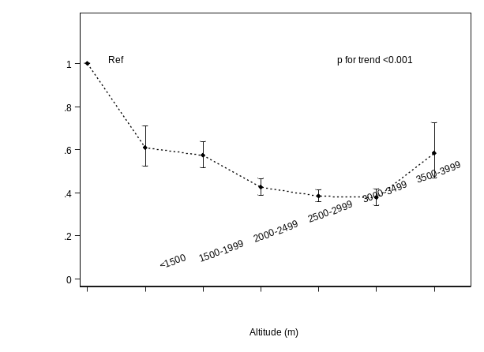
C
B
A

Supplementary Figure 2. Poisson regression analyses of COVID-19 cases (1000 x COVID-19 cases/inhabitants) in Peru in relation to altitude (m): total population (A), men (B), and women (C).
IRR, Incidence-rate ratio; 95% CI, 95% Confidence Interval

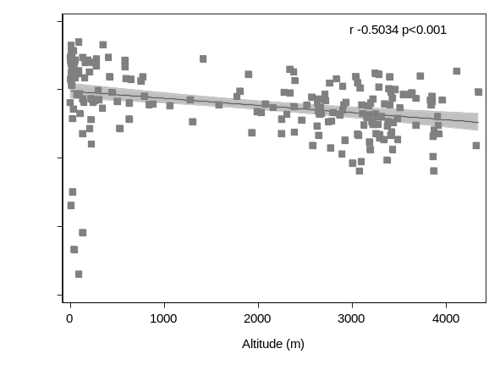
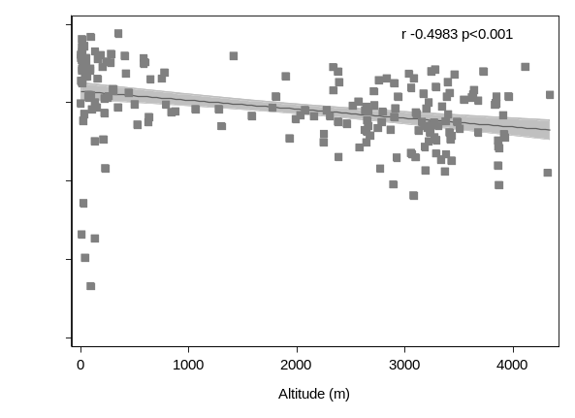
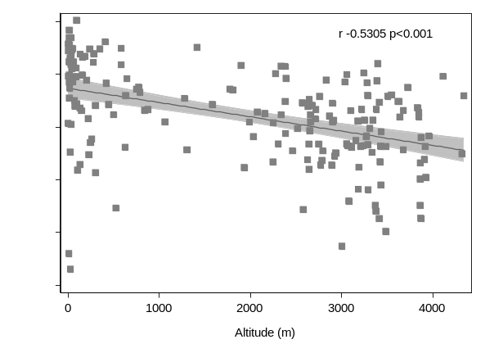
A
C
B

Supplementary Figure 3. Association between COVID-19 mortality 1000 x COVID-19 mortality cases/inhabitants) in Peru in relation to altitude (m): total population, (A) men (B), and women (C).

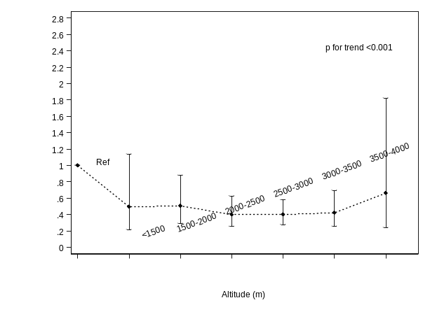
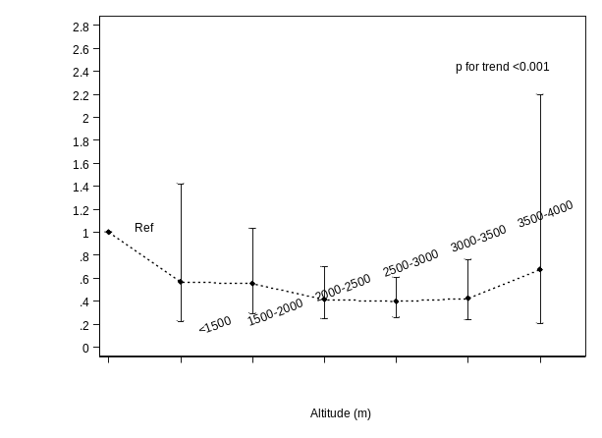
A
B
C

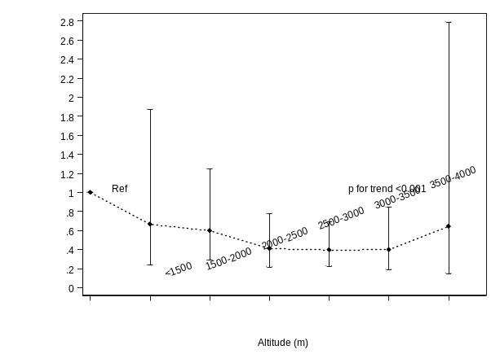

Supplementary Figure 4. Poisson regression analyses of COVID-19 mortality (1000 x COVID-19 cases mortality/inhabitants) in Peru in relation to altitude (m): total population (A), men (B) and women (C).
IRR, Incidence-rate ratio; 95% CI, 95% Confidence Interval

