Additional File 12. Concordance rate (CR) of MMP14 expression among biopsies, ENE sites, and resected specimens
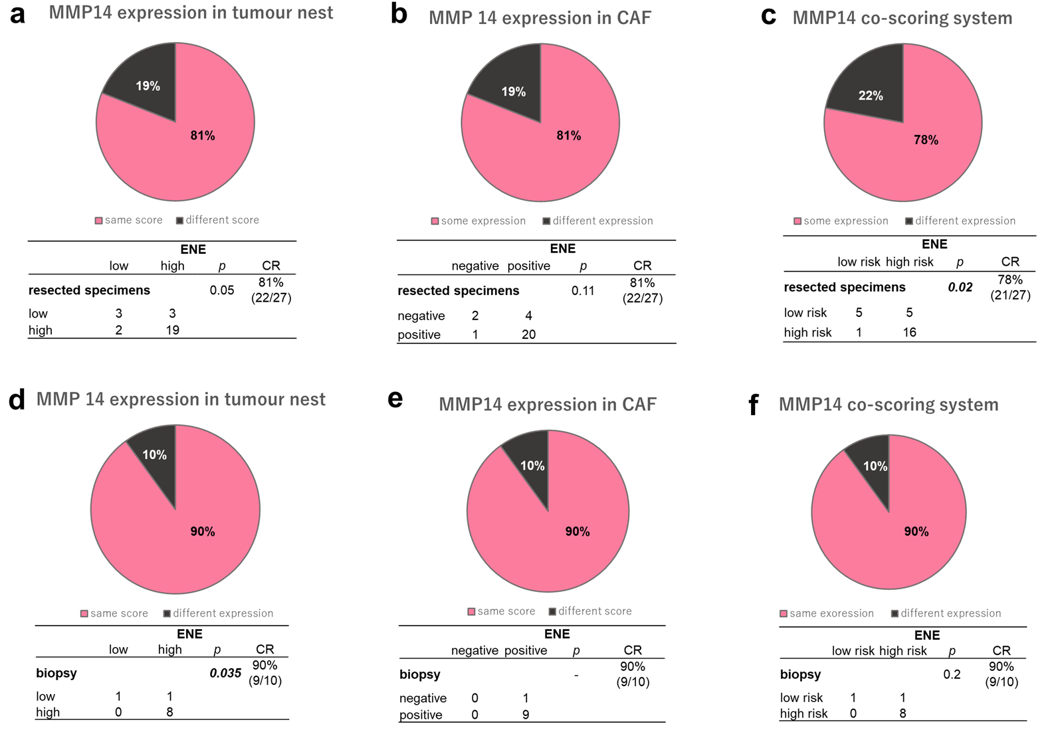
A high CR was found at the tumour nest (a, 81%), in the cancer-associated fibroblasts (CAFs) (b, 81%) and in the total score group (c, 78%) between extranodal extension (ENE) sites and the surgically resected specimens. Similar results were found between ENE sites and biopsy specimens in the MMP14 co-scoring system (d−f), at the tumour nest (d, 90%), in the CAFs (e, 90%), and the MMP14 co-scoring system (f, 90%).

