Additional File 7. Expression of MMP2, 3, and 9 and concordance rates of their expression at the ENE site in dissected LNs and at the TSI in resected specimens
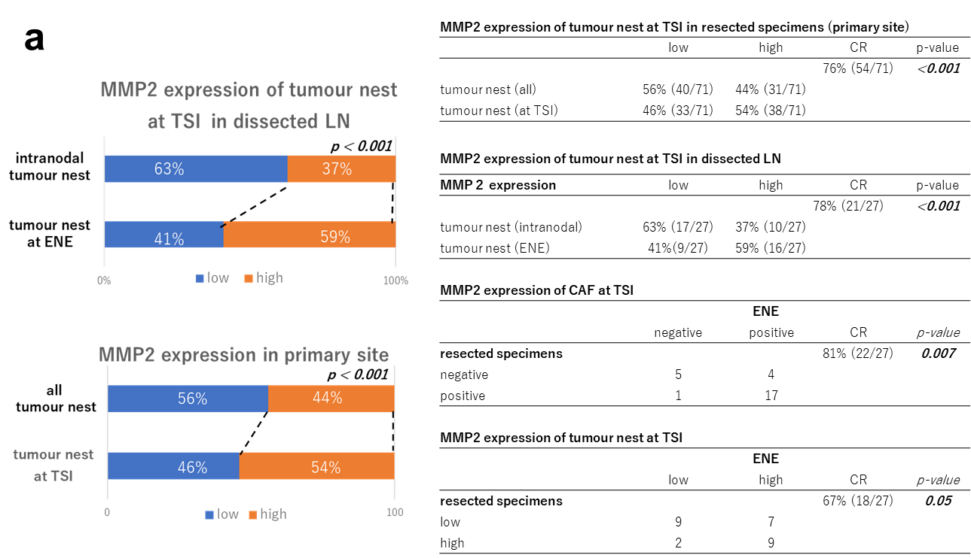

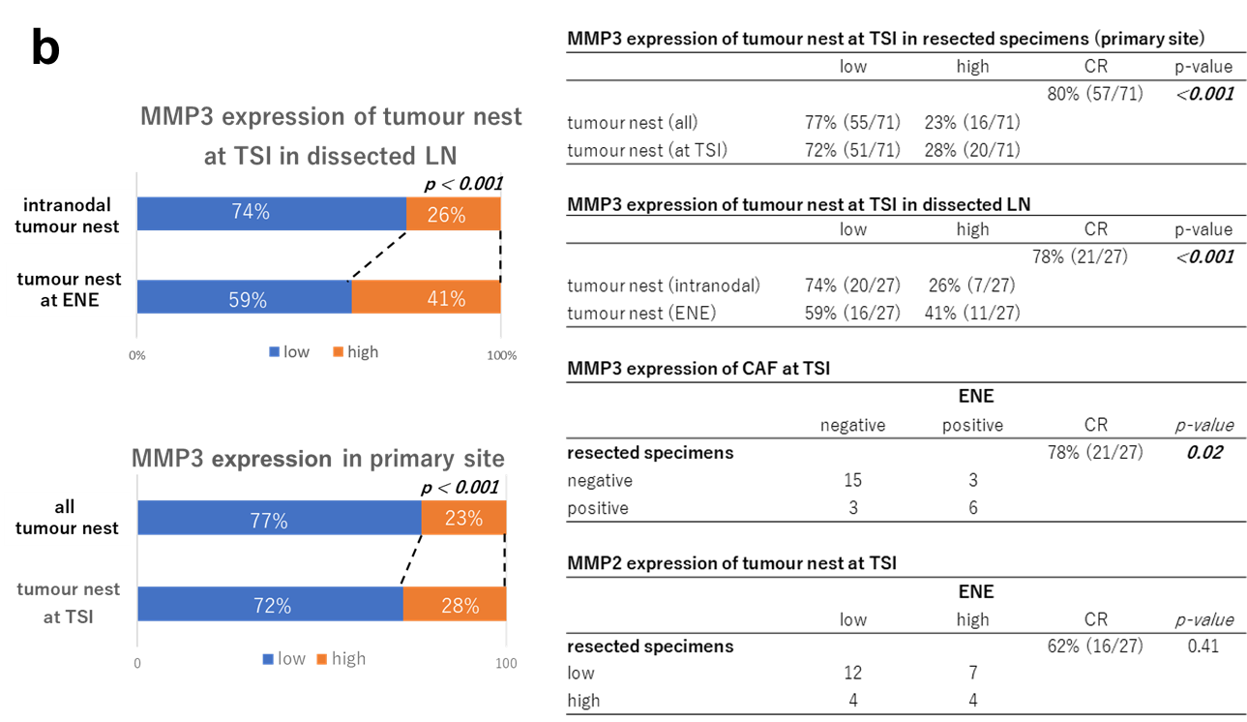
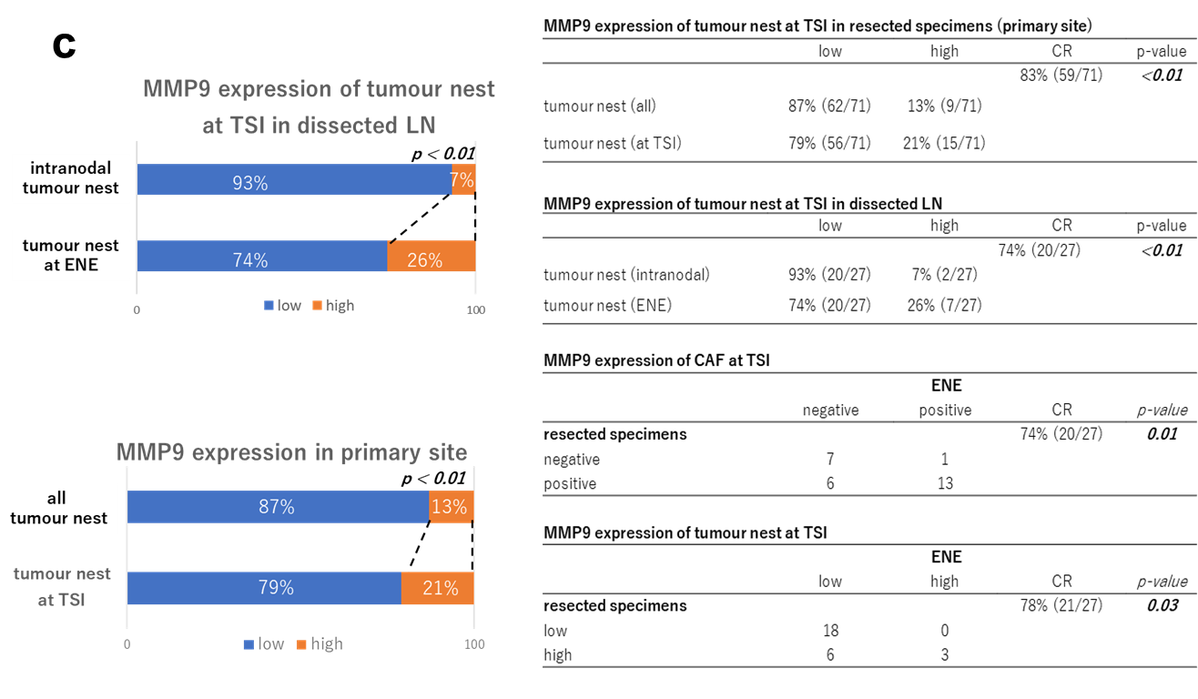
a. MMP2 expression, b. MMP3 expression, c. MMP9 expression.
CAFs, cancer-associated fibroblasts; CR, concordance rate; ENE, extranodal extension; LNs, lymph nodes; TSI: tumour–stromal interface.

