Additional File 4. Immunohistochemical analysis of MMP2, 3, and 9 expression at tumour nests and cancer-associated fibroblasts
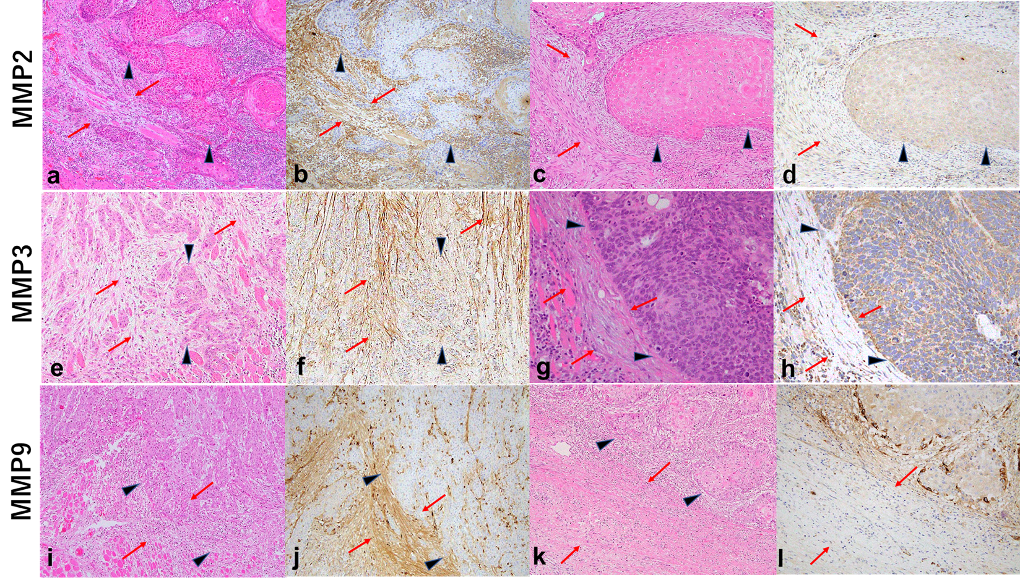
MMP2 expression score in OSCC (a−d) tumour nest: ‘low’ (a) and ‘high’ (c), and cancer-associated fibroblasts (CAFs): ‘positive’ (b) and ‘negative’ (d). MMP3 expression scores in OSCC (e−h) tumour nest: ‘low’ (e) and ‘high’ (g), and CAFs: ‘positive’ (f) and ‘negative’ (h). MMP9 expression scores in OSCC (i−l) tumour nest: ‘low’ (i) and ‘high’ (k), and CAFs: ‘positive’ (j) and ‘negative’ (l).
MMP, matrix metalloproteinase; OSCC, oral squamous cell carcinoma.
Black arrowheads indicate tumour nest; blue arrows indicate CAFs. Original magnification, 200×.

