Supplementary information for
FGF18 alleviates liver ischemia reperfusion injury via USP16 mediated KEAP1/Nrf2 signaling pathway
Gaozan Tong, ¹* Yiming Chen, ²* Xixi Chen,³* Junfu Fan, ¹ Kunxuan Zhu, ¹ ZiJing Hu,¹ Santie Li,¹ Junjie Zhu,¹ Jianjun Feng,¹ Zhaohang Wu,¹ Zhenyu Hu,¹ Bin Zhou, ² Litai Jin,¹ Jingling Shen,^{4#} Weitao Cong,^{1#} XiaoKun Li,^{1#}

Table of contents
Supplementary materials and methods 2
Supplementary figures 8
Supplementary tables 21
Supplementary references 24

Supplementary Materials and Methods
RNA-seq analysis and Kyoto Encyclopedia of Genes and Genomes (KEGG) pathway enrichment analysis
RNA-seq was performed at Guangzhou Epibiotek Co., Ltd., (Guangzhou, CHINA). Total RNA was isolated using Trizol reagent (Invitrogen). VAHTS Stranded mRNA-seq Library Prep Kit for Illumina V2 (Vazyme Biotech, NR612-02) was used for library preparation according to the instructions. Reads were aligned to the human Ensemble genome GRCh38 (mouse Ensemble genome GRCm38) using Hisat2 aligner (v2.1.0) under parameters: “--rna-strandness RF”. The reads mapped the genome were calculated using featureCounts (v1.6.3). Differential gene expression analysis was performed using the DESeq2 R-package. The information of open RNA-seq was shown in the Supplementary Table S5.
KEGG pathway and Gene Ontology (GO) terms enrichment analysis of differentially expressed genes (DEGs) was carried out by clusterProfiler R Bioconductor package with a p-value < 0.05 as statistically significant cutoffs.
Co-immunoprecipitation and ubiquitination assays
For co-immunoprecipitation assays, cells were lysed with ice-cold IP buffer (P10013J, Beyotime) with PMSF. Total lysates (200 µg) were incubated with primary antibodies (1 µg) or IgG overnight at 4°C with gentle shaking followed by Protein A/G magnetic beads (Thermo Fisher Scientific) for 4 h at room temperature. Then the co-immunoprecipitated complexes were boiled with 2×SDS loading buffer at 95°C for 10 min, followed by western blotting analyses. For ubiquitination analysis, cells were lysed in IP buffer supplemented with 1% SDS and PMSF. Obtained cell lysates were subsequently boiled for 10 min at 95°C, diluted to 0.1% SDS with IP buffer, and immunoprecipitated as previously described (1).
Mass spectrometry analysis
HEK293T cells were transfected with FLag-USP16, and cells were performed with immunoprecipitation by Flag antibody or IgG (CST, 3900, USA) with protein A/G beads (Meck, LSKMAGAG10, USA). Co-immunoprecipitation was carried out in HEK293T cells and visualized with silver staining by using the beyotime fast silver stain kit (P0017S). Then mass spectrometry was used to detect all the proteins connected with Flag-USP16. In brief, the gradient consisted of 5~35% (v/v) acetonitrile in 0.1% (v/v) formic acid at a flow rate of 200 nL/min for 10 min, 35~100% (v/v) acetonitrile in 0.1% (v/v) formic acid at a flow rate of 200 nL/min for 2 min and 100% acetonitrile in 0.1% formic acid at a flow rate of 200 nL/min for 8 min. The eluted peptides were ionized and introduced into a Thermo Fisher LTQ Velos Pro mass spectrometer (Thermo Fisher Scientific, Bremen, Germany) using a Proxeon nanoelectrospray ion source. Survey full-scan MS spectra (from m/z 200~1800) were acquired. A full mass spectrum (m/z 200~1800) was followed by fragmentation of the ten most abundant peaks, using 35% of the normalized collision energy for obtaining MS/MS spectra. All peptide assignments were verified by manual inspection.

Luciferase assays
The USP16 promoter: luciferase reporter plasmid was constructed in the pGL3 luciferase vector according to the manufacturer’s instructions (OBiO Technology, Shanghai, China). The motif in USP16-WT (GCTCATGAGTCAGCC) is mutated to USP16-Mutant (GCTCACAATCCACTT). HEK293T cells or HepG2 cells were transfected with 3 μg of pGL3-USP16-luciferase vector and then transfected with the Nrf2-vector. Transcriptional activity was measured using a Dual-Luciferase® Reporter Assay System according to the manufacturer’s instructions (OBiO Technology, Shanghai, China).
Nuclear/cytoplasmic fractionation
Cells were subjected to nuclear and cytosolic fractionation using Nuclear/Cytosolic Fractionation Kit (BioVision, Milpitas, CA, USA), following the protocol recommended by the manufacturer.
Materials
FGF18 was produced by Wenzhou Medical University Gene Engineering Laboratory and was stored as powder form at -80°C. LY294002 (CAS: 154447-36-6) was purchased from Selleck Chemicals (USA). ML385 (CAS: 846557-71-9) was purchased from Selleck Chemicals (USA). MG132 (CAS: 1211877-36-9) was purchased from Selleck Chemicals (USA). CQ (CAS: 54-05-7) was purchased from Selleck Chemicals (USA). Male C57BL/6 mice were purchased from Shanghai Slac Laboratory Animal Co. Ltd.

Immunohistochemistry and immunofluorescence staining
For immunohistochemistry, liver sections were permeabilized in PBS with 0.2% Triton X-100 for 15 min at room temperature, then blocked with PBS containing 0.5% bovine serum albumin. After 1 h, the liver sections were incubated with primary antibodies at 4°C overnight: anti-c-CAS-3 (9661, CST, USA). And then incubated with a biotinylated secondary antibody of anti-rabbit IgG at room temperature for 3 h. Next, the liver sections were treated with Diaminobenzidine (DAB) Histochemistry Kit. Finally, the nuclei were stained with hematoxylin. Images were captured with a Nikon Eclipse Ni light microscopy (JAPAN).
For immunofluorescence, in vivo studies, paraffin liver sections were used. For L02 cells and HepG2 cells, cells cultured on glass coverslips were fixed in 4% paraformaldehyde for 30 min. Paraffin liver sections or cells permeabilized in PBS with 0.2% Triton X-100 for 15 min at room temperature. Blocked as above, and then incubated with primary antibody overnight at 4°C overnight. And then it was incubated with a secondary antibody of Alexa Fluor 647-conjugated anti-mouse IgG (1:200) (Abcam, ab150119) or Alexa Fluor 488-conjugated anti-rabbit IgG secondary antibody (1:200) (Abcam, ab150077). Finally, the nuclei were stained with DAPI. Images were captured with a Leica TCS SP5 Confocal microscope (Leica, Wetzlar, Germany).
Proximity Ligation Assay (PLA)
The PLA kit was purchased from Merck (DUO92102-1KT). The directly binding between KEAP1 and USP16 was carried out the manufacturer’s instructions.
Plasmid construction and transfection
The full-length homo KEAP1 cDNA was cloned into pcDNA5-HA to express HA-tagged KEAP1 recombinant proteins and full-length homo USP16 cDNA was cloned into pcDNA5-Flag to express Flag-tagged USP16 recombinant proteins. Expression plasmids encoding truncated KEAP1 (1-315aa, 179-624aa, 1-179aa and 315-624aa) were amplified using PCR and cloned into pcDNA5-HA. All the above plasmids were constructed by OBiO Technology (Shanghai, China) Corp., Ltd.. HA-Ub, His-Ub, and His-Ub with different ubiquitin modification types were constructed by limibio Co. Ltd. Transient transfections for plasmids were performed with Lipo 2000 (Thermo Fisher Scientific, USA) and transfected into HEK293T cells. At the same time, MG132 was treated for 6 h before collection. After transfected for 48 h, HEK293T cells were harvested for co-immunoprecipitation and ubiquitination assays.
Adeno-associated virus 8/9 (AAV8/9) vectors construction and injection
For the generation of Usp16^{△HEP} mice, Usp16^{f/f} mice were injected with AAV-TBG-Cre (3×10¹¹ virus particles/200 μL PBS) by tail vein. After stably expressed for two weeks, Usp16^{△HEP} mice were performed with further study.
For the generation of AAV9-FGF18 mice, C57BL/6 mice were injected with AAV9-FGF18 (1×10¹¹ viral particles/200 μL PBS) via the tail vein. After stably expressed for two weeks, AAV9-FGF18 mice were performed with further study.
For the generation of hepatocyte specific Usp16 knockout Fgf18^{△HSC} mice, Fgf18^{△HSC} mice were injected with AAV8-TBG-shUsp16 (2×10¹¹ virus particles/200 μL PBS) to obtain hepatocyte specific Usp16 knockout Fgf18^{△HSC} mice. After stably expressed for two weeks, the mice were performed with further study.
For the generation of FGF18 overexpression in Usp16^{△HEP} mice, Usp16^{f/f} mice were injected with AAV-TBG-Cre (3×10¹¹ virus particles/200 μL PBS) in combination with AAV9-FGF18 (1×10¹¹ viral particles/200 μL PBS) through the tail veil. After stably expressed for two weeks, the mice were performed with further study.

Supplemental Figure 1
Supplemental Figure 1 (A-B) Relative mRNA expression of genes in the indicated group by RT-PCR. (C) The serum level of FGF18 in mice subjected to I/R surgery or not (n=3 per group). (D) Immunofluorescence for FGF18 (red) and desmin (green). Scale bar=50 μm. (E) To induce Fgf18-tdtomato expression, mice were injected with tamoxifen (2 mg dissolved in 150 μL Corn Oil) every other day for a total of five times prior to the I/R surgery. Immunofluorescence for Tdtomato (red) and different cell markers (green). Scale bar=50 μm. (F) Transwell assay was performed. Relative protein expression by western blotting. (G) Protein levels of FGFR1, FGFR2, FGFR3, and FGFR4 in L02 cells subjected to H/R challenge or not. (H) Relative protein expression by western blotting. (I) Immunofluorescence showed the transfection efficiency of AAV-FGF18 in liver mice sections (n=3 per group). Scale bar: 100 μm. The statistical significance of differences were assessed by student unpaired t-test. Data are presented as means ± SEM for at least triplicate experiments. (*p < 0.05; **p < 0.01.)

Supplemental Figure 2
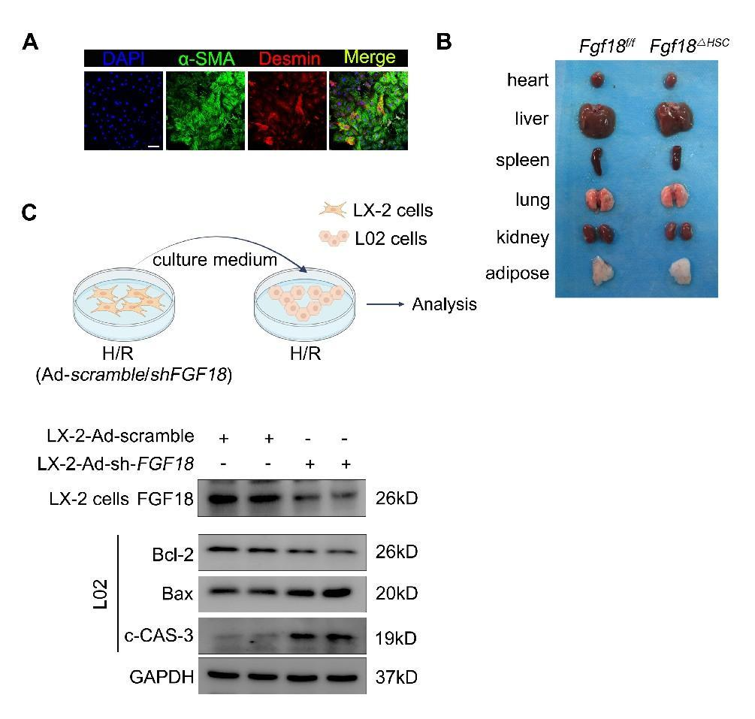
Supplemental Figure 2 (A) Morphology of different organs from Fgf18^{f/f} and Fgf18^{△HSC} mice. (B) HSCs were extracted from Fgf18^{f/f} and Fgf18^{△HSC} mice subjected to I/R surgery. Immunofluorescence for α-SMA (green), desmin (red), and DAPI (blue). Scale bar: 100 μm. (C) schematic representation of the cell-based supernatant transfer assay. Relative protein expression by western blotting. Data are presented as means ± SEM for at least triplicate experiments.

Supplemental Figure 3
Supplemental Figure 3 (A) RNA-sequence was carried out between Sham and I/R with different reperfusion times (0, 1, 3, 6, 12, 24). The results of USP family changes were presented in the form of heat maps (n=5 per group).

Supplemental Figure 4
Supplemental Figure 4 (A) Protein levels of USP16 and KEAP1 in AAV-LacZ and AAV-FGF18 mice subjected to I/R surgery or not (n=3 per group). The statistical significance of differences were assessed by one-way ANOVA wherever applicable, followed by appropriated post-hoc test. Data are presented as means ± SEM for at least triplicate experiments. (*p < 0.05; **p < 0.01.)

Supplemental Figure 5
Supplemental Figure 5 FGF18 activates Nrf2 signaling pathway during hepatic IRI. (A) A heatmap representation of genes from Fgf18^{f/f} mice and Fgf18^{△HSC} mice. (B) Volcano plots representation of significantly up-regulated (red) and down-regulated (blue) genes between Fgf18^{f/f} mice and Fgf18^{△HSC} mice. (C-D) KEGG and BP. (E) Relative protein expression by western blotting. (F) Protein levels of (total) t-Nrf2, (nuclear) n-Nrf2, and HO-1 in FGF18 (200 ng/mL) treated L02 cells subjected to H/R challenge or not. (G) Nrf2 immunofluorescence staining in H/R treated L02 cells, HepG2 cells, primary hepatocytes in the presence of FGF18 or not. Scale bar=50 μm. (H) The purity of primary hepatocytes was verified by the immunofluorescence of albumin and the bright field photoed by inverted microscope. (I) DCFH-DA staining. Scale bar=100 μm. (J) L02 cells were transfected with si-Nrf2 or Scramble, and then subjected to H/R challenge in the presence of FGF18 (n=3 per group). (K) Relative protein expression by western blotting. The statistical significance of differences were assessed by one-way ANOVA wherever applicable, followed by appropriated post-hoc test. Data are presented as means ± SEM for at least triplicate experiments. (*p < 0.05; **p < 0.01; n.s., not significant.)

Supplemental Figure 6
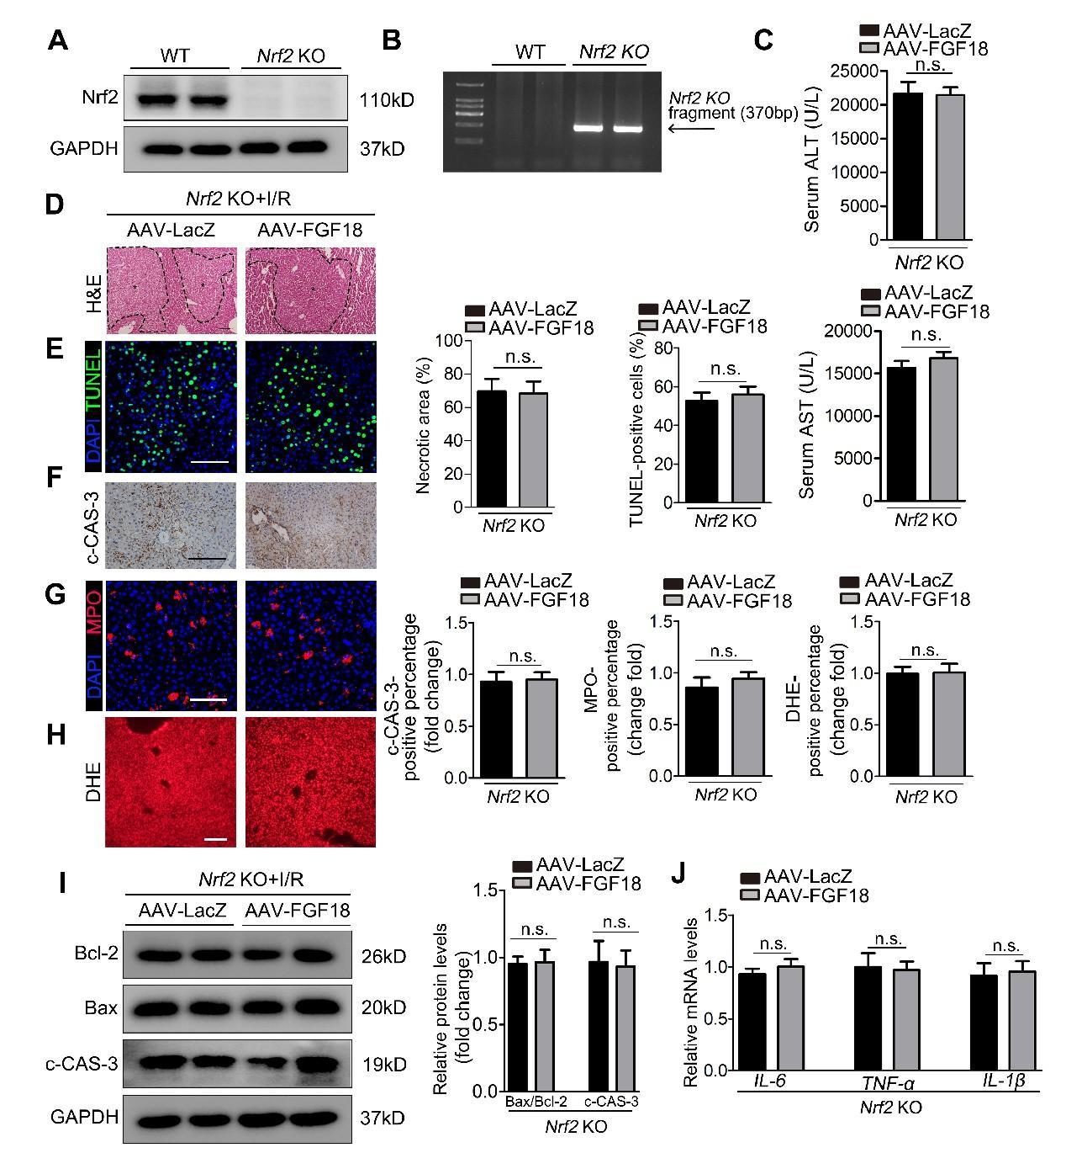
Supplemental Figure 6 FGF18 activates Nrf2 signaling pathway during hepatic IRI (A) Relative protein expression by western blotting. (B) The genotype of Nrf2 KO mice were confirmed by RT-PCR. (C) Serum ALT and AST level. (D) Representative H&E staining of liver sections from Nrf2 KO and Nrf2 KO+AAV-FGF18 mice subjected to I/R surgery. H&E staining of liver sections. Scale bar=100 μm. (E-H) TUNEL staining, c-CAS-3 immunohistochemistry, MPO, and DHE staining of liver sections. (I) Relative protein expression by western blotting. (J) Relative mRNA expression of genes by RT-PCR. The statistical significance of differences were assessed by student unpaired t-test. Data are presented as means ± SEM for at least triplicate experiments. (n.s., not significant.)

Supplemental Figure 7
Supplemental Figure 7 (A) HEK293T cells were transfected with FLag-USP16, and cells were performed with co-immunoprecipitation by Flag antibody or IgG with protein A/G beads. Then mass spectrum was used to detect all the proteins connected with Flag-USP16. (B) Co-immunoprecipitation was carried out in HEK293T cells and then conducting silver staining. (C) Co-immunoprecipitation assay showed the endogenous interaction between USP16 and KEAP1 in HepG2 cells.

Supplemental Figure 8
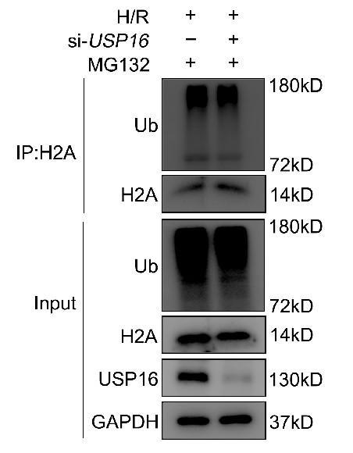
Supplemental Figure 8 (A) The ubiquitination level of H2A was determined in H/R treated HepG2 cells transfected with si-USP16 or si-scramble in the presence of MG132 (10 μM). Data are presented as means ± SEM for at least triplicate experiments.

Supplemental Figure 9
Supplemental Figure 9 (A) HEK293T cells were transfected with HA-KEAP1 and Flag-USP16. Then cells were simultaneously overexpressed with different His-Ub plasmids (His-Ub, K6-Ub, K11-Ub, K27-Ub, K29-Ub, K33-Ub, K48-Ub, and K63-Ub). After 48 h, cells were collected and performed with Co-IP. Data are presented as means ± SEM for at least triplicate experiments.

Supplemental Figure 10
Supplemental Figure 10 The optimal timing of the H/R models in hepatocytes (A) Protein levels of USP16, Nrf2, and HO-1 in HepG2 cells subjected to different time points of H/R challenge. (B) Protein levels of USP16, Nrf2, and HO-1 in L02 cells subjected to different time points of H/R challenge. (C) Protein levels of USP16, Nrf2, and HO-1 in primary hepatocytes subjected to different time points of H/R challenge. Data are presented as means ± SEM for at least triplicate experiments.

Supplementary Tables
Supplementary Table S1. Patients’ characteristics of hepatectomy
Variables | Patients
N | 32
Sex (male/female) | 24/8
Age (year) | 57.13 ± 11.78
Aetionlogy of disease (N) | Hepatic hemangioma (18)  Intrahepatic cholelithiasis (2）  FNH (12)
Ischemia time (min) | 15-40
reperfution time (H) | 1-2
Types of HEPATECTOMY | PARTIAL HEPATECTOMY
Albumin of POD1 (g/L) | 33.43±4.18
ALT of pod1 (U/L) | 370.34±300.77

Supplementary Table S2. Real-time PCR primers.
Primer | Forward | Reverse
Fgf18 (Mouse) | 5’-CTGCGCTTGTACCAGCTCTAT-3' | 5’-GACTCCCGAAGGTATCTGTCT-3'
IL-1β (Mouse) | 5'-CATGAGCCGAAGCTAACCC-3' | 5'- TGTGGCAGATACAGATCAAGC-3'
IL-6 (Mouse) | 5'-AGGATACCACTCCCAACAGACCT-3' | 5'-CAAGTGCATCATCGTTGTTCATAC-3'
TNFα (Mouse) | 5'-AGCCGATGGGTTGTACCTTG-3' | 5'-ATAGCAAATCGGCTGACGGT-3'
IL-1β (Human) | 5'-ATGATGGCTTATTACAGTGGCAA-3' | 5'-GTCGGAGATTCGTAGCTGGA-3'
IL-6 (Human) | 5'-ACTCACCTCTTCAGAACGAATTG-3' | 5'-CCATCTTTGGAAGGTTCAGGTTG-3'
TNFα (Human) | 5'-CAGCCTCTTCTCCTTCCTGAT-3' | 5'-GCCAGAGGGCTGATTAGAGA-3'
USP16 (Human) | 5'-ATGAGGTCGGGGCATTACAC-3' | 5'-GCACATGTGTGTCGCTGATG-3'
Usp16 (Mouse) | 5'-TTGGGCCAAGTGGTTGATTATGTTAGAAA-3' | 5'-AAGAAACAAGTATTCCCCAAATTACTGAG-3'
Nrf2 (Mouse)  Transgenic Animal | 5'-CTTTGGTAACCATCTGTATGCTGGG-3' | 5'-ATGTTGCAAGCTCCTATACGTTGTG-3'
Fgf18 (Mouse) Transgenic Animal | 5'-TACTTTGAGGAGTAGAAGGCTCTG-3' | 5'-CTGAATCAAGAGAAGGACACCAAG-3'
GFAP-Cre (Mouse)  Transgenic Animal | 5'-TAGCCCACTCCTTCATAAAGCCCT-3' | 5'-GCTAAGTGCCTTCTCTACACC-3'

Supplementary Table S3. Antibodies used in this study
Antibody | Catalog | Company | Application | Dilution
FGF18 | sc-393471 | Santa cruz | WB/IF | 1:1000/1:200
FGF18 | ER60001 | Huabio | WB | 1:1000
FGFR1 | 9740S | CST | WB | 1:1000
FGFR2 | 23328S | CST | WB | 1:1000
FGFR3 | 4574S | CST | WB | 1:1000
FGFR4 | 8562S | CST | WB | 1:1000
BCL2 | ET1702-53 | Huabio | WB | 1:1000
BAX | 2772S | CST | WB | 1:1000
c-Cas-3 | 9661S | CST | IHC | 1:200
Nrf2 | 16396-1-AP | Proteintech | WB | 1:1000
Nrf2 | ab31163 | Abcam | IF | 1:200
HO-1 | 10701-1-AP | Proteintech | WB | 1:1000
KEAP1 | 10503-2-AP | Proteintech | WB/IF/IP | 1:1000/1:200/1:100
KEAP1 | ab66620 | Abcam | WB/IF/IP | 1:1000/1:200/1:100
KEAP1 | sc-514914 | Santa cruz | IP | 1:100
USP16 | 14055-1-AP | Proteintech | WB/IF/IP | 1:1000/1:200/1:100
USP16 | sc390683 | Santa cruz | IF/IP | 1:200/1:100
HA | 51064-2-AP | Proteintech | WB/IP | 1:1000/1:100
Flag | 66008-4-Ig | Proteintech | WB/IP | 1:1000/1:100
His | sc-8036 | Santa cruz | WB/IP | 1:1000/1:100
Ubiquitin | sc8017 | Santa cruz | WB | 1:1000
H₂A | A3692 | ABclonal | WB/IP | 1:1000/1:100
α-SMA | 19245 | CST | IF | 1:200
Desmin | ET1606-30 | Huabio | IF | 1:200
LYVE-1 | 67538 | CST | IF | 1:200
Albumin | 0806-9 | Huabio | IF | 1:200
F4/80 | 30325S | CST | IF | 1:400
MPO | ab208670 | Abcam | IF | 1:200
4-HNE | AB48506 | Abcam | IF | 1:200
Flag | sc-166355 | Santa cruz | IP | 1:100
HA | sc-7392 | Santa cruz | IP | 1:100
IgG | B0619 | Santa cruz | IP | 1:100

Supplementary Table S4 primers for si-RNA sequence used in this study
Gene | Forward | Reverse
USP16 (homo) | CCACAGAGGAAGUAGAUAUTT | AUAUCUACUUCCUCUGUGGTT

Supplementary Table S5 the open RNA-seq used in this study
GEO no. | Species | Strain | Control | Treatment |  | Description |  |  | PubMed ID
SRP117594 | Mouse | C57BL/6 | 30 SAMPLES |  |  |  | Mice liver tissues from Sham and I/R with different reperfusion times (n=5 per group) |  | 29227475
GSE93034 | Mouse | C57BL/6 | GSM2442830  GSM2442831  GSM2442832 |  | GSM2442821  GSM2442822  GSM2442823 |  |  | RNA sequencing of RNA isolated from liver tissue from mice that underwent liver reperfusion treatment (IR) or sham surgery（n=5 per group） | 29109123

Supplementary References
- Ji J, Ding K, Luo T, Zhang X, Chen A, Zhang D, et al. TRIM22 activates NF-κB signaling in glioblastoma by accelerating the degradation of IκBα. Cell Death Differ. 2021;28:367-381.

.

