Revised Manuscript for Clean Technologies and Environmental Policy, Number: CTEP-D-20-01085
Presented at the 23rd Conference on Process Integration, Modelling and Optimisation for Energy Saving and Pollution Reduction held in Xi'an on August 17-23, 2020. Original Paper Number: PRES20_0146
Effects of Freezing-Thawing Pretreatment on Anaerobic Digestion of Wheat Straw and its Kinetics Analysis
Qianru Zhang ^{1,2} · Yiqing Yao^{1,2} · Xinming Xi^{1,2*}
Graphic abstract
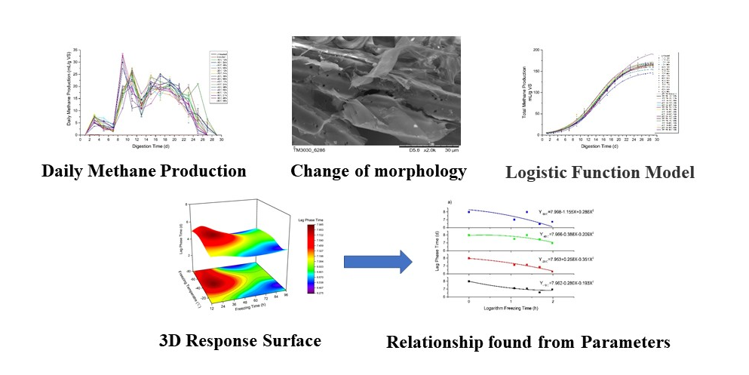
Affiliations
Qianru Zhang ^{1,2} · Yiqing Yao^{1,2} · Xinming Xi^{1,2*}
* Xinming Xi
play6@sohu.com; 13720455112@163.com
1. College of Mechanical and Electrical Engineering, Northwest A&F University, Yangling, Shaanxi
2. Northwest Research Center of Rural Renewable Energy Exploitation and Utilization of M.O.A, Yangling, Shaanxi, 712100

