Online Resources
Combining Fission-Track Radiography and Scanning Electron Microscopy to Elucidate Uranium Mobility Controls
Journal name: Environmental Earth Sciences
Rakiba Sultana*, Martin A Dangelmayr, Charles J Paradis, Raymond H Johnson
Corresponding Author Affiliation: Department of Geosciences, University of Wisconsin-Milwaukee, 3209 N Maryland Ave, Milwaukee, WI 53201-0413, USA,
Corresponding Author Email: sultanar@uwm.edu
ORCID: 0000-0001-6422-2962

Table of Contents
Source zone: borings 859 and 860 1
Boring 859: (below water table) 1
Boring 859 (below water table): spot-01 3
Boring 860: (below water table) 10
Boring 860 (below water table): spot-01 11
Boring 860 (below water table): spot-02 12
Plume zone: boring 858 15
Boring 858 15

Source zone: borings 859 and 860

Boring 859: (below water table)

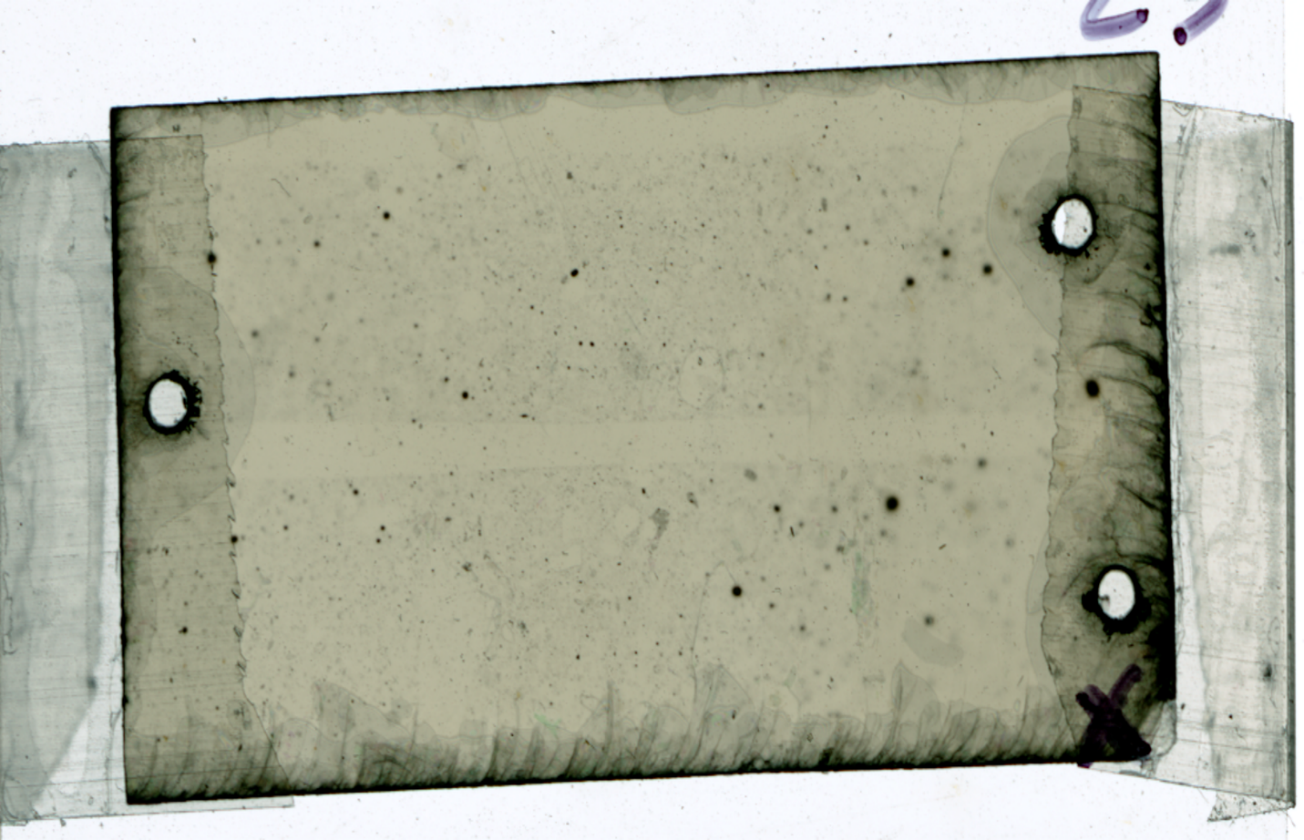
Spot-02
Spot-01
Fig. S1 Fission tracks on thin section of boring 859 (8.5 ft below ground surface)

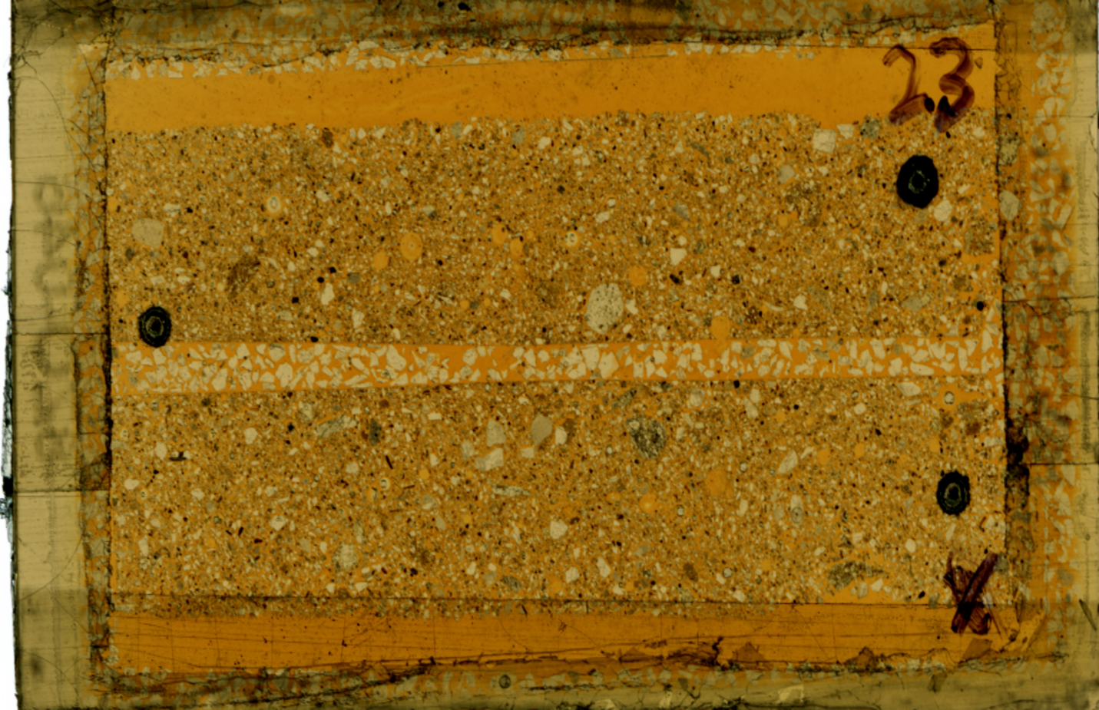
Fig. S2 Transmitted light image of thin section of boring 859 (8.5 ft below ground surface)

Boring 859 (below water table): spot-01

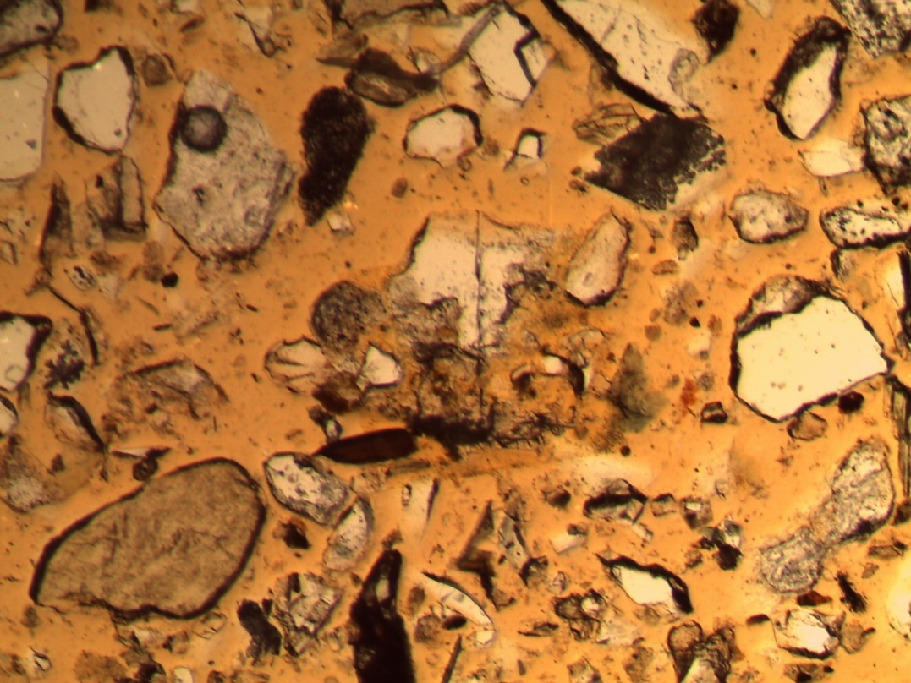
Fig. S3 Transmitted light image of spot 01

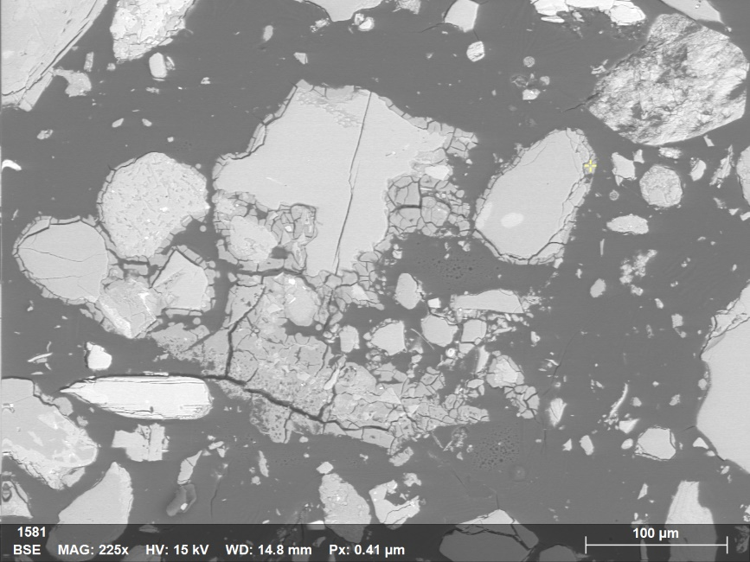
Fig. S4 Point map-01 (yellow point showing location)
Table S1 Quantitative analysis of point map-01 (Fig. S4)

Fig. S5 Spectrum of point map-01 showing a high Al peak (Fig. S4)

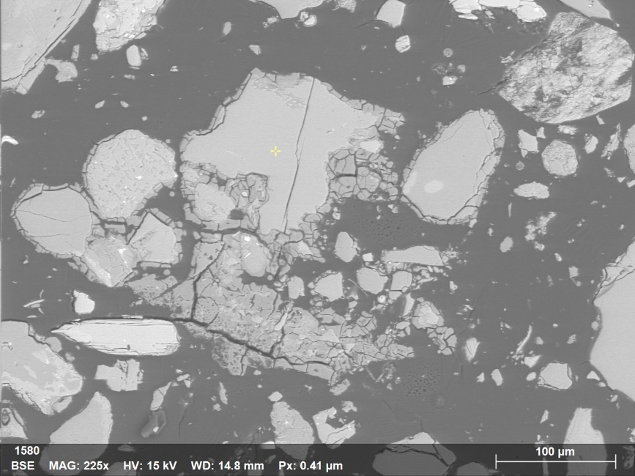
Fig. S6 Point map-02

Table S2 Quantitative analysis of point map-02 (Fig. S6)

Fig. S7 Spectrum of point map-02 showing feldspar (Fig. S6)

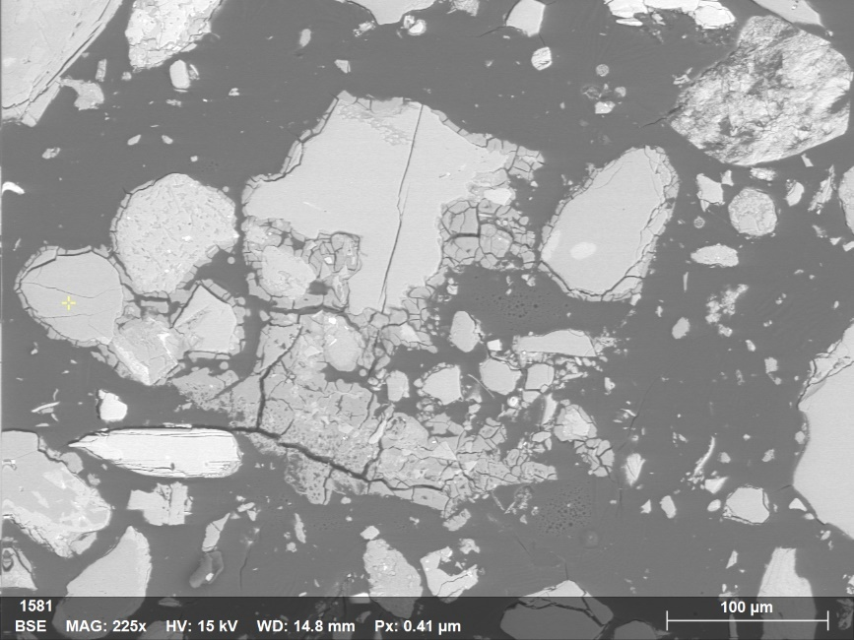
Fig. S8 Point map-03

Table S3 Quantitative analysis of point map-03 (Fig. S8)

Fig. S9 Spectrum of point map-03 showing quartz (Fig. S8)

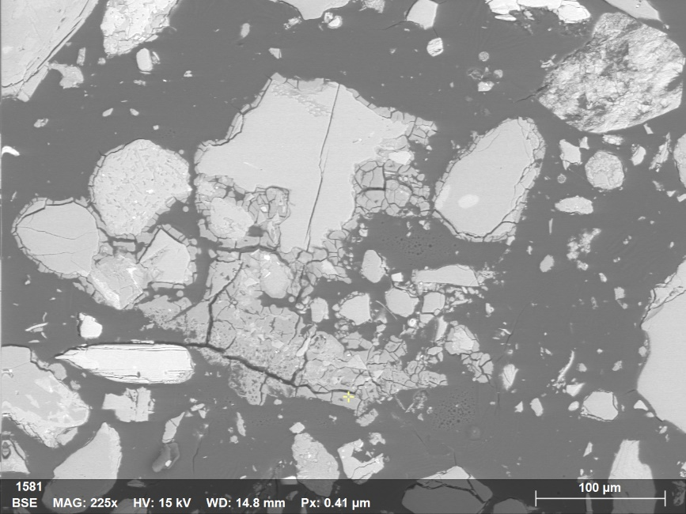
Fig. S10 Point map-04

Table S4 Quantitative analysis of point map-04 (Fig. S10)

Fig. S11 Spectrum of point map-04 showing Al-rich precipitate (Fig. S10)

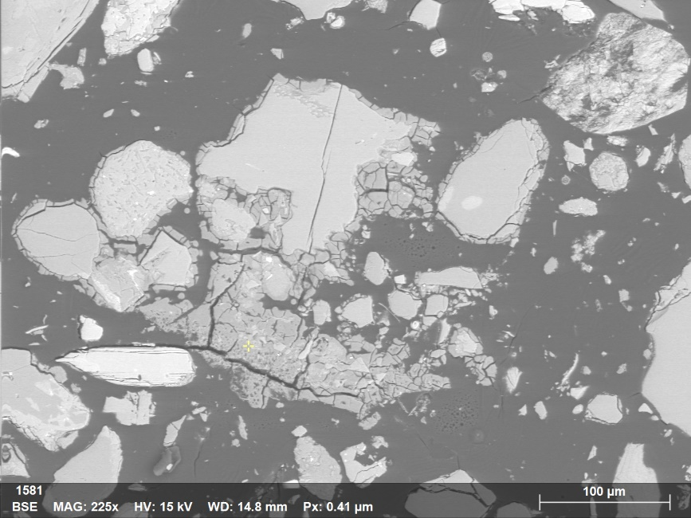
Fig. S12 Point map-05

Table S5 Quantitative analysis of point map-05 (Fig. S12)

Fig. S13 Spectrum of point map-05 showing Al-rich precipitate (Fig. S12)

Boring 860: (below water table)

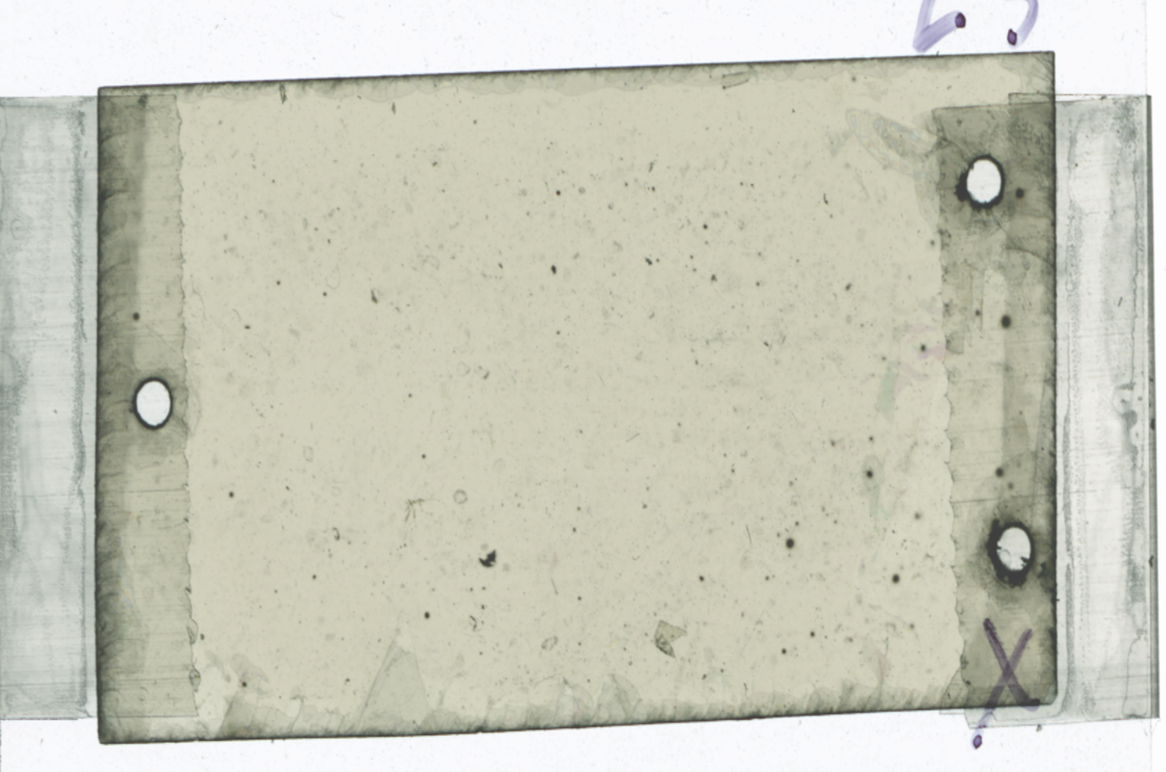
Spot-02
Spot-01
Fig. S14 Fission tracks on thin section of boring 860 (15.5 ft below ground surface)

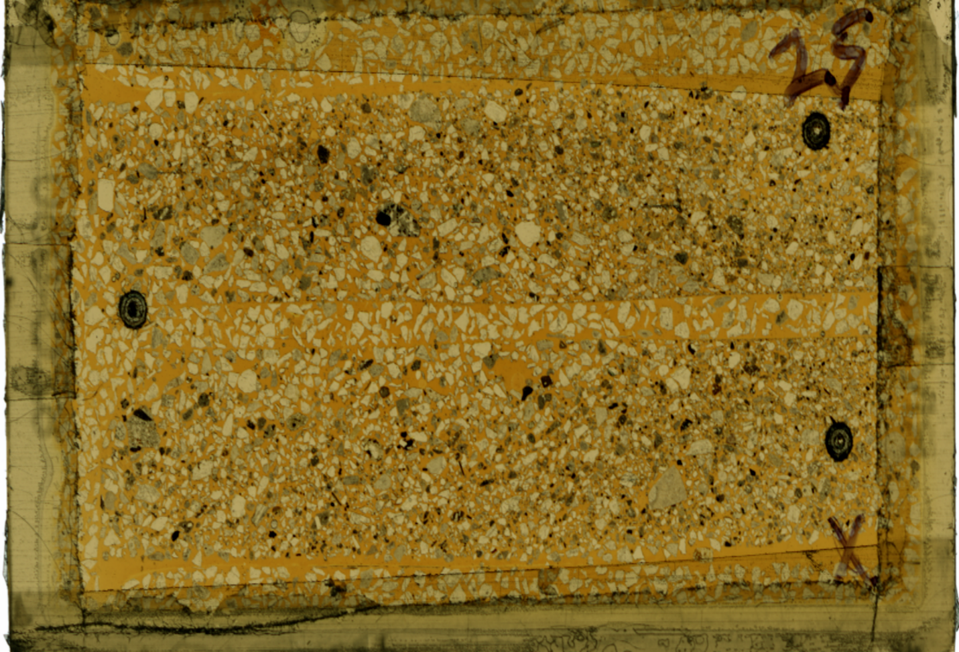
Fig. S15 Plain light image of thin section of boring 860 (15.5 ft below ground surface)

Boring 860 (below water table): spot-01

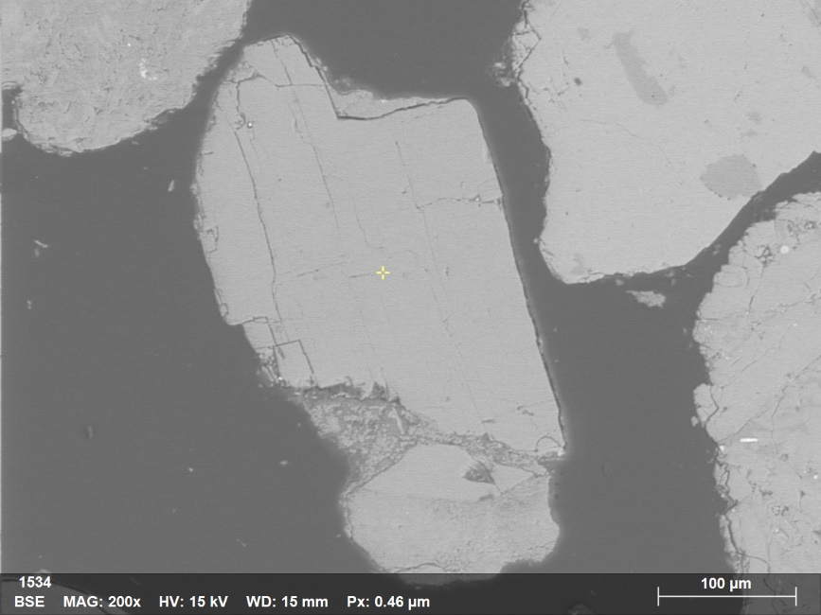
Fig. S16 Point map-01

Table S6 Quantitative analysis of point map-01 (Fig. S15)

Fig. S17 Spectrum of point map-01 showing feldspar (Fig. S15)

Boring 860 (below water table): spot-02

Fig. S18 Al elemental map

Fig. S19 Si elemental map

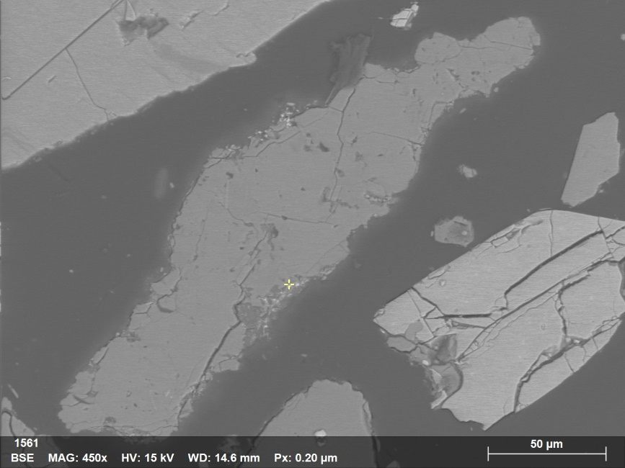
Fig. S20 Point map-03

Table S7 Quantitative analysis of point map-03 (Fig. S19)

Fig. S21 Spectrum of point map-03 Fe particles (Fig. S19)

Plume zone: boring 858

Boring 858
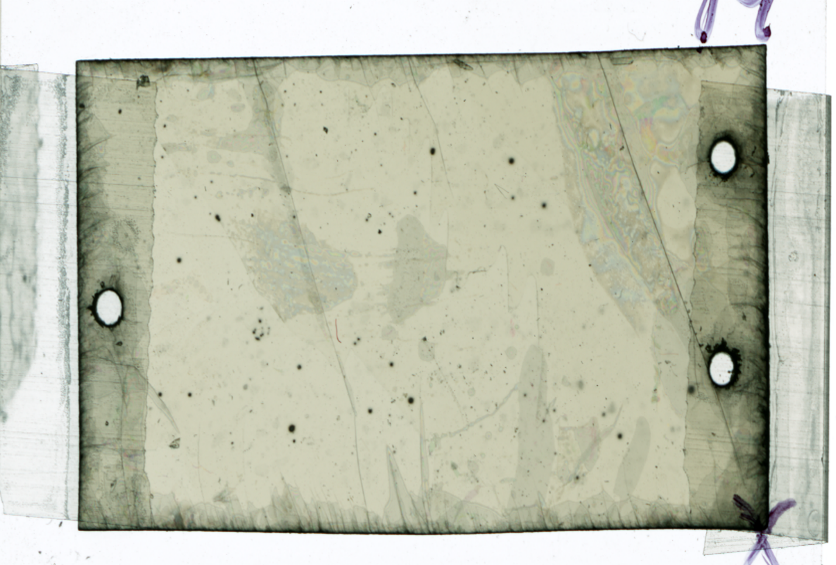
Spot-01
Fig. S22 Fission tracks on thin section of boring 858 (13 ft below ground surface)
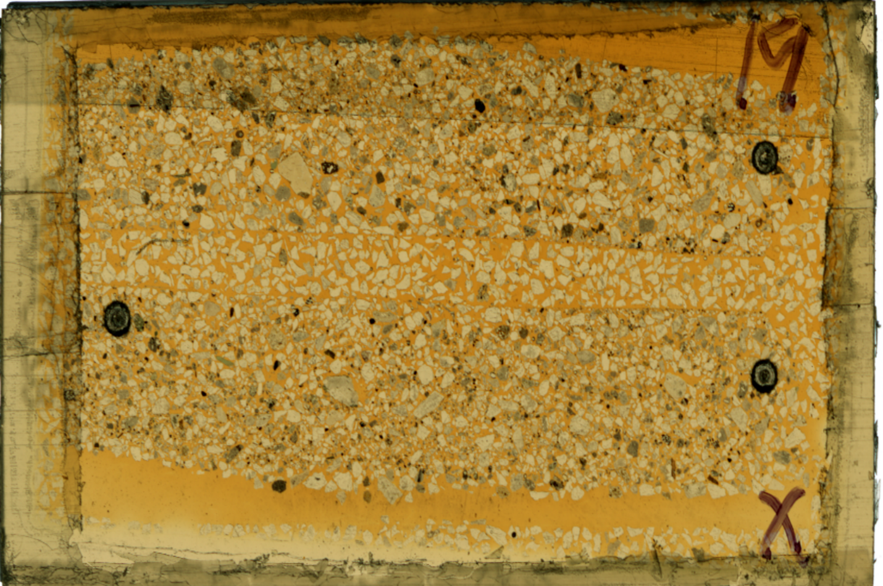
Fig. S23 Transmitted light image of thin section of boring 858 (13 ft below ground surface)

